Assignment 1

Code — A1Q1.m
clc
close all
clear all
format short
n = 19;
true_value = factorial(n)
app_value = (sqrt((2*n + 1/3)*pi))*(n^n)*(exp(-n))

%error
error = abs((true_value - app_value)/(true_value))

Output
true_value =

1.2165e+17

app_value =

1.2164e+17

error =

1.8720e-05

Code — A1Q2.m
clc
close all
clear all

format short

a = 27;
b = 43;
c = 57;

disp("=======")
disp("[part a]")
disp("=======")
%ANGLE Y
ALPHA = acosd((a^2 - b^2 - c^2)/(-2*b*c))
BETA = acosd((b^2 - c^2 - a^2)/(-2*a*c))
GAMMA = acosd((c^2 - a^2 - b^2)/(-2*a*b))

disp("=======")
disp("[part b]")
disp("=======")
LHT = ( b - c ) / ( b + c )
RHT = (tand(1/2*(BETA - GAMMA))) / (tand(1/2*(BETA + GAMMA)))

tol = 0.00001;

if (LHT - RHT) < tol
disp("RHT = LHT, thus the eqn holds")
else
disp("RHT /= LHT, thus the eqn doesnt hold")
end

Output
=======
[part a]
=======

ALPHA =

26.9669

BETA =

46.2365

GAMMA =

106.7966

=======
[part b]
=======

LHT =

-0.1400

RHT =

-0.1400

RHT = LHT, thus the eqn holds

Code — A1Q2_a.m
clc
close all
clear all

format short

a = 27;
b = 43;
c = 57;

disp("part a")
%ANGLE Y
ALPHA = acosd((a^2 - b^2 - c^2)/(-2*b*c))
BETA = acosd((b^2 - c^2 - a^2)/(-2*a*c))
GAMMA = acosd((c^2 - a^2 - b^2)/(-2*a*b))

disp("part b")
LHT = ( b - c ) / ( b + c )
RHT = (tand(1/2*(BETA - GAMMA))) / (tand(1/2*(BETA + GAMMA)))

Output
part a

ALPHA =

26.9669

BETA =

46.2365

GAMMA =

106.7966

part b

LHT =

-0.1400

RHT =

-0.1400

Code — A1Q3.m
clc
close all
clear all

a = [5,8,-1,0,2];
b = [4,1,9,-2,3];
c = [-3,5,0,6,1];

disp("========")
disp("[Part a]")
disp("========")
vector_a = [a(:,1:3) b(:,1:3) c(:,1:3)]

disp("========")
disp("[Part b]")
disp("========")
%vector_b = [a(3:5) b(3:5) c(3:5)]'
vector_b = vector_a'

disp("========")
disp("[Part c]")
disp("========")
MAT_c = [a; b; c;]

disp("========")
disp("[Part d]")
disp("========")
MAT_d = [c(1:5); b(1:5); a(1:5);]'

disp("========")
disp("[Part e]")
disp("========")
MAT_e = [a(2:4); b(3:5); c(1:3);]

Output
========
[Part a]
========

vector_a =

5 8 -1 4 1 9 -3 5 0

========
[Part b]
========

vector_b =

5
8
-1
4
1
9
-3
5
0

========
[Part c]
========

MAT_c =

5 8 -1 0 2
4 1 9 -2 3
-3 5 0 6 1

========
[Part d]
========

MAT_d =

-3 4 5
5 1 8
0 9 -1
6 -2 0
1 3 2

========
[Part e]
========

MAT_e =

8 -1 0
9 -2 3
-3 5 0

Code — A1Q4.m
clc
clear all
close all

format short

k = [0.25, 0.5, 0.75, 1.0, 1.25, 1.5, 1.75; 2, 4, 6, 8, 10, 12, 14; 25, 30, 35, 40, 45, 50, 55;]

disp("========")
disp("[Part A]")
disp("========")
row_1 = [k(1,1:2) k(1,6:7)];
row_2 = [k(3,1:2), k(3,6:7)];
MAT_a = [row_1; row_2;];
ka = MAT_a

disp("========")
disp("[Part B]")
disp("========")
row_a = [k(:,2)' k(:,5)'];
row_b = k(2, 1:6);
row_c = k(3, 2:7);

kb = [row_a; row_b; row_c;]

Output
k =

0.2500 0.5000 0.7500 1.0000 1.2500 1.5000 1.7500
2.0000 4.0000 6.0000 8.0000 10.0000 12.0000 14.0000
25.0000 30.0000 35.0000 40.0000 45.0000 50.0000 55.0000

========
[Part A]
========

ka =

0.2500 0.5000 1.5000 1.7500
25.0000 30.0000 50.0000 55.0000

========
[Part B]
========

kb =

0.5000 4.0000 30.0000 1.2500 10.0000 45.0000
2.0000 4.0000 6.0000 8.0000 10.0000 12.0000
30.0000 35.0000 40.0000 45.0000 50.0000 55.0000

Code — A1Q5.m
clc
close all
clear all

A = eye(2,2)
B = ones(1,2)
C = zeros(3,3)

D(1:3, 1:3) = C;
D(3, 4:5) = B;
D(1:2, 4:5) = A

Output
A =

1 0
0 1

B =

1 1

C =

0 0 0
0 0 0
0 0 0

D =

0 0 0 1 0
0 0 0 0 1
0 0 0 1 1

Code — A1Q6.m
clc
close all
clear all

a = 0.75
b = 11.3

x = [2,5,1,9];
y = [0.2, 1.1, 1.8, 2]
z = [-3,2,5,4]

A = ( (x.^1.1 .*y.^-2 .* z.^5)/(a+b)^(b/3) + (a .*(z./x + y./2) ./z.^a) )

Output
a =

0.7500

b =

11.3000

y =

0.2000 1.1000 1.8000 2.0000

z =

-3 2 5 4

A =

-0.7783 + 0.3257i 0.4368 + 0.0000i 1.4052 + 0.0000i 0.6263 + 0.0000i

Code — test.m
clc
close all
clear all
a=[5 35 43; 4 76 81; 21 32 40]
%disp(a)

Output
a =

5 35 43
4 76 81
21 32 40

Assignment 2

Code — A2Q1.m
clc
clear all
close all

format rational

v = [5 4 3 2]

disp("==================")
disp(" PART A ")
disp("==================")

V = v + v;
a = 1 ./ V

disp("==================")
disp(" PART B ")
disp("==================")

b = v.^v

disp("==================")
disp(" PART C ")
disp("==================")

c = v./sqrt(v)

disp("==================")
disp(" PART D ")
disp("==================")

d = (v.^2)./(v.^v)

Output
v =

5 4 3 2

==================
PART A
==================

a =

1/10 1/8 1/6 1/4

==================
PART B
==================

b =

3125 256 27 4

==================
PART C
==================

c =

2889/1292 2 1351/780 1393/985

==================
PART D
==================

d =

1/125 1/16 1/3 1

Code — A2Q2.m
clc
close all
clear all

A = [25 40 60 70 32 0; 1 1 1 1 1 1; 0 -1 1 0 0 0; 0 1 0 1 -10 0; -1 1 1 0 0 0; 1 0 1 0 -4 -4]
%x = ['STUDENT'; 'ALUMNI'; 'FACULTY'; 'PUBLIC'; 'VETERANS'; 'G';]
b = [4897000; 100000; -11000; 0; 0; 0;]

x = round((A^-1)*b)

student = x(1)
alumni = x(2)
faculty = x(3)
public = x(4)
veterans = x(5)
guests = x(6)

Output
A =

25 40 60 70 32 0
1 1 1 1 1 1
0 -1 1 0 0 0
0 1 0 1 -10 0
-1 1 1 0 0 0
1 0 1 0 -4 -4

b =

4897000
100000
-11000
0
0
0

x =

25000
18000
7000
42000
6000
2000

student =

25000

alumni =

18000

faculty =

7000

public =

42000

veterans =

6000

guests =

2000

Code — A2Q4.m
clc
close all
close all

format short

r = 14;
h_vals = [0:2:14];

%V = round(pi*r^2.*h_vals);
V = round(pi*r^2.*h_vals);
%round(V);

mat(1,:) = h_vals;
mat(2,:) = V;

MAT = mat';
disp(" HEIGHT VOLUME")
disp(table(MAT))

Output
HEIGHT VOLUME
MAT
__________

0 0
2 1232
4 2463
6 3695
8 4926
10 6158
12 7389
14 8621

Code — A2Q5.m
clc
close all
clear all

%size = input("Enter thy size of grade array ");
%size = 3
%grades = (1:size);

%for k = 1:1:size
% %disp(k)
% g = input("Enter value ");
% grades(k) = g;
%end [93 77 51 62 99 41 82 77 71 68 100 46 78 80 83]
grades = input("Enter thy grades ")

len_values = (length(grades));
avg_values = (mean(grades));
std_values = (std(grades));

fprintf("\n")
fprintf('The are %5.2f grades; \n', len_values);
fprintf('The avg grade is %5.2f; \n', avg_values);
fprintf('Standard Deviation is %5.2f; \n', std_values);

Output
ERROR: Support for user input is required, which is not available on this platform.

Code — A2Q6.m
clc
clear
close all

T = [80 82 84 86 88 90 92 94];
R = [50 55 60 65 70 75]';

[t,r] = meshgrid(T,R);

HI = round(-42.379 + 2.04901523*T + 10.14333127*R - 0.22475541*(T.*R) - 6.83783e-3*(T.^2) - 5.481717e-2*(R.^2) + 1.22874e-3*(T.^2).*R + 8.5282e-4*T.*(R.^2) - 1.99e-6*(T.^2).*(R.^2));

disp(" Temperature (F) ")
%disp(T)
fprintf("%12i %5i %5i %5i %5i %5i %5i %5i %5i %5i \n", T)
fprintf("\n")
disp("Relative")
disp("Humidity")
disp(" (%)")
hi(:,2:9)=HI;
hi(:,1)=R;
disp(hi)

Output
Temperature (F)
80 82 84 86 88 90 92 94
Relative
Humidity
(%)
50 81 83 85 88 91 95 99 103
55 81 84 86 89 93 97 101 106
60 82 84 88 91 95 100 105 110
65 82 85 89 93 98 103 108 114
70 83 86 90 95 100 106 112 119
75 84 88 92 97 103 109 116 124

Code — A3Q3.m
clc
clear all
close all

format long
%format rational

disp("==================")
disp(" PART A ")
disp("==================")

n = [1:5];
s = (n.^2)./(2.^n);
sum(s)

disp("==================")
disp(" PART B ")
disp("==================")

n = [1:15];
s = (n.^2)./(2.^n);
sum(s)

disp("==================")
disp(" PART C ")
disp("==================")

n = [1:30];
s = (n.^2)./(2.^n);
sum(s)

Output
==================
PART A
==================

ans =

4.406250000000000

==================
PART B
==================

ans =

5.991119384765625

==================
PART C
==================

ans =

5.999999044463038

Code — A3Q5.m

Output
(no output found — run with --run matlab, or paste it here)

Code — plot.m
clc
clear all
close all

R = [1 2 3 4]
T = [5 6 7 8]
plot(R,T)

Output
R =

1 2 3 4

T =

5 6 7 8

ERROR: Execution of script plot as a function is not supported:
C:\Users\user\Desktop\Matlab-and-R\ASSIGNMENT 2\plot.m

Code — test.m
clc
clear all
close all

R = [1 2 3 4]
T = [5 6 7 8]
plot(R,T)

Output
R =

1 2 3 4

T =

5 6 7 8

ERROR: Execution of script plot as a function is not supported:
C:\Users\user\Desktop\Matlab-and-R\ASSIGNMENT 2\plot.m

Code — tick_tack.m
m = zeros(3,3)

Output
m =

0 0 0
0 0 0
0 0 0

Assignment 3

Code — A3A6.m
clc
close all
clear all

figure(1)

fimplicit(@(x,y) x.^(2).^(1/3) + y.^(2).^(1/3) - 1)
title("Cartesian Equation")

figure(2)

x = @(t) (cos(t)).^3
y = @(t) (sin(t)).^3

%fplot(x,y, [-pi pi])

fplot(x, y, [-pi pi], 'r');
title("Parametric Equation")
%legend("Implicit curve", "Parametric curve");
%xlabel('x');
%ylabel('y');

Output
x =

function_handle with value:

@(t)(cos(t)).^3

y =

function_handle with value:

@(t)(sin(t)).^3

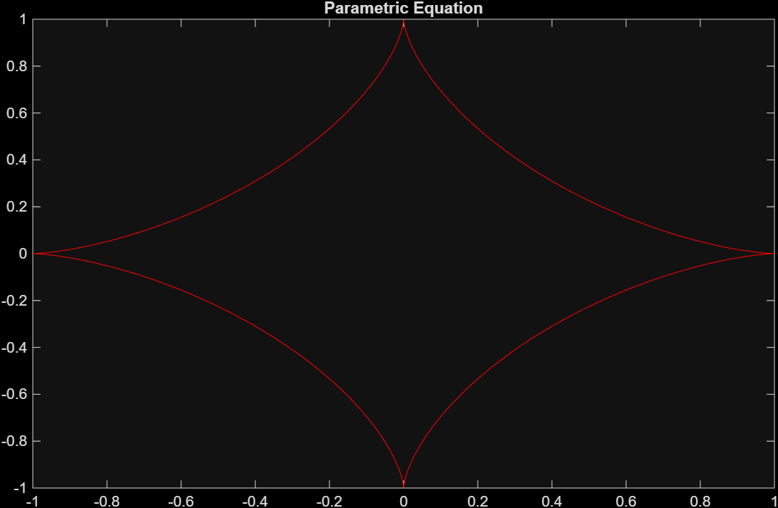

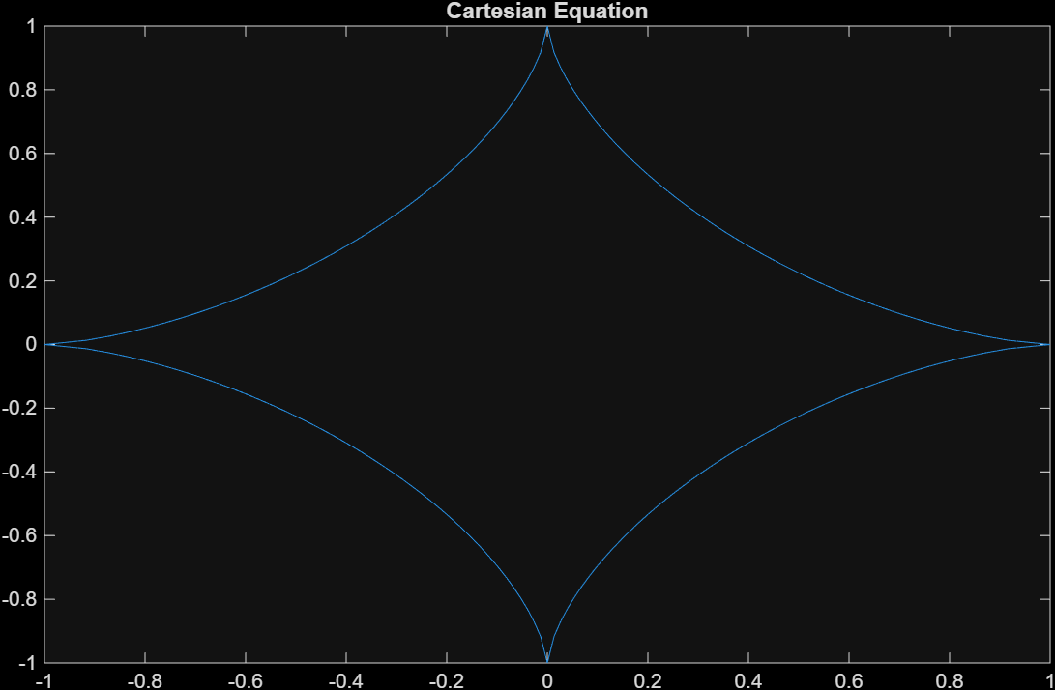

Code — A3Q1.m
clc
close all
clear all

x = [0:0.01:10];
y = (x.^2).*exp(-x);
y1 = 2*x.*exp(-x) - (x.^2).*exp(-x);
y2 = 2*exp(-x) + (x.^2).*exp(-x) - 4.*x.*exp(-x);

idx = find(x==3)

plot(x,y, '-','linewidth',2,'markersize',13)
hold on;
plot(x(idx), y(idx), 'o', 'MarkerFaceColor','green', 'markersize', 10);
plot(x(idx), y1(idx), 'o', 'MarkerFaceColor','red', 'markersize', 11);
plot(x(idx), y2(idx), 'o', 'MarkerFaceColor','black', 'markersize', 13);
%p1 = plot(3,0.0003921,'o','MarkerFaceColor','red');

plot(x,y1,'--','linewidth',3,'markersize',14)
plot(x,y2,':','linewidth',4,'markersize',15)
legend("y","y1","y2")

Output
idx =

301

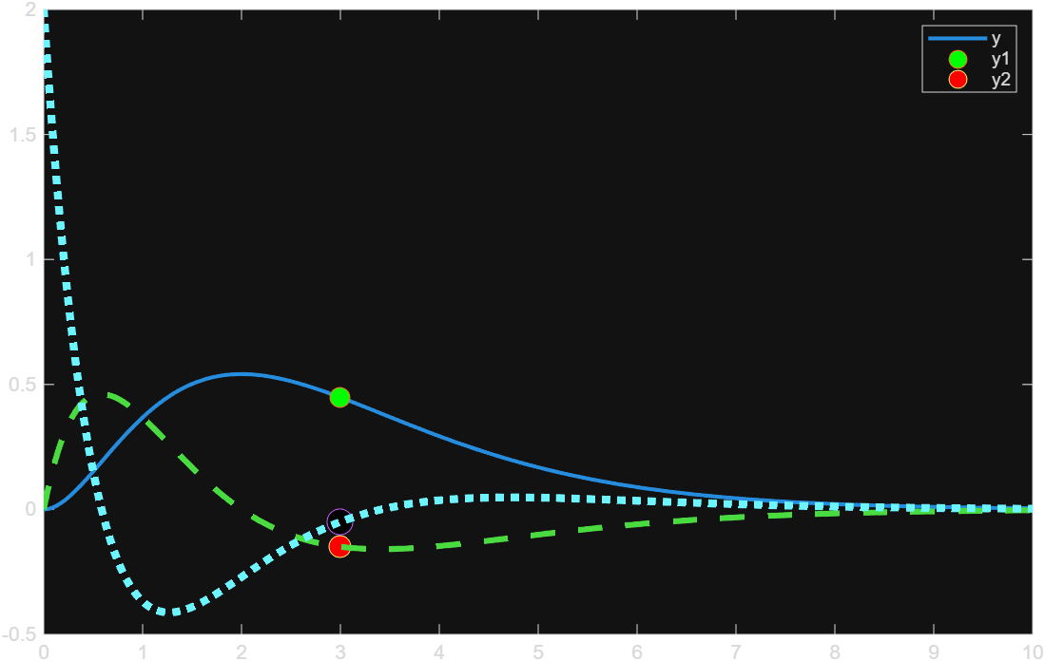

Code — A3Q2.m
clc
close all
clear all

syms x
%x = [0:0.01:10];
y = @(x) (x.^2).*exp(-x);
%y1 = @(x) 2*x.*exp(-x) - (x.^2).*exp(-x);
%y2 = @(x) 2*exp(-x) + (x.^2).*exp(-x) - 4.*x.*exp(-x);

y1 = diff(y, x)
y2 = diff(y, x, 2)

fplot(y, [0 10],'b');
hold on;
fplot(y1, [0 10],'g');
fplot(y2, [0 10],'r');
legend("y","y1","y2")

Output
ERROR: Undefined function 'syms' for input arguments of type 'char'.

Code — A3Q3.m
%y = @(x) (x.^2 - 6.*x + 7)/(x.^3 - 8)

%fplot(y, [0 1.9], 'b');
%hold on;
%fplot(y, [2.1 4], 'b');

clc;
close all;
clear all;

x1 = [0:0.01:1.9];
x2 = [2.1:0.01:4];

y1 = (x1.^2 - 6.*x1 + 7) ./ (x1.^3 - 8);
y2 = (x2.^2 - 6.*x2 + 7) ./ (x2.^3 - 8);

plot(x1, y1, '-', 'LineWidth', 2, 'MarkerSize', 13);
hold on;
plot(2, 0);
plot(x2, y2, '--', 'LineWidth', 4, 'MarkerSize', 14);

legend("y on [0,1.9]", "y on [2.1,4]");
%title('Plot of y = (x^2 - 6x + 7)/(x^3 - 8)');
%grid on;

Output

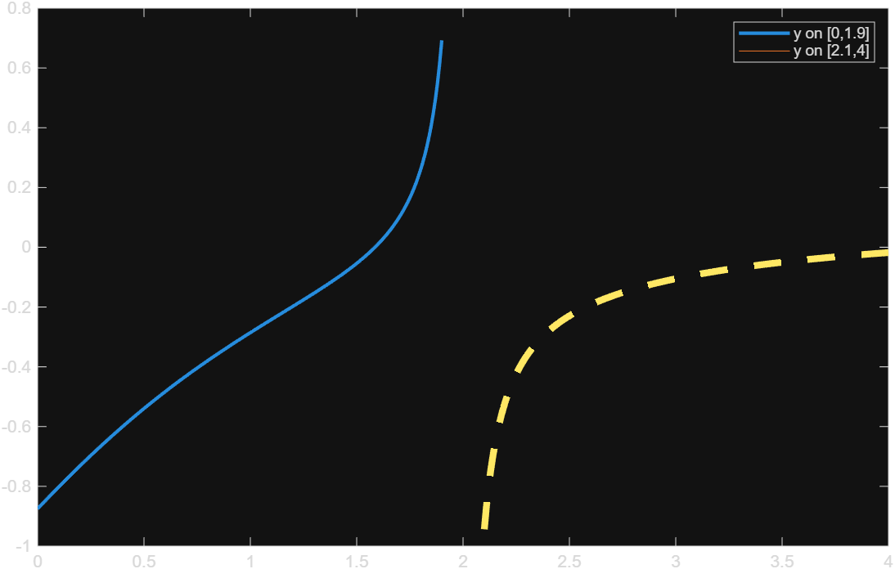

Code — A3Q4.m
clc;
close all;
clear all;

t = [10:10:70];
h = [9 22 44 63 80 94 97];

H = @(t) (100.8) ./ (1 + 23 .* exp(-0.093 .* t));

fplot(H)
hold on;
plot(t, h, 'o', 'LineWidth', 2, 'MarkerSize', 8)
%flpot(
%hold on;
%plot(t, H, '-', 'LineWidth', 2);

legend("Measured h", "Model H");
xlabel('t');
ylabel('h, H');
title('Comparison of Measured and Model Values');
grid on;

Output

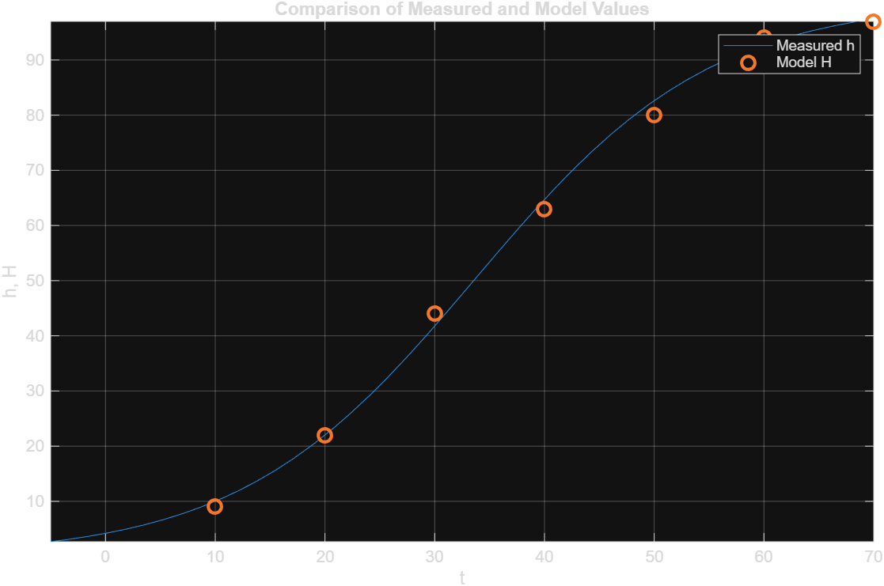

Code — A3Q5.m
clc;
close all;
clear all;

% Symbolic work
syms t
y = 8 - 4*t^3*exp(-0.4*t) + 2*t^2;
y1 = diff(y,t); % first derivative
y2 = diff(y,t,2); % second derivative

% Numeric evaluation
x = [0:0.1:8];
y1_num = double(subs(y1,t,x));
y2_num = double(subs(y2,t,x));

% Plotting
subplot(3,1,1);
%plot(x, double(subs(y,t,x)), 'LineWidth', 2);
fplot(y,[0,8])
title('Position x(t)');
xlabel('t'); ylabel('y(t)');

subplot(3,1,2);
%plot(x, y1_num, 'LineWidth', 2);
fplot(y1, [0,8])
title('Velocity y1(t)');
xlabel('t'); ylabel('y1(t)');

subplot(3,1,3);
%plot(x, y2_num, 'LineWidth', 2);
fplot(y2, [0,8])
title('Acceleration y2(t)');
xlabel('t'); ylabel('y2(t)');

Output
ERROR: Undefined function 'syms' for input arguments of type 'char'.

Code — A3Q7.m
clc
close all
clear all

x = [1200, 3500, 3200, 1500, 1700];
di = {'Dhaka' 'Sylhet' 'Chattogang' 'Rajshahi' 'Khulna'}

explode = [0 1 0 0 0];

pie(x,explode)

legend(di)

title("Rainfall Across Divisions")

Output
di =

1×5 cell array

{'Dhaka'} {'Sylhet'} {'Chattogang'} {'Rajshahi'} {'Khulna'}

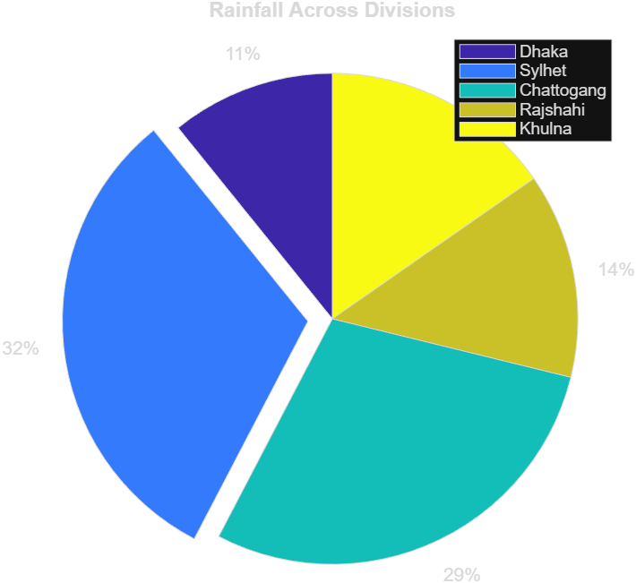

Code — A3Q8.m
clc
close all
clear all

MONTHS = categorical({'Jan' 'Feb' 'Mar' 'Apr' 'May' 'Jun' 'Jul' 'Aug' 'Sep' 'Oct' 'Nov' 'Dec'})

TEMP = [18 21 26 29 30 31 30 30 29 27 24 20];

b = bar(TEMP)
xticklabels(MONTHS)

b.FaceColor = "flat";

b.CData(3:6, :) = repmat([1 0 0], 4,1);
b.CData(11:12, :) = repmat([0 1 1], 2,1);
b.CData(1:2, :) = repmat([0 1 1], 2,1);

hold on

summer = bar(NaN, 'FaceColor', [1 0 0]);
winter = bar(NaN, 'FaceColor', [0 1 1]);
title("Monthly avg temp")
legend('Winter', 'Summer')
%legend({'Line 1','Line 2'})
%legend({'cos(x)','cos(2x)','cos(3x)','cos(4x)'},'Location','northwest','NumColumns',2)
%legend([summer, winter], {'Summer', 'Winter'});

Output
MONTHS =

1×12 categorical array

Jan Feb Mar Apr May Jun Jul Aug Sep Oct Nov Dec

b =

Bar with properties:

BarLayout: 'grouped'
BarWidth: 0.8000
FaceColor: [0.0660 0.4430 0.7450]
EdgeColor: [0.1294 0.1294 0.1294]
BaseValue: 0
XData: [1 2 3 4 5 6 7 8 9 10 11 12]
YData: [18 21 26 29 30 31 30 30 29 27 24 20]

Use GET to show all properties

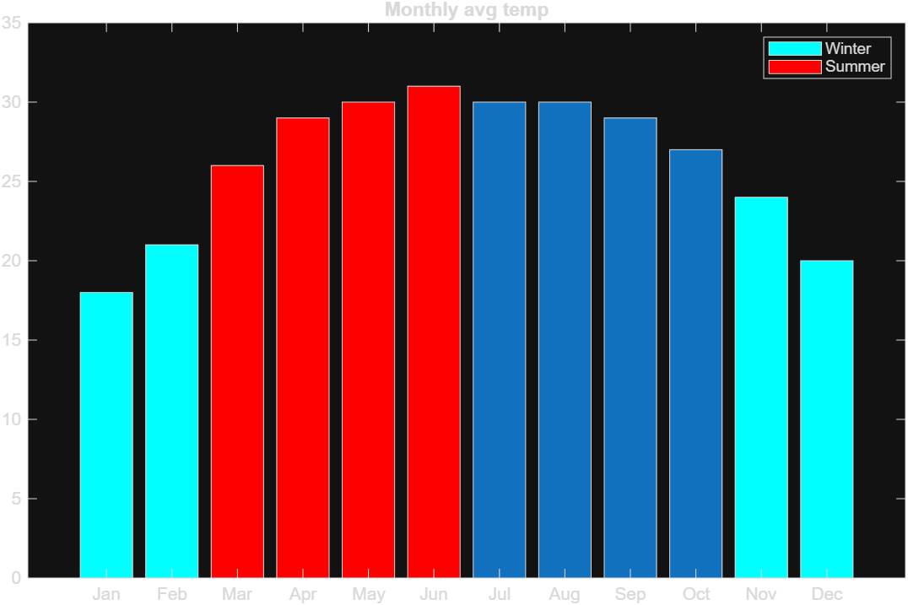

Code — A3Q9.m
clc
close all
clear all

Day = [1 2 3 4 5 6 7 8 9 10];
Max_Temp = [31 32 34 33 35 36 34 33 32 31];

Moving_Avg = movmean(Max_Temp, 7);

figure;
plot(Day, Max_Temp, '-o', 'LineWidth', 1.5, 'MarkerFaceColor', 'b');
hold on;
plot(Day, Moving_Avg, '-s', 'LineWidth', 1.5, 'MarkerFaceColor', 'r');
hold off;

title('Daily Maximum Temperature and 7-Day Moving Average in Dhaka (July 2023)');
xlabel('Day');
ylabel('Maximum Temperature (°C)');
legend('Daily Max Temperature', '7-Day Moving Average', 'Location', 'best');
grid on;

Output

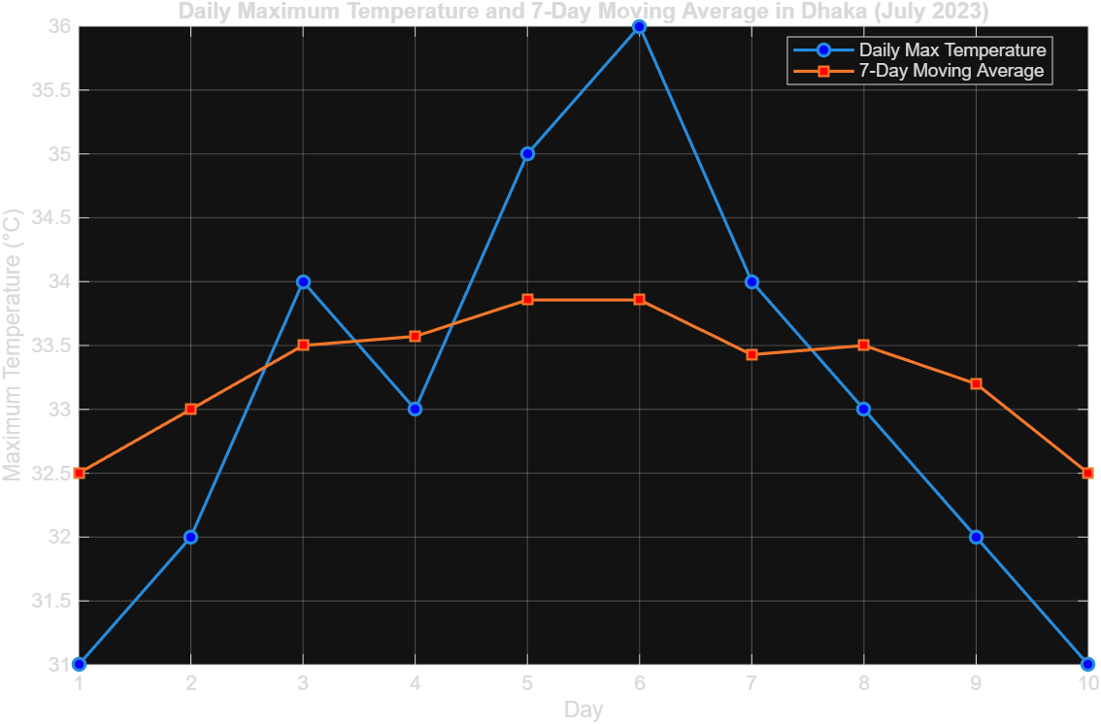

Code — t.m

Output
(no output found — run with --run matlab, or paste it here)

Code — test11.m
clc;
close all;
clear all;x = [1200, 3500, 3200, 1500, 1700];
explode = [0 1 0 0 0];
p = pie(x, explode); % Create pie chart and get handles% Find text objects in the pie chart
pText = findobj(p, 'Type', 'text');% The pie chart returns handles in reverse order, so sort them by position
[~, idx] = sort(cellfun(@(h) h.Position(2), num2cell(pText)), 'descend');
pText = pText(idx);percentValues = get(pText, 'String');
txt = {'Dhaka : '; 'Sylhet : '; 'Chattogang : '; 'Rajshahi :'; 'Khulna :'};
combinedtxt = strcat(txt, percentValues);for k = 1:length(pText)
pText(k).String = combinedtxt{k};
endtitle('Rainfall Across Divisions');

Output
ERROR: Error: File: C:\Users\user\Desktop\Matlab-and-R\ASSIGNMENT 3\test11.m Line: 10 Column: 42
At least one END is missing. The statement beginning here does not have a matching end.

Code — test.m
clc; close all; clear all;

player_cnt = 0;

board = [ 0 0 0; 0 0 0; 0 0 0; ]

running = 1

while running != 1

if player_cnt == 0
x = input("Enter Board x Position: ")
y = input("Enter Board y Position: ")
end
end

Output
ERROR: File: C:\Users\user\Desktop\Matlab-and-R\ASSIGNMENT 3\test.m Line: 9 Column: 15
Invalid use of operator.

Assignment 4

Code — A4Q1.m
clc
close all
clear all

m = 4;
n = 6;
Z = disp_prog(m,n)

function A = disp_prog(m,n)
A = zeros(m,n);

for i = 1:m
for j = 1:n
A(i,j) = 2*i - 3*j;
end
end
end

Output
Z =

-1 -4 -7 -10 -13 -16
1 -2 -5 -8 -11 -14
3 0 -3 -6 -9 -12
5 2 -1 -4 -7 -10

Code — A4Q2.m
clc
close all
clear all

%disp("Original Vector")
Z = input("Enter the vectos: \n");
X=disp_prog(Z);
disp("Modified Vectors")
disp(X)

function [A] = disp_prog(Z)

n = length(Z);

%disp("OG Vector")
%disp(A)
%fprintf("\n")
for i = 1:n
if Z(i) > 0
A(i) = 2 * Z(i);
else
A(i) = 3 * Z(i);
end
end
end

Output
ERROR: Support for user input is required, which is not available on this platform.

Code — A4Q3.m
clc
close all
clear all
format bank

NYC = [33 33 18 29 40 55 19 22 32 37 58 54 51 52 45 41 45 39 36 45 33 18 19 19 28 34 44 21 23 30 39];
DEN = [39 48 61 39 14 37 43 38 46 39 55 46 46 39 54 45 52 52 62 45 62 40 25 57 60 57 20 32 50 48 28];

avg_nyc = (sum(NYC)/length(NYC));
avg_den = (sum(DEN)/length(DEN));

disp("===========part a====================")
fprintf("The avg temp of NYC %0.2f \n",avg_nyc);
fprintf("The avg temp of DEN %0.2f \n",avg_den);

disp("===========part b====================")
cnt_nyc = count(NYC, DEN, avg_nyc, "A");
cnt_den = count(NYC, DEN, avg_den, "A");

fprintf("Desired num of days in NYC %d \n",cnt_nyc);
fprintf("Desired num of days in DEN %d \n",cnt_den);

disp("===========part c====================")
cnt_days = count(NYC, DEN, 0, "B");

fprintf("The number of days: %d\n", cnt_days)

function cnt = count(arr1, arr2, threshold, param)
cnt = 0;

if param == "A"
for i = 1:length(arr1)
if arr1(i) > threshold
cnt = cnt + 1;
end
end
end

if param == "B"
for i = 1:length(arr1)
if arr1(i) < arr2(i)
cnt = cnt + 1;
end
end
end
end

%function cnt = count_above(arr, threshold)
% cnt = 0;
% for i = 1:length(arr)
% if arr(i) > threshold
% cnt = cnt + 1;
% end
% end
%end

%function cnt = count_less_than(arr1, arr2)
% cnt = 0;
% for i = 1:length(arr1)
% if arr1(i) < arr2(i)
% cnt = cnt + 1;
% end
% end
%end

Output
===========part a====================
The avg temp of NYC 35.23
The avg temp of DEN 44.48
===========part b====================
Desired num of days in NYC 15
Desired num of days in DEN 8
===========part c====================
The number of days: 22

Code — A4Q4.m
clc
close all
clear all

n = 4;
fprintf("Pascals trig for n = %d\n",n)
P4 = Pascals_trig(n);

%disp(P4);

n = 9;
fprintf("Pascals trig for n = %d\n",n)
P7 = Pascals_trig(n);

%disp(P7);

function p = Pascals_trig(n)
p = zeros(n, n);

for i = 1:n
for j = 1:i
p(i, j) = factorial(i - 1) / (factorial(j - 1) * factorial(i - j));
fprintf('%5d',p(i,j))
end
fprintf("\n")
end
fprintf("\n")
end

Output
Pascals trig for n = 4
1
1 1
1 2 1
1 3 3 1

Pascals trig for n = 9
1
1 1
1 2 1
1 3 3 1
1 4 6 4 1
1 5 10 10 5 1
1 6 15 20 15 6 1
1 7 21 35 35 21 7 1
1 8 28 56 70 56 28 8 1

Code — A4Q5.m
clc
close all
clear
format long

n_values = [5, 10, 40, 45, 55];

print_prog(n_values)

v = [1 2 3 6 9]
disp(v(0))

function p = print_prog(n_values)
disp("First func")
for k = 1:length(n_values)
n = n_values(k);
PI = estimate_pi_cubic(n);
fprintf("The estimation of pi for n = %d: %.6f; error(rel) = %.6f\n", n, PI, abs(PI - pi)/pi);
end
end

function PI = estimate_pi_cubic(n)
sum_val = 0;

for i = 0:(n-1)
sum_val = sum_val + ( (-1)^i / (2*i + 1)^3 );
end

PI = (32 * sum_val)^(1/3);
end

Output
First func
The estimation of pi for n = 5: 3.142104; error(rel) = 0.000163
The estimation of pi for n = 10: 3.141526; error(rel) = 0.000021
The estimation of pi for n = 40: 3.141592; error(rel) = 0.000000
The estimation of pi for n = 45: 3.141593; error(rel) = 0.000000
The estimation of pi for n = 55: 3.141593; error(rel) = 0.000000

v =

1 2 3 6 9

ERROR: Array indices must be positive integers or logical values.

Code — A4Q6.m
clc;
close all;
clear;

N = 10000;
[z] = Mersp(N)

length(z)

function v = Mersp(N)
cnt = 1;
for i = 1:N
p(i) = 2^i - 1;

if isprime(p(i))

%temp = p(i)
%fprintf("%dth mersone prime is %d", i, p(i))
v(cnt) = p(i);
cnt = cnt + 1;
end

if p(i) > 10000
break;
end

end
%length(v)
end

Output
z =

3 7 31 127 8191

ans =

5

Code — A4Q7.m
clc
close all
clear all

disp("===========part a====================")
P1 = 8;
ans_a = halley(P1);
fprintf("The cubic root of 800 is: %f\n", ans_a);

disp("===========part b====================")
P2 = 59071;
ans_b = halley(P2);
fprintf("The cubic root of 59071 is: %f\n", ans_b);

function x = halley(P)
x = 10; %initial guess of cubic root of P
E = 1; %error term

while E > 0.00001
x_next = x * (x^3 + 2*P) / (2*x^3 + P);
E = abs((x_next - x) / x);
x = x_next;
end
end

Output
===========part a====================
The cubic root of 800 is: 2.000000
===========part b====================
The cubic root of 59071 is: 38.945574

Code — A4Q8.m
clc
close all
clear all

disp("=========== Part (a) =============")
hw_a = [65, 79, 80, 50, 71, 73, 61, 70, 69, 74];
mid_a = [83, 91];
final_a = 84;
scale_factor = 80;

grade_a = compute_course_grade(hw_a, mid_a, final_a, scale_factor);
fprintf("Overall course grade for case (a): %.2f\n", grade_a);

disp("=========== Part (b) =============")
hw_b = [70, 69, 83, 45, 90, 89, 52, 78, 100, 87];
mid_b = [87, 72];
final_b = 90;
scale_factor = 100;

grade_b = compute_course_grade(hw_b, mid_b, final_b, scale_factor);
fprintf("Overall course grade for case (b): %.2f\n", grade_b);

function course_grade = compute_course_grade(hw, midterms, final_exam, scale_factor)
sorted_hw = sort(hw);
higher_hw = sorted_hw(3:end);
avg_hw = mean(higher_hw);

hw_score = (avg_hw / scale_factor) * 20;
hw_component = hw_score;

avg_mid = mean(midterms);

if avg_mid >= final_exam
mid_component = avg_mid * 0.40;
final_component = final_exam * 0.40;
else
mid_component = avg_mid * 0.30;
final_component = final_exam * 0.50;
end

course_grade = hw_component + mid_component + final_component;
end

Output
=========== Part (a) =============
Overall course grade for case (a): 86.56
=========== Part (b) =============
Overall course grade for case (b): 85.50

Code — avg_den.m

Output
(no output found — run with --run matlab, or paste it here)

Code — pt.m
function p = Pascals_trig(n)
p = zeros(n, n);

for i = 1:n
for j = 1:i
p(i, j) = factorial(i - 1) / (factorial(j - 1) * factorial(i - j));
fprintf('%5d',p(i,j))
end
fprintf("\n")
end
fprintf("\n")
end

Output
ERROR: Not enough input arguments.

Assignment 5

Code — A5Q1.m
clc
close all
clear all

a = -pi;
b = pi;
tol = 10^(-5);
i = 0;
rel = 1;
%f_ = @(x) x .* cos(x) - 2*x.^2 + 3*x - 1;
f_ = @(x) 1/2 + 1/4*x^2 - x*sin(x) - 1/2*cos(2*x);
exact_val = fzero(f_, 0)

fplot(f_, [-2, 2])

[i,a,b,tol,rel] = MAIN(i,a,b,tol,rel, exact_val);

function [i,a,b,tol,rel] = MAIN(i,a,b,tol,rel, exact_val)
fprintf("i a b c f(c) Rel\n")

if (A_FUNC(a) * A_FUNC(b)) < 0
while rel > tol
i = i + 1;
t_old = a;
t = (a+b)/2;

if A_FUNC(t) == 0
fprintf("Root found %0.2f\n", t)
break;
end

rel = abs(exact_val - t_old) / exact_val;

fprintf("%d %0.5f %0.5f %0.5f %0.5f %f \n", i, a, b, t, A_FUNC(t), rel)

if A_FUNC(t) * A_FUNC(a) < 0
b = t;
else
a = t;
end

end
else
fprintf("Root doesnt exist between %f and %f\n\n", a, b)
end
% fprintf("Ans = %f\n", t)
end

function f = A_FUNC(x)
f = 1/2 + 1/4*x^2 - x*sin(x) - 1/2*cos(2*x);
end

%function f = A_FUNC(x)
% f = x * cos(x) - 2*x^2 + 3*x - 1;
%end

Output
exact_val =

0

Warning: Function behaves unexpectedly on array inputs. To improve performance, properly vectorize your function to return an output with the same size and shape as the input
arguments.
> In matlab.graphics.function.FunctionLine>getFunction
In matlab.graphics.function/FunctionLine/updateFunction
In matlab.graphics.function/FunctionLine
In fplot>singleFplot (line 268)
In fplot>@(f)singleFplot(cax,{f},limits,extraOpts,args) (line 223)
In fplot>vectorizeFplot (line 223)
In fplot (line 186)
In A5Q1 (line 14)
In run (line 112)
In wrapper (line 6)
In run (line 112)
i a b c f(c) Rel
Root doesnt exist between -3.141593 and 3.141593

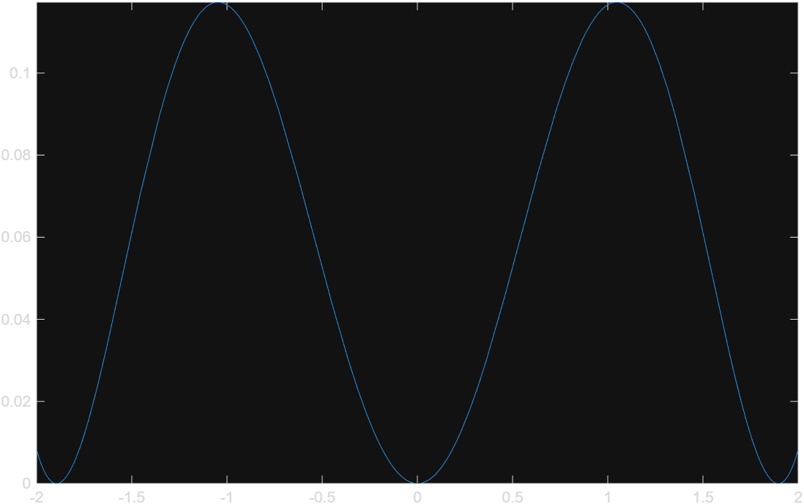

Code — A5Q2.m
clc;
close all;
clear all;

args = [pi/4, pi, -pi];
for i = 1:3
arg = args(i);
fprintf("For initial value x0 = %f\n", arg);
fprintf("%-6s %-10s %-10s %-10s %-10s %-10s\n", 'iter', 'Pn-1', 'df(Pn-1)', 'Pn', 'f(Pn)', 'err')
the_func(arg)
fprintf("\n\n")
end
%arg = 0.1
%the_func(arg)

function the_func(arg)
for i=1:1000
x_old = arg;

df_val = df(x_old);

x_new = x_old - f(x_old)/df_val;
f_new = f(x_new);

rel = abs((x_new - x_old) / (x_new + 1e-12));
err = abs(x_new - x_old);

fprintf("%-6d %-10.5f %-10.5f %-10.5f %-10.5f %-10.5f\n", i, x_old, df_val, x_new, f_new, rel)

if err < 10^-5
break;
end

arg = x_new;
end
fprintf("Ans %f ", x_new)
end

function y = f(x)
y = 1/2 + 1/4*x^2 - x*sin(x) - 1/2*cos(2*x);
end

function y_prime = df(x)
y_prime = x/2 - sin(x) - x*cos(x) + sin(2*x);
end

function y_ = f_(x)
f = x * cos(x) - 2*x^2 + 3*x - 1;
end

function y_fdashprime = df_(x)
y_dashprime = -1 * x * sin(x) + cos(x) -4*x + 3;
end

%==== to do =====
%matlabfunction

Output
For initial value x0 = 0.785398
iter Pn-1 df(Pn-1) Pn f(Pn) err
1 0.78540 0.13023 0.02635 0.00017 28.80544
2 0.02635 0.01316 0.01317 0.00004 1.00093
3 0.01317 0.00658 0.00658 0.00001 1.00023
4 0.00658 0.00329 0.00329 0.00000 1.00006
5 0.00329 0.00165 0.00165 0.00000 1.00001
6 0.00165 0.00082 0.00082 0.00000 1.00000
7 0.00082 0.00041 0.00041 0.00000 1.00000
8 0.00041 0.00021 0.00021 0.00000 1.00000
9 0.00021 0.00010 0.00010 0.00000 1.00000
10 0.00010 0.00005 0.00005 0.00000 1.00000
11 0.00005 0.00003 0.00003 0.00000 1.00000
12 0.00003 0.00001 0.00001 0.00000 1.00000
13 0.00001 0.00001 0.00001 0.00000 1.00000
Ans 0.000006

For initial value x0 = 3.141593
iter Pn-1 df(Pn-1) Pn f(Pn) err
1 3.14159 4.71239 2.61799 0.65448 0.20000
2 2.61799 2.21022 2.32188 0.18489 0.12753
3 2.32188 1.01687 2.14006 0.05186 0.08496
4 2.14006 0.47322 2.03047 0.01417 0.05397
5 2.03047 0.22465 1.96740 0.00376 0.03206
6 1.96740 0.10869 1.93280 0.00097 0.01790
7 1.93280 0.05332 1.91453 0.00025 0.00954
8 1.91453 0.02639 1.90511 0.00006 0.00494
9 1.90511 0.01312 1.90033 0.00002 0.00252
10 1.90033 0.00654 1.89792 0.00000 0.00127
11 1.89792 0.00327 1.89671 0.00000 0.00064
12 1.89671 0.00163 1.89610 0.00000 0.00032
13 1.89610 0.00082 1.89580 0.00000 0.00016
14 1.89580 0.00041 1.89565 0.00000 0.00008
15 1.89565 0.00020 1.89557 0.00000 0.00004
16 1.89557 0.00010 1.89553 0.00000 0.00002
17 1.89553 0.00005 1.89551 0.00000 0.00001
18 1.89551 0.00003 1.89550 0.00000 0.00001
Ans 1.895504

For initial value x0 = -3.141593
iter Pn-1 df(Pn-1) Pn f(Pn) err
1 -3.14159 -4.71239 -2.61799 0.65448 0.20000
2 -2.61799 -2.21022 -2.32188 0.18489 0.12753
3 -2.32188 -1.01687 -2.14006 0.05186 0.08496
4 -2.14006 -0.47322 -2.03047 0.01417 0.05397
5 -2.03047 -0.22465 -1.96740 0.00376 0.03206
6 -1.96740 -0.10869 -1.93280 0.00097 0.01790
7 -1.93280 -0.05332 -1.91453 0.00025 0.00954
8 -1.91453 -0.02639 -1.90511 0.00006 0.00494
9 -1.90511 -0.01312 -1.90033 0.00002 0.00252
10 -1.90033 -0.00654 -1.89792 0.00000 0.00127
11 -1.89792 -0.00327 -1.89671 0.00000 0.00064
12 -1.89671 -0.00163 -1.89610 0.00000 0.00032
13 -1.89610 -0.00082 -1.89580 0.00000 0.00016
14 -1.89580 -0.00041 -1.89565 0.00000 0.00008
15 -1.89565 -0.00020 -1.89557 0.00000 0.00004
16 -1.89557 -0.00010 -1.89553 0.00000 0.00002
17 -1.89553 -0.00005 -1.89551 0.00000 0.00001
18 -1.89551 -0.00003 -1.89550 0.00000 0.00001
Ans -1.895504

Code — A5Q3.m
clc
close all
clear all

a = -2;
b = 2;
tol = 10^(-5);
i = 0;
rel = 1;

f_ = @(x) 54*x.^6 + 45*x.^5 + - 102*x.^4 -69*x.^3 + 35*x.^2 + 16*x -4;
%exact_val = roots(f_)

fplot(f_, [-5, 5])
yline(0, '--r', 'LineWidth', 1.5)

[i,a,b,tol,rel] = MAIN(i,a,b,tol,rel);

function [i,a,b,tol,rel] = MAIN(i,a,b,tol,rel)
fprintf("i a b c f(c) rel_err\n")

while rel > tol
i = i + 1;

fa = A_FUNC(a);
fb = A_FUNC(b);

t = b - fb * (b - a) / (fb - fa);

fprintf("%d %0.5f %0.5f %0.5f %0.5f %f \n", i, a, b, t, A_FUNC(t), rel)

if A_FUNC(t) == 0
fprintf("Root found %0.5f\n", t)
break;
end

rel = abs(t - b);

a = b;
b = t;
end
fprintf("\n Ans = %f\n", t)
end

function f = A_FUNC(x)
f = 54*x^6 + 45*x^5 + - 102*x^4 -69*x^3 + 35*x^2 + 16*x -4;
end

Output
i a b c f(c) rel_err
1 -2.00000 2.00000 -4.26087 232217.52637 1.000000
2 2.00000 -4.26087 2.07862 3758.42598 6.260870
3 -4.26087 2.07862 2.18292 5237.12832 6.339493
4 2.07862 2.18292 1.81354 1429.15258 0.104292
5 2.18292 1.81354 1.67492 779.41439 0.369372
6 1.81354 1.67492 1.50862 322.79733 0.138627
7 1.67492 1.50862 1.39106 143.97837 0.166295
8 1.50862 1.39106 1.29641 58.25262 0.117559
9 1.39106 1.29641 1.23209 21.40913 0.094654
10 1.29641 1.23209 1.19471 6.16148 0.064320
11 1.23209 1.19471 1.17961 1.09066 0.037375
12 1.19471 1.17961 1.17636 0.07561 0.015103
13 1.17961 1.17636 1.17612 0.00104 0.003248
14 1.17636 1.17612 1.17612 0.00000 0.000242

Ans = 1.176116

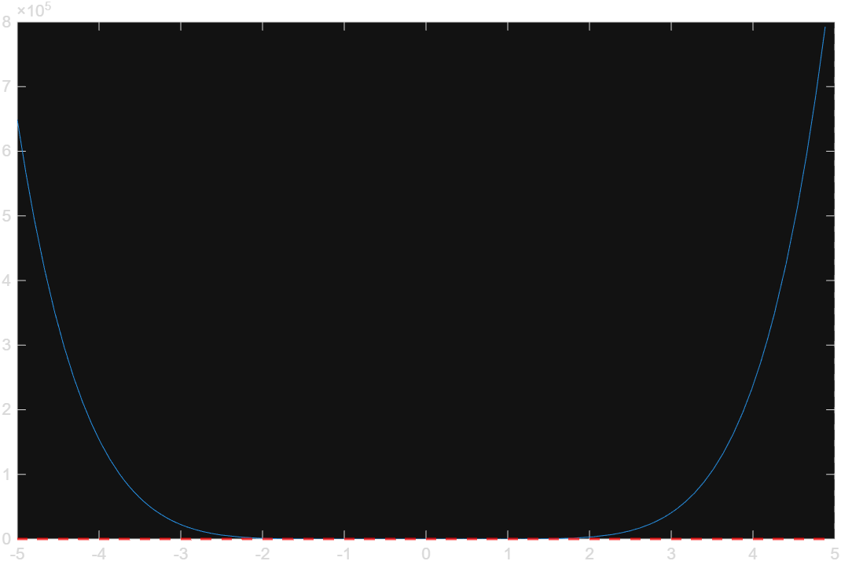

Code — A5Q4.m
clc
close all
clear all

a = 1.3;
b = 2.0;
tol = 10^(-5);
i = 0;
rel = 1;

[i,a,b,tol,rel] = MAIN(i,a,b,tol,rel);

function [i,a,b,tol,rel] = MAIN(i,a,b,tol,rel)
fprintf("i a b c f(c) Rel\n")

c_old = a;

while rel > tol
i = i + 1;

fa = A_FUNC(a);
fb = A_FUNC(b);

t = b - (fb * (a - b)) / (fa - fb);

ft = A_FUNC(t);

if ft == 0
fprintf("Exact root found: %0.5f\n", t)
break;
end

rel = abs(t - c_old);
c_old = t;

fprintf("%d %0.5f %0.5f %0.5f %0.5f %f \n", i, a, b, t, ft, rel)

if fa * ft < 0
b = t;
else
a = t;
end
end
fprintf("\nAns = %f\n", c_old)
end

function f = A_FUNC(x)
f = log(x - 1) + cos(x - 1);
end

Output
i a b c f(c) Rel
1 1.30000 2.00000 1.52061 0.21476 0.220607
2 1.30000 1.52061 1.41837 0.04236 0.102239
3 1.30000 1.41837 1.40114 0.00717 0.017230
4 1.30000 1.40114 1.39830 0.00118 0.002833
5 1.30000 1.39830 1.39784 0.00019 0.000465
6 1.30000 1.39784 1.39776 0.00003 0.000076
7 1.30000 1.39776 1.39775 0.00001 0.000012
8 1.30000 1.39775 1.39775 0.00000 0.000002

Ans = 1.397749

Code — A5Q5.m
clc;
close all;
clear all;

%% Step 1: Load Data
A = readmatrix("a.txt");
b = readmatrix("b.txt");

%====================== Part I: Gauss-Jordan Exact Solution ======================
Aug = [A, b];
R = rref(Aug);
x_exact = R(:, end);

disp('===================================================');
disp('--- (i) Exact Solution (Gauss-Jordan) ---');
disp(x_exact);

%====================== Part II: Positive Definiteness Check ======================
disp('--- (ii) Positive Definiteness Check ---');
check_eig(A);

%====================== Part III: Row Reordering for Convergence ======================
% Reorder rows so largest absolute elements sit on the main diagonal
[~, max_cols] = max(abs(A), [], 2);
A_dom = zeros(size(A));
b_dom = zeros(size(b));

for i = 1:length(b)
A_dom(max_cols(i), :) = A(i, :);
b_dom(max_cols(i)) = b(i);
end

A_dom;
b_dom;
% Set parameters for iterative methods
tol = 5e-5; % 5 significant digits (0.5 * 10^(1-5))
max_iter = 500;
x0 = zeros(size(b));

%====================== Part IV: Iterative Solvers ======================
disp('===================================================');
disp('--- Iterative Results (Correct to 5 Significant Digits) ---');

% (a) Jacobi Method
[x_jacobi, iter_j, status_j] = jacobi_method(A_dom, b_dom, x0, tol, max_iter);
fprintf('Jacobi Solution (%d iterations, Status: %s):\n', iter_j, status_j);
disp(x_jacobi);

% (b) Gauss-Seidel Method
[x_gs, iter_gs, status_gs] = gauss_seidel_method(A_dom, b_dom, x0, tol, max_iter);
fprintf('Gauss-Seidel Solution (%d iterations, Status: %s):\n', iter_gs, status_gs);
disp(x_gs);

% (c) SOR Method (omega = 1.1)
omega = 1.1;
[x_sor, iter_sor, status_sor] = sor_method(A_dom, b_dom, x0, omega, tol, max_iter);
fprintf('SOR (omega = 1.1) Solution (%d iterations, Status: %s):\n', iter_sor, status_sor);
disp(x_sor);

% (d) Additional Table Output via sor_ (omega = 1.2)
disp('--- Custom SOR Table Output (omega = 1.2) ---');
x_init = zeros(size(b));
[x_sor_tbl, iter_tbl, err_tbl, table_data] = sor_(A_dom, b_dom, x_init, 1.2, 700);
T = array2table(table_data, 'VariableNames', {'iteration','x1','x2','x3','x4','x5', 'error'});
disp(T);
disp("The solution:");
disp(x_sor_tbl);

%=================================================================================
% LOCAL FUNCTIONS
%=================================================================================

function check_eig(a)
% Positive definiteness requires symmetry: A = A'
if ~isequal(a, a')
disp("Matrix A is NOT Positive Definite.");
disp("Reason: Matrix is asymmetric (A ~= A').");
return;
end

eigen = eig(a);
if all(eigen > 0)
disp("Matrix A is Positive Definite.");
else
disp("Matrix A is NOT Positive Definite (Eigenvalues <= 0).");
end
end

function [x, iter, status] = jacobi_method(A, b, x0, tol, max_iter)
n = length(b);
D = diag(diag(A));
LU = A - D;
x = x0;
status = 'Converged';

for iter = 1:max_iter
x_new = D \ (b - LU * x);

% Divergence Guard
if any(isnan(x_new)) || any(isinf(x_new)) || max(abs(x_new)) > 1e10
status = 'Diverged';
x = x_new;
return;
end

% Relative Error Check
if max(abs(x_new - x) ./ (abs(x_new) + 1e-12)) < tol
x = x_new;
return;
end
x = x_new;
end
status = 'Max iterations reached';
end

function [x, iter, status] = gauss_seidel_method(A, b, x0, tol, max_iter)
L_D = tril(A); % Lower triangular + Diagonal
U = triu(A, 1); % Upper triangular
x = x0;
status = 'Converged';

for iter = 1:max_iter
x_new = L_D \ (b - U * x);

if any(isnan(x_new)) || any(isinf(x_new)) || max(abs(x_new)) > 1e10
status = 'Diverged';
x = x_new;
return;
end

if max(abs(x_new - x) ./ (abs(x_new) + 1e-12)) < tol
x = x_new;
return;
end
x = x_new;
end
status = 'Max iterations reached';
end

function [x, iter, status] = sor_method(A, b, x0, omega, tol, max_iter)
D = diag(diag(A));
L = tril(A, -1);
U = triu(A, 1);

M = D + omega * L;
N = (1 - omega) * D - omega * U;
c = omega * (M \ b);
T = M \ N;

x = x0;
status = 'Converged';

for iter = 1:max_iter
x_new = T * x + c;

if any(isnan(x_new)) || any(isinf(x_new)) || max(abs(x_new)) > 1e10
status = 'Diverged';
x = x_new;
return;
end

if max(abs(x_new - x) ./ (abs(x_new) + 1e-12)) < tol
x = x_new;
return;
end
x = x_new;
end
status = 'Max iterations reached';
end

function [iter, x, err, table_data] = gauss_sed(A, b, x0, max_iter)
n = length(b);
tol = 1e-5;
x = x0;

table_data = zeros(max_iter + 1, n + 2);
table_data(1,:) = [0, x', 0];

for iter = 1:max_iter
x_old = x;

for i = 1:n
d = b(i);
for j = 1:n
if i ~= j
d = d - A(i,j) * x(j);
end
end
x(i) = d / A(i,i);
end

err = max(abs(x - x_old));
table_data(iter+1,:) = [iter, x', err];

if err < tol
break;
end
end
table_data = table_data(1:iter+1,:);
end

function [x, iter, err, table_data] = sor_(A, b, x0, w, max_iter)
n = length(b);
tol = 1e-5;
x = x0;

table_data = zeros(max_iter + 1, n + 2);
table_data(1,:) = [0, x', 0];

for iter = 1:max_iter
x_old = x;
for i = 1:n
d = b(i);
for j = 1:n
if i ~= j
d = d - A(i,j) * x(j);
end
end
x_gs = d / A(i,i);
x(i) = (1 - w) * x_old(i) + w * x_gs;
end

err = max(abs(x - x_old));
table_data(iter+1,:) = [iter, x', err];

if err < tol
break;
end
end
table_data = table_data(1:iter+1,:);
end

Output
===================================================
--- (i) Exact Solution (Gauss-Jordan) ---
0.7866
-1.0026
1.8663
1.9126
1.9897

--- (ii) Positive Definiteness Check ---
Matrix A is NOT Positive Definite.
Reason: Matrix is asymmetric (A ~= A').
===================================================
--- Iterative Results (Correct to 5 Significant Digits) ---
Jacobi Solution (16 iterations, Status: Converged):
0.7866
-1.0026
1.8663
1.9126
1.9897

Gauss-Seidel Solution (9 iterations, Status: Converged):
0.7866
-1.0026
1.8663
1.9126
1.9897

SOR (omega = 1.1) Solution (10 iterations, Status: Converged):
0.7866
-1.0026
1.8663
1.9126
1.9897

--- Custom SOR Table Output (omega = 1.2) ---
iteration x1 x2 x3 x4 x5 error
_________ _______ ________ ______ ______ ______ __________

0 0 0 0 0 0 0
1 1.8 -3.12 1.3248 1.8014 3.529 3.529
2 0.91986 -0.89345 2.2272 2.1158 1.6637 2.2266
3 0.71678 -0.7708 1.7426 1.8834 1.8875 0.48467
4 0.79887 -1.115 1.8806 1.8927 2.0879 0.34419
5 0.78417 -0.98134 1.8783 1.9258 1.957 0.13366
6 0.78698 -0.99687 1.8577 1.9092 1.9913 0.034299
7 0.78697 -1.0087 1.8689 1.9123 1.9939 0.011794
8 0.78636 -1.0003 1.8663 1.9132 1.9873 0.0083408
9 0.78672 -1.0028 1.8659 1.9123 1.9903 0.0029522
10 0.78663 -1.0028 1.8665 1.9126 1.9898 0.00061439
11 0.78662 -1.0024 1.8663 1.9126 1.9896 0.00039042
12 0.78664 -1.0026 1.8663 1.9126 1.9898 0.00019712
13 0.78663 -1.0026 1.8663 1.9126 1.9897 6.0839e-05
14 0.78663 -1.0026 1.8663 1.9126 1.9897 1.6144e-05
15 0.78663 -1.0026 1.8663 1.9126 1.9897 1.1196e-05
16 0.78663 -1.0026 1.8663 1.9126 1.9897 4.4312e-06

The solution:
0.7866
-1.0026
1.8663
1.9126
1.9897

Code — A5Q5_test.m

Output
(no output found — run with --run matlab, or paste it here)

Code — A5Q6.m
clc;
clear all;
close all;

% Initial interval
a = 2;
b = 3;

% Run root-finding algorithms
[x_b, re_b] = bisection(a, b);
[x_new, re_ne] = newton(a, b);
[x_sec, re_sec] = secant(a, b);
[x_fal, re_fal] = false(a, b);

% Pad vectors with NaN to match maximum iteration length
n_max = max([length(x_b), length(x_new), length(x_sec), length(x_fal)]);

x_b(end+1:n_max) = NaN;
x_new(end+1:n_max) = NaN;
x_sec(end+1:n_max) = NaN;
x_fal(end+1:n_max) = NaN;

re_b(end+1:n_max) = NaN;
re_ne(end+1:n_max) = NaN;
re_sec(end+1:n_max) = NaN;
re_fal(end+1:n_max) = NaN;

% 1. Run algorithms
[x_b, re_b] = bisection(a, b);
[x_new, re_ne] = newton(a, b);
[x_sec, re_sec] = secant(a, b);
[x_fal, re_fal] = false(a, b);

% 2. Find maximum length
n_max = max([length(x_b), length(x_new), length(x_sec), length(x_fal)]);

% 3. Pad roots by repeating the final value
x_b(end+1:n_max) = x_b(end);
x_new(end+1:n_max) = x_new(end);
x_sec(end+1:n_max) = x_sec(end);
x_fal(end+1:n_max) = x_fal(end);

% 4. Pad errors with 0
re_b(end+1:n_max) = 0;
re_ne(end+1:n_max) = 0;
re_sec(end+1:n_max) = 0;
re_fal(end+1:n_max) = 0;

% 5. NOW create the matrix (or table) AFTER padding is done!
matrix = [x_b(:), x_new(:), x_sec(:), x_fal(:), re_b(:), re_ne(:), re_sec(:), re_fal(:)];

% Optional: Display it cleanly as a Table so you see column names
Iteration = (1:n_max)';
T = table(Iteration, x_b(:), x_new(:), x_sec(:), x_fal(:), re_b(:), re_ne(:), re_sec(:), re_fal(:));
T.Properties.VariableNames = {'Iteration', 'x_bisection', 'x_newton', 'x_secant', 'x_false', 'err_bisection', 'err_newton', 'err_secant', 'err_false'};

disp(' ');
disp('=============================================================================================================');
disp(' ROOT-FINDING METHODS ITERATION TABLE');
disp('=============================================================================================================');
disp(T);

% Plot Relative Error vs Iteration
figure;
plot(1:n_max, re_b, 'r-o', 'LineWidth', 1.5, 'DisplayName', 'Bisection');
%Font adjustment
ax = gca;
ax.FontSize = 14;

hold on;
plot(1:n_max, re_ne, 'g-s', 'LineWidth', 1, 'DisplayName', 'Newton-Raphson');
plot(1:n_max, re_sec, 'b-d', 'LineWidth', 0.5, 'DisplayName', 'Secant');
plot(1:n_max, re_fal, 'm-^', 'LineWidth', 0.25, 'DisplayName', 'False Position');
hold off;
%plot function to do

xlabel('Iteration');
ylabel('Error');
title('Convergence Comparison of Root-Finding Methods');
legend('Location', 'northeast');
grid on;

%% =========================================================================
% LOCAL FUNCTIONS
% =========================================================================

function y = f(x)
y = x^3 - x - exp(x) - 2;
end

function dy = df(x)
dy = 3*x^2 - 1 - exp(x);
end

function [x_b, re_b] = bisection(a, b)
i = 1;
tol = 1e-5;
FA = f(a);
po = 0;
x_b = [];
re_b = [];

if (f(a) * f(b)) < 0
while i <= 100
p = a + (b - a)/2;
FP = f(p);
re_b(i) = abs((p - po)/p) * 100;
x_b(i) = p;

if FP == 0 || abs((b - a)/2) < tol
break;
end

i = i + 1;
if (FA * FP) > 0
a = p;
else
b = p;
end
po = p;
end
elseif (f(a) * f(b)) >= 0
disp('Bisection not possible: f(a) and f(b) must have opposite signs.');
end
end

function [x_new, re_ne] = newton(a, b)
i = 1;
tol = 1e-5;
p0 = (a + b)/2;
x_new = [];
re_ne = [];

if df(p0) == 0
return;
else
while i <= 100
p = p0 - f(p0)/df(p0);
re_ne(i) = abs((p - p0)/p) * 100;
x_new(i) = p;

if abs(p0 - p) < tol
break;
end

i = i + 1;
p0 = p;
end
end
end

function [x_sec, re_sec] = secant(a, b)
i = 1;
tol = 1e-5;
x_sec = [];
re_sec = [];

if df(a) < df(b)
p1 = a;
p0 = b;
else
p1 = b;
p0 = a;
end

q0 = f(p0);
q1 = f(p1);

while i <= 100
q0 = f(p0);
q1 = f(p1);
if (q1 - q0) == 0
break;
end

p = p1 - q1 * (p1 - p0) / (q1 - q0);
re_sec(i) = abs((p - p1)/p) * 100;
x_sec(i) = p;

if abs(p - p1) < tol
%fprintf('Secant Output: %f\n', p);
break;
end

i = i + 1;
p0 = p1;
p1 = p;
end
end

function [x_fal, re_fal] = false(a, b)
tol = 1e-5;
i = 1;
p0 = a;
p1 = b;
q0 = f(p0);
q1 = f(p1);
x_fal = [];
re_fal = [];

while i <= 100
p = p1 - q1 * (p1 - p0) / (q1 - q0);
re_fal(i) = abs((p - p1)/p) * 100;
x_fal(i) = p;

if abs(p - p1) < tol
break;
end

i = i + 1;
q = f(p);

if q * q1 < 0
p0 = p1;
q0 = q1;
end
p1 = p;
q1 = q;
end
end

Output

=============================================================================================================
ROOT-FINDING METHODS ITERATION TABLE
=============================================================================================================
Iteration x_bisection x_newton x_secant x_false err_bisection err_newton err_secant err_false
_________ ___________ ________ ________ _______ _____________ __________ __________ __________

1 2.5 2.6899 2.639 2.639 100 7.0611 24.214 13.679
2 2.75 2.6827 2.6919 2.6821 9.0909 0.26867 1.9662 1.6051
3 2.625 2.6827 2.6827 2.6827 4.7619 0.00023203 0.34575 0.024171
4 2.6875 2.6827 2.6827 2.6827 2.3256 0 0.0019821 0.00027362
5 2.6562 2.6827 2.6827 2.6827 1.1765 0 2.2136e-06 0
6 2.6719 2.6827 2.6827 2.6827 0.5848 0 0 0
7 2.6797 2.6827 2.6827 2.6827 0.29155 0 0 0
8 2.6836 2.6827 2.6827 2.6827 0.14556 0 0 0
9 2.6816 2.6827 2.6827 2.6827 0.072833 0 0 0
10 2.6826 2.6827 2.6827 2.6827 0.036403 0 0 0
11 2.6831 2.6827 2.6827 2.6827 0.018198 0 0 0
12 2.6829 2.6827 2.6827 2.6827 0.0091 0 0 0
13 2.6827 2.6827 2.6827 2.6827 0.0045502 0 0 0
14 2.6827 2.6827 2.6827 2.6827 0.0022752 0 0 0
15 2.6827 2.6827 2.6827 2.6827 0.0011376 0 0 0
16 2.6827 2.6827 2.6827 2.6827 0.00056878 0 0 0
17 2.6827 2.6827 2.6827 2.6827 0.00028439 0 0 0

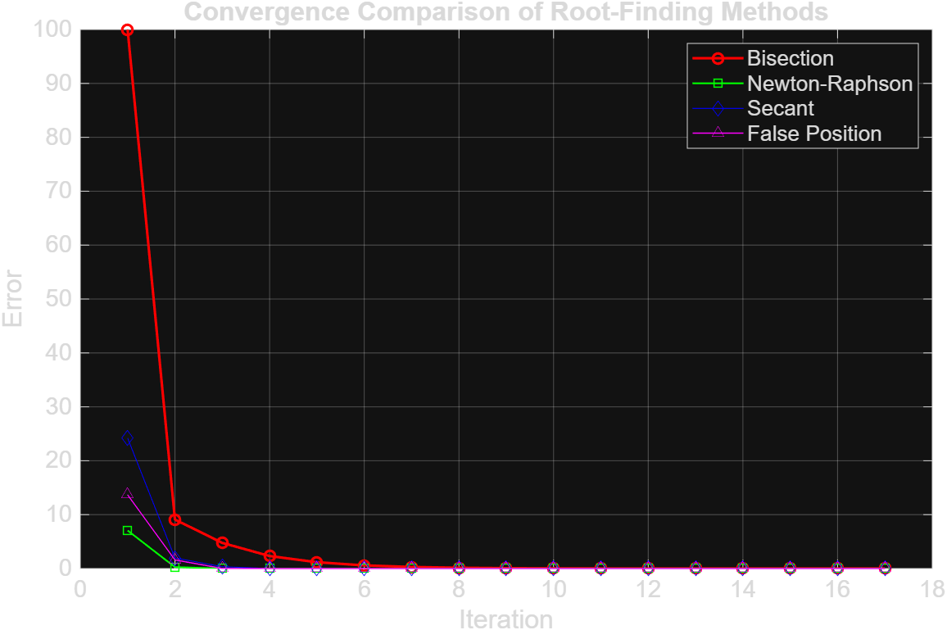

Code — bisection.m
clc; close all; clear all;

a = 2;
b = 3;

function y = f(x)
y = x^3 - x - e^x - 2;
end

Output
(no output found — run with --run matlab, or paste it here)

Code — f.m

Output
(no output found — run with --run matlab, or paste it here)

Code — gauss_seidal.m
clc; close all; clear all;

A = [4 1 2;
3 5 1;
1 1 3];

b = [4 7 3]';

aug = [A, b];

x0 = [0; 0; 0;];

[x, iter, err, table_data] = gauss_sed(A, b, x0, 600);

% Display iteration table
T = array2table(table_data, ...
'VariableNames', {'Iteration','x1','x2','x3','Error'});

disp(T);

function [iter, x, err, table_data] = gauss_sed(A, b, x0, max_iter)
n = length(b);
tol = 10e-5;
x = x0;

table_data = zeros(max_iter + 1, n + 2);
table_data(1,:) = [0, x', 0];

for iter = 1:max_iter
x_old = x;

for i = 1:n

d = b(i);

for j = 1:n
if i ~= j
d = d - A(i,j) * x(j);
end
end

x(i) = d / A(i,i);
end

err = max(abs(x - x_old));

table_data(iter+1,:) = [iter, x', err];

if err < tol
break;
end

end
table_data = table_data(1:iter+1,:);
end

Output
Iteration x1 x2 x3 Error
_________ _______ _______ _______ ________

0 0 0 0 0
1 1 0.8 0.4 1
2 0.6 0.96 0.48 0.4
3 0.52 0.992 0.496 0.08
4 0.504 0.9984 0.4992 0.016
5 0.5008 0.99968 0.49984 0.0032
6 0.50016 0.99994 0.49997 0.00064
7 0.50003 0.99999 0.49999 0.000128
8 0.50001 1 0.5 2.56e-05

Code — rocket_nozzle.m
generate_rao_bell_nozzle()

function generate_rao_bell_nozzle()
% --- 1. Nozzle Input Parameters ---
R_t = 15.0; % Throat radius (mm)
expansion_ratio = 8.0; % Area expansion ratio (A_e / A*)
percent_length = 85; % % length of equivalent 15-deg conical nozzle
theta_i = 28; % Initial divergent parabola wall angle (degrees)
theta_e = 9; % Exit wall angle (degrees)
num_points = 100; % Resolution for divergent bell section

% --- 2. Geometric Calculations ---
R_e = R_t * sqrt(expansion_ratio);

% Reference 15-degree conical length
L_15 = (R_e - R_t) / tand(15);
L_n = (percent_length / 100.0) * L_15;

% Radians for trigonometric evaluations
t_i = deg2rad(theta_i);
t_e = deg2rad(theta_e);

% --- 3. Convergent Region ---
R_chamber = R_t * 2.5;
theta_conv = deg2rad(30); % Standard 30-deg contraction angle

x_conv_start = - ((R_chamber - R_t) / tan(theta_conv));
x_conv = linspace(x_conv_start, -0.382 * R_t, round(num_points / 2));
y_conv = R_chamber - (x_conv - x_conv_start) * tan(theta_conv);

% --- 4. Throat Region (Circular Arc Downstream) ---
r_dn = 0.382 * R_t;
x_i = r_dn * sin(t_i);
y_i = R_t + r_dn * (1 - cos(t_i));

theta_arc = linspace(0, t_i, 20);
x_throat_arc = r_dn * sin(theta_arc);
y_throat_arc = R_t + r_dn * (1 - cos(theta_arc));

% --- 5. Divergent Parabolic Bell Section ---
x_e = L_n;
y_e = R_e;

m1 = tan(t_i);
m2 = tan(t_e);

% Quadratic Bezier Control Point Intersection
x_c = (y_e - y_i + m1 * x_i - m2 * x_e) / (m1 - m2);
y_c = y_i + m1 * (x_c - x_i);

% Parabolic parameter t from 0 to 1
t = linspace(0, 1, num_points);
x_div = (1 - t).^2 * x_i + 2 * (1 - t) .* t * x_c + t.^2 * x_e;
y_div = (1 - t).^2 * y_i + 2 * (1 - t) .* t * y_c + t.^2 * y_e;

% Combine full profile coordinates
x_full = [x_conv, x_throat_arc, x_div];
y_full = [y_conv, y_throat_arc, y_div];

% --- 6. Visualization in MATLAB ---
fig = figure('Color', [0.12 0.12 0.18], 'Position', [100 100 1000 500]);
ax = axes('Parent', fig, 'Color', [0.12 0.12 0.18], 'XColor', 'w', 'YColor', 'w');
hold(ax, 'on');
grid(ax, 'on');
set(ax, 'GridColor', [0.3 0.3 0.4], 'GridAlpha', 0.6, 'GridLineStyle', '--');

% Upper & Lower Nozzle Walls
plot(ax, x_full, y_full, 'Color', '#00d2ff', 'LineWidth', 2.5, 'DisplayName', 'Nozzle Wall Contour');
plot(ax, x_full, -y_full, 'Color', '#00d2ff', 'LineWidth', 2.5, 'HandleVisibility', 'off');

% Centerline Axis
yline(ax, 0, '--w', 'Centerline Axis', 'Alpha', 0.5, 'LineWidth', 1, 'Color', 'w', 'DisplayName', 'Centerline Axis');

% Gas Flow Domain Fill
patch(ax, [x_full, fliplr(x_full)], [y_full, -fliplr(y_full)], [0 0.82 1], ...
'FaceAlpha', 0.08, 'EdgeColor', 'none', 'HandleVisibility', 'off');

% Key Stations
xline(ax, x_conv_start, ':r', 'Chamber Inlet', 'Color', '#ff4757', 'Alpha', 0.7, 'LineWidth', 1.2);
xline(ax, 0, ':y', 'Throat (M = 1.0)', 'Color', '#ffa502', 'Alpha', 0.7, 'LineWidth', 1.2);
xline(ax, L_n, ':g', 'Exit Geometry', 'Color', '#2ed573', 'Alpha', 0.7, 'LineWidth', 1.2);

% Formatting
title(ax, '2D Rao Parabolic Bell Nozzle Profile', 'Color', 'w', 'FontSize', 13, 'FontWeight', 'bold');
xlabel(ax, 'Axial Distance X (mm)', 'Color', 'w', 'FontSize', 11);
ylabel(ax, 'Radial Distance Y (mm)', 'Color', 'w', 'FontSize', 11);
axis(ax, 'equal');
legend(ax, 'Location', 'southwest', 'TextColor', 'w', 'Color', [0.1 0.1 0.15], 'EdgeColor', [0.3 0.3 0.4]);

% --- 7. Export CSV for SolidWorks (X, Y, Z) ---
z_full = zeros(size(x_full));
data_out = [x_full', y_full', z_full'];

writematrix(data_out, 'solidworks_nozzle_curve.csv');
fprintf('Exported %d points to "solidworks_nozzle_curve.csv"\n', length(x_full));
end

Output
Exported 170 points to "solidworks_nozzle_curve.csv"

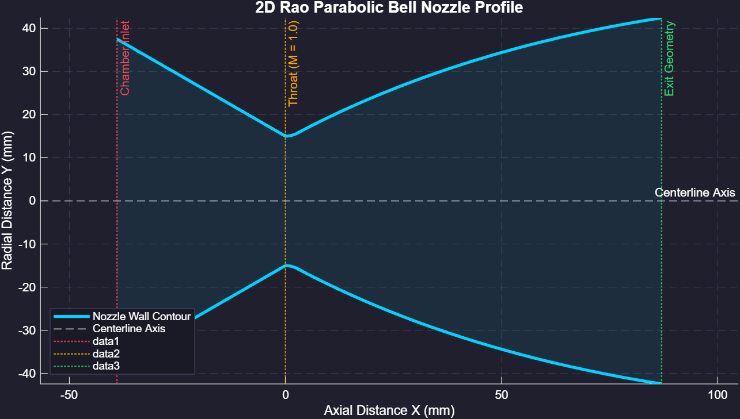

Code — sor.m
clc; close all; clear all;

A = [4 1 2;
3 5 1;
1 1 3];

b = [4 7 3]';

aug = [A, b];

x0 = [0; 0; 0;];

[x, iter, err, table_data] = sor_(A, b, x0, 1.2, 700);

T = array2table(table_data, 'VariableNames', {'iteration','x1','x2','x3','error'});
disp(T);
disp("The solution ")
disp(x)

function [x, iter, err, table_data] = sor_(A, b, x0, w, max_iter)
n = length(b);
tol = 1e-5;
x = x0;

table_data = zeros(max_iter + 1, n + 2);
table_data(1,:) = [0, x', 0];

for iter = 1:max_iter
x_old = x;
for i = 1:n
d = b(i);
x_old = x;

for j = 1:n
if i ~= j
d = d - A(i,j)*x(j);
end
end

x_gs = d/A(i,i);
x(i) = (1-w) * x_old(i) + w*x_gs;

end

err = max(abs(x-x_old));
table_data(iter+1,:) = [iter,x',err];

if err < tol
break;
end

end
table_data = table_data(1:iter+1,:);
end

Output
iteration x1 x2 x3 error
_________ _______ _______ _______ __________

0 0 0 0 0
1 1.2 0.816 0.3936 0.3936
2 0.47904 1.0774 0.49869 0.10509
3 0.48175 0.99797 0.50837 0.0096812
4 0.49923 0.99895 0.49905 0.009322
5 0.50104 0.99969 0.4999 0.00084579
6 0.49995 1.0001 0.49999 9.3764e-05
7 0.49998 0.99999 0.50001 2.1394e-05
8 0.5 1 0.5 1.5091e-05
9 0.5 1 0.5 1.7604e-06

The solution
0.5000
1.0000
0.5000

Code — test.m
clc
close all
clear all

global a;
a = 5;

disp_prog();

function disp_prog()
global a
disp(a)
end

Output
5

Assignment 6

Code — A6Q1.m
clc; clear; close all;

f = @(t,y) (2 - 2*t*y) / (t^2 + 1);
y_exact_fn = @(t) (2*t + 1) ./ (t.^2 + 1);

step_sizes = [0.5, 0.25, 0.1, 0.01];
colors = ["#D95319", "#EDB120", "#7E2F8E", "#77AC30"];

t0 = 0; target_x = 1; y0 = 1;

plot_euler_results(target_x, t0, y0, step_sizes, colors, f, y_exact_fn);

%%======================================================================%%
%%TODO: have to understand and implement the plot function from scratch%%
%%=====================================================================%%

dis_result(target_x, t0, y0, step_sizes, f, y_exact_fn);

function dis_result(target_x, t0, y0, step_sizes, f, y_exact_fn)
for i = 1:length(step_sizes)
h = step_sizes(i);

[iter, x_history, y_history, final_err] = euler(target_x, t0, y0, h, f, y_exact_fn);

fprintf('\n=== TABLE FOR h = %.2f ===\n', h);
fprintf('%-10s %-12s %-12s %-12s\n', 't', 'Exact', 'Euler Appr');
fprintf('%s\n', repmat('-', 1, 48));

for k = 1:length(x_history)
t_val = x_history(k);
y_appr = y_history(k);
y_exact = y_exact_fn(t_val);
%err_val = abs(y_exact - y_appr);

fprintf('%-10.2f %-12.6f %-12.6f \n', t_val, y_exact, y_appr);
end
fprintf('\n');
end
end

function plot_euler_results(target_x, t0, y0, step_sizes, colors, f, y_exact_fn)

t_common = (t0:0.1:target_x)';
sol_matrix = zeros(length(t_common), length(step_sizes));

figure('Position', [100, 100, 800, 500]);
hold on; grid on;

t_fine = 0:0.001:target_x;
plot(t_fine, y_exact_fn(t_fine), 'k-', 'LineWidth', 2.5, 'DisplayName', 'Exact Solution');

for i = 1:length(step_sizes)
h = step_sizes(i);

[iter, x_history, y_history, final_err] = euler(target_x, t0, y0, h, f, y_exact_fn);

sol_matrix(:, i) = interp1(x_history, y_history, t_common, 'linear');

plot(x_history, y_history, 'o--', 'LineWidth', 1.5, 'MarkerSize', 5, ...
'Color', colors(i), ...
'DisplayName', sprintf('h = %.2f (Iter: %d, Err: %.4f)', h, iter, final_err));
end

xlabel('t', 'FontSize', 12);
ylabel('y(t)', 'FontSize', 12);
title("Euler's Method Approximation vs. Exact Solution", 'FontSize', 14);
legend('Location', 'southeast', 'FontSize', 10);
hold off;

% fprintf('\n%-10s %-12s %-12s %-12s %-12s %-12s\n', 't', 'Exact', 'h=0.5', 'h=0.25', 'h=0.1', 'h=0.01');
% fprintf('%s\n', repmat('-', 1, 72));

% for k = 1:length(t_common)
% t_val = t_common(k);
% y_exact = y_exact_fn(t_val);
% fprintf('%-10.2f %-12.6f %-12.6f %-12.6f %-12.6f %-12.6f\n', ...
% t_val, y_exact, sol_matrix(k, 1), sol_matrix(k, 2), sol_matrix(k, 3), sol_matrix(k, 4));
% end
% fprintf('\n');
end

function [iter, x_history, y_history, err] = euler(x, x0, y, h, f, y_exact_fn)

x_new = x0;
iter = 0;

x_history = x_new;
y_history = y;

while (x - x_new) > 1e-9
%step = min(h, x - x_new);

y = y + h * f(x_new, y);
x_new = x_new + h;
iter = iter + 1;

x_history(end+1) = x_new; %#ok<AGROW>
y_history(end+1) = y; %#ok<AGROW>
end

exact_sol = y_exact_fn(x_new);
err = abs(exact_sol - y);
end

Output
=== TABLE FOR h = 0.50 ===
t Exact Euler Appr ------------------------------------------------
0.00 1.000000 1.000000
0.50 1.600000 2.000000
1.00 1.500000 2.000000

=== TABLE FOR h = 0.25 ===
t Exact Euler Appr ------------------------------------------------
0.00 1.000000 1.000000
0.25 1.411765 1.500000
0.50 1.600000 1.794118
0.75 1.600000 1.835294
1.00 1.500000 1.714824

=== TABLE FOR h = 0.10 ===
t Exact Euler Appr ------------------------------------------------
0.00 1.000000 1.000000
0.10 1.188119 1.200000
0.20 1.346154 1.374257
0.30 1.467890 1.513709
0.40 1.551724 1.613872
0.50 1.600000 1.674984
0.60 1.617647 1.700985
0.70 1.610738 1.697957
0.80 1.585366 1.672646
0.90 1.546961 1.631412
1.00 1.500000 1.579669

=== TABLE FOR h = 0.01 ===
t Exact Euler Appr ------------------------------------------------
0.00 1.000000 1.000000
0.01 1.019898 1.020000
0.02 1.039584 1.039794
0.03 1.059047 1.059370
0.04 1.078275 1.078717
0.05 1.097257 1.097824
0.06 1.115982 1.116679
0.07 1.134441 1.135272
0.08 1.152623 1.153593
0.09 1.170519 1.171631
0.10 1.188119 1.189379
0.11 1.205414 1.206826
0.12 1.222397 1.223963
0.13 1.239060 1.240783
0.14 1.255394 1.257279
0.15 1.271394 1.273441
0.16 1.287051 1.289265
0.17 1.302362 1.304743
0.18 1.317319 1.319870
0.19 1.331918 1.334640
0.20 1.346154 1.349048
0.21 1.360023 1.363090
0.22 1.373522 1.376762
0.23 1.386646 1.390061
0.24 1.399395 1.402983
0.25 1.411765 1.415526
0.26 1.423754 1.427688
0.27 1.435362 1.439468
0.28 1.446588 1.450864
0.29 1.457430 1.461876
0.30 1.467890 1.472503
0.31 1.477967 1.482747
0.32 1.487663 1.492606
0.33 1.496979 1.502083
0.34 1.505916 1.511179
0.35 1.514477 1.519895
0.36 1.522663 1.528234
0.37 1.530478 1.536199
0.38 1.537924 1.543791
0.39 1.545005 1.551015
0.40 1.551724 1.557874
0.41 1.558086 1.564372
0.42 1.564094 1.570512
0.43 1.569753 1.576299
0.44 1.575067 1.581737
0.45 1.580042 1.586831
0.46 1.584681 1.591587
0.47 1.588992 1.596009
0.48 1.592978 1.600102
0.49 1.596645 1.603872
0.50 1.600000 1.607325
0.51 1.603047 1.610467
0.52 1.605793 1.613302
0.53 1.608244 1.615838
0.54 1.610406 1.618081
0.55 1.612284 1.620035
0.56 1.613886 1.621709
0.57 1.615216 1.623107
0.58 1.616283 1.624237
0.59 1.617091 1.625104
0.60 1.617647 1.625715
0.61 1.617958 1.626076
0.62 1.618029 1.626194
0.63 1.617868 1.626075
0.64 1.617480 1.625725
0.65 1.616872 1.625151
0.66 1.616049 1.624359
0.67 1.615018 1.623355
0.68 1.613786 1.622145
0.69 1.612357 1.620736
0.70 1.610738 1.619133
0.71 1.608936 1.617342
0.72 1.606955 1.615370
0.73 1.604801 1.613222
0.74 1.602481 1.610904
0.75 1.600000 1.608422
0.76 1.597363 1.605781
0.77 1.594576 1.602987
0.78 1.591644 1.600045
0.79 1.588572 1.596961
0.80 1.585366 1.593740
0.81 1.582030 1.590386
0.82 1.578570 1.586905
0.83 1.574990 1.583303
0.84 1.571295 1.579583
0.85 1.567489 1.575750
0.86 1.563578 1.571809
0.87 1.559565 1.567765
0.88 1.555455 1.563622
0.89 1.551253 1.559384
0.90 1.546961 1.555056
0.91 1.542585 1.550641
0.92 1.538128 1.546143
0.93 1.533594 1.541567
0.94 1.528987 1.536917
0.95 1.524310 1.532195
0.96 1.519567 1.527406
0.97 1.514761 1.522552
0.98 1.509896 1.517638
0.99 1.504974 1.512667
1.00 1.500000 1.507642

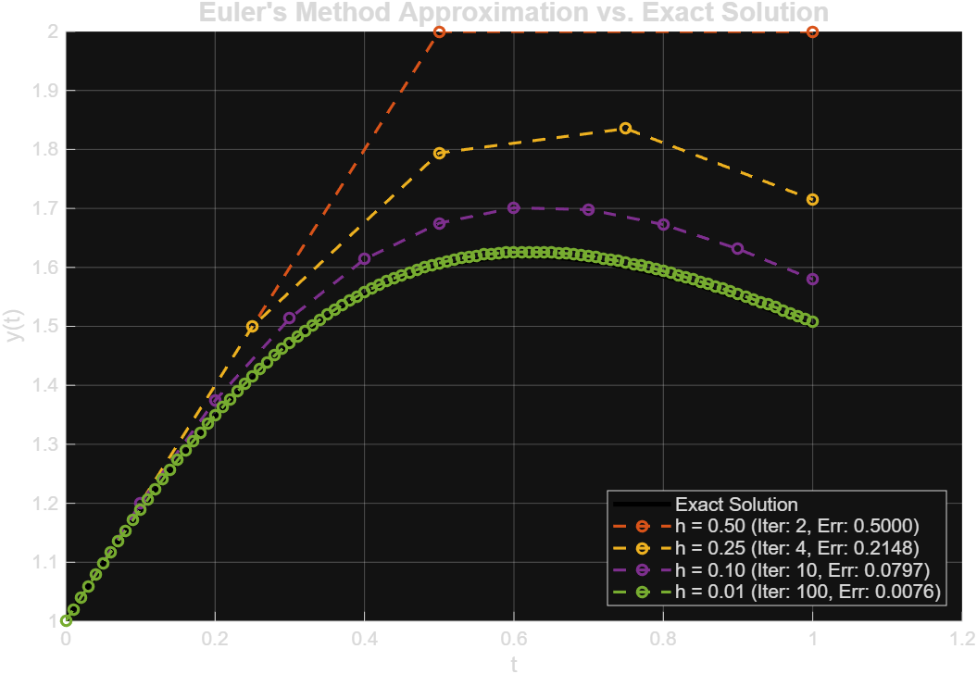

Code — A6Q2.m
clc; close all; clear all;

%========Define Functions================
y_anal = @(t) (2*t + 1) / (t^2 + 1);
y_prime = @(t,y) (2 - 2*t*y) ./ (t^2 + 1);
%========================================

%=================Constants=============
h_vals = [0.5, 0.25, 0.1, 0.01];
t0 = 0; y0 = 1;

disp("[Comparison]")
fprintf("\n")
% Print the overall Table Header
fprintf("%-6s %-10s %-10s %-10s %-10s\n", 'h', 'Total_Iter', 'Exact_Val', 'Approx_Val', 'Abs_Error');
fprintf("-----------------------------------------------------------------\n");

for i = 1:length(h_vals)
[iter, t_vals, y_vals, exact, err] = euler(1, t0, y0, h_vals(i), y_prime, y_anal);

% Use 'end' to grab the final computed value at target_T
final_y = y_vals(end);

% Print a clean, formatted row for each step size
fprintf("%-6.2f %-10d %-10.5f %-10.5f %-10.5e\n", ...
h_vals(i), iter, exact, final_y, err);
end

fprintf("\n")
disp("[Detailed Table]")
for i = 1:length(h_vals)

current_h = h_vals(i); % Changed name to avoid variable collisions
[total_steps, t_vals, y_vals, final_exact, final_err] = euler(1, t0, y0, current_h, y_prime, y_anal);

% Fixed format token from .2%f to %.2f
fprintf("\nTable for h = %.2f\n", current_h);

% Cleaned up 5 structural columns matching 5 column names
fprintf("%-6s %-10s %-10s %-10s %-10s\n", "iter", "t_vals", "exact", "y_vals", "error");
fprintf("===============================================================\n");

for j = 1:length(t_vals)
% Compute exact solution dynamically for the current time step t_vals(j)
step_exact = y_anal(t_vals(j));
step_error = abs(step_exact - y_vals(j));

% Print each step row cleanly (j-1 gives us step 0, step 1, step 2...)
fprintf("%-6d %-10.2f %-10.4f %-10.4f %-10.4e\n", ...
j-1, t_vals(j), step_exact, y_vals(j), step_error);
end
end

function [iter, t_vals, y_vals, exact, err] = euler(target_X, x0, y0, h, y_prime, y_anal)
x = x0;
y = y0;
iter = 0;
t_vals = [x];
y_vals = [y];
iter = 0;

while x < target_X-1e-9
iter = iter + 1;

y = y + h * y_prime(x,y);
x = x + h;

t_vals(iter+1) = x;
y_vals(iter+1) = y;
end

exact = y_anal(target_X);
err = abs(exact - y);
end

Output
[Comparison]

h Total_Iter Exact_Val Approx_Val Abs_Error
-----------------------------------------------------------------
0.50 2 1.50000 2.00000 5.00000e-01
0.25 4 1.50000 1.71482 2.14824e-01
0.10 10 1.50000 1.57967 7.96695e-02
0.01 100 1.50000 1.50764 7.64154e-03

[Detailed Table]

Table for h = 0.50
iter t_vals exact y_vals error
===============================================================
0 0.00 1.0000 1.0000 0.0000e+00
1 0.50 1.6000 2.0000 4.0000e-01
2 1.00 1.5000 2.0000 5.0000e-01

Table for h = 0.25
iter t_vals exact y_vals error
===============================================================
0 0.00 1.0000 1.0000 0.0000e+00
1 0.25 1.4118 1.5000 8.8235e-02
2 0.50 1.6000 1.7941 1.9412e-01
3 0.75 1.6000 1.8353 2.3529e-01
4 1.00 1.5000 1.7148 2.1482e-01

Table for h = 0.10
iter t_vals exact y_vals error
===============================================================
0 0.00 1.0000 1.0000 0.0000e+00
1 0.10 1.1881 1.2000 1.1881e-02
2 0.20 1.3462 1.3743 2.8104e-02
3 0.30 1.4679 1.5137 4.5819e-02
4 0.40 1.5517 1.6139 6.2148e-02
5 0.50 1.6000 1.6750 7.4984e-02
6 0.60 1.6176 1.7010 8.3338e-02
7 0.70 1.6107 1.6980 8.7219e-02
8 0.80 1.5854 1.6726 8.7280e-02
9 0.90 1.5470 1.6314 8.4451e-02
10 1.00 1.5000 1.5797 7.9669e-02

Table for h = 0.01
iter t_vals exact y_vals error
===============================================================
0 0.00 1.0000 1.0000 0.0000e+00
1 0.01 1.0199 1.0200 1.0199e-04
2 0.02 1.0396 1.0398 2.0985e-04
3 0.03 1.0590 1.0594 3.2341e-04
4 0.04 1.0783 1.0787 4.4248e-04
5 0.05 1.0973 1.0978 5.6684e-04
6 0.06 1.1160 1.1167 6.9627e-04
7 0.07 1.1344 1.1353 8.3055e-04
8 0.08 1.1526 1.1536 9.6942e-04
9 0.09 1.1705 1.1716 1.1126e-03
10 0.10 1.1881 1.1894 1.2599e-03
11 0.11 1.2054 1.2068 1.4110e-03
12 0.12 1.2224 1.2240 1.5657e-03
13 0.13 1.2391 1.2408 1.7235e-03
14 0.14 1.2554 1.2573 1.8843e-03
15 0.15 1.2714 1.2734 2.0478e-03
16 0.16 1.2871 1.2893 2.2136e-03
17 0.17 1.3024 1.3047 2.3814e-03
18 0.18 1.3173 1.3199 2.5510e-03
19 0.19 1.3319 1.3346 2.7221e-03
20 0.20 1.3462 1.3490 2.8942e-03
21 0.21 1.3600 1.3631 3.0672e-03
22 0.22 1.3735 1.3768 3.2407e-03
23 0.23 1.3866 1.3901 3.4145e-03
24 0.24 1.3994 1.4030 3.5881e-03
25 0.25 1.4118 1.4155 3.7615e-03
26 0.26 1.4238 1.4277 3.9342e-03
27 0.27 1.4354 1.4395 4.1060e-03
28 0.28 1.4466 1.4509 4.2767e-03
29 0.29 1.4574 1.4619 4.4459e-03
30 0.30 1.4679 1.4725 4.6135e-03
31 0.31 1.4780 1.4827 4.7792e-03
32 0.32 1.4877 1.4926 4.9427e-03
33 0.33 1.4970 1.5021 5.1039e-03
34 0.34 1.5059 1.5112 5.2625e-03
35 0.35 1.5145 1.5199 5.4184e-03
36 0.36 1.5227 1.5282 5.5713e-03
37 0.37 1.5305 1.5362 5.7211e-03
38 0.38 1.5379 1.5438 5.8676e-03
39 0.39 1.5450 1.5510 6.0106e-03
40 0.40 1.5517 1.5579 6.1501e-03
41 0.41 1.5581 1.5644 6.2859e-03
42 0.42 1.5641 1.5705 6.4178e-03
43 0.43 1.5698 1.5763 6.5459e-03
44 0.44 1.5751 1.5817 6.6699e-03
45 0.45 1.5800 1.5868 6.7897e-03
46 0.46 1.5847 1.5916 6.9054e-03
47 0.47 1.5890 1.5960 7.0169e-03
48 0.48 1.5930 1.6001 7.1240e-03
49 0.49 1.5966 1.6039 7.2268e-03
50 0.50 1.6000 1.6073 7.3252e-03
51 0.51 1.6030 1.6105 7.4192e-03
52 0.52 1.6058 1.6133 7.5089e-03
53 0.53 1.6082 1.6158 7.5940e-03
54 0.54 1.6104 1.6181 7.6748e-03
55 0.55 1.6123 1.6200 7.7512e-03
56 0.56 1.6139 1.6217 7.8231e-03
57 0.57 1.6152 1.6231 7.8907e-03
58 0.58 1.6163 1.6242 7.9540e-03
59 0.59 1.6171 1.6251 8.0130e-03
60 0.60 1.6176 1.6257 8.0677e-03
61 0.61 1.6180 1.6261 8.1182e-03
62 0.62 1.6180 1.6262 8.1646e-03
63 0.63 1.6179 1.6261 8.2069e-03
64 0.64 1.6175 1.6257 8.2452e-03
65 0.65 1.6169 1.6252 8.2795e-03
66 0.66 1.6160 1.6244 8.3099e-03
67 0.67 1.6150 1.6234 8.3365e-03
68 0.68 1.6138 1.6221 8.3594e-03
69 0.69 1.6124 1.6207 8.3786e-03
70 0.70 1.6107 1.6191 8.3943e-03
71 0.71 1.6089 1.6173 8.4065e-03
72 0.72 1.6070 1.6154 8.4152e-03
73 0.73 1.6048 1.6132 8.4207e-03
74 0.74 1.6025 1.6109 8.4229e-03
75 0.75 1.6000 1.6084 8.4220e-03
76 0.76 1.5974 1.6058 8.4181e-03
77 0.77 1.5946 1.6030 8.4112e-03
78 0.78 1.5916 1.6000 8.4015e-03
79 0.79 1.5886 1.5970 8.3890e-03
80 0.80 1.5854 1.5937 8.3738e-03
81 0.81 1.5820 1.5904 8.3560e-03
82 0.82 1.5786 1.5869 8.3357e-03
83 0.83 1.5750 1.5833 8.3131e-03
84 0.84 1.5713 1.5796 8.2881e-03
85 0.85 1.5675 1.5757 8.2608e-03
86 0.86 1.5636 1.5718 8.2315e-03
87 0.87 1.5596 1.5678 8.2001e-03
88 0.88 1.5555 1.5636 8.1667e-03
89 0.89 1.5513 1.5594 8.1314e-03
90 0.90 1.5470 1.5551 8.0944e-03
91 0.91 1.5426 1.5506 8.0556e-03
92 0.92 1.5381 1.5461 8.0151e-03
93 0.93 1.5336 1.5416 7.9731e-03
94 0.94 1.5290 1.5369 7.9297e-03
95 0.95 1.5243 1.5322 7.8848e-03
96 0.96 1.5196 1.5274 7.8385e-03
97 0.97 1.5148 1.5226 7.7910e-03
98 0.98 1.5099 1.5176 7.7423e-03
99 0.99 1.5050 1.5127 7.6925e-03
100 1.00 1.5000 1.5076 7.6415e-03

Code — A6Q3.m
clc; close all; clear all;

% Differential equation & Analytical exact solution handles
f = @(t,y) (y/t - (y/t)^2);
f_anal = @(t) (t ./ (1 + log(t)));

% Parameters
x0 = 1;
x = 2;
y = 1;
h = 0.1;

% Solve using custom euler function
[iter, x_history, y_history, err] = euler(x, x0, y, h, f, f_anal);

%%===========================================================
%ODE45 Function
[t_ode, y_ode] = ode45(f, [1:h:2], 1);

%%===========================================================
exact_sol = f_anal(2);

%%=============================================================
%RK -2

% Print results table
fprintf('Iteration count: %d\n', iter);
fprintf('Final error at x = %.2f: %.6f\n\n', x_history(end), err);

fprintf('%-10s %-12s %-12s %-12s\n', 't', 'Exact', 'Euler Appr', 'Abs Error');
fprintf('%s\n', repmat('-', 1, 48));

for k = 1:length(x_history)
t_val = x_history(k);
y_appr = y_history(k);
y_exact = f_anal(t_val);
err_val = abs(y_exact - y_appr);

%fprintf('%-10.2f %-12.6f %-12.6f %-12.6f\n', t_val, y_exact, y_appr, err_val);
end

% ---------------- Plotting Both Curves on Same Graph ----------------
figure('Position', [100, 100, 800, 500]);
hold on; grid on;

% Fine time vector for smooth analytical plot
t_fine = x0:0.001:x;
plot(t_fine, f_anal(t_fine), 'm-', 'LineWidth', 2, 'DisplayName', 'Analytical Exact Solution');

% Plot Euler approximation points
plot(x_history, y_history, 'ro--', 'LineWidth', 1.5, 'MarkerSize', 6, ...
'DisplayName', sprintf('Euler Appr (h = %.2f)', h));

xlabel('t', 'FontSize', 12);
ylabel('y(t)', 'FontSize', 12);
title("Oiler Method vs Analytical Solution", 'FontSize', 14);
legend('Location', 'best', 'FontSize', 11);
hold off;

%%===========================================================
%OILED UP METHOD
function [iter, x_history, y_history, err] = euler(x, x0, y, h, f, y_exact_fn)

x_new = x0;
iter = 0;

x_history = x_new;
y_history = y;

while (x - x_new) > 1e-9
%step = min(h, x - x_new);

y = y + h * f(x_new, y);
x_new = x_new + h;
iter = iter + 1;

x_history(end+1) = x_new; %#ok<AGROW>
y_history(end+1) = y; %#ok<AGROW>
end

exact_sol = y_exact_fn(x_new);
err = abs(exact_sol - y);
end

Output
Iteration count: 10
Final error at x = 2.00: 0.010581

t Exact Euler Appr Abs Error
------------------------------------------------

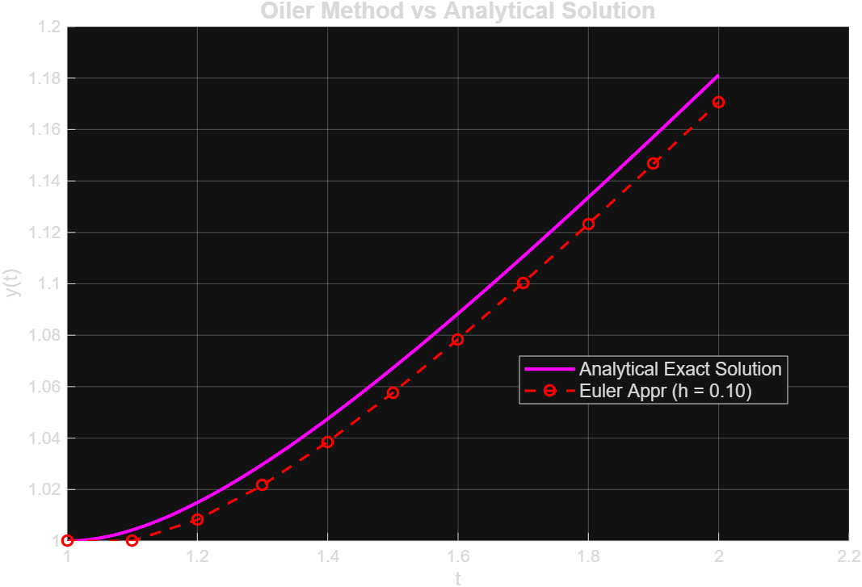

Code — A6Q3_test.m
clc; close all; clear all;

% Differential equation & Analytical exact solution handles
f = @(t,y) (y/t - (y/t)^2);
f_anal = @(t) (t ./ (1 + log(t)));

% Parameters
t0 = 1;
t_end = 2;
y0 = 1;
h = 0.1;

% Define time vector for the steps
t_steps = t0:h:t_end;
N = length(t_steps);

%% ===========================================================
% a) ODE45 Solver (Evaluated at specific t steps)
%% ===========================================================
[x_ode45, y_ode45] = ode45(f, t_steps, y0);

%% ===========================================================
% b) Euler's Method
%% ===========================================================
y_euler = zeros(N, 1);
y_euler(1) = y0;
for i = 1:N-1
y_euler(i+1) = y_euler(i) + h * f(t_steps(i), y_euler(i));
end

%% ===========================================================
% c) RK-2 Method (Heun's Method / Modified Euler)
%% ===========================================================
y_rk2 = zeros(N, 1);
y_rk2(1) = y0;
for i = 1:N-1
k1 = f(t_steps(i), y_rk2(i));
k2 = f(t_steps(i) + h, y_rk2(i) + h * k1);
y_rk2(i+1) = y_rk2(i) + (h / 2) * (k1 + k2);
end

%% ===========================================================
% d) RK-4 Method (FIXED: Changed [] to () indexing)
%% ===========================================================
y_rk4 = zeros(N, 1);
y_rk4(1) = y0;
for i = 1:N-1
k1 = f(t_steps(i), y_rk4(i));
k2 = f(t_steps(i) + h/2, y_rk4(i) + h*k1/2);
k3 = f(t_steps(i) + h/2, y_rk4(i) + h*k2/2);
k4 = f(t_steps(i) + h, y_rk4(i) + h*k3);
y_rk4(i+1) = y_rk4(i) + (h / 6) * (k1 + 2*k2 + 2*k3 + k4);
end

%% ===========================================================
% Generate Data Table
%% ===========================================================
% Calculate Exact Values
y_exact = f_anal(t_steps)';

% Display table with exact requested headings
fprintf('\n%-5s %-10s %-10s %-10s %-10s %-10s\n', 't', 'Exact', 'ODE45', 'Euler', 'RK2', 'RK4');
fprintf('%s\n', repmat('-', 1, 60));
for i = 1:N
% FIXED: Changed t_steps[i] to t_steps(i)
fprintf('%-5.1f %-10.6f %-10.6f %-10.6f %-10.6f %-10.6f\n', ...
t_steps(i), y_exact(i), y_ode45(i), y_euler(i), y_rk2(i), y_rk4(i));
end

%% ===========================================================
% Plotting Results
%% ===========================================================
figure('Position', [100, 100, 900, 600]);
hold on; grid on;

% Smooth curve for exact analytical solution
t_fine = t0:0.001:t_end;
plot(t_fine, f_anal(t_fine), 'k-', 'LineWidth', 2.5, 'DisplayName', 'Exact Solution');

% Plot approximations
plot(t_steps, y_ode45, 'b-^', 'LineWidth', 1.5, 'MarkerSize', 7, 'DisplayName', 'ODE45');
plot(t_steps, y_euler, 'r-o', 'LineWidth', 1.5, 'MarkerSize', 6, 'DisplayName', 'Euler Method');
plot(t_steps, y_rk2, 'g-s', 'LineWidth', 1.5, 'MarkerSize', 6, 'DisplayName', 'RK-2');
plot(t_steps, y_rk4, 'm--x', 'LineWidth', 1.5, 'MarkerSize', 8, 'DisplayName', 'RK-4');

xlabel('t', 'FontSize', 12);
ylabel('y(t)', 'FontSize', 12);
title('Comparison of Numerical Solvers vs Exact Solution', 'FontSize', 14);
legend('Location', 'best', 'FontSize', 11);
hold off;

Output
t Exact ODE45 Euler RK2 RK4
------------------------------------------------------------
1.0 1.000000 1.000000 1.000000 1.000000 1.000000
1.1 1.004282 1.004282 1.000000 1.004132 1.004282
1.2 1.014952 1.014952 1.008264 1.014714 1.014952
1.3 1.029814 1.029814 1.021689 1.029520 1.029813
1.4 1.047534 1.047534 1.038515 1.047204 1.047534
1.5 1.067262 1.067262 1.057668 1.066909 1.067262
1.6 1.088433 1.088433 1.078461 1.088064 1.088432
1.7 1.110655 1.110655 1.100432 1.110275 1.110655
1.8 1.133654 1.133654 1.123262 1.133266 1.133653
1.9 1.157228 1.157228 1.146724 1.156835 1.157228
2.0 1.181232 1.181232 1.170652 1.180834 1.181232

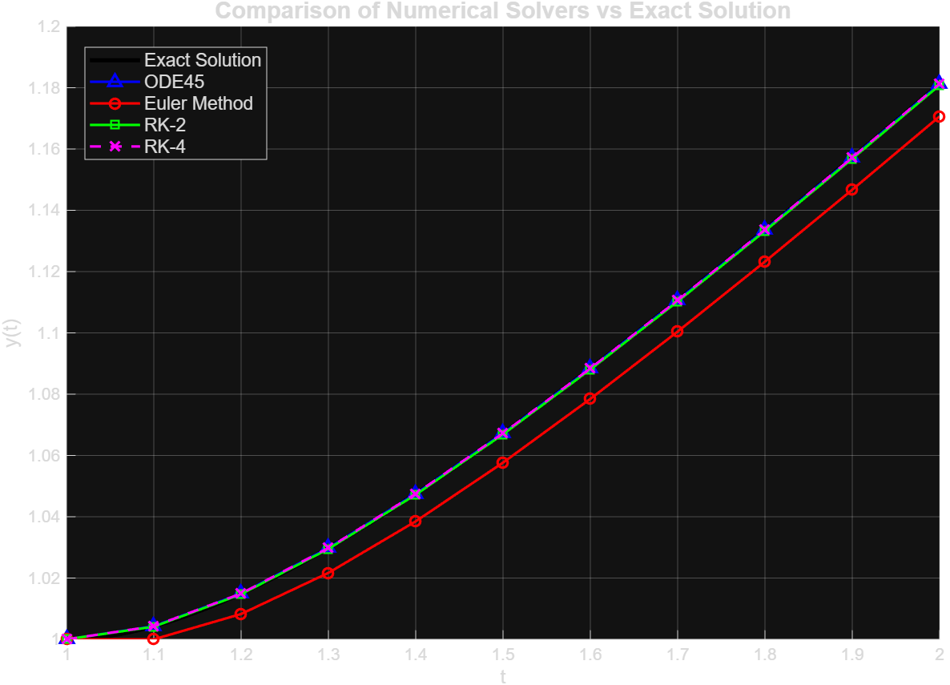

Code — A6Q4.m
clc; close all; clear all;

% Function definitions
f_prime = @(t,y) (y/t - (y/t).^2);
f_anal = @(t) (t ./ (1 + log(t)));

x0 = 1;
y0 = 1;
x = 2;
y = 1;
h = 0.1;
t_steps = [1:h:2];
N = length(t_steps);

%=====================================================
exact_sol = f_anal(2);

%======================================================
% Solve using ODE45
[t_ode, y_ode] = ode45(f_prime, [1:h:2], y0);
error_ode = abs(exact_sol - y_ode);
% Solve using Oiled up method
[iter, x_history, y_history, error] = euler(x, x0, y0, h, f_prime, f_anal); %forgot to pass functions as arguments
% Solve using the RK-2 method
[y_rk2, error_rk2] = RK_2(N, t_steps, y0, h, f_anal, f_prime);
% Solve using the RK-4 method
[y_rk4, error_rk4] = RK_4(N, t_steps, y0, h, f_anal, f_prime);

%======================================================
% Display Result
fprintf("%-6s %-12s %-14s %-14s %-14s %-14s\n", ...
"t", "Exact", "Error Ode45", "Error Euler", "Error Rk2", "Error Rk4");
for i = 1:N
fprintf("%-6.1f %-12.6f %-14.6e %-14.6e %-14.6e %-14.6e\n", ...
t_steps(i), f_anal(t_steps(i)), error_ode(i), error(i), error_rk2(i), error_rk4(i));
end

%=======================================================
% Oiled Up Method
function [iter, x_history, y_history, error] = euler(x_target, x0, y0, h, f_prime, f_anal)
x_history = x0;
y_history = y0;
iter = 0;
x = x0;
y = y0;
error = abs(f_anal(x0) - y0);

while x < x_target - 1e-9
iter = iter + 1;
y = y + h * f_prime(x,y);
x = x + h;

exact = f_anal(x);
x_history(iter + 1) = x;
y_history(iter + 1) = y;
error(iter + 1) = abs(exact - y);
end
end

%========================================================
% RK-2 Method
function [y_rk2, error_rk2] = RK_2(N, t_steps, y0, h, f_anal, f_prime)
y_rk2 = zeros(N, 1);
y_rk2(1) = y0;
error_rk2(1) = abs(y_rk2(1) - f_anal(t_steps(1)));

for i = 1:length(t_steps)-1
exact = f_anal(t_steps(i+1));

k1 = f_prime(t_steps(i), y_rk2(i));
k2 = f_prime(t_steps(i) + h, y_rk2(i) + h * k1);
y_rk2(i+1) = y_rk2(i) + (h/2) * (k1 + k2);

error_rk2(i + 1) = abs(y_rk2(i+1) - exact);
end
end

%========================================================
% RK-4 Method
function [y_rk4, error_rk4] = RK_4(N, t_steps, y0, h, f_anal, f_prime)
y_rk4 = zeros(N, 1);
y_rk4(1) = y0;
error_rk4 = abs(y_rk4 - t_steps(1));

for i = 1:length(t_steps)-1
exact = f_anal(t_steps(i+1));

k1 = h * f_prime(t_steps(i), y_rk4(i));
k2 = h * f_prime(t_steps(i) + h/2, y_rk4(i) + k1/2);
k3 = h * f_prime(t_steps(i) + h/2, y_rk4(i) + k2/2);
k4 = h * f_prime(t_steps(i) + h, y_rk4(i) + k3);

y_rk4(i) = y_rk4(i) + h * 1/6 * (k1 + 2*k2 + 2*k3 + k4);
error_rk4(i+1) = abs(exact - y_rk4(i+1));
end
end

Output
t Exact Error Ode45 Error Euler Error Rk2 Error Rk4
1.0 1.000000 1.812322e-01 0.000000e+00 0.000000e+00 0.000000e+00
1.1 1.004282 1.769505e-01 4.281728e-03 1.494965e-04 1.004282e+00
1.2 1.014952 1.662799e-01 6.687851e-03 2.386397e-04 1.014952e+00
1.3 1.029814 1.514185e-01 8.124217e-03 2.939972e-04 1.029814e+00
1.4 1.047534 1.336983e-01 9.019185e-03 3.295487e-04 1.047534e+00
1.5 1.067262 1.139699e-01 9.594162e-03 3.530391e-04 1.067262e+00
1.6 1.088433 9.279953e-02 9.971593e-03 3.689534e-04 1.088433e+00
1.7 1.110655 7.057717e-02 1.022289e-02 3.799877e-04 1.110655e+00
1.8 1.133654 4.757866e-02 1.039151e-02 3.878155e-04 1.133654e+00
1.9 1.157228 2.400379e-02 1.050484e-02 3.935040e-04 1.157228e+00
2.0 1.181232 3.339835e-10 1.058065e-02 3.977492e-04 1.181232e+00

Assignment 7

Code — A7Q1.m
clc; close all; clear all;
%==================== a ===============================
disp('================= a =====================')
y_2 = f(-2);
fprintf("y(-2) = %f\n", y_2)

y_4 = f(4);
fprintf("y(4) = %f\n", y_4)
disp('==========================================')

%==================== b ===============================
fplot(@(x) f(x),[-4, 8])
title("Plot of y(x)")
xlabel("y")
ylabel("y(x)")
grid on;

function y = f(x)
y = 0.6.*x.^3*exp(-0.47.*x) + 1.5.*x.^2*exp(-0.6.*x);
end

Output
================= a =====================
y(-2) = 7.632791
y(4) = 8.036691
==========================================
Warning: Function behaves unexpectedly on array inputs. To improve performance, properly vectorize your function to return an output with the same size and shape as the input
arguments.
> In matlab.graphics.function.FunctionLine>getFunction
In matlab.graphics.function/FunctionLine/updateFunction
In matlab.graphics.function/FunctionLine
In fplot>singleFplot (line 268)
In fplot>@(f)singleFplot(cax,{f},limits,extraOpts,args) (line 223)
In fplot>vectorizeFplot (line 223)
In fplot (line 186)
In A7Q1 (line 12)
In run (line 112)
In wrapper (line 6)
In run (line 112)

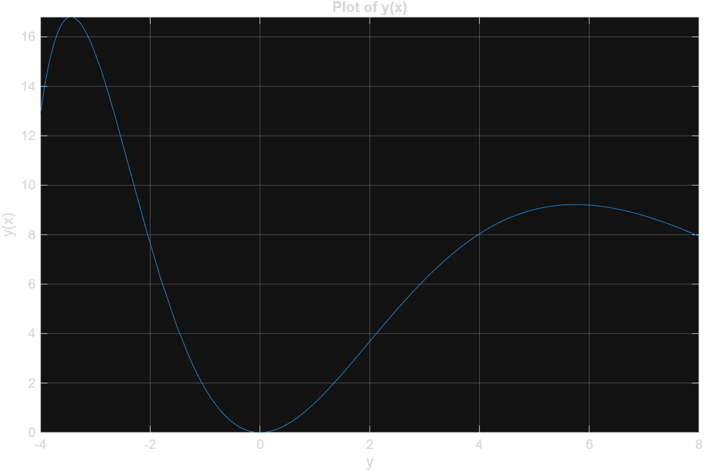

Code — A7Q2.m
clc; close all; clear all;

x_data = [0.9, 1.5, 3, 4, 6, 8, 9.5];
y_data = [0.9, 1.5, 2.5, 5.1, 4.5, 4.9, 6.3];

% 1. Create a smooth x array that spans your ENTIRE dataset (from 0.9 to 9.5)
x_fit = linspace(min(x_data), max(x_data), 200);

% 2. Plot the raw data exactly ONCE
figure;
plot(x_data, y_data, 'ko', 'MarkerSize', 8, 'LineWidth', 2, 'MarkerFaceColor', 'k');
hold on; % Keep the window open so everything layers together

% 3. Create a cell array to dynamically build the legend entries
legend_labels = {'Original Data'};

% 4. Loop through degrees 1 to 6 to fit, evaluate, and plot each curve
for i = 1:6
p = polyfit(x_data, y_data, i);
y_fit = polyval(p, x_fit);

plot(x_fit, y_fit, 'LineWidth', 2);

% Append the degree label to our legend list
legend_labels{end+1} = ['Degree ' num2str(i)];
end

% 5. Apply graph styles AFTER all data has been plotted
grid on;
xlabel('X Data');
ylabel('Y Data');
title('Polynomial Curve Fitting (Degrees 1-6)');
legend(legend_labels, 'Location', 'best');

hold off; % Release the plot

Output

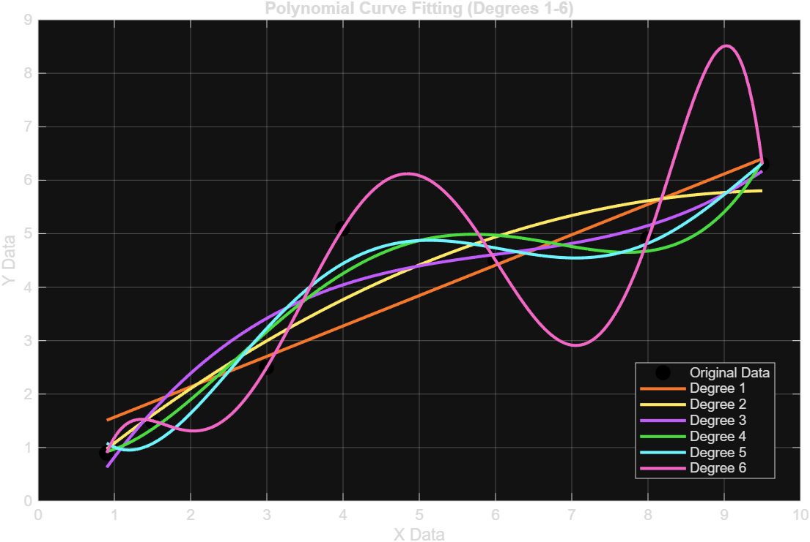

Code — A7Q3.m
% Given data
x = [-5, -4, -1, 1, 4, 6, 9, 10];
y = [12, 10, 6, 2, -3, -6, -11, -12];

% a) Determine coefficients m and b using polyfit (degree 1)
p = polyfit(x, y, 1);
m = p(1);
b = p(2);

fprintf('Slope (m) = %.4f\n', m);
fprintf('Y-Intercept (b) = %.4f\n', b);
fprintf('Best-fit equation: y = %.4fx + %.4f\n', m, b);

% b) Make a plot showing the function and the data points
figure;
scatter(x, y, 60, 'blue', 'filled', 'DisplayName', 'Data Points');
hold on;

% Generate smooth x-values for plotting the line
x_line = linspace(min(x) - 1, max(x) + 1, 100);
y_line = m * x_line + b;

plot(x_line, y_line, 'r-', 'LineWidth', 1.5, ...
'DisplayName', sprintf('Best Fit Line: y = %.2fx + %.2f', m, b));

% Formatting the plot
grid on;
xlabel('x');
ylabel('y');
title('Linear Least-Squares Regression');
legend('Location', 'northeast');
hold off;

Output
Slope (m) = -1.6195
Y-Intercept (b) = 3.7987
Best-fit equation: y = -1.6195x + 3.7987

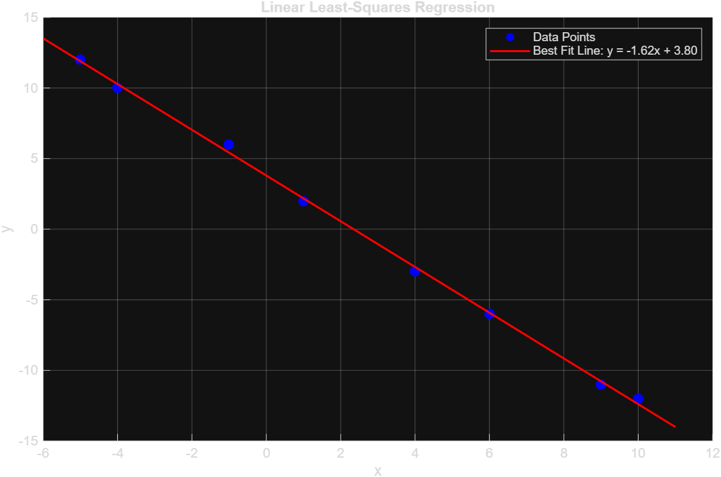

Code — A7Q4.m
clc; close all; clear all;

% Given data
t = [0, 1, 3, 4, 6, 7, 9];
NB = [500, 600, 1000, 1400, 2100, 2700, 4100];
t_est = 5.0;
t_dense = linspace(min(t), max(t), 200);

%% ==========================================
% Part a: Exponential Fit (NB = N * exp(alpha * t))
% ==========================================
% Linearize via natural logarithm: ln(NB) = ln(N) + alpha * t
p = polyfit(t, log(NB), 1);
alpha = p(1);
N_coeff = exp(p(2));

% Estimate at t = 5h
NB_exp_5 = N_coeff * exp(alpha * t_est);

fprintf('--- Part a: Exponential Fit ---\n');
fprintf('Equation: NB = %.2f * exp(%.4f * t)\n', N_coeff, alpha);
fprintf('Estimated NB at t = 5h: %.2f\n\n', NB_exp_5);

% Plot for Part a
figure('Name', 'Exponential Fit', 'Position', [100, 100, 800, 500]);
scatter(t, NB, 60, 'black', 'filled', 'DisplayName', 'Data Points');
hold on;
plot(t_dense, N_coeff * exp(alpha * t_dense), 'r-', 'LineWidth', 1.5, ...
'DisplayName', sprintf('Exp Fit: N_B = %.2f e^{%.3ft}', N_coeff, alpha));
scatter(t_est, NB_exp_5, 100, 'magenta', 'p', 'filled', ...
'DisplayName', sprintf('Estimate at 5h: %.2f', NB_exp_5));
xlabel('Time t (h)');
ylabel('Bacteria Count N_B');
title('a) Exponential Curve Fitting');
legend('Location', 'northwest');
grid on;
hold off;

%% ==========================================
% Part b: Interpolation Methods
% ==========================================
% 1. Linear Interpolation
NB_linear_5 = interp1(t, NB, t_est, 'linear');

% 2. Cubic Spline Interpolation (using 'spline')
NB_spline_5 = spline(t, NB, t_est);

% 3. PCHIP Interpolation (Shape-preserving piecewise cubic)
NB_pchip_5 = pchip(t, NB, t_est);

fprintf('--- Part b: Interpolation Estimates at t = 5h ---\n');
fprintf('Linear Interpolation: %.2f\n', NB_linear_5);
fprintf('Cubic Spline Interpolation: %.2f\n', NB_spline_5);
fprintf('PCHIP Interpolation: %.2f\n', NB_pchip_5);

% Evaluate dense curves for plotting
y_linear = (t, NB, t_dense, 'linear');
y_spline = spline(t, NB, t_dense);
y_pchip = pchip(t, NB, t_dense);

% Plot for Part b
figure('Name', 'Interpolation Methods', 'Position', [150, 150, 800, 500]);
scatter(t, NB, 60, 'black', 'filled', 'DisplayName', 'Data Points');
hold on;
plot(t_dense, y_linear, 'b--', 'LineWidth', 1.5, 'DisplayName', 'Linear Interpolation');
plot(t_dense, y_spline, 'g-', 'LineWidth', 1.5, 'DisplayName', 'Cubic Spline');
plot(t_dense, y_pchip, 'Color', [0.85, 0.33, 0.1], 'LineStyle', '-.', 'LineWidth', 1.5, 'DisplayName', 'PCHIP Interpolation');

% Mark estimates at t = 5h
scatter(t_est, NB_linear_5, 80, 'blue', 'o', 'filled', 'HandleVisibility', 'off');
scatter(t_est, NB_spline_5, 80, 'green', 's', 'filled', 'HandleVisibility', 'off');
scatter(t_est, NB_pchip_5, 80, [0.85, 0.33, 0.1], '^', 'filled', 'HandleVisibility', 'off');

xlabel('Time t (h)');
ylabel('Bacteria Count N_B');
title('b) Interpolation Methods (Linear, Spline, PCHIP)');
legend('Location', 'northwest');
grid on;
hold off;

Output
ERROR: Error: File: C:\Users\user\Desktop\Matlab-and-R\ASSIGNMENT 7\A7Q4.m Line: 58 Column: 15
Unexpected ',' in parentheses. When creating a matrix, use square brackets [].

Code — A7Q5.m
clc; close all; clear all;
% Define time vector from 0 to 20 s with high resolution
t = linspace(0, 20, 1000);

% Calculate position coordinates as a function of time
x = 0.01 .* (30 - t).^2 .* sin(2 * t);
y = 0.01 .* (30 - t).^2 .* cos(2 * t);
z = 0.5 .* t.^1.5;

% Create 3D figure
figure('Name', 'Particle Trajectory', 'Position', [100, 100, 800, 600]);
plot3(x, y, z, 'LineWidth', 1.8, 'Color', 'b');
hold on;

% Mark the start (t = 0 s) and end (t = 20 s) positions
scatter3(x(1), y(1), z(1), 80, 'green', 'filled', 'DisplayName', 'Start (t = 0 s)');
scatter3(x(end), y(end), z(end), 80, 'red', 'filled', 'DisplayName', 'End (t = 20 s)');

% Format axes and labels
grid on;
xlabel('X Position');
ylabel('Y Position');
zlabel('Z Position');
title('3D Trajectory of the Moving Particle (0 \le t \le 20 s)');
legend('Trajectory', 'Start', 'End', 'Location', 'best');
view(3); % Set standard 3D view angle
hold off;

Output

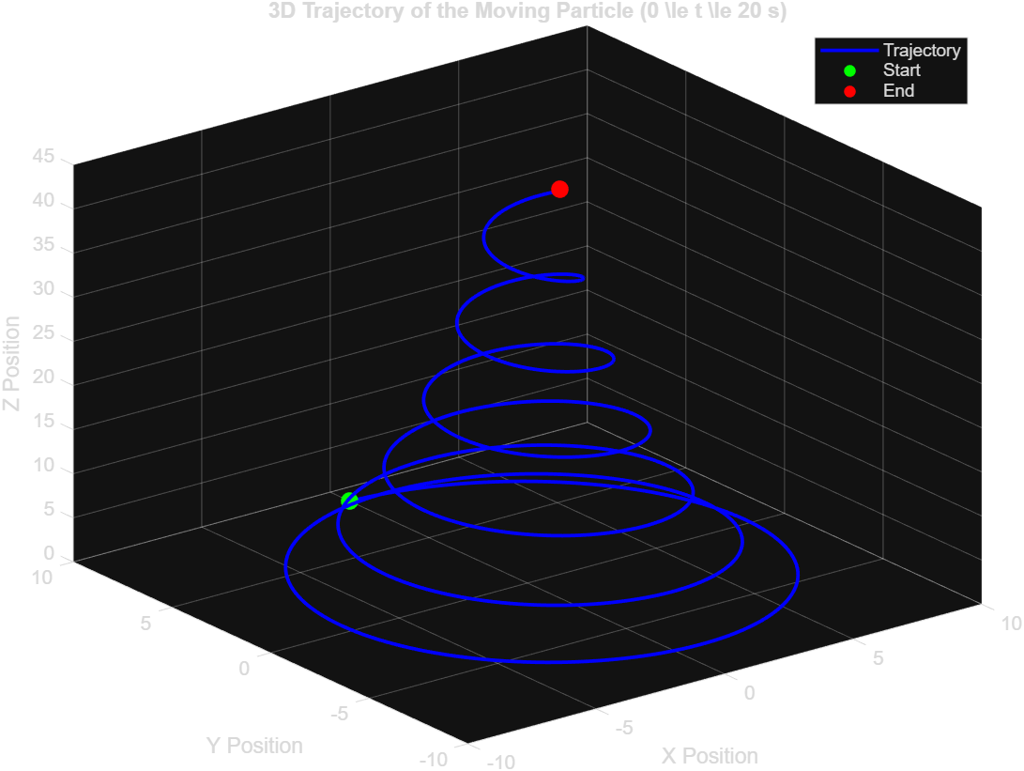

Code — A7Q6.m
clc; close all; clear all;

% Data setup: Rows = Years (2020-2023), Columns = Cities (Dhaka, Sylhet, Chattogram, Rajshahi, Khulna)
years = [2020; 2021; 2022; 2023];
rainfall_matrix = [
850, 920, 780, 690, 860;
900, 890, 820, 720, 880;
870, 940, 790, 700, 890;
910, 930, 810, 740, 870
];
city_names = {'Dhaka', 'Sylhet', 'Chattogram', 'Rajshahi', 'Khulna'};

%% a) Grouped Bar Chart
figure('Name', 'Grouped Bar Chart - Annual Rainfall', 'Position', [100, 100, 850, 500]);
bar(years, rainfall_matrix, 'grouped');
title('Annual Rainfall of Cities in Bangladesh (2020-2023)', 'FontSize', 14, 'FontWeight', 'bold');
xlabel('Year', 'FontSize', 12);
ylabel('Rainfall (mm)', 'FontSize', 12);
legend(city_names, 'Location', 'northeastoutside');
grid on;

%% b) 3D Pie Chart of Total Rainfall Contribution
% Calculate total rainfall across all 4 years for each city
total_rainfall = sum(rainfall_matrix, 1);

figure('Name', '3D Pie Chart - Rainfall Contribution', 'Position', [150, 150, 750, 650]);
pie3(total_rainfall);
title('City Contribution to Total Rainfall (2020-2023)', 'FontSize', 14, 'FontWeight', 'bold');
legend(city_names, 'Location', 'northeastoutside');
%==================================================================

Output

