**Database Advanced Assignment (15 Q)**

**1.**Write a SQL statement to create a simple table cities including columns city_id,city_name and region_id.

**2.** Write a SQL statement to create a simple table cities including columns city_id,city_name and region_id which is already exists.

**3.** Write a SQL statement to create the structure of a table dup_cities similar to cities.

**4.** Write a SQL statement to create a duplicate copy of cities table including structure and data by name dup_cities.

**5.**Write a SQL statement to create a table cities set a constraint NULL.

**6.** Write a SQL statement to create a table named jobs including columns job_id, job_title, min_salary, max_salary and check whether the max_salary amount exceeding the upper limit 35000.

**7.**Write a SQL statement to create a table named cities including columns city_id, city_name and region_id and make sure that no cities except Italy, Gaza and Rafah will be entered in the table.

**8.**Write a SQL statement to create a table named job_histry including columns employee_id, start_date, end_date, job_id and department_id and make sure that the value against column end_date will be entered at the time of insertion to the format like '--/--/----'.

**9.**Write a SQL statement to create a table named cities including columns city_id,city_name and region_id and make sure that no duplicate data against column city_id will be allowed at the time of insertion.

**10.**Write a SQL statement to create a table named jobs including columns job_id, job_title, min_salary and max_salary, and make sure that, the default value for job_title is blank and min_salary is 9000 and max_salary is NULL will be entered automatically at the time of insertion if no value assigned for the specified columns.

**11.**Write a SQL statement to create a table named cities including columns city_id, city_name and city_id and make sure that the city_id column will be a key field which will not contain any duplicate data at the time of insertion.

**12.**Write a SQL statement to create a table cities including columns city_id, city _name and region_id and make sure that the column city_id will be unique and store an auto incremented value.

**13.**Write a SQL statement to create a table cities including columns city_id, city _name and region_id and make sure that the combination of columns city_id and region_id will be unique.

**14.**Write a SQL statement to create a table job_history including columns employee_id, start_date, end_date, job_id and department_id and make sure that, the employee_id column does not contain any duplicate value at the time of insertion and the foreign key column job_id contain only those values which are exists in the jobs table.

Here is the structure of the table jobs;

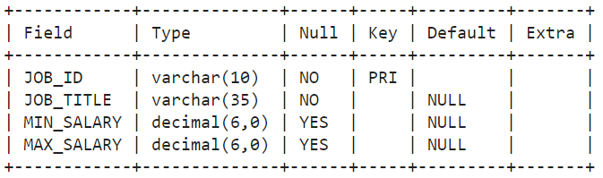

**15.**Write a SQL statement to create a table employees including columns employee_id, first_name, last_name, email, phone_number hire_date, job_id, salary, commission, manager_id and department_id and make sure that, the employee_id column does not contain any duplicate value at the time of insertion and the foreign key columns combined by department_id and manager_id columns contain only those unique combination values, which combinations are exists in the departments table.

Assume the structure of departments table below.

