# USE-CASE DIAGRAM

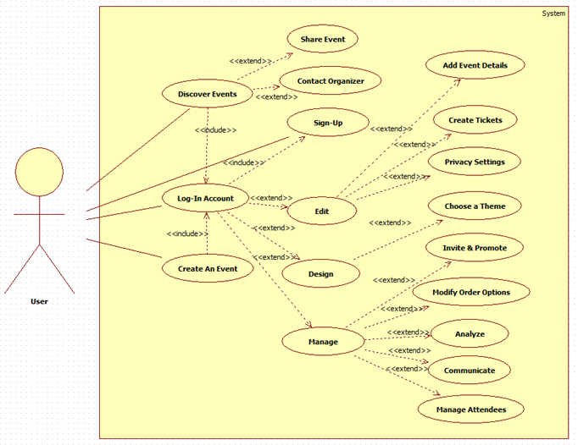

### Use Case Template for User Story Narrative (with filled example)

|  |  |
| --- | --- |
| **Use Case ID** | UC101: Buy Ticket |
| **User Story** | As a passenger, I want to buy a ticket via Online Ticketing System so that I can travel from one city to another city in Australia. |
| **Goal** | Buy a ticket online for traveling from one destination to another destination. |
| **Priority** | H, M , L |
| **Actors** | Primary Actor – Passenger  Secondary Actor – Credit Card System, Printing System |
| **Pre-conditions** | The passenger has access to the Online Ticketing System.  The passenger has a valid credit card. |
| **Post-conditions** | The passenger has successfully bought the ticket via the Online Ticketing System. |
| **Trigger** | The passenger launches the Online Ticketing (OT) system via their internet browser. |
| **Main Flow** | 1. The (OT) system displays the OT system landing page and displays the hyperlink to list the available tickets i.e. departure, destination, types, dates and fare. If the OT system is not available, then refer to **Alternate Flow 1 “System Down”**. 2. The passenger clicks on the hyperlink to list the available tickets. 3. The OT system displays the available tickets to select from. 4. The passenger selects the desired ticket and presses the “Buy Ticket” button. 5. The OT system displays the **“Pay Fare”** page for the selected ticket and requests for payment. 6. The passenger chooses to “**Pay via Credit Card”**. 7. The OT system asks the passenger to enter their credit card details. 8. The passenger submits the credit card details. 9. The OT system checks the credit card number format and processes the credit card details via the **“Credit Card” System”**.   Please see **“UC102: Pay via Credit Card Fare”** for credit card payment processing details.   1. The OT system successfully receives the payment via the **“Credit Card” System”** and displays the payment receipt.  If the OT system does not receive the payment, then refer to **Alternate Flow 2 “Failed Payment”**. 2. The passenger chooses to **“Print Receipt”.** Please see **“UC103: Print Receipt”** for receipt printing process details. 3. The OT system successfully prints the payment receipt via the **“Printing System”.** 4. The use case ends. |
| **Exceptions** | E1. Steps 1-12 – passenger closes the browser window anytime, and then the OT system blocks the transaction at that point in time and log the activity.  E.2. Steps 12 – printer does not respond. |
| **Includes** | UC102: Pay via Credit Card, UC103: Print Receipt |
| **Supporting Information** | Passenger, Purchased Ticket, Payment and Receipt information needs to be stored on a central server. |
| **Non-functional Requirements** | Performance: Page load time  Security: Secure credit card transaction |

|  |  |
| --- | --- |
| **Alternate Flow 2** | “Failed Payment” |
| **Trigger** | The OT system does not receive the payment. |
| **Step** | 1. The OT system takes the passenger to the fare and payment options page. 2. The OT system displays the payment error message “Insufficient Funds”. 3. Re-join at Step 5 in the Main Flow. . |
| **Alt Flow** | N/A |
| **Post conditions** | The OT system successfully displayed the payment error message. |
| **Exceptions** | E1.Steps1-2 – passenger closes the browser window anytime, and then the OT system blocks the transaction at that point in time and logs the activity. |