NH-LDM Developer Guide
Technical Reference & Onboarding Manual (Part 2)
For Internal Development

1. Getting Started
Welcome to the NH-LDM project. This guide is designed to help you understand the codebase, reproduce results, and extend the functionality of the Neuro-Hybrid Latent Diffusion Model.
Note: For a high-level overview of the project background and results, please refer to the 'NH-LDM Project Report' (Part 1).

1.1 Environment Setup
The project relies on Python 3.8+ and PyTorch. Dependencies are listed in `requirements.txt`.
# Clone the repository
git clone https://github.com/your-org/nh-ldm.git
# Install dependencies
pip install -r requirements.txt

1.2 Configuration
All hyperparameters and paths are managed in `config.yaml`. Do not hardcode paths in scripts.
data:
nsd_path: "./data/nsd" # Update this to point to your local NSD copy
diffusion:
device: "cuda" # Change to 'cpu' for debugging on laptop

2. Codebase Orientation
The project is structured as follows:
project/
├── data/ # Data loading (NSD dataset wrappers)
│ ├── preprocessing.py
│ └── roi_masks.py
├── models/ # Neural network architectures
│ ├── semantic_stream.py # Ridge Regression for CLIP
│ ├── structural_stream.py # Ridge Regression for VAE
│ └── diffusion_pipeline.py
├── train.py # Main training loop
└── inference.py # Reconstruction script

3. Architecture Implementation
The dual-stream architecture is implemented via two distinct decoder classes. See `project/models/semantic_stream.py` and `project/models/structural_stream.py`.
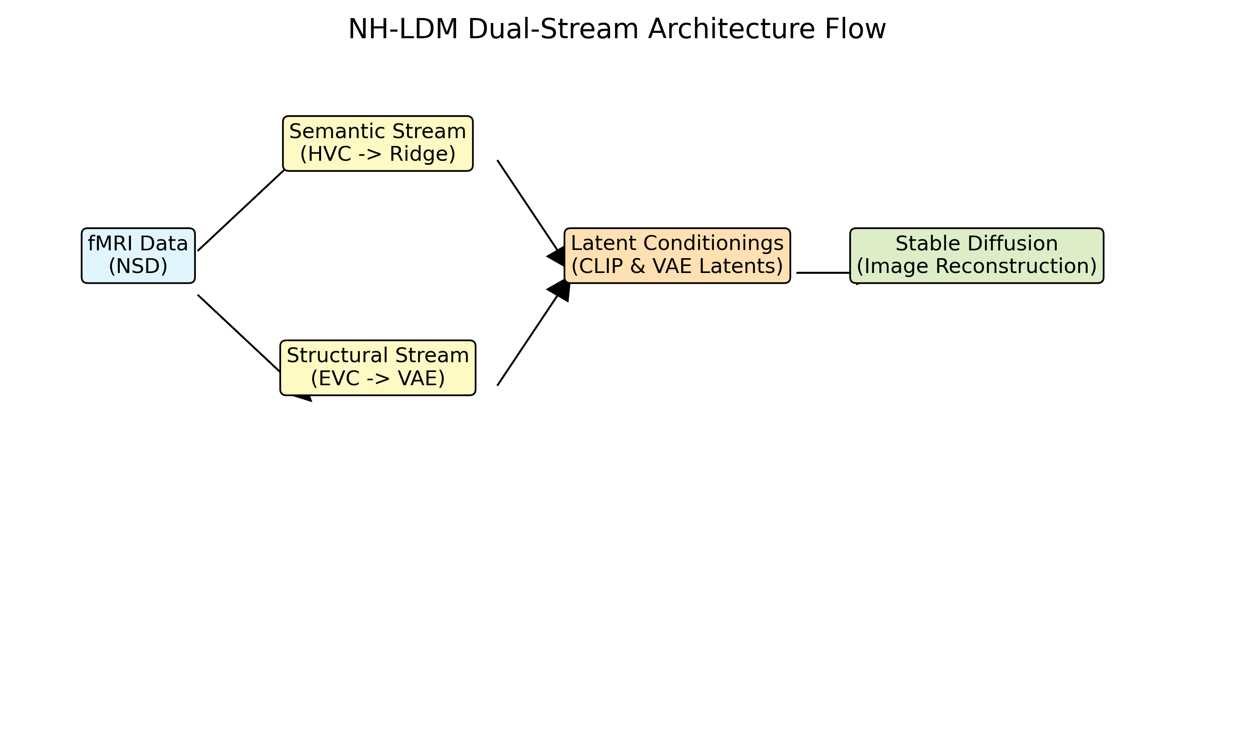
Figure 1: Architecture Reference

3.1 Semantic Stream (HVC -> CLIP)
The `SemanticDecoder` class maps voxels from the Higher Visual Cortex to CLIP text embeddings. It uses a multi-output Ridge Regression. We select the top N voxels (default 1000) based on correlation during training.
class SemanticDecoder:
def train(self, X, Y):
# voxel selection logic...
self.voxel_indices = select_top_voxels(X, Y, keep=self.n_voxels)
# fit ridge...

3.2 Structural Stream (EVC -> VAE)
The `StructuralDecoder` maps Early Visual Cortex voxels to the 64x64x4 latent space of the Stable Diffusion VAE. Since the dimensionality is high (16384 outputs), we use a more aggressive regularization or dimensionality reduction if needed.

4. Data Pipeline
Data loading is handled by `project.data.preprocessing.DataProcessor`. This class abstracts away the complexity of HDF5 files from the NSD dataset.
- Key responsibilities:
- Loading fMRI betas
- Applying ROI masks (using `roi_masks.py`)
- Z-score normalization (statistics computed on training set)
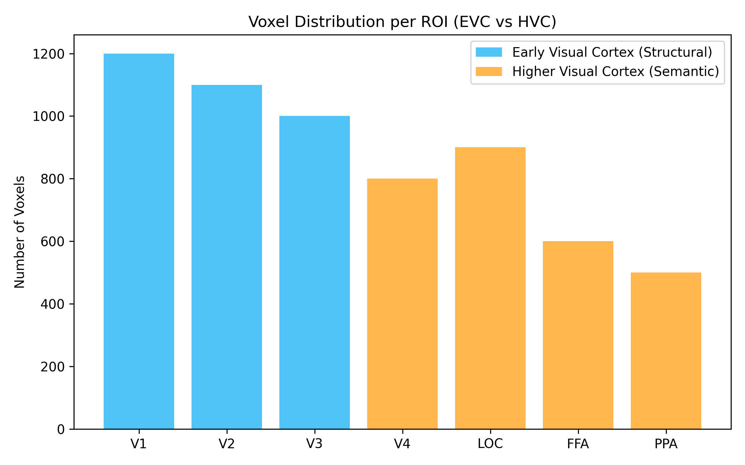
Reference: Voxel Counts per ROI

5. Workflow guide

5.1 Training (`train.py`)
The training script `train.py` orchestrates the fitting of both decoders. It saves the trained models as `.pkl` files in the `project/models/` directory.
To start training:
python -m project.train --config config.yaml

5.2 Inference (`inference.py`)
Inference loads the pickled models and the Stable Diffusion pipeline. It iterates through the test set, predicts latents/embeddings, and runs the diffusion loop.
To run inference:
python -m project.inference --output_dir results/

6. Troubleshooting
Issue | Solution
CUDA Out of Memory | Reduce `batch_size` in config.yaml or set `device: cpu`.
FileNotFoundError: nsd_stim_info.pkl | Ensure you have downloaded the NSD metadata and placed it in the data root.

7. Extending the Project
To add a new subject, update the `subjects` list in `config.yaml`. Note that you will need to re-run training as voxel mappings are subject-specific.

