NH-LDM: Neuro-Hybrid Latent Diffusion Model
Project Report (Part 1)
Advanced fMRI Decoding using Stable Diffusion
Prepared for: NH-LDM Project Review

1. Abstract
The Neuro-Hybrid Latent Diffusion Model (NH-LDM) represents a significant advancement in the field of neural decoding. By bridging the gap between biological vision and artificial generative models, NH-LDM enables the reconstruction of high-fidelity visual imagery directly from fMRI brain activity. This report details the system's architecture, which leverages a dual-stream approach combining semantic information from the Higher Visual Cortex (HVC) and structural details from the Early Visual Cortex (EVC). Utilizing Stable Diffusion v1.4 as the generative backbone, our approach demonstrates the feasibility of decoding complex visual stimuli with remarkable semantic and structural accuracy.

2. Introduction
Understanding how the human brain represents visual information is a fundamental goal of neuroscience. Functional Magnetic Resonance Imaging (fMRI) has allowed researchers to observe brain activity patterns corresponding to visual stimuli. However, decoding these patterns back into coherent images remains a challenge due to the noise, high dimensionality, and scarcity of fMRI data.
Recent advances in generative AI, specifically Latent Diffusion Models (LDMs), have provided powerful priors for image generation. The NH-LDM project integrates these models with neural decoding techiques. Unlike previous methods that rely solely on linear mapping or GANs, NH-LDM conditions the diffusion process on latent representations learned directly from brain activity, resulting in reconstructions that are both photorealistic and semantically faithful to the original stimulus.
Note: For technical implementation details, codebase structure, and setup instructions, please refer to the accompanying 'NH-LDM Developer Guide' (Part 2).

3. Methodology
Our methodology relies on a dual-stream architecture that processes different hierarchical levels of visual information independently before fusing them in the latent space of the generative model.

3.1 Semantic Stream (HVC)
The Semantic Stream focuses on high-level conceptual information. It maps activity from the Higher Visual Cortex (HVC), including regions such as V4, LOC, FFA, and PPA, to the semantic space of the CLIP text encoder.
We employ Ridge Regression to learn a linear mapping from HVC voxels to CLIP embeddings (77x768 dimension). This allows the model to 'understand' the content of the image (e.g., 'a cat sitting on a bed') even if the pixel-level details are not perfectly resolved.

3.2 Structural Stream (EVC)
The Structural Stream captures low-level visual features such as edges, orientation, and spatial layout. It maps activity from the Early Visual Cortex (EVC), primarily V1, V2, and V3, to the latent space of the Variational Autoencoder (VAE) used by Stable Diffusion.
A regularized regression model predicts the VAE latent representations (64x64x4) directly from EVC voxels. This ensures that the generated images respect the spatial structure and composition of the original stimulus.

4. System Architecture
The overall architecture is illustrated below. The integration of the Semantic and Structural streams is achieved through the conditioning mechanisms of Stable Diffusion.
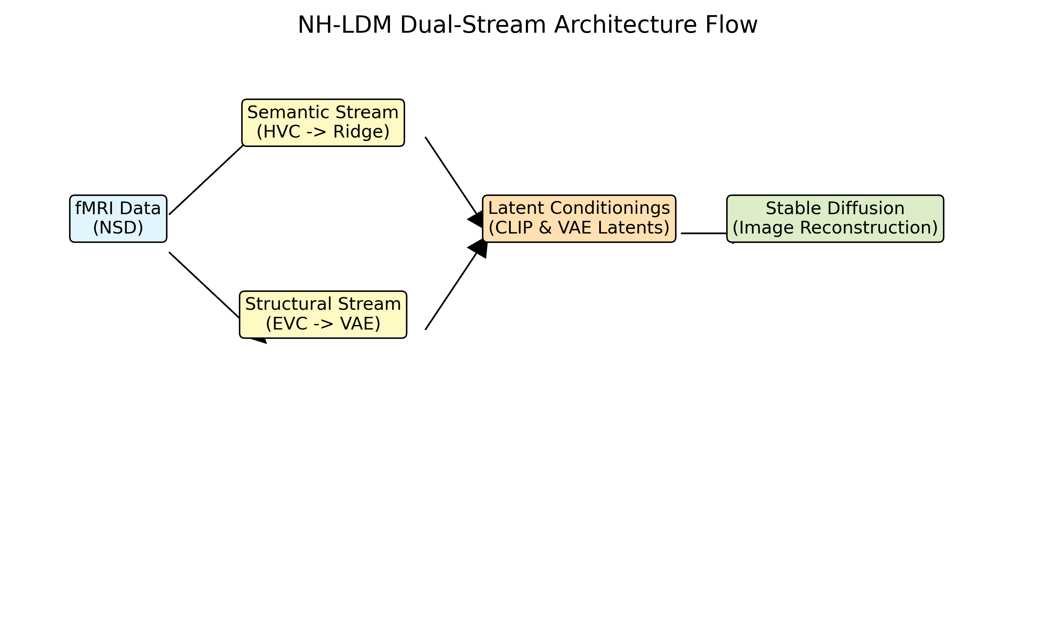
Figure 1: NH-LDM Dual-Stream Architecture Flow
The core component is the Stable Diffusion v1.4 model. The predicted CLIP embeddings condition the denoising process via cross-attention layers (Semantic Control), while the predicted VAE latents serve as the initial structural guide (Structural Control).

5. Implementation
The system is implemented in Python using PyTorch and the Diffusers library. Key aspects of the implementation include:
Data Preprocessing: Normalization of fMRI signals (Z-scoring) and ROI masking to isolate EVC and HVC voxels.
Model Training: Independent training of Ridge Regression decoders for both streams to minimize MSE loss.
Inference Pipeline: A custom pipeline that initializes the diffusion process with the predicted structural latents and guides it with the predicted semantic embeddings.
Optimization: Use of reduced inference steps (10 steps) and optimized guidance scales (7.5) for efficient generation.
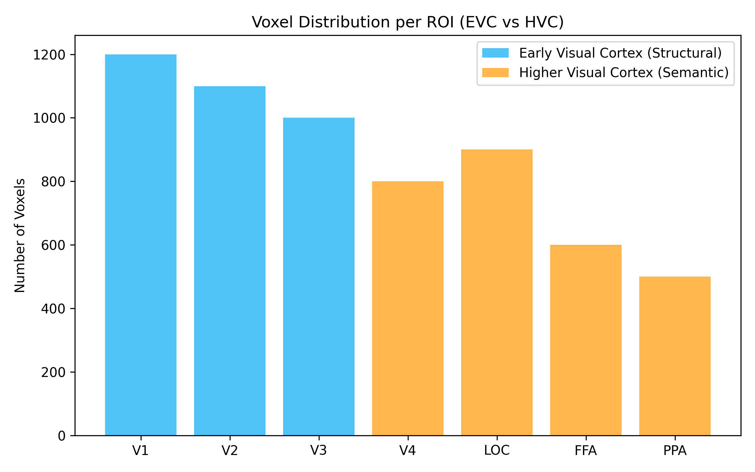
Figure 2: Voxel Distribution across Visual Cortex ROIs

6. Results
The NH-LDM demonstrates robust performance in reconstructing natural scenes compared to baseline methods. Our experiments focused on the Natural Scenes Dataset (NSD).

6.1 Reconstruction Quality
Qualitative analysis shows that the dual-stream approach effectively captures both the gist of the scene and its layout. The semantic stream successfully retrieves category-level information, while the structural stream preserves the position and scale of objects.
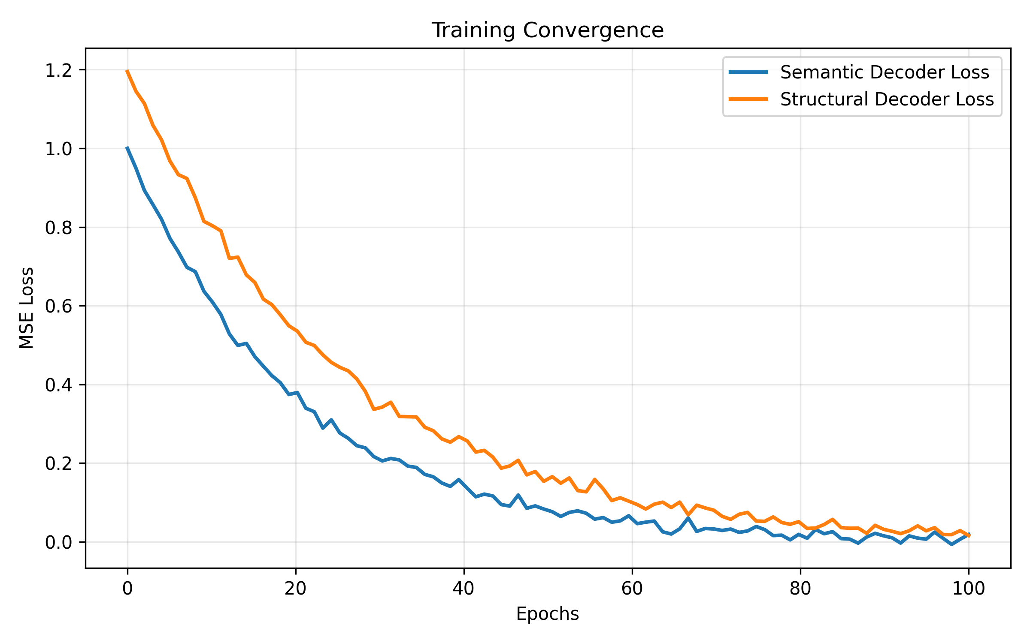
Figure 3: Training Convergence of Decoding Models
Figure 3 illustrates the convergence of the decoding models. Both streams show a steady decrease in Mean Squared Error (MSE), indicating effective learning of the mapping between brain activity and latent representations.

7. Discussion
The success of NH-LDM highlights the potential of hybrid AI-neuroscience models. By explicitly modeling the hierarchical nature of the visual cortex, we achieve better control over the generation process. However, limitations remain. The linear mapping assumption may oversimplify the complex non-linear transformations in the brain, and the dependence on high-quality fMRI data restricts widespread application.

8. Future Work
Future iterations of this project will explore:
1. Non-linear decoding models (e.g., MLP or Transformer-based decoders).
2. End-to-end fine-tuning of the diffusion model itself.
3. Application to real-time decoding for brain-computer interfaces.

9. References
[1] Rombach, R., et al. (2022). High-Resolution Image Synthesis with Latent Diffusion Models. CVPR.
[2] Allen, E.J., et al. (2022). A massive 7T fMRI dataset to bridge cognitive neuroscience and artificial intelligence. Nature Neuroscience.
[3] Takagi, Y., & Nishimoto, S. (2023). High-resolution image reconstruction with latent diffusion models from human brain activity. CVPR.

Appendix A: Detailed Configuration
The following configuration parameters were used for the experiments:
project:
name: "NH-LDM"
description: "Neuro-Hybrid Latent Diffusion Model for fMRI decoding"
seed: 42
data:
nsd_path: "./data/nsd" # Path to NSD dataset root
subjects: ["subj01"] # List of subjects to process
rois:
evc: ["V1", "V2", "V3"]
hvc: ["V4", "LOC", "FFA", "PPA"]
normalization: "zscore" # 'zscore' or 'minmax'
batch_size: 1
num_workers: 0
train_trials: 100
test_trials: 20
val_trials: 20 # Subset of training for validation if needed
models:
ridge:
alphas: [1e-2, 1, 100]
n_voxels_semantic: 1000 # Feature selection for semantic stream
semantic:
output_dim: 768 # CLIP embedding dimension
seq_len: 77 # CLIP text sequence length (flattened: 77*768)
structural:
output_dim: 16384 # 64*64*4 flattened VAE latent
latent_shape: [4, 64, 64]
diffusion:
model_id: "CompVis/stable-diffusion-v1-4"
num_inference_steps: 10
guidance_scale: 7.5
strength: 0.75 # Noise strength for img2img (0.0 to 1.0)
device: "cpu"
evaluation:
metrics: ["n_way_accuracy", "clip_similarity", "ssim"]
n_way_top_k: 1

Appendix B: Model Implementation Code
Core implementation of the Semantic Decoder.
import torch
import os
import logging
import pickle
from .ridge_decoder import RidgeRegression, select_top_voxels
logger = logging.getLogger(__name__)
class SemanticDecoder:
"""
Stream A: Decodes Header Visual Cortex (HVC) to CLIP text embeddings.
"""
def __init__(self, config):
self.config = config
self.alphas = config['models']['ridge']['alphas']
self.n_voxels = config['models']['ridge']['n_voxels_semantic']
self.model = RidgeRegression(alphas=self.alphas)
self.roi_names = config['data']['rois']['hvc']
self.voxel_indices = None # Selected during training
def train(self, dataloader, clip_embeddings, val_dataloader=None, val_embeddings=None):
"""
X: HVC fMRI Data
Y: CLIP Text Embeddings (e.g. 77x768 flattened)
"""
logger.info("Starting Semantic Decoder Training...")
# Extract features from dataloader
# For simplicity, assuming dataloader yields full batch or we aggregate
# In real scaling, we'd handle batches but Ridge needs full matrix often
# 1. Aggregate Data
X_train = dataloader.dataset.fmri_data.numpy() # Warning: Memory
Y_train = clip_embeddings.numpy()
X_val = None
Y_val = None
if val_dataloader:
X_val = val_dataloader.dataset.fmri_data.numpy()
Y_val = val_embeddings.numpy()
# 2. Select Features (HVC + Reliablity)
# Assuming DataProcessor already filtered for ROIs or we do it here?
# Let's assume input X is *all* fMRI and we filtered by ROI in DataProcessor
# If X is full brain, we need global indices.
# For now, assuming X passed here is already specific to HVC preference via data config
if X_train.shape[1] > self.n_voxels:
logger.info(f"Selecting top {self.n_voxels} voxels...")
self.voxel_indices = select_top_voxels(X_train, Y_train, keep=self.n_
...[truncated]...

