Dillinger.io - Online Markdown Editor

**User Guide**

Welcome to Dillinger.io! This user guide will help you navigate and utilize the key features of our online markdown editor. Whether you're a beginner or an experienced Markdown user, this guide will assist you in maximizing your productivity and creating stunning documents. Let's get started!

**Getting started**

To use Dillinger.io, simply open your favorite web browser and navigate to <https://dillinger.io/>

You will see a web page containing the following:

**Main editing area**

**Preview area**

**Top navigation bar**

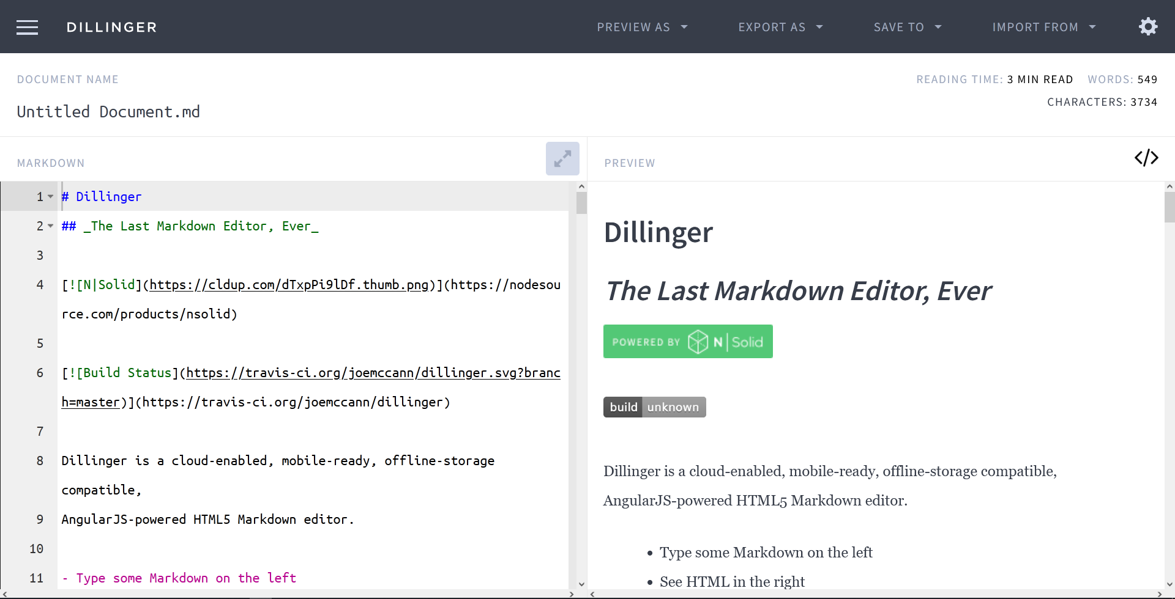

**Key features**

**Writing and formatting**

To start writing you only need to type while having your text cursor on the main editing area.

The Markdown syntax is used to render the document in the preview area on the right.

To learn more about Markdown, you can visit this guide {<https://www.markdownguide.org/getting-started/>}

**Saving**

There are two ways you can save your markdown document:

Locally

With a cloud service provider

Start by opening the left toolbar on the navigation bar: 

You will see this sidebar appear: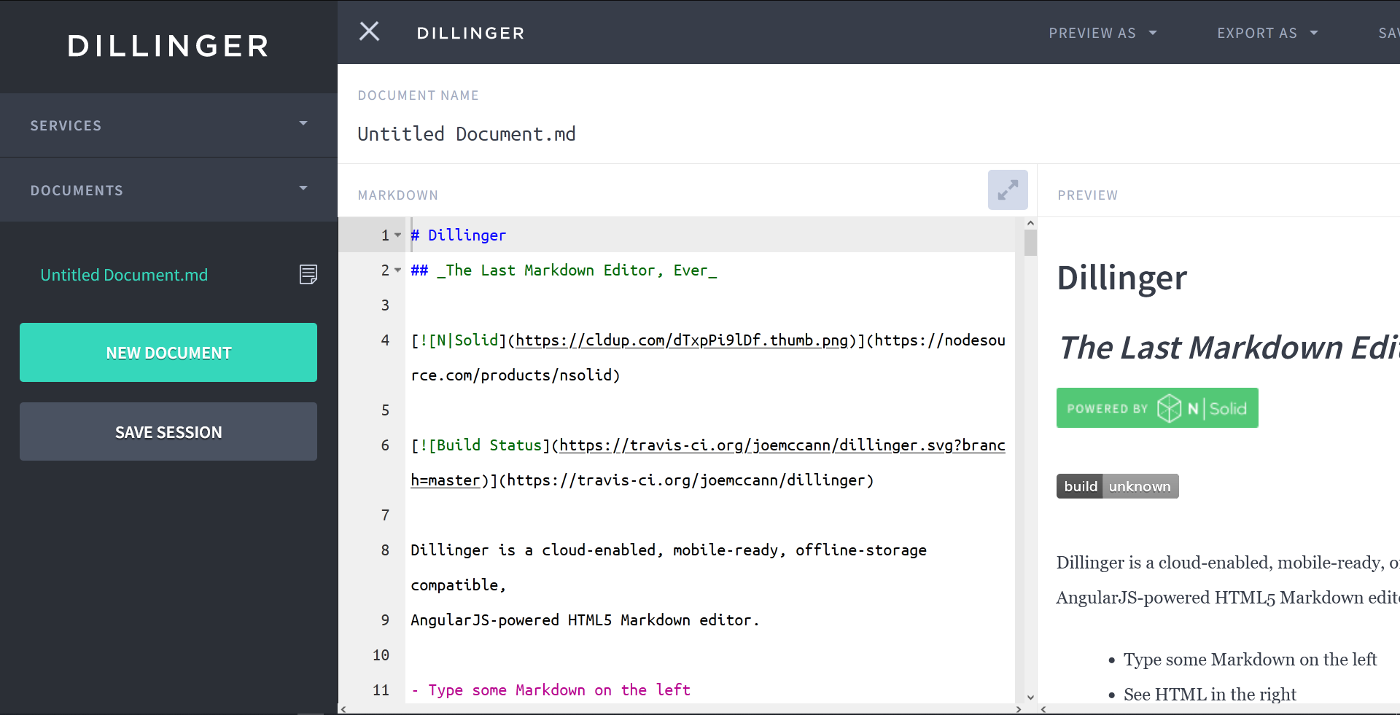

*Saving Locally*

To save your session on your browser click on “SAVE SESSION”.

You should be able to access your document later as long as you don’t clear your browser cache or the websites local storage.

*Saving with a cloud service provider*

Go to the “SERVICES” tab of the left sidebar. You will see different cloud providers appear:

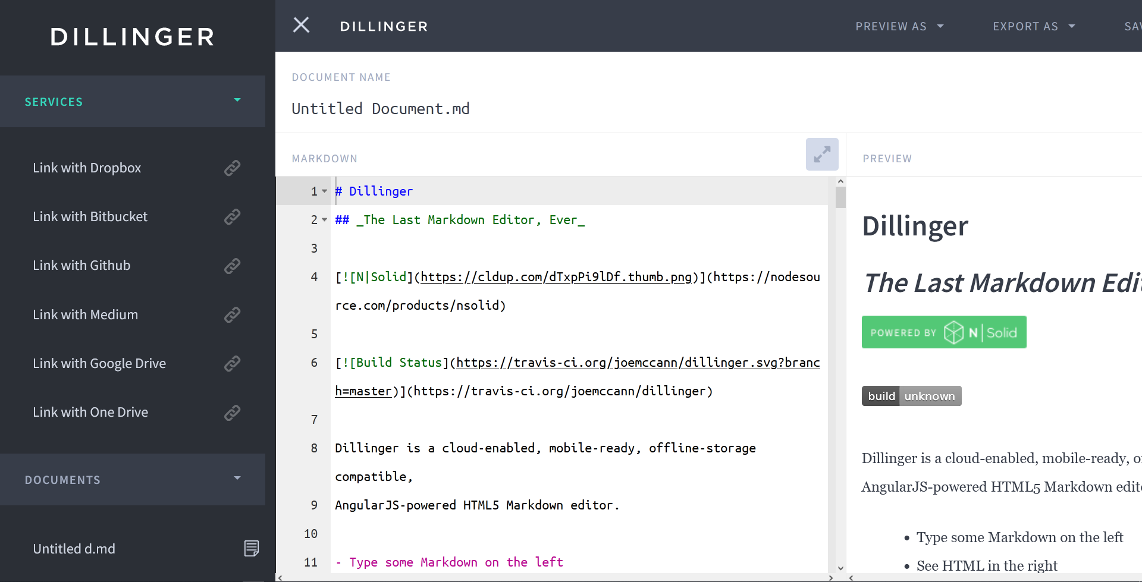

Select whichever service you wish to save your document on.

The service provider will then ask you to log into you account.

If you linked using Google Drive, you should see this:

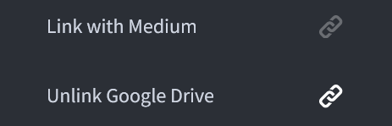

Once linked, you can go back to top navigation bar and click on the “SAVE TO” tab.

Your linked service provider should be highlighted like this:

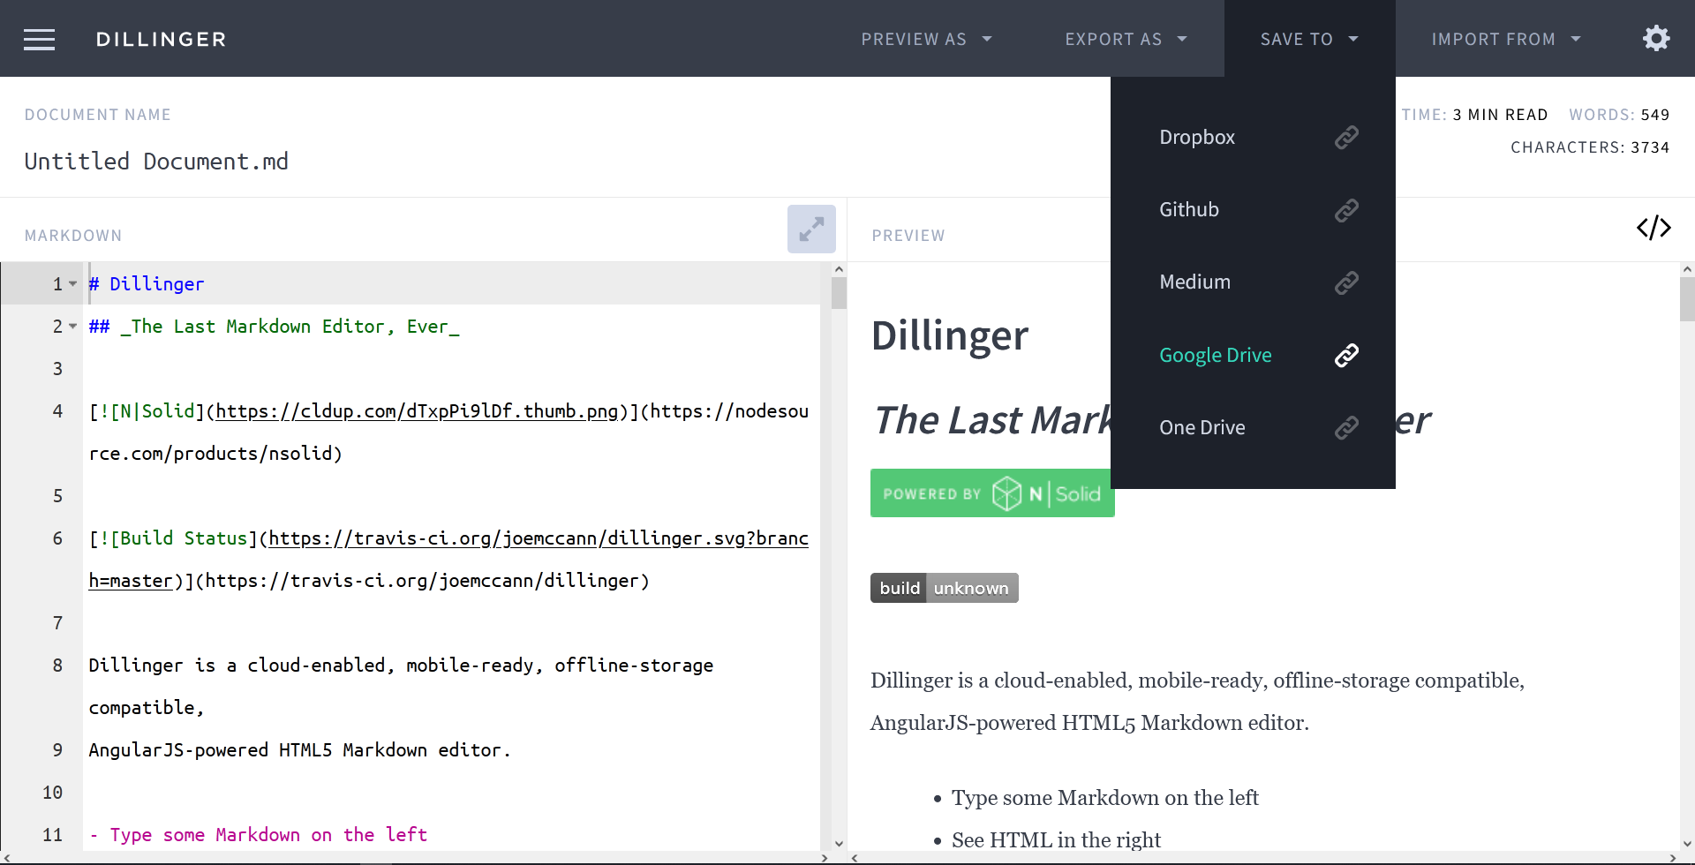

You can now save your document on the cloud by clicking on your linked cloud service provider.

**Importing files**

There are two ways you can import files: locally and from a cloud service provider.

*Import Locally*

You can drag and drop your own files on the main editing area.

If you import an HTML file, it will automatically be converted to Markdown.

*Import from a cloud service provider*

To import from a cloud provider, you first need to link your account (#).

You can go to the “IMPORT FROM” tab on the top navigation bar:

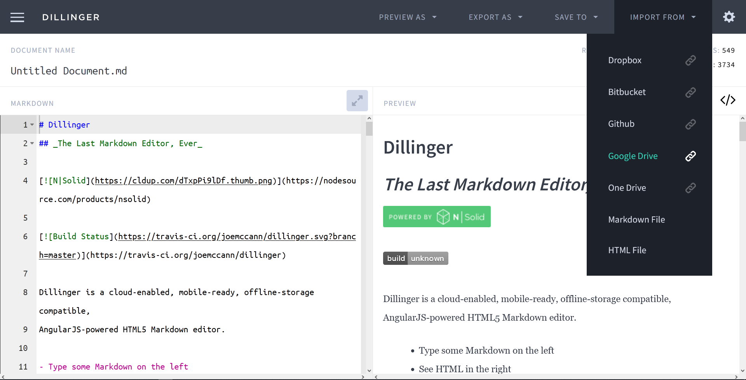

By clicking on the linked cloud service provider, you will be able to access and import any of your saved Markdown or HTML files on the cloud.

**Previewing and Exporting**

There are four preview option to view your markdown document. Start by going to the “PREVIEW AS” tab:

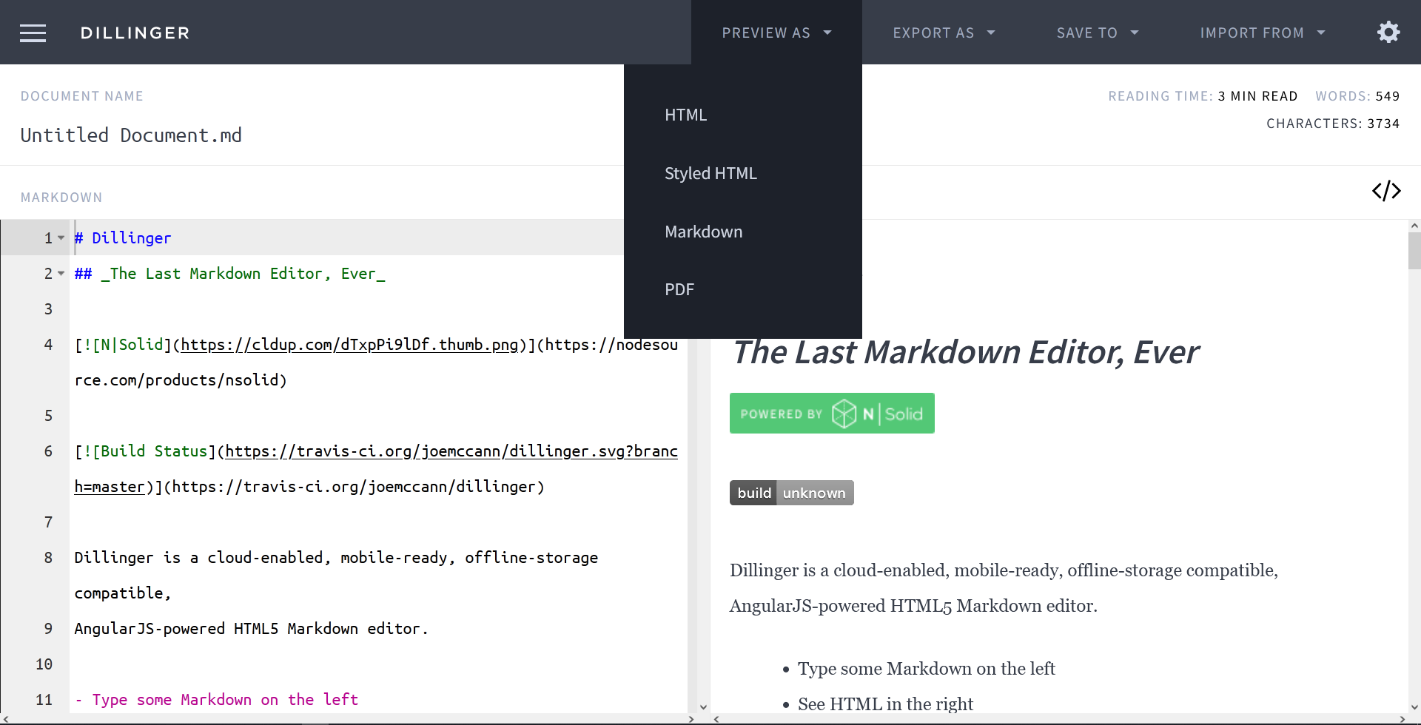

Select whichever type of preview you want, and a new tab on your browser will appear with your preview.

When you are satisfied with your work you can export your document by first clicking on the “EXPORT AS” tab.

You can then select the format of your document.

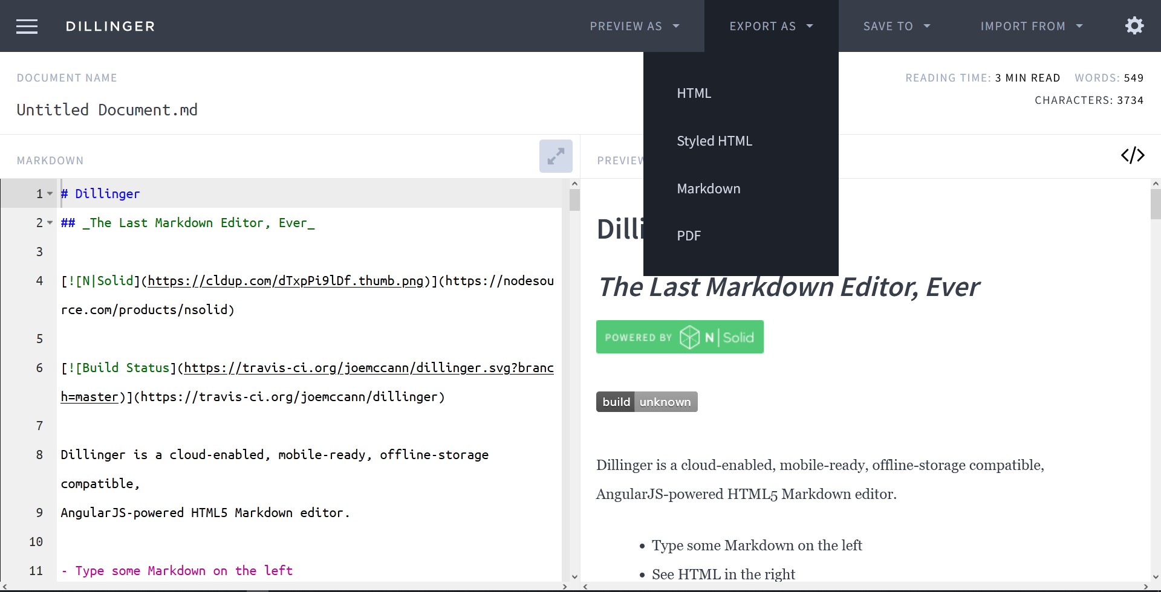

We hope this user guide has provided you with a clear understanding of Dillinger.io's key features and how to use them effectively. Remember to explore the various formatting options, preview your work, and take advantage of our features to streamline your Markdown editing experience. Happy writing!