**Systems Modeling to Improve River, Riparian, and Wetland Habitat Quality and Area**

**Authors**

Ayman H. Alafifi1 and David E. Rosenberg2

1*Corresponding Author:* PhD Candidate Department of Civil and Environmental Engineering and Utah Water Research Laboratory, Utah State University, Logan, UT, USA [aafifi@aggiemail.usu.edu](mailto:aafifi@aggiemail.usu.edu). Phone: +1(435)881-0541, Fax: +1(435)797-1185

2Associate Professor, Department of Civil and Environmental Engineering and Utah Water

Research Laboratory, Utah State University, Logan, UT, USA [david.rosenberg@usu.edu](mailto:david.rosenberg@usu.edu)

March 2017

**Systems Modeling to Improve River, Riparian, and Wetland Habitat Quality and Area**

**Abstract**

Regulated rivers, while often managed for human uses, offer opportunities to restore and improve invaluable habitat. Managers need to define water requirements for priority species and then manage spatially and temporally connected infrastructure to allocate water between competing environmental users to improve habitat without harming human uses. We present a new systems optimization model that considers multiple aquatic, floodplain, and wetlands habitat species and allocates water and financial resources to improve ecological benefits at the watershed. We applied our model to the Lower Bear River watershed, UT to improve degraded habitat and communicate tradeoffs between human and ecosystem uses of water. Results show that the River is largely developed and appropriated for human water uses. However, increasing reservoirs winter releases and minimizing spring spill volumes can create additional suitable habitat area without harming human users. WASH results are displayed on an open-access web map that allows stakeholders to visualize opportunities to manage water and improve habitat quality and area.

*Keywords*: Systems models; River habitat quality; Reservoir operations; Ecological restoration; Watershed management; Web mapping application

**Highlights**

* A systems model to allocate water to improve competing river, floodplains, and wetlands habitats
* A model to prioritize restoration sites without harming human uses
* Controlling reservoir spring spills and winter releases can improve habitat quality
* Selecting indicator species and defining their water requirements is key to managing water
* An accessible web map facilitates communicating model development and application with stakeholders

**Software and Data Availability**

We developed our model using the General Algebraic Modeling System software (GAMS) and solved it using the non-linear global solver Branch-And-Reduce Optimization Navigator (BARON) The GAMS code reads the input data and the parameters from an MS Excel spreadsheet and passes them to the model in a GDX (GAMS Data Exchange format) file. We ran the model on a Dell XPS Windows10 64-bit environment. We used MS Excel 2016, R 3.3.0, and ArcGIS Online to post-process and display model results. The model input data, code, and post-processing files are available at: <https://github.com/ayman510/WASH>. Model results are displayed on open-access web map: [www.WASHmap.usu.edu](http://www.WASHmap.usu.edu)

**Systems Modeling to Improve River, Riparian, and Wetland Habitat Quality and Area**

1. **Introduction**

Rivers and their riparian and wetland areas provide numerous services for humans, including domestic and agricultural water supply, in addition to ecological services for their living organisms. While policy makers acknowledge the need to allocate water to maintain a healthy and functioning riverine ecosystem, human beneficial water uses typically receive the highest priority (Bunn and Arthington, 2002; Petts, 2009). Regulated rivers, while often managed for human uses, also offer opportunities to restore and protect invaluable aquatic, floodplains, and wetlands habitat (Jager and Smith, 2008; Tharme, 2003). Managing water to improve river habitat quality for priority species requires managers to; first define hydrologic requirements for different life stages of each priority species and mathematically quantify the species response to alterations in flow regimes. Next, managers need to map species’ competing need of water and make decisions on the volumes and times of spatially connected diversions, reservoirs, and impounded wetlands gates to improve ecological habitat in the watershed without compromising human water use.

The growing need to protect and restore threatened riverine species pushed forward the development of several methods to define species hydrologic requirements (Stewardson and Webb, 2010). Poff et al. (1997) developed the natural flow paradigm to mimic important features of natural flow regime such as timing, duration, magnitude, and frequency. This method assumes that historical natural flows are both known and adequate for existing ecosystem functions (Baron et al., 2002). Other methods used flow-ecology relationships in the form of habitat quality index to measure tradeoffs between flow alternations and habitat conditions. Habitat quality indexes describe the suitability of habitat to the survival and productivity of a single species. The values of these indexes are based on a single or multiple habitat attributes such as instream water depth, water temperature, substrate, etc. (Hemker et al., 2008; Hooper, 2010; Pinto et al., 2009). The Habitat Suitability Index (HSI; U.S. Fish and Wildlife Service 1981) is a common example of ecological habitat quality indexes that are used to determine species minimum flows requirements. HSIs have been largely used to develop methods to estimate the effects of water flow reduction on fish population (e.g. IFIM; Stalnaker, 1995), produce relationships between hydrologic physical habitat and ecological functions (e.g. HEC-EFM; Hickey and Fields, 2013), and define environmental flows for priority species (e.g. ELOHA; Poff et al., 2010). HSIs are useful tools to report on instantaneous species- and site-specific habitat suitability (Giller, 2005; Palmer et al., 2005; Woolsey et al., 2007). However, suitability indexes need to account for competing species demands at multiple habitats in the watershed in order to help managers to holistically allocate water to improve habitat quality (Barry and Elith, 2006; Mowrer, 2000).

Systems models mathematically find the best (maximum or minimum) value of one or multiple objectives, such as hydropower yield, by adjusting several management decision variables like reservoir releases, given system natural, physical, and management constraints, such as reservoir storage capacity (Barbour et al., 2016). Systems models have been used to manage reservoirs in regulated river systems to maximize human delivery target of water, hydropower generation, or distribution system reliability while trying to meet hydrologic needs of a single-species as constraints on flow (see, for example, Cioffi and Gallerano, 2012; Harman and Stewardson, 2005; Null et al., 2014; Porse et al., 2015; Ryu et al., 2003). Other models included environmental flow targets as penalties in the objective function that minimizes deviations between modeled and simulated reservoir release and storage values (Steinschneider et al., 2014). Conversely, fewer models tried to maximize ecological functions to improve habitat for priority species (e.g. O’Hanley, 2011) or use a multi-objective approach to find the tradeoffs between human and environmental needs (e.g. Kuby et al., 2005; Simonović and Nirupama, 2005; Yang, 2011). Also, few studies developed ecological models to address multiple habitat environments. For example, Higgins et al. (2011) developed a nonlinear integer optimization model to mimic natural flow regimes for rivers, floodplains, and wetlands habitat to improve ecosystem health. In addition, Szemis et al. (2012) developed an antcolony optimization model (ACO) to maximize ecological benefits by scheduling reservoir releases to improve river, floodplain, and wetlands habitats. ACO, however, requires embedding ecological benefits into an objective function to minimize with a penalty to constraint decision variables. The selection of a suitable objective function formulation here is both data- and case-specific and, hence, limits the ability to use the same formulation for other cases. ACO is also limited to finding near-optimum solutions using the survival of the fittest search mechanism (Blum and Roli, 2003) and uses a probabilistic search for feasible alternatives to find optimal solutions (Shiau and Wu, 2013). Thus, the sequence of search, conditional dependency between decision variables and the assumptions of the starting search points are all factors that influence the optimal solution value on every iteration.

Many eco-hydrologic models are designed for specific cases in response to degraded conditions of endangered species. They largely overlook competing ecological objectives between different species and, therefore, do not highlight promising water-management alternatives to holistically improve habitat conditions. This paper presents the Watershed Area of Suitable Habitat (WASH) systems optimization model that allocates scarce water and financial resources to maximize the area of suitable habitat between competing multiple species that use river habitat, river floodplains, or connected wetlands during their different life stages while meeting human demands. WASH simultaneously (i) considers temporal and spatial connectivity of water management infrastructures, (ii) meets human beneficial uses, (iii) identify sites in the watershed where managers can most improve ecosystem functions with limited water, (iv) is adaptable to other sites and species, and (v) engages stakeholders in defining ecological objectives and validating results. WASH results are displayed on an open-access web mapping application that allows stakeholders to interact with the model data and visualize opportunities to manage water to improve habitat quality and area.

1. **Methods**

Improving river habitat quality requires a collective effort between different stakeholders to define habitat species needs, water supply, river reaches geomorphology, and management priorities to meet human demands within system constraints. Here, we demonstrate a participatory approach to develop a systems model that addresses multiple habitat management goals and highlights promising alternatives and restoration priorities in a watershed. WASH development and application includes stakeholders in (i) identifying watershed management goals, (ii) selecting priority species and reaches in the watershed with ecological importance, (iii) developing habitat suitability curves that are used to define ecological response of species to alterations in flow, (iv) selecting model scenarios to reflect priorities and undress uncertainties, and (v) validating model recommendations to adjust flow control operations to improve habitat quality.

To improve river habitat quality, managers, first, identify watershed component targets that are in need of restoration. Here, we include the common areas of habitat management within a watershed: aquatic, floodplain, and impounded wetland habitats (Figure 1). Next, we select indicator species for each habitat component. Indicator species are organisms that (a) their presence can be monitored and their abundance can be measured, (b) have an ecological and managerial significance, and (c) their habitat requirements are directly impacted by flow regime conditions. Then, we design habitat suitability indexes as functions of flow components, such as water depth and flood recurrence. These functions are site- and species-dependent and are based on the tolerance of species to changes in hydrologic and ecologic conditions. We measure hydrologic changes by controlling reservoir releases and storage volumes in addition to diversion volumes. We also control vegetation cover of indicator trees by revegetating the floodplains. These decision variables dictate the values of a group of state variables such as water depth, channel cross sectional area, reservoir surface area, storage and flood recurrence (Figure 1). We measure habitat performance by multiplying each suitability index [unitless] by an affected area. Habitat indicators are aggregated together using spatial and temporal weights to determine the overall WASH performance indicator value in unit area for the entire watershed. Expressing WASH in unit area (e.g. m2) helps communicate results to stakeholders and describe the implications of management actions over time. WASH model works with river systems as a group of nodes for demand sites and reservoirs and links for river reaches, diversions, and return flows (see example, Appendix A: Figure A.1)

**Figure 1.** A flow diagram of WASH systems model components including decision and state variables, parameters, suitability indexes, objective function, and model constraints

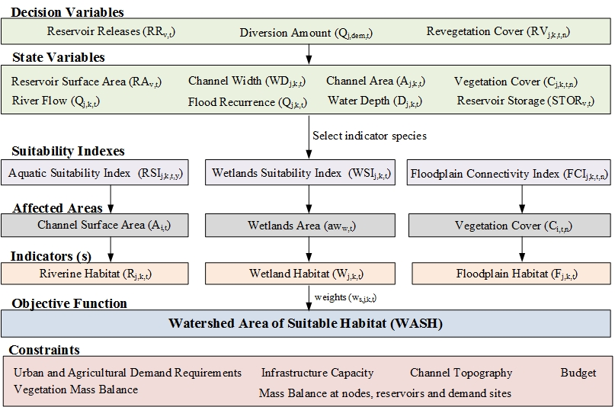

* 1. **Optimization Framework**

WASH model formulation uses capitalized terms to represent variables and lower case terms to indicate parameters and model inputs. The formulation uses the following indexes to describe and define variables and parameters: *j*=nodes, *k*=alias of *j*, *dem*= demand sites, *v*= reservoirs, *y* = fish species, *n*= vegetation species, *h*= bird species, *t*= timesteps (month), *s*: habitat indicators where *s1* =Riverine, *s2* =Floodplain, *s3* =Impounded Wetlands. We selected a monthly time step for WASH because the watershed managers plan and schedule flow management actions at monthly intervals. In addition, monthly flows are easier to predict and characterize than daily flows (Poff, 1996) and therefore ecological response of species can be better predicted and modeled.

***Decision Variables:*** To improve habitat quality, managers can control the: volume of reservoir release *RRv*,t, reservoir storage *STORv*,t [ both Mm3/month: million cubic meters per month], and reservoir surface area *RAv*,t [Mm2/month] at reservoir *v* in month *t*. Managers can actively re-vegetate *RVj*,k,t,n [Mm2/month] the floodplain site adjacent to river link from node *j* to node *k* during month *t* by planting vegetation species *n*. Adjusting these variables control a group of state variables that include river flow *Qj*,k,t [Mm3/month] from node *j* to node *k* in month *t*, river water depth *Dj*,k,t [m/month], channel surface area Aj,k,t, [Mm2/month] and channel width *WDj*,k,t [m/month], and vegetation cover *Cj*,k,t,n [Mm2/month].

***Objective Function:*** The WASH objective function value [Mm2] is the weighted sum of three ecological indicators (*IND*): aquatic [*INDaquatic*], floodplain [*INDfloodplains*] and wetlands [*INDwetlands*]. is the spatial and temporal weights for each indicator and can take the value between 0 (not important) to 1 (important).

-- [1]

***Habitat Indicators:*** The value of each indicator is the product of a suitability index and an affected area. Suitability indexes (*SIs*) reflect species response to alterations in habitat attributes (e.g. flow) and can take a value between 0 [poor conditions] and 1 [excellent conditions]. Whereas multiple species are considered (e.g. two or more fish species exist at the same reach), a composite index is calculated by multiplying the values of individual suitability indexes together. The multiplication of index values implies the concurrent need for suitable habitat conditions for multiple species at the same time and location. Other methods to aggregate indexes such as arithmetic or geometric averages are based on the assumption that a good habitat condition for one species compensates a poor one for another which can overshadow poor habitat conditions for a priority species (Ahmadi-Nedushan et al., 2006).

The relationships between *SIs* and habitat attributes are established using empirical data from the literature. Excellent *SI* values are assigned to habitat attributes where selected species exist (or their density exceeds a certain threshold). Similarly, poor *SI* values are assigned to habitat attributes where selected species do not live or their density does not exceed a threshold (Roloff and Kernohan, 1999). If such data is not available, *SI* values are assigned based on expert opinions of what habitat attribute is considered suitable and unsuitable for fish species. Here, we use both the Boltzmann sigmoidal (Appendix B, eq. B.1) and the exponential decay (Appendix B, eq. B.2) models to define *SI* curves as continuous and smooth nonlinear functions to avoid numerical difficulties in the optimization model. We selected these two equation forms to match the suitability curve shapes for water depth that are depicted in many Fish and Wildlife Service reports for different species.

Where *SI* is the suitability index value that corresponds to *u* habitat attribute such as water depth or flow for river link from node *j to* node *k* at time *t.* The top and bottom values are the maximum and minimum SI values, typically 1 and 0 representing excellent to poor habitat conditions. *centroid* is the x-axis value that corresponds to the middle SI values (i.e. at 0.5 suitability), and describes the curve slope which is the rate at which the curve reaches its maximum value.

**Aquatic Habitat []:** Managers can improve fish habitat in river systems by meeting flow regime and water quality requirements that shape physical habitat health and, in turn, are the major determinant of biotic composition (Bunn and Arthington, 2002). Here, we use water depth as the primary abiotic factor in defining habitat suitability. Water depth is easier to control and measure while water temperature is dictated by atmospheric and elevation variations. However, since water temperature influences the survival, distribution, and productivity of fish species, we designed species- and site-specific water depth suitability curves that are adjusted to water temperature tolerance of fish species. In each reach, we developed habitat suitability curves to describe the suitability of water depth to fish survival and productivity at each life stage (i.e. fry and adult) of the reach’s fish species and for every month of the year. At sites where water temperature does not exceed the tolerable temperature of fish species, suitable depth ranges are defined based on empirical data, literature review, or expert opinion. At sites where water temperature is the limiting factor, the minimum water depth is identified from temperature-depth observations as the water depth observed at these reaches at the warmest time of the year under study.

The aquatic habitat indicator [Mm2] measures the response of fish species to changes in river water depth D [m]. is calculated by multiplying an Aquatic Suitability Index (RSI) for each fish species by the channel surface area *A* [Mm2]. RSI takes a value between 0 to 1 representing poor to excellent habitat conditions. The product of suitability index values for multiple fish species emphasizes the concurrent need for suitable water depths at the location.

---- [2]

**Floodplain Habitat []:** Floodplains are areas adjacent to streams that are periodically inundated with water. Floodplains are characterized by a high water table level that interacts with riparian vegetation roots and keeps soil moist (Meier and Hauer, 2010). The lateral connectivity between the river channel and its floodplain area is the primary factor shaping vegetation communities’ composition, abundance, and survival (Merritt et al., 2010; Poff et al., 1997; Rivaes et al., 2013; Rood et al., 2005). Successful connectivity means that vegetation recruitment and seed germination coincide with flood events that occur when the discharge exceeds bankfull flow (Meier and Hauer, 2010; Yarnell et al., 2010). Bankfull flood level is defined at a visible break in slope between the un-vegetated bank and adjacent vegetated floodplain surface (Li et al., 2015; Parker et al., 2007). Bankfull discharge is reported to occur, on average, every 1 to 2 years (Dunne et al., 1978; Harman and Jennings, 1999; Leopold et al., 1964) and is often associated with the 1.5 year flood recurrence interval (Kilpatrick and Barnes, 1964; NOAA, 2015; Rosgen, 1994). Restoring lateral connectivity for vegetation habitat restoration requires timely managing flow magnitude to exceed bankfull discharge during seed germination season for desired riparian vegetation. The value of the floodplain connectivity indicator *INDfloodplains* [Mm2] is calculated by multiplying a floodplain connectivity index *FCI* by the area of vegetation cover C [Mm2] for each month *t* and then summing the values for each vegetation species *n* [eq. 3]. *FCI* is a function of streamflow and takes the value of 1 [excellent lateral connectivity] if the instream flow equals or exceeds the 2-year recurrence flow which is sufficient to create a flood event for adjacent riparian vegetation. FCI takes the value of 0 [poor connectivity] when the flow is at the regular 1-year recurrence value. The 1- and 2-year recurrence flow thresholds are determined from historical records of flow using the Log Pearson Type III distribution that uses the mean and standard deviation of the log-transformed annual flow series. The summation in equation [3] is used to emphasize the individual requirements of each vegetation species for water. Riparian vegetation exists at different distances from the river banks and thus might require different flood event to establish connectivity.

----[3]

**Impounded Wetlands []:** Wetlands are recognized as one of the most productive ecosystems for a variety of wildlife species, particularly waterbirds. Maintaining and managing wetlands ecological services requires an understanding of the water depth and vegetation cover requirements that for different bird species (Downard and Endter-Wada, 2013; Faulkner et al., 2010). Waterbirds increase their productivity during high flow pulses when food items becomes abundant and they tend to migrate at low water depths (Rogers and Ralph, 2011). Managers can improve wetlands habitat structure and diversity by integrating wetlands water requirement timing and volumes in a systems model. The Wetlands Suitability Index (*WSI*) of WASH represents the suitability of impounded wetlands to support priority bird species. *WSI* value is a function of water availability to wetlands and is species-dependent. Water availability controls several hydrologic variables that are important to wetlands species such as water depth, wetlands volume, and surface area. *WSI* relationships for different bird species are established from literature review and expert opinion (Alminagorta et al., 2016). The impounded wetlands indicator is calculated by multiplying a *WSI* index by the wetlands total surface area *aw* [Mm2] as shown in eq. [4]. Similar to equation [3], a summation is used where multiple bird species *r* are considered to emphasize the individual requirements of each species for water.

----- [4]

***System Constraints:*** Reservoir storage, reservoir release, diversion, and stream flow decisions are bound by a set of physical, infrastructure, and management constraints which include simple low-order finite-difference approximation to conservation of water mass balance at each reservoir, node, and demand site eqs. [5 -8] in addition to constraints on riparian vegetation cover area eq. [9-10]. Other equations define channel topology-hydrology eqs. [11 -13] while the remaining equations place minimum and maximum limits on infrastructure capacity, demand requirements, and management limitations eqs. [14 – 17].

* 1. A mass balance requires that reservoir storage for each reservoir *v* at the beginning of each time step *t+1* equal storage [Mm3/month] at the beginning of time step *t* plus the net flows along links leading to reservoir [Mm3/month] from nodes *j* to reservoir *v* minus reservoir releases [Mm3/month] and minus evaporation losses. Reservoir releases are calculated by summing all the flows that are leaving a reservoir *v* at month *t.* Evaporation losses are estimated by multiplying the monthly evaporative rate [m/month] by the reservoir surface area [Mm2]. a function of reservoir storage [Mm3]. The term is the net loss rate on links connecting to reservoir *v* and are expressed as a fraction of link flow

--- [5]

= ----- [6]

* 1. Mass balance at each non-reservoir node *j: w*here *localInflowj,t* describes local flows, reach gains, groundwater inflows or other flows that accumulate at node *j* in time *t* . When the node is the most upstream node in a network, the *localInflow* is the head flow and represents the boundary condition and cumulative contribution of climate, runoff, and other hydrologic processes. *linkEvap* describes the evaporative loss rate on links [m/month]; link evaporation (m3/month) is the product of the evaporative loss rate and channel surface area.

---[7]

* 1. Mass balance at each demand site *dem:* where the total inflow to each demand site has to be larger than or equal to the total return flow back to the river network. Total inflow is multiplied by depleted flow amounts that include diversion losses and the urban or agricultural consumptive use fraction , both expressed as a percentage of inflow received.

---- [8]

* 1. Vegetation cover and growth: where the cover [Mm2] for each species *n* in each link *j* to *k* at the end of time step *t* equals cover at the end of the prior time step *t-1* plus re-vegetated areas [Mm2] and the natural growth [Mm2]. Also, vegetation cover cannot exceed the floodplain area adjacent to every reach .

---- [9]

---- [10]

* 1. Channel topology: equations [12-14] define the hydraulic relationship between river flow, stage, width, and surface area on each link *j* to *k* in each time step *t*:

Stage-flow relationships: ---- [11]

Width-flow relationships: ---- [12]

Channel surface area: ---- [13]

Here, = Length of river segment [m], channel width [m], and are functions that define stage- and width-flow relationships, and is the channel surface area as defined previously.

* 1. Reservoir storage cannot go below a minimum storage volume *minstor*v [Mm3] and cannot exceed capacity maximum storage maxstor*v* [Mm3] at any time *t*:

---- [14]

* 1. Diversions to each demand site should meet demand requirements *dReqdem*,t [Mm3/month] in each time t

--- [15]

* 1. Flow in each river link or diversion is bounded by minimum and maximum constraints . Minimum constraints include regulated minimum instream flow and diversion minimum requirements. Maximum boundsinclude local inflows, head flows, reservoir and diversion capacity.

---- [16]

* 1. The total cost to implement restoration management objectives should not exceed the financial budget *b* ($). Costs include management actions to control reservoir releases and adjust diversion gates plus revegetate and plant desired vegetation species. *ctn* is the unit cost [$/m2] to revegetate floodplain species and *stn* is the unit cost [$/m3] for water management actions.

------[17]

The nonlinear systems model maximizes the value of the WASH performance in eq. [1] subject to the constraints in eqs. [5] through [17]. Section 3 shows an application of WASH systems model to the Bear River, Utah and the recommendations to improve habitat quality.

1. **Lower Bear River, UT Case Study**

The WASH model is applied to Utah’s portion of the Lower Bear River from the Utah-Idaho state line to its terminal end at the Great Salt Lake (Figure 2: red box). We selected this Lower Bear River because it is subject to intensive human disturbance due to grazing, agricultural, and logging activities. Fish barriers and urbanization lead to loss of native species, introduction of nonnative species (e.g. cheatgrass, rainbow trout), and fragmentation of habitat. These disturbances reduce floodplain connectivity and alter plant community composition. Urbanization has also altered channel shape and regulated flow hydraulics. The Bear River Conservation Action Plan (CAP), led by the Nature Conservancy, Trout Unlimited, landowners, and local, state, and federal agencies has identified low flow and warm water temperature as major threats to fish population, riparian vegetation, and migratory bird species (Bear River CAP, 2008). The application of WASH to the Lower Bear followed a participatory approach to guide ongoing conservation and restoration efforts by allocating water and management resources to improve ecological habitat for priority and threatened species.

We collaborated with the CAP implementation team to identify priority species and verify their water requirements. We recognize that allocating available water to improve aquatic, floodplain, and wetland functions is a more attainable goal than trying to restore or mimic natural flow regimes at the highly disturbed Bear River system. Soliciting feedback from the stakeholders on model input data, suitability curves, and model scenarios helped address the modelling uncertainties which exist in the data and the model structure.

* 1. **Background and Model Input Data**

The Bear River is the largest river in North America that does not flow to an ocean or sea. The River is approximately 491 miles in length and starts from Uinta Mountains in northeastern Utah and flows north weaving along the Wyoming-Utah state line. The River passes near the Bear Lake, which is connected to the River through canals, and then abruptly turns south from Idaho back to Utah (Figure 2: inset map). The last 10 miles of the Bear near its end at the Great Salt Lake are designated as part of the Bear River Migratory Bird Refuge (hereafter The Bird Refuge). The Bear is the largest tributary of the Great Salt Lake with an average estimated annual discharge rate of the river into the Great Salt Lake of 1.75 million acre-feet. The River is highly managed with approximately 500 irrigation systems in the basin that supply water for half a million acres of land across Utah, Idaho, and Wyoming. The River also supplies numerous cities, communities, and individual families, plus run-of-river hydroelectric plants (Bear River Commission, 2012). The Lower Bear River (Figure 2) covers an area of 3,381 square miles and produces nearly 4 million acre-feet of water (The Division of Water Resources, 2004). The Lower Bear and its tributaries are essential for sustaining the rapid growth and development in Cache and Box Elder Counties. Utah Division of Water Resources (2004) estimates that approximately 60% of the river flow comes from the annual runoff of the snowmelt in April, May, and June.

WASH requires hydrologic, ecological, topological, and management data (Table 1). We supplemented the model with the required data from several sources including the Utah Division of Water Resources (DWRe) GenRes model for the Bear River (Adams et al., 1992) which is used by the DWRe to plan future water development. We also used the USA NAIP Imagery (USDA, 2014) and the National Hydrography Dataset (USGS, 2012), its attribute extensions (NHDPlus V2), several USGS gage stations including #10092700, 10126000, 10020100, 10020300, 10093000, 10105900, and 10113500 in addition to the USU Little Bear River WATERS Test Bed monitoring sites. We also used several Fish and Wildlife Service (FWS) references and literature review to develop suitability curves for different species. We established three monitoring sites to collect and groundtruth hydrologic and ecological data between August 2012 and November 2016, two sites on the Bear River main stem and a site on the Cub Rivers, a major tributary to the Bear River. Processed hydrologic and ecologic data is available at the Bear River Fellows website: <http://bearriverfellows.usu.edu> and model input data is available at the model GitHub Repository: <https://github.com/ayman510/WASH>

|  |  |  |  |
| --- | --- | --- | --- |
| **Model Component** | **Data Required and (sources)** | **Sources of Data** | **Applied on Nodes (N) or Links (L)** |
| Aquatic Habitat | Reach lengths | NHDPlus V2, field measurements | L |
| Water depth-ecological suitability curves | FWS, stakeholders, and literature | L |
| Floodplain Habitat | Vegetation cover and distance from banks | NAIP Imagery, field measurements | L |
| Floodplain area | NAIP Imagery, field measurements | L |
| Flow-ecological suitability curves | FWS, stakeholders, and literature | L |
| Wetlands Habitat | Wetlands unit water level-storage-flood | LiDAR, field measurements | L |
| Invasive vegetation cover | Landsat satellite imagery | L |
| Evaporation rates | Western Regional Climate Center | L |
| Flow-ecological suitability curves | FWS, stakeholders, and literature | L |
| Physical Constraints | Reservoirs operations and capacity | GenRes, U.S. BoR | N |
| Diversions capacity | GenRes | L |
| Natural Constraints | Headwater and local inflows | USGS, NHDPlus V2, LittleBear WATERS TestBed | N |
| Water level and channel cross section | GenRes, field measurements | L |
| Evaporative losses on reaches | NHDPlus V2 | L |
| Natural growth of riparian vegetation | Stakeholders | L |
| Management Constraints | Urban and agricultural demand | GenRes | N |
| Consumptive use of flow | GenRes | N |
| Budget and unit costs | Stakeholders | L |
| Instream flow requirements | Stakeholders | L |
| Model Formulation | Weights | Stakeholders | L |

**Table 1.** Data required for WASH model components and their sources

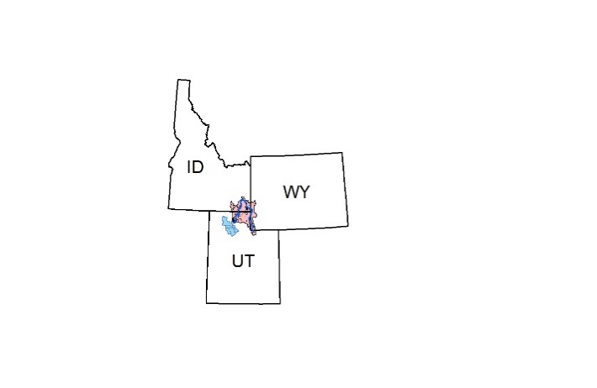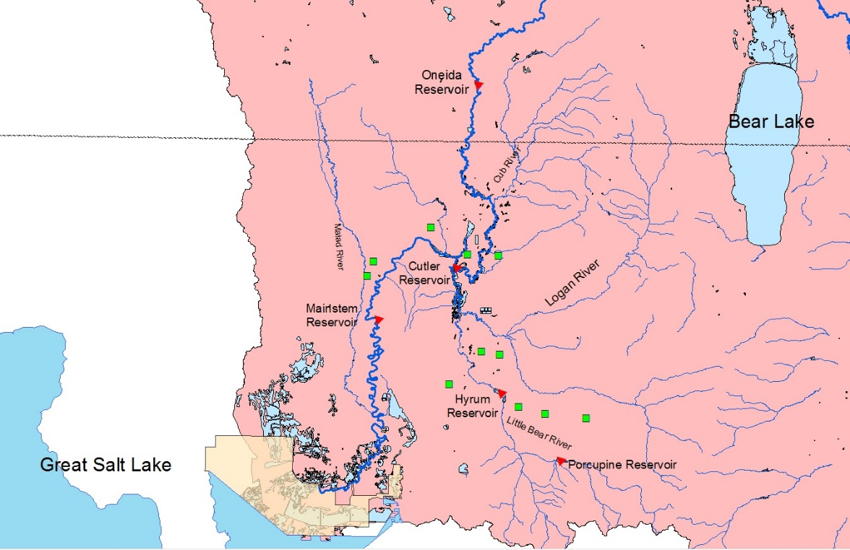

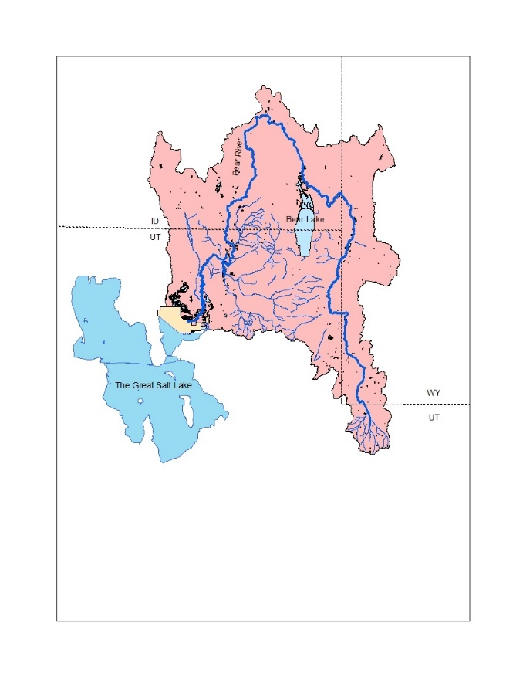

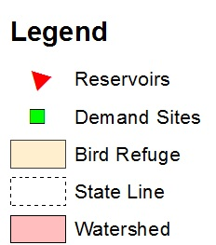

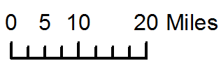

**Figure 2.** The Lower Bear River Watershed including the reservoirs and demand sites

We segmented the Bear River and its main tributaries into a network of 43 nodes and 56 links which includes 5 reservoirs, 12 municipal and agricultural demand sites, and 26 environmental sites where ecological species of concern live (see Appendix I for full network). We implemented the model on a monthly time basis for one calendar year (2003) as a representative year in the basin that had monthly headflows close to the monthly means observed in the Bear River in the last 15 years. We selected a single year time horizon to initially run the model because reservoir and watershed managers plan operations at monthly intervals for a one-year cycle. We also extended the model time frame to 5 years (2003 – 2007) to consider annual variability. We ran the model with the same weight values of 1 for all indicators to avoid favoring a location, species, or month.

* 1. **Selection of indicator species**

The presence and abundance of indicator species is a strong signal of ecosystem response to alterations in flow regimes. We identified indicator fish, riparian vegetation, and wetlands bird species in the Lower Bear River watershed along with our stakeholders from the CAP team. Table 2 summarizes the selected indicator species for the case study and their water requirements.

|  |  |  |  |  |  |  |  |
| --- | --- | --- | --- | --- | --- | --- | --- |
| **Habitat** | **Indicator Species** | **Life Stage** | **Ecosystem Function** | **Eco-hydrologic and hydraulic parameters** | **Parameter value** | **Biological period** | **Affected Area** |
| Aquatic | Bonneville cutthroat trout (*Onchorynchus clarki utah*) | Adult | Native spawning | Water depth | 0.30 - 0.75m | Sep. – Mar. | Channel surface area |
| Fry | Native maturing | 0.10 - 0.45m | Apr. – Aug. |
| Brown trout (*Salmo trytta*) | Adult | Game fish spawning | 0.00 - 0.80m | Sep. - Mar |
| Fry | Game fish maturing | 0.00 - 0.50m | Apr. – Aug. |
| Floodplains | Cottonwoods (*Populus)* | Seed germination and dispersal | Native riparian recruitment | Flood recurrence | > Bankfull flow | Apr. – Aug. | Floodplain area |
| Wetlands | Black-necked stilt (*Himantopus mexicanus*) | Adult | Feeding, resting, and breeding | Water depth | 0.15– 0.25m | Apr. – Sep. | Impounded wetlands area |
| Invasive vegetation cover | < 10% |
| American avocet (*Recurvirostra Americana)* | Water depth | 0.35- 0.45m | Mar. – Oct. |
| Invasive vegetation cover | < 10% |
| Tundra swan (*Cygnus columbianus*) | Water depth | > 0.55m | Nov.– Mar. |
| Invasive vegetation cover | < 10% |

**Table 2.** Habitat indicator species and their water requirements at different life stages, biological periods and the corresponding affected area

* + 1. **Aquatic Habitat:** Bonneville cutthroat trout (BCT; *Onchorynchus clarki utah*) was identified as a priority native beneficiary species of designated environmental flows in the Blacksmith Fork and the Little Bear Rivers, two main tributaries to the Bear River (Bio-West, 2015). Brown Trout (*Salmo trytta*) is a popular game fish because it has high tolerance to low summer flows, warmer lower-elevation reaches, and parasites causing whirling disease compared to other members of the trout family (UtahFishingInfo Website, 2016). The Bear River main stem is at lower elevation and experiences a warmer water temperature in the summer that reaches 26o C. The Little Bear and Blacksmith Fork Rivers are at a higher elevations and have cooler water temperatures that do not exceed 22.5o C (Watershed Sciences, 2007). Johnstone and Rahel (2003) reported that a water temperature at or above 25o C could be lethal for BCT, while Raleigh et al. (1984) reported that brown trout can tolerate a water temperature up to 27.2o C. Therefore, based on further confirmation with DeRito (2016), BCT is only abundant in the headwaters of the Blacksmith and Little Bear Rivers. We assigned BCT as the indicator fish species in these river reaches and assigned Brown trout on the remaining reaches and the Bear River main stem.

Both fry trout species are observed between April – August in the Bear River watershed while adult trout exist year-round, but BCT spawn in early spring and Brown trout spawn in the Fall. Braithwaite (2011) carried out a 2-year empirical study to identify preferred habitat conditions for BCT in the Strawberry River, UT by visually locating undisturbed adult, juvenile, and spawning redds and measuring water depth, velocity and substrate size at these locations. He reported that adult and juvenile trout need at least 75cm of water depth for spawning and water depths under 30 and 10cm could limit spawning adults and fry. Since Braithwaite (2011) did not report suitable water depth for fry BCT, we use Hickman and Raleigh (1982) Habitat Suitability Index (HSI) curves which state that BCT fry requires at least 45cm of water depth to survive. For brown trout, Raleigh et al. (1984) reported that adult and juvenile brown trout need 2.8ft (80cm) of water depth to spawn, while fry trout need 1.6ft (50cm) of water depth to mature and can tolerate very shallow water depths. We developed suitability index curves for BCT (Figure 3-right) and Brown trout (Figure 3-left) using Boltzmann model and exponential decay function respectively based on the curve shapes of the FWS HSI for water depth (Hickman and Raleigh, 1982; Raleigh et al., 1984).

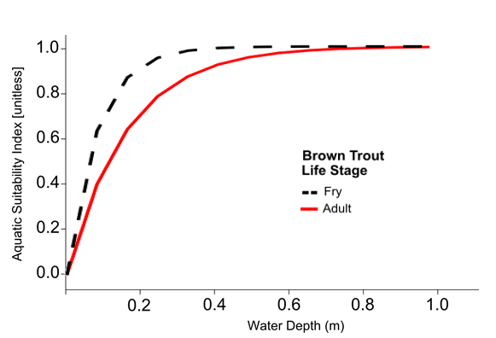

**Figure 3.** Aquatic Suitability Index values for water depth for Bonneville cutthroat trout (right) and brown trout (left). In the model, adult trout curves are used from September to March and fry trout curves from April to August.

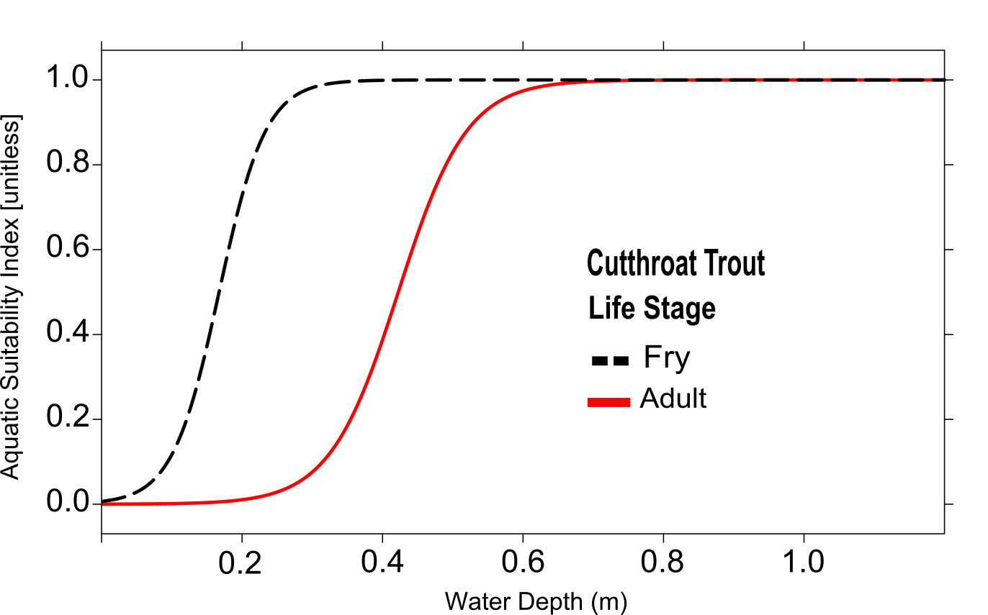

* + 1. **Floodplain habitat**: we selected cottonwood trees (*Populus),* as an indicator native vegetation because it predominates the immediate floodplains in the Lower Bear. It provides shade, food, and habitat for beavers, mammals, birds, and insects. Cottonwoods release seeds just after peak flows in snowmelt-driven rivers (Bhattacharjee et al., 2006; Mahoney and Rood, 1998). Thus, lateral connectivity between the channel and the floodplains is mostly needed between April to June for successful seed dispersion and then through August for continued soil moisture which is crucial for establishment of dispersed seeds (Meier and Hauer, 2010). Cottonwood trees grow adjacent to the river channel which means that most flow magnitudes over the bankfull flow (1.5-year flood recurrence value) will inundate these trees and achieve successful lateral connectivity.

We developed the values of the floodplain connectivity index (*FCI*) [0 (poor) – 1 (excellent)] as a function of streamflow assuming that a 2-year recurrence flow is sufficient to create a flood event (Figure 4). We set the initial vegetation cover as the existing cottonwood tree cover alongside every reach in the watershed measured from NAIP Imagery. The limit on cottonwood cover from both active revegetation and natural growth was set to be the entire floodplain area adjacent to every reach.

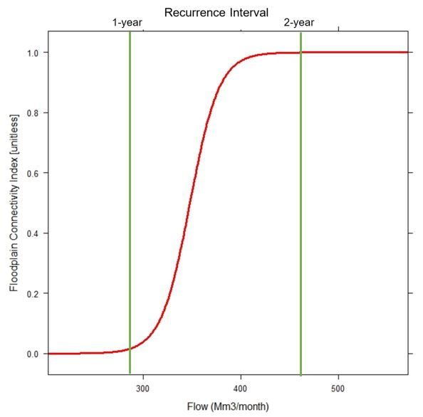

**Figure 4.** An example of floodplain connectivity index curve as a function of flow at the Bear River Corinne site. Floodplain suitability transitions from 0 to 1 between flow values with recurrence interval of 1- and 2-years

* + 1. **Wetlands habitat:** The Bear River supplies the 300 km2 Bear River Migratory Refuge. Prior work by Alminagorta et al. (2016) developed Usable Area for Wetlands (WU) for the Refuge and used it as a performance metric in a systems model to maximize the surface area of wetlands whose water depth and invasive vegetation cover can support three indicator bird species with different and competing water needs at different times of the year (Table 2). Here, we estimated monthly wetlands suitability index values by dividing Alminagorta’s monthly WU areas at selected wet and dry years between 1992 to 2011 by the total Refuge area. The we developed monthly relationships between estimated suitaibilty index values and monthly river flows, measured at Corinne, UT USGS station (one example in Figure 5). In WASH formulation, we use these relationships to measure wetlands suitability indexes (*WSI*) based on allocated flow for the Refuge. The wetlands habitat suitable area (*INDwetlands*) indicator is then calculated by multiplying suitability (*WSI)* by the Refuge total wetlands area *aw* [Mm2] as shown in eq. [5].

**Figure 5.** An example of WASH wetlands suitability index for February

* 1. **Model Implementation**

We coded and implemented WASH model formulation [equations 1 – 17] using the General Algebraic Modeling System software (GAMS; Hozlar, 1990) and solved it using the non-linear global solver Branch-And-Reduce Optimization Navigator (BARON; Sahinidis, 1996). The GAMS code reads the input data and the parameters from an MS Excel spreadsheet and passes them to the model in a GDX (GAMS Data Exchange format) file. The 1-year implementation of the model for the lower Bear River system has approximately 27,000 variables and 5,300 equations and takes 2 hours and 15 minutes to find a global optimal solution on a Dell XPS Windows10 64-bit. We used Excel, R, and ArcGIS Online to post-process and display model results. The model input data, code, and post-processing files are available at: <https://github.com/ayman510/WASH>

* 1. **Model Scenarios**

We first ran the model in simulation mode for the same base case year (2003) by fixed modeled flows on all river segments to observe gaged values. Comparing WASH performance with existing conditions can show the potential environmental gains to manage water as the model recommends. In addition, we ran the model with different headflows for a wetter year (2005) and a dryer year (2004) to examine the model’s response to changes in headflows. We also examined the tradeoff between WASH performance indicator and demands for urban and agricultural water uses by multiplying each urban and agricultural demand in the basin by a reduction target fraction. This allows us to quantify the increased WASH area that is potentially available for ecological habitat if additional water was available in the system. Also, we ran the model for 5 years (2003 to 2007) to better understand the implications of flow annual variability on the model results.

Also, to understand the significance of selecting indicator species to define habitat quality, we also the model response to an additional species with more water depth requirements. In the base case, we had both Bonneville cutthroat trout (BCT) and Brown trout as the two priority fish species in the watershed. Based on feedback from the project stakeholders, we learned that Bluehead sucker *(Catostomus discobolus)* is also abundant downstream of Cutler Reservoir. It is important to note that the largest agricultural user of water in the watershed is the Bear River Canal Company which diverts water out of the River from Cutler reservoir, which could limit additional instream flow for suckers downstream of Cutler. Although Bluehead sucker is a nongame fish, it is listed as a sensitive species by state and federal agencies and their declining numbers in the Bonneville Basin in Utah might warrant listing them as threatened or endangered species (UDNR, 2006; Webber et al., 2012). We designed and added suitability curves for Bluehead sucker based on the empirical study of Anderson and Stewart (2003) where they recommended a water depth of 100 to 150cm (3.3 – 5 ft) for suckers in all life stages. In this scenario, we continued to include BCT in the headwaters of the Little Bear and the Blacksmith Fork rivers, Bluehead sucker downstream of Cutler, and Brown trout elsewhere in the watershed.

* 1. **Model Outputs and Visualization**

WASH results are displayed on an open-access web mapping application that allows stakeholders to access, visualize, and interact with the model input data and results. The web app displays the model recommended flows, reservoir releases, and storage volumes and compares them to current operations. The app also displays the temporal variations of aquatic, floodplain, and wetlands habitats using a time slider. Users can also input their own base maps and data layers to customize the tool. The web app is available at: <http://WASHmap.usu.edu>

1. **Results**

The results are displayed in US Customary Units to better communicate with local stakeholders. Running the model for the case of 2003 simulated flows shows that nearly 100 thousand acres are available and suitable for aquatic, floodplain, and wetlands habitat in the watershed (blue diamond, Figure 9). The global optimal solution of WASH shows that there is a potential to increase the suitable habitat area to by 25 thousand acres (green circle, Figure 9). The model’s recommended area constitutes nearly 18% of the total available habitat area in the watershed that is theoretically available for selected species if all suitability index values were 1.

The model suitable habitat area is achieved by considering species-water requirements in managing the releases and storage of the two main reservoirs in the watershed, Hyrum and Porcupine, without harming existing human users. For instance, WASH recommends increasing reservoir winter and early spring releases at Hyrum Reservoir and minimizing late spring spill volumes at both reservoirs in May (Figure 6). Here, WASH uses its perfect knowledge of future inflows to show the benefit to reduce spills during the spring runoff season and increasing instream flow in January, February, and at the end of the season in November and December. The recommended operation of Hyrum serves both human uses during summer months and improves water allocated for environmental users.

**Figure 6.** Comparison between model recommended and current reservoir releases for 2003 for (right) Hyrum and (left) Porcupines reservoirs

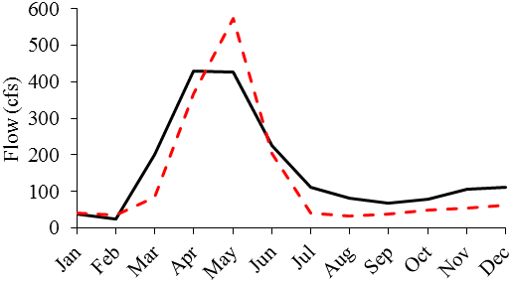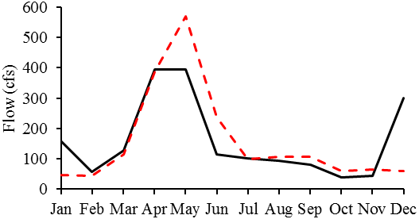

**Porcupine Reservoir**

**Hyrum Reservoir**



Implementing WASH water management recommendations improve habitat quality over observed conditions for fish species year-round and for the Refuge birds in summer months (Figure 7). Although the wetlands’ area is the largest in the model, monthly suitable areas do not exceed 40% of the total Refuge area. Aquatic habitat, on the other hand, is gaining more suitable area throughout the year that is close to its total available surface area, which is measured at the maximum bounds of flow in eq. [16] that include head flows and reservoir capacity. The area of suitable aquatic habitat varies across reaches in the watershed based on available water, channel geometry, and river length. The sites that contribute more to aquatic area in Figure 7 are on the Bear River before Cutler reservoir which have wider channels and little urban demand. WASH improves floodplain connectivity in summer months when cottonwoods germinate seeds and require flood events to re-establish. Floodplain habitat area, however, is very limited in the watershed due to low summer month flows that are unable to inundate cottonwood trees.

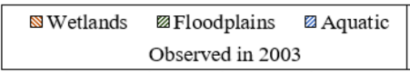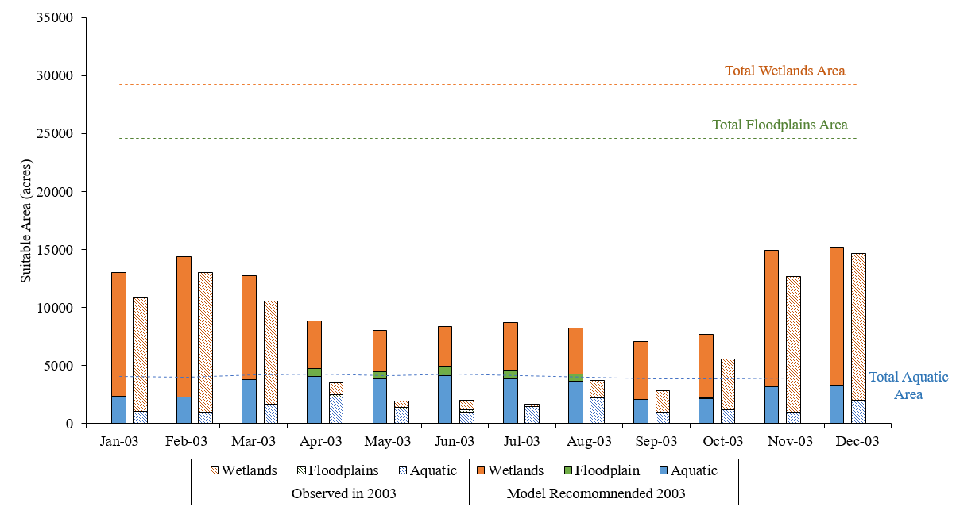

**Figure 7.** Monthly suitable habitat area in the Bear River watershed compared to total available areas (horizontal lines) for aquatic, floodplains, and wetlands habitat

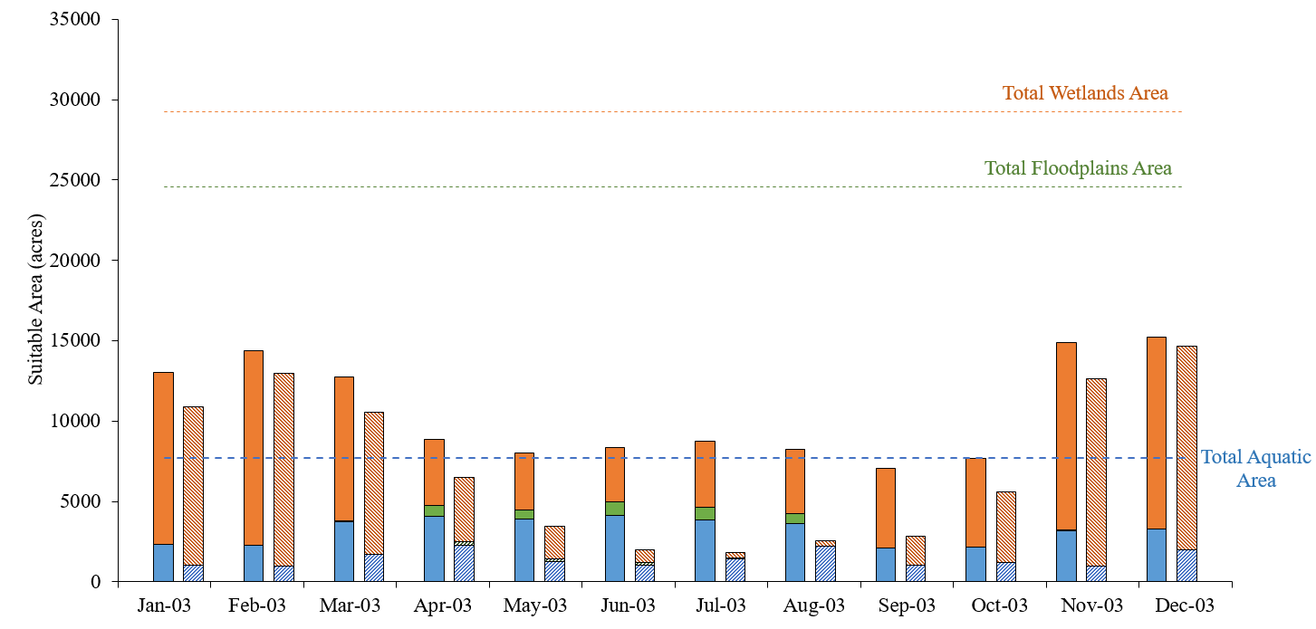

WASH recommends flows to improve habitat quality for bird species in summer months when the Refuge dos not receive its allocated water right. The Refuge holds a junior right for water volume that is required to meet the needs of waterfowl. This water right was determined by the UDWR and USFWS to sustain functional ecosystem for different bird species, maintain water quality parameters such as nutrients limits, and to protect a minimum elevation for the Great Salt Lake (Downard et al., 2014). Figure 8 (right) shows that WASH increases wetlands suitability index at the Refuge in summer months. Comparing existing flow of the Bear River at Corinne, UT that the Refuge received to WASH recommended flow in 2003 at the same location shows that WASH is able to meet the Refuge’s water right nearly all year long (Figure 8-left).

**Figure 8.** Comparison between observed conditions and model recommendations for the Refuge. (A) Improvement in wetlands suitability index. (B) Comparison between observed flows at Corinne, model recommended flows that the Brid Refuge received in 2003 and the Refuge’s monthly water right from Downard et al. (2014)

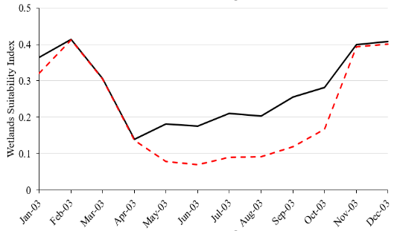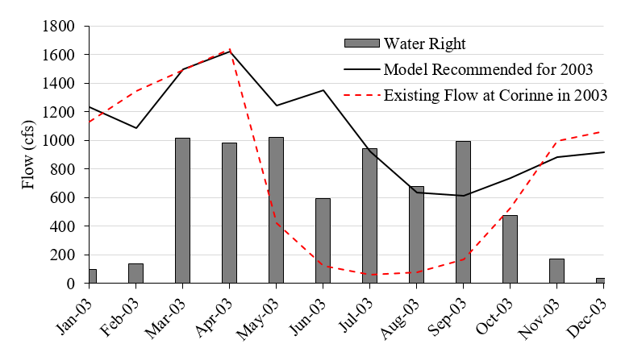

**A. Wetlands habitat suitability Index at the Refuge**

**B. River flow at the Refuge**

We ran the model for 2005 as an example of a wet year and 2004 as a dry year and the suitable habitat area increased by 18 thousand acres in 2005 (red circle: Figure 9) and decreased by 15 thousand acres in 2004 (orange triangle). Examining the tradeoff with annual urban and agricultural demand shows that the suitable area can potentially increase if the human water demand is reduced. For instance, if 20% demand reduction is achieved, more water will be available to allocate for the environment and the habitat suitability area can increase by 8 thousand acres. The tradeoff also shows that the model is infeasible in the base case scenario (in 2003) if the human demand exceeds 10% of existing demand volume. This shows that efficient management of flow-control infrastructure in the watershed can significantly decrease the systems’ vulnerability to future demand requirements.

**Figure 9.** Tradeoff Analysis between WASH suitable area and annual demand delivery targets

Running the model for 5 years from January 2003 to September 2007 shows that the model responds to annual variations in flow regimes. For instance, aquatic habitat suitability dropped in 2004 as a result of being a dry year (Figure 10). However, the model was able to improve aquatic habitat performance every year. Figure 10 shows that the model recommended flows created larger habitat area for fish species in late spring and summer when fry fish need water to mature. The figure also shows that WASH improved aquatic habitat for adult trout which need deeper water depth on the Little Bear river.

The addition of Bluehead sucker to the model spatial fish distribution decreased WASH performance indicator value by 6 thousand acres from the base case with two trout species. This decrease is attributed to deeper water depth (3.3 – 5 ft) required by adult Suckers to spawn which the model was unable to satisfy because of limited water availability downstream of Cutler reservoir in summer months. Managing water to improve Sucker habitat requires managers to release more water into the system which is challenging given existing agricultural users in the area. This illustrates the importance of selecting indicator species when defining environmental flows and managing reservoirs and diversions to restore habitat quality. 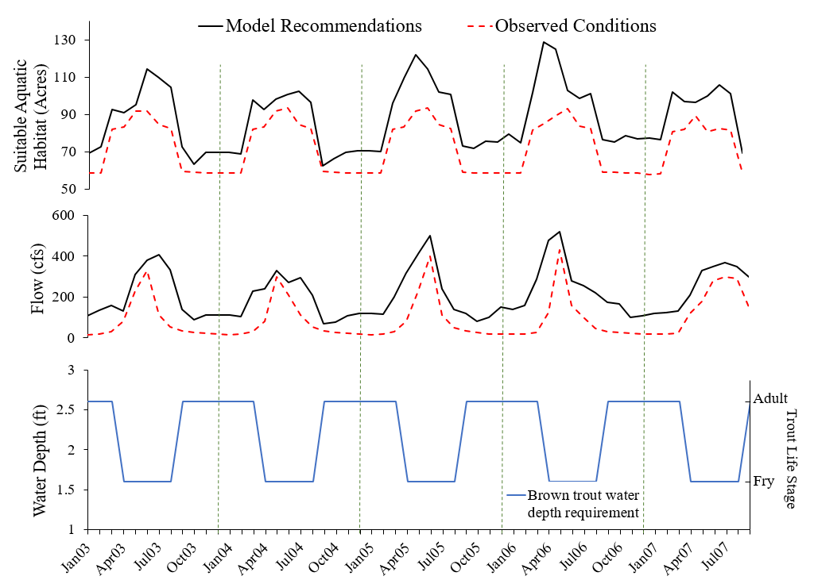

**Figure 10.** Comparison of suitable aquatic habitat area (acres) and flow (cfs) between model recommendation and observed conditions for 5 years (2003 – 2007) on the Little Bear River just above Cutler reservoir. Bottom line is Brown trout monthly water requirements (ft)

In order to explore the ecological benefits of adding more flow to the network, we examined the shadow values (Lagrange multipliers) that are associated with the water mass balance constraint eq. [7] at nodes with headwater flow. Shadow values show the increase in WASH performance (in acres) when one additional unit volume of flow (in cfs) is made available (Table 3). The results suggest that managers should focus their time and effort on the Little Bear River because the largest shadow values occur between August and December and therefore releasing more water in later summer and during winter can increase habitat conditions more for indicator species.

**Table 3.** Shadow values of additional water increase in the network measured at the headflows

|  |  |  |  |  |  |  |  |  |  |  |  |
| --- | --- | --- | --- | --- | --- | --- | --- | --- | --- | --- | --- |
| **Shadow Values/ Month** | **Jan** | **Feb** | **Mar** | **Apr** | **Jun** | **Jul** | **Aug** | **Sep** | **Oct** | **Nov** | **Dec** |
| Bear River (acres/cfs) | 2.19 | 1.54 | 1.54 | 1.54 | 2.40 | 2.44 | 7.62 | 1.73 | 1.09 | 0.73 | 1.09 |
| Cub River (acres/cfs) | 1.35 | 0.75 | 0.53 | 2.26 | 0.66 | 2.09 | 0.95 | 0.86 | 1.07 | 0.97 | 0.98 |
| Blacksmith Fork River (acres/cfs) | 1.80 | 1.20 | 1.10 | 2.87 | 3.29 | 3.25 | 3.32 | 2.43 | 2.50 | 1.41 | 1.42 |
| Little Bear River at East Fork (acres/cfs) | 4.36 | 3.36 | 4.73 | 2.73 | 3.73 | 4.27 | 7.80 | 12.15 | 3.99 | 3.81 | 3.81 |
| Little Bear River at South Fork (acres/cfs) | 1.80 | 1.20 | 1.10 | 2.87 | 1.29 | 1.25 | 3.32 | 3.43 | 2.50 | 2.41 | 1.42 |
| Malad River (acres/cfs) | 0.80 | 0.20 | 0.12 | 0.15 | 0.11 | 0.12 | 0.15 | 0.18 | 0.43 | 0.32 | 0.39 |

1. **Discussion**

WASH model results for the Lower Bear River show that there are opportunities to increase aquatic, floodplains, and wetlands habitat area by 25 thousand acres for priority species in the River watershed without negatively affecting existing human users. The main limitation of creating additional habitat area was water availability. The River is highly appropriated for urban and agricultural uses. The model ran infeasible when human demand increased by 10%.

WASH recommends releasing more water in winter months and reducing late spring spills. This largely supports Brown trout late fall spawning and provides enough water for gravel redds to maintain their eggs until spring hatching. In addition, gradual release of water from reservoirs protect trout eggs from winter and spring flood events that could lead to scour-related mortality of incubated eggs and newly emerged fry (George et al., 2015). Managing flow to improve Bluehead suckers habitat requires deeper water depth that is currently unavailable given existing human users which could threaten Bluehead persistence in the Bear River watershed.

WASH results show that the suitability of the floodplain habitat is limited in the watershed because of several factors. First, the River is highly regulated by several reservoirs and diversion canals which lower instream flow in summer months. This constrains flood instances and leads to poor lateral connectivity. Second, the width and density of the riparian corridor in many reaches in the watershed is limited by the proximity of urban development such as bridges and roads and agricultural fields and grazing land. This means that even if lateral connectivity is possible with more instream flow, limited floodplain areas in some parts of the watershed do not allow for more vegetation cover. Third, the limited budget to plant additional trees in the available floodplain area also constrains improving floodplain habitat suitability. However, the first two are the main factors limiting floodplain habitat connectivity in the Lower Bear River watershed.

WASH defines wetlands habitat suitability for impounded wetlands because managers can control wetlands gates and thus the water available to wetlands species. WASH does not currently consider naturally-occurring or oxbow wetlands but the model formulation is applicable as long as adjacent wetlands are hydrologically connected to the river and a relationship is established between river flow and wetlands water depth. The application of WASH to the Lower Bear River shows that WASH was able to allocate more water to the Bird Refuge by managing upstream reservoir releases and storage to meet bird water needs in summer months. Since the Refuge is the last downstream water user in the Bear River, the Refuge’s managers need to actively manage water through planning for draughts, forecasting supply and demand, communicating with upstream users, and monitoring response of bird species to changes in flow regimes.

WASH model formulation uses suitability curves to define ecological response of different species to alterations in flow regimes. We recognize that habitat suitability indexes (HSIs) need to be verified with empirical data (Merritt et al., 2010). A before and after monitoring approach is recommended to gauge prescribed instream flows and the response of target species. Such empirical data could significantly help modify the suitability curves to represent a local response of selected species to flow alterations.

The underlying assumption of WASH is that providing adequate and suitable habitat conditions will protect existing selected priority species or encourage their reestablishment. While WASH focuses on physical and abiotic factors to define suitability indexes, the formulation can be adapted to include water quality parameters such as dissolved oxygen, or biotic interactions between species if the relationships between flow characteristics and these parameters are established. We demonstrated one example using temperature-flow relationship, but there is a likely benefit of including other water quality parameters in gaging species response to flow alterations. For example, measuring the effects of reducing water depth on dissolved oxygen levels for fish survival.

WASH determines water allocation between users with perfect foresight of future water availability. The effect of perfect foresight assumption is limited on the Bear River case study because the river basin is a snow-melt driven system that allows managers to reliably forecast water availability and plan for reservoir operations based on snowpack measurements. Although we tested the model’s ability to meet species requirements on multiyear time horizon, we recognize that reservoir managers will not have the ability to forecast and plan operations beyond one year.

Implementing WASH recommendations at the Bear River requires that environmental flows are recognized and protected in the water development permitting and planning process. Although Utah’s water law statute does not allow new appropriations of water for instream flow, State law provides for temporary or permanent transfers of existing rights to environmental users (Szeptycki et al., 2015). The mechanisms to acquiring an instream flow right includes donation, lease, or purchase. These transfers are then owned by the Utah Division of Wildlife Resources, the Division of Parks and Recreation, or a nonprofit fishing group such as Trout Unlimited and are subject to approval from the State Engineer (Szeptycki et al., 2015). To implement WASH recommendations, additional reservoir releases (Figure 6) need to be leased as storage volume from current agricultural water users downstream of Hyrum and Porcupine so water can be released in winter months for environmental users.

1. **Conclusion**

Managing river flow for environmental restoration requires allocating water to satisfy the spatial and temporal needs of different species in the watershed without harming human users. This paper introduces the Watershed Area of Suitable Habitat (WASH) performance indicator that measures and quantifies suitable habitat area in watersheds. Embedding this indicator in a systems model as an objective to maximize helps to recommend management actions to improve habitat quality in the face of scarce water and budget. Performance is defined by three common areas of habitat management within a watershed: aquatic, floodplain, and impounded wetland habitats and their associated indicators. These indicators are summed together with weights that vary spatially and temporally and are based on collected data and stakeholder participation. WASH considers multiple aquatic, floodplain, and wetlands habitats, accounts for competing ecological needs of water for multiple species and their different life stage-water needs, considers temporal and spatial dependency between flow control structures at the watershed, meets human beneficial use of available water and is generic and adaptable to other sites and species. The model outputs comprise time series of recommended monthly reservoir releases, storage and diversion volumes that would provide better habitat conditions at the watershed.

We applied WASH to the Lower Bear River, UT using stakeholder-verified and species- and site-specific habitat suitability curves for Cutthroat trout, Brown Trout, Cottonwood, Black-necked stilt, American avocet, and Tundra swan. WASH shows that the river is highly appropriated for urban and agricultural uses and the model is infeasible if the human demand exceeds 10% of existing demand volume in 2003. However, there is some flexibility to increase aquatic, floodplain, and wetland habitat area 25 thousand acres without harming existing human uses. This increase can be achieved by adjusting Hyrum and Porcupine reservoir storage and release volumes to release more water in winter months and reduce late spring spills. Results also show that the Little Bear River has the most potentials to increase the watershed habitat performance, particularly between August – December.

WASH identified spatial and temporal opportunities to allocate water to species to meet their water requirements through their different life stages. We ran multiple scenarios to compare the model recommendations for the base case against existing flow control operations, additional species, additional years, and for different hydrologic conditions. The model results are displayed on an interactive web mapping application to provide managers and restoration practitioners with readily-available and accessible tools to improve and restore ecological habitat. The maps serve as a guide that highlights the reaches within the watershed that are in need of restoration and the potential gains in habitat quality that could be achieved by allocating more water to environmental users.

**Acknowledgements**

This research was supported by a grant from the National Science Foundation (NSF) grant #1149297. The authors thank Joan Degiorgio, Bryan Dixon, Bob Fotheringham, James DeRito, Paul Thompson, and Sarah Null for providing significant feedback and contributing to the model development and application process. The authors also acknowledge the Bear River undergraduate research fellows who helped collect, synthesis, and analyze flow, stage, and cross sectional data in addition to contributing to testing model scenarios.

**References**

Adams, T.D., Cole, D.B., Miller, C.W., Stauffer, N.E., 1992. GENRES A Computer Program System for Reservoir Operation with Hydropower, In: Resources, U.D.o.W. (Ed.).

Ahmadi-Nedushan, B., St-Hilaire, A., Berube, M., Robichaud, E., Thiemonge, N., Bobee, B., 2006. A review of statistical methods for the evaluation of aquatic habitat suitability for instream flow assessment. River Research and Applications 22(5) 503-523.

Alminagorta, O., Rosenberg, D.E., Kettenring, K.M., 2016. Systems modeling to improve the hydro-ecological performance of diked wetlands. Water Resources Research n/a-n/a.

Anderson, R., Stewart, G., 2003. Riverine Fish Flow Investigations, In: F-289-R6, F.A.P. (Ed.), Federal Aid in Fish and Wildlife Restoration - Job Progress Report Colorado Division of Wildlife Fort Collins, Colorado.

Barbour, E.J., Holz, L., Kuczera, G., Pollino, C.A., Jakeman, A.J., Loucks, D.P., 2016. Optimisation as a process for understanding and managing river ecosystems. Environmental Modelling & Software 83 167-178.

Baron, J.S., Poff, N.L., Angermeier, P.L., Dahm, C.N., Gleick, P.H., Hairston, N.G., Jackson, R.B., Johnston, C.A., Richter, B.D., Steinman, A.D., 2002. MEETING ECOLOGICAL AND SOCIETAL NEEDS FOR FRESHWATER. Ecological Applications 12(5) 1247-1260.

Barry, S., Elith, J., 2006. Error and uncertainty in habitat models. Journal of Applied Ecology 43(3) 413-423.

Bear River CAP, 2008. The Bear River, A conservation priority. The Nature Conservnacy: Utah.

Bear River Commission, 2012. Sixteenth Biennial Report 2009 - 2010: BOUNTIFUL, UTAH.

Bhattacharjee, J., Taylor, J., Smith, L., 2006. Controlled flooding and staged drawdown for restoration of native cottonwoods in the Middle Rio Grande Valley, New Mexico, USA. Wetlands 26(3) 691-702.

Bio-West, 2015. Little Bear and Blacksmith Fork Rivers Environmental Flows: Background Report. Bio-West Inc.: Logan, UT.

Blum, C., Roli, A., 2003. Metaheuristics in combinatorial optimization: Overview and conceptual comparison. Acm Computing Surveys 35(3) 268-308.

Braithwaite, N.R., 2011. The Effect of Stream Restoration on Preferred Cutthroat Trout Habitat in the Strawberry River, Utah, Watershed Sciences. Utah State Univeristy: Logan, UT, p. 950.

Bunn, S.E., Arthington, A.H., 2002. Basic Principles and Ecological Consequences of Altered Flow Regimes for Aquatic Biodiversity. Environmental Management 30(4) 492-507.

Cioffi, F., Gallerano, F., 2012. Multi-objective analysis of dam release flows in rivers downstream from hydropower reservoirs. Applied Mathematical Modelling 36(7) 2868-2889.

DeRito, J., 2016. Status of Cutthroat Trout and Brown Trout on the Bear River and its tributaries, In: Alafifi, A. (Ed.): Personal Communications

Downard, R., Endter-Wada, J., 2013. Keeping wetlands wet in the western United States: Adaptations to drought in agriculture-dominated human-natural systems. Journal of Environmental Management 131(0) 394-406.

Downard, R., Endter-Wada, J., Kettenring, K.M., 2014. Adaptive wetland management in an uncertain and changing arid environment. Ecology and Society 19(2).

Dunne, Thomas, Leopold, L.B., 1978. Water in environmental planning. W.H. Freeman Co.: San Francisco, Calif, p. 818.

Faulkner, S., Barrow, W., Keeland, B., Walls, S., Telesco, D., 2010. Effects of conservation practices on wetland ecosystem services in the Mississippi Alluvial Valley. Ecological Applications 21(sp1) S31-S48.

George, S.D., Baldigo, B.P., Smith, A.J., Robinson, G.R., 2015. Effects of extreme floods on trout populations and fish communities in a Catskill Mountain river. Freshwater Biology 60(12) 2511-2522.

Giller, P.S., 2005. River restoration: seeking ecological standards. Editor's introduction. Journal of Applied Ecology 42(2) 201-207.

Harman, C., Stewardson, M., 2005. Optimizing dam release rules to meet environmental flow targets. River Research and Applications 21(2-3) 113-129.

Harman, W.A., Jennings, G.D., 1999. River course - Application of the Rosgen stream classification system to North Carolina. North Carolina Cooperative extension service, Raleigh, N.C.

Hemker, T., Fowler, K.R., Farthing, M.W., von Stryk, O., 2008. A mixed-integer simulation-based optimization approach with surrogate functions in water resources management. Optimization and Engineering 9(4) 341-360.

Hickey, J., Fields, W., 2013. HEC-EFM Ecosystem Functions Model. US Army Corps of Engineers - Hydrologic Engineering Center.

Hickman, T., Raleigh, R., 1982. Habitat Suitability Index Models: Cutthroat Trout, Biological Services Program. Fish and Wildlife Service.

Higgins, A.J., Bryan, B.A., Overton, I.C., Holland, K., Lester, R.E., King, D., Nolan, M., Connor, J.D., 2011. Integrated modelling of cost-effective siting and operation of flow-control infrastructure for river ecosystem conservation. Water Resources Research 47(5) W05519.

Hooper, B., 2010. River basin organization performance indicators: application to the Delaware River basin commission. Water Policy 12(4) 461-478.

Hozlar, E., 1990. Gams - General Algebraic Modeling System for Mathematical-Modeling. Ekonomicko-Matematicky Obzor 26(1) 96-99.

Jager, H.I., Smith, B.T., 2008. Sustainable reservoir operation: can we generate hydropower and preserve ecosystem values? River Research and Applications 24(3) 340-352.

Johnstone, H.C., Rahel, F.J., 2003. Assessing Temperature Tolerance of Bonneville Cutthroat Trout Based on Constant and Cycling Thermal Regimes. Transactions of the American Fisheries Society 132(1) 92-99.

Kilpatrick, F.A., Barnes, H.H., 1964. Channel Geometry of Piedmont Streams as Related to Frequency of Floods, In: Interior, U.S.D.o.t. (Ed.), Physiographic and Hydraulic Studies of Rivers: Washington D.C.

Kuby, M.J., Fagan, W.F., ReVelle, C.S., Graf, W.L., 2005. A multiobjective optimization model for dam removal: an example trading off salmon passage with hydropower and water storage in the Willamette basin. Advances in Water Resources 28(8) 845-855.

Leopold, L.B., Wolman, M.G., Miller, J.P., 1964. Fluvial processes in geomorphology. W.H. Freeman and Co: San Francisco, California, p. 522.

Li, C., Czapiga, M.J., Eke, E.C., Viparelli, E., Parker, G., 2015. Variable Shields number model for river bankfull geometry: bankfull shear velocity is viscosity-dependent but grain size-independent. Journal of Hydraulic Research 53(1) 36-48.

Mahoney, J., Rood, S., 1998. Streamflow requirements for cottonwood seedling recruitment—An integrative model. Wetlands 18(4) 634-645.

Meier, C.I., Hauer, F.R., 2010. Strong effect of coarse surface layer on moisture within gravel bars: Results from an outdoor experiment. Water Resources Research 46.

Merritt, D.M., Scott, M.L., Poff, N.L., Auble, G.T., Lytle, D.A., 2010. Theory, methods and tools for determining environmental flows for riparian vegetation: riparian vegetation-flow response guilds. Freshwater Biology 55(1) 206-225.

Mowrer, H.T., 2000. Uncertainty in natural resource decision support systems: sources, interpretation, and importance. Computers and Electronics in Agriculture 27(1–3) 139-154.

NHDPlus V2, 2016. NHD Plus V2 Attribute Extensions, In: Systems, H. (Ed.), Great Basin (Vector Processing Unit 16). Esri.

NOAA, 2015. High Water Level Terminology: Alaska - pacific River Forecast Center.

Null, S.E., Medellín-Azuara, J., Escriva-Bou, A., Lent, M., Lund, J.R., 2014. Optimizing the dammed: Water supply losses and fish habitat gains from dam removal in California. Journal of Environmental Management 136(0) 121-131.

O’Hanley, J.R., 2011. Open rivers: Barrier removal planning and the restoration of free-flowing rivers. Journal of Environmental Management 92(12) 3112-3120.

Palmer, M.A., Bernhardt, E.S., Allan, J.D., Lake, P.S., Alexander, G., Brooks, S., Carr, J., Clayton, S., Dahm, C.N., Shah, J.F., Galat, D.L., Loss, S.G., Goodwin, P., Hart, D.D., Hassett, B., Jenkinson, R., Kondolf, G.M., Lave, R., Meyer, J.L., O'Donnell, T.K., Pagano, L., Sudduth, E., 2005. Standards for ecologically successful river restoration. Journal of Applied Ecology 42(2) 208-217.

Parker, G., Wilcock, P.R., Paola, C., Dietrich, W.E., Pitlick, J., 2007. Physical basis for quasi-universal relations describing bankfull hydraulic geometry of single-thread gravel bed rivers. Journal of Geophysical Research-Earth Surface 112(F4).

Petts, G.E., 2009. Instream Flow Science For Sustainable River Management1. JAWRA Journal of the American Water Resources Association 45(5) 1071-1086.

Pinto, R., Patricio, J., Baeta, A., Fath, B.D., Neto, J.M., Marques, J.C., 2009. Review and evaluation of estuarine biotic indices to assess benthic condition. Ecological Indicators 9(1) 1-25.

Poff, N.L., 1996. A hydrogeography of unregulated streams in the United States and an examination of scale-dependence in some hydrological descriptors. Freshwater Biology 36(1) 71-91.

Poff, N.L., Allan, J.D., Bain, M.B., Karr, J.R., Prestegaard, K.L., Richter, B.D., Sparks, R.E., Stromberg, J.C., 1997. The natural flow regime. Bioscience 47(11) 769-784.

Poff, N.L., Richter, B.D., Arthington, A.H., Bunn, S.E., Naiman, R.J., Kendy, E., Acreman, M., Apse, C., Bledsoe, B.P., Freeman, M.C., Henriksen, J., Jacobson, R.B., Kennen, J.G., Merritt, D.M., O'Keeffe, J.H., Olden, J.D., Rogers, K., Tharme, R.E., Warner, A., 2010. The ecological limits of hydrologic alteration (ELOHA): a new framework for developing regional environmental flow standards. Freshwater Biology 55(1) 147-170.

Porse, E.C., Sandoval-Solis, S., Lane, B.A., 2015. Integrating Environmental Flows into Multi-Objective Reservoir Management for a Transboundary, Water-Scarce River Basin: Rio Grande/Bravo. Water Resources Management 29(8) 2471-2484.

Raleigh, R.F., Zuckerman, L.D., Nelson, P.C., 1984. Habitat suitability index models and instream flow suitability curves: Brown trout, Biological Report, 10.24 ed. U.S. Fish and Wildlife Service, p. 65.

Rivaes, R., Rodríguez-González, P.M., Albuquerque, A., Pinheiro, A.N., Egger, G., Ferreira, M.T., 2013. Riparian vegetation responses to altered flow regimes driven by climate change in Mediterranean rivers. Ecohydrology 6(3) 413-424.

Rogers, K., Ralph, T.J., 2011. Floodplain Wetland Biota in the Murray-Darling Basin: Water and Habitat Requirements. CSIRO Publishing.

Roloff, G.J., Kernohan, B.J., 1999. Evaluating Reliability of Habitat Suitability Index Models. Wildlife Society Bulletin (1973-2006) 27(4) 973-985.

Rood, S.B., Samuelson, G.M., Braatne, J.H., Gourley, C.R., Hughes, F.M.R., Mahoney, J.M., 2005. Managing river flows to restore floodplain forests. Frontiers in Ecology and the Environment 3(4) 193-201.

Rosgen, D.L., 1994. A classification of natural rivers, In: Catena (Ed.), pp. 169-199.

Ryu, J., Palmer, R., Jeong, S., Lee, J., 2003. An Optimization Model to Mitigate Conflicts in the Geum River Basin, Korea, World Water & Environmental Resources Congress 2003. American Society of Civil Engineers, pp. 1-10.

Sahinidis, N.V., 1996. BARON: A general purpose global optimization software package. Journal of Global Optimization 8 201-205.

Shiau, J.T., Wu, F.C., 2013. Optimizing environmental flows for multiple reaches affected by a multipurpose reservoir system in Taiwan: Restoring natural flow regimes at multiple temporal scales. Water Resources Research 49(1) 565-584.

Simonović, S.P., Nirupama, 2005. A spatial multi-objective decision-making under uncertainty for water resources management. Journal of Hydroinformatics 7(2) 117-133.

Stalnaker, C.B., B.L. Lamb, J. Henriksen, K. Bovee, and J. Bartholow, 1995. The Instream Flow Incremental Methodology: A Primer for IFIM. . Washington, DC: US Geological Survey Biological Report 29 45.

Steinschneider, S., Bernstein, A., Palmer, R., Polebitski, A., 2014. Reservoir Management Optimization for Basin-Wide Ecological Restoration in the Connecticut River. Journal of Water Resources Planning and Management 140(9) 04014023.

Stewardson, M., Webb, A., 2010. Modelling ecological responses to flow alteration: making the most of existing data and knowledge In: Saintilan, N., Overton, I. (Eds.), Ecosystem Response Modelling in the Murray-Darling Basin. CSIRO Australia.

Szemis, J.M., Maier, H.R., Dandy, G.C., 2012. A framework for using ant colony optimization to schedule environmental flow management alternatives for rivers, wetlands, and floodplains. Water Resources Research 48.

Szeptycki, L.F., Forgie, J., Hook, E., Lorick, K., Womble, P., 2015. Environmental Water Rights Transfers: A Review of State Laws. Water in the West for The National Fish and Wildlife Foundation: Stanford, CA.

Tharme, R.E., 2003. A global perspective on environmental flow assessment: emerging trends in the development and application of environmental flow methodologies for rivers. River Research and Applications 19(5-6) 397-441.

The Division of Water Resources, 2004. Bear River Basin, Planning for the Future: Utah.

UDNR, 2006. RANGE-WIDE CONSERVATION AGREEMENT AND STRATEGY FOR ROUNDTAIL CHUB Gila robusta, BLUEHEAD SUCKER Catostomus discobolus, AND FLANNELMOUTH SUCKER Catostomus latipinnis Utah Divison of Natural Resources.

USDA, 2014. USA NAIP Imagery: NDVI, Esri Living Atlas of the World.

USGS, 2012. USA NHDPlusV2, Esri Living Atlas of the World.

UtahFishingInfo Website, 2016. Brown Trout.

Watershed Sciences, 2007. Airborne Thermal Infrared Remote Sensing Bear River Basin, ID/WY/UT Pacificorp and Trout Unlimited: Corvallis, OR.

Webber, P.A., Thompson, P., Budy, P., 2012. STATUS AND STRUCTURE OF TWO POPULATIONS OF THE BLUEHEAD SUCKER (CATOSTOMUS DISCOBOLUS) IN THE WEBER RIVER, UTAH. THE SOUTHWESTERN NATURALIST 75(3) 267–276

Woolsey, S., Capelli, F., Gonser, T., Hoehn, E., Hostmann, M., Junker, B., Paetzold, A., Roulier, C., Schweizer, S., Tiegs, S.D., Tockner, K., Weber, C., Peter, A., 2007. A strategy to assess river restoration success. Freshwater Biology 52(4) 752-769.

Yang, W., 2011. A multi-objective optimization approach to allocate environmental flows to the artificially restored wetlands of China's Yellow River Delta. Ecological Modelling 222(2) 261-267.

Yarnell, S.M., Viers, J.H., Mount, J.F., 2010. Ecology and Management of the Spring Snowmelt Recession. Bioscience 60(2) 114-127.

**Appendix A: Lower Bear River Network**

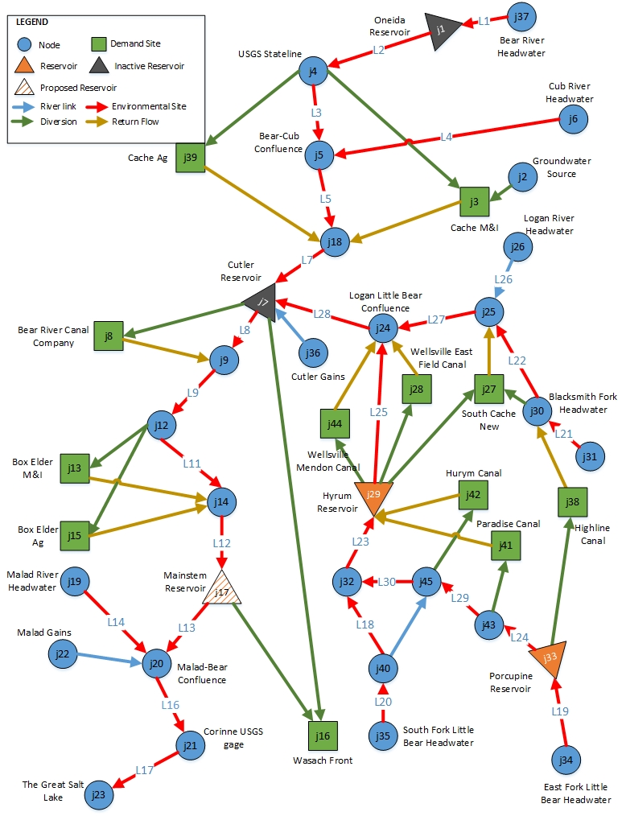

Figure 1. Lower Bear River network represented as a group of nodes and links

**Appendix B: Formulas used to develop suitability curves**

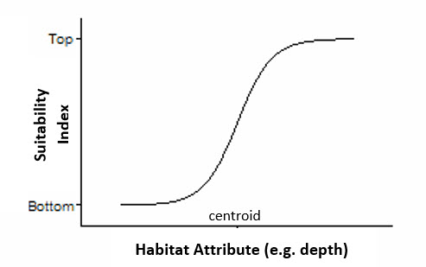

1. Boltzmann sigmoidal function

-- [1]

Figure 1. An example of Boltzmann sigmoidal function and the parameters required to define the equation

1. 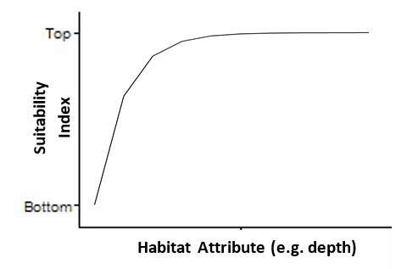Exponential decay function

-- [2]

Figure 2. An example of the exponential decay function and the parameters required to define the equation