SIMATS ENGINEERING
Saveetha Institute of Medical and Technical Sciences
ASSIGNMENT 4 – CO4
Designing Reusable Class Hierarchies
Field | Details
Student Name | S. Ayman Ibrahim
Register Number | 192573027
Course | Object Oriented Programming with C++ (DSA01)
Course Outcome | CO4 – Inheritance, virtual base classes, abstract classes, pointers and polymorphism
Bloom’s Level | K5 – Evaluate
Total Marks | 50
Nature | Individual
Compiler | g++ 13.3.0 (Ubuntu 24.04)
Compile command | g++ -std=c++17 -Wall -Wextra file.cpp -o file
GitHub repository | https://github.com/<your-username>/DSA01-192573027-Assignment4 (replace with your real link)

Contents: Task 1 Class Design Review (6) · Task 2 From Requirement to Hierarchy (8) · Task 3 Constructors and Member Classes (9) · Task 4 Pointers to Derived Classes: Forensics (7) · Task 5 Pointers to Objects and this (7) · Task 6 Design Challenge: Vehicle Rental Fleet (13) · Appendix: README and repository layout

TASK 1 – Class Design Review (6 Marks)

Task 1.1 – Diagnose the Design (2 Marks)
# | Deficiency | Why it is a problem
1 | Repeated fields and repeated pay rules | name, id, basic, da and the formula basic + basic*0.42 are copied in Professor and LabAssistant. A fix to the DA rule must be made in several places and can be missed.
2 | All data members are public | Any code can set basic to a negative value or change id. There is no encapsulation or validation.
3 | Inconsistent names for the same information | GuestFaculty uses nm and code where the others use name and id. Generic code cannot treat them alike.
4 | Unused da field | da is stored in Professor and LabAssistant but pay() never reads it (the rate 0.42 is hard-coded). It wastes memory and misleads readers.
5 | Magic number 0.42 | The DA percentage has no name and is duplicated. It cannot be changed in one place.
6 | Effort to add a new staff category | A new category needs a fresh class, copy-pasted fields and a copy of the pay logic, and every function that handles staff must be edited.
7 | Cannot process all staff in one loop | The three classes are unrelated, so there is no common type for a Staff* array or vector. A separate loop is needed per class.
8 | No constructors | Objects can exist with uninitialised data (double and int members are indeterminate).
9 | pay() is not const and no virtual destructor | pay() cannot be called on const objects, and deleting through a base pointer would be unsafe if a base were later added.

Task 1.2 – Repair the Design (3 Marks)
Professor and LabAssistant share “basic + DA” pay, so they share an intermediate class SalariedStaff. GuestFaculty is paid by hours so it derives directly from the abstract base Staff. Data is protected or private, DA_RATE is a named constant, and pay() is a pure virtual function overridden in every concrete class.
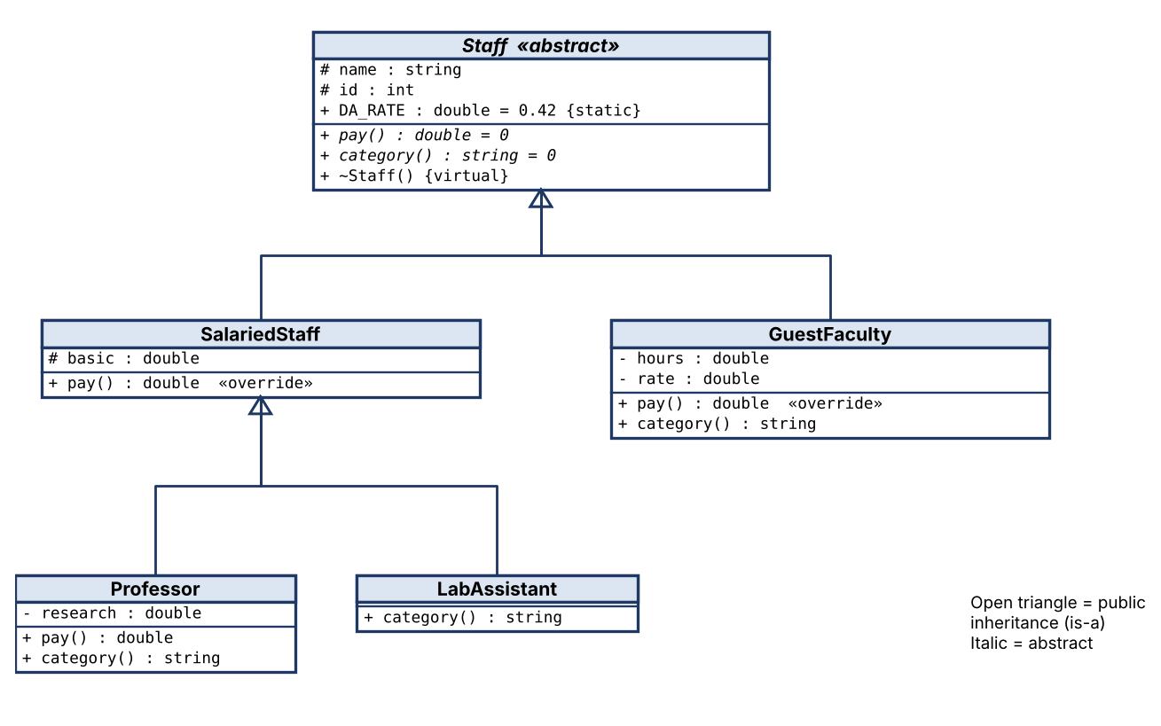
Figure 1: UML class diagram of the repaired payroll hierarchy.
#include <iostream>
#include <string>
#include <vector>
#include <memory>
#include <iomanip>

class Staff {
protected:
std::string name_;
int id_;
public:
static constexpr double DA_RATE = 0.42; // named constant replaces magic number 0.42
Staff(const std::string& n, int i) : name_(n), id_(i) {}
virtual ~Staff() = default;
virtual double pay() const = 0; // pure virtual: every category defines its own rule
virtual std::string category() const = 0;
const std::string& name() const { return name_; }
int id() const { return id_; }
};

class SalariedStaff : public Staff { // common rule: basic + DA
protected:
double basic_;
public:
SalariedStaff(const std::string& n, int i, double b) : Staff(n, i), basic_(b) {}
double pay() const override { return basic_ + basic_ * DA_RATE; }
};

class Professor : public SalariedStaff {
double research_;
public:
Professor(const std::string& n, int i, double b, double r) : SalariedStaff(n, i, b), research_(r) {}
double pay() const override { return SalariedStaff::pay() + research_; }
std::string category() const override { return "Professor"; }
};

class LabAssistant : public SalariedStaff {
public:
LabAssistant(const std::string& n, int i, double b) : SalariedStaff(n, i, b) {}
std::string category() const override { return "LabAssistant"; }
};

class GuestFaculty : public Staff {
double hours_, rate_;
public:
GuestFaculty(const std::string& n, int i, double h, double r) : Staff(n, i), hours_(h), rate_(r) {}
double pay() const override { return hours_ * rate_; }
std::string category() const override { return "GuestFaculty"; }
};

int main() {
std::vector<std::unique_ptr<Staff>> staff;
staff.push_back(std::make_unique<Professor>("Dr. Rao", 101, 80000, 15000));
staff.push_back(std::make_unique<LabAssistant>("Meena", 102, 30000));
staff.push_back(std::make_unique<GuestFaculty>("Mr. Khan", 103, 20, 1500));
std::cout << std::fixed << std::setprecision(2);
for (const auto& s : staff) // one loop for all staff
std::cout << std::setw(13) << std::left << s->category() << std::setw(10) << s->name()
<< std::right << std::setw(12) << s->pay() << '\n';
}

Output
Professor Dr. Rao 128600.00
LabAssistant Meena 42600.00
GuestFaculty Mr. Khan 30000.00

[Insert screenshot: Task01 output]
Check: Professor = 80000 + 80000×0.42 + 15000 = 128600. LabAssistant = 30000 + 12600 = 42600. GuestFaculty = 20 × 1500 = 30000.

Task 1.3 – Design Defence (1 Mark)
To add a new category, such as VisitingResearcher, I write one new derived class that inherits Staff (or SalariedStaff) and overrides pay() and category(). No existing class is edited, and the payroll loop over Staff pointers works immediately because the calls are virtual. Shared data and the 42% DA rule live once, in the hierarchy, so a policy change happens in one place. Protected members stop outside code corrupting salaries. This is the open–closed principle: open for extension, closed for modification, which lowers the risk of breaking working code. (≈ 85 words)

Alternative Concept and Complexity Analysis
Alternative: a single Staff class with a type field and a switch inside pay().
// Alternative: one Staff class with a type field and a switch
#include <iostream>
#include <string>
enum class Type { Professor, LabAssistant, Guest };
struct Staff {
Type type; std::string name; int id;
double basic = 0, research = 0, hours = 0, rate = 0; // unused fields for some types
double pay() const {
switch (type) {
case Type::Professor: return basic + basic * 0.42 + research;
case Type::LabAssistant: return basic + basic * 0.42;
case Type::Guest: return hours * rate;
}
return 0;
}
};
int main() {
Staff a{Type::Professor, "Dr. Rao", 101, 80000, 15000};
Staff b{Type::Guest, "Mr. Khan", 103, 0, 0, 20, 1500};
std::cout << a.pay() << ' ' << b.pay() << ' ' << sizeof(Staff) << '\n';
}

Criterion | Hierarchy (virtual pay) | Single class + switch
Time per pay() call | O(1): one indirect call through the vtable | O(1): one switch jump
Space per object (measured with sizeof, g++ x86-64) | Measured as plain data structs: Professor 56 B, LabAssistant 48 B, GuestFaculty 56 B (the real classes add one 8 B vtable pointer). Each object holds only the fields it needs. | One Staff = 80 B for every object. A LabAssistant wastes research, hours and rate (24 B) and a GuestFaculty wastes basic and research.
Places to change for a new type | 1: write the new class (and create it where needed). Existing classes untouched. | At least 4: add to the enum, add new fields to the class, add a case in pay(), and add a case in every other switch (category, print, validation).
Compiler help | A missing pay() override makes the class abstract, so the error appears at compile time. | A forgotten case silently returns a wrong value (warning only with -Wswitch).

Conclusion: both are O(1) per call and O(n) for n staff, but the hierarchy saves space per object and confines extension to one new class.

TASK 2 – From Requirement to Hierarchy (8 Marks)

Task 2.1 – Identify the Relationships (2 Marks)
Relationship | Is-a or Has-a | Type of inheritance / note
Student → Person | is-a (inheritance) | Single inheritance
Staff → Person | is-a (inheritance) | Single; together with Student it forms hierarchical inheritance (two classes from one base)
ResearchScholar → Student → Person | is-a | Multilevel inheritance
TeachingAssistant → Student and Staff | is-a (both) | Multiple inheritance
Person, Student, Staff, TeachingAssistant together | – | Hybrid inheritance (hierarchical + multiple), shaped like a diamond
Person has an Address | has-a (member class) | Composition: Address object is a member of Person
Student has a Course | has-a (member class) | Composition: Course object is a member of Student
ResearchScholar has a fellowship | has-a (data member) | The fellowship amount is an attribute; it is not a kind of Student

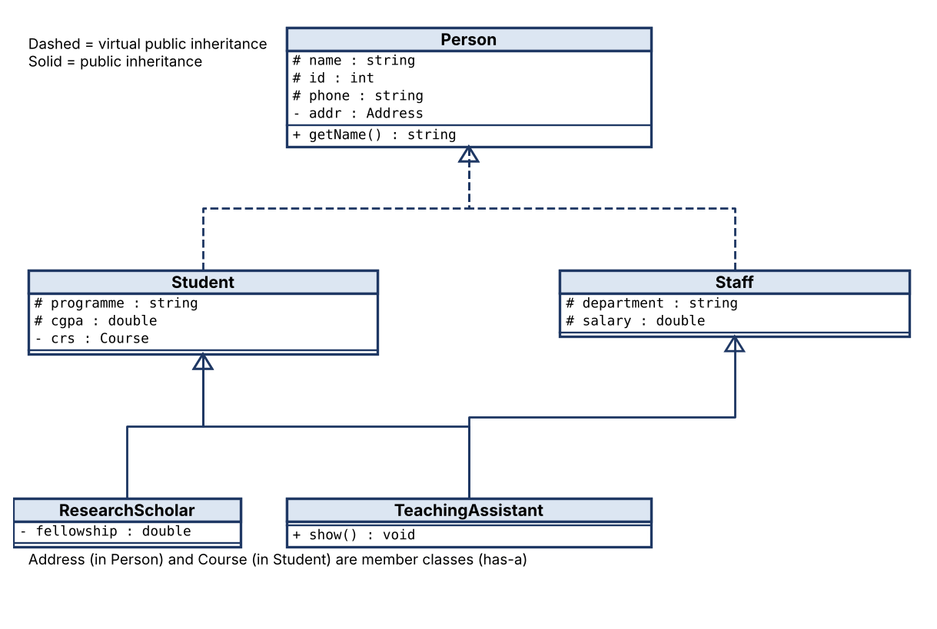
Figure 2: University hierarchy with a virtual base class.

Task 2.2 – Resolve the Diamond (2 Marks)
Problem. If Student and Staff both inherit Person normally, every TeachingAssistant contains two Person sub-objects (one inside Student, one inside Staff). Consequences: (1) ta.name is ambiguous and the compiler refuses it; (2) Person data is stored twice and the two copies can disagree; (3) the Person constructor runs twice; (4) a TeachingAssistant cannot be converted to a Person* without ambiguity.
Compiler message produced by g++ 13 for the non-virtual version:
Output
error: request for member 'name' is ambiguous
note: candidates are: 'std::string Person::name'
note: 'std::string Person::name'

Solution. Declare class Student : virtual public Person and class Staff : virtual public Person. A virtual base class is shared: one Person sub-object exists in the complete TeachingAssistant object, so ta.name is unambiguous, memory is saved, and Person is constructed once.

Task 2.3 – Design the Classes (3 Marks)
Every base is inherited publicly because each relationship is a true is-a (a Student can be used wherever a Person is expected). Protected or private inheritance would hide the Person interface from users and model “implemented in terms of”, which is wrong here. Student and Staff use virtual inheritance to resolve the diamond.
#include <iostream>
#include <string>
class Person {
protected:
std::string name; int id; std::string phone;
public:
Person(const std::string& n, int i, const std::string& p) : name(n), id(i), phone(p) {}
virtual ~Person() = default;
const std::string& getName() const { return name; }
};
class Student : public virtual Person {
protected:
std::string programme; double cgpa;
public:
Student(const std::string& n, int i, const std::string& p, const std::string& prog, double c)
: Person(n, i, p), programme(prog), cgpa(c) {}
};
class Staff : public virtual Person {
protected:
std::string department; double salary;
public:
Staff(const std::string& n, int i, const std::string& p, const std::string& d, double s)
: Person(n, i, p), department(d), salary(s) {}
};
class TeachingAssistant : public Student, public Staff {
public:
TeachingAssistant(const std::string& n, int i, const std::string& p,
const std::string& prog, double c, const std::string& d, double s)
: Person(n, i, p), Student(n, i, p, prog, c), Staff(n, i, p, d, s) {}
void show() const { std::cout << name << " | " << programme << " " << cgpa << " | " << department << " " << salary << '\n'; }
};
class ResearchScholar : public Student {
double fellowship;
public:
ResearchScholar(const std::string& n, int i, const std::string& p, const std::string& prog, double c, double f)
: Person(n, i, p), Student(n, i, p, prog, c), fellowship(f) {}
};
int main() {
TeachingAssistant ta("Ayman", 1, "99999", "MCA", 8.7, "CSE", 25000);
ta.show();
std::cout << ta.getName() << '\n';
std::cout << "sizeof(TA virtual) = " << sizeof(TeachingAssistant) << '\n';
}

Output
Ayman | MCA 8.7 | CSE 25000
Ayman
sizeof(TA virtual) = 176

[Insert screenshot: Task02 design output]

Task 2.4 – Access Table (1 Mark)
Access of Person members as seen in Student (S = inside Student member functions, O = outside code using a Student object):
Person member | Public inheritance | Protected inheritance | Private inheritance
public | public in Student  S: yes O: yes | protected in Student  S: yes O: no | private in Student  S: yes O: no
protected | protected in Student  S: yes O: no | protected in Student  S: yes O: no | private in Student  S: yes O: no
private | not accessible  S: no O: no | not accessible  S: no O: no | not accessible  S: no O: no

Rule: inheritance can only tighten access, never loosen it, and private members of the base are never directly accessible in the derived class.

Predict the Output
My predicted output (written before running): Person Student Staff TA (then a newline)
Output
Person Student Staff TA

[Insert screenshot: terminal showing this output]
Explanation / differences: The virtual base Person is constructed first, once, by the most derived class (TeachingAssistant). Then the direct bases are constructed in declaration order (Student, then Staff), and finally the body of TeachingAssistant runs. Prediction and actual output match, so there is no difference to explain. Person appears once because only one shared Person sub-object exists.
Experiment: remove “virtual” from both bases. Prediction: Person Student Person Staff TA. The program has no member access to Person, so it compiles with no errors or warnings. Verified output:
Output
Person Student Person Staff TA

Each of Student and Staff now owns its own Person sub-object, so Person’s constructor runs twice. Only accessing a Person member through TeachingAssistant (for example ta.name) would produce the “ambiguous” error shown in Task 2.2.

Alternative Concept and Complexity Analysis
Alternative: TeachingAssistant contains a Student object and a Staff object as members (has-a) instead of inheriting.
struct TA_Composition { Student s; Staff f; }; // two Person sub-objects, no is-a

Criterion | Virtual inheritance | Composition (has-a)
sizeof (measured, same fields) | sizeof(TA_Virtual) = 168 B (one Person, 72 B, plus vbptr) | sizeof(TA_Composition) = 224 B (two Person sub-objects, 72 B each, plus Student and Staff data)
Reaching name | ta.name: unambiguous, one name. Access goes through the virtual-base offset (one extra indirection), still O(1). | ta.s.name or ta.f.name: no compile-time ambiguity, but two independent names that can disagree. Direct offset, O(1).
Meaning | A TA is a Student and a Staff: can be passed to functions taking Student& or Staff&, polymorphism works. | A TA merely has a student part and a staff part; it cannot be used where a Student or Staff is expected.
Complexity | Time O(1), space one Person per object | Time O(1), space two Person sub-objects per object

TASK 3 – Constructors in Derived Classes and Member Classes (9 Marks)

Task 3.1 – Pass Values to Base Constructors (3 Marks)
Each constructor passes values to its base classes through the member initializer list. The complete program below (also used for 3.2, 3.3 and 3.4) shows Student, Staff and TeachingAssistant.
#include <iostream>
#include <string>
struct Address { std::string city; Address(const std::string& c) : city(c) { std::cout << "Address "; } ~Address() { std::cout << "~Address "; } };
struct Course { std::string t; Course(const std::string& c) : t(c) { std::cout << "Course "; } ~Course() { std::cout << "~Course "; } };
struct Person {
Address addr;
Person(const std::string& city) : addr(city) { std::cout << "Person "; }
virtual ~Person() { std::cout << "~Person "; }
};
struct Student : virtual Person {
Course crs;
Student(const std::string& city, const std::string& c) : Person(city), crs(c) { std::cout << "Student "; }
~Student() { std::cout << "~Student "; }
};
struct Staff : virtual Person {
Staff(const std::string& city) : Person(city) { std::cout << "Staff "; }
~Staff() { std::cout << "~Staff "; }
};
struct TeachingAssistant : Student, Staff {
TeachingAssistant(const std::string& city, const std::string& c)
: Person(city), Student(city, c), Staff(city) { std::cout << "TA "; }
~TeachingAssistant() { std::cout << "~TA "; }
};
int main() {
{ std::cout << "Student: "; Student s("Salem", "C++"); std::cout << "| "; } std::cout << '\n';
{ std::cout << "Staff: "; Staff f("Salem"); std::cout << "| "; } std::cout << '\n';
{ std::cout << "TA: "; TeachingAssistant t("Salem", "C++"); std::cout << "| "; } std::cout << '\n';
std::cout << "sizeof(TeachingAssistant) = " << sizeof(TeachingAssistant) << '\n';
}

Why the most-derived class must call the virtual base constructor directly. Student and Staff each might call Person(...) with different arguments. A TeachingAssistant has only one shared Person, so the compiler cannot choose between them. The C++ rule is that the most-derived class initialises every virtual base, and the Person(...) calls inside Student and Staff are ignored when a TeachingAssistant is built. That is why TeachingAssistant writes Person(city) itself.

Task 3.2 – Member Classes (2 Marks)
Person has a member Address addr, initialised in the Person constructor as addr(city). Student has a member Course crs, initialised as crs(c). Values reach member objects through the initializer list of the owning class, so the member is constructed directly with the right value instead of being default-constructed and then assigned.

Task 3.3 – Trace the Order (3 Marks)
Output
Student: Address Person Course Student | ~Student ~Course ~Person ~Address
Staff: Address Person Staff | ~Staff ~Person ~Address
TA: Address Person Course Student Staff TA | ~TA ~Staff ~Student ~Course ~Person ~Address
sizeof(TeachingAssistant) = 88

[Insert screenshot: Task03 trace output]
Object | Construction order | Destruction order
Student | Address, Person, Course, Student | ~Student, ~Course, ~Person, ~Address
Staff | Address, Person, Staff | ~Staff, ~Person, ~Address
TeachingAssistant | Address, Person, Course, Student, Staff, TA | ~TA, ~Staff, ~Student, ~Course, ~Person, ~Address

Rule observed. (1) Virtual base classes are constructed first, before any non-virtual base. (2) Then non-virtual bases, in the order they are declared in the class header (not the initializer-list order). (3) Then member objects, in declaration order. (4) Finally the body of the derived constructor. Within each class, its own members (Address in Person) are built before that class’s constructor body. Destruction is the exact reverse of construction.

Task 3.4 – Experiment (1 Mark)
After removing virtual from Student and Staff (and removing the direct Person(city) call from the TeachingAssistant initializer list, which is no longer allowed because Person is now an indirect base):
Output
TA: Address Person Course Student Address Person Staff TA | ~TA ~Staff ~Person ~Address ~Student ~Course ~Person ~Address
sizeof(TeachingAssistant) = 112

Person (with its Address) is constructed and destroyed twice, and sizeof(TeachingAssistant) grows from 88 to 112 bytes because there are two Person sub-objects and no virtual-base pointers.

Predict the Output
My predicted output (written before running): Vehicle Engine Car | ~Car ~Engine ~Vehicle (then a newline)
Output
Vehicle Engine Car | ~Car ~Engine ~Vehicle

[Insert screenshot: terminal showing this output]
Explanation / differences: No difference. The base class Vehicle is constructed first, then the member object Engine, then the body of Car prints “Car”. At the closing brace the order reverses: Car’s destructor body, then member Engine, then the base Vehicle.
Rule. Construction: base classes (virtual first), then member objects in declaration order, then the derived class body. Destruction: derived body, then member objects in reverse declaration order, then base classes in reverse order.

Complete the Code
TODO 1 (the only line added is the constructor):
#include <iostream>
#include <string>
class Person {
protected:
std::string name;
int age;
public:
Person(const std::string& n, int a) : name(n), age(a) {}
};
class Address { // used as a member class (composition)
std::string city;
int pin;
public:
Address(const std::string& c, int p) : city(c), pin(p) {}
std::string str() const { return city + "-" + std::to_string(pin); }};
class Student : public Person {
long long regNo;
Address home;
public:
Student(const std::string& n, int a, long long r, const std::string& city, int pin)
: Person(n, a), regNo(r), home(city, pin) {}
void print() const
{
std::cout << regNo << ' ' << name << " (" << age << ") " << home.str() << '\n';
}
};
int main()
{
Student s("Kavya", 19, 192311001, "Salem", 636001);
s.print();
}

Output
192311001 Kavya (19) Salem-636001

[Insert screenshot: Task03 complete-the-code output (matches expected output)]
Experiment: swap the initializer order (home(city, pin), regNo(r), Person(n, a)). The program still compiles, but g++ -Wall reports:
Output
warning: 'Student::home' will be initialized after [-Wreorder]
warning: 'long long int Student::regNo' [-Wreorder]
warning: when initialized here [-Wreorder]

Members and bases are always initialised in declaration order (base Person, then regNo, then home), not in the order written in the list. Writing them in a different order is misleading and dangerous if one member’s initial value depends on another.

Alternative Concept and Complexity Analysis
Alternative: Student holds Address* home = new Address(...).
#include <iostream>
#include <string>
class Address {
std::string city; int pin;
public:
Address(const std::string& c, int p) : city(c), pin(p) {}
std::string str() const { return city + "-" + std::to_string(pin); }
};
class Student {
std::string name; long long regNo;
Address* home; // pointer to heap object
public:
Student(const std::string& n, long long r, const std::string& c, int p)
: name(n), regNo(r), home(new Address(c, p)) {}
Student(const Student& o) : name(o.name), regNo(o.regNo), home(new Address(*o.home)) {} // deep copy
Student& operator=(const Student& o) { if (this != &o) { delete home; home = new Address(*o.home); name = o.name; regNo = o.regNo; } return *this; }
~Student() { delete home; } // release
void print() const { std::cout << regNo << ' ' << name << ' ' << home->str() << '\n'; }
};
int main() { Student s("Kavya", 192311001, "Salem", 636001); Student t = s; t.print(); std::cout << "sizeof(Student) = " << sizeof(Student) << '\n'; }

Criterion | Address member object | Address* to heap object
Allocation time | None: built inside the Student object | One extra new (and delete). Constant time O(1) but much slower than a stack construction (typically tens of nanoseconds, with possible fragmentation).
Space | sizeof(Address) inside Student | 8 B pointer inside Student (sizeof(Student) = 48 B here) plus the heap block and allocator overhead
Constructor | Initialiser list builds it | home(new Address(c, p)): allocates the object
Copy constructor | Compiler-generated copy is correct | Must make a deep copy: new Address(*o.home). The default shallow copy would make two Students share one Address.
Destructor | Automatic | Must delete home, otherwise a memory leak. With a shallow copy it would cause a double delete.

The rule of three (destructor, copy constructor, copy assignment) now applies. Total time for n Students stays O(n); space becomes n × (pointer + heap block).

TASK 4 – Pointers to Derived Classes: Forensics (7 Marks)

Task 4.1 – Locate the Defects (2 Marks)
Defect | Cause | Effect
Senior rate never used | rate() is not virtual. Through an Account* the function is chosen at compile time from the pointer type. | Both objects print 3.5. SeniorAccount::rate() (4.0) is never called.
Memory leak (and undefined behaviour) | ~Account() is not virtual. delete a with an Account* pointing at a SeniorAccount calls only ~Account(). | ~SeniorAccount() never runs, so history (new double[100] = 800 bytes) is never released.
Object slicing | Account copy = SeniorAccount() copies only the Account part into an Account object. | The SeniorAccount part (history, the 4.0 rate and its overrides) is cut off. copy.rate() gives 3.5. The same happens when pushing into vector<Account>.
Extra: raw owning pointer without copy control | SeniorAccount owns history but has no copy constructor or assignment. | A copy would share one array and cause a double delete.

Task 4.2 – Construct Evidence (2 Marks)
Original program with destructor messages added (compiled with g++ -std=c++17 -g -fsanitize=address):
#include <iostream>
#include <vector>
class Account { public: double rate() const { return 3.5; } ~Account() { std::cout << "~Account\n"; } };
class SeniorAccount : public Account {
double* history = new double[100];
public: double rate() const { return 4.0; } ~SeniorAccount() { std::cout << "~SeniorAccount\n"; delete[] history; } };
int main() {
Account* accounts[2] = { new Account, new SeniorAccount };
for (Account* a : accounts) std::cout << a->rate() << "\n";
for (Account* a : accounts) delete a;
Account copy = SeniorAccount(); // slicing
std::cout << "copy.rate() = " << copy.rate() << "\n";
}

Output
3.5
3.5
~Account
~Account
~SeniorAccount
~Account
copy.rate() = 3.5
~Account

Reading the output: the first two lines prove the rate defect (4.0 was expected for the second account). After the two delete statements only ~Account appears twice and ~SeniorAccount is missing, which proves the destructor defect. The next ~SeniorAccount ~Account belongs to the temporary SeniorAccount() in the last line, and copy.rate() = 3.5 proves slicing.
AddressSanitizer reports the wrong-type delete immediately:
Output
==ERROR: AddressSanitizer: new-delete-type-mismatch
object passed to delete has wrong type:
size of the allocated type: 8 bytes;
size of the deallocated type: 1 bytes.
#1 in main task4_buggy.cpp:10

With ASAN_OPTIONS=new_delete_type_mismatch=0 the run continues and LeakSanitizer reports the leak:
Output
ERROR: LeakSanitizer: detected memory leaks
Direct leak of 800 byte(s) in 1 object(s) allocated from:
#1 in SeniorAccount::SeniorAccount() task4_buggy.cpp:4
#2 in main task4_buggy.cpp:8
SUMMARY: AddressSanitizer: 800 byte(s) leaked in 1 allocation(s).

[Insert screenshot: ASan and LeakSanitizer reports]

Task 4.3 – Repair the Program (2 Marks)
#include <iostream>
#include <memory>
#include <vector>
class Account {
public:
virtual double rate() const { return 3.5; }
virtual ~Account() { std::cout << "~Account\n"; }
};
class SeniorAccount : public Account {
double* history = new double[100];
public:
double rate() const override { return 4.0; }
~SeniorAccount() override { std::cout << "~SeniorAccount\n"; delete[] history; }
SeniorAccount() = default;
SeniorAccount(const SeniorAccount&) = delete; // rule of three: no shallow copy
SeniorAccount& operator=(const SeniorAccount&) = delete;
};
int main() {
Account* accounts[2] = { new Account, new SeniorAccount };
for (Account* a : accounts) std::cout << a->rate() << "\n";
for (Account* a : accounts) delete a;
std::cout << "-- unique_ptr version --\n";
std::vector<std::unique_ptr<Account>> v;
v.push_back(std::make_unique<Account>());
v.push_back(std::make_unique<SeniorAccount>());
for (const auto& a : v) std::cout << a->rate() << "\n";
Account& ref = *v[1]; // reference instead of copy
std::cout << "via reference: " << ref.rate() << "\n";
}

Output
3.5
4
~Account
~SeniorAccount
~Account
-- unique_ptr version --
3.5
4
via reference: 4
~Account
~SeniorAccount
~Account

Now rate() prints 4 for the senior account, delete runs ~SeniorAccount() (then ~Account()), the sanitizer reports no error (exit code 0), and the last line uses a reference instead of a copy so nothing is sliced.

Task 4.4 – Prevent Recurrence (1 Mark)
- A base class that has virtual functions or is deleted through a base pointer must have a virtual destructor.
- Mark every overriding function with override (and make the base function virtual). The compiler then rejects a function that does not really override.
Additional safeguards: store polymorphic objects by pointer or reference (or smart pointer), never by value; follow the rule of three/five; test with -fsanitize=address and -Wall -Wextra.

Predict the Output
My predicted output (written before running): 3.5 4 3.5 (then a newline)
Output
3.5 4 3.5

[Insert screenshot: terminal showing this output]
Explanation / differences: No difference. p->rate() is not virtual, so the call is bound at compile time from the static type Account* and calls Account::rate() = 3.5. p->vrate() is virtual, so it is bound at run time to the real object (SeniorAccount) and returns 4. copy is a plain Account initialised from s: only the Account sub-object is copied (slicing), its dynamic type is Account, so copy.vrate() calls Account::vrate() = 3.5.

Alternative Concept and Complexity Analysis
Alternative: std::vector<std::unique_ptr<Account>> instead of raw pointers deleted by hand (this is the second half of the repaired program above).
Criterion | Raw pointers + manual delete | vector of unique_ptr
Time to process n accounts | O(n) | O(n): same loop. The virtual call and deletion cost are the same.
Space | n raw pointers (8 B each) | n unique_ptr (8 B each with the default deleter): the same
Forgetting delete (leak) | Possible | Prevented: the destructor of the vector deletes every element automatically
Double delete | Possible | Prevented: unique_ptr cannot be copied
Copy by value / slicing | Possible | Copying the pointer is a compile error, but Account x = *v[1]; still slices
Non-virtual rate() | Possible | Still possible: smart pointers do not fix binding
Non-virtual destructor | Possible | Still possible and still undefined behaviour: unique_ptr<Account> deletes through Account*, so ~Account must be virtual

Of the three defects, the leak from a forgotten delete is removed by unique_ptr, but the non-virtual function and the non-virtual destructor must still be fixed in the class design, and slicing is only blocked when the copy goes through the smart pointer.

TASK 5 – Pointers to Objects and the this Pointer (7 Marks)

Task 5.1 – Four Ways to Reach an Object (3 Marks)
The program uses (a) the object by name, (b) a pointer with ->, (c) a reference, and (d) a pointer from new released with delete. add() returns *this so calls can be chained, and setDiscount() uses this-> to separate the member from the parameter with the same name. Section 5.2 (array of pointers) is in the same file.
#include <iomanip>
#include <iostream>
#include <string>
class Cart {
std::string items[10]; double prices[10]; int n = 0; double discount = 0;
public:
Cart& add(const std::string& item, double price) { if (n < 10) { items[n] = item; prices[n] = price; ++n; } return *this; }
Cart& setDiscount(double discount) { this->discount = discount; return *this; }
double total() const { double t = 0; for (int i = 0; i < n; ++i) t += prices[i]; return t * (100 - discount) / 100; }
};
void viaRef(Cart& c) { c.add("Tea", 50); }
int main() {
std::cout << std::fixed << std::setprecision(2);
Cart a; // (a) directly by name
a.add("Rice", 60).add("Dal", 120).setDiscount(10);
Cart* p = &a; // (b) through a pointer
p->add("Oil", 180);
viaRef(a); // (c) through a reference
Cart* h = new Cart; // (d) heap object
h->add("Milk", 30).add("Bread", 40);
std::cout << "a = " << a.total() << " h = " << h->total() << '\n';
delete h;
// Task 5.2: array of pointers, find highest total
Cart* carts[3] = { new Cart, new Cart, new Cart };
carts[0]->add("A", 100); carts[1]->add("B", 500); carts[2]->add("C", 250);
Cart** best = carts;
for (Cart** q = carts + 1; q != carts + 3; ++q) if ((*q)->total() > (*best)->total()) best = q;
std::cout << "highest: index " << (best - carts) << " total " << (*best)->total() << '\n';
for (Cart* c : carts) delete c;
}

Output
a = 369.00 h = 70.00
highest: index 1 total 500.00

[Insert screenshot: Task05 output]
Check: cart a = (60 + 120 + 180 + 50) × 0.90 = 369.00. Cart h = 30 + 40 = 70.00.

Task 5.2 – Change the Requirement (2 Marks)
The code above keeps Cart* carts[3] and finds the highest total with a pointer-to-pointer that walks the array (pointer arithmetic: q = carts + 1 … carts + 3). best - carts gives the index. The search is O(n) and calls total() once per comparison. Each cart is deleted at the end.

Task 5.3 – Compare (2 Marks)
Way | Safety | Lifetime | Use when
(a) By name | Safest: cannot be null or dangling | Automatic: ends at the closing brace | The default choice for local objects
(b) Pointer -> | Can be null or dangling; needs checks | Does not own the object | Optional objects, arrays of objects, reseating
(c) Reference | Cannot be null, cannot be reseated | Does not own the object; must not outlive it | Function parameters and return values (and chaining with Cart&)
(d) new / delete | Risk of leak, double delete, dangling | Manual: until delete is called | Size or lifetime decided at run time, polymorphic objects (prefer unique_ptr)

Why this is a pointer. A member function receives the address of the object it was called on as a hidden first argument. This mechanism existed before references were added to C++, so this has pointer type (Cart* const in a non-const member, const Cart* const in a const member). *this is the object itself: dereferencing the pointer gives the object (type Cart&), so return *this returns the same object, not a copy.

Complete the Code
TODO 1 (add) and TODO 2 (setDiscount) completed; nothing else changed:
#include <iomanip>
#include <iostream>
#include <string>
class Cart {
std::string items[10];
double prices[10];
int n = 0;
double discount = 0; // percent
public:
Cart& add(const std::string& item, double price)
{
if (n < 10) { items[n] = item; prices[n] = price; ++n; }
return *this;
}
Cart& setDiscount(double discount)
{
this->discount = discount;
return *this;
}
double total() const
{
double t = 0;
for (int i = 0; i < n; ++i) t += prices[i];
return t * (100 - discount) / 100;
}
};
int main()
{ Cart c;
c.add("Rice", 60).add("Dal", 120).setDiscount(10);
Cart* p = &c; // pointer to an object
p->add("Oil", 180);
std::cout << std::fixed << std::setprecision(2) << p->total() << '\n';
}

Output
324.00

[Insert screenshot: Task05 complete-the-code output (matches expected output)]
Check: (60 + 120 + 180) × 90 / 100 = 324.00.
What if add() returned Cart instead of Cart&? The return statement would copy *this into a temporary object. In c.add("Rice", 60).add("Dal", 120).setDiscount(10); only the first add() changes c. The second add() and setDiscount() modify the temporary copy, which is destroyed at the end of the statement. The program would then print 240.00 (only Rice and Oil, with no discount: 60 + 180) instead of 324.00. Each call also copies the whole 10-item cart (about 416 bytes). A small demonstration (task5_nocopy.cpp) printed 1 instead of 3 after three chained add() calls.
Output
1

Alternative Concept and Complexity Analysis
Alternative: std::vector<Cart> (objects) instead of an array of Cart*.
Criterion | Array of Cart* | vector<Cart>
Time to find highest total | O(n); one pointer dereference per element | O(n); elements are contiguous so the cache is used better
Space | One pointer (8 B) per cart in the array plus each Cart (416 B) on the heap | Each Cart (sizeof = 416 B) is stored in the vector. Pushing a Cart copies or moves 416 B.
Ownership | You must delete each Cart | Vector owns and destroys the objects
When the container grows | Cart objects do not move; pointers to them stay valid | Reallocation moves every Cart: pointers and references into the vector become dangling

Measured: after reserve(1) and two more emplace_back calls, the address of element 0 changed (“address changed (dangling)”). Keeping a Cart* from &v[0] across push_back is therefore a bug; use indices or reserve() in advance.

TASK 6 – Design Challenge: Vehicle Rental Fleet (13 Marks)

Stage 1 – Interpret the Problem (2 Marks)
Entity | Data | Behaviour that differs
Vehicle (all) | registration number, daily rate, rented flag | Rental charge
Bicycle | only the common data | days × rate (+ late charge)
Motor vehicle | fuel/charge level, service due date | Adds fuel or charge cost
Two-wheeler | as motor vehicle | days × rate + litres × per-litre price
Car | seating capacity | days × rate + litres × per-litre price
Electric car | battery capacity (kWh) | days × rate + kWh × per-kWh price (not per litre)
Future: electric bus | passengers | Added later without changing existing classes

Requirements as testable statements:
- R1: Every vehicle has a registration number and a daily rate. Test: list() shows them for all vehicles.
- R2: Renting an available vehicle marks it rented; renting it again throws an error.
- R3: Returning a vehicle that is not rented throws an error.
- R4: Bicycle charge = days × rate. Test: 2 days at 100 gives 200.00.
- R5: Two-wheeler and car charge = days × rate + litres × 100. Test: two-wheeler, 3 days at 400 and 4 litres, on time gives 1600.
- R6: Electric car charge uses 12 per kWh instead of 100 per litre. Test: 3 days at 2000 and 25 kWh gives 6300.
- R7: A late day costs 1.5 × the daily rate. Test: car, 2 days at 1500, 2 days late, 10 litres gives 8500.
- R8: A new vehicle type can be added by writing one new class; no existing class changes.
- R9: Motor vehicles carry a level and a service due date; cars carry seats; electric cars carry battery capacity.

Stage 2 – Propose the Hierarchy (2 Marks)
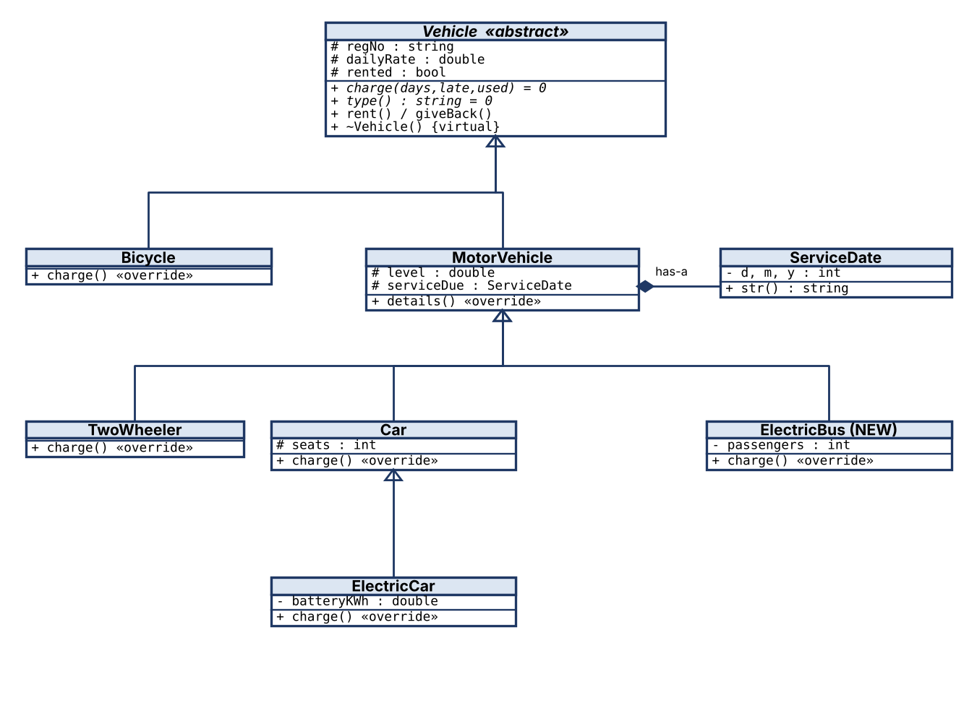
Figure 3: Fleet hierarchy. Vehicle is abstract (pure virtual charge() and type()). All inheritance is public single inheritance (Bicycle and MotorVehicle from Vehicle; multilevel for Vehicle → MotorVehicle → Car → ElectricCar). ServiceDate is a member class of MotorVehicle (composition).

Stage 3 – Critical Design Decisions (2 Marks)
Decision | Choice and reason
Vehicle (abstract) | regNo, dailyRate, rented, late-charge helper, rent() and giveBack(). Pure virtual charge() and type() force every kind to define its own rule.
MotorVehicle | level and ServiceDate: only motor vehicles have them, so bicycles do not carry unused fields.
Virtual functions | charge(), type(), details() and the destructor. Rental logic calls charge() through a Vehicle*.
Non-virtual | lateCharge(), rent(), isRented(): the same for all types (written once).
Storage | Fleet keeps an array Vehicle* v_[20]. Fleet owns the vehicles and deletes them through the virtual destructor. Copying Fleet is deleted to avoid double deletion.
Inheritance type | Public everywhere (is-a). No diamond exists, so virtual bases are not needed.
Constants | LATE_FACTOR = 1.5, PER_LITRE = 100, PER_KWH = 12 are named constants, not magic numbers.

Stage 4 – Design the Classes (4 Marks)
Pseudocode (structured, language-independent):
ALGORITHM RentVehicle(fleet, regNo)
INPUT : fleet (array of Vehicle pointers), regNo
OUTPUT: vehicle marked as rented
v <- FleetFind(fleet, regNo)
IF v = NULL THEN RAISE "vehicle not found"
IF v.rented = TRUE THEN RAISE "already rented"
v.rented <- TRUE
END ALGORITHM

ALGORITHM ReturnVehicle(fleet, regNo, days, lateDays, used)
INPUT : regNo, days rented, lateDays beyond agreed period,
used = litres (fuel types) or kWh (electric types)
OUTPUT: total charge
v <- FleetFind(fleet, regNo)
IF v = NULL THEN RAISE "vehicle not found"
IF v.rented = FALSE THEN RAISE "not rented"
v.rented <- FALSE
total <- v.charge(days, lateDays, used) // virtual: runs the rule of the real type
RETURN total
END ALGORITHM

ALGORITHM Charge (each type overrides)
Bicycle : days*rate + lateDays*rate*1.5
Two-wheeler : days*rate + used*100 + lateDays*rate*1.5
Car : days*rate + used*100 + lateDays*rate*1.5
ElectricCar : days*rate + used*12 + lateDays*rate*1.5
ElectricBus : days*rate + used*20 + lateDays*rate*1.5
END ALGORITHM

Class declarations are in the implementation below (Stage 5). Note: the exact layout rules of the SIMATS pseudocode standard document were not available while preparing this report; adjust keywords to match your handout if it differs.

Stage 5 – Implement and Demonstrate (3 Marks)
ElectricBus was added after the other classes as a new class only. Nothing above it in the file is edited, and Fleet and main work with it through Vehicle*.
// Task 6 - Vehicle Rental Fleet
#include <iostream>
#include <iomanip>
#include <string>
#include <stdexcept>

// ---------- member class (has-a) ----------
class ServiceDate {
int d_, m_, y_;
public:
ServiceDate(int d, int m, int y) : d_(d), m_(m), y_(y) {}
std::string str() const { return std::to_string(d_) + "/" + std::to_string(m_) + "/" + std::to_string(y_); }
};

// ---------- abstract base ----------
class Vehicle {
protected:
std::string regNo_;
double dailyRate_;
bool rented_ = false;
static constexpr double LATE_FACTOR = 1.5; // late days cost 150% of the daily rate
public:
Vehicle(const std::string& r, double rate) : regNo_(r), dailyRate_(rate) {}
virtual ~Vehicle() = default;
virtual double charge(int days, int lateDays, double used) const = 0; // pure virtual
virtual std::string type() const = 0;
virtual std::string details() const { return ""; }
double lateCharge(int lateDays) const { return lateDays * dailyRate_ * LATE_FACTOR; }
bool isRented() const { return rented_; }
const std::string& regNo() const { return regNo_; }
void rent() { if (rented_) throw std::runtime_error(regNo_ + " already rented"); rented_ = true; }
double giveBack(int days, int lateDays, double used) {
if (!rented_) throw std::runtime_error(regNo_ + " is not rented");
rented_ = false;
return charge(days, lateDays, used);
}
};

class Bicycle : public Vehicle {
public:
Bicycle(const std::string& r, double rate) : Vehicle(r, rate) {}
double charge(int days, int late, double) const override { return days * dailyRate_ + lateCharge(late); }
std::string type() const override { return "Bicycle"; }
};

class MotorVehicle : public Vehicle {
protected:
double level_; // fuel litres or charge %
ServiceDate serviceDue_; // member class
public:
MotorVehicle(const std::string& r, double rate, double level, const ServiceDate& s)
: Vehicle(r, rate), level_(level), serviceDue_(s) {}
std::string details() const override { return "level=" + std::to_string((int)level_) + " service due " + serviceDue_.str(); }
};

class TwoWheeler : public MotorVehicle {
static constexpr double PER_LITRE = 100;
public:
using MotorVehicle::MotorVehicle;
double charge(int days, int late, double litres) const override { return days * dailyRate_ + litres * PER_LITRE + lateCharge(late); }
std::string type() const override { return "TwoWheeler"; }
};

class Car : public MotorVehicle {
protected:
int seats_;
static constexpr double PER_LITRE = 100;
public:
Car(const std::string& r, double rate, double level, const ServiceDate& s, int seats)
: MotorVehicle(r, rate, level, s), seats_(seats) {}
double charge(int days, int late, double litres) const override { return days * dailyRate_ + litres * PER_LITRE + lateCharge(late); }
std::string type() const override { return "Car"; }
std::string details() const override { return MotorVehicle::details() + " seats=" + std::to_string(seats_); }
};

class ElectricCar : public Car {
double batteryKWh_;
static constexpr double PER_KWH = 12;
public:
ElectricCar(const std::string& r, double rate, double level, const ServiceDate& s, int seats, double kwh)
: Car(r, rate, level, s, seats), batteryKWh_(kwh) {}
double charge(int days, int late, double kwhUsed) const override { return days * dailyRate_ + kwhUsed * PER_KWH + lateCharge(late); }
std::string type() const override { return "ElectricCar"; }
std::string details() const override { return Car::details() + " battery=" + std::to_string((int)batteryKWh_) + "kWh"; }
};

// ---------- NEW TYPE added later: no existing class is edited ----------
class ElectricBus : public MotorVehicle {
int passengers_; static constexpr double PER_KWH = 20;
public:
ElectricBus(const std::string& r, double rate, double level, const ServiceDate& s, int p)
: MotorVehicle(r, rate, level, s), passengers_(p) {}
double charge(int days, int late, double kwh) const override { return days * dailyRate_ + kwh * PER_KWH + lateCharge(late); }
std::string type() const override { return "ElectricBus"; }
std::string details() const override { return MotorVehicle::details() + " passengers=" + std::to_string(passengers_); }
};

// ---------- fleet: array of base-class pointers ----------
class Fleet {
static const int MAX = 20;
Vehicle* v_[MAX];
int n_ = 0;
public:
Fleet() = default;
Fleet(const Fleet&) = delete;
Fleet& operator=(const Fleet&) = delete;
~Fleet() { for (int i = 0; i < n_; ++i) delete v_[i]; }
void add(Vehicle* v) { if (n_ < MAX) v_[n_++] = v; else delete v; }
Vehicle* find(const std::string& reg) const { for (int i = 0; i < n_; ++i) if (v_[i]->regNo() == reg) return v_[i]; return nullptr; }
void list() const {
for (int i = 0; i < n_; ++i)
std::cout << std::left << std::setw(8) << v_[i]->regNo() << std::setw(12) << v_[i]->type()
<< std::setw(10) << (v_[i]->isRented() ? "RENTED" : "available") << v_[i]->details() << '\n';
}
};

int main() {
std::cout << std::fixed << std::setprecision(2);
Fleet f;
f.add(new Bicycle("BC-01", 100));
f.add(new TwoWheeler("TW-01", 400, 5, ServiceDate(1, 12, 2026)));
f.add(new Car("CR-01", 1500, 30, ServiceDate(15, 1, 2027), 5));
f.add(new ElectricCar("EC-01", 2000, 80, ServiceDate(10, 2, 2027), 5, 40));
f.add(new ElectricBus("EB-01", 6000, 90, ServiceDate(5, 3, 2027), 30)); // new type, no existing class changed
std::cout << "--- Fleet ---\n"; f.list();
for (const char* r : {"BC-01", "TW-01", "CR-01", "EC-01", "EB-01"}) f.find(r)->rent();
std::cout << "--- After renting all ---\n"; f.list();

struct Ret { const char* reg; int days, late; double used; };
Ret rets[] = { {"BC-01", 2, 0, 0}, {"TW-01", 3, 1, 4}, {"CR-01", 2, 2, 10}, {"EC-01", 3, 0, 25}, {"EB-01", 1, 1, 50} };
std::cout << "--- Returns (days, late days, litres/kWh used) ---\n";
for (const auto& r : rets) {
Vehicle* v = f.find(r.reg);
double amt = v->giveBack(r.days, r.late, r.used);
std::cout << std::left << std::setw(8) << r.reg << std::setw(12) << v->type() << "days=" << r.days << " late=" << r.late
<< " used=" << std::setw(5) << r.used << " charge = " << std::right << std::setw(9) << amt << std::left << '\n';
}
try { f.find("BC-01")->giveBack(1, 0, 0); } catch (const std::exception& e) { std::cout << "Error: " << e.what() << '\n'; }
std::cout << "--- Final ---\n"; f.list();
}

Output
--- Fleet ---
BC-01 Bicycle available
TW-01 TwoWheeler available level=5 service due 1/12/2026
CR-01 Car available level=30 service due 15/1/2027 seats=5
EC-01 ElectricCar available level=80 service due 10/2/2027 seats=5 battery=40kWh
EB-01 ElectricBus available level=90 service due 5/3/2027 passengers=30
--- After renting all ---
BC-01 Bicycle RENTED
TW-01 TwoWheeler RENTED level=5 service due 1/12/2026
CR-01 Car RENTED level=30 service due 15/1/2027 seats=5
EC-01 ElectricCar RENTED level=80 service due 10/2/2027 seats=5 battery=40kWh
EB-01 ElectricBus RENTED level=90 service due 5/3/2027 passengers=30
--- Returns (days, late days, litres/kWh used) ---
BC-01 Bicycle days=2 late=0 used=0.00 charge = 200.00
TW-01 TwoWheeler days=3 late=1 used=4.00 charge = 2200.00
CR-01 Car days=2 late=2 used=10.00 charge = 8500.00
EC-01 ElectricCar days=3 late=0 used=25.00 charge = 6300.00
EB-01 ElectricBus days=1 late=1 used=50.00 charge = 16000.00
Error: BC-01 is not rented
--- Final ---
(all five vehicles available again)

[Insert screenshot: Task06 demonstration output]
Vehicle | Calculation | Result
Bicycle | 2 × 100 | 200.00
Two-wheeler (1 day late) | 3 × 400 + 4 × 100 + 1 × 400 × 1.5 = 1200 + 400 + 600 | 2200.00
Car (2 days late) | 2 × 1500 + 10 × 100 + 2 × 1500 × 1.5 = 3000 + 1000 + 4500 | 8500.00
Electric car | 3 × 2000 + 25 × 12 = 6000 + 300 | 6300.00
Electric bus (1 day late) | 1 × 6000 + 50 × 20 + 1 × 6000 × 1.5 = 6000 + 1000 + 9000 | 16000.00

The error line shows R3 (returning a vehicle that is not rented) is rejected. All five types, including the new ElectricBus, were rented, returned with late charges and listed through the same Vehicle* array.

Alternative Concept and Complexity Analysis
Alternative: one Vehicle class with a type code and a switch inside charge().
#include <iostream>
#include <string>
enum class VType { Bicycle, TwoWheeler, Car, ElectricCar };
struct Vehicle {
VType type; std::string regNo; double dailyRate;
double level = 0; int seats = 0; double batteryKWh = 0; // unused for some types
double charge(int days, int late, double used) const {
double late_c = late * dailyRate * 1.5;
switch (type) {
case VType::Bicycle: return days * dailyRate + late_c;
case VType::TwoWheeler:
case VType::Car: return days * dailyRate + used * 100 + late_c;
case VType::ElectricCar:return days * dailyRate + used * 12 + late_c;
}
return 0;
}
};
int main() { Vehicle v{VType::Car, "CR-01", 1500}; std::cout << v.charge(2, 2, 10) << ' ' << sizeof(Vehicle) << '\n'; }

Criterion | Abstract base + virtual charge() | Single class + switch
Time per charge() call | O(1): vtable pointer load plus indirect call | O(1): compare/jump table
Measured (5,000,000 calls, g++ -O2) | 38.4 ms (virtual calls through heap objects, includes pointer chasing) | 16.1 ms (switch over a flat int array)
Space per object | One vtable pointer (8 B), only the fields the type needs | sizeof(Vehicle) = 72 B for all types: level, seats and batteryKWh are unused by a bicycle, and so on
Classes changed for a new type (electric bus) | 0 existing classes; 1 new class | The enum, the Vehicle class (new fields), the charge() switch and every other switch
Safety | Missing override is a compile error (abstract class) | A missing case silently returns 0

The switch is faster in this micro-benchmark, but the two timings are not comparable like for like (heap objects versus a flat array), and in real code the difference per call is a few nanoseconds. Both are O(1) per call and O(n) for n vehicles. The virtual design wins on extensibility: the requirement that new vehicle types be added without changing existing classes is only met by the hierarchy.

Appendix – Repository Layout and README
Repository name: DSA01-192573027-Assignment4 (public, or private with the faculty added as collaborator). Commit at least once per task.
DSA01-192573027-Assignment4/
README.md
Task01/ task1.cpp task1_alt.cpp output.png
Task02/ task2_predict.cpp task2_novirtual.cpp task2_ambig.cpp task2_design.cpp task2_alt.cpp output.png
Task03/ task3_trace.cpp task3_novirtual.cpp task3_predict.cpp task3_complete.cpp task3_swapped.cpp task3_alt.cpp
Task04/ task4_buggy.cpp task4_fixed.cpp task4_predict.cpp asan_report.png
Task05/ task5_cart.cpp task5_ways.cpp task5_nocopy.cpp
Task06/ task6_fleet.cpp task6_alt.cpp

# Name: S. Ayman Ibrahim Register number: 192573027
Compiler: g++ 13.3.0
Compile : g++ -std=c++17 -Wall -Wextra <file>.cpp -o <file>
Run : ./<file>
Sanitizer (Task 4): g++ -std=c++17 -g -fsanitize=address task4_buggy.cpp -o t4b && ./t4b

Task 1: abstract Staff hierarchy; one loop prints pay of all staff.
Task 2: virtual base removes the duplicate Person; access table in report.
Task 3: construction order Address, Person, Course, Student ...; destruction reversed.
Task 4: ASan shows new-delete-type-mismatch and an 800-byte leak; fixed with virtual.
Task 5: cart chaining with *this; array-of-pointers search prints highest total.
Task 6: fleet of 5 vehicle types; ElectricBus added without editing existing classes.

Suggested commit messages: “Task 1: payroll hierarchy”, “Task 2: virtual base and access table”, “Task 3: constructor trace and experiments”, “Task 4: ASan evidence and repaired accounts”, “Task 5: Cart with this pointer”, “Task 6: vehicle fleet”, “Add README”.

