SIMATS ENGINEERING
OPERATING SYSTEMS – SCENARIO BASED ASSESSMENT
CO2 AT2
Course Code & Course Name
CSA0401 – OPERATING SYSTEMS
Submitted By
Name: S.Ayman Ibrahim
Register Number: 192573027
Programme: B.Tech CSE with Data Science
Submitted To
Dr. Ruby Elizabeth J

Question 1 — CPU Scheduling in a Real-Time Ticket Booking System
A railway ticket booking system experiences heavy load during festival seasons. The system handles three categories of processes:
• P1 – Payment gateway transactions (High priority)
• P2 – Seat availability checks (Medium priority)
• P3 – Ticket confirmation and printing (Low priority)
• Burst times vary from 2 ms to 20 ms.
Recently, customers complained that ticket confirmations are taking too long.
Tasks:
• Identify the most suitable scheduling algorithm (FCFS, SJF, Priority, RR) for this scenario.
• Justify why your chosen method improves CPU utilization and reduces customer wait time.
• Provide a sample execution order for the above categories.
• Discuss one drawback of this scheduling method in real-time systems.
Answer
1. Most Suitable Scheduling Algorithm
The most suitable algorithm for this scenario is Priority Scheduling (Preemptive). Each category of process is already ranked by importance to the business: payment transactions are the most critical, seat availability checks are moderately important, and ticket confirmation/printing is the least time-critical. Priority scheduling lets the CPU serve processes in this exact order of importance, which matches the real-time nature of the ticket booking system.
2. Justification
If a simple FCFS approach were used, a long ticket-printing job (up to 20 ms) that arrives first could block a payment transaction that only needs 2 ms, which would delay the customer's payment confirmation. With Preemptive Priority Scheduling, a High priority process (P1) can interrupt a currently running Medium or Low priority process and get the CPU immediately.
This improves CPU utilization because the CPU is always spent on the process that matters most to completing a booking (the payment). It reduces customer wait time because payment gateway responses, which the customer is directly watching, are no longer stuck behind slower background tasks such as printing.
3. Sample Execution Order
The exact number of processes and their individual burst times are not given in the question, only that burst times vary between 2 ms and 20 ms. To illustrate the execution order, the following sample burst times (within the given 2–20 ms range) are assumed:
Process | Category | Priority | Burst Time (ms)
P1 | Payment gateway transaction | High (1) | 4
P2 | Seat availability check | Medium (2) | 10
P3 | Ticket confirmation & printing | Low (3) | 18

Under Preemptive Priority Scheduling, the CPU always picks the highest priority process available. If all three arrive together at time 0, the execution order is:
P1 → P2 → P3
Gantt Chart
P1 | P2 | P3
0 – 4 ms | 4 – 14 ms | 14 – 32 ms

If a new P1 (payment) arrives while P2 or P3 is running, it preempts the running process immediately, executes fully, and then the interrupted process resumes from where it left off. This keeps payment transactions almost instantly served even under heavy festival-season load.
4. Drawback of This Scheduling Method
The main drawback is starvation of low priority processes. Since payment transactions (P1) and seat checks (P2) keep arriving continuously during a festival sale, the ticket confirmation and printing jobs (P3) can be preempted again and again and may never get enough CPU time to finish. This directly explains the customer complaint given in the scenario — ticket confirmations take too long because they are always pushed behind higher priority payment and seat-check work. A technique such as priority aging (gradually increasing the priority of a process the longer it waits) can be used to prevent this starvation.

Question 2 — Deadlock in a Banking Transaction Server
A bank server handles the following operations simultaneously:
• T1: Transfers money between accounts
• T2: Updates passbook entries
• T3: Generates monthly statements
Due to simultaneous locking of Account Database (A), Customer Info Database (B), and Transaction Logs (C), the system enters a state where:
• T1 holds A and requests B
• T2 holds B and requests C
• T3 holds C and requests A
Tasks:
• Draw the resource request situation (text-based RAG).
• Identify whether a deadlock has occurred and justify your answer.
• Recommend one specific technique (avoidance/prevention/recovery) and explain how it fixes the issue.
• Suggest a redesign for the locking order to avoid future deadlocks.
Answer
1. Resource Allocation Graph (RAG)
Nodes: T1, T2, T3 are process nodes (circles). A, B, C are resource nodes (rectangles). A solid arrow from a resource to a process is an allocation edge (resource is currently held by the process). A dashed arrow from a process to a resource is a request edge (process is waiting for that resource).
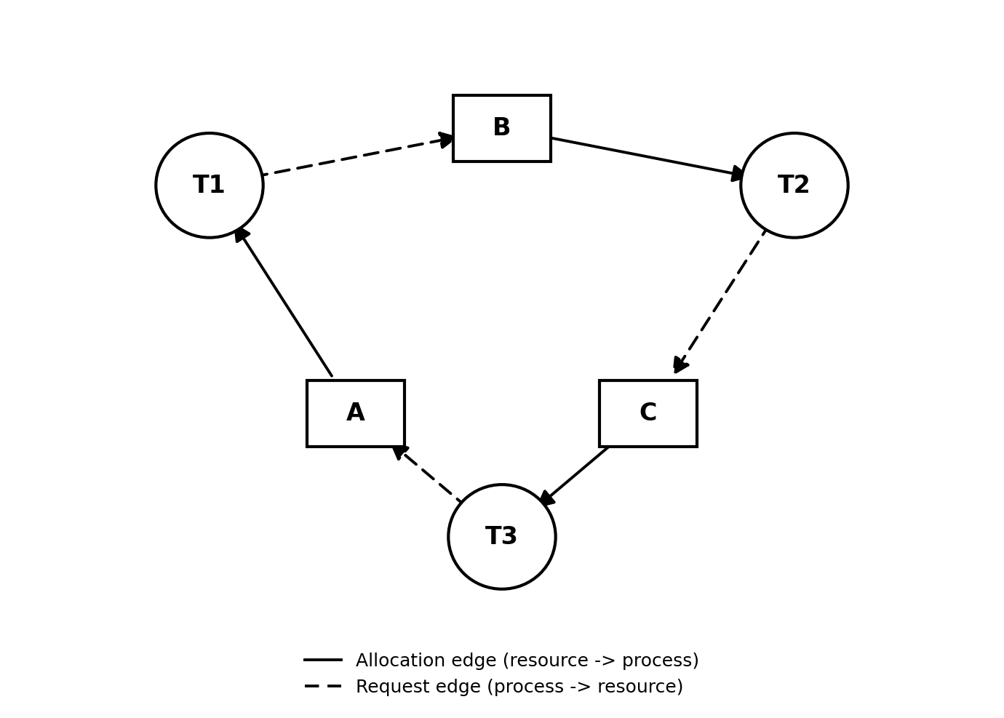
Allocation edges: A → T1, B → T2, C → T3
Request edges: T1 → B, T2 → C, T3 → A
2. Deadlock Identification
Following the edges: T1 holds A and requests B, which is held by T2. T2 requests C, which is held by T3. T3 requests A, which is held by T1. This forms a closed loop: A → T1 → B → T2 → C → T3 → A.
Since each resource (A, B, C) has only a single instance and every process in the loop is simultaneously waiting for a resource held by the next process, none of the three transactions can ever proceed. This is a circular wait, and because a cycle exists in a single-instance Resource Allocation Graph, a cycle is both necessary and sufficient proof of deadlock. Therefore, a deadlock has definitely occurred, involving T1, T2, T3 and resources A, B, C, caused by the cycle A–T1–B–T2–C–T3–A.
3. Recommended Technique
The recommended technique is Deadlock Prevention by eliminating the circular wait condition, using resource ordering (Havender's ordering technique). A fixed global order is defined for all lockable resources, for example A before B before C. Every transaction must request resources strictly in this increasing order, and can never request a resource that comes earlier in the order once it already holds a later one.
This fixes the issue because a cycle in the Resource Allocation Graph can only form if some process requests resources out of order (as T3 does above, holding C and requesting A). If every transaction is forced to follow the same increasing order, no process can ever hold a higher-ordered resource while requesting a lower-ordered one, so a circular chain of waits can never form. Prevention is preferred over recovery here because rolling back a banking transaction after it has partially updated the Account Database (A) risks data inconsistency, so it is safer to stop the deadlock from occurring in the first place.
4. Redesign of the Locking Order
Apply the global lock order A → B → C to all three transactions:
Transaction | Resources Needed | Old Request Order | New Request Order (A → B → C)
T1 | A, B | A, then B (already correct) | A, then B
T2 | B, C | B, then C (already correct) | B, then C
T3 | C, A | C, then A (out of order) | A, then C

Only T3 needs to change: instead of locking Transaction Logs (C) first and then requesting the Account Database (A), it must acquire A first and only then C. With this redesign, T1, T2 and T3 all request resources in the same increasing order (A before B before C), so the circular wait A → T1 → B → T2 → C → T3 → A can never form again.

Question 3 — Mobile OS App Switching Lag
A mobile operating system is designed to support smooth app switching. But users report that:
• Opening WhatsApp delays the background music player.
• Switching between social media apps feels laggy.
• CPU shows high idle times despite multiple running apps.
The OS currently uses Round Robin (quantum = 20 ms) with 20 background apps active.
Tasks:
• Analyze why the CPU remains idle despite many active processes.
• Determine whether the time quantum is helping or hurting performance.
• Recommend a better scheduling method or quantum value, with justification.
• Explain how the change will reduce switching lag and improve system throughput.
Answer
1. Why the CPU Remains Idle Despite Many Active Processes
With Round Robin and 20 processes in the ready queue, every process must wait for all the other 19 processes to use their full quantum before it gets the CPU again. In the worst case, a process waits (n − 1) × quantum = 19 × 20 ms = 380 ms before its next turn.
Most of these 20 background apps are not CPU-bound; they are mostly idle or waiting on network/user input (for example, a music player waiting for the next audio buffer, or a chat app waiting for a network reply). While the scheduler is busy rotating through processes in a fixed order, many of them do not actually need to do CPU work when their turn comes — they simply consume their turn checking for input/output and then give up the CPU or wait, which shows up as CPU idle time even though 20 apps are technically "running".
2. Is the Time Quantum Helping or Hurting Performance?
The 20 ms quantum is hurting performance here. A 20 ms quantum was chosen without considering that there are 20 processes competing for the CPU. Even though each individual quantum looks small, the cumulative rotation time (n × quantum = 20 × 20 ms = 400 ms for one full cycle) is far too long for an interactive task like switching from a social media app to WhatsApp. The user notices this full-cycle delay as lag, and the background music player is delayed for the same reason when WhatsApp is opened and competes for the same rotation.
3. Recommended Scheduling Method / Quantum Value
Two changes are recommended together:
• Reduce the time quantum from 20 ms to a smaller value such as 5 ms, so each process gets the CPU more often and returns control faster.
• Move from plain Round Robin to a Multilevel Feedback Queue (MLFQ), where the foreground app the user is actively interacting with (for example WhatsApp) is placed in a higher priority queue with a short quantum, and the 20 background apps are placed in a lower priority queue that is only scheduled when the foreground queue is empty.
This is justified because interactive, foreground work needs a fast response time, while most of the 20 background apps are I/O-bound and do not need frequent large CPU slices. MLFQ naturally separates these two needs instead of treating all 20 apps as equally CPU-hungry.
4. Effect of the Change on Lag and Throughput
With a shorter quantum, a process gets a turn more frequently, so the maximum wait before the foreground app responds drops sharply (for example, with MLFQ giving WhatsApp near-immediate access instead of waiting behind 19 other apps). This directly reduces the app-switching lag the users are reporting.
Throughput improves because CPU time is no longer wasted rotating through mostly-idle background apps in fixed large slices; the background apps still get serviced, but only when the CPU is actually free, so the CPU spends more of its time doing useful work for the app the user cares about at that moment, and less time idling while waiting for its turn to come back around.

Question 4 — Deadlock Risk in an Operating System Update
During a Windows OS update, several modules run in parallel:
• M1: Copy update files
• M2: Install drivers
• M3: Update registry
• M4: Validate system integrity
Resources involved:
• R1 = Disk I/O
• R2 = Kernel lock
• R3 = Configuration lock
Recently logs show:
• M1 holds R1, waiting for R2
• M2 holds R2, waiting for R3
• M3 holds R3, waiting for R1
Tasks:
• Identify whether this sequence can lead to a deadlock.
• If yes, explain the exact circular wait condition.
• Propose Banker's algorithm style resource allocation to avoid risk.
• Suggest how OS designers can prioritize modules to improve CPU utilization during update.
Answer
1. Resource Allocation Graph and Deadlock Identification
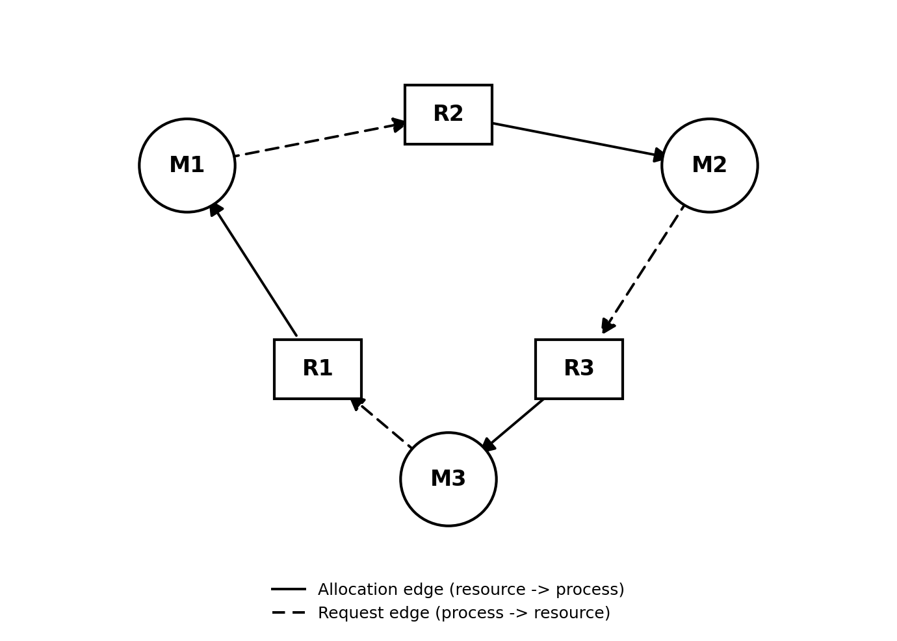
Allocation edges: R1 → M1, R2 → M2, R3 → M3
Request edges: M1 → R2, M2 → R3, M3 → R1
Yes, this sequence leads to a deadlock. M1 holds R1 and waits for R2 (held by M2). M2 holds R2 and waits for R3 (held by M3). M3 holds R3 and waits for R1 (held by M1). Following these edges traces a closed loop: R1 → M1 → R2 → M2 → R3 → M3 → R1. M4 (Validate system integrity) is not part of this cycle since it does not appear in the hold/wait list, so it simply cannot start because it depends on M1–M3 finishing first.
2. Circular Wait Condition
The circular wait condition here is: M1 → R2 → M2 → R3 → M3 → R1 → M1. Each module holds one resource and simultaneously requests the resource held by the next module in the chain, and the last module (M3) requests the resource held by the first module (M1), closing the loop. Since R1, R2 and R3 are each a single lock (Disk I/O, Kernel lock, Configuration lock), no module can proceed, no module can release its resource, and the update process freezes — this satisfies all four conditions for deadlock (mutual exclusion, hold-and-wait, no preemption, and circular wait).
3. Banker's Algorithm Style Resource Allocation
Instead of granting a lock to a module the instant it is requested, the OS update manager should treat each lock request like a Banker's Algorithm safety check before granting it:
• Maintain a record of which locks (R1, R2, R3) each module may still need (its maximum claim) and which locks it currently holds.
• Before granting a requested lock, temporarily assume the grant has happened and check if there still exists some order in which all modules (M1–M4) could finish with the remaining available locks.
• If such a safe order exists, grant the lock. If granting the lock would leave no safe order (as happens here, since granting R2 to M1, R3 to M2 or R1 to M3 would each close the cycle), make that module wait instead of granting the lock immediately.
Applying this check to the given logs: when M3 requests R1 while M1 still holds it and is itself waiting on R2, granting is refused because no safe completion order exists at that point, so M3 is simply held back until R1 becomes free. This prevents the circular wait from ever completing.
4. Prioritizing Modules to Improve CPU Utilization
• Order the modules by dependency instead of running them fully in parallel: run M1 (copy files) to completion first since M2 and M3 both logically depend on the files M1 copies, so they are not competing for R1 in parallel with M1 at all.
• Run M2 (install drivers) and M3 (update registry) one after another using the fixed lock order R1 → R2 → R3 recommended above, instead of letting them grab R2 and R3 independently.
• Schedule M4 (validate system integrity) strictly last, since it depends on M1–M3 completing, so it never contends for R1, R2 or R3 with the others.
This keeps the CPU doing useful sequential progress on the update instead of stalling on a locked resource, which improves CPU utilization during the update compared to letting all four modules compete for the same three locks at the same time.

Question 5 — Cloud Server CPU Utilization Analysis
A cloud hosting provider notices:
• 80% of the time, VM processes wait for network or disk
• Only 20% of the time is spent on CPU
• Each server runs 7 VMs
Using the formula: U = 1 − pⁿ , where p = I/O wait probability.
Tasks:
• Calculate CPU utilization.
• Interpret whether the server is underutilized or optimally loaded.
• Suggest how increasing or decreasing number of VMs affects throughput.
• Propose two OS-level strategies for improving CPU utilization in this cloud environment.
Answer
1. CPU Utilization Calculation
Formula: U = 1 − pⁿ
Given values: p (I/O wait probability) = 80% = 0.8, n (number of VMs) = 7
Substitution: U = 1 − (0.8)⁷
Step | Expression | Value
1 | 0.8¹ | 0.8
2 | 0.8² | 0.64
3 | 0.8³ | 0.512
4 | 0.8⁴ | 0.4096
5 | 0.8⁵ | 0.32768
6 | 0.8⁶ | 0.262144
7 | 0.8⁷ | 0.2097152

U = 1 − 0.2097152 = 0.7902848
CPU Utilization ≈ 79.03%
2. Interpretation
A CPU utilization of about 79% means the server is reasonably well utilized, not underutilized. Even though each individual VM spends 80% of its time waiting for network or disk, running 7 VMs together on one server means the chance that all 7 VMs are waiting on I/O at exactly the same moment is small (only about 21%), so the CPU stays busy running some other VM's process most of the time. The server is closer to optimally loaded than underutilized, though there is still some room (about 21% idle probability) to push utilization higher.
3. Effect of Increasing or Decreasing Number of VMs on Throughput
Increasing the number of VMs (n) raises CPU utilization further, because pⁿ becomes smaller as n grows, so U = 1 − pⁿ moves closer to 100%. This means more work is available for the CPU to switch to whenever one VM is stuck on I/O, which increases overall throughput. However, this benefit has a limit — beyond a certain number of VMs, memory, context-switch overhead and disk/network contention increase, so throughput gains taper off even though CPU utilization stays high.
Decreasing the number of VMs lowers CPU utilization (U moves closer to 0), because there are fewer alternative VMs ready to use the CPU while others wait on I/O, so the CPU idles more often and overall throughput drops.
4. Two OS-Level Strategies to Improve CPU Utilization
• Increase the degree of multiprogramming by running more VMs (as shown above, more VMs reduce the chance that all VMs are I/O-bound at once), as long as memory and I/O bandwidth can support them.
• Use asynchronous / non-blocking I/O and overlap CPU work with I/O operations (for example through interrupt-driven I/O or DMA), so a VM's process does not sit idle holding the CPU while waiting for disk or network, and the scheduler can switch to another VM's ready process immediately instead of waiting for the I/O wait probability to naturally resolve.

Additional Points
• Priority scheduling improves response time for critical tasks.
• Deadlock prevention avoids resource conflicts.
• Multilevel feedback queue scheduling improves interactive performance.
• Banker's algorithm helps maintain a safe state in resource allocation.
• Multiprogramming increases overall CPU utilization.

