📈
Stock Market Analysis System
Project Documentation

Supervised by: Dr. Khalaf
Level: Simple | Team Size: 4 Members
Academic Year 2025 – 2026
Team Members
Muhamed Fadl | 202206827
Basmala Ayman | 202206282
Sara Nasser | 202206529
Ayman Ahmed | 202106125

Table of Contents
1. Project Overview 3
2. Objectives 3
3. Scope 3
4. System Architecture 4
5. Functional Requirements 4
6. Non-Functional Requirements 5
7. Tools and Technologies 5
8. Project Structure 5
9. Module Descriptions 6
10. System Workflow 7
11. Data Flow Diagrams 7
12. Use Case Diagram 8
13. Sequence Diagram 8
14. Activity Diagram 8
15. ER Diagram 9
16. User Interface 9
17. Team Task Allocation 11
18. Testing 12
19. Installation & Running 12
20. Conclusion 13

1. Project Overview
The Stock Market Analysis System is a web-based application developed using Streamlit (Python). It enables users to search for stock symbols, retrieve real-time and historical price data via Yahoo Finance (yfinance), and explore interactive charts and summary statistics — all within a simple, browser-based interface.

Project Title | Stock Market Analysis System
Platform | Streamlit (Python Web App)
Data Source | Yahoo Finance via yfinance library
Visualization | Plotly (interactive charts)
Supervisor | Dr. Khalaf
Team Size | 4 Members
Level | Simple / Beginner-Friendly

2. Objectives
The primary goals of this project are:
- Understand how stock market data is collected, processed, and displayed.
- Build a simple, interactive web application using Streamlit.
- Visualize stock price trends using line charts and indicators.
- Provide meaningful summary statistics (current price, high/low, market cap).
- Handle erroneous or invalid user inputs gracefully.

3. Scope
The system focuses on the following capabilities:
- Stock symbol search (by name or ticker code).
- Display of current and historical stock prices.
- Graphical representation of price trends over selectable time periods.
- Basic technical indicators: 5-day and 10-day moving averages (MA_5, MA_10).
- A responsive, clean user interface accessible from any browser.

Out of scope: user authentication, portfolio management, real-time streaming, and advanced predictive analytics.

4. System Architecture
The application follows a single-tier architecture where Streamlit handles both the front-end rendering and the back-end logic on a single Python process. The diagram below summarises the high-level component flow:

User → Streamlit App → Symbol Validator
↓
yfinance API → Pandas Processing → Plotly Chart
↓
Streamlit UI Output (Metrics + Table + Chart)

5. Functional Requirements
The application meets the following functional requirements:

# | Requirement | Implementation
FR-1 | Accept stock symbol input from the user | Sidebar text input + dropdown selector
FR-2 | Fetch stock data from an external API | yfinance library (Yahoo Finance)
FR-3 | Display stock name and current price | st.metric() with symbol, name, price
FR-4 | Display historical data (7 days to 5 years) | Period selector — 5d, 1mo, 3mo, 6mo, 1y, 2y, 5y
FR-5 | Generate line charts for price trends | Plotly chart via create_price_figure()
FR-6 | Handle invalid inputs with error messages | validate_symbol() + st.error() + st.stop()
FR-7 | Compute basic technical indicators | add_indicators() — MA_5, MA_10, daily return
FR-8 | Display searchable historical data table | st.dataframe() inside expander

6. Non-Functional Requirements
- Usability: The interface uses clear labels, logical layout, and helpful placeholder text to minimise the learning curve.
- Performance: Data loading uses st.spinner() for user feedback; yfinance requests are lightweight and fast.
- Reliability: All API calls are wrapped in error handling; the app gracefully stops on failure.
- Responsiveness: Streamlit's wide layout and use_container_width=True ensure the UI adapts to screen size.
- Maintainability: The codebase is split into focused modules (api, charts, data_processing, utils).

7. Tools and Technologies

Language | Python 3.10+
Web Framework | Streamlit (>= 1.36)
Data API | yfinance (>= 0.2.43) — Yahoo Finance wrapper
Data Handling | Pandas (>= 2.2) — DataFrames, cleaning, indicators
Visualization | Plotly (>= 5.22) — Interactive line charts
Testing | pytest (>= 8.2) — Unit testing
Version Control | Git / GitHub
IDE | VS Code / PyCharm (recommended)

8. Project Structure
The repository is organised as follows:

stock-market-analysis-streamlit/
├── app.py # Main Streamlit entry point
├── requirements.txt # Python dependencies
├── data/
│ └── stock_catalog.csv # Pre-loaded stock symbol catalog
├── src/
│ ├── __init__.py
│ ├── api.py # yfinance data fetching
│ ├── charts.py # Plotly chart creation
│ ├── data_processing.py # Cleaning & indicator computation
│ └── utils.py # Validation, formatting, catalog search
├── docs/
│ └── diagrams/ # Mermaid diagram source files
└── screenshots/ # Application screenshots

9. Module Descriptions

Module / File | Description
app.py | Entry point. Configures the Streamlit page, renders the sidebar search/period selector, orchestrates calls to all src modules, and renders metrics, chart, and data table.
src/api.py | Defines fetch_stock_data(symbol, period, interval). Uses yfinance to retrieve the Ticker object, extracts historical OHLCV data and info fields (name, current price, currency, market cap). Returns a dataclass/payload object.
src/charts.py | Defines create_price_figure(df, symbol). Builds an interactive Plotly figure with a closing-price line and optional moving average overlays.
src/data_processing.py | Three functions: clean_history() normalises column names and resets the index; add_indicators() computes MA_5, MA_10, Daily Change, and Daily Return %; summarize_history() returns a dict of key stats.
src/utils.py | Helper utilities: validate_symbol() checks for empty/invalid ticker strings; search_stock_catalog() performs case-insensitive fuzzy search on stock_catalog.csv; get_popular_stocks() returns the top stocks; display_to_symbol() and format_currency/format_number handle display formatting.
data/stock_catalog.csv | CSV with two columns (symbol, name) containing the pre-loaded catalog of popular tickers. Enables name-based search without API calls.

10. System Workflow
The following steps describe the end-to-end request lifecycle:

Step 1: User opens the app in a browser and sees the sidebar with a search input and time-period selector.
Step 2: User types a company name or ticker (e.g., 'Apple' or 'AAPL'). The catalog is searched and matching tickers are listed.
Step 3: The selected symbol passes through validate_symbol(). If invalid, an error is shown and execution stops.
Step 4: fetch_stock_data() calls yfinance, retrieving historical OHLCV data and current metadata.
Step 5: clean_history() removes nulls and normalises column names. add_indicators() appends MA_5, MA_10, daily change, and return columns.
Step 6: Three st.metric() widgets display Symbol, Company Name, and Current Price at the top.
Step 7: create_price_figure() renders an interactive Plotly chart; st.plotly_chart() embeds it in the page.
Step 8: An expandable st.dataframe() shows the full enriched historical table.

11. Data Flow Diagrams

DFD Level 0 — Context Diagram
The Level-0 DFD shows the system as a single process. The user sends a stock symbol and receives four outputs: Stock Info, Historical Data, Charts, and Error Messages.

User ──► [ Stock Market Analysis System ]
│
┌────────────────┼────────────────┐
▼ ▼ ▼
Stock Info Historical Data Charts / Errors

DFD Level 1 — Internal Process Flow
The Level-1 DFD decomposes the system into individual processing steps:

User ──► [1. Enter Stock Symbol] ──► [2. Validate Symbol]
│ │
Invalid Valid
│ │
[7. Show Error] [3. Fetch Data from yfinance]
│ │
│ [4. Clean & Structure Data]
│ / \
│ [5. Generate [6. Display
│ Chart] Table]
└──────────┴────────────┘
│
Output to User

12. Use Case Diagram
The actor (User) interacts with the following use cases:

- Search stock symbol (by name or ticker)
- View current stock price
- View historical price data
- View interactive trend chart
- Receive error message for invalid input

13. Sequence Diagram
The sequence of interactions between the User, Streamlit UI, yfinance API, Data Processing module, and Chart Generator:

User → UI: Enter symbol and select time period
UI → UI: Validate symbol format
UI → yfinance API: Request historical data + stock info
yfinance API → UI: Return raw OHLCV DataFrame + metadata
UI → Data Processing: Clean and enrich data (indicators)
Data Processing → UI: Processed DataFrame
UI → Chart Generator: Create trend figure
Chart Generator → UI: Plotly figure object
UI → User: Render metrics, chart, and data table

14. Activity Diagram
The activity flow when a user interacts with the system:

- Start
- User enters a stock symbol
- System validates the symbol → if invalid: show error → End
- System fetches stock data from yfinance
- System cleans and enriches the data (indicators)
- System generates the Plotly chart
- System displays metrics, chart, and historical table
- End

15. ER Diagram
Although the system does not use a persistent database, the conceptual entities are:

USER | user_id (PK), name, role
SEARCH_REQUEST | request_id (PK), symbol, requested_at, status
STOCK_DATA | symbol (PK), company_name, current_price, currency, date_recorded

Relationships: A USER makes one or more SEARCH_REQUESTs. Each SEARCH_REQUEST retrieves one STOCK_DATA record.

16. User Interface
The following screenshots demonstrate the application in operation.

16.1 Application Launch & Setup
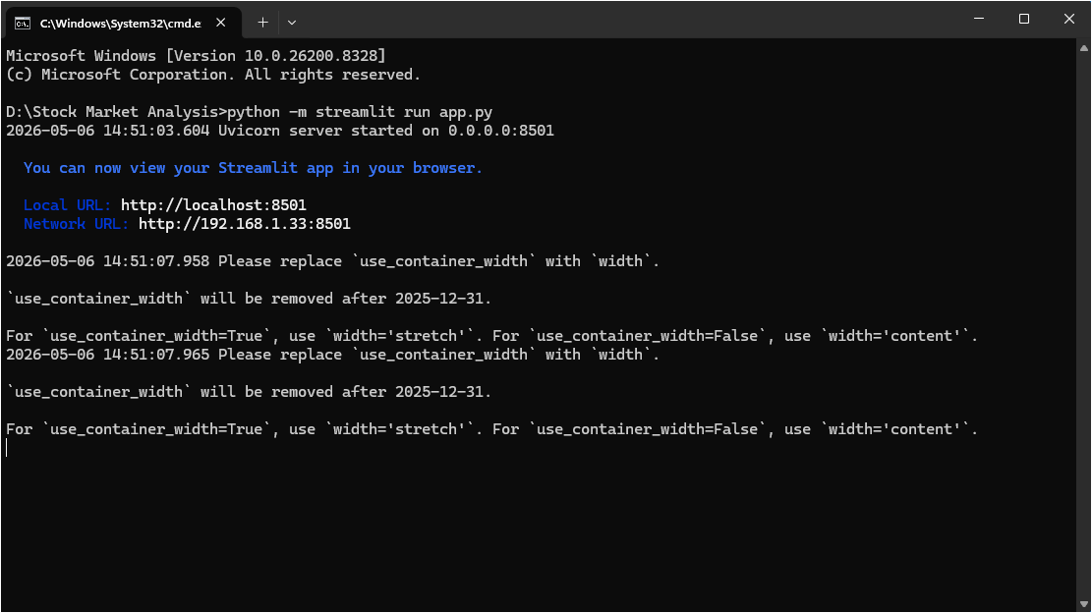
Figure 1 – Running the Streamlit app from the terminal

16.2 Main Dashboard — Stock Overview
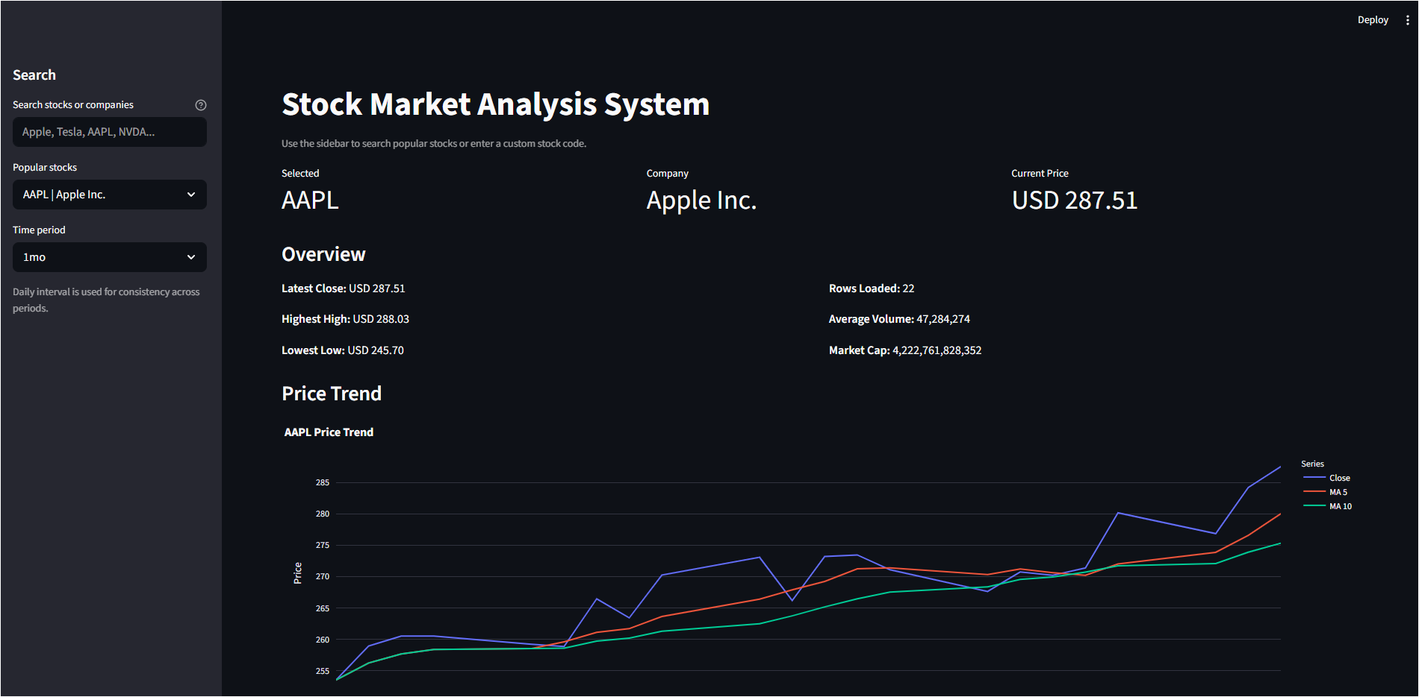
Figure 2 – Main dashboard showing metrics, chart, and overview panel

16.3 Interactive Price Chart
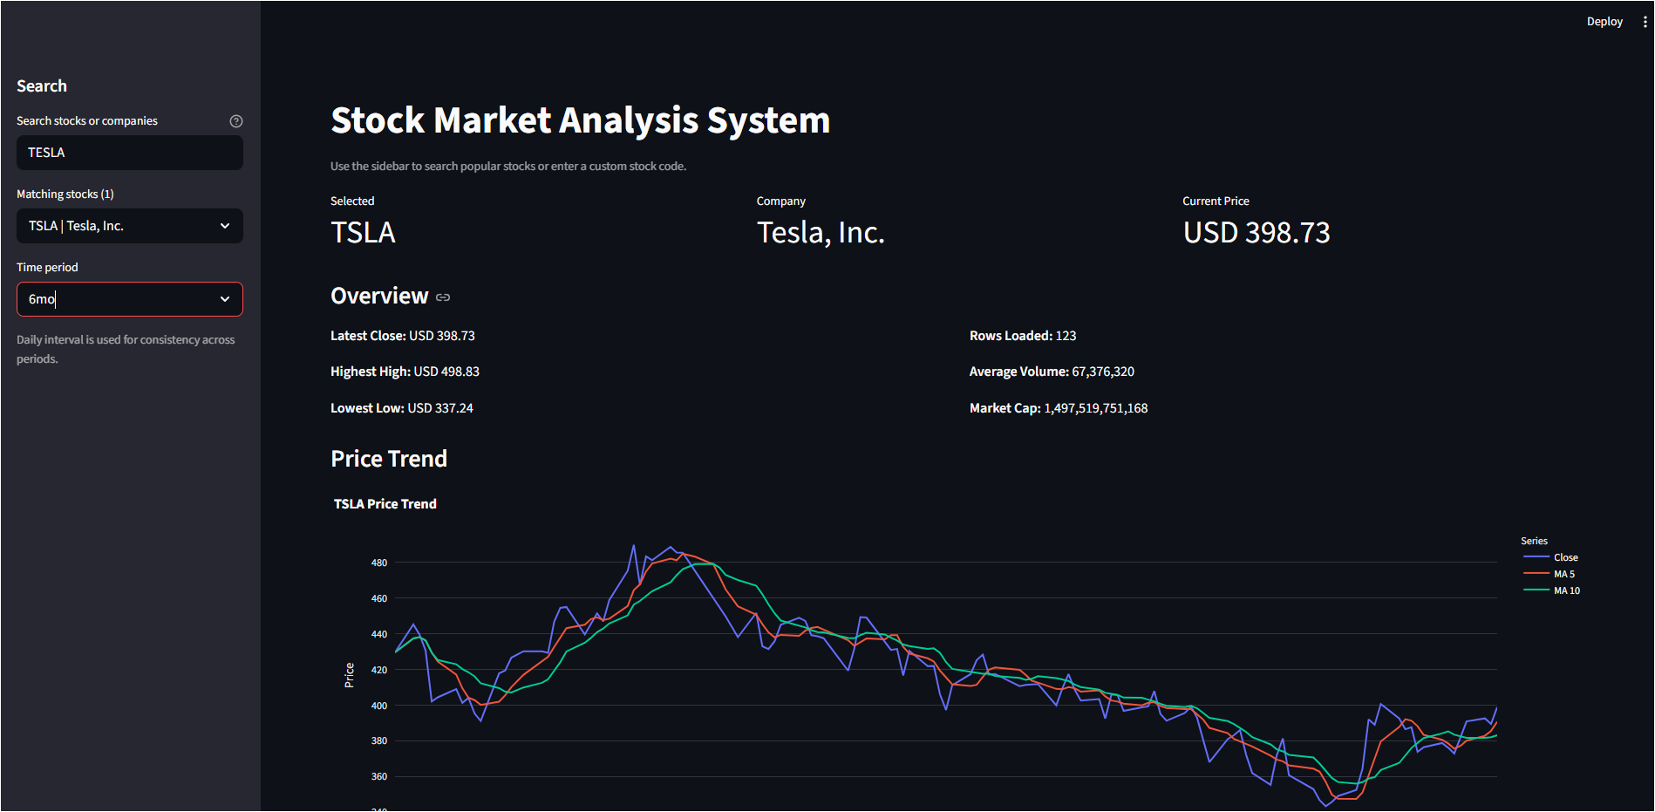
Figure 3 – Plotly interactive chart with close price and moving averages

16.4 Historical Data Table
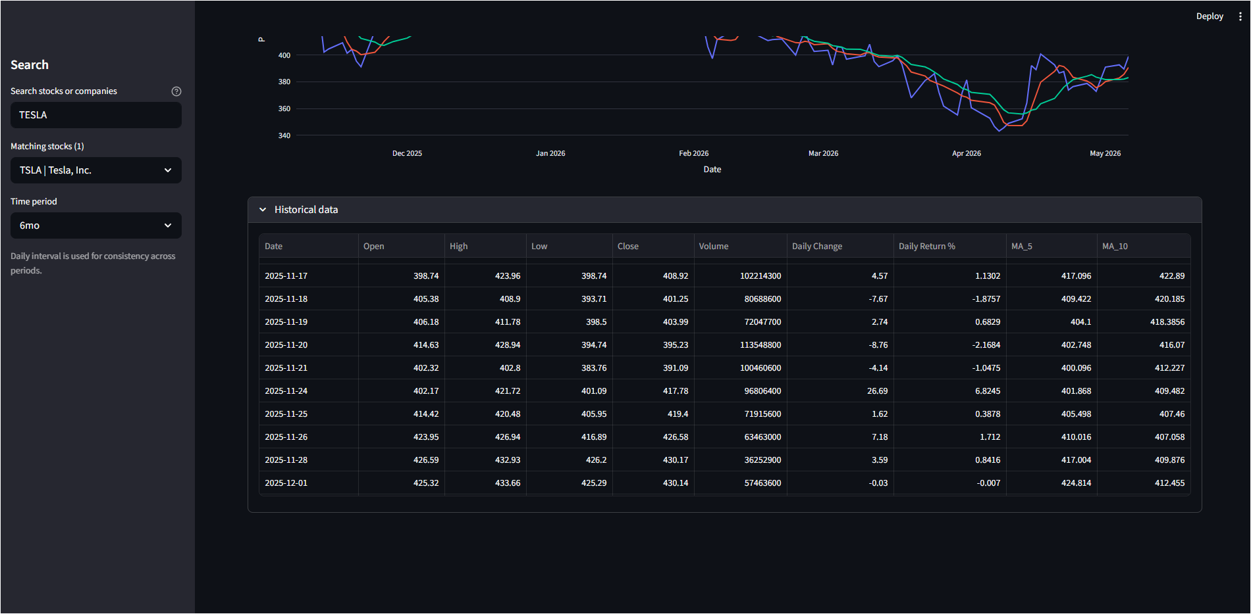
Figure 4 – Expandable historical data table with OHLCV and indicators

16.5 Sidebar Search & Period Selection
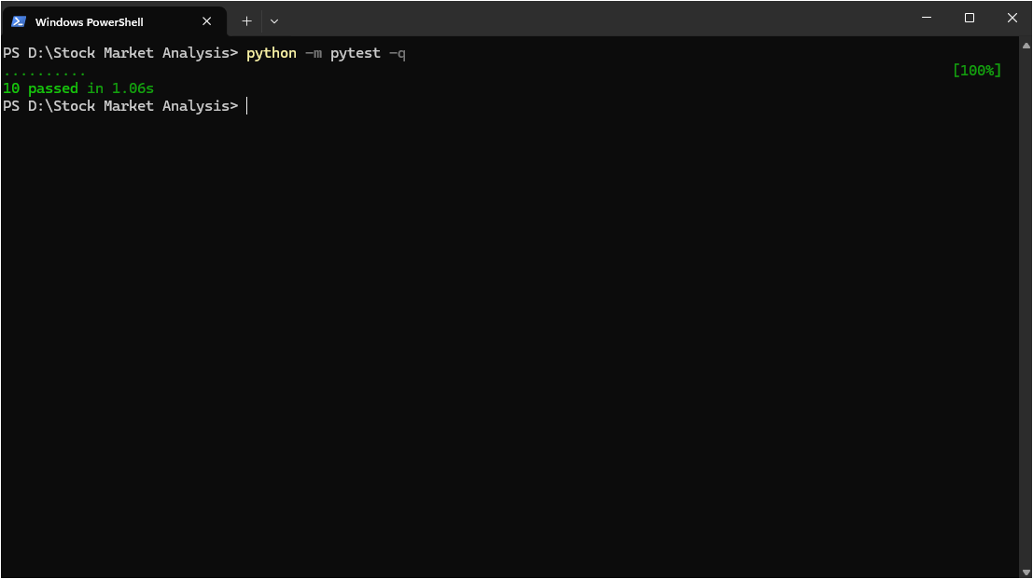
Figure 5 – Sidebar with stock search input and time-period dropdown

17. Team Task Allocation
The project is divided among four team members, each responsible for a specific technical domain:

Member | Role | Responsibilities
Member 1 | Project Lead / Backend Developer | - Set up Python project structure  - Integrate yfinance API (src/api.py)  - Handle stock symbol input and validation  - Fetch current and historical stock data  - Manage error handling (invalid symbols, API failures)
Member 2 | Data Processing & Analysis | - Clean and structure stock data using Pandas (src/data_processing.py)  - Extract OHLCV fields (Open, Close, High, Low, Volume)  - Prepare data for visualization  - Compute indicators: MA_5, MA_10, Daily Change, Daily Return %
Member 3 | Visualization Developer | - Create stock trend charts using Plotly (src/charts.py)  - Build interactive line charts with moving average overlays  - Design graph layout for clarity  - Ensure charts update dynamically based on user input
Member 4 | UI Developer / Tester / Documentation | - Build Streamlit interface: sidebar, input, layout (app.py)  - Display stock info, metrics, and charts in UI  - Test application with valid and invalid inputs  - Prepare documentation, screenshots, and presentation

18. Testing

18.1 Test Strategy
The project uses pytest for automated unit testing. Tests cover the core logic modules to ensure correct behaviour under normal and edge-case conditions.

18.2 Test Cases

ID | Test Case | Input | Expected Result
TC-1 | Valid stock symbol | AAPL | Data loads; metrics displayed
TC-2 | Invalid stock symbol | INVALID999 | Error message shown; app stops
TC-3 | Empty symbol input | (blank) | Validation error before API call
TC-4 | Chart accuracy | MSFT, 1mo period | Chart matches historical close prices
TC-5 | Moving averages | TSLA, 3mo period | MA_5 and MA_10 columns present
TC-6 | Period selection | NVDA, 5y period | 5 years of data returned in table
TC-7 | Company name search | Tesla | TSLA matched in dropdown
TC-8 | API failure handling | Simulate timeout | Graceful error message displayed

18.3 Running Tests
Execute the test suite from the project root:

python -m pytest -q

19. Installation & Running

19.1 Prerequisites
- Python 3.10 or higher
- pip (Python package installer)
- Internet connection (for yfinance API calls)

19.2 Installation Steps

Step 1: Clone the repository
git clone https://github.com/your-repo/stock-market-analysis-streamlit.git
Step 2: Navigate to project directory
cd stock-market-analysis-streamlit
Step 3: Create a virtual environment
python -m venv .venv
Step 4: Activate the environment
source .venv/bin/activate # Windows: .venv\Scripts\activate
Step 5: Install dependencies
pip install -r requirements.txt
Step 6: Run the application
python -m streamlit run app.py

Once running, open http://localhost:8501 in your browser to access the application.

19.3 Dependencies Summary

streamlit >= 1.36 | Web application framework
pandas >= 2.2 | Data manipulation and analysis
yfinance >= 0.2.43 | Yahoo Finance stock data API
plotly >= 5.22 | Interactive charting library
pytest >= 8.2 | Unit testing framework

20. Conclusion
The Stock Market Analysis System successfully demonstrates the fundamentals of financial data retrieval, processing, and visualisation using a modern Python web stack. The application allows any user to:

- Search for any publicly traded stock using its ticker symbol or company name.
- View real-time and historical price data across multiple time horizons.
- Explore interactive charts enriched with moving average technical indicators.
- Rely on robust error handling to receive meaningful feedback on invalid inputs.

The project is intentionally scoped at a beginner-friendly level, making it an ideal foundation for learning web application development, API integration, and data visualisation with Python. Future extensions could include:

- Real-time streaming data using WebSockets or live API polling.
- Additional technical indicators (RSI, Bollinger Bands, MACD).
- Portfolio tracking across multiple symbols.
- User authentication and saved preferences.
- Deployment to a cloud platform such as Streamlit Community Cloud or AWS.

This documentation, alongside the project source code, fulfils the requirements set by Dr. Khalaf and demonstrates the team's ability to collaboratively design, develop, and document a functional software system.

