**Game Design:-**

|  |
| --- |
| **CONSEBT:** |

*The game simulates an environment in which an electron walks to obtain speed, score, and power to obtain the second complementary atom to reach a state of stability.*

*Then, it walks in an environment full of dangers in which it faces many evil and helpful characters.*

|  |
| --- |
| ***OUTCOME:*** |

*After the end of the game, the player is expected to understand the physical concepts and understand the structure of the water Drop and its components.*

*which is to understand the physical components that I will present and show their pictures in the future, which are physical components that have meanings and properties.*

|  |
| --- |
| **Instructional Objectives:** |

*there are two basic goals for the player in this game.*

*🡪The first: goal is to reach an understanding of all the physical elements.*

*🡪The second: goal is to understand the basic components of the water atom, as it consists of two hydrogen atoms and an oxygen atom.*

|  |
| --- |
| ***Description of Character or Characters:*** |

*A hydrogen atom has properties: speed, score, and power. It walks in a blue world that resembles the real world. The electron seeks to reach a state of stability, which is to turn into a drop of water, and its journey begins from scratch, ending with killing the leader and reaching a state of stability.*

|  |
| --- |
| ***Description of the Game Environment:*** |

*The story tells the story of an electron{ hydrogen } who was looking for stability in his blue world and in an atmosphere similar to the atmosphere of both autumn and winter, where he searches for another hydrogen atom and a large group of obstacles that will lead him either to death and instability or to eternal stability and the formation of a drop of water that faces many elements that want it. Expending his strength kills him. During the period of searching for stability, the electron gains many advantages, but there are characters who want to help him, there are characters who want to eliminate him, and there are peaceful characters, but they want some things from this electron so that he can continue his path in peace. If he does not bring this thing, he will be killed, and his story will end either in death. Or by creating a drop of water and killing all the enemies and killing the main enemy who does not want to achieve stability*

|  |
| --- |
| **Description of the Game Play:** |

*The game begins by pressing the Space button, then the electron begins to confront the characters that I will mention, where it confronts them and gains points through them, or loses them, or loses the entire game, all of them through three, through one button, then using the mouse to select and kill the character.*

*1-{Electron} ((which is a hydrogen atom)) and it has a power, speed, and score ((and each of its characteristics is a specific function in the game, and how it is obtained is also specific))*

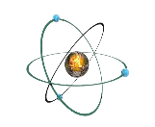

*2-{ NP Diode }If the electron is not able to pass through it until it touches it, the electron must jump higher than it in order to avoid it. However, in the case of no, like the body electron, the game will end with the loss of all possessions of speed, score, and power*

*3-{PN Diode}}The electron passes through it and nothing happens to the electron. This is one of the “auxiliary characters” that increases the speed by one every time the electron passes through it*

*4-{Capacitor} This situation applies to Capacitor just as it applies to NP Diode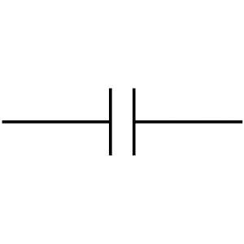*

*5-{Resistor}} In this case, or in this character, if the electron passes successfully, this means that the electron has a speed of more than zero((The speed is reduced by 2)), and if it does not pass and the loss screen appears, this means that the electron does not have enough speed to pass through*

**

*6-{Inductor}} In this character, it has three characteristics that interact with the electron. The first is that if the electron has a speed greater than one, it will pass through it safely and decrease its speed by one degree. If it does not have enough speed, the loss screen will appear, and if it jumps over it, it will attract it with the magnetic field that it possesses*

*7-{Transistor} The electron passes through it, which is also one of the auxiliary characters, and the power increases by one*

*8-{Bulb} An electron cannot pass through it if it has a power less than one. However, if it has a power of one or greater, it can pass through it and illuminate the light, then its power decreases by one.*

*9-{ proton } It works like a bullet, but it would be more aesthetically pleasing to make it a proton fired by an electron, where it kills the element that was fired at it*

*10-{ clouds } Run aesthetic player in the background.*

**

*------------------------------------------------------------------------------------------------------*

*10-{ oxygen || 2hydrogen atom }* *The oxygen atom appears once at the end of the second level, where it fuses with the oxygen atom and the hydrogen atom to become a drop of water and has no specific properties in general.*

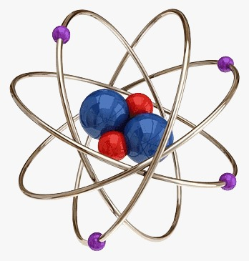

|  |
| --- |
| **Reward Structure** |

*There are many ways in which an electron gets a score, power, or speed.*

*🡪An electron gets the power if it passes through a transistor.*

*🡪 Secondly, the speed The electron gets a speed if it passes through NP-diode.*

*🡪 Third, and finally, the electron gets a score when the light bulb lights up.*

|  |
| --- |
| ***Look and Feel of the Game*** |

*The game does not depend primarily on aesthetics, but rather on reactions and reactions, and there is certainly aesthetics in it, due to the diversity of characters and their different shapes and personalities, as I attached previously.*

|  |
| --- |
| ***Technical Description:*** |

*To play this game, you must have a server capable of running Scratch. Scratch is a program for simple games that I programmed the game on, as the game only runs on it. Its operation is simple and does not require high capabilities, and it can be played online On Scratch Online.*

|  |
| --- |
| ***Project Timeline:*** |

*We started the project on the 19th of the first month of 2024 and finished on 21/1/2024, and all our meetings were Online.*