

BIRZEIT UNIVERSITY
DEPARTMENT OF COMPUTER SCIENCE
COMP438 - Distributed Computing
Course Project Report - Phase 2
Peer-to-Peer Chat Application Using Hadoop HDFS Registry
Student Name: Ayman Jamal
Student ID: 1220115
Student Name: Nagham Khawaja
Student ID: 1220825

Dr. Mohammad Hela

Project Design
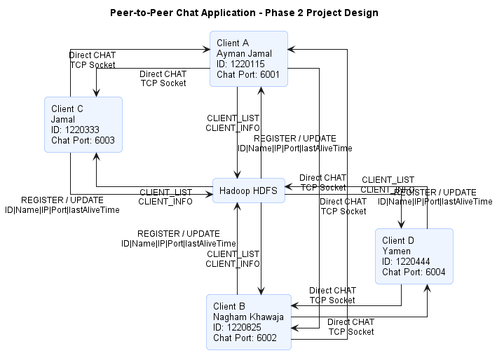
Figure 1:General Design of the Peer-to-Peer Chat Application Using Hadoop HDFS Registry
The project was redesigned as a peer-to-peer chat application supported by Hadoop HDFS instead of the central Dictionary Server used in Phase 1.
The system contains two main parts:
- The Client
- Each client represents a user in the chat application.
- The client is responsible for starting a chat server, registering its information, displaying the active clients list, and sending direct chat messages to other clients using TCP sockets.

- The HadoopClientRegistry
- The HadoopClientRegistry replaces the Dictionary Server that was used in Phase 1.
- Instead of connecting to a central server, each client registers and updates its information inside the shared HDFS file clients.txt.
- The stored information includes the client ID, client name, IP address, chat port, and last alive time.
- The HadoopClientRegistry manages the shared clients file by adding new clients, updating existing records, retrieving active clients, and removing inactive clients.
When a client wants to communicate with another client, it uses the registry to search for the destination client by ID. After the destination IP address and port number are found, the sender opens a direct TCP socket connection with the destination client and sends the chat message directly.
Hadoop HDFS is not used to forward chat messages between clients; it is only used as a shared registry for storing and retrieving client connection information.
This design keeps the chat communication peer-to-peer while replacing the old Dictionary Server with a Hadoop-based shared storage solution.
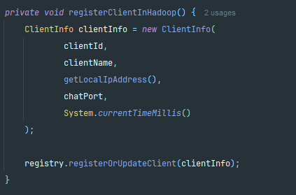
Figure 2:Registering Client Information in Hadoop HDFS
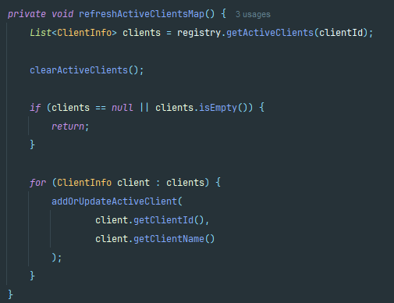
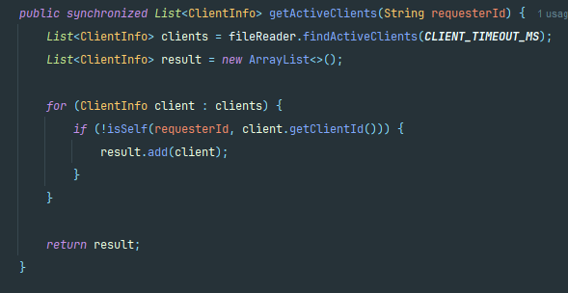
This method registers client information in the Hadoop HDFS registry. It creates a ClientInfo object that contains the client ID, name, IP address, chat port, and last alive time.

Figure 3: Getting the Active Clients List from Hadoop Registry.
This code shows how the Hadoop registry retrieves the active clients list from the shared HDFS file. The method reads the clients stored in Hadoop, filters only the active clients based on the timeout value and removes the requester client from the result. This prevents the user from seeing himself in the active clients list.

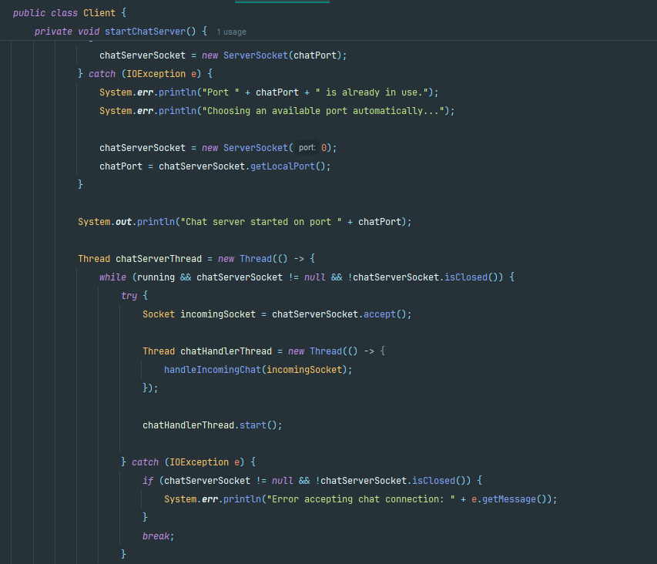
Figure 4:Starting the Client Chat Server
This design separates client discovery from message exchange.
Hadoop HDFS is responsible for storing and retrieving active client information through the shared clients.txt file, while chat communication is performed directly between clients using TCP sockets.

System components
The system is divided into five main components:
1. The Client component
2. The HadoopClientRegistry component
3. The ClientInfo component
4. The HadoopFileReader component
5. The HadoopFileWriter component
Each component has a specific responsibility in the system:
- The Client component handles user interaction and direct chat communication. It starts a local chat server, displays the active clients list, and sends chat messages directly to other clients using TCP sockets.
- The HadoopClientRegistry component replaces the Dictionary Server used in Phase 1. It manages client discovery by using the shared Hadoop HDFS file clients.txt. It is responsible for registering clients, updating their last alive time, retrieving active clients, searching for a client by ID, and removing inactive clients.
- The ClientInfo component stores the information of each client. This includes the client ID, client name, IP address, chat port, and last alive time. This information is converted into text format and saved inside the HDFS shared file so other clients can read it.
- The HadoopFileReader component is responsible for reading client information from Hadoop HDFS. It opens the shared clients.txt file, reads each line, converts the stored text back into ClientInfo objects, and returns the list of registered clients. It also provides methods to find a specific client by ID and to return only the active clients based on the timeout value.
- The HadoopFileWriter component is responsible for writing and updating client information in Hadoop HDFS. It creates the shared clients.txt file if it does not exist, writes the updated list of clients, and uses a temporary file before replacing the old file. This helps keep the shared registry file updated and avoids corrupting the main file during write operations.

Client Component
The Client component represents one user in the chat application.
When a client starts, it opens its own local chat server socket using a specific chat port.
If the selected port is already in use, the program automatically chooses another available port.
After starting the chat server, the client registers its information in Hadoop HDFS through the HadoopClientRegistry.
This registration includes the client ID, name, IP address, chat port, and last alive time.
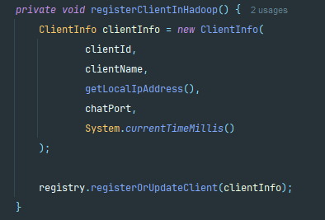
Figure 5:Client registration in Hadoop HDFS registry.
Figure 5 shows how the client creates its information object and registers it in the Hadoop HDFS registry.
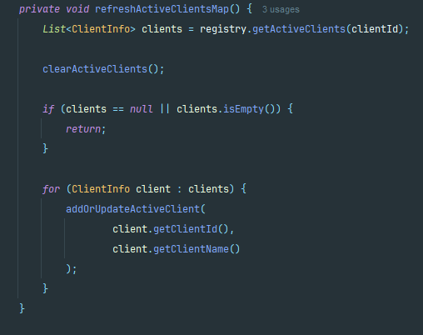
Figure 6:Updating the active clients list from Hadoop HDFS.
The client also refreshes the active clients list by reading the updated data from Hadoop HDFS. This allows the user to see which clients are currently available.

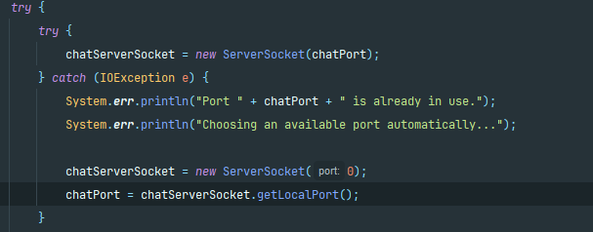
Figure 7:Client-side chat server for receiving direct peer-to-peer messages.
Figure 7 shows how the client opens a chat server socket to receive direct messages from other clients. This makes each client work as both a sender and a receiver. The client uses Hadoop only to discover other users, while the actual chat messages are exchanged directly using TCP sockets.
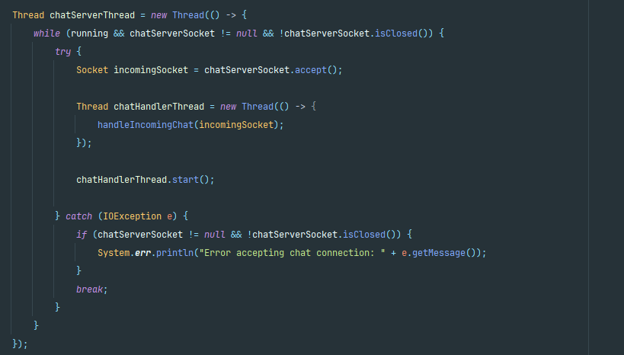
Figure 8: Client-side chat server for receiving direct peer-to-peer messages _2.
When a message arrives, the client accepts the incoming TCP connection and handles it in a separate thread.

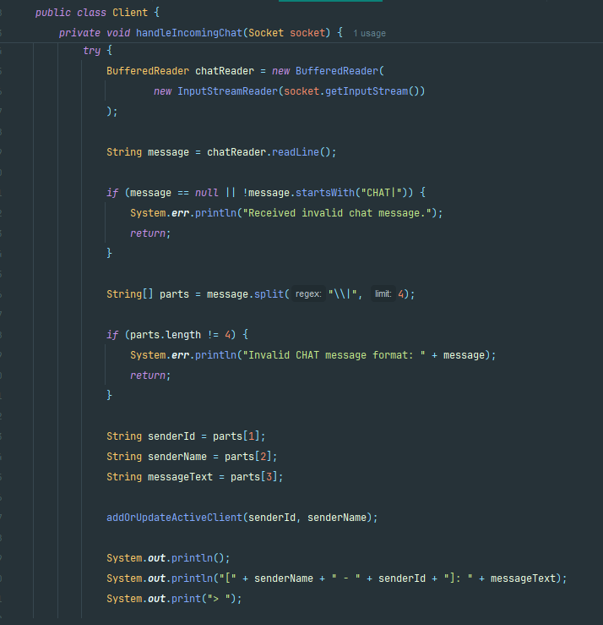
Figure 9: Handling incoming chat messages
This allows the client to receive incoming messages in the background while it continues updating the active clients list from Hadoop HDFS and sending messages to other users. In addition, the handleUserInput method keeps the client ready to receive commands from the user, such as list, refresh, chat, and exit.
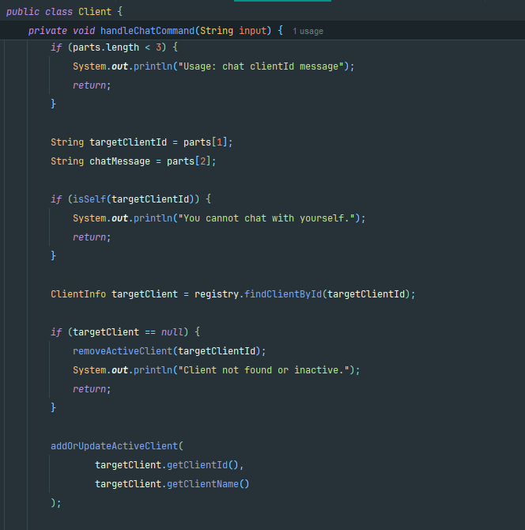
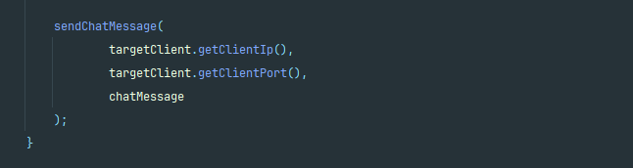
Figure 10:Handling the Chat Command and Finding the Target Client
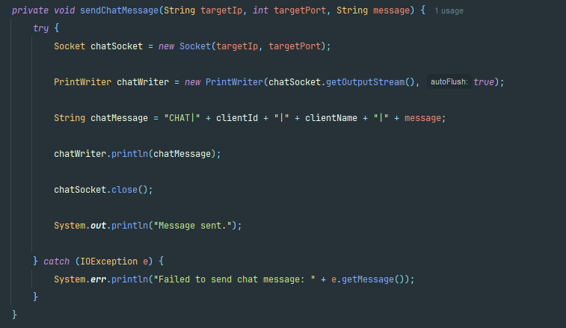
Figure 11:Sending a Direct Chat Message Using TCP Socket
This method sends the chat message directly to the destination client using a TCP socket. It receives the target IP address and port from the Hadoop registry, creates the message format, sends it through the socket, and then closes the connection.
Dictionary Server Component
The HadoopClientRegistry component replaces the Dictionary Server used in Phase 1. Its main role is to manage client discovery using the shared Hadoop HDFS file clients.txt. Instead of storing active clients inside a running server process, the registry reads and updates the client information stored in HDFS.
The registry manages the client ID, client name, IP address, chat port, and last alive time. When a client starts, it registers its information in Hadoop HDFS. After that, the startAliveSender method keeps calling the registration method every second to refresh the client’s last alive time.
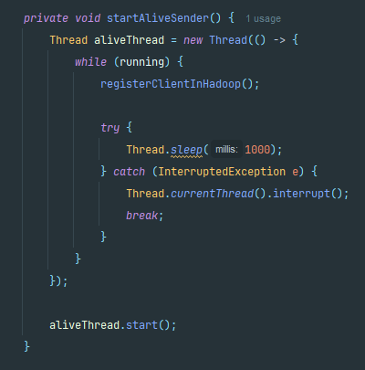
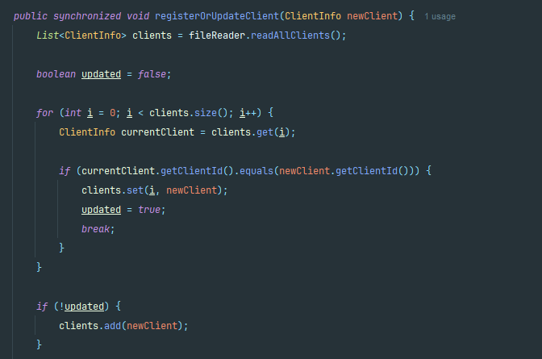
This works like an alive mechanism, but it does not send an ALIVE message to a Dictionary Server. Instead, it updates the client record inside the shared HDFS file.
Figure 12:Periodic client status update in Hadoop HDFS.
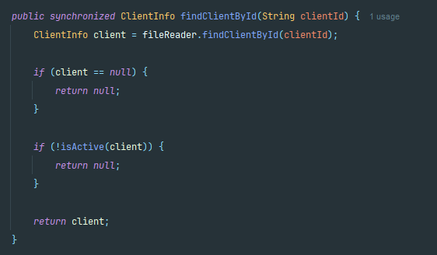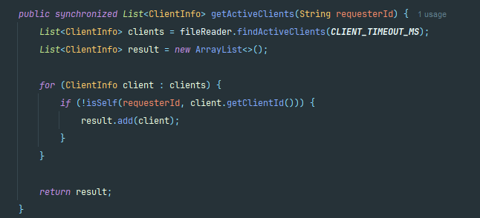
Figure 13:HadoopClientRegistry methods for retrieving active clients and destination client information.
HadoopClientRegistry also provides discovery methods for clients.
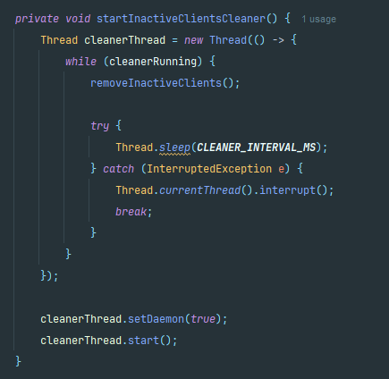
The getActiveClients method returns the list of active clients, while findClientById searches for a specific destination client. These methods help the client get the destination IP address and chat port before starting direct communication.
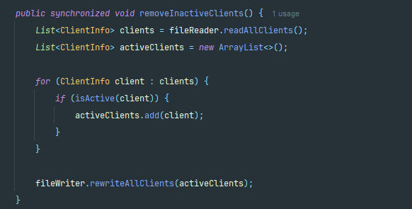
Figure 14: Removing inactive clients from the Hadoop HDFS registry.
The registry also removes inactive clients. If a client stops updating its last alive time, it will be considered inactive after the timeout period. Then, the inactive client is removed from the shared HDFS file, which keeps the active clients list updated.

ClientInfo Component
The ClientInfo component is used to represent the information of each client stored in Hadoop HDFS. Each active client is represented by one ClientInfo object.
This object contains the client ID, client name, IP address, chat port, and last alive time.
These values are stored in the shared clients.txt file and are used by other clients to discover how to connect to each other.
The lastAliveTime field is used to detect inactive clients.
The client IP address and chat port are used to allow direct peer-to-peer communication between clients..
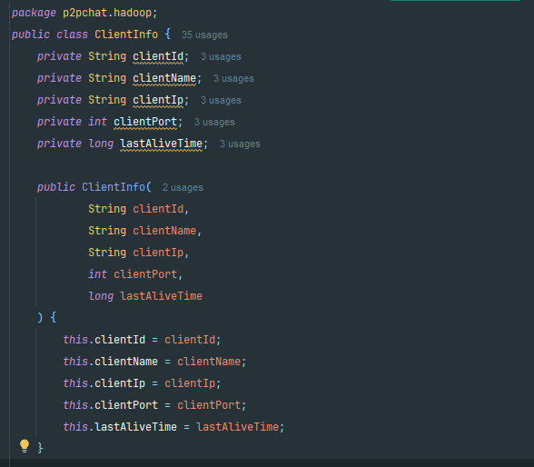
Figure 15: ClientInfo component fields used to store active client data.
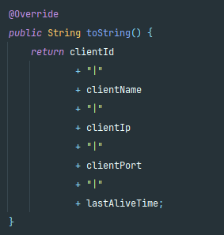
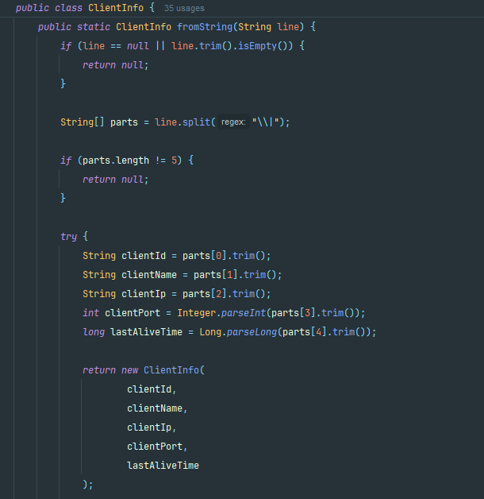

Figure 16:toString and fromString.

The ClientInfo class also provides two important methods:
toString and fromString.
The toString method converts the client information into a single text line separated by the | symbol so it can be saved inside the HDFS file.
The fromString method reads a line from the file and converts it back into a ClientInfo object.

HadoopFileReader Component
The HadoopFileReader component is responsible for reading client information from the shared Hadoop HDFS file clients.txt. It connects to HDFS using the Hadoop FileSystem API and reads the stored client records line by line.
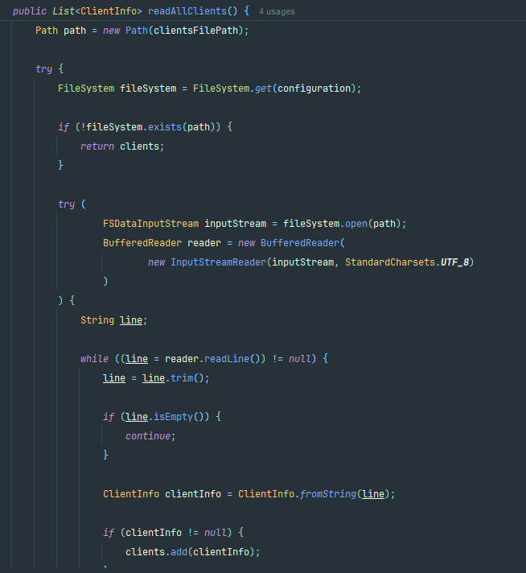
Figure 17:Reading Client Information from Hadoop HDFS

HadoopFileWriter Component
The HadoopFileWriter component is responsible for writing and updating client information in the shared Hadoop HDFS file clients.txt. It makes sure that the file exists before writing and creates the parent directory if needed.
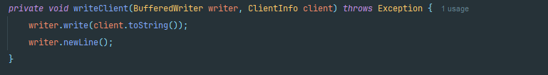
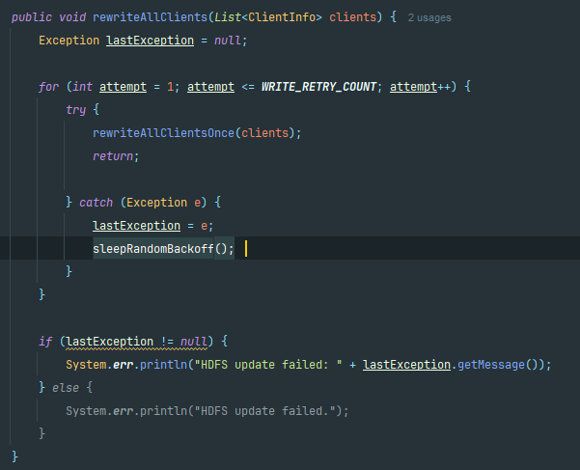
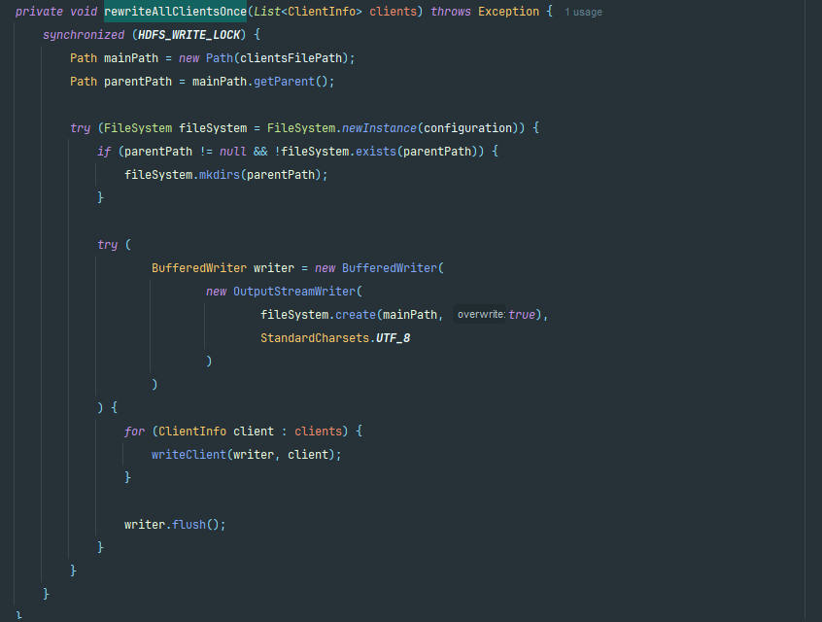
Figure 18:Writing and Updating Client Information in Hadoop HDFS

Socket Design
The project uses TCP sockets for direct peer-to-peer communication between clients. In Phase 2, there is no socket connection with a Dictionary Server because client discovery is done through Hadoop HDFS.
Each client opens a ServerSocket on its own chat port to receive incoming messages from other clients.
When a client wants to send a message, it first gets the destination IP address and port number from the Hadoop registry, then opens a temporary Socket to send the message directly.
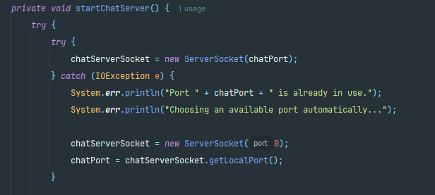
Figure 19:Client chat ServerSocket used to receive direct messages.
Concurrency Management
Concurrency is important in this project because
- The client must handle several tasks at the same time.
- The client needs to read user commands.
- Update its status in Hadoop HDFS.
- Refresh the active clients list.
- And receive direct chat messages from other clients.
For this reason, multithreading is used in the Client component and the HadoopClientRegistry component. Each thread has a specific job, which helps the application continue working without blocking the user.

Concurrency in the Client
The Client component uses multiple threads to handle different tasks at the same time. When the client starts, the start method runs the main setup steps. It starts the chat server, registers the client in Hadoop HDFS, refreshes the active clients list, starts the periodic update threads, and then handles user input.
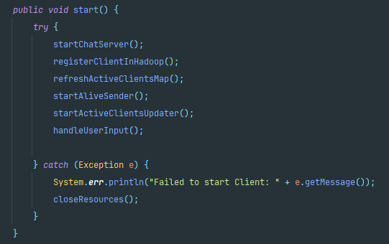
Figure 20: Client startup flow and thread initialization.
The startAliveSender method creates a thread that updates the client information in Hadoop HDFS every second.
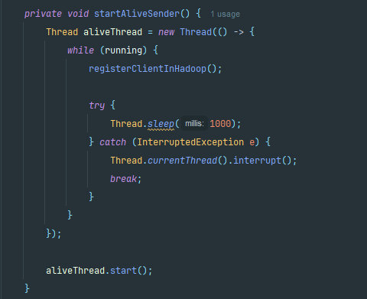
Figure 21:Periodic client status update in Hadoop HDFS.

The startActiveClientsUpdater method creates another thread that refreshes the active clients list every few seconds.
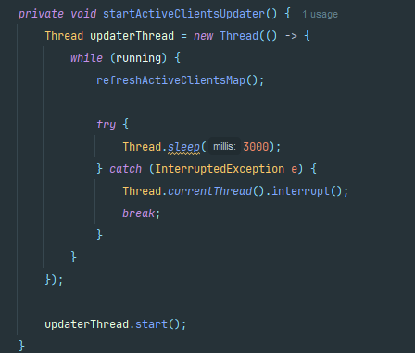
Figure 22:Updating the active clients list from Hadoop HDFS.
The startChatServer method starts a separate chat server thread. This thread keeps listening for incoming TCP connections from other clients. When a new message arrives, the client creates another handler thread to process the incoming message using handleIncomingChat.
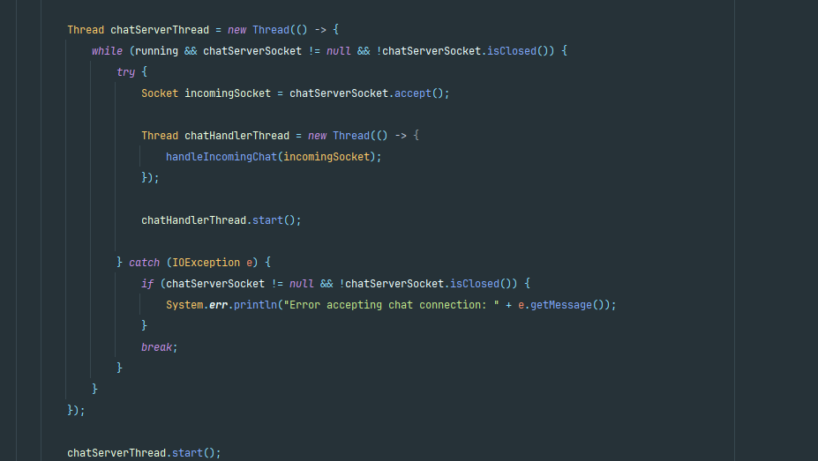
Figure 23:Client chat server thread and incoming message handling.

Concurrency in HadoopClientRegistry
The HadoopClientRegistry component also uses concurrency to manage the shared HDFS clients file safely.
The methods registerOrUpdateClient, findClientById, getActiveClients, and removeInactiveClients are synchronized to avoid conflicts when several operations access the shared file.
Figure 24:Synchronization used to protect the active clients list

Concurrency in HadoopFileWriter
The HadoopFileWriter component uses concurrency control to ensure safe updates to the shared HDFS clients file. Since multiple clients may attempt to rewrite the same file at the same time, the rewriteAllClients method is protected using a shared synchronized lock. In addition, the writer applies a retry mechanism with a small random backoff delay when an update fails. This reduces write collisions between clients and improves the reliability of updating the HDFS file during concurrent execution.

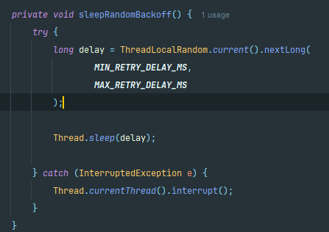
Figure 25:Synchronized writing with retry and random backoff for safe HDFS file updates.
.

Application Layer Header
In Phase 2, the Dictionary Server messages were removed because client discovery is now done through Hadoop HDFS.
Therefore, the application uses two main text formats:
- Storing client information in the shared HDFS file,
- Sending direct chat messages between clients.
Since both the HDFS file and TCP sockets use text-based data in this project, fields are separated using the pipe symbol "|".

HDFS Client Record Format
CLIENT_ID|CLIENT_NAME|CLIENT_IP|CLIENT_PORT|LAST_ALIVE_TIME
Example:
1220115|Ayman|127.0.0.1|6001|1717359000000
1220825 Nagham |127.0.0.1|6002|1717359000008
Direct Chat Message Format
CHAT|SENDER_ID|SENDER_NAME|MESSAGE_TEXT
Example:
CHAT|1220115|Ayman|Hello Nagham

Testing and Results
Start Hadoop HDFS in cmd
cd "C:\Users\ayman\OneDrive\Desktop\Distributed\P2P_Chat_Phase2\hadoop-3.4.3"
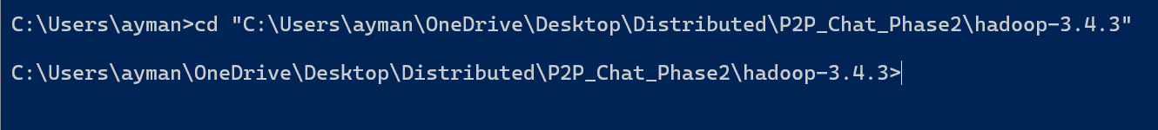
start-dfs.cmd
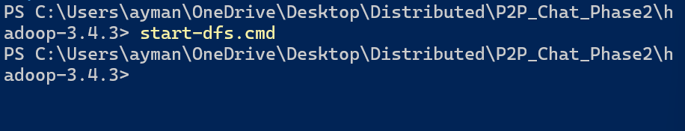
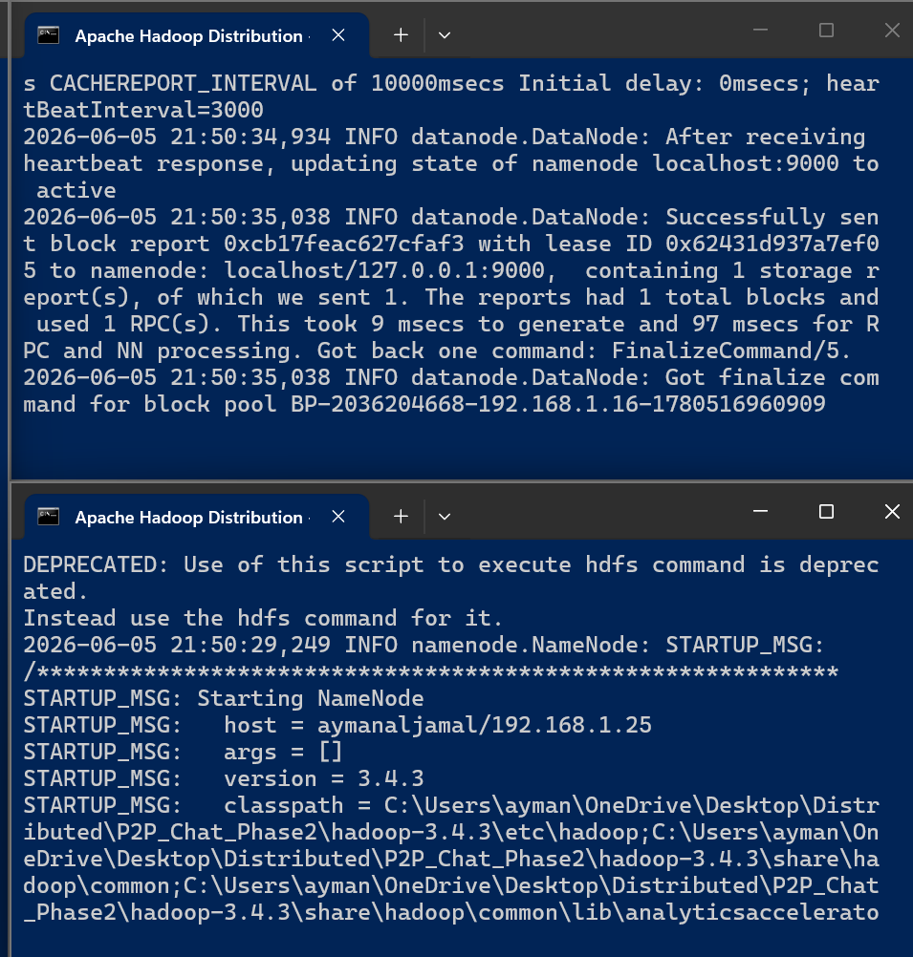

Run Two Clients and Register Them in Hadoop
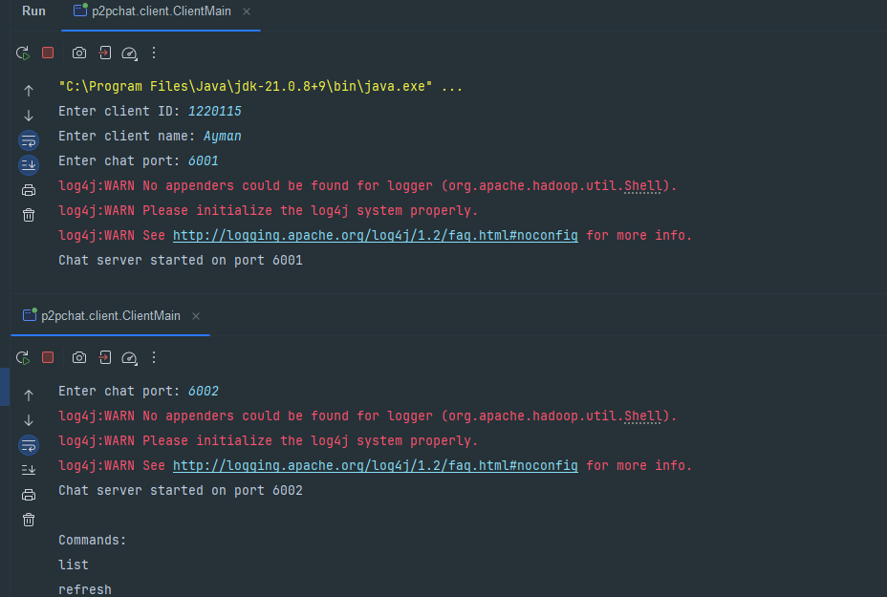

hdfs dfs -cat /p2pchat/clients.txt
Display Active Clients List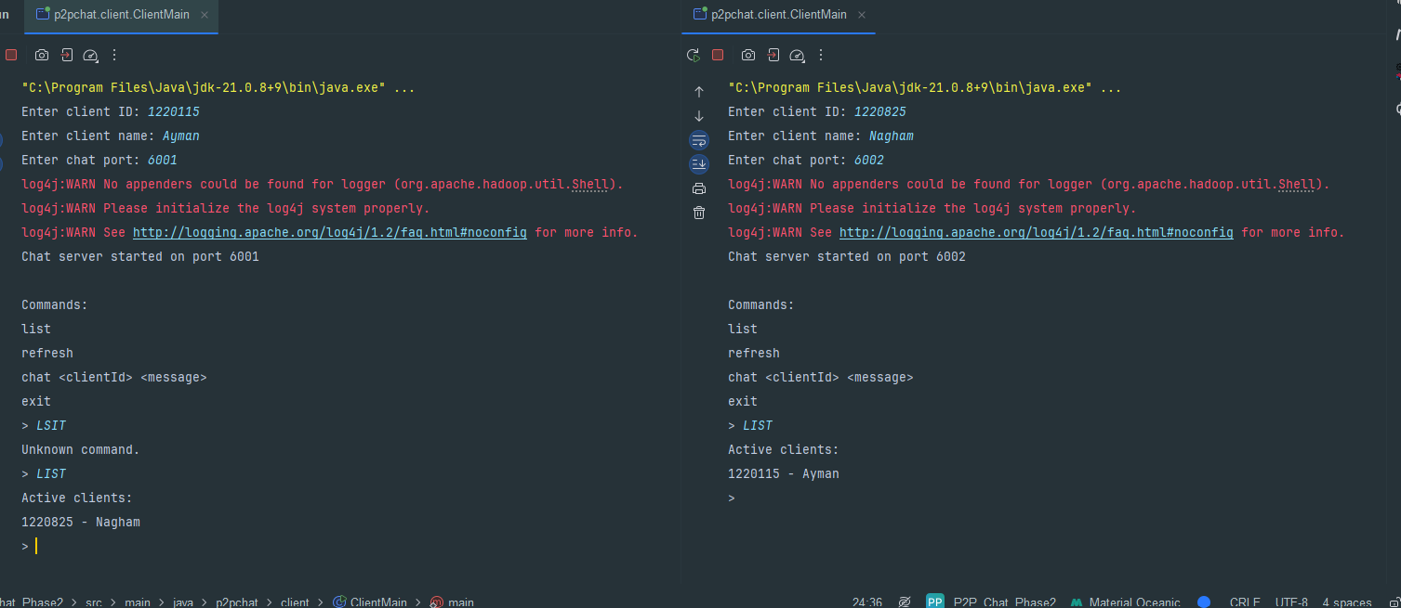

Send Message from Ayman to Nagham
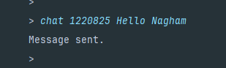


Try to Chat with a Non-existing Client
