Ayman Alzein
Control and System engineer

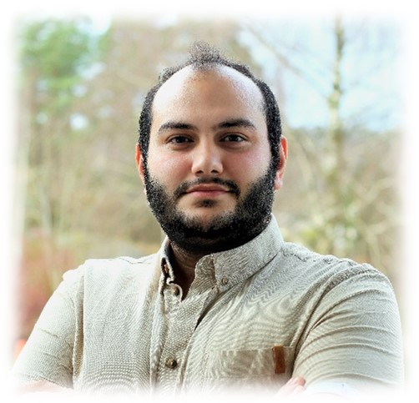

INDUSTRIAL EXPERIENCE
Model-based development - Control design - Sensor fusion - Robotics - Automation and PLC – Embedded Systems - Automotive diagnostics - Test and Validation.

EDUCATION
Chalmers University, Gothenburg, January 2025
- MSc System, Control and Mechatronics.
- Bachelor, Automation and Mechatronics.

Work experience
Volvo Cars, Automation and fault tracing 1/2025 - Ongoing
Developing an infrastructure for an automated testing
environment that replicates the final vehicle assembly production flow,
enabling validation of software releases and the SW production before deployment to the factory. The automation encompassed preparation of test objects, execution of tests, log management, and presentation of results.
The role required a strong understanding of complete vehicle systems and automation experience, along with expertise in diagnostics.

Satcube, Thesis student, 8/2024 – 1/2025
Developed a prototype antenna system for continuous satellite tracking on moving vehicles. Built a full Simulink simulation environment, modeled system dynamics, and designed control and sensor fusion algorithms. Validated simulations on a prototype implementation.

Chalmers formula student, Project Engineer, 10/2023 – 10/2024
Responsible for self-driving car electronics (IMU, LiDAR, PC, telemetry, Ethernet/CAN, remote emergency systems).

RaySafe, Calibration technician, 10/2022 – 10/2023
Performed x-ray radiation measurements, compared results with reference data, and updated sensor software for accuracy.

SOFTWARE SKILLS
- Modeling and simulation: Matlab, Simulink, Simscape
- Mechatronics: LabVIEW, ROS.
- SW development: VS Code, Git, Docker
- Programming languages: Python, Java, C, FreeRots.
- Volvo’s: DSA, Parallel diag, GradeX, SiiG, OneEngine, CarFlow, ReVi, AutoTester, AutoVBFdownloader.
- Others: Catia V5, Cura, Circuit Lab.

Self taken COURSES
- Safety when working on and in Electric Vehicles. University West, Trollhättan.
- EMC in Automotive. EMC services, Gothenburg.
- LabView. LinkedIn academy.
- 3D printing and laser cutting. Case Lab, Gothenburg

PROFILE - summery
I'm a passionate engineer with a strong education and hands-on experience. I love solving problems and coming up with innovative solutions. I've worked on various projects before and am eager for new challenges to learn and grow. With my analytical skills and collaborative mindset, I excel in dynamic environments and contribute to project success.

CONTACT INFORMATION
Tel: 0737591610
Email: aymanalzein@hotmail.com
Adress: Mossvägen 13, 44943 NOL

Language Skills
English: ●●●●○
Swedish: ●●●●●

Personal Skills
Creative
Hands-on Experience
Hard worker
Structured and Organized

