AYMAN PATEL
Supporting Statement
Software Developer with AI in Modern Construction
Ultrapanel / University of Hertfordshire KTP

I am applying for the Software Developer with AI in Modern Construction post because it combines the kind of work I am looking for next: software development, applied AI, data integration, and research-led delivery in an industrial setting.

The project with Ultrapanel is interesting as it combines all layers of software and AI engineering; from leveraging software, data, and AI to improve design-to-manufacturing processes at Ultrapanel.
My background is built around continuous learning and technical ownership. I worked for six years as a full-stack software engineer at Mastercard before moving to the UK to pursue an MSc in Advanced Computer Science at Queen Mary University of London.

I started in backend engineering, building APIs and defining business workflows using Camunda, BPMN, Java, Spring, Oracle, and PostgreSQL. Over time, my role expanded into full-stack engineering, with major contributions across React frontend architecture, microfrontends, backend microservices, API integration, observability, and CI/CD.

Although my title was "Software Engineer", my work often went beyond implementation. I translated product requirements into technical specifications, user stories, and acceptance criteria; led delivery across teams in different time zones; and took ownership of architecture and product decisions where a stronger end-to-end view was needed. In some projects, I effectively operated across engineering, product management, and user experience design because I could connect technical implementation with user needs and delivery constraints.

I have also shown that I can communicate technical work clearly. I contributed to a frontend engineering whitepaper that was recognised by the Mastercard CTO and adopted as internal reference material for developers. I have written more than 40 technical articles on software architecture, infrastructure, databases, observability, and AI. (Link: https://aymanace2049.hashnode.dev/. One of my blogs was also accepted in eBPF newsletter (Blog Link)

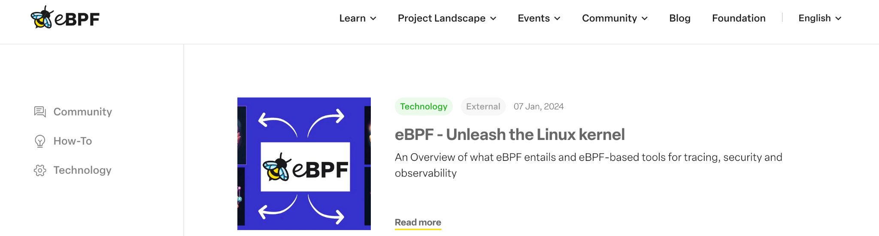

I see this as directly relevant to the KTP requirement to contribute to papers, presentations, dissemination, and high-quality written outputs.

I am a team player who works with executives to build products with urgency and quality whilst helping intern/junior/new joiners get up to speed so that they can start contributing. This can be seen in the recommendations (https://patelofthought.com/me/#recommendations) where you can see people from VPs to junior engineers providing recommendations based on my work above and beyond my job role.
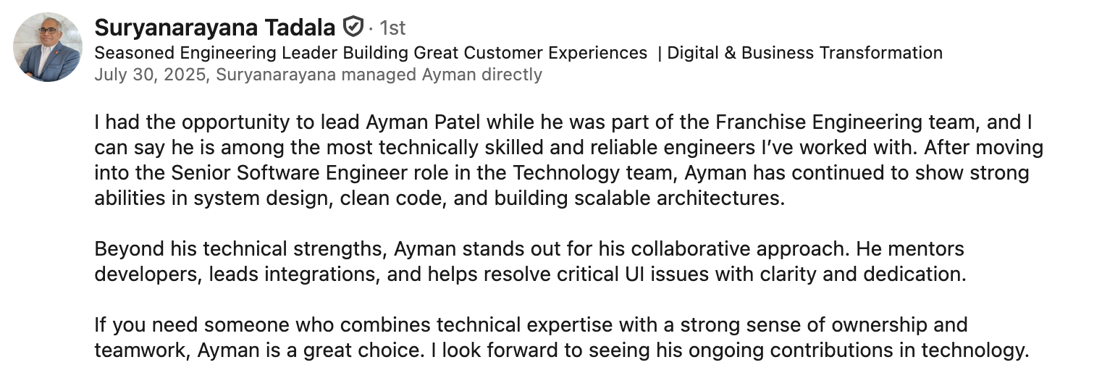
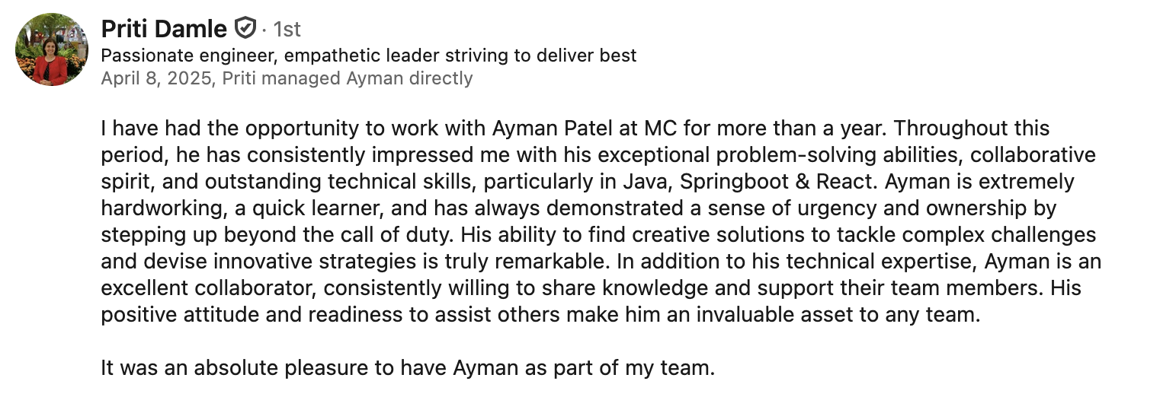 | 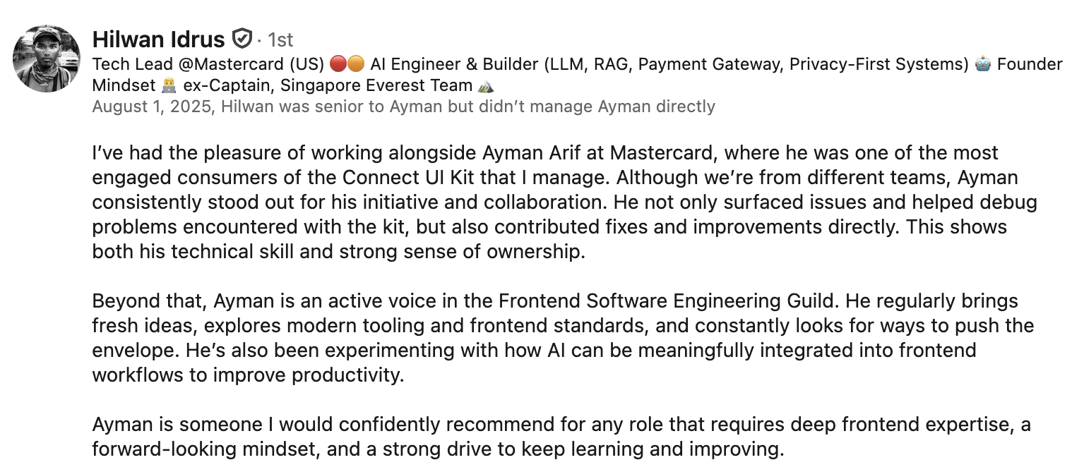
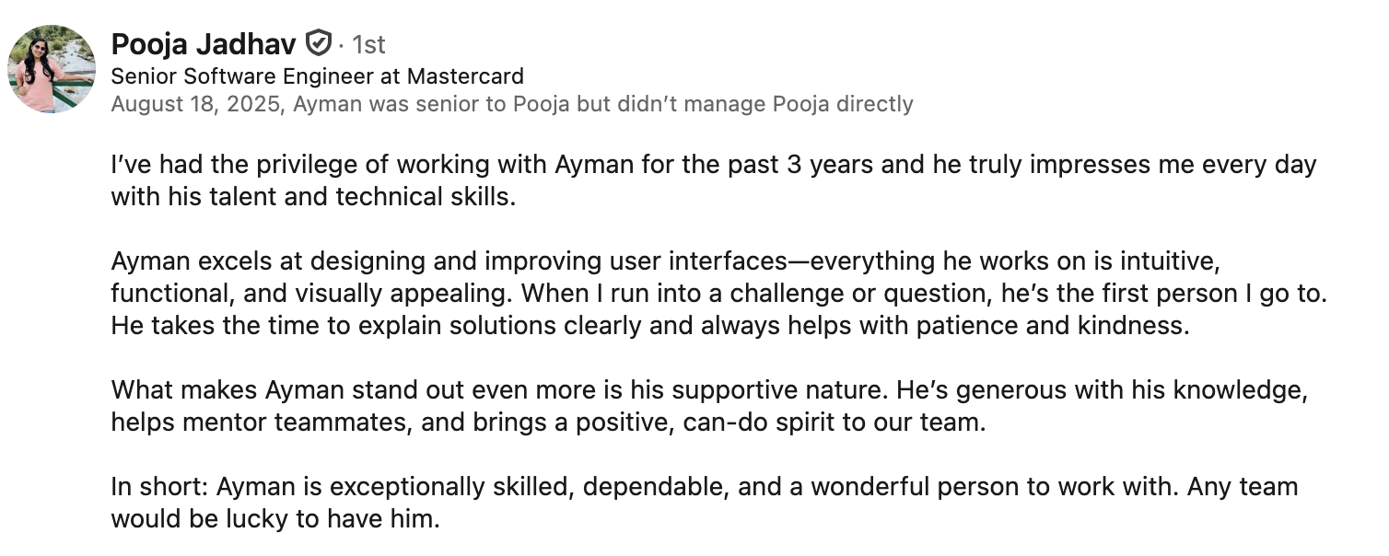 | 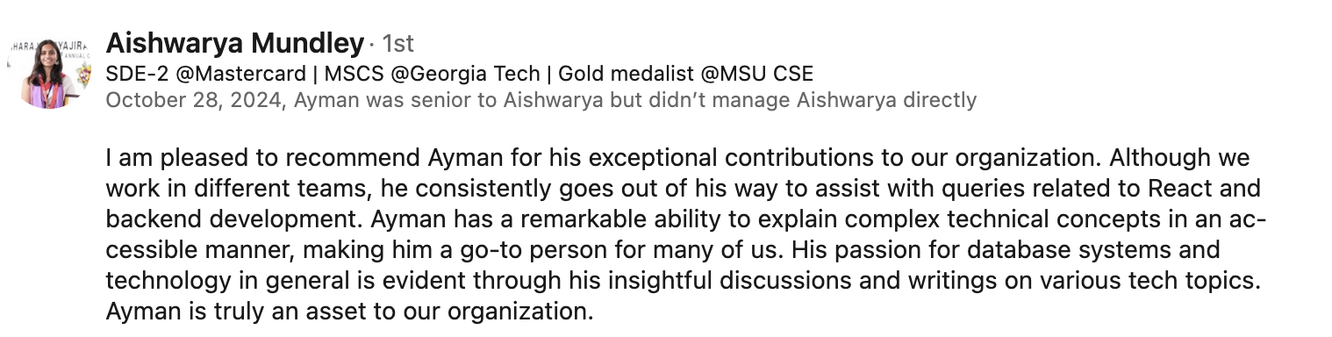
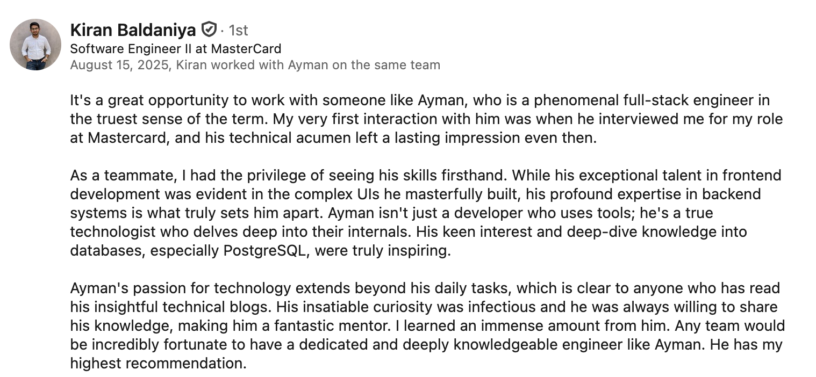
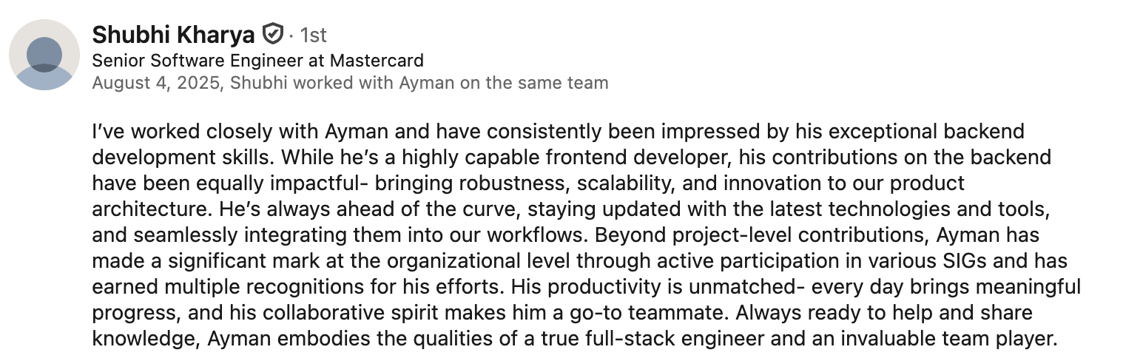

My AI experience is both academic and practical. I have taken modules in machine learning and big data, achieving a distinction grade in Machine Learning. In my big data coursework, I built a fraud-detection analysis on the IEEE-CIS credit card dataset, merging 590,540 transactions across 434 transaction and identity features. I identified severe class imbalance at a 3.5% fraud rate, reduced the feature space to the strongest predictors, and tuned Random Forest models with SMOTE variants and threshold optimisation. The best model achieved 96.9% test accuracy, 0.503 F1, 0.541 precision, 0.470 recall, and 0.879 ROC-AUC on a strict chronological test split.

I have also applied AI in practical projects and hackathons, where I placed in the top three on multiple occasions. These projects included multimodal LLMs, RAG systems, vector databases.
More recently, I joined the Nebius AI Engineering Fellowship, a hands-on programme covering LLM architectures, AI agents, MLOps, distributed training, and GPU performance engineering. This gave me practical exposure to building, evaluating, and optimising AI systems rather than only using LLM APIs at a surface level.

For my Master’s dissertation, I am developing a Graph Neural Network (GNN) focused on web accessibility. During my tenure at Mastercard, I identified a significant gap in machine learning applications for web accessibility, which frequently resulted in unresolved false negatives and high turnaround time for fixing and validating. My research aims to address this by leveraging novel GNN architectures and ML techniques to automate the detection and remediation of accessibility barriers for the web.

What attracts me to Ultrapanel is the chance to apply this background to a real business and engineering problem. Ultrapanel already has commercial traction and product recognition; the opportunity now is to help advance its design-to-manufacturing capability using AI, data, and modern software engineering. I want to help turn design and construction data into actionable insight, build software that improves processes, use AI to surface hidden patterns or risks, and support better-informed decisions for Ultrapanel’s growth in offsite construction.

I believe I meet the criteria for this role because I bring software engineering depth, applied AI knowledge, data analysis experience, API and integration skills, project ownership, and strong communication. I would bring a methodical approach, attention to detail, and the ability to work independently while collaborating closely with academic and business stakeholders.

