



Ingénierie des Systèmes d’information et Réseaux

-- INTERNSHIP --

REPORT

JOBIFY: Job Management Platform

Supervised by:

HACHMI El Ayachi

Carried out by:

ATIGUI Aymane

2022/2023

ACKNOWLEDGEMENT

Before commencing this report, I would like to seize this opportunity to express my heartfelt gratitude. Firstly, I am immensely thankful to Mr. **HACHMI EL AYACHI**, the CEO of the company, for granting me the invaluable opportunity to embark on an internship within his esteemed organization. His unwavering support, continuous encouragement, and invaluable guidance throughout the entirety of my internship are deeply appreciated. Moreover, I am grateful for the company's generosity in terms of training and support.

I would also like to extend my sincere thanks to the dedicated team at **SOTRAGEP** for their motivation, unwavering support, and for sharing their wealth of experience and expertise with me. Their contributions have played a pivotal role in shaping my professional growth and development during the internship.

INTRODUCTION

In today's digital age, having a website has become more crucial than ever before. It serves as a vital tool for various purposes, whether it's facilitating communication with others or expanding one's client base. The power of a web page lies in its accessibility, transcending geographical boundaries and time constraints. Unlike traditional media, the internet enables individuals from across the globe to access information at any given moment.

As a third-year student at the Ecole Supérieure De Technologie de SAFI, I had the opportunity to complete an 8-week internship at SOTRAGEP, a company located in Casablanca. During my internship at SOTRAGEP, I had the invaluable opportunity to put into practice the skills and knowledge I had acquired throughout my studies. This hands-on experience allowed me to bridge the gap between theory and practice, as I actively engaged in various web design and development projects. By applying my academic knowledge in a professional setting, I gained a comprehensive understanding of the intricacies involved in creating effective and visually appealing websites.

In addition to project-based work, my internship at SOTRAGEP provided me with insights into the day-to-day operations of a company. I gained hands-on experience in client acquisition, project management methodologies, and maintaining effective communication with clients. This exposure not only solidified my theoretical knowledge but also equipped me with practical skills and industry insights that will undoubtedly benefit my future career.

In this report, I will provide an overview of the company, SOTRAGEP, and delve into the practical aspects of my internship. I will discuss the specific tasks and responsibilities I undertook during my time at the company, offering insights into the hands-on experiences I gained. Through this analysis, I aim to present a comprehensive understanding of the company and the practical impact of my internship.

PLAN

ACKNOWLEDGEMENT 2

INTRODUCTION 3

PLAN 4

List of Figures 5

1. THE INTERNSHIP 6
   1. Company Overview .........................................................6
   2. Internship Role and Responsibilities ............................... 6
2. Project Overview 8
3. Data Modeling and Design 9
   1. Conceptual Data Modeling .............................................9
   2. Logical Data Modeling .....................................................10
4. Technologies Used 11
   1. HTML ...............................................................................11
   2. CSS .................................................................................. 11
   3. Tailwind CSS..................................................................... 11
   4. React ............................................................................... 12
   5. Node JS ............................................................................12
   6. MongoDB ........................................................................ 12
5. Interface Presentation 13
   1. Home Page ...................................................................... 13
   2. Login Page .......................................................................15
   3. Sign up Page .................................................................... 17
   4. About Page .....................................................................19
   5. Contact Page ................................................................... 20
   6. Jobs Page ........................................................................ 21
   7. Apply Page .......................................................................22
   8. Dashboard .......................................................................23

CONCLUSION 26

REFERENCES 27

List of Figures

8  
9  
10  
11  
11  
11  
12  
12  
12  
13  
14  
14  
15  
16  
17  
18  
19  
20  
21  
22  
23  
24  
25

1. Platform LOGO .....................................................................................
2. MCD .....................................................................................................
3. MLD ......................................................................................................
4. HTML LOGO ..........................................................................................
5. CSS LOGO .............................................................................................
6. Tailwind CSS LOGO ...............................................................................
7. React LOGO ..........................................................................................
8. NodeJS LOGO .......................................................................................
9. MongoDB LOGO ...................................................................................
10. Home Page ...........................................................................................
11. Lates Jobs section ................................................................................
12. Platform navigation bar .......................................................................
13. Sign in Page ..........................................................................................
14. Login process .......................................................................................
15. Sign Up Page ........................................................................................
16. Sign Up process ....................................................................................
17. About Page ...........................................................................................
18. Contact Page ........................................................................................
19. Jobs Page ..............................................................................................
20. Apply page ............................................................................................
21. Administrators navigation bar .............................................................
22. Dashboard Page – users – ..................................................................
23. Dashboard Page – user submissions – .................................................

THE INTERNSHIP

1. THE INTERNSHIP
   1. Company Overview

SOTRAGEP is a well-established company that has been operating in the field of painting, decoration, and renovation for several years. The company has built a strong reputation for delivering high-quality services and meeting the diverse needs of its clients.

Initially focused solely on providing painting, decoration, and renovation services, SOTRAGEP recognized the importance of adapting to the changing business landscape. With the rapid growth of the internet and the increasing demand for online presence, the company made a strategic decision to expand its services to include web agency solutions.

By integrating web development and digital marketing into its portfolio, SOTRAGEP aimed to provide a comprehensive range of services to its clients. This expansion allowed the company to not only enhance its existing offerings but also cater to the growing needs of businesses looking to establish a strong online presence.

The decision to diversify into the web agency field was driven by the company's desire to stay ahead of the curve and offer a one-stop solution for its clients' painting, decoration, renovation, and online marketing needs. By combining their expertise in traditional services with the emerging field of web development, SOTRAGEP aimed to create a seamless experience for its customers.

As an intern at SOTRAGEP, I had the opportunity to witness this expansion firsthand. It was fascinating to observe how the company seamlessly integrated its existing capabilities with the new web agency services. This strategic move not only allowed SOTRAGEP to tap into a new market but also positioned them as a versatile and innovative company within their industry.

* 1. Internship Role and Responsibilities

During my internship at SOTRAGEP, I was entrusted with a variety of tasks and responsibilities that contributed to the company's operations and growth. These tasks spanned different areas. This comprehensive range of responsibilities provided me with a holistic understanding of the company's operations and allowed me to gain valuable experience in various aspects of the business. By actively participating in these diverse tasks, I had the opportunity to apply my skills and knowledge in real-world scenarios, further enhancing my professional development. It also allowed me to develop a strong sense of adaptability and versatility as I navigated through different projects and collaborated with various teams within the organization.

THE INTERNSHIP

Here are the different missions I undertook during my internship at SOTRAGEP:

Web Development:

* I actively participated in the process of converting design mockups into fully functional websites. This involved using tools like Photoshop to slice and extract the necessary assets for web development.
* Using my skills in HTML, CSS, and JavaScript, I developed web pages with a focus on creating engaging and user-friendly interfaces. I worked closely with the team to ensure the implementation aligned with client requirements and project deadlines.

Database Management:

* As part of the internship, I had the opportunity to work on database.
* I gained experience ensuring data integrity, and implementing security measures to safeguard sensitive information.

Quality Assurance and Testing:

* In order to ensure the quality and functionality of the websites developed, I was involved in conducting tests and validations. This included performing various tests to identify and resolve any issues or bugs in the websites.
* I also paid close attention to website security, ensuring that proper measures were in place to protect against potential vulnerabilities and threats.

Digital Marketing Support:

* With my personal knowledge in digital marketing, I provided support to the digital marketing team at SOTRAGEP. This involved assisting in the creation and management of digital advertising campaigns.

Technical Support and Troubleshooting:

* As part of the internship, I actively participated in providing technical support to both clients and internal team members. I addressed website-related issues, answered technical queries, and guided users in utilizing web-based tools and systems effectively.

Collaboration and Learning:

* Throughout my internship, I actively participated in team meetings, brainstorming sessions, and training programs. I collaborated with experienced professionals from various departments, learning from their expertise and contributing to the company's collective knowledge.

Project Overview

1. Project Overview



Figure 1: Platform LOGO

JOBIFY is a platform that provides a comprehensive range of features designed to assist job seekers in their search for employment. With a user-friendly interface and personalized job recommendations, JOBIFY aims to make the job search experience efficient, effective, and enjoyable.

Our platform serves as a bridge between job seekers and employers, offering benefits to both parties. For job seekers, JOBIFY simplifies the process of finding employment by providing easy access to a multitude of job opportunities in various sectors and domains. Whether one is seeking a full-time, part-time, freelance, or remote position, JOBIFY offers a wide range of tailored opportunities to suit different needs and skill sets. JOBIFY also benefits employers by providing them with a platform to showcase their companies and connect with a diverse pool of talented candidates. By creating a symbiotic relationship between job seekers and employers, JOBIFY helps facilitate the perfect match between the two.

The platform features an intuitive search interface that allows job seekers to explore a wide range of job listings and refine their search results based on specific criteria. Additionally, JOBIFY offers personalized job recommendations based on the user's preferences and qualifications, making the job search process more targeted and efficient. One of the key strengths of JOBIFY is its seamless application process. Job seekers can easily submit their resumes and cover letters directly to employers through the platform, streamlining the application process and increasing convenience for both parties.

JOBIFY is constantly evolving to meet the needs of its users. The platform is committed to excellence and innovation, continually enhancing its features and functionality to provide a seamless and rewarding experience. By creating a user-friendly environment, JOBIFY empowers job seekers to find meaningful employment while enabling employers to discover top talent.

Data Modeling and Design

1. Data Modeling and Design
   1. Conceptual Data Modeling

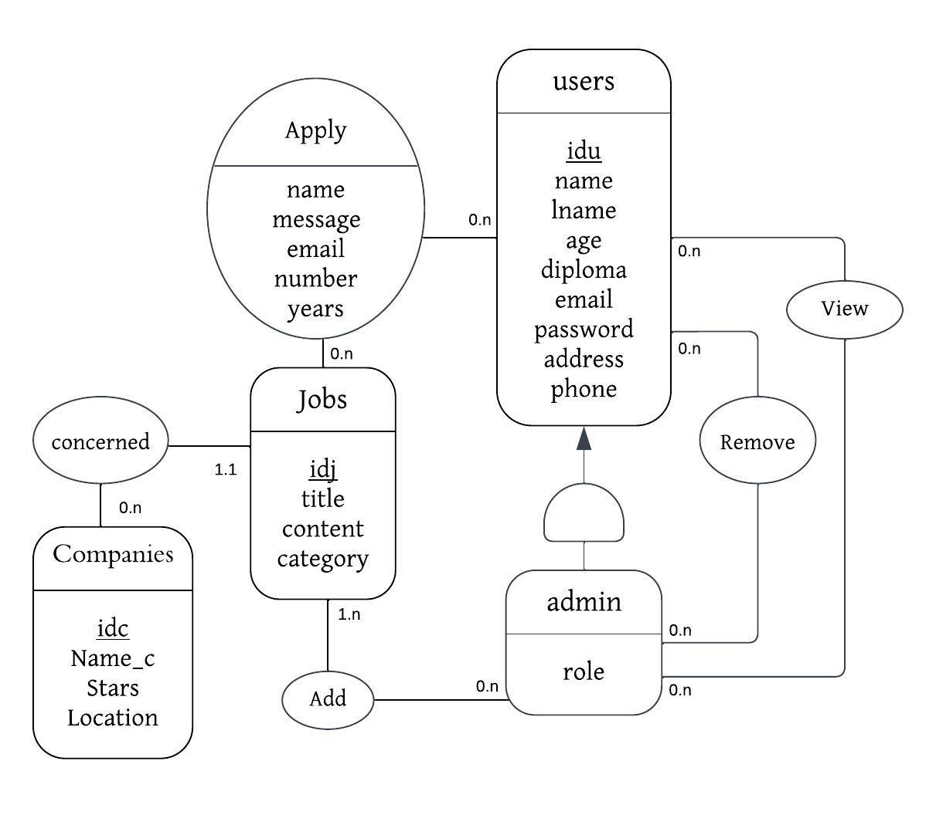

Figure 2: MCD

Data Modeling and Design

* 1. Logical Data Modeling

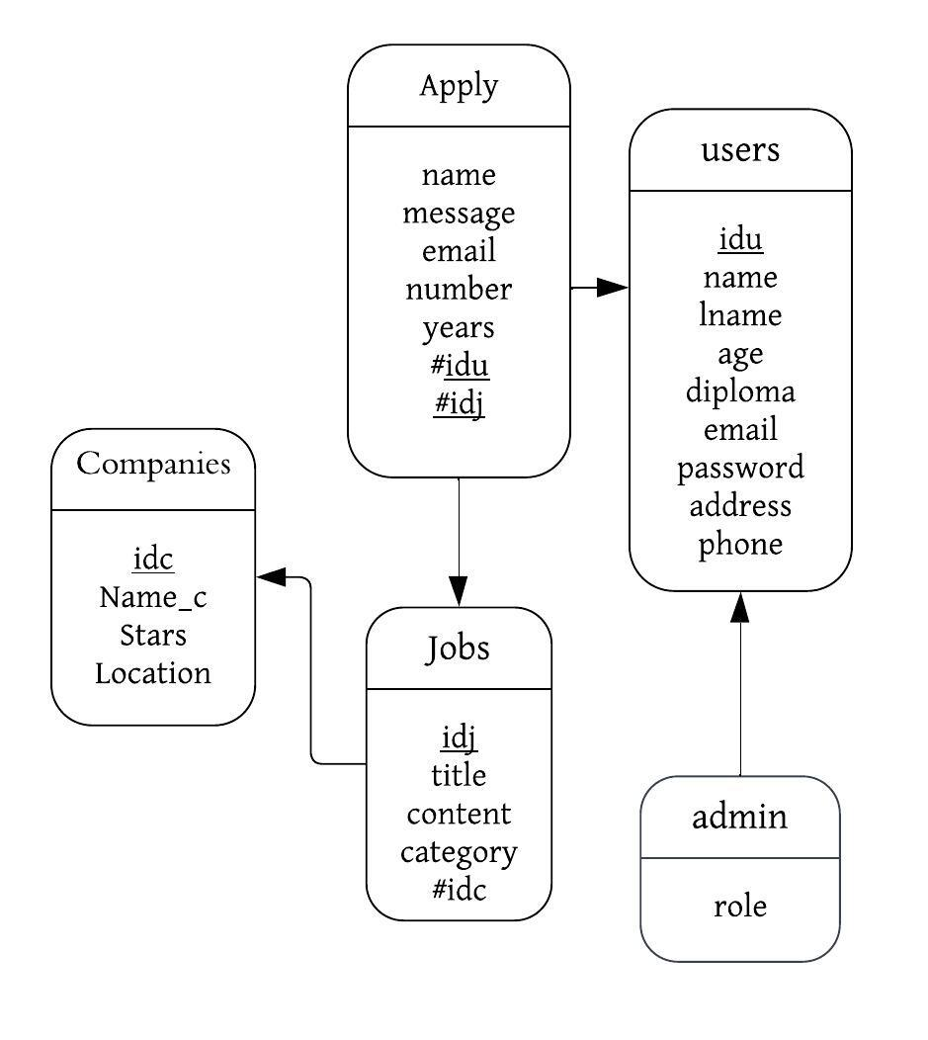

Figure 3: MLD

Technologies Used

1. Technologies Used
   1. HTML

HTML, which stands for Hypertext Markup Language, is the backbone of the web. It provides a structure and semantic meaning to the content displayed on websites. HTML allows developers to define the elements and layout of web pages, organizing text, images, links, and other media into a cohesive structure. By using HTML, developers can create accessible and well-structured web pages that can be interpreted and rendered correctly by different web browsers. It follows the recommended practices of separating content and presentation, as specified by the W3C (World Wide Web Consortium).



Figure 4: HTML LOGO

* 1. CSS

CSS, or Cascading Style Sheets, is a foundational technology for web design. It controls the visual appearance and layout of web pages, allowing developers to apply styles such as colors, fonts, spacing, and positioning to HTML elements. By separating presentation from content (HTML), CSS promotes code organization and maintainability. It provides flexibility and efficiency, enabling global changes to be applied across multiple pages. CSS follows W3C recommendations for compatibility across browsers and devices.



Figure 5: CSS LOGO

* 1. Tailwind CSS

Tailwind CSS is a powerful utility-first CSS framework that empowers developers to easily and completely customize the design of their applications or websites. With Tailwind CSS, you can create a user interface design directly within the HTML file itself. This approach to programming does not interfere with recommended practices by the W3C, such as separating HTML from CSS stylesheets. Tailwind CSS offers a comprehensive set of pre-designed utility classes that can be combined to rapidly build complex layouts and styles. It provides a highly efficient workflow, allowing developers to focus on building functionality rather than writing custom CSS code from scratch. Tailwind CSS is known for its flexibility, responsiveness, and the ability to streamline the design process.



Figure 6:   
Tailwind CSS LOGO

Technologies Used

* 1. React



React is a JavaScript library for building user interfaces. It allows developers to create reusable UI components that efficiently update and render based on data changes. With a component-based architecture, react promotes code reusability, maintainability, and scalability. It uses a virtual DOM for optimized rendering performance and provides a declarative syntax for describing UI based on application state. React is suitable for building SPAs and complex web interfaces, and it integrates well with other JavaScript libraries/frameworks.

Figure 7:   
React LOGO

* 1. Node JS



Node.js is a runtime environment that allows developers to run JavaScript code outside of a web browser. It is built on the V8 JavaScript engine and provides a server-side execution environment for building scalable and efficient web applications. Node.js uses an event-driven, non-blocking I/O model, making it lightweight and capable of handling concurrent requests. It enables developers to write server-side code using JavaScript, which allows for easy sharing of code between the client and server. Node.js has a vast ecosystem of modules and packages available through npm (Node Package Manager), making it highly extensible and suitable for various application domains. With Node.js, developers can build high-performance and real-time applications, handle large amounts of data, and create APIs or microservices.

Figure 8:   
NodeJS LOGO

* 1. MongoDB

MongoDB is a powerful and flexible NoSQL database that revolutionizes the way data is stored and accessed. Unlike traditional relational databases, MongoDB uses a document-oriented approach, where data is stored in flexible, JSON-like documents instead of tables with fixed schemas. This allows for dynamic and scalable data models, making it easier to handle evolving and complex data structures. MongoDB offers high performance and scalability, with built-in support for horizontal scaling across multiple servers or clusters. It also provides advanced querying capabilities, indexing, and aggregation frameworks, enabling efficient data retrieval and analysis



Figure 9:   
MongoDB LOGO

Interface Presentation

1. Interface Presentation
   1. Home Page

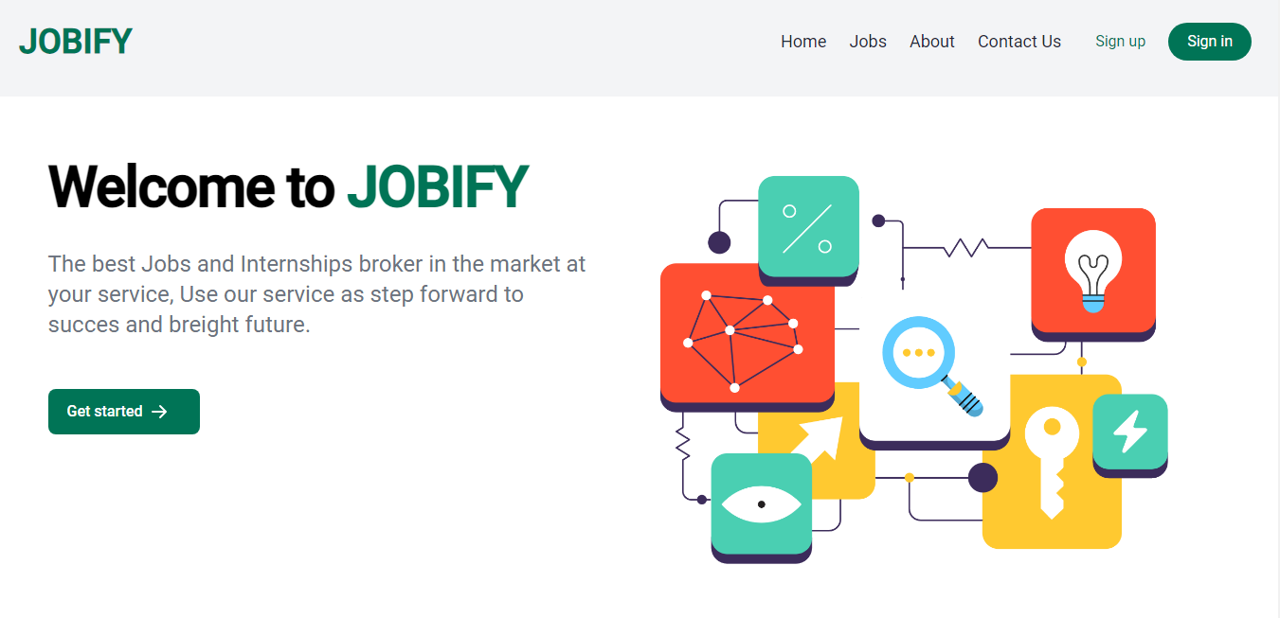

Figure 10: Home Page

The Home Page of our platform welcomes you with a vibrant and engaging design, aimed at providing a seamless user experience. Divided into three sections, it ensures that you have all the necessary information at your fingertips to embark on a successful career journey.

At the top of the Home Page, you will find our distinctive header. It features a captivating image that showcases the diverse and exciting world of job opportunities. Accompanying the image is a powerful message: "The best Jobs and Internships broker in the market at your service." This statement reflects our commitment to serving as your trusted partner, helping you navigate the job market and secure a bright future. With our platform, you can take the first step towards success.

Directly below the header, you will encounter our Services Section, where we highlight the key offerings of our platform.

Home Page

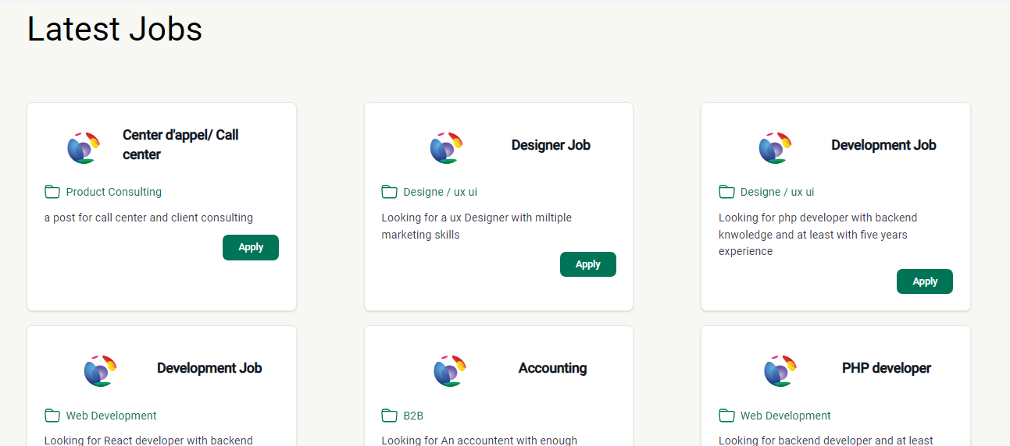

Figure 11: Lates Jobs section

Moving further down the Home Page, you will discover our Latest Jobs and Company Posts Section. Here, we showcase the most recent job openings and company updates, allowing you to stay up-to-date with the latest opportunities. Each listing provides a direct link that takes you to the respective application page, enabling you to apply seamlessly with just a few clicks.



Figure 12: Platform navigation bar

Additionally, our Home Page features a user-friendly navigation bar at the top, granting easy access to various sections of our platform. Whether you want to explore different job categories, learn more about our company, or access your Contact Us, the navigation bar ensures a smooth browsing experience.

Finally, at the bottom of the page, you will find our footer, which contains important links, contact information, and additional resources. It serves as a convenient reference point, allowing you to access essential information and connect with us effortlessly.

Login Page

* 1. Login Page

Our Login Page offers a streamlined and secure way for users to access their accounts. With a user-friendly interface and essential features, we aim to provide a hassle-free experience for both new and returning users.

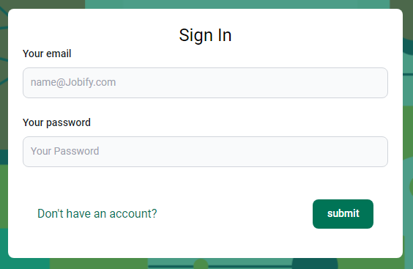

Figure 13: Sign in Page

The page begins with a convenient navigation bar at the top, offering easy access to different sections of our platform. Below the navigation bar, you'll find a prominent heading that says "Sign In," guiding users towards logging into their accounts.

A concise form is provided, allowing users to enter their login credentials. The form prompts users to input their email address and password to securely access their account. The "Your email" field is where users should enter the email address associated with their account, such as "name@Jobify.com." This ensures accurate identification and personalized access. The "Your password" field prompts users to enter their account password, ensuring only authorized individuals can access the account and protecting user data and privacy. Password characters are masked for security purposes.

Below the form, a link is included for users who don't have an account. Clicking this link redirects users to the registration or signup page, where they can easily create a new account and unlock all the benefits our platform has to offer.

Login Page

At the bottom of the form, a prominent "Submit" button is placed. Clicking "Submit" initiates the login process.

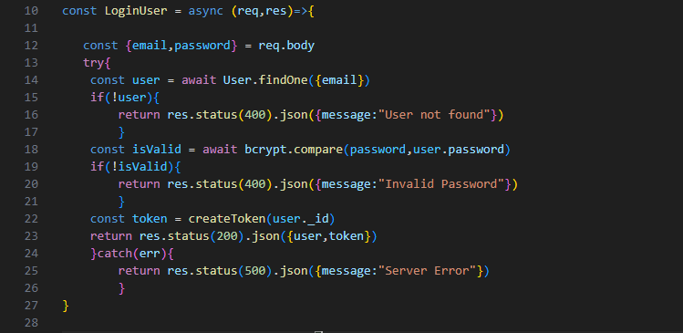

Figure 14: Login process

After submitting, the platform checks if the provided email exists in the database using the function findOne({email}).

If the email exists, the platform compares the provided password with the password stored in the database using the function compare(password, user.password) This ensures a secure and accurate login process.

Our Login Page excels in providing a highly user-centric experience, offering a meticulously designed interface that effortlessly guides users through the sign-in process and empowers them to conveniently access their accounts. With a focus on simplicity and intuitiveness, we have carefully crafted the interface to ensure that users of all technical backgrounds can effortlessly navigate and successfully log in to their accounts, fostering a seamless and frustration-free experience. By prioritizing user needs and leveraging intuitive design principles, our Login Page optimizes accessibility, streamlines the authentication process, and enables users to effortlessly gain access to their personalized accounts with just a few simple steps.

Sign up Page

* 1. Sign up Page

Our Sign-Up Page offers a user-friendly and secure platform for individuals to create their accounts and unlock the full range of features and services available on our platform. With a carefully designed interface and essential input fields, we aim to provide a seamless and efficient registration experience for new users.

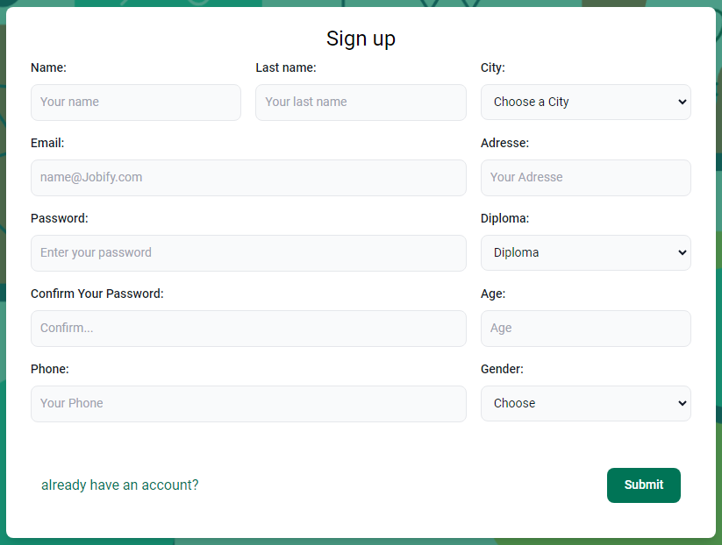

Figure 15: Sign Up Page

As you arrive at the Sign-Up Page, you'll notice a prominent heading that says "Sign up," indicating the purpose of the page and guiding users towards creating their accounts.

Below the heading, you'll find a series of input fields labeled to prompt users for specific information. They can enter their first name, last name, select their city, provide a valid email address, residential address, choose a secure password, confirm it, select their highest educational qualification, enter their age, phone number, and select their gender from a list of

Sign up Page

options. These inputs enable us to personalize their experience, provide relevant job opportunities, and ensure effective communication.

At the bottom of the page, we include a link or checkbox stating "Already have an account?" This provides a convenient option for users who may have accidentally landed on the Sign-Up Page but already have an existing account. Clicking on this link will redirect them to the login page.

Finally, a prominent "Submit" button is displayed, indicating that users have completed the necessary input fields and are ready to proceed.

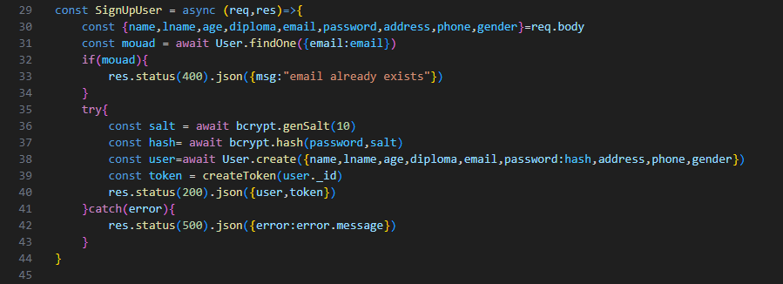

Figure 16: Sign Up process

Upon submission, the backend processes the information provided by the user. This includes checking if the email already exists in the database using the function findOne({email: email}). If the email is already registered, an appropriate error message is returned. Otherwise, the password is securely hashed using a salt and bcrypt, and the user's account is created in the database.

Our Sign-Up Page has been meticulously designed to deliver an exceptional user experience, placing a strong emphasis on user-centricity and intuitive design. With a focus on simplicity and ease of use, our interface seamlessly guides users through the registration process, enabling them to create their accounts effortlessly. We have taken great care to ensure that users of all technical backgrounds can navigate the interface with ease, removing any potential barriers to a smooth and frustration-free sign-up experience. By prioritizing user needs and leveraging intuitive design principles, our Sign-Up Page optimizes accessibility, streamlines the registration process, and empowers users to create their personalized accounts in just a few simple steps.

About Page

* 1. About Page

The About Page provides a comprehensive overview of our platform, highlighting its key features and the benefits it offers to both job seekers and employers. Through a well-crafted interface and innovative functionalities, we aim to transform the job search process and facilitate meaningful connections in the professional world.

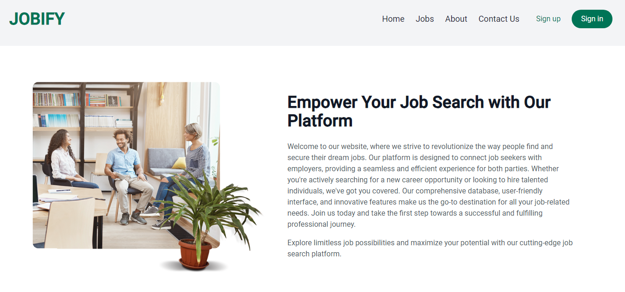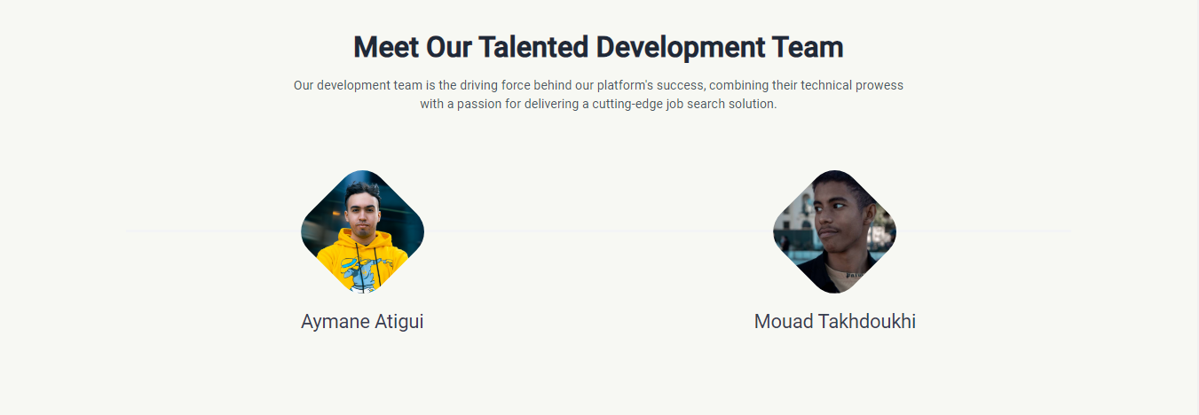

Figure 17: About Page

Upon landing on the About Page, you'll be greeted by the captivating image of our platform, symbolizing the power and potential it holds for job seekers and employers alike. This visual representation sets the tone for the content that follows, capturing your attention and sparking curiosity.

About Page

The introductory text serves as a warm welcome, emphasizing our mission to revolutionize the job search experience. We understand the challenges and frustrations that can arise during the job-hunting process, which is why we have developed a platform that aims to simplify and optimize it. By connecting job seekers with employers in a seamless and efficient manner, we empower individuals to take control of their professional lives and pursue their dream careers.

The About Page also introduces our talented development team, a group of dedicated professionals who possess technical expertise and a genuine passion for delivering a top-notch job search solution. Their collective efforts and commitment to excellence have played a crucial role in shaping the platform's success and ensuring its continuous improvement.

* 1. Contact Page

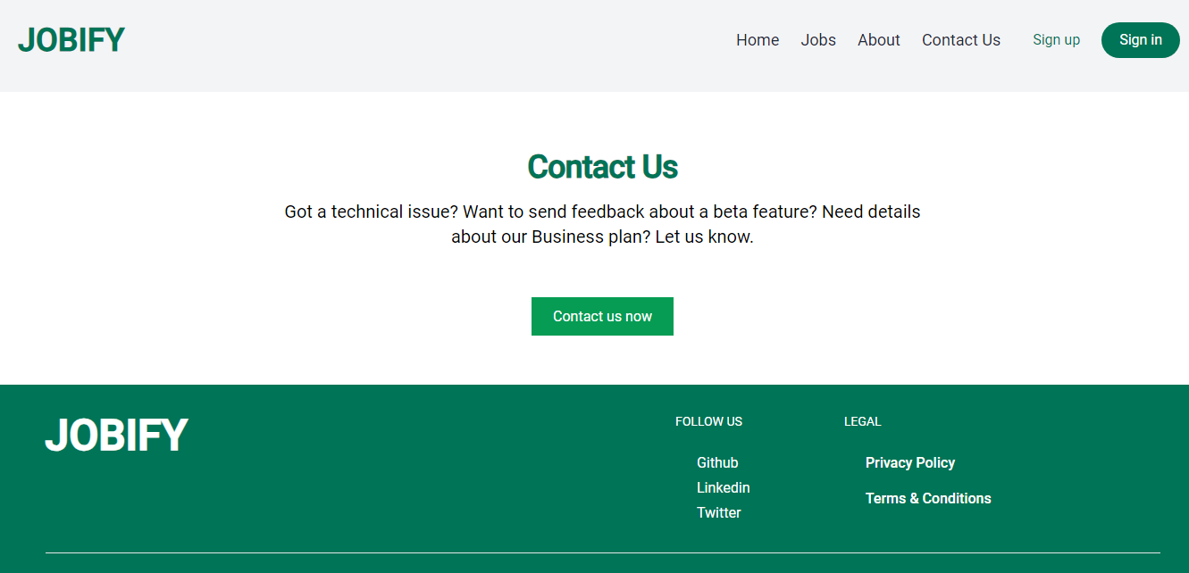

Figure 18: Contact Page

The Contact Page serves as a convenient communication channel for various inquiries. If there are any technical issues experienced while using our platform, users are encouraged to contact us via email. The support team promptly addresses concerns and provides necessary assistance to ensure a seamless experience.

Jobs Page

* 1. Jobs Page

The Jobs Page on our platform serves as a centralized hub where users can discover and apply for various job opportunities. This page features a comprehensive list of available jobs, each accompanied by essential details to aid users in their decision-making process.

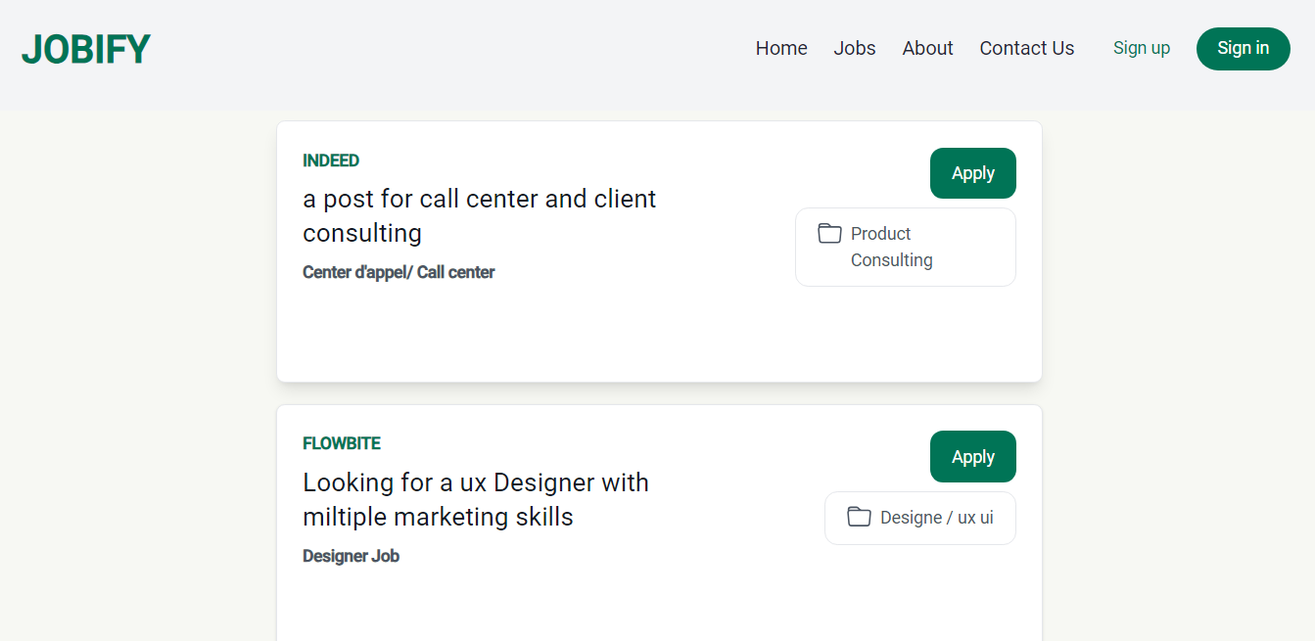

Figure 19: Jobs Page

Upon reaching the Jobs Page, visitors will find a well-organized layout with a user-friendly interface. At the top of the page, a convenient navigation bar offers easy access to different sections of our platform, ensuring a seamless browsing experience. Additionally, a footer containing essential links is available for quick reference. As users scroll down the page, they will come across a diverse range of job listings. Each listing includes key information such as the company name, a description of the job post, the job title, and the type of position. This clear categorization allows users to quickly identify and focus on job opportunities that align with their skills and interests.

When users find a job listing that piques their interest, they can simply click on the "Apply" button associated with that specific job. This action redirects them to a dedicated application page where they can further explore the job requirements and complete the application process. Our platform is designed to facilitate a seamless and efficient application experience, ensuring that users have all the necessary features at their disposal.

Apply Page

By providing a user-friendly interface, convenient navigation, and comprehensive job listings, our Jobs Page aims to connect users with a wide range of exciting career opportunities. Whether users are embarking on their career journey or seeking new prospects for professional growth, our platform serves as a valuable resource. Start exploring our Jobs Page today and take the next step towards a successful and fulfilling career path.

* 1. Apply Page

After users have selected a job from the Jobs Page and clicked the "Apply" button, they will be redirected to our Apply Page. This page represents a pivotal component of our platform, embodying professionalism and efficiency in the application process. This section provides applicants with a seamless and sophisticated experience as they submit their applications.

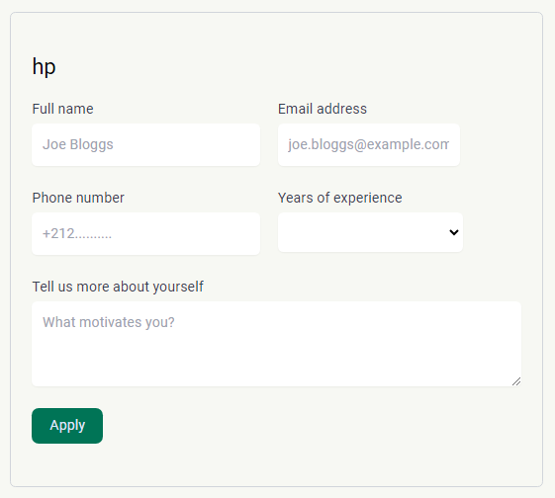

Figure 20: Apply page

Comprising a user-friendly form, the Apply Page empowers applicants to effortlessly enter their information and express their interest in a desired position. With fields such as Full Name, Email Address, Phone Number, and Years of Experience, the form captures essential details necessary for effective communication and evaluation of applicants' qualifications.

Apply Page

The Apply Page ensures clear and user-friendly navigation with thoughtfully labeled and well-organized fields. Applicants provide their Full Name for personalized representation and accurate identification. The Email Address field facilitates seamless communication, enabling timely updates on application status. Additionally, the Phone Number field offers an extra contact option for further discussions. The Years of Experience field plays a crucial role in assessing applicants' expertise, allowing potential employers to make informed decisions. The open-ended section, "Tell us more about yourself," encourages applicants to showcase their skills, qualifications, and achievements, leaving a strong impression. Upon completing the form, applicants demonstrate their interest by clicking the "Apply" button, officially submitting their application and expressing their commitment to the opportunity.

The Apply Page showcases our dedication to maintaining a professional and streamlined application process. With its simple and intuitive design, thorough form, and meticulous attention to detail, the Apply Page enables applicants to convey their interest and provide crucial information with ease and accuracy. By utilizing the Apply Page, individuals can confidently take a significant step towards their desired job, knowing that their application will be carefully evaluated by prospective employers.

* 1. Dashboard

For Administrator the platform provides an exclusive space to manage and oversee various aspects of the system. This page is specifically designed to cater to the unique needs and responsibilities of administrators.



Figure 21: Administrators navigation bar

For administrators, accessing the Dashboard is made simple through this dedicated link in the navigation bar. This link is specifically designed to be accessible only to administrators, ensuring that they have exclusive access to the administrative functionalities and features offered by the platform.

Dashboard

Once administrators access the Dashboard, they are presented with a comprehensive set of tools and options to manage the system effectively. From this centralized hub, administrators can perform a range of administrative tasks.

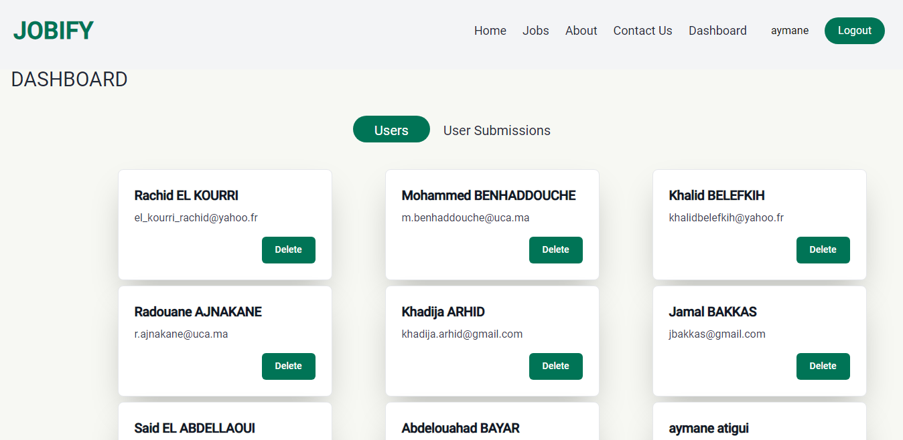

Figure 22: Dashboard Page -users-

Within the Dashboard, administrators have the primary function of overseeing and managing user accounts. They are provided with the capability to view all registered users within the platform, allowing them to have a comprehensive overview of the user base. Administrators can access a list of users, including their profiles and associated information. In addition to user visibility, administrators also have the authority to remove user accounts when necessary. By removing accounts that violate platform policies or exhibit suspicious or inappropriate behavior., administrators maintain the platform's integrity, security, and user experience.

The ability to see and remove users provides administrators with an essential tool for user management and maintaining a healthy and reliable user community within the platform. With this function, administrators can effectively monitor user activity and take prompt actions to address any issues, ensuring a safe and positive user experience for all platform users.

Dashboard

Another important feature available to administrators in the Dashboard is the ability to manage user submissions for jobs. The platform provides administrators with a dedicated section where they can oversee and review all job submissions made by users. This function allows administrators to have a clear overview of the companies and individuals who have submitted applications.

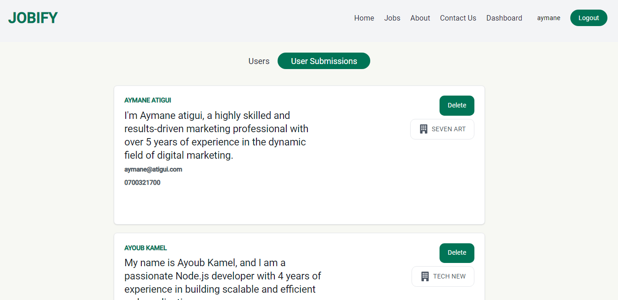

Figure 23: Dashboard Page -user submissions-

Within this section, administrators can access details such as the name of the submitting company, the name of the individual who submitted the application, a description provided by the applicant, as well as their email address and phone number. This comprehensive information allows administrators to effectively review and evaluate the job submissions. Moreover, administrators have the authority to delete any inappropriate or irrelevant submissions to maintain the quality and relevance of the job listings. This control ensures that only valid and suitable submissions are displayed, providing a reliable and efficient job application process for both companies and job seekers.

By offering the option to oversee and delete user submissions, the Dashboard provides administrators with valuable tools to manage and curate the job application data. This functionality allows for effective moderation and ensures that the platform maintains a high standard of quality and relevance for job listings and applications.

CONCLUSION

In conclusion, my internship at SOTRAGEP was a valuable opportunity to apply my skills in a professional setting. I worked on various web design and development projects, gaining hands-on experience and bridging the gap between theory and practice. Tasks such as web development, database management, quality assurance, and digital marketing support allowed me to enhance my adaptability and problem-solving skills. Working on the development of JOBIFY, a job search platform, further expanded my technical proficiency in HTML, CSS, React, and more. I am grateful to the CEO, Mr. HACHMI EL AYACHI, and the dedicated team at SOTRAGEP for their guidance and support throughout my internship.

Overall, this internship has been a transformative experience that provided me with practical skills, industry insights, and a deeper understanding of web design and development. I am confident that the knowledge and experiences gained during this internship will greatly contribute to my future career endeavors.

REFERENCES

* Mozilla HTML Documentation : https://developer.mozilla.org/en-US/docs/Web/HTML *22/05/2023*
* Mozilla CSS Documentation : https://developer.mozilla.org/en-US/docs/Web/CSS *05/06/2023*
* MDN CSS Documentation : https://tailwindcss.com/docs *05/06/2023*
* React Documentation : https://reactjs.org/docs *05/06/2023*
* React Router Documentation : https://reactrouter.com/web/guides/quick-start *05/06/2023*
* Redux Documentation : https://redux.js.org/introduction/getting-started *05/06/2023*
* Node.js Documentation : https://nodejs.org/en/docs *05/06/2023*
* Express.js Documentation : https://expressjs.com *05/06/2023*
* MongoDB Documentation : https://docs.mongodb.com/ *12/06/2023*
* Artificial intelligence chabot : https://chat.openai.com *13/06/2023*
* Mongoose (MongoDB ODM) Documentation: https://mongoosejs.com/docs *13/06/2023*
* Git Documentation : https://git-scm.com/doc *13/06/2023*
* Artificial intelligence chabot : https://bard.google.com *13/06/2023*
* Node.js Tutorial : https://www.youtube.com/watch?v=TlB_eWDSMt4 *05/06/2023*
* Node.js Tutorial : https://www.youtube.com/watch?v=Oe421EPjeBE *05/06/2023*
* Harvard EDU: https://pll.harvard.edu/course/cs50-introduction-computer-science *05/06/2023*