Advanced Scientific Calculator

# Description:

The project is a calculator capable of scientific computations such as square roots, trigonometric functions and logarithmic functions to different bases. The calculator supports order of operations, detecting syntactic and mathematical errors such as dividing by 0 or infinity resulting operations.

# How to use the Software

The calculator has a straightforward GUI with help messages to assist with the usage of scientific functions and to display errors when they occur.

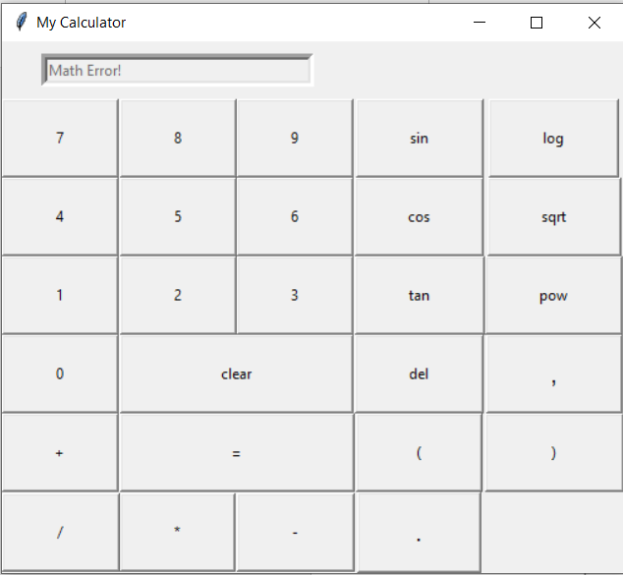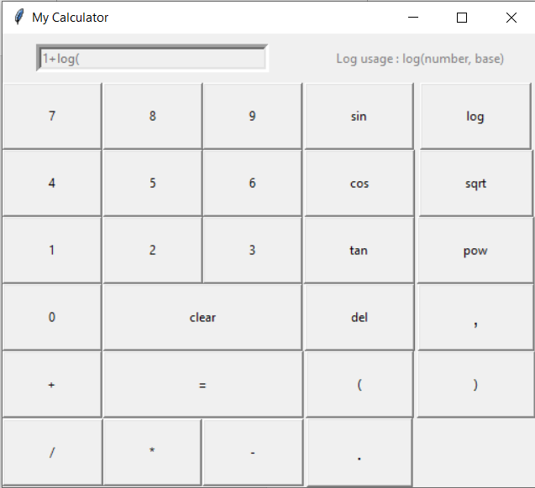

Figure 2 Error message when an infinity resulting operation is used

Figure 1 Helper message for using the log operation

# Members Roles:

## Member 1:

• Made the GUI: how the buttons were organized, how the helper messages and error messages were shown to user

• Click

• Clear

• SC operations

## Member 2:

• Made the buttons functionality: adding the corresponding button text to the screen or clearing text from it.

• Delete

• Button operations

• Error check

## Member 3:

• Made the evaluation function and error checking functions to ensure the program was flowing as expected

• Equal, change angle to radian