# CPSC 233 – Coding Challenge 4 – Practice 2

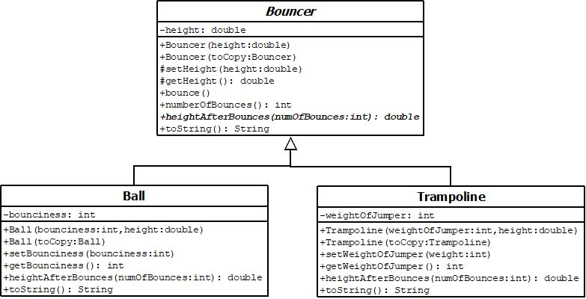

Note that # indicated protected access. Bold and italics indicates abstract.

**Bouncer class:** The ***height*** should be greater than 0. If 0 or less is provided, set it to a default of 1.0. ***heightAfterBounces*** is abstract and represents height after specified number of bounces. ***bounce*** should update the height to reflect a single bounce: implement by calling ***heightAfterBounces***. ***numberOfBounces***: returns number of bounces the ball takes before remaining still on the ground. A height of less than 1 means there will be no more bounces. Call heightAfterBounces (in a loop) to get the number of bounces. Format returned by ***toString***: ‘Height: <height> Number of bounces: <number>’

**Ball class:**The ball will be ***bounciness***% of it’s original height after a single bounce. Round a height less than 1 to 0. The bounciness is a percentage value (between 0 (exclusive) and 100 (exclusive)). Default to 50%. Format returned by ***toString***: ‘[Ball] Height: <height> Number of bounces: <number> Bounciness: <bounciness>’.

**Trampoline class:** The bounciness of a jumper is (weight + height)/(3.5*height) percent. The ***weight*** of the jumper is between 50 (inclusive) and 300 (inclusive) pounds. If weight is invalid, default to 140. Format returned by ***toString***: ‘[Trampoline] Weight: <weight> Height: <height> Number of bounces: <number>.

**Notes:** Do not duplicate instance variables from parent class in child class. Instead invoke appropriate super constructor and methods in parent class. The toString methods in child classes should invoke toString in parent rather than getter methods in parent class.