**MMS4 experiment instructions**

Thank you very much for participating in today’s experiment!

The experiment is designed to test your ability to make quick motor responses. To test this, we will sit you down in front of a computer, and we will hand you two handles with buttons on top, one for your left and one for your right hand. Hold these handles firmly in your hand and make sure you can easily reach the buttons with your thumb.

The actual experiment is very simple: you will look at a computer screen and you will respond to arrows that appear in the center of the screen. These arrows point either to the right or to the left, and your task is to respond as fast as possible by pressing the appropriate button: left hand for left, right hand for right. Again, it is important that you do this **as fast as you can!**

The experiment will help you achieve this goal by giving you **two cues** before an arrow will appear. More precisely, a fixation cross will be displayed in the center of the screen, which indicates where exactly the arrow will appear. **Pay attention to this fixation cross**, because **exactly half a second before the arrow appears, a green circle will appear!** This will give you a hint that the arrow is about to appear! (First cue)

Furthermore, you will get an additional cue that will make it easier for you to know when exactly the arrow will appear: **you will also hear a ‘beep’ tone** at the same time the fixation cross disappears, i.e., a half second before the arrow will appear. (Second cue). Make sure to attend to both cues (green circle, beep tone) to maximize your ability to respond quickly.

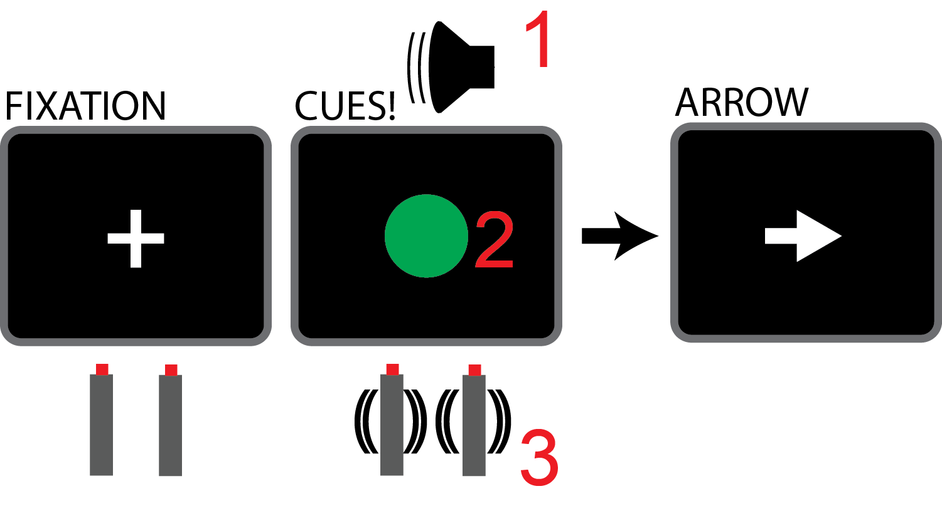

We will give you ample time to rest during the task. You will do this task for around 4 minutes at a time, after which you can take a break, and the experimenter will give you some feedback regarding your performance. The experimenter will remain in the room with you throughout the experiment in case you have any questions.

Again, thank you very much for your participation, and good luck!