Prison Management System

Semester Project Report
Aymen Faisal 575366
Asad Naeem 541405
Haseeb Amjad 541417

Table of Contents
- Abstract
- Introduction
- Problem Statement
- Project Objectives and Scope
- Tables summary and datatypes
- System Modules and Architecture
- ERD and Database Design
- Relational Algebra
- SQL Queries
- JDBC GUI Implementation
- Analysis and Conclusion

1. Abstract
The Prison Management System (PMS) is a comprehensive relational database designed to efficiently track and manage the complex operations of correctional facilities. The system is built to handle inmate records, staff assignments, cell occupancy, disciplinary actions, medical histories, visitation, and parole processes. By centralizing this information, the PMS aims to improve security, streamline administrative tasks, and provide an accurate, real-time overview of the prison environment. This project focuses on the database implementation using MySQL, demonstrating practical applications of database design, normalization, constraints, and query formulation.

2. Introduction
Managing a prison involves coordinating a vast amount of sensitive and critical data. From tracking the exact location of high-risk inmates to scheduling staff shifts and monitoring medical records, traditional paper-based or fragmented digital systems are prone to errors and inefficiencies. The Prison Management System provides a centralized database solution tailored for these specific needs. This report details the design and implementation of the PMS, highlighting the architectural choices, database schema, and the SQL queries necessary to support the system's functionality.

3. Problem Statement
Correctional facilities face significant challenges in managing disparate data sources. Critical information regarding inmate locations, security classifications, medical needs, and disciplinary histories must be instantly accessible and reliably accurate to ensure the safety of both staff and inmates. A poorly designed system can lead to overcrowding in specific cells, improper assignment of security levels, missed parole hearings, or unauthorized visitations. The challenge is to design a robust relational database that enforces strict data integrity, handles complex relationships (e.g., an inmate having multiple sentences or transfers), and provides actionable insights through efficient data retrieval.

4. Project Objectives and Scope

4.1 Objectives
- Centralized Record Keeping: Create a single source of truth for inmate demographics, sentences, medical records, and disciplinary actions.
- Facility Management: Track the hierarchy of prisons, blocks, and individual cells, including real-time monitoring of cell capacity and current occupancy.
- Staff and Security Management: Manage staff assignments, roles, and shift timings, linking them to specific blocks or administrative duties.
- Process Tracking: Maintain detailed logs of inmate transfers, visitation approvals, and parole application statuses.
- Data Integrity: Enforce strict business rules using constraints and triggers (e.g., ensuring a cell's occupancy does not exceed its capacity).

4.2 Scope
The scope of this project is focused on the backend database design and implementation. It includes the creation of the schema, definition of relationships, implementation of constraints, and the development of SQL scripts for data manipulation and retrieval. The project covers core modules such as facility tracking, inmate management, staff tracking, and incident reporting. It does not include the development of a graphical user interface (GUI) or integration with external biometric or physical security hardware.

5.Table Summary and Data Types :

Table | Primary Key | Key Attributes | Notable Constraints
PRISON | prison_id (INT) | prison_name, location, prison_type, total_capacity, contact_number | CHECK on prison_type; UNIQUE on contact_number
BLOCK | block_id (INT) | block_name, block_type, total_capacity, prison_id | CHECK on block_type; FK to PRISON
CELL | cell_id (INT) | cell_number, capacity, current_occupancy, security_level, block_id | UNIQUE cell_number; CHECK occupancy >= 0; FK to BLOCK
STAFF | staff_id (INT) | full_name, gender, role, shift_timing, date_of_joining, contact_number, block_id | CHECK on role/shift/gender; UNIQUE contact; FK to BLOCK (nullable)
INMATE | inmate_id (INT) | full_name, dob, gender, national_id, status, risk_level, admission_date, cell_id | UNIQUE national_id; CHECK on status/risk; FK to CELL (nullable)
SENTENCE | sentence_id (INT) | crime_type, sentence_duration, start_date, expected_release_date, court_name | FK to INMATE; actual_release_date nullable
VISITOR | visitor_id (INT) | full_name, national_id, relation, contact, address, approved_status, inmate_id | UNIQUE national_id; CHECK on approved_status; FK to INMATE
VISIT | visit_id (INT) | visitor_id, inmate_id, visit_date, duration_minutes, visit_type, approved_by | CHECK duration > 0; FK to VISITOR, INMATE, STAFF
MEDICAL_RECORD | record_id (INT) | inmate_id, staff_id, diagnosis, treatment, date_of_checkup | FK to INMATE and STAFF
DISCIPLINARY_RECORD | disciplinary_id (INT) | inmate_id, reported_by, incident_type, incident_date, punishment_given | FK to INMATE and STAFF
TRANSFER | transfer_id (INT) | inmate_id, from_cell_id, to_cell_id, authorized_by, transfer_date, reason | FK to INMATE, CELL (x2), STAFF
PAROLE | parole_id (INT) | inmate_id, sentence_id, reviewed_by, application_date, hearing_date, status, conditions | CHECK on status; FK to INMATE, SENTENCE, STAFF

6. System Modules and Architecture
The architecture of the Prison Management System is centered around a relational database model.

6.1 Selection of DBMS
We selected MySQL, a relational database management system (SQL).
- Justification: The data inherent to prison management is highly structured and heavily interrelated (e.g., an inmate must be assigned to a cell; a medical record must be linked to both an inmate and a doctor). A relational model is ideal for enforcing these strict relationships through primary and foreign keys, ensuring referential integrity. Complex queries involving multiple joins (e.g., finding all high-risk inmates in a specific block) are efficiently handled by SQL databases.

6.2 System Modules
- Facility Module: Manages PRISON, BLOCK, and CELL tables, establishing the physical hierarchy and tracking capacity.
- Personnel Module: Handles STAFF details, roles, and shift assignments.
- Inmate Module: The core module managing INMATE demographics, status, and current location.
- Legal & Administrative Module: Tracks SENTENCE details and PAROLE applications.
- Operations Module: Logs TRANSFER events, DISCIPLINARY_RECORDs, and MEDICAL_RECORDs.
- Visitation Module: Manages approved VISITORs and schedules VISITs.

6.3 Indexes
Indexes were created to optimize common search and filtering operations:
- idx_inmate_status: On INMATE(status) to quickly find 'Active' inmates.
- idx_inmate_risk: On INMATE(risk_level) for rapid identification of high-security individuals.
- idx_visit_date: On VISIT(visit_date) for scheduling and historical queries.
- idx_sentence_release: On SENTENCE(expected_release_date) to track upcoming releases.
- idx_visitor_status: On VISITOR(approved_status) to quickly filter pending or blacklisted visitors.

6.4 Normalization Approach
The database is designed adhering to Third Normal Form (3NF):
- 1NF: All attributes are atomic (e.g., no comma-separated lists of offenses).
Our database satisfies 1NF because:
- Every attribute stores a single value. For example, the INMATE table stores one national_id per row, one admission_date per row, and one risk_level per row. There are no comma-separated lists or arrays stored in any column.
- Inmates with multiple sentences (for example, a repeat offender) are not stored as multiple values in one row — instead, they have separate rows in the SENTENCE table, each linked to the same inmate_id via a foreign key.
- Every table has a clearly defined primary key (prison_id, block_id, cell_id, staff_id, inmate_id, etc.) that uniquely identifies each row.
- No table contains repeating column groups such as crime1, crime2, crime3.

- 2NF: All non-key attributes depend on the entire primary key. Since surrogate single-column primary keys are used, 2NF is inherently satisfied.

Partial dependencies only arise when a table has a composite primary key (a primary key made of two or more columns). In our schema, every single table uses a single-column integer surrogate primary key:
- PRISON → prison_id
- BLOCK → block_id
- CELL → cell_id
- STAFF → staff_id
- INMATE → inmate_id
- SENTENCE → sentence_id
- VISITOR → visitor_id
- VISIT → visit_id
- MEDICAL_RECORD → record_id
- DISCIPLINARY_RECORD → disciplinary_id
- TRANSFER → transfer_id
- PAROLE → parole_id

- 3NF: No transitive dependencies exist. This prevents data anomalies when updating facility details.
- STAFF table: All attributes (full_name, role, shift_timing, contact_number) depend directly on staff_id. The block_id is only a foreign key reference — block name, block type, and capacity are stored in BLOCK, not repeated in STAFF.
- VISIT table: visit_date, duration_minutes, and visit_type all depend on visit_id. The approved_by column is a foreign key to STAFF — the approving staff member's name, role, and shift are not duplicated inside VISIT. They are retrieved via JOIN when required.
- BLOCK table: block_name, block_type, and total_capacity all depend on block_id. Prison details such as prison_name and location are not stored in BLOCK — they are stored in PRISON and referenced via prison_id as a foreign key.
- SENTENCE table: crime_type, sentence_duration, start_date, expected_release_date, and court_name all depend directly on sentence_id. Inmate details are not repeated here — only inmate_id is stored as a foreign key.
- INMATE table: full_name, date_of_birth, gender, national_id, risk_level, and admission_date all depend directly on inmate_id. The cell_id column is a foreign key reference — it does not store cell details like block name or security level inside INMATE. Those details live in the CELL table and are fetched via JOIN when needed. No transitive dependency exists.

7. ERD and Database Design
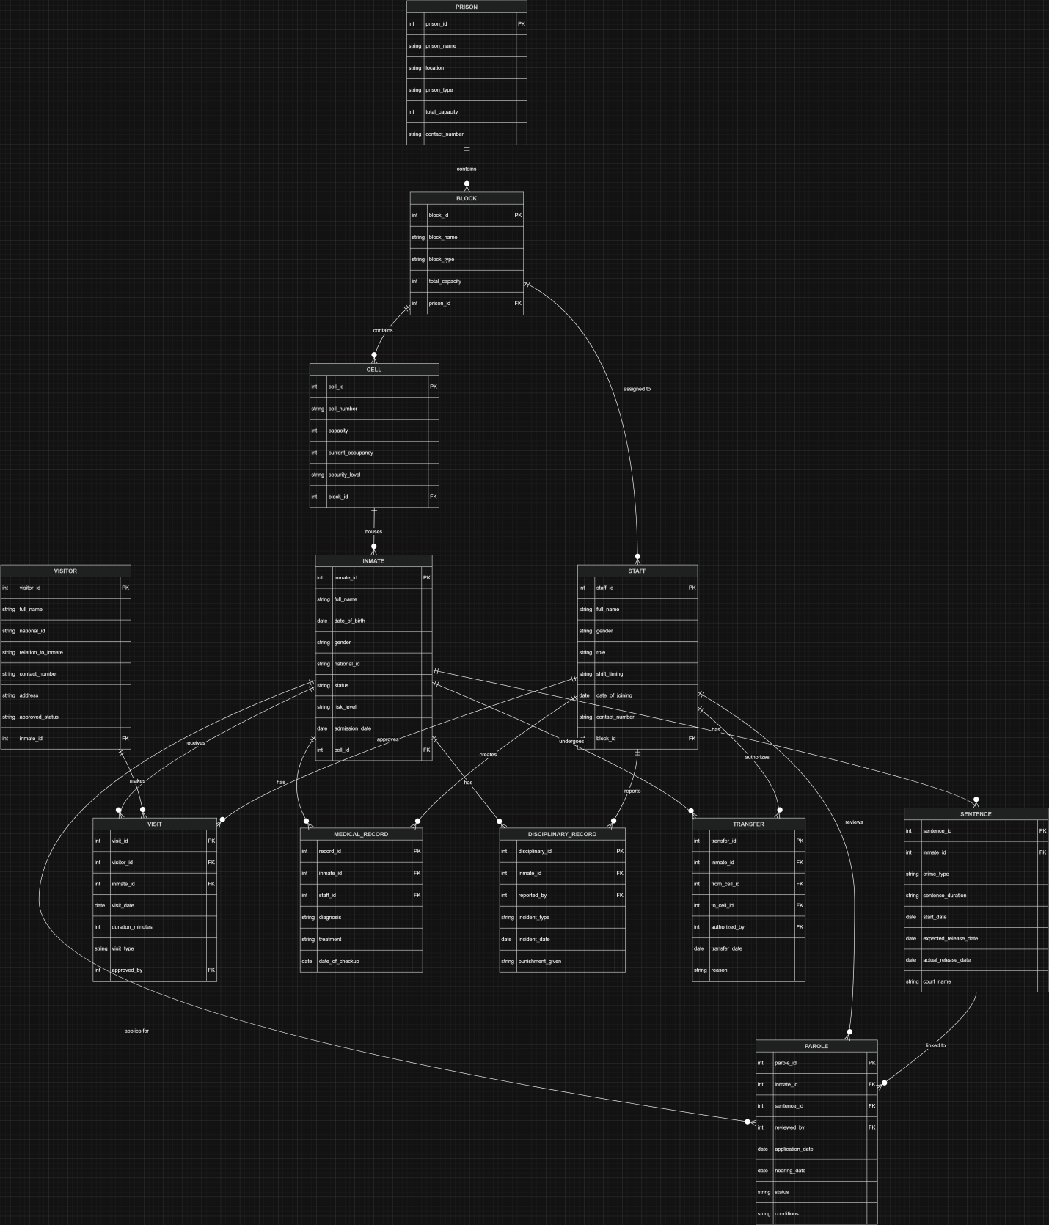

7.1 Entities and Relationships

Relationship | Cardinality | Description
PRISON → BLOCK | 1 : Many | One prison contains multiple blocks
BLOCK → CELL | 1 : Many | One block contains multiple cells
BLOCK → STAFF | 1 : Many (optional) | Staff may be assigned to a block
CELL → INMATE | 1 : Many (optional) | A cell holds multiple inmates; released inmates have NULL cell
INMATE → SENTENCE | 1 : Many | An inmate can have one or more sentences (e.g., repeat offenders)
INMATE → VISITOR | 1 : Many | An inmate may have multiple registered visitors
VISITOR → VISIT | 1 : Many | A visitor can make multiple visit requests
INMATE → VISIT | 1 : Many | An inmate can receive multiple visits
STAFF → VISIT | 1 : Many | A staff member approves visits
INMATE → MEDICAL_RECORD | 1 : Many | An inmate can have multiple health checkups
STAFF → MEDICAL_RECORD | 1 : Many | A doctor can treat multiple inmates
INMATE → DISCIPLINARY_RECORD | 1 : Many | An inmate can have multiple incidents
STAFF → DISCIPLINARY_RECORD | 1 : Many | A staff member reports incidents
INMATE → TRANSFER | 1 : Many | An inmate can be transferred multiple times
CELL → TRANSFER | 1 : Many | Cells appear as source or destination of transfers
STAFF → TRANSFER | 1 : Many | A staff member authorizes transfers
INMATE → PAROLE | 1 : Many | An inmate can apply for parole multiple times
SENTENCE → PAROLE | 1 : 1 or Many | A parole is tied to a specific sentence
STAFF → PAROLE | 1 : Many | A counselor/warden reviews parole applications

8. Relational Algebra
The following expressions demonstrate the theoretical foundation for key data retrieval operations in the system.
- Find all active inmates: σ status = 'Active' (INMATE)
- Find names and contact numbers of all night shift guards: π full_name, contact_number (σ role = 'Guard' ∧ shift_timing = 'Night' (STAFF))
- List cell numbers and their capacities for cells that are completely full: π cell_number, capacity (σ current_occupancy = capacity (CELL))
- Display the names of inmates along with the names of the blocks they are housed in: π INMATE.full_name, BLOCK.block_name
((INMATE ⋈ INMATE.cell_id = CELL.cell_id CELL)
⋈ CELL.block_id = BLOCK.block_id BLOCK)
- Find the names of visitors who are blacklisted: π full_name (σ approved_status = 'Blacklisted' (VISITOR))
- Find inmates who have pending parole applications: π INMATE.full_name, INMATE.risk_level
(INMATE ⋈ INMATE.inmate_id = PAROLE.inmate_id
(σ status = 'Pending' (PAROLE)))
7. Find inmates who have a 'Life' sentence (Join & Selection):
π INMATE.full_name, SENTENCE.start_date
(INMATE ⋈ INMATE.inmate_id = SENTENCE.inmate_id
(σ sentence_duration = 'Life' (SENTENCE)))
8. Find the names of inmates who have NEVER received a visitor (Set Difference):
π full_name
((π inmate_id (INMATE) − π inmate_id (VISIT))
⋈ INMATE.inmate_id = inmate_id INMATE)
9. List all staff members who have approved a 'Legal' visit type (Multiple Joins/Relations):
π STAFF.full_name
(STAFF ⋈ STAFF.staff_id = VISIT.approved_by
(σ visit_type = 'Legal' (VISIT)))
10. Find block names and capacities for all High-Security or Maximum security blocks (Logical OR):
π block_name, total_capacity
(σ block_type = 'High-Security' ∨ block_type = 'Death Row' (BLOCK))

9. SQL Queries

9.1 Basic SELECT Queries

Q1: View all active inmates
SELECT * FROM INMATE
WHERE status = 'Active';

Q2: Get all staff with their roles and shift timings
SELECT full_name, role, shift_timing, contact_number
FROM STAFF
ORDER BY role;

Q3: Find high and maximum risk inmates
SELECT inmate_id, full_name, national_id, risk_level, admission_date
FROM INMATE
WHERE risk_level IN ('High', 'Maximum')
ORDER BY risk_level;

Q4: Get all visitors with pending approval
SELECT full_name, relation_to_inmate, contact_number, address
FROM VISITOR
WHERE approved_status = 'Pending';

Q5: Find all active (unfinished) sentences
SELECT sentence_id, inmate_id, crime_type, sentence_duration, expected_release_date
FROM SENTENCE
WHERE actual_release_date IS NULL
ORDER BY expected_release_date;

Q6: Find all completely full cells
SELECT cell_id, cell_number, capacity, current_occupancy, security_level
FROM CELL
WHERE current_occupancy = capacity;

Q7: Get all night shift guards
SELECT full_name, contact_number, block_id
FROM STAFF
WHERE role = 'Guard' AND shift_timing = 'Night';

6.2 WHERE and Filtering Queries
Q8: Long-term prisoners (admitted before 2020)
SELECT full_name, admission_date, status, risk_level
FROM INMATE
WHERE admission_date < '2020-01-01'
ORDER BY admission_date;

Q9: Legal visits longer than 45 minutes
SELECT visit_id, inmate_id, visitor_id, visit_date, duration_minutes
FROM VISIT
WHERE visit_type = 'Legal' AND duration_minutes > 45;

Q10: All blacklisted visitors
SELECT visitor_id, full_name, national_id, relation_to_inmate, contact_number
FROM VISITOR
WHERE approved_status = 'Blacklisted';

Q11: All pending parole applications
SELECT parole_id, inmate_id, application_date, hearing_date
FROM PAROLE
WHERE status = 'Pending'
ORDER BY application_date;

Q12: Disciplinary incidents in 2024
SELECT disciplinary_id, inmate_id, incident_type, incident_date, punishment_given
FROM DISCIPLINARY_RECORD
WHERE YEAR(incident_date) = 2024
ORDER BY incident_date;

6.3 JOIN Queries
Q13: Each active inmate with cell and block information
SELECT i.inmate_id, i.full_name AS inmate_name, i.risk_level,
c.cell_number, c.security_level, b.block_name, b.block_type
FROM INMATE i
JOIN CELL c ON i.cell_id = c.cell_id
JOIN BLOCK b ON c.block_id = b.block_id
WHERE i.status = 'Active'
ORDER BY b.block_name;

Q14: Full visit details with visitor, inmate, and approving staff
SELECT v.visit_id, vr.full_name AS visitor_name, vr.relation_to_inmate,
i.full_name AS inmate_name, v.visit_date, v.duration_minutes,
v.visit_type, s.full_name AS approved_by
FROM VISIT v
JOIN VISITOR vr ON v.visitor_id = vr.visitor_id
JOIN INMATE i ON v.inmate_id = i.inmate_id
JOIN STAFF s ON v.approved_by = s.staff_id
ORDER BY v.visit_date;

Q15: Medical records with inmate and treating doctor
SELECT mr.record_id, i.full_name AS inmate_name, s.full_name AS doctor_name,
mr.diagnosis, mr.treatment, mr.date_of_checkup
FROM MEDICAL_RECORD mr
JOIN INMATE i ON mr.inmate_id = i.inmate_id
JOIN STAFF s ON mr.staff_id = s.staff_id
ORDER BY mr.date_of_checkup;

Q16: Disciplinary records with inmate and reporting staff
SELECT dr.disciplinary_id, i.full_name AS inmate_name, i.risk_level,
s.full_name AS reported_by, s.role AS reporter_role,
dr.incident_type, dr.incident_date, dr.punishment_given
FROM DISCIPLINARY_RECORD dr
JOIN INMATE i ON dr.inmate_id = i.inmate_id
JOIN STAFF s ON dr.reported_by = s.staff_id
ORDER BY dr.incident_date;

Q17: Each inmate with their full sentence and prison location
SELECT i.full_name AS inmate_name, i.status, i.risk_level,
s.crime_type, s.sentence_duration, s.start_date,
s.expected_release_date, s.court_name, b.block_name, p.prison_name
FROM INMATE i
JOIN SENTENCE s ON i.inmate_id = s.inmate_id
JOIN CELL c ON i.cell_id = c.cell_id
JOIN BLOCK b ON c.block_id = b.block_id
JOIN PRISON p ON b.prison_id = p.prison_id
WHERE i.status = 'Active'
ORDER BY s.expected_release_date;

6.4 Subquery Queries
Q18: Inmates who have never received a visitor
SELECT inmate_id, full_name, admission_date, risk_level
FROM INMATE
WHERE inmate_id NOT IN (
SELECT DISTINCT inmate_id FROM VISIT
);

Q19: High and maximum risk inmates (above-average risk)
SELECT full_name, risk_level, admission_date
FROM INMATE
WHERE risk_level IN (
SELECT DISTINCT risk_level FROM INMATE
WHERE risk_level IN ('High', 'Maximum')
)
ORDER BY risk_level;

Q20: Staff who have approved at least one visit
SELECT DISTINCT s.full_name, s.role, s.shift_timing
FROM STAFF s
WHERE s.staff_id IN (
SELECT DISTINCT approved_by FROM VISIT
);

Q21: Inmates with a pending parole application
SELECT i.full_name, i.risk_level, i.admission_date, p.application_date
FROM INMATE i
JOIN PAROLE p ON i.inmate_id = p.inmate_id
WHERE p.status = 'Pending'
ORDER BY p.application_date;

Q22: Cells in Adiala Central Prison only
SELECT c.cell_number, c.capacity, c.current_occupancy, c.security_level
FROM CELL c
WHERE c.block_id IN (
SELECT block_id FROM BLOCK
WHERE prison_id = (
SELECT prison_id FROM PRISON
WHERE prison_name = 'Adiala Central Prison'
)
);

6.5 Aggregate Queries
Q23: Total active inmates per block
SELECT b.block_name, b.block_type, COUNT(i.inmate_id) AS total_inmates
FROM BLOCK b
JOIN CELL c ON b.block_id = c.block_id
JOIN INMATE i ON c.cell_id = i.cell_id
WHERE i.status = 'Active'
GROUP BY b.block_name, b.block_type
ORDER BY total_inmates DESC;

Q24: Total visits received per inmate
SELECT i.full_name AS inmate_name, COUNT(v.visit_id) AS total_visits
FROM INMATE i
LEFT JOIN VISIT v ON i.inmate_id = v.inmate_id
GROUP BY i.inmate_id, i.full_name
ORDER BY total_visits DESC;

Q25: Most problematic inmates (more than 1 disciplinary incident)
SELECT i.full_name AS inmate_name, i.risk_level,
COUNT(dr.disciplinary_id) AS total_incidents
FROM INMATE i
JOIN DISCIPLINARY_RECORD dr ON i.inmate_id = dr.inmate_id
GROUP BY i.inmate_id, i.full_name, i.risk_level
HAVING COUNT(dr.disciplinary_id) > 1
ORDER BY total_incidents DESC;

Q26: Total checkups per doctor
SELECT s.full_name AS doctor_name, COUNT(mr.record_id) AS total_checkups
FROM STAFF s
JOIN MEDICAL_RECORD mr ON s.staff_id = mr.staff_id
WHERE s.role = 'Doctor'
GROUP BY s.staff_id, s.full_name
ORDER BY total_checkups DESC;

Q23: Average visit duration per visit type
SELECT visit_type, COUNT(*) AS total_visits,
AVG(duration_minutes) AS avg_duration_minutes,
MAX(duration_minutes) AS longest_visit
FROM VISIT
GROUP BY visit_type;

6.6 UPDATE Queries
Q24: Release an inmate
UPDATE INMATE
SET status = 'Released', cell_id = NULL
WHERE inmate_id = 3;

Q25: Approve a pending parole application
UPDATE PAROLE
SET status = 'Approved',
hearing_date = '2024-04-01',
conditions = 'Must report to probation officer every two weeks.'
WHERE parole_id = 3;

Q26: Update cell occupancy after new inmate is added
UPDATE CELL
SET current_occupancy = current_occupancy + 1
WHERE cell_id = 1;

Q28: Approve a previously pending visitor
UPDATE VISITOR
SET approved_status = 'Approved'
WHERE visitor_id = 5;

6.7 DELETE Queries
Q29: Remove a blacklisted visitor
DELETE FROM VISITOR
WHERE approved_status = 'Blacklisted'
AND visitor_id = 10;

Q30: Delete a cancelled or mistakenly entered visit
DELETE FROM VISIT
WHERE visit_id = 6;

10. Application Layer — JDBC GUI Implementation
The Prison Management System includes a Java-based Graphical User Interface (GUI) built using Java Swing, connected to the MySQL database through JDBC (Java Database Connectivity). The application is implemented in a single class, PrisonManagementApp, which extends JFrame.

10.1 Database Connectivity
The application establishes a connection to the MySQL database using the following configuration:
- Driver: com.mysql.cj.jdbc.Driver
- URL: jdbc:mysql://localhost:3306/PrisonManagementSystem

10.2 Application Modules
The interface is organized into three tabs:
Dashboard Tab : Displays six real-time summary cards by executing COUNT queries against the database: Total Prisons, Total Blocks, Total Cells, Total Staff, Total Inmates, and Active Inmates. The dashboard refreshes on demand.
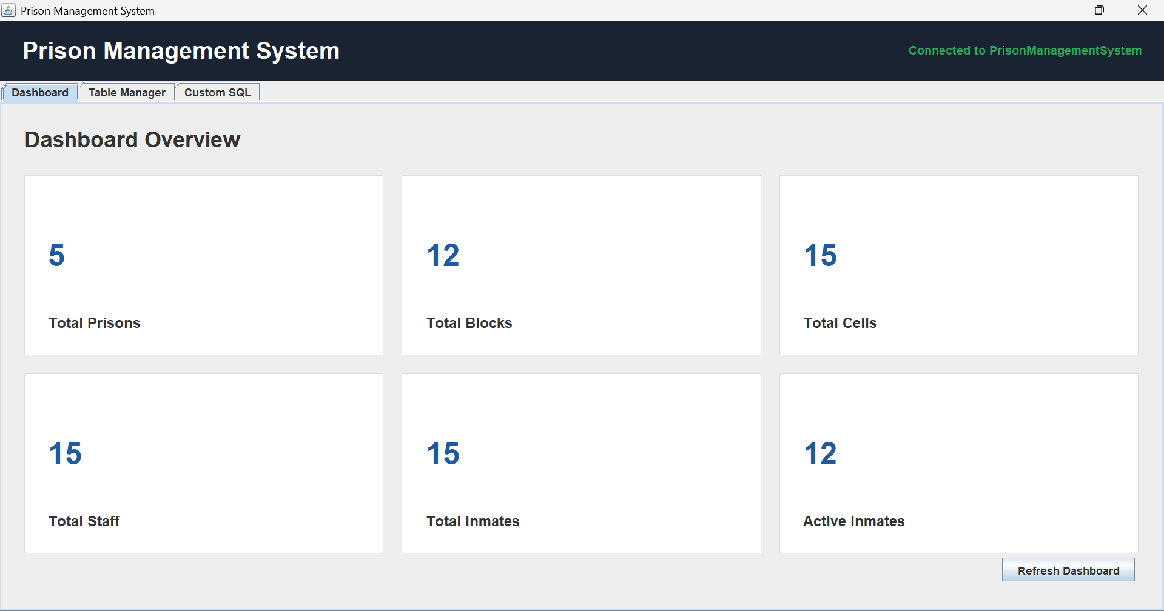
Table Manager Tab: Allows the user to select any of the 12 database tables from a dropdown and view its full contents in a scrollable table.
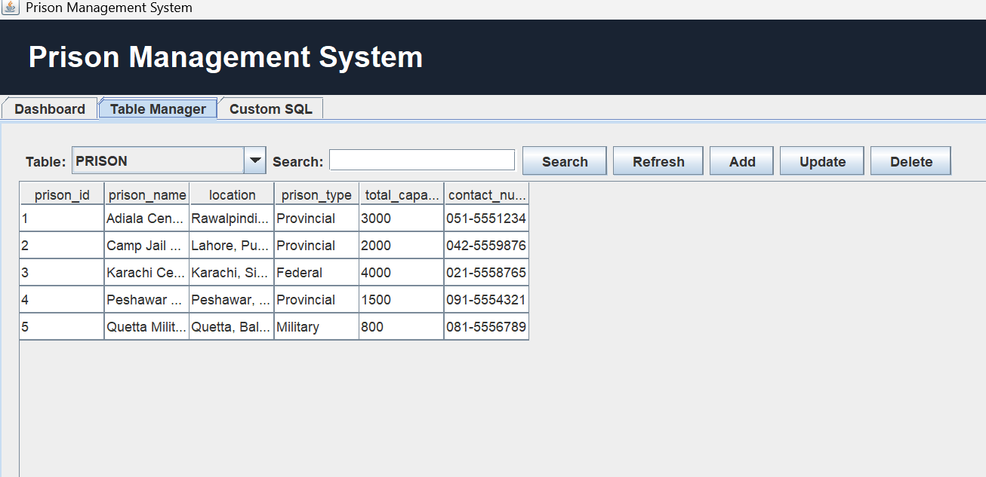

Custom SQL Tab : Provides a free-text SQL editor where any query can be typed and executed. SELECT queries display results in a table. INSERT, UPDATE, and DELETE statements display the number of rows affected.
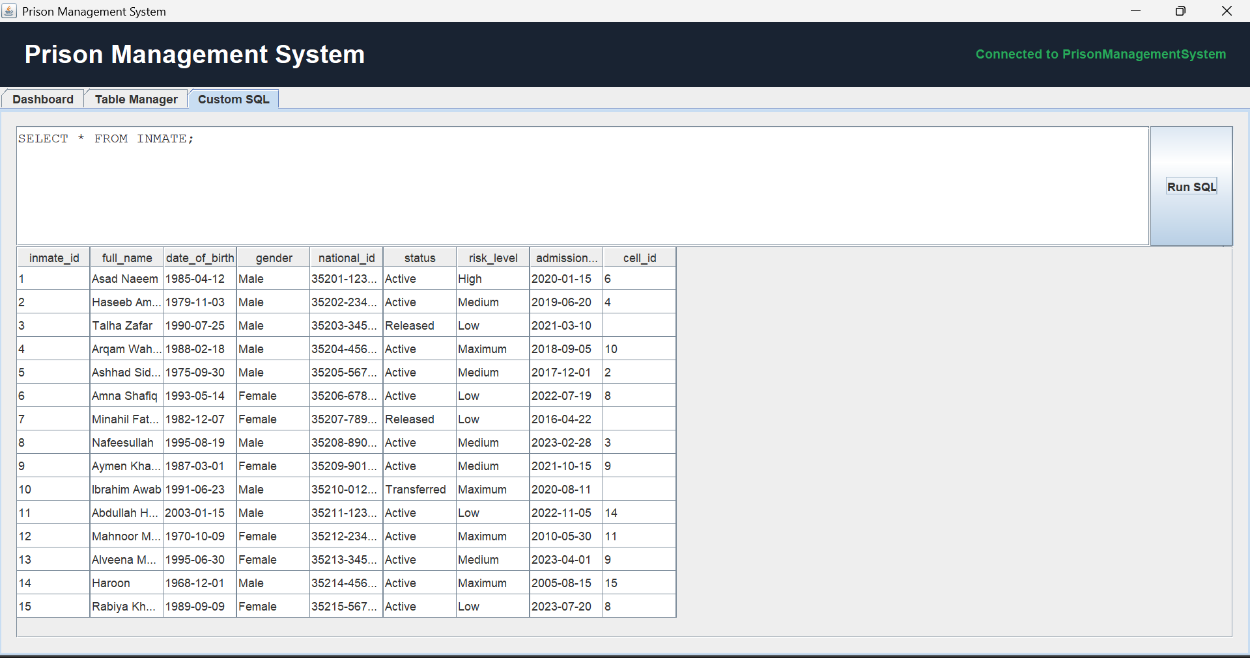

10.3 Design Decisions
- The GUI is fully dynamic — it does not hardcode any table structure. Column names, data types, and primary keys are all fetched at runtime from DatabaseMetaData, meaning the interface automatically adapts if the schema changes.
- PreparedStatements are used for all INSERT, UPDATE, and DELETE operations to prevent SQL injection.
- Nullable columns are handled explicitly — if a field is left empty and the column allows NULL, setNull() is called instead of passing an empty string.

11. Analysis and Conclusion

11.1 Strengths
- Strong Data Integrity: The extensive use of CHECK constraints ensures that only valid data (e.g., correct security levels, valid block types) enters the system. The implementation of triggers automates the critical task of tracking cell occupancy, eliminating a common source of human error.
- Comprehensive Audit Trails: By separating current status (in the INMATE table) from historical events (in TRANSFER, DISCIPLINARY_RECORD, and MEDICAL_RECORD tables), the system maintains a robust history of an inmate's time in the facility without complicating current data retrieval.
- Scalability: The hierarchical design (Prison -> Block -> Cell) allows the system to scale from managing a single small facility to a complex network of multi-level prisons.

11.2 Limitations
- Lack of Historical Cell Tracking: While transfers are logged, finding exactly who was in a specific cell on a specific past date requires complex querying of the TRANSFER table rather than a direct relationship.
- Simplified Staff Assignments: Currently, staff are assigned to a single block_id. Real-world scenarios often involve staff rotating through different blocks or having facility-wide roles that this schema handles poorly (requiring NULL block IDs).
- Security & Encryption: The current schema stores sensitive information (like National IDs and Medical Records) in plain text. A production environment would require robust encryption at the database level.

11.3 Future Improvements
- Role-Based Access Control (RBAC): Implement user tables and roles to restrict database access. For instance, medical staff should only see medical records, while guards should only see security and location data.
- Advanced Scheduling: Expand the STAFF module to include detailed shift scheduling tables to track historical and future staff deployments accurately.
- Biometric Integration: Add fields or tables to store hashes of biometric data (fingerprints, facial recognition) to interface with physical security gates.
- Automated Alerts: Implement event schedulers or application-layer logic to trigger alerts for upcoming parole hearings, medical checkups, or when a cell reaches maximum capacity.

11.4 Conclusion
The Prison Management System database successfully models the complex, interconnected data requirements of a correctional facility. By leveraging relational database principles, normalization, and automated triggers, the design provides a secure, efficient, and reliable foundation for managing inmate records, facility operations, and administrative processes. This project demonstrates a strong practical understanding of translating real-world operational needs into a structured database schema.

