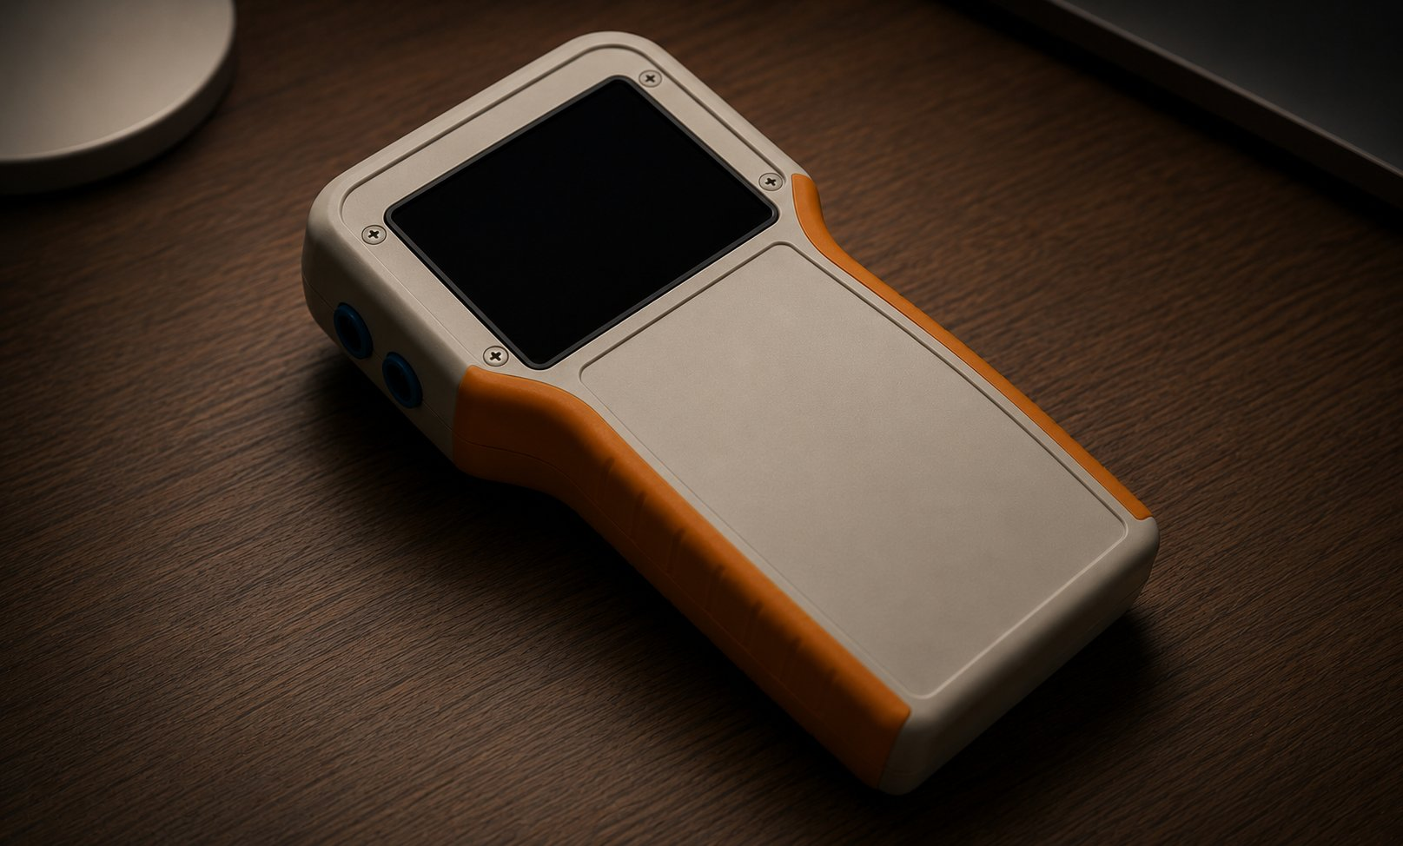

INSTITUT SUPERIEUR DES ETUDES TECHNOLOGIQUES
DE NABEUL — JET NABEUL
RAPPORT

MINI PROJET
Smart Power Monitor

Gharbi Mohamed Wassim
Hammami Aymen

ELNI21
2025 / 2026

1. Introduction

This mini project presents the design and implementation of a Smart Power Monitor — an intelligent device capable of measuring real-time electrical parameters and automatically detecting energy waste in household appliances, with a focus on refrigerators.
The system uses an ESP32 microcontroller (integrated in the CYD board) combined with a PZEM-004T power measurement module and a 2.8 inch ILI9341 TFT display. It measures voltage, current, active power, energy, frequency and power factor, then analyzes the data to detect abnormal consumption patterns.
The core innovation is automatic waste detection: the system distinguishes between normal compressor operation and abnormal idle consumption, notifying the user in real time when energy is being wasted — before it leads to high electricity bills or appliance failure.
The project evolved through multiple development phases:
- Phase 1 — Wokwi simulation: virtual prototype using potentiometers to simulate bridge rectifier outputs
- Phase 2 — Real hardware: CYD board + PZEM-004T with local TFT display
- Phase 3 — IoT integration: WiFi connectivity + Blynk dashboard + push notifications

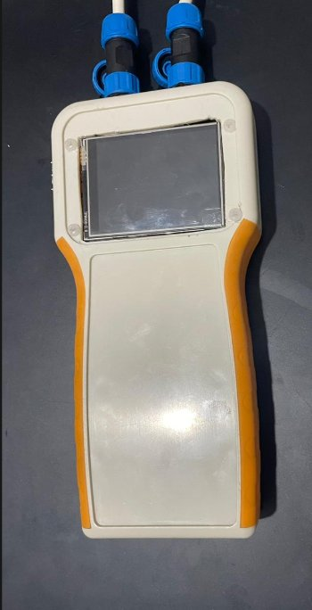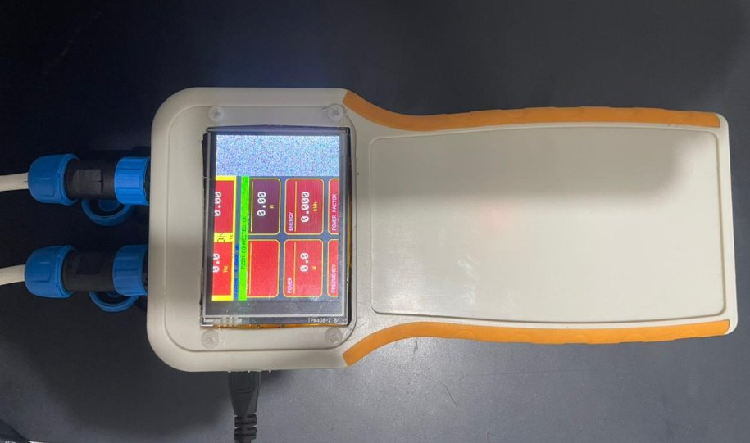
Figure 1 — Smart Power Monitor physical device (left: off, right: running)

2. Project Objectives

- Measure real-time: Voltage (V), Current (A), Power (W), Energy (kWh), Frequency (Hz), Power Factor
- Automatically detect fridge state: COMPRESSOR ON, STANDBY OK, or ENERGY WASTE
- Alert the user immediately when abnormal idle consumption is detected
- Track cumulative wasted energy in Wh over time
- Detect compressor anomalies by monitoring cycle frequency and duration
- Remote monitoring via Blynk IoT dashboard on smartphone
- Push notifications for all alert types: waste, anomaly, and hourly energy reports

3. Hardware Components

3.1 Components List

Component | Model | Role
Microcontroller + Display | ESP32-2432S028 (CYD) | Main controller + WiFi + 2.8" TFT
Power Sensor | PZEM-004T v3.0 (100A) | Measures V, I, P, E, F, PF via UART
CT Clamp | Included with PZEM | Non-invasive current measurement
Enclosure | Custom handheld case | Orange/white ergonomic housing

3.2 The CYD Board — ESP32-2432S028
The CYD (Cheap Yellow Display) is an all-in-one development board that integrates an ESP32-WROOM-32 microcontroller with a 2.8 inch ILI9341 TFT display (320x240 pixels) directly on the PCB. It also features a MicroSD slot, RGB LED, speaker connector, resistive touch screen, BOOT/RST buttons, and a P5 external IO connector.

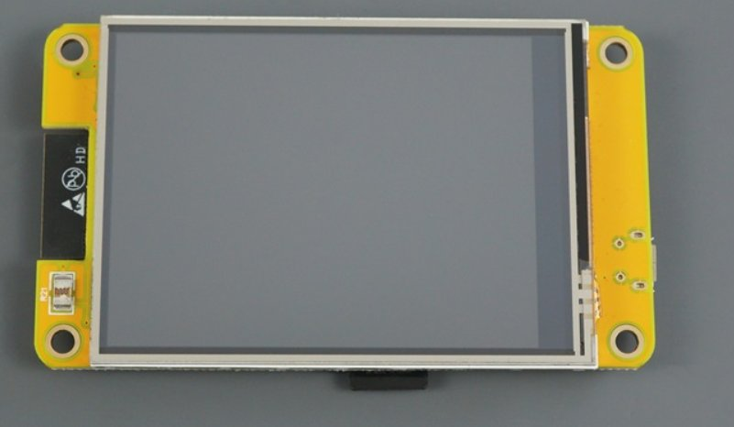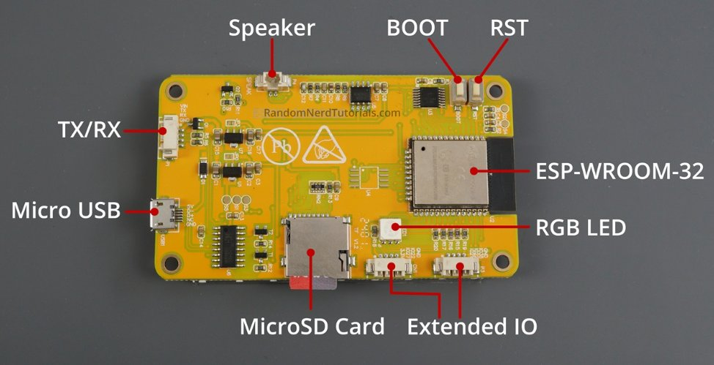
Figure 2 — CYD ESP32-2432S028: front (display) and back (PCB components labeled)

Specification | Value
MCU | ESP32-WROOM-32 (Dual core 240MHz)
Display | 2.8" ILI9341 TFT 320x240px
Touch | XPT2046 resistive touch
WiFi | 802.11 b/g/n 2.4GHz built-in
Bluetooth | BT 4.2 + BLE built-in
Storage | MicroSD card slot
Indicators | RGB LED + Speaker connector
External IO | P5 connector (GND, 5V, IO22, IO27, IO35)
SPI Display pins | MOSI=13, SCLK=14, CS=15, DC=2
Backlight | GPIO 21
Power | 5V via Micro-USB

3.3 PZEM-004T v3.0 (100A Version)
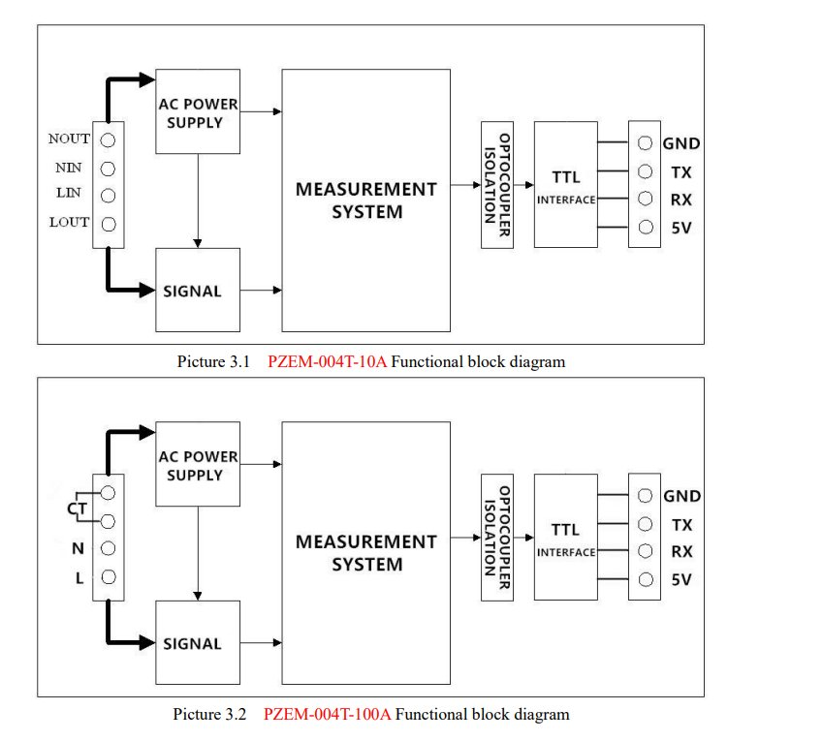
Figure 3 — PZEM-004T functional block diagrams (10A and 100A versions)
The PZEM-004T is a professional AC power measurement module with optocoupler isolation for electrical safety. The 100A version uses an external CT clamp for non-invasive current measurement, making it safe to install without breaking the electrical circuit. Communication uses UART TTL at 9600 baud with Modbus-RTU protocol.
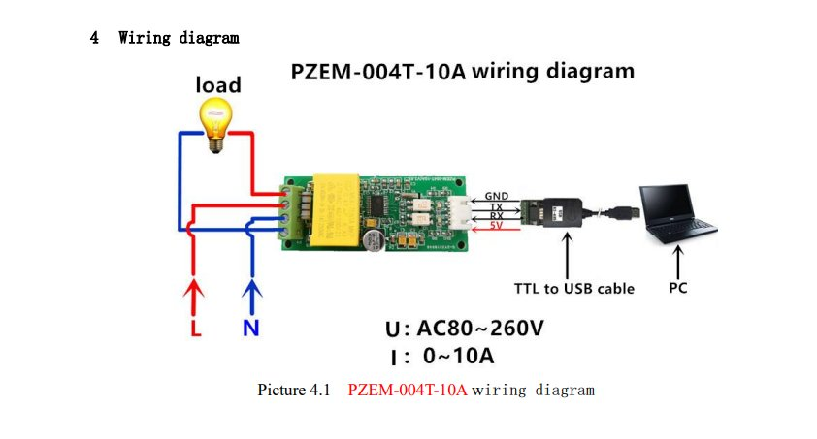
Figure 4 — PZEM-004T wiring diagram (from official datasheet)

4. Hardware Wiring

4.1 PZEM-004T to CYD via P5 Connector

PZEM-004T Pin | CYD P5 Pin
GND | Pin 1 — GND
5V (VCC) | Pin 2 — 5V
RX | Pin 3 — IO22 (TX2 from ESP32)
TX | Pin 4 — IO27 (RX2 to ESP32)

4.2 UART Port Assignment

UART Port | Purpose
UART0 (GPIO 1/3) | USB Serial — debug output only
UART1 (GPIO 9/10) | Internal flash — DO NOT USE
UART2 (GPIO 22/27) | PZEM-004T communication

5. Software Architecture

5.1 Libraries Used

Library | Version | Purpose
PZEM004Tv30 | 1.2.1 | PZEM-004T UART communication
TFT_eSPI | 2.5.43 | ILI9341 full-screen display driver
BlynkSimpleEsp32 | Latest | IoT dashboard and push alerts
WiFi | ESP32 built-in | WiFi connectivity

5.2 System State Detection

State | Power Range | Display Color
COMPRESSOR ON | >= 100W | Cyan header
STANDBY OK | < 50W | Cyan header
ENERGY WASTE | 50W - 99W | Red alert screen

5.3 Compressor Cycle Monitoring
- Cycle count per hour tracked — Blynk alert if > 15 cycles/hour
- Average cycle duration tracked — alert if average > 10 minutes
- Immediate alert on any single cycle exceeding 10 minutes
- Hourly energy summary automatically sent to Blynk

6. IoT Integration — Blynk

6.1 Blynk Virtual Pins

Virtual Pin | Data
V0 → V5 | V, I, P, kWh, Hz, PF
V6 | Wasted Energy (Wh)
V7 | Fridge State (text)
V8 | Compressor cycles/hour
V9 | Average cycle duration (min)

6.2 Alert Events

Event | Trigger | Content
energy_waste | Idle power 50-99W | Measured waste in W
compressor_anomaly | Cycle count or duration exceeded | Full cycle statistics
hourly_report | Every 60 minutes | Energy + cycle summary

7. Development Challenges & Solutions

Challenge Encountered | Solution Applied
Wrong board: Arduino Nano ESP32 selected | Changed to ESP32 Dev Module
DFU upload error — exit status 74 | Correct board selection fixed DFU mode
Checksum upload error — result 0107 | Reduced upload speed to 115200 baud
PZEM returning NaN for all values | Swapped TX/RX: PZEM TX to IO27, RX to IO22
PZEM address reading as 0x00 | Used 0xF8 broadcast address in constructor
Screen only filling partial area | Replaced Adafruit ILI9341 with TFT_eSPI library
White static on left side of screen | Removed manual SPI.begin() call
Display rendered upside down | Changed tft.setRotation() from 0 to 1
5V being fed into PZEM TX via P5 pin 2 | Corrected P5 connector pin order mapping
TFT_eSPI using wrong GPIO numbers | Rewrote User_Setup.h with CYD-specific pins
Libraries PZEM/U8g2 not found | Installed via Arduino Library Manager

8. Results & Discussion

The Smart Power Monitor successfully demonstrates low-cost real-time energy waste detection using accessible components. The CYD board simplified hardware assembly by combining ESP32 processing, WiFi, and display on a single PCB. The TFT_eSPI library enables full 320x240 resolution at 40MHz SPI clock, allowing smooth real-time data updates every 2 seconds.
The three-state detection system provides immediate visual feedback: cyan for normal operation, red for energy waste alerts. The compressor cycle tracker adds a predictive maintenance dimension, flagging abnormal behavior before it leads to compressor failure or food spoilage.
The Blynk IoT integration transforms the standalone device into a remote monitoring system, enabling real-time data access and push notifications from anywhere in the world via smartphone.

Figure 5 — Smart Power Monitor running, showing the 6-card dashboard

9. Future Work

- Machine learning model for predictive maintenance — predict compressor failure 2-3 days ahead
- Data logging to MicroSD card (hardware already available on CYD board)
- Monthly electricity cost calculation based on local tariff (e.g. STEG Tunisia)
- Telegram bot integration as alternative notification platform
- Touch screen interface using CYD built-in XPT2046 resistive touch controller
- OTA (Over-The-Air) firmware updates via WiFi
- Multi-appliance monitoring with additional PZEM modules on separate UART ports

10. Conclusion

The Smart Power Monitor demonstrates that a complete embedded IoT solution for household energy monitoring can be built at very low cost using open-source tools and accessible components. The system successfully detects energy waste in real time, provides local visual alerts, and delivers remote notifications through a smartphone dashboard.
Beyond the technical result, this project developed strong skills in ESP32 programming, serial communication protocols (UART/Modbus), SPI display configuration, library selection and troubleshooting, and IoT platform integration. Each hardware and software challenge encountered during development deepened the understanding of embedded system design principles.
The device has real practical value: detecting abnormal fridge behavior before food spoils or electricity costs surge, using hardware totaling under 30 dollars — a compelling demonstration that smart home technology does not require expensive proprietary systems.

End of Report
Smart Power Monitor — Mini Projet ELNI21 — JET Nabeul 2025/2026

