Integrity Solve AML Portal — Product Scope, Operating Model and Wireframe Specification
Developer scope document for MVP and phased build. Prepared from the current portal workflow, onboarding, program management and client screening design.

1. Executive Summary
This document defines the scope, operating model, information architecture, workflow logic and wireframe direction for the Integrity Solve AML portal. It is intended to give a software developer, product designer or implementation team a clear understanding of what is to be built, how the portal should operate, which workflows are mandatory, and where paid API checks are triggered.
The platform has two linked purposes:
- enable a business client to implement and maintain its own AML/CTF program through guided workflows
- enable that same business client to onboard, verify, screen, assess and monitor its own customers through integrated client file workflows
The design principle is that the portal should operate as a guided compliance environment, not a static document repository. Users should answer questions once, be routed only to relevant steps, and have documents, risk outputs, tasks and workflow triggers generated automatically from structured data.

2. Build Objective
The build objective is to deliver a secure web portal with a public site, registration flow, restricted first-login implementation experience, full post-implementation dashboard, program maintenance area, customer onboarding engine, billing and usage controls, and API-driven verification and screening activation.
The portal must support:
- workspace creation for each business client
- user-level identity verification at registration
- business-level registration and ABN / ACN lookup
- guided first-time AML/CTF implementation
- automatic generation of a business risk assessment summary
- automatic generation and versioning of standard AML/CTF policy and process documents
- ongoing maintenance of the client’s AML/CTF program
- customer onboarding and due diligence workflows
- conditional activation of paid checks via integrated third-party APIs
- file-level audit trail, review history and role-based permissions
- subscription billing plus usage-based charging for paid checks

3. Scope Boundary
This document describes the portal scope, workflow, screen structure and operating logic. It does not yet prescribe a final technical stack. The build should therefore be read as a product and functional specification, with technology choices to be confirmed separately.
Out of scope for this version:
- final visual branding system and polished UI design
- full mobile-first optimisation beyond responsive support
- multi-jurisdiction regulatory logic outside the current Australian tranche 2 design
- advanced analytics or benchmarking dashboards beyond core usage and risk outputs

4. Core Product Structure
The portal is split into three environments:
Environment | Purpose | Primary Users
Public site | Marketing, explanation, conversion and sign-up | Prospective business clients
Registration / onboarding environment | User registration, identity verification, business registration, workspace creation | New portal users
Logged-in portal | Program setup, program maintenance, client onboarding, screening, billing, settings | Business clients and internal users

5. High-Level User Journey
- Visitor lands on public site and selects Get Started.
- User creates account, verifies email/mobile and completes facial ID plus identity matching.
- User registers the business using legal entity details and ABN / ACN, with ASIC / ABR verification.
- Workspace is created and the user is taken to a restricted first-login dashboard.
- User completes the six-step AML/CTF implementation wizard.
- The platform generates My Business Risk Assessment and standard policy / process outputs.
- The full dashboard unlocks, including Manage My Program and Onboard and Manage Clients.
- Billing is confirmed before live paid checks and operational screening flows are activated.

6. Information Architecture

6.1 Public Site
- Home
- How It Works
- Solutions
- Pricing
- Resources
- Contact
- Login
- Get Started

6.2 Logged-In Portal Main Navigation
- Dashboard
- Manage My Program
- Onboard and Manage Clients
- Billing and Usage
- Settings
- Help / Support

7. Registration and Workspace Setup Workflow

7.1 User Registration
- email address and password creation
- email verification
- mobile verification if required
- facial ID / liveness verification
- identity document upload and document matching

7.2 Business Registration
- legal entity name
- ABN / ACN and official registry check
- registered address confirmation
- authorised person role and authority declaration
- workspace name creation
- initial subscription / billing profile

7.3 Registration Outcomes
- workspace admin created
- business profile created
- billing status stored
- workspace state set to Implementation Not Started

8. Restricted First-Login Experience
On first login, the user should not yet have access to the full dashboard. The portal should display a restricted implementation state that makes the next action obvious and prevents the client from attempting customer onboarding before the AML/CTF program foundation is built.
The first-login dashboard should include:
- welcome banner
- implementation progress card
- 6-step setup checklist
- locked preview of later features
- billing status card
- support / help card

9. Implementation Wizard
The implementation wizard is the first critical functional workflow. It should operate as a guided sequence rather than a list of isolated documents.
Mandatory step sequence:
- Practice / Business Profile Intake Form
- Designated Services Applicability Form
- Governance and AML Program Setup Form
- AML Roles and Responsibilities Form
- Compliance Officer Appointment Form
- Personnel Suitability / Statutory Declaration Form
Wizard behaviour requirements:
- save progress continuously or on each step
- permit Save Draft and Save & Exit
- lock later steps until required prior steps are completed
- reuse previously entered data to prefill later fields
- show only relevant sections based on industry and designated service routing logic
- display visible progress status at all times

10. Outputs Generated from Implementation
Once implementation is complete, the system should generate structured outputs from the captured data rather than relying on manual document drafting.
- My Business Risk Assessment summary on the dashboard with detailed click-through view
- standard AML/CTF Policy document generated from implementation variables
- standard Process / SOP document generated from implementation variables
- program settings profile including review cycle, Compliance Officer, escalation rules and enabled integrations
- version history and audit trail for generated outputs

11. Full Dashboard Structure
Once the initial implementation flow is complete, the full portal unlocks.
Recommended dashboard components:
- Program Health
- My Business Risk Assessment
- Program Documents
- Tasks and Alerts
- Client Onboarding Activity
- Reviews Due
- Usage and Billing Snapshot

12. Manage My Program
This area is for internal AML/CTF program maintenance by the client business.

12.1 Update My Program
- Practice / Business Profile Intake Form
- Designated Services Applicability Form
- Governance and AML Program Setup Form
- AML Roles and Responsibilities Form
- Compliance Officer Appointment Form
- Personnel Suitability / Statutory Declaration Form

12.2 Program Maintenance
- AML/CTF Training Record
- AML/CTF Program Review / Update Record
When the Program Review / Update Record is completed, it should be capable of updating the business risk assessment, regenerating policy and process outputs, creating a new document version, and logging the change for audit purposes.

13. Onboard and Manage Clients
This area is the operational compliance environment used by the client business to onboard, assess and monitor its own customers.
The portal should not present these as a flat library of disconnected forms. Instead, they should be activated contextually within customer workflows.

13.1 Client Workflow Components
- Initial Customer / Client Due Diligence Form
- Enhanced CDD Form
- Beneficial Ownership and Control Form
- Source of Funds / Source of Wealth Form
- Escalation Form
- Unusual Activity / Suspicious Matter Review Form
- Ongoing Monitoring / Periodic Review Form

13.2 Primary Operational Entry Points
- New Client Onboarding
- Open Existing Client File
- Run Periodic Review
- Manage Escalations

14. Paid Checks and API Activation
Paid checks should not run at registration or during implementation. They should be triggered only when the client’s workflow reaches the relevant onboarding or monitoring step.
Expected paid checks include:
- facial ID / liveness
- ID document verification
- sanctions / PEP / adverse media screening
- ASIC / company / entity verification
- director and controller lookup
- KYB and beneficial ownership support checks
- repeat screening refresh where applicable
Commercial model:
- platform subscription for access and program management
- usage-based charging for API-driven checks
- clear usage and spend visibility on the dashboard

15. User Roles
- Workspace Admin — manages workspace, billing, users and core settings
- Compliance Officer — full access to program and customer compliance functions
- Program Contributor — can update program information but may have limited approval rights
- Onboarding User — can create and progress customer files
- Reviewer / Escalation User — can review escalated and higher-risk files
- Read Only / Auditor — view only

16. Key Functional Requirements
- Role-based access control across program and client functions
- Secure file and evidence storage
- Version control for generated policy, process and risk documents
- Audit trail for all data updates, document regenerations, decisions and reviews
- Autosave or reliable save-draft functionality in guided workflows
- Conditional branching logic based on industry, designated service, client type and risk triggers
- Ability to pause matters, escalate matters and record decision outcomes
- Task generation for reviews, updates, training and unresolved escalations
- Billing controls that prevent use of paid checks where billing is inactive or invalid

17. Wireframes
The following wireframes are schematic only. They are intended to communicate structure, hierarchy, and expected user flow rather than final visual design.

17.1 Wireframe 1 — First-login Restricted Dashboard
This screen limits the user to program setup, shows progress, and surfaces billing and support status without allowing operational client onboarding.
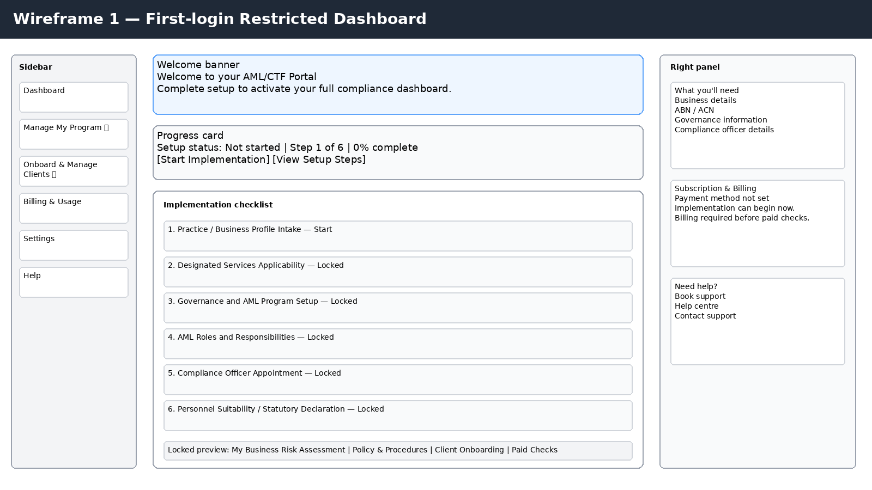

17.2 Wireframe 2 — Implementation Wizard
This screen shows the guided six-step wizard, contextual help, save behaviour, and billing visibility while preserving focus on implementation.
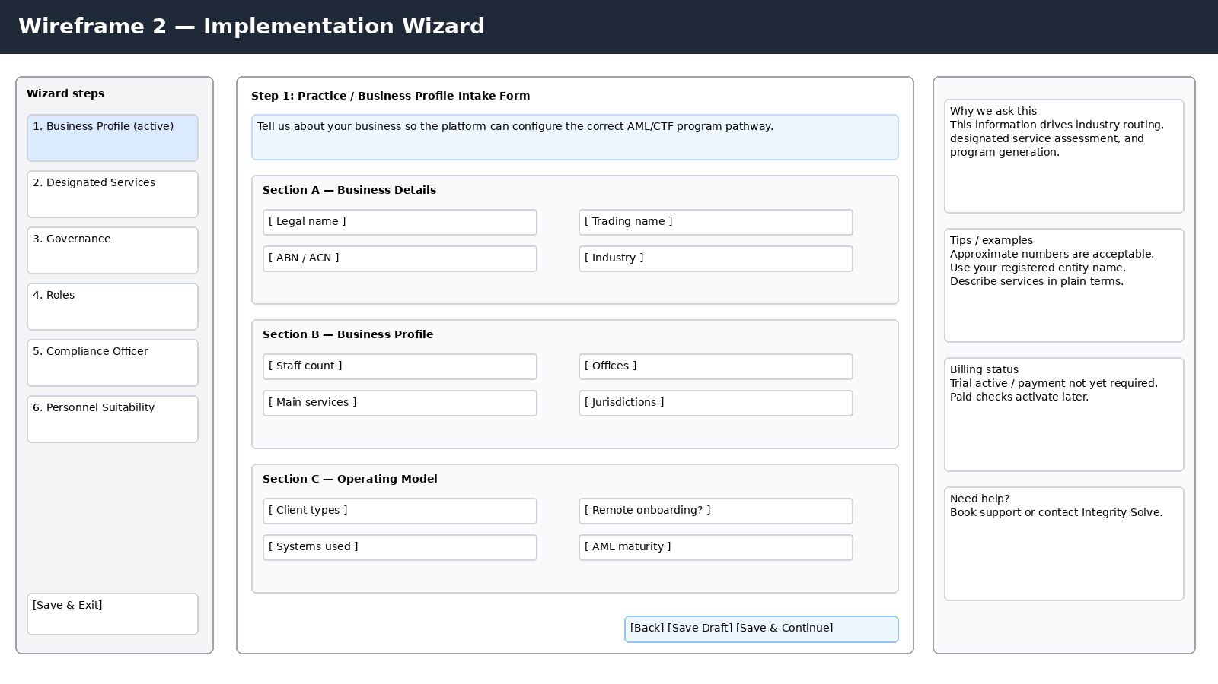

17.3 Wireframe 3 — Full Post-implementation Dashboard
This screen shows the unlocked state after setup, including risk assessment, documents, action centre, client activity and billing snapshot.
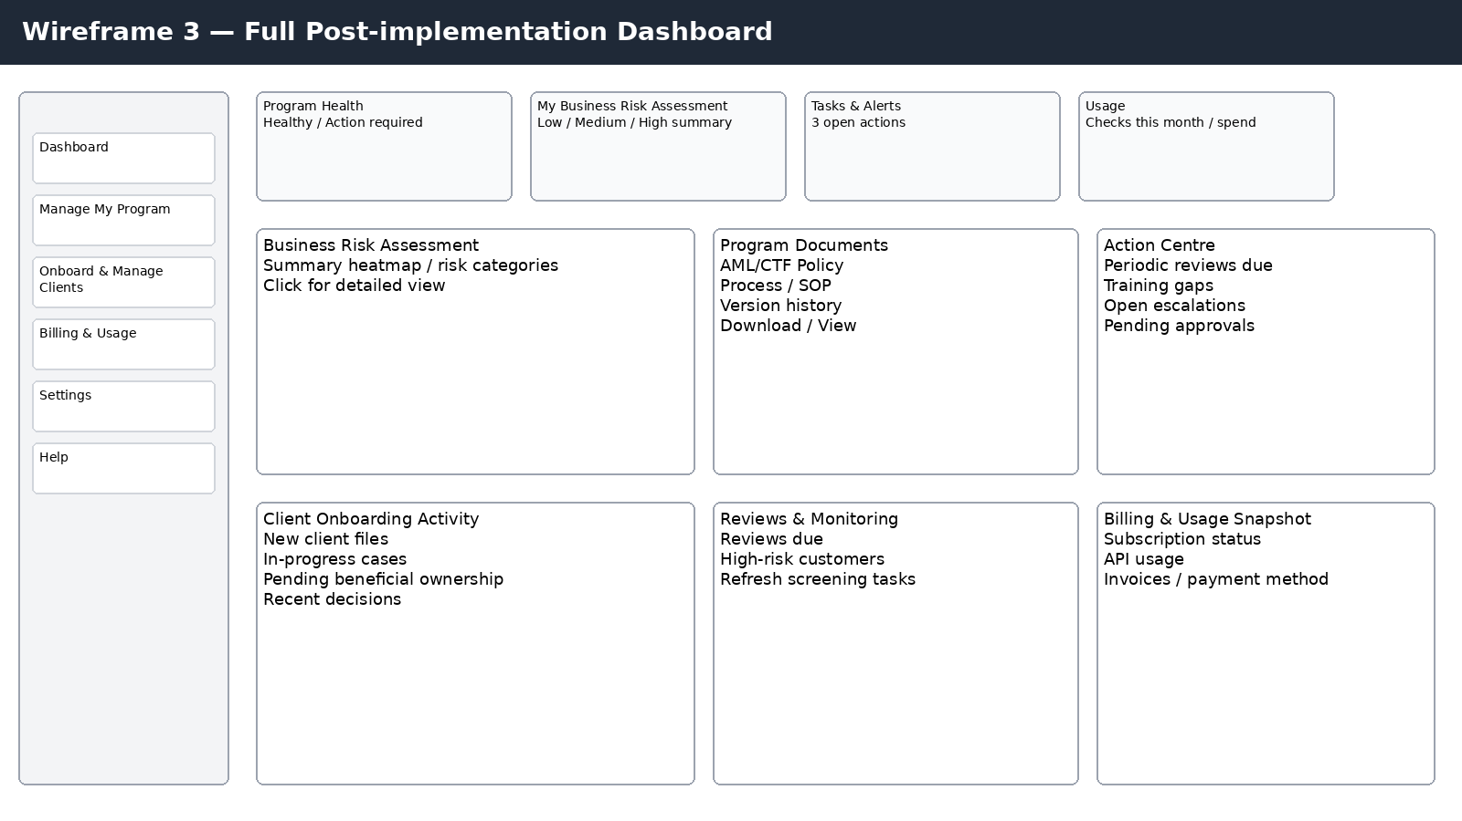

17.4 Wireframe 4 — New Client Onboarding Workflow
This screen shows the operational customer file flow, including dynamic form triggers, risk engine outputs and paid API activation points.
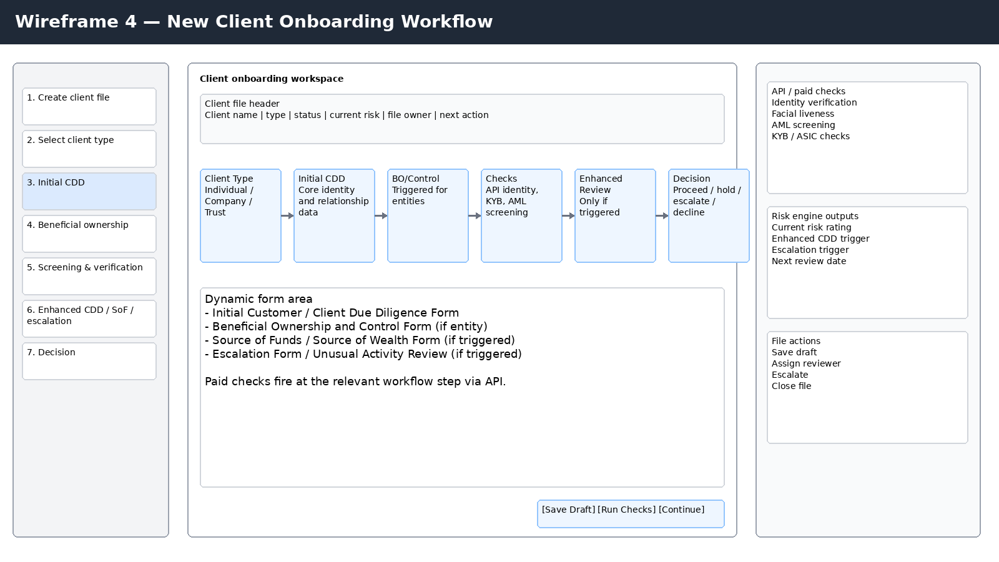

18. Developer Delivery Sequence
- Build public site pages and registration entry points.
- Build user registration, identity verification and business workspace setup.
- Build restricted first-login dashboard and implementation progress state.
- Build the six-step implementation wizard and persistence model.
- Build generation logic for Business Risk Assessment, Policy and Process outputs.
- Build full dashboard shell and navigation.
- Build Manage My Program area, including Training Record and Program Review / Update Record.
- Build client onboarding engine with conditional branching.
- Integrate paid checks APIs and usage metering.
- Build billing activation and payment method flow.
- Build ongoing monitoring, review due logic and escalation views.
- Build audit trail, versioning and permissions hardening.

19. MVP Phasing Recommendation
Phase | Scope | Outcome
Phase 1 | Registration, restricted dashboard, implementation wizard, generated risk and policy outputs | Client can register and set up AML/CTF program
Phase 2 | Client onboarding workflows, client files, API checks, escalation flows | Client can onboard and manage customers
Phase 3 | Ongoing monitoring engine, billing and usage refinement, deeper automation, reporting | Client can operate portal at scale with reduced manual effort

20. Open Design / Technical Decisions
- final technical stack
- final identity verification vendor and KYB / AML screening vendor sequence
- document generation engine architecture
- whether generated documents are DOCX-first, PDF-first, or both
- payment gateway selection and subscription/usage billing model
- exact permission model for client workspaces

21. Recommended Immediate Next Task
The next practical build step is to convert this scope document into a developer backlog and annotated component map. That should include:
- page list and route map
- data model / object model
- API integration points
- workflow state machine definitions
- field mapping from forms to generated outputs
- billing trigger matrix

