**Digital ID**

A digital identity is information on an entity used by computer systems to represent an external agent. The information contained in a digital identity allows for assessment and authentication of a user interacting with a business system on the web, without the involvement of human operators. Digital identities allow our access to computers and the services they provide to be automated, and make it possible for computers to mediate relationships.

The term "digital identity" also denotes certain aspects of civil and personal identity that have resulted from the widespread use of identity information to represent people in an acceptable trusted digital format in computer systems.

Digital identity is now often used in ways that require data about persons stored in computer systems to be linked to their civil, or national, identities. Furthermore, the use of digital identities is now so widespread that many discussions refer to "digital identity" as the entire collection of information generated by a person’s online activity. This includes usernames and passwords, online search activities, birth date, social security, and purchasing history. Especially where that information is publicly available and not anonymized, and can be used by others to discover that person's civil identity. In this wider sense, a digital identity is a version, or facet, of a person's social identity. This may also be referred to as an online identity.

With the help of digital ID many processes of the bank can be done online and it will be more secured and less time consuming. This will also lead to the automation of various banking services and eliminate the risk of fraud and forgery.

The digital ID will display basic information such as name, address of residence and photo of the ID owner and also will have other biometric details hidden with the help of Steganography. Any kind of tampering done with the digital ID will easily be detected and thus it will eliminate the risk of forgery.

**Biometrics (fingerprint, Iris scan etc.) Other important information**

**Encryption Algorithm Encryption Algorithm**

Digital ID

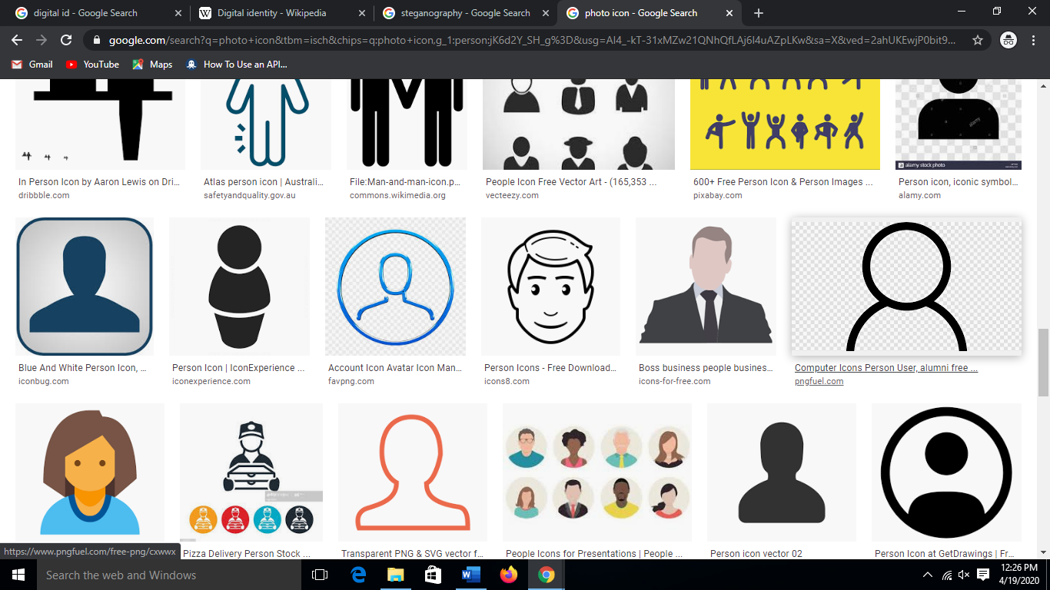

Basic details

**(Steganography) (Steganography)**

Authentication

Electronic authentication is the process of establishing confidence in user identities electronically presented to an information system. Digital authentication or e-authentication may be used synonymously when referring to the authentication process that confirms or certifies a person's identity and works. When used in conjunction with an electronic signature, it can provide evidence of whether data received has been tampered with after being signed by its original sender. In a time where fraud and identity theft has become rampant, electronic authentication can be a more secure method of verifying that a person is who they say they are when performing transactions online. There are various e-authentication methods that can be used to authenticate a user's identify ranging from a password to higher levels of security that utilize multifactor authentication (MFA). Depending on the level of security used, the user might need to prove his or her identity through the use of security tokens, challenge questions or being in possession of a certificate from a third-party certificate authority that attests to their identity.

**CLIENT**

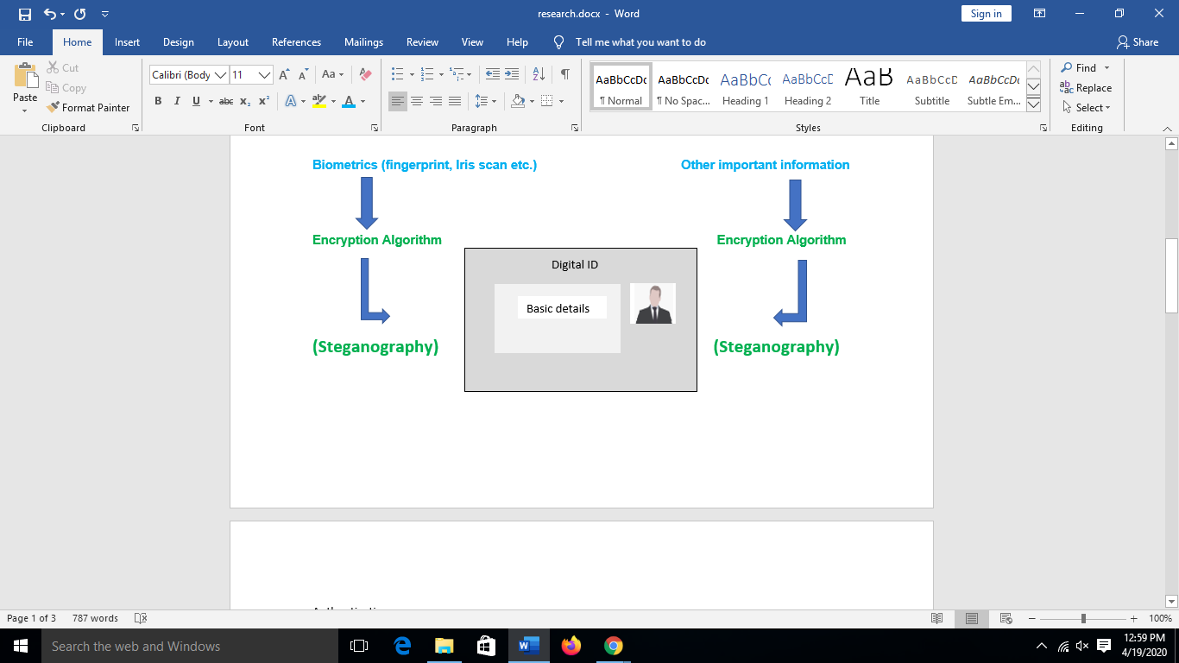

**Transaction details +**

**(Encrypted message)**

SERVER

**Verification of digital ID successful** **Verification of digital ID failed**

**Transaction successful Transaction unsuccessful**

**Acknowledge the client**

**Application**

This digital ID can be used in various banking services to promote online transaction of money. It also eliminates the risk of forgery and fraud.

1. **Online transaction using Debit/Credit cards-**

Many times, unauthorized person steals the details of the debit/credit card and use it for illegal online transaction of money. This is one of the most common case of fraud. This can be prevented if the user has to upload his/hers digital ID along with the transaction details. The digital ID will be first verified and various checking will be done to verify that it has not been tampered. If the verification is successful then only the transaction happens else the transaction fails. Thus it adds an extra layer of security during transaction via debit cards or credit cards.

1. **Opening of the bank account instantly and online-**

To open a new bank account, the customers has to visit the bank for some paperwork and submit various documents like Government issued ID, proof of nationality, proof of address etc. This process is very time consuming as it depends on man power. People have to stand in long queue wasting large amount of time. This can be prevented if the whole process gets automated and is done online. The customer has to just upload his digital ID to the bank server and it will very the ID provided and will get the necessary details from the ID. If the verification is successful then the new bank account is opened instantly and the customer can avail all the bank services without wasting much time.

1. **Instant online application of loan-**

To get even small amount of loan, people has to visit the bank and provide necessary documents for verification. This whole process is time consuming. The banks can easily provide loan on small amount online, thus, saving a lot of time. For verification purpose the bank can ask for the digital ID and sanction the loan immediately after the verification is successful. Any person can easily take small loans quickly even without visiting the bank.

1. **Withdrawal of Fixed Deposit-**

To withdraw FD, people has to visit the bank and deal with the necessary paperwork. This process can easily be automatized with the use of digital ID. The owner of the FD or even the nominee can easily withdraw the money by simply uploading their digital ID and other necessary documents. If the verification is successful then the money of the FD will be transferred to the bank account of the FD owner or the nominee in case the owner is not alive. Thus, saving time for both the bank employees and the customers.