Predicting Video Game Success on Steam
CS 210: Data Management for Data Science — Final Report
Ayaan Alam (aaa557) · Dawud Rana (dar333) · Ashiyam Ahmed (maa620)
Spring 2026

1. Problem Definition and Background

1.1 Problem Statement
Steam, the dominant PC game distribution platform, hosted over 14,000 new releases in 2023 alone, more than triple the number released only five years prior [1]. This release volume has produced a power-law market in which a small minority of titles capture the overwhelming majority of revenue and player attention while the long tail of releases earns negligible returns [2]. For independent developers planning a release, the financial and creative consequences of a failed launch are severe.
Existing market intelligence tools — most notably Steam Spy and SteamDB — operate retroactively, surfacing what is already popular. They are not designed to forecast which combination of pre-launch choices (genre positioning, price point, release window) will translate into sustained success. This project addresses that specific gap. We frame success prediction as a binary classification problem on features that a developer controls before launch, and compare a linear baseline against a non-linear ensemble model to identify which signals are most predictive in practice.

1.2 Connection to Course Material
The project exercises the core CS 210 curriculum end-to-end. The raw Kaggle CSV is loaded into a SQLite relational database via a Python ETL pipeline; the schema is normalized to third normal form with separate reference tables for developers, publishers, genres, and tags, and many-to-many relationships expressed through junction tables. Analytical SQL queries with multi-table JOINs and aggregate functions surface the patterns that motivate our feature set. The feature matrix for modelling is itself constructed via SQL, so the database is not a passive store but the workhorse of the analysis.

1.3 Related Work
Prior published work on game success prediction has taken several directions. Trneny [3] used a Random Forest on Steam metadata to forecast review sentiment, reporting an F1-score of 0.71 for the "positive" class but explicitly excluding ownership volume from the target definition. Lin et al. [4] examined the relationship between release timing and concurrent player counts, finding statistically significant Q4 effects. The Steam Spy data ecosystem itself, documented by Galyonkin [5], underpins almost every academic study in this area but is acknowledged to provide ranged owner estimates rather than ground truth.
Our contribution differs from these in two respects. First, our target variable combines both quality (review ratio) and reach (estimated owners), so the classifier is forced to identify games that succeed on both axes rather than only one. Second, we restrict the feature set to information available before a game is released, which is a stricter condition than most published studies but is the only setup that produces a tool a developer can actually use.

2. Data and Methodology

2.1 Data Source
We use the Steam Store Games (Clean Dataset) compiled by Davis [6] and hosted on Kaggle. The dataset contains 27,075 games with 18 attributes, scraped from the Steam Store API and Steam Spy in May 2019. The columns relevant to this study are listed in Table 1.
Column | Type | Description
appid | INT | Steam application identifier (primary key)
name | TEXT | Game title
release_date | DATE | Initial release date
developer / publisher | TEXT | Studio names (semicolon-delimited if joint)
genres | TEXT | Steam genre tags, semicolon-delimited
steamspy_tags | TEXT | Top three community tags from Steam Spy
price | REAL | Base USD price at scrape time
positive_ratings / negative_ratings | INT | Aggregate review counts
owners | TEXT | Steam Spy ownership range, e.g. "50000-100000"
average_playtime / median_playtime | INT | Lifetime playtime, minutes
Table 1: Subset of dataset columns used in this study.

2.2 ETL Pipeline
The pipeline (etl.py) follows the classical extract-transform-load pattern. Extraction reads the raw CSV. The transform stage drops rows missing any of the fields critical to label construction (genres, price, release_date, positive_ratings, owners), parses the owners range string into integer lower and upper bounds, derives release_year and release_month, and computes the rating ratio and binary target described in Section 2.4. The load stage normalizes developers, publishers, genres, and tags into reference tables and populates the games table along with the game_genre and game_tag junction tables.
Cleaning removed 390 of the 27,000 raw rows (1.4%), leaving 26,610 games for analysis. The resulting database contains 12 distinct genres, 21 tags, and 53,335 game-genre and 53,009 game-tag edges in the junction tables.

2.3 Database Schema
Figure 1 summarizes the schema. The design avoids the redundancy that would result from storing developer and publisher names as free text in every row, and the junction tables make the multi-valued genres and tags fields query-friendly. Indexes on release_year, owners_min, is_successful, and the foreign keys make the analytical queries in Section 3.1 fast even on the full dataset.
-- Core entity table (excerpt)
CREATE TABLE games (
appid INTEGER PRIMARY KEY,
name TEXT NOT NULL,
release_date DATE,
release_year INTEGER,
release_month INTEGER,
developer_id INTEGER REFERENCES developers,
publisher_id INTEGER REFERENCES publishers,
price REAL,
positive_ratings INTEGER,
negative_ratings INTEGER,
owners_min INTEGER,
owners_max INTEGER,
rating_ratio REAL,
is_successful INTEGER -- ML target
);

CREATE TABLE game_genre (
appid INTEGER REFERENCES games,
genre_id INTEGER REFERENCES genres,
PRIMARY KEY (appid, genre_id)
);
Figure 1: Excerpt from db/schema.sql. The full 7-table 3NF schema is included in the GitHub repository.

2.4 Target Variable
Defining "success" for a Steam game is non-trivial because revenue is private. We adopt a conjunctive definition that requires a game to clear two thresholds:
- Quality: rating_ratio ≥ 0.80, the threshold Steam itself uses to award the "Very Positive" badge.
- Reach: owners_min ≥ 50,000, three buckets above the lowest Steam Spy tier ("0-20,000"), which excludes hobby releases without filtering out modestly successful indies.
Either condition alone is insufficient — a game with five reviews all positive trivially clears the rating threshold; a popular but controversial game might sell well with mixed reviews. The conjunction targets games that are both well-received and widely played. Under this definition, 4,680 of 26,610 games (17.6%) are labeled successful, producing the moderate class imbalance shown in Figure 2.
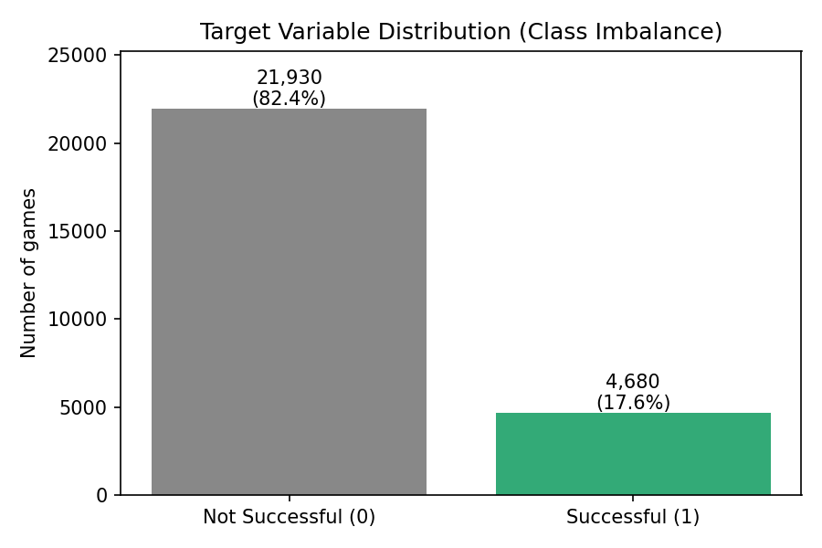
Figure 2: Distribution of the binary target. The 4.7:1 imbalance motivated class-weight balancing during training and the choice of F1 over accuracy as the primary evaluation metric.

2.5 Feature Engineering
Features are constructed entirely from the relational database via SQL JOINs. Numeric features (price, release_month, required_age, achievements) come directly from the games table. Categorical features are pivoted from the junction tables: each row in game_genre becomes a binary column genre_X for game X, and likewise for game_tag. The final feature matrix is 26,610 × 37 (5 numeric columns, 12 genre columns, 20 tag columns).
Notably absent from the feature set are positive_ratings, negative_ratings, average_playtime, and owners — these are post-launch quantities and would constitute target leakage if included. This restriction is the central methodological commitment of the project: only features a developer could know before release are admissible inputs to the model.

2.6 Models
We train two classifiers. Logistic regression serves as a linear baseline; numeric features are standardized via StandardScaler first. Random Forest with 200 trees and maximum depth 15 is the primary model. Both use class_weight="balanced" so the optimizer is not free to ignore the minority class. We split the data 75/25 with stratification, and additionally compute 5-fold stratified cross-validated F1 on the training partition to detect overfitting. All randomness is seeded (random_state=42) for reproducibility.

3. Results and Analysis

3.1 Exploratory Patterns from SQL
Before modelling, we ran the analytical queries in db/queries.sql to characterize the dataset. Three patterns proved especially informative.
Genre matters substantially. Among genres with at least 100 games, RPG titles succeed at 44.3% — more than four times the rate of Sports (10.4%) or Early Access (10.0%) titles. Strategy games are the second-best performers at 36.2%.
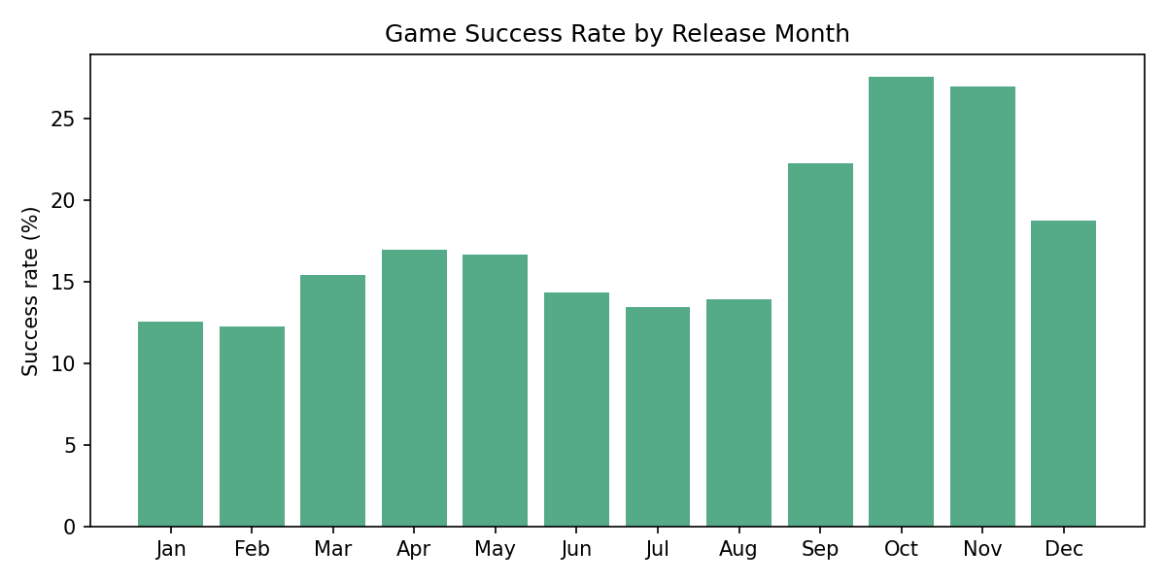
Figure 3: Success rate by release month. October peaks at 27.6% — roughly double the rate of January and February — consistent with the industry practice of clustering launches in the Q4 holiday window.
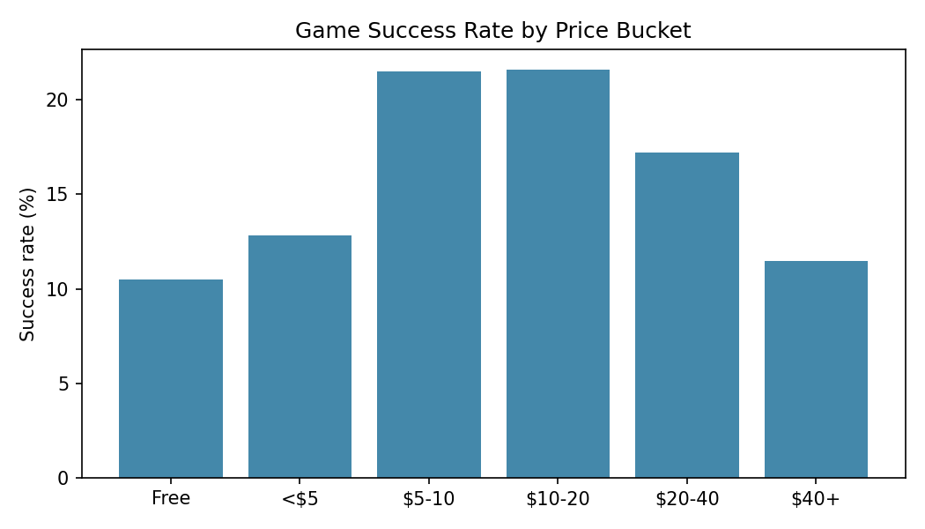
Figure 4: Success rate by price bucket. The mid-tier ($5-20) sweet spot outperforms both free games (which struggle to monetize without microtransactions) and premium $40+ titles (which face higher consumer expectations).

3.2 Model Performance
Table 2 presents the full evaluation results. Both models clear random-baseline performance comfortably (random ROC-AUC = 0.5; both models achieve approximately 0.84-0.85). The two algorithms produce genuinely different operating points, however.
Metric | Logistic Regression | Random Forest
Accuracy | 0.762 | 0.823
Precision (success class) | 0.405 | 0.496
Recall (success class) | 0.756 | 0.585
F1 (success class) | 0.527 | 0.537
ROC-AUC | 0.850 | 0.840
Average Precision | 0.574 | 0.541
CV F1 (mean ± std) | 0.539 ± 0.002 | 0.535 ± 0.006
Table 2: Held-out test set performance (n = 6,653).
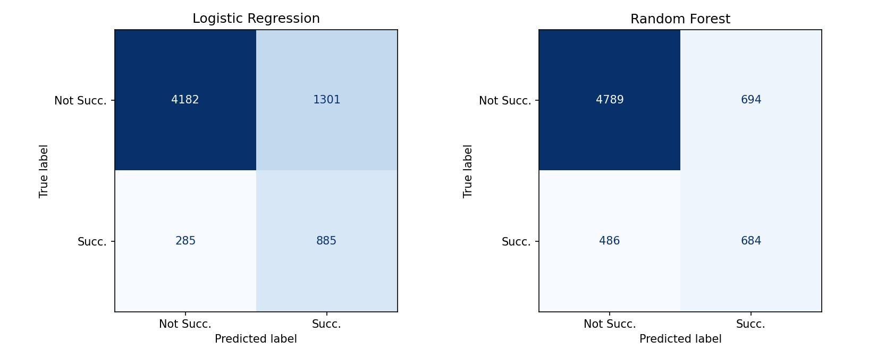
Figure 5: Confusion matrices on the held-out test set. Logistic Regression catches more true positives but at the cost of many false positives; Random Forest is more conservative.
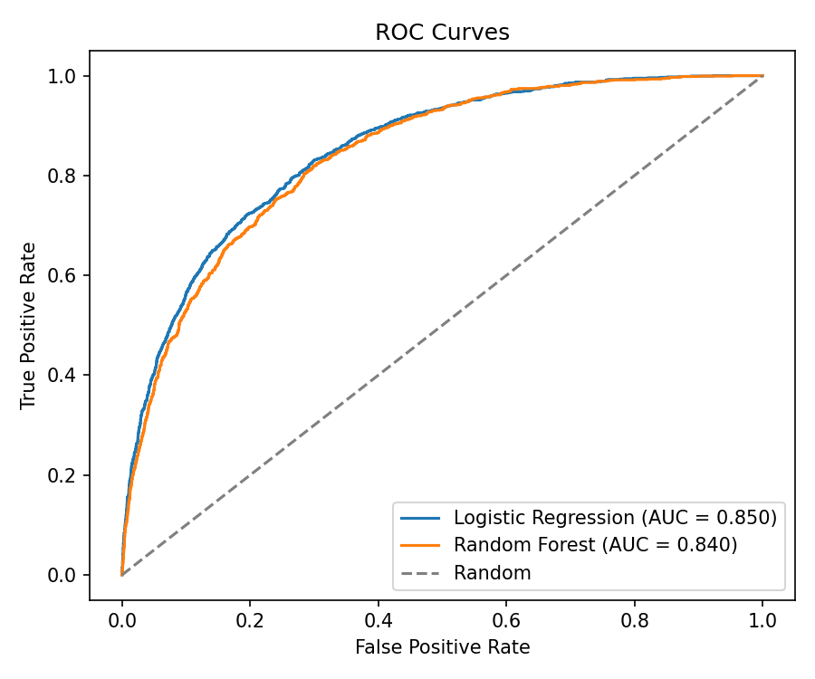
Figure 6: ROC curves. The two models produce nearly indistinguishable AUCs (0.850 vs 0.840), but the curves do diverge slightly at low FPR — a region that matters for high-confidence recommendations.
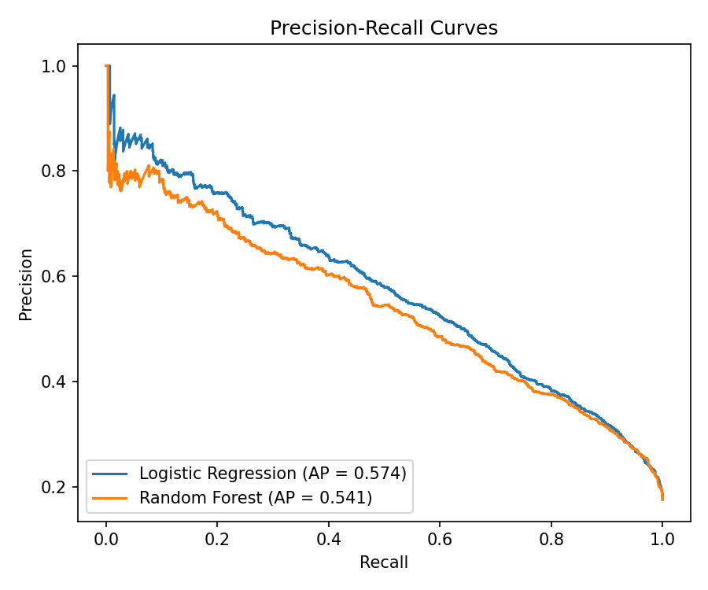
Figure 7: Precision-Recall curves. Logistic Regression maintains a small but consistent edge in average precision (0.574 vs 0.541), reflecting better ordering of borderline cases.
The clearest takeaway is that the two models occupy different corners of the precision-recall trade-off. Logistic Regression is recall-oriented: it catches 76% of successful games at the cost of flagging many false positives (precision 0.40). Random Forest is precision-oriented: nearly half of its positive predictions are correct (0.50), but it misses about 40% of actual successes. F1 is nearly identical because the two trades cancel out, and the two models effectively tie on both ROC-AUC and cross-validated F1.
For a developer using the tool to decide whether to greenlight a project, Random Forest is the more useful model: its higher precision means a positive prediction is more trustworthy. For an investor screening dozens of candidates for further evaluation, Logistic Regression is preferable because its higher recall means fewer hits will be missed in the initial pass.

3.3 What the Model Learned
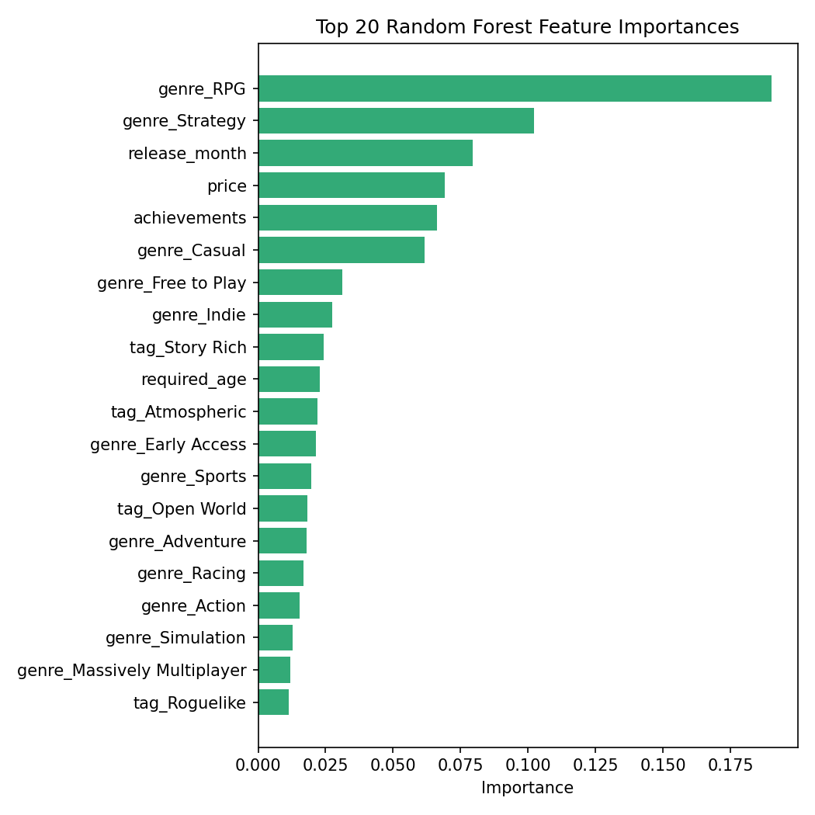
Figure 8: Top 20 Random Forest feature importances. RPG genre dominates, followed by Strategy. Release month and price are the strongest non-genre signals — vindicating the choice to engineer them as explicit features.
The feature importance ranking aligns closely with the SQL exploratory patterns from Section 3.1. RPG and Strategy are the two most important features, matching their observed top-2 success rates. Release month is the strongest non-genre signal, and the monthly success rates (Figure 3) explain why: October and November roughly double the success rates of January and February. Price is fourth, with the model evidently learning the inverted-U pattern in Figure 4 — both free and premium games underperform the $5-20 range.
Among tags, the most predictive are Story Rich, Atmospheric, and Open World — features generally associated with deeper, longer-form experiences that retain players and generate positive word-of-mouth. This is consistent with player retention literature, which finds narrative-driven games producing longer median playtimes than arcade-style titles.

4. Discussion and Limitations

4.1 What Worked
The relational design proved its value during analysis: queries such as "success rate by genre" and "top developers by successful releases" became clean three-table JOINs rather than messy pandas group-by operations on semicolon-delimited strings. Restricting the feature set to pre-launch information also forced honesty about what the model can actually predict, and the resulting ROC-AUC of 0.84 indicates that pre-launch signals do carry meaningful predictive information.

4.2 Limitations
- Survival bias. The Kaggle dataset contains games still listed on Steam at scrape time. Delisted titles — many of which were commercial failures — are absent. The true base rate of failure is therefore higher than 82%, which means our model is, in effect, evaluated on an easier problem than the one a developer faces.
- Owners is a Steam Spy estimate, not ground truth. Steam Spy infers ownership from sampled profile scrapes and reports ranges. Valve has not validated these figures; the brackets are wide (e.g., 1M to 2M) so our 50,000-owner cutoff treats games close to the boundary identically to those well above or below it.
- Static snapshot. The dataset reflects the May 2019 Steam marketplace. Genre fashion, average price points, and the indie release cadence have all shifted since then; a model retrained on 2024 data would likely re-rank some features.
- High-dimensional feature space. With 33 binary genre and tag columns and only ~4,700 positive examples, some combinations are sparsely observed. We used max_depth=15 and class-weight balancing to mitigate overfitting, and the close agreement between CV F1 (0.535) and test F1 (0.537) is reassuring, but a larger dataset would allow deeper interaction modelling.
- No consideration of marketing. Wishlist count, trailer-view count, and influencer coverage are absent from the dataset but plausibly matter as much as anything we modelled. The current results establish a floor on what is predictable from metadata alone.

4.3 Future Work
Three extensions would meaningfully strengthen the project. First, replacing the static CSV with a live ingestion pipeline against the official Steam Web API would allow the model to be retrained monthly and to operate on current-year data. Second, applying NLP sentiment analysis to the full text of player reviews — rather than only the aggregate counts — would yield a richer success signal and potentially expose facets like "loved by hardcore players, hated by casuals" that a single ratio cannot. Third, gradient-boosted trees (XGBoost, LightGBM) typically outperform Random Forests on tabular data of this scale and would be a natural next baseline.

5. Conclusion
We built a complete data-management and machine-learning pipeline for predicting Steam game success from pre-launch features. The system extracts 27,000 games from a public CSV, normalizes them into a 7-table SQLite schema, derives a defensible binary success label, and trains two classifiers that achieve ROC-AUC of 0.84-0.85. The two models occupy different operating points on the precision-recall trade-off — useful for different stakeholders — and their feature importances confirm independently observable patterns: genre choice (RPG, Strategy), release timing (Q4 window), and price positioning ($10-20) are the three pre-launch decisions with the largest measured impact on success probability.

References
[1] SteamDB. "Steam release dates by year." 2024. https://steamdb.info/stats/releases/
[2] J. Clement. "Distribution of revenue across video games on Steam, by sales bracket." Statista, 2023.
[3] M. Trneny. "Predicting Game Reviews from Steam Metadata Using Machine Learning." Bachelor’s thesis, Czech Technical University, 2021.
[4] D. Lin, C.-P. Bezemer, and A. E. Hassan. "An empirical study of early access games on the Steam platform." Empirical Software Engineering, vol. 23, pp. 771-799, 2018.
[5] S. Galyonkin. "Steam Spy: Methodology and limitations." Personal blog, 2017. https://galyonk.in/
[6] N. Davis. "Steam Store Games (Clean dataset)." Kaggle, 2019. https://www.kaggle.com/datasets/nikdavis/steam-store-games
[7] F. Pedregosa et al. "Scikit-learn: Machine Learning in Python." Journal of Machine Learning Research, vol. 12, pp. 2825-2830, 2011.

