**Biodiversity Application Admin Guide**

1. **Filing improvement requests:**

Feature requests and bug can be relayed to the development team with the “Feedback / Bugs” icon at the top right of the menu bar.



1. **Managing Users:**

Application users and permissions are managed through the “Manage Users” page, accessible from the “Settings” dropdown menu:

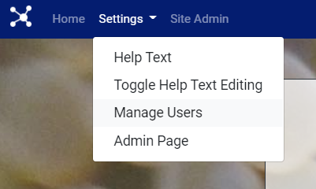

Any user with a DFO email linked to DMApps can be added and have their permissions modified using the form:

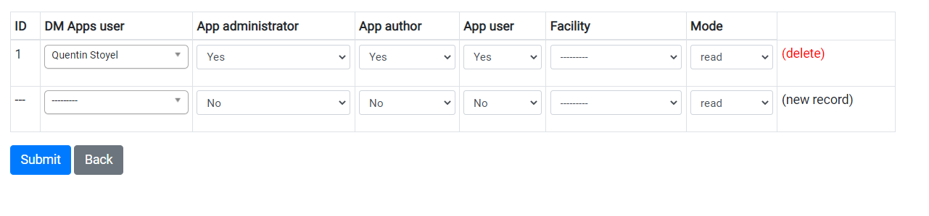

Users with administrator permissions can access/update/delete all pages and users with author or user permissions can only view and enter a limited amount of data. To update the scope of the permissions (eg. Users should be able to create ____/authors should not be able to update____) reach out to the development team.

Personnel relevant to data entry (i.e. staff that performed actions to be recorded in the database) should be recorded as personnel codes under “Facility Info” -> “Personnel Code”.

1. **Initialize System:**

The majority of system codes that need to be set initially can be accessed through the admin links on the home page:

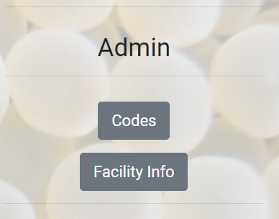

* Many of the application “settings” can be configured through the Codes page. This includes specifying codes such as the River Codes, Feeding Codes, Animal Detail codes, Etc.
* Facility based values (containers, site locations, and program and personnel information) can be entered through the Facility Info page and Bulk Entry parser.

1. **Bulk Entry Parser**

The bulk entry parser is used to enter large numbers of site and containers at once. It can be accessed through Facility Info -> Bulk Entry. The parser will either read the sites information or all of container information (all three sheets). One file should be sufficient to log site and container data or each facility.

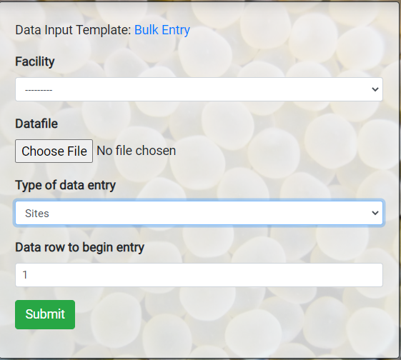

1. **Help Text**

Help text can be added to the creation forms by toggling the “Toggle Help Text Editing” option from the dropdown menu and navigating to a form:

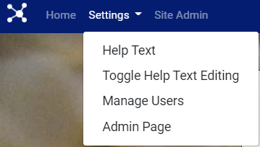

All of the help texts can also be managed through the “Help Text” page.