**Biodiversity Application Event Entry Guide**

1. **Measuring Data:**

This is the generic and most flexible data parser in the application and can be used to enter custom data to an event. There are three tabs in the template:

- Individuals: used to record measurements on PIT Tagged Fish

- Untagged: Used to record details on individual fish in a group, without PIT tags

- Group: Used to record details and movements on groups of non-PIT tagged fish.

The untagged and group sheets are frequently used in combination. For example in sorting events, a number of individual fish may have measurements recorded on them while switching ponds. The group sheet can be used to record how many fish were moved to which ponds, while the Untagged sheet can be used to record the values of any fish that was measured.

Pay attention to the order in which you load these sheets when a movement is involved. Typically, the group data should be loaded first. The Untagged can then be related to either only the initial or final group.

Additional detail columns can be added to these parsers using the data entry form:

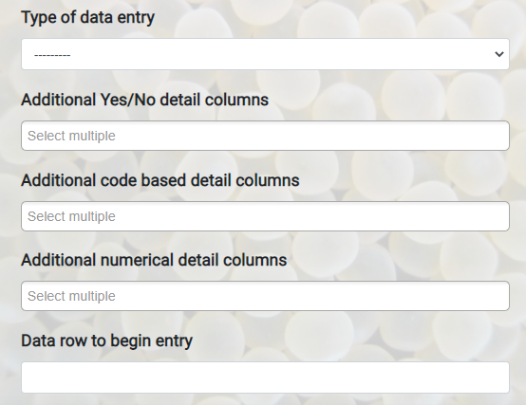

There are three types of columns Yes/No, code based and numerical:

1. Yes/No columns: allow for the selection of Animal Detail Subjective Codes. Select the codes in the search field and add matching column headers into the template. The columns should be filled with y/n values. (Y/N, 1/0, Yes/No, T/F):

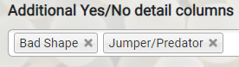 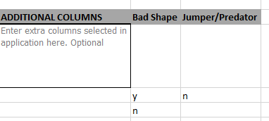

1. Code based columns: Allow for the selecting multiple animal detail subjective codes with a single column. Select an Animal Detail Code in the form and create a matching column header (don’t include the unit parentheses). The column can be filled with the names of animal detail subjective codes in the database:

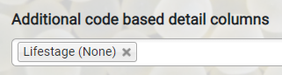

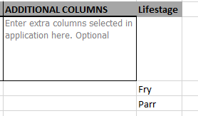

1. Value based columns: Allow for numerical values to be entered for numerical Animal Detail Codes. Select the animal detail code in the form and create a matching column header (don’t include the unit parentheses). The column can then include numerical values:

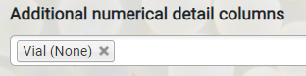

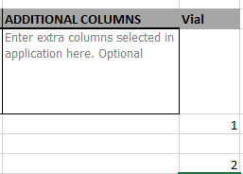

1. **Collections Parsers:**