Experience

- General Ophthalmologist (current position)
  - Edirne Sultan 1. Murat Sate Hospital
- FEBOphth
  - October 30, 2024- Fellow of European Board of Ophthalmology

- PhD Student
  - 2019-2021: Marmara University, Faculty of Metallurgy and Material Sciences Engineering, Biomaterial PhD program

- General Practitioner- Medical Doctor
  - 2018-2019: Uskudar State Hospital- Department of Emergency and Critical Care Medicine

- Intern Doctor
  - 2017-2018: Marmara University, School of Medicine

- Clinical Observer:
  - July 13- August 14, 2015- Brigham and Women’s Hospital, Harvard School of Medicine, Department of Surgery, Section of Plastic Surgery Supervisor: Prof. Bohdan Pomahac and Prof. Elof Eriksson

- Clinical Observer:
  - July 14-August 15, 2014, Yale School of Medicine, Department of Surgery, Section of Plastic Surgery- Supervisor: Prof. John Persing

- Co-chair:
  - September 2014-2016, of the Student Research Club of Marmara University, School of Medicine

Linked In
https://www.linkedin.com/in/aynur-e-393a321ba

Academic
Orchid:0000-0003-1453-4137

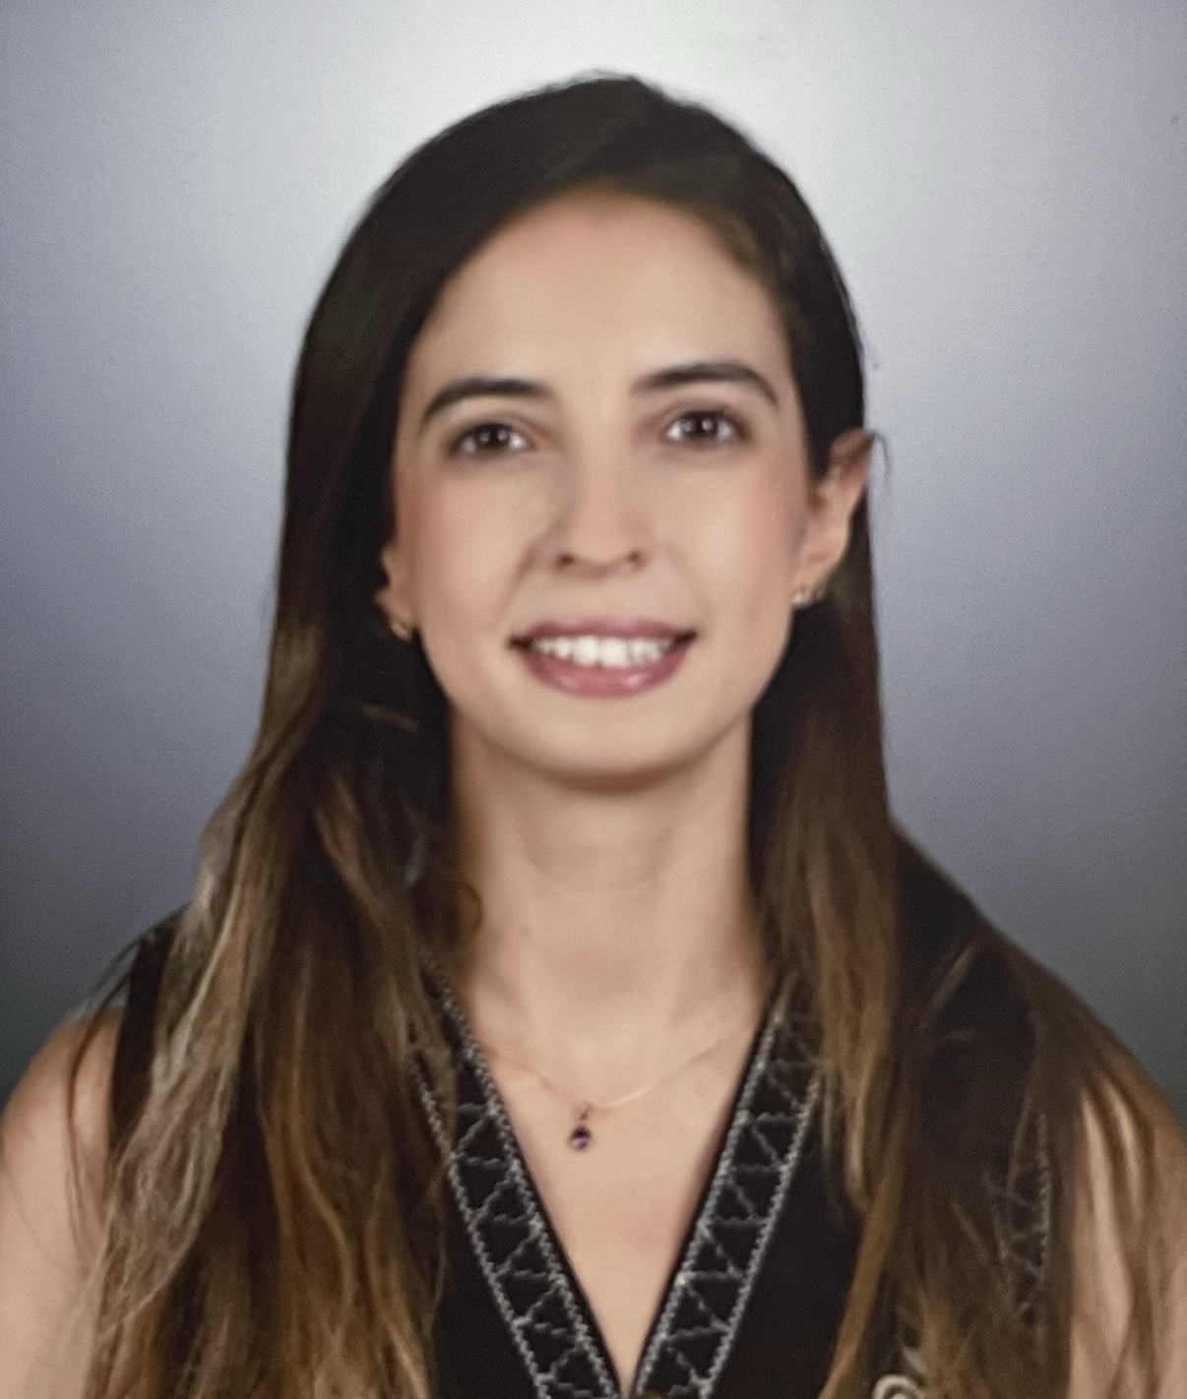
Within the framework of research topics: Cornea and Refractive Surgery, Low Vision Rehabilitation, Oculoplastics and Ocular Oncology, Artificial Intelligence, Deep Learning, Machine Learning, Tissue Engineering, Rat and cadaver experiments. She also has a target and aims in her life to do the best in future studies with her opportunities.

AYNUR ER BILIR

Education
2021-2025: Afyonkarahisar Health Sciences University,
Department of Ophthalmology

2012-2018: Marmara University, School of Medicine

Address

Idealtepe M. Rifki Tongsir C. 73/9 Kucukyali 34841- Istanbul, Turkey

Tel: +905375118704

E-mail: draynurer@gmail.com

Date of Birth: 23.07.1994

Languages
- Turkish (Native) 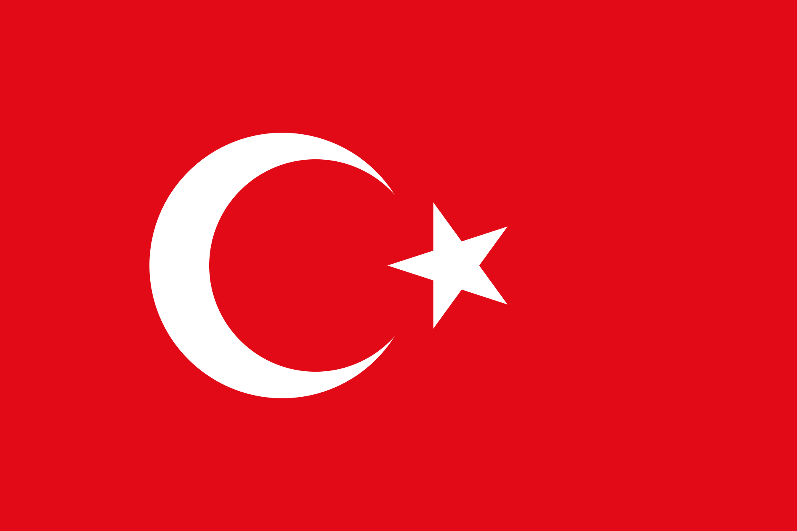
- English (Advanced)  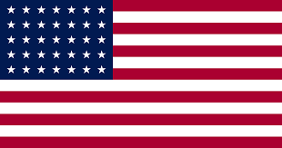Spanish (Intermediate) 
- French (Beginner) 
- German (Beginner) 
- Turkish Sign Language (Elementary)

ACHIEVEMENTS

- October 30, 2024- Fellow of European Board of Ophthalmology Exam
- March 21, 2021- Degree in Turkish National Medicine Specialization Exam
- May 28-30, 2015-Member of Scientific Committee of MASCO 2015 (Marmara Student Congress)
- March 2015- Booklet of Physical Therapy Exercises for Pectus Excavatum Patients(The subject activity has been held in Turkish)
- May 2014, member of MASCO 2014 (Marmara Student Congress) scientific program committee
- January 17-19, 2014, Best 3rd poster in National Marmara Pediatrics Congress, Mujdat Basaran Award, Pectus Excavatum and Pectus Carinatum: Family History, Possible Risk Factors and Associated Conditions(The subject activity has been held in Turkish)
- January 2014, Booklet of Chest Wall Deformities for Patients(The subject activity has been held in Turkish)
- August 2013, Plastic Surgery summer internship in Marmara School of Medicine; Department of Plastic, Reconstructive and Aesthetic Surgery.
- July 1, 2013, Founder of Thoracic Surgery Student Research Club
- July 2013, Thoracic Surgery summer internship in Marmara School of Medicine; Department of Thoracic Surgery
- June 2013, Biochemistry internship in Marmara School of Medicine; Department of Biochemistry
- October 2012, Exempted the English Preparation Class and started first class in Medical School
- June 2012, Degree in University Acceptance Exam and achieved in being 0.1%, out of 2,500,000 high school graduate
- September 2011, Degree in Cambridge English: First (FCE)
- April 2009, qualified to attend to TÜBİTAK (The Scientific and Technological Research Council of Turkey) National Biology Olympiads

MEMEBERSHIPS:
- American Association of Ophthalmology
- Turkish Association of Ophthalmology
- American Society of Cataract and Refractive Surgery
- European Society of Cataract and Refractive Surgery
- Women in Ophthalmology
- ORBIS- International
- YoungMD Connect
- Association for Research in Vision and Ophthalmology
- American Society of Ophthalmic Trauma
- International Society of Ocular Oncology

THE PAPERS IN THE JOURNALS:
- BMC Ophthalmology, February 2026-Artificial intelligence–assisted quantitative evaluation of upper eyelid blepharoplasty outcomes in dermatochalasis: methodological validation and clinical correlation -
- Turkiye Klinikleri Oftalmoloji Dergisi, January 2026- Choroidal Vascularity Index in patients with Papulopustuler Rosacea, A localized skin disease
- Journal of Photodiagnosis and Photodynamic Therapy, June 2025- Photodiagnosis with deep learning: A GAN and autoencoder-based approach for diabetic retinopathy detection
- Cureus Journal of Medical Science, April 2024- Evaluating Turkish Readability and Quality of Strabismus- Related Websites
- Journal of European Eye Research, March 2024- A retrospective Overview of Scientific Researches of Turkish Female Ophthalmology Academics: Is there a gender discrimination?
- Journal of Clinical Medicine of Kazakhstan, June 2023- Accesing disease information via smartphones: A senile macular degeneration investigation in over-65-year-old patients
- Journal of Photodiagnosis and Photodynamic Therapy, June 2023- Optical coherence tomography angiography aspects of the retinal and optic disc microvascular morphology in erythemato-telangectati rosacea
- Journal of Photodiagnosis and Photodynamic Therapy, March 2023- Is it useful to do OCTA in coronary artery disease patients to improve SYNTAX-based cardiac revascularization decision?
- Van Medical Journal, October 2022- The Readability of Level of Websites Regarding COVID-19 Ocular Findings: An Internet Based Analysis
- Korean Journal of Thoracic and Cardiovascular Surgery, February 2016- Pectus Excavatum and Pectus Carinatum: Family History, Possible Risk Factors and Associated Conditions
- Tıp Eğitimi Dünyası Journal, January 2015- Summer Intership Program Organized by the Student Scientific Research Club of Marmara University Faculty of Medicine: A Satisfactory Survey Study

THE PAPERS IN THE PROCEEDINGS OF SCIENTIFIC EVENTS:
- December 19-21, 2025- Poster Presentation- Theamatic Approaches in OCT-Angiography Age Related Macular Degeneration- Turkish Association of Ophthalmology, Medical Retina Days Symposium
- November 19-23, 2025- Oral Presentation- A Descriptive Analysis of Strabismus Research in 2024: Trends and Priorities- Turkish National Ophthalmology Meeting (The subject activity has been held in Turkish)
- May 3-5, 2024- Poster Presentation- Morning Glory Syndrome and Associated Epiretinal Membrane Case Report- Turkish Association of Ophthalmology, Spring Symposium
- September 8-12, 2023, Video Presentation- YO Session- Meeting of the ESCRS (European Society of Cataract and Refractive Surgery)
- November 2-6, 2022- Oral Presentation- Evaluation of Strabismus associated Websites Readability and Comprehension- Turkish National Ophthalmology Meeting (The subject activity has been held in Turkish)
- November 2-6, 2022- Poster Presentation- The Readability Level of Websites Regarding COVID-19 Ocular Findings: An Internet Based Analysis- Turkish National Ophthalmology Meeting
- November 25-29, 2015, Poster Presentation in National Gastroenterology Congress of Turkey, Evaluation of Vagal Activity in Crohn Disase Patients with Disease Activity
- June 2015, Marmara Medical Journal, Evaluation of Vagal Activity in Crohn Disase Patients with Disease Activity
- May 28-30, 2015-Oral Presentation in MASCO 2015(Marmara Student Congress), Evaluation of Vagal Activity in Crohn Disase Patients with Disease Activity
- March 8‐9, 2014, Oral Presentation in CTF Science Days (Cerrahpasa Medical Faculty, Student Scientific Research Club Congress), Pectus Excavatum and Pectus Carinatum: Family History, Possible Risk Factors and Associated Conditions (The subject activity has been held in Turkish)
- January 17-19, 2014, Poster Presentation in National Marmara Pediatrics Congress, Pectus Excavatum and Pectus Carinatum: Family History, Possible Risk Factors and Associated Conditions(The subject activity has been held in Turkish)
- May 23-24, 2013, Oral Presentation in MASCO (Marmara Student Congress), The Effects of Childhood Intension on Studying Medicine (The subject activity has been held in Turkish)

COURSE, CONGRESS AND SYMPOSIUM

- December 19-21, 2025- Turkish Association of Ophthalmology, Medical Retina Days Symposium
- June 20-21, 2025- Oculoplastics Cadaver Course, Turkish Association of Ophthalmology
- April 11-13, 2025- Neurophthalmology April Course, Turkish Association of Ophthalmology
- May 3-5, 2024- Turkish Association of Ophthalmology, Spring Symposium
- November 8-12, 2023-Turkish National Ophthalmology Meeting
- March 18-19, 2023- 26th Esat Isik Interactive Optics, Refraction and Low Vision Rehabilitation Course
- November 3-4, 2022- Image Processing and Artificial Intelligence Skill Transfer Course, Turkish Association of Ophthalmology
- April 16, 2022- Basic Phaco Techniques Skill Transfer Course, Turkish Association of Ophthalmology
- April 1-3, 2022- Optics, Refraction and Refractive Surgery- April Course, Turkish Association of Ophthalmology
April 3-6, 2014, Attendancy to Annual Meeting of the ASCVTS (Asian Society for Cardiovascular and Thoracic Surgery Congress)

SOCIAL INTERESTS

- Art: Anatomical Drawing
- Music: Violin
Sports: Cycling, Running, Pilates

