INSTALLATION AND SETUP GUIDE
Project: Architecture-Constrained UI Migration — Improving LLM-based Translation from Android XML Layouts to Jetpack Compose with MVVM Compliance
Graduation thesis artifact · Dang Vu Quynh Huong (UEH) · Command-line research pipeline only
Repository: https://github.com/ayo-lole/llm-based-project

1. Overview
This repository is the research artifact for the graduation thesis Architecture-Constrained UI Migration: Improving LLM-based Translation from Android XML Layouts to Jetpack Compose with MVVM Compliance (Dang Vu Quynh Huong, University of Economics Ho Chi Minh City). It re-executes the protocol of Paper 244 (Nguyen & Dang, ICAIN 2026) with the departures documented in Thesis Section 3.6.2 (Table 8).
The pipeline couples constraint-aware prompting (MVVM, state hoisting, UDF, Separation of Concerns, Clean Architecture) with a static-analysis-guided refinement loop (compiler, Android Lint, Detekt, ktlint and the R1–R6 checks; k = 4: the initial generation plus at most three refinements).
ID | Name | What it does
B0 | Transpiler baseline | Deterministic XML→Compose mapping. No LLM, no ViewModel.
S1 | Direct prompt | One-line instruction. No architecture constraints. No loop.
S2 | Prompt engineering | Senior-engineer role, Material 3, @Preview. No loop.
S3 | Architecture-constrained | MVVM / Clean Architecture prompt. No refinement loop.
S4 | Full system | Same prompt as S3, plus generate–analyze–refine, k = 4.

Ablations (all on S4, same 150 screens and three models):
- no_feedback_loop — single constrained pass, no refinement (equivalent to S3).
- no_arch_constraint — the loop repairs an unconstrained first draft; no architecture feedback.
- no_static_analysis — compile-only feedback; architecture-aware analysis removed from the feedback.
A screen is MVVM-compliant if and only if it passes R1, R3, R4 and R5. R2 and R6 count towards violations and the Clean Architecture (CA) Score = 100 − Σ weights of the violated rules (Figure 1).
Rule | Requirement | Violation pattern detected | Weight | Decides compliance
R1 | Presentation state lives in a ViewModel as immutable StateFlow<UiState> | ViewModel without an immutable StateFlow-exposed UI state (or no ViewModel at all) | 20 | Yes
R2 | UI observes state lifecycle-safely | StateFlow collected without collectAsStateWithLifecycle() | 10 | No
R3 | No business logic, data access or I/O in any @Composable | Repository, network, database or file calls inside a composable | 25 | Yes
R4 | Leaf composables are stateless; state is hoisted | Business state held in remember { mutableStateOf } inside a composable | 15 | Yes
R5 | Events are raised upward as lambdas | UI mutating state directly; no event callbacks hoisted | 10 | Yes
R6 | Dependencies point UI → ViewModel → domain | Concrete outer-layer client instantiated in UI or ViewModel | 20 | No

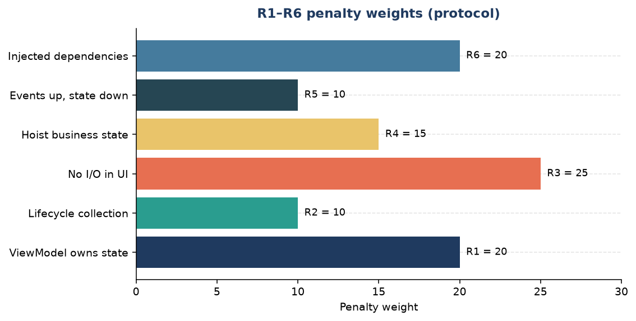
Figure 1. R1–R6 penalty weights used by the Clean Architecture Score (heuristic; see Thesis Section 3.4.2).
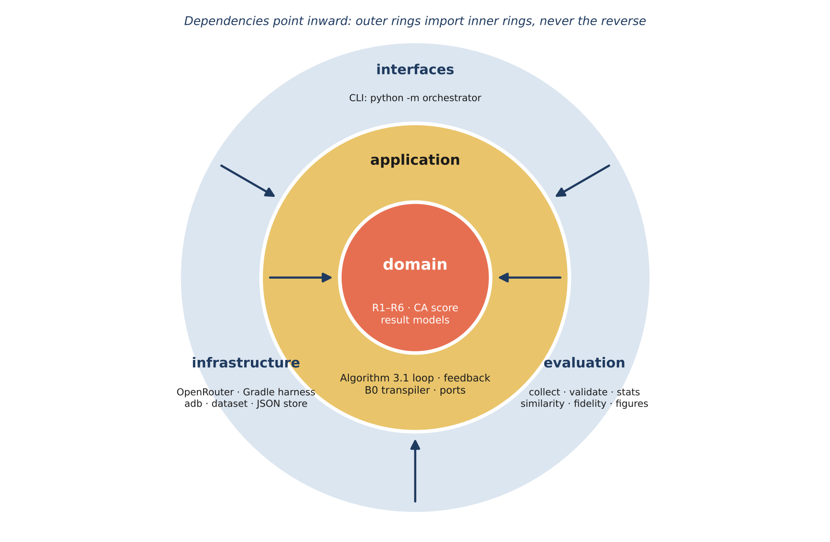
Figure 2. Clean Architecture layers of the orchestrator — dependencies point inward.
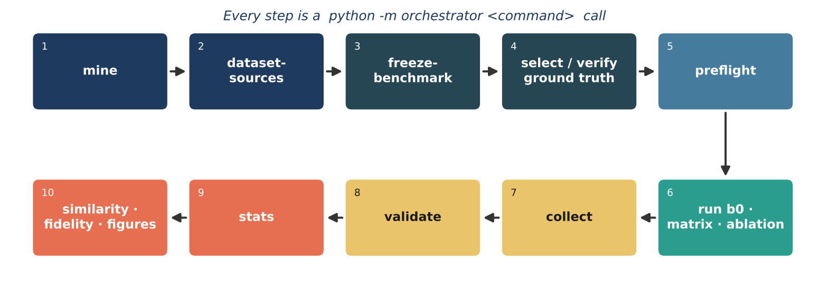
Figure 3. Operator pipeline in execution order — every step is a python -m orchestrator subcommand.
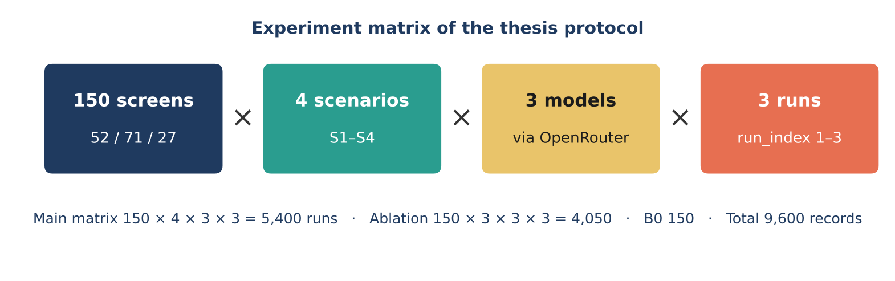
Figure 4. Experiment matrix of the thesis protocol (9,600 result records).
This artifact is command-line only. There is no web app, demo server, browser UI or interactive frontend.
The source tree does not ship experimental result JSON. Tables appear only after the pipeline has been run with a real OpenRouter key, JDK 17, the Android SDK and an API 34 emulator.

2. System Requirements
Component | Required / recommended | Notes
Operating system | Windows 11 + PowerShell (Linux, macOS also work) | Hardware virtualization enabled for the emulator (WHPX / Hyper-V on Windows, KVM on Linux)
CPU / RAM / disk | 8 cores, 32 GB RAM, 60 GB free | The full run uses 4 harness copies, each with its own emulator
Python | 3.11 or newer | Use a virtual environment
JDK | 17 | Required by the Android Gradle harness (JAVA_HOME)
Android toolchain (pinned) | Kotlin 2.0, Compose BOM 2024.09, Android Gradle Plugin 8.5 | Pinned in apps/harness; do not upgrade for reported runs
Android SDK | Platform API 34, emulator, system image API 34 | assembleDebug / installDebug / adb
Static analysis (required) | Android Lint, Detekt 1.23.6, ktlint 1.3.1 | Run in every analysis pass. Style findings are fed back but never block convergence
Gradle | Wrapper in apps/harness | Do not commit build/ or .gradle/
LLM access | OpenRouter account with credit | One key for the three models in Section 6
GitHub token | Optional GITHUB_TOKEN | Higher rate limit for mine and dataset-sources

3. Required Libraries
pip install -e ".[dev]"
Group | Libraries
LLM client | openai (OpenRouter-compatible API)
HTTP / config | requests, python-dotenv
Data / numerics / statistics | pandas, numpy, scipy
Figures | matplotlib
Visual fidelity | scikit-image, Pillow (plus adb and UI Automator)
Code similarity | tree-sitter, tree-sitter-kotlin
Dev / tests | pytest, ruff, import-linter

Kotlin-side tools (Compose compiler, Android Lint, Detekt, ktlint) are resolved by Gradle inside apps/harness on the first build.

4. Project Directory Structure
llm-based-project/
├── orchestrator/
│ ├── domain/ # R1–R6 rules, CA score, result models
│ ├── application/ # Algorithm 3.1 loop, feedback, B0 transpiler, ports
│ ├── infrastructure/ # OpenRouter, Gradle harness, adb, dataset, JSON store
│ ├── evaluation/ # collect, validate, stats, similarity, fidelity, figures
│ ├── interfaces/ # CLI
│ ├── prompts/ # S1–S4 + refinement templates (v1.1-thesis, Appendix B)
│ ├── config.py
│ ├── __main__.py # python -m orchestrator
│ └── main.py # python -m orchestrator.main (same CLI)
├── apps/harness/ # Android Gradle harness (entry: MigrationRoot)
├── data/dataset/ # mined screens + meta.json, benchmark_150.json
├── data/ground_truth/ # selection.json + manual/<id>.kt (35 references)
├── tests/
├── docs/ # ARCHITECTURE.md, PROTOCOL.md, DATASET_SOURCES.md
├── outputs/ # git-ignored results and figures
├── THIRD_PARTY_NOTICES.md
└── .env.example
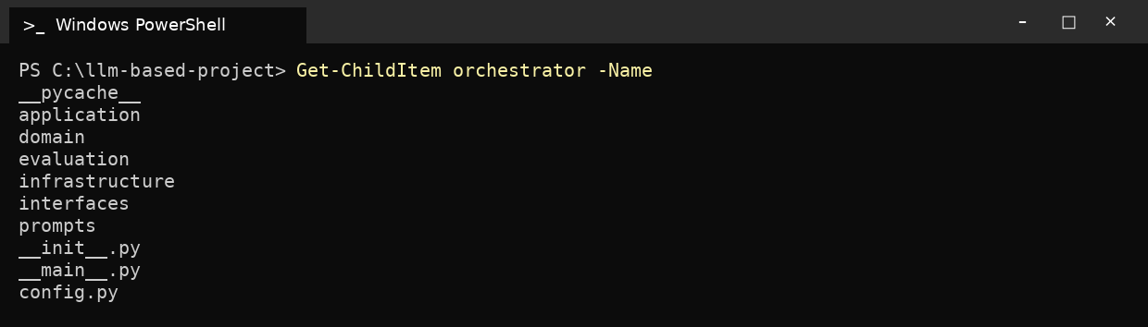
Figure 5. Orchestrator package layout.

5. Dataset Access and Setup
Screens under data/dataset/screens are excerpts of public, Apache-2.0-licensed Android repositories written in Kotlin with evidence of an MVVM or layered architecture, including android/architecture-components-samples, android/databinding-samples, android/platform-samples, android/testing-samples, android/uamp, android/user-interface-samples, google/iosched and nickbutcher/plaid. The frozen benchmark draws its 150 screens from 17 repositories; the complete list with commit hashes and licences is written to docs/DATASET_SOURCES.md by dataset-sources.
freeze-benchmark applies the eligibility rules of Paper 244: it excludes seed/demonstration screens, screens with unparseable layout XML and screens without evidence of a ViewModel (no ViewModel class in the screen folder, no data-binding variable of a ViewModel type, no ViewModel reference in the Activity or Fragment). From the eligible pool it draws a stratified sample of 52 Simple / 71 Medium / 27 Complex screens with seed 244, writes data/dataset/benchmark_150.json (with a SHA-256 hash per screen) and refuses to overwrite an existing file. If the eligible pool is smaller than the quotas, the command raises.
select-ground-truth draws the 35-screen ground-truth subset (12 / 16 / 7, seed 244) from the frozen benchmark. The references in data/ground_truth/manual/ are hand-authored; verify-ground-truth builds each one in the harness, launches it on the emulator and requires zero R1–R6 violations.
Run the commands in this order:
python -m orchestrator mine --repos <owner/name> # 1. mine candidate screens
python -m orchestrator dataset-sources # 2. docs/DATASET_SOURCES.md
python -m orchestrator freeze-benchmark # 3. 52/71/27, seed 244
python -m orchestrator select-ground-truth # 4. 12/16/7, seed 244
python -m orchestrator verify-ground-truth # 5. needs JDK, SDK, emulator
Steps 1–4 need only Python. Step 5 needs the Android toolchain of Section 6, Step 4.

6. Setup Steps

Step 1 — Clone the repository and create a virtual environment
git clone https://github.com/ayo-lole/llm-based-project.git
cd llm-based-project
python -m venv .venv
.\.venv\Scripts\Activate.ps1 # Linux/macOS: source .venv/bin/activate

Step 2 — Install libraries
pip install -e ".[dev]"

Step 3 — Configure .env
Copy-Item .env.example .env # Linux/macOS: cp .env.example .env
# edit .env: set OPENROUTER_API_KEY (never commit .env)
Variable | Thesis protocol value
OPENROUTER_API_KEY | your key (empty in .env.example)
OPENROUTER_GPT_MODEL | openai/gpt-4o
OPENROUTER_GEMINI_MODEL | google/gemini-2.5-flash
OPENROUTER_CLAUDE_MODEL | anthropic/claude-sonnet-4
OPENROUTER_MAX_TOKENS | 8192
LLM_TEMPERATURE | 0.2
GEMINI_REASONING | off
PROMPT_TEMPLATE_VERSION | v1.1-thesis

Paper 244 used GPT-4o, Gemini 2.0 Flash and Claude 3.5 Sonnet. At the time of the thesis re-execution, Gemini 2.0 Flash had been withdrawn (OpenRouter HTTP 404; absent from Google’s model list) and the whole Claude 3.x Sonnet line had no OpenRouter endpoints, so google/gemini-2.5-flash and anthropic/claude-sonnet-4 are used as substitutes (Thesis Section 3.7.5). openai/gpt-4o is an alias for a dated snapshot; the snapshot actually served is logged with every call as model_returned.
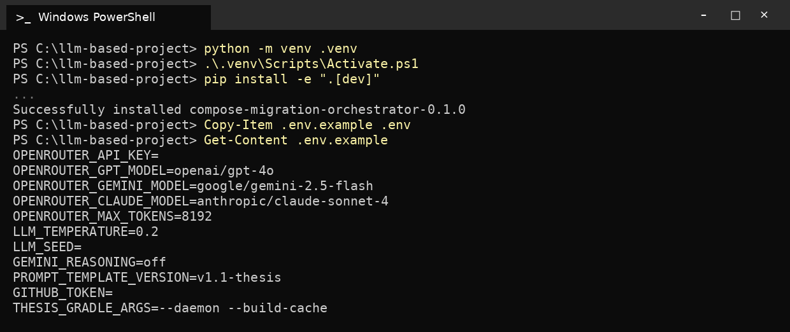
Figure 6. Environment setup.

Step 4 — Install JDK 17, the Android SDK and the emulators
- Install JDK 17 and set JAVA_HOME; install Android SDK platform API 34, the emulator and the API 34 system image.
- Create one AVD per worker (four for the full run) and start them; adb devices must list every emulator.
- Runtime success and visual fidelity are evaluated only on an emulator. When a device is attached its verdict is final; without a device these metrics are not evaluated, and no structural proxy is used for any reported result.
sdkmanager "platforms;android-34" "emulator" \
"system-images;android-34;google_apis;x86_64"
avdmanager create avd -n api34_1 -k "system-images;android-34;google_apis;x86_64"
# repeat for api34_2, api34_3, api34_4
emulator -avd api34_1 -no-window -no-audio
adb devices

Step 5 — Tests and static contracts
python -m pytest -q
lint-imports
ruff check .
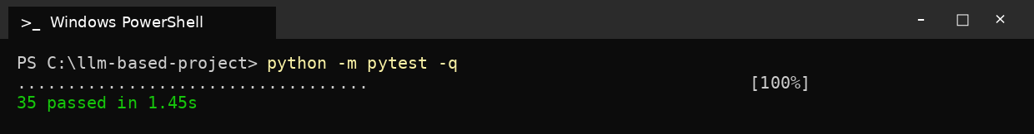
Figure 7. Unit tests.
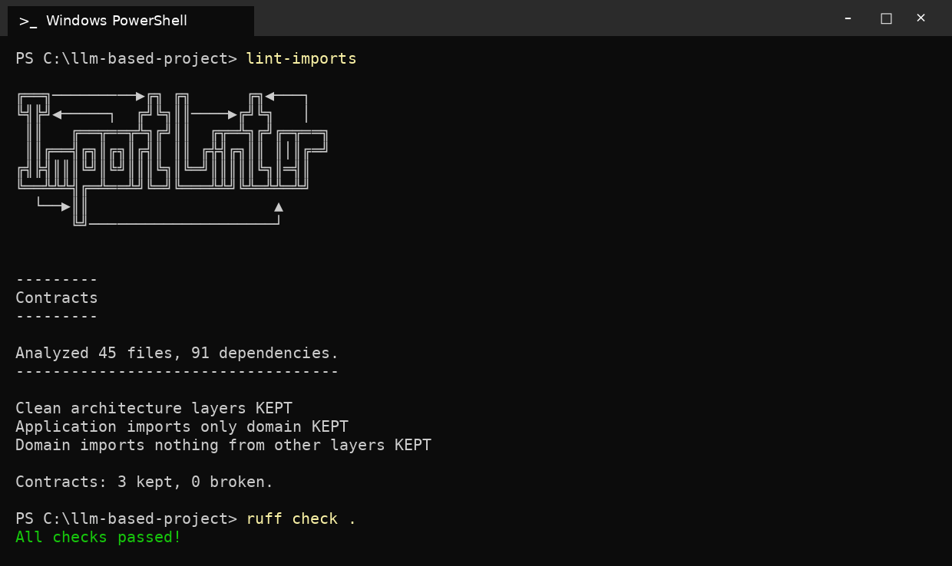
Figure 8. Import-linter layer contracts and ruff.

Step 6 — CLI and preflight
python -m orchestrator --help
python -m orchestrator preflight
preflight checks the API key, the three model routes, JDK 17, the pinned toolchain versions (Kotlin, Compose BOM, AGP, Detekt, ktlint), the Gradle wrapper and the attached emulators. Run it only after Step 4.
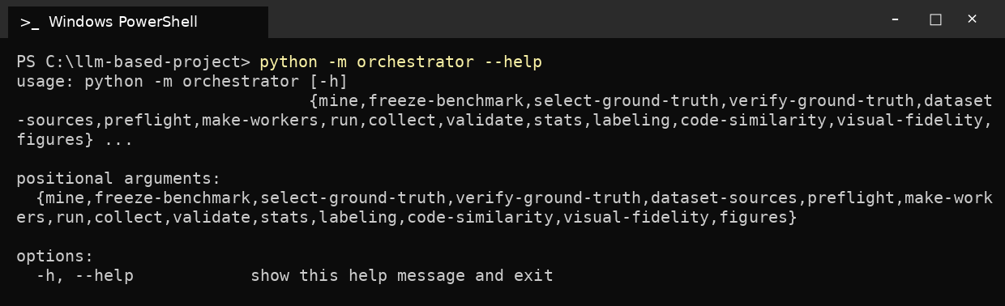
Figure 9. CLI entry point (python -m orchestrator --help).

7. Running the Pipeline
All commands are python -m orchestrator <command>; python -m orchestrator.main <command> is an equivalent entry point (e.g. python -m orchestrator.main b0, the form cited in Thesis Table 8). Completed result files are never overwritten, so every run is resumable at the level of one (model, scenario, screen, run) record.

7.1. Smoke test (optional, not part of the reported results)
python -m orchestrator run b0 --limit 2
python -m orchestrator run matrix --limit 1 --n-runs 1

7.2. Full run (thesis protocol)
python -m orchestrator make-workers 4 # 4 harness copies, 1 emulator each
python -m orchestrator run b0 # 150 records
python -m orchestrator run matrix --workers 4 # 150 × 4 × 3 × 3 = 5,400 records
python -m orchestrator run ablation --workers 4 # 150 × 3 × 3 × 3 = 4,050 records
Strict mode is on for every run: a missing harness raises, an unknown model raises, a model_returned mismatch raises, and the runner never falls back to an offline client. OpenRouter is the only LLM adapter.

7.3. Post-processing (in this order)
python -m orchestrator collect # R1–R6 recomputed from final code
python -m orchestrator validate # completeness, truncation, cache replay, emulator
python -m orchestrator stats # Wilson, McNemar, Wilcoxon, Mann–Whitney, Holm
python -m orchestrator labeling prepare # then labeling score (20 screens, 2 rounds)
python -m orchestrator code-similarity # CodeBLEU-adapted, AST match (35 references)
python -m orchestrator visual-fidelity # SSIM, pixel diff, accessibility (emulator)
python -m orchestrator figures

7.4. Convergence rules
Condition | Loop stops when
S4 (default) | compile_ok ∧ build_ok ∧ no R1–R6 violations, or k = 4 iterations used
no_arch_constraint, no_static_analysis | compile_ok ∧ build_ok, or k = 4 iterations used
no_feedback_loop, S1–S3, B0 | Single pass, no refinement

Feedback is ranked compiler errors first (≤ 8), then architecture violations ordered by rule weight (≤ 6), then other analyzer findings (≤ 6), at most 20 lines.
Outputs (git-ignored): outputs/results/<model>/<scenario>/<screen>_runN.json, outputs/results/_calls/calls.jsonl, outputs/results/tables/, outputs/figures/.

8. Paper 244 Reference Charts
The following charts reproduce the published Paper 244 aggregates (Nguyen & Dang, ICAIN 2026, Section 4): means over three models and three runs. They are the reference series of the thesis reproduction table. A local re-execution writes its own CSVs with python -m orchestrator stats; those files are not stored in the source tree.
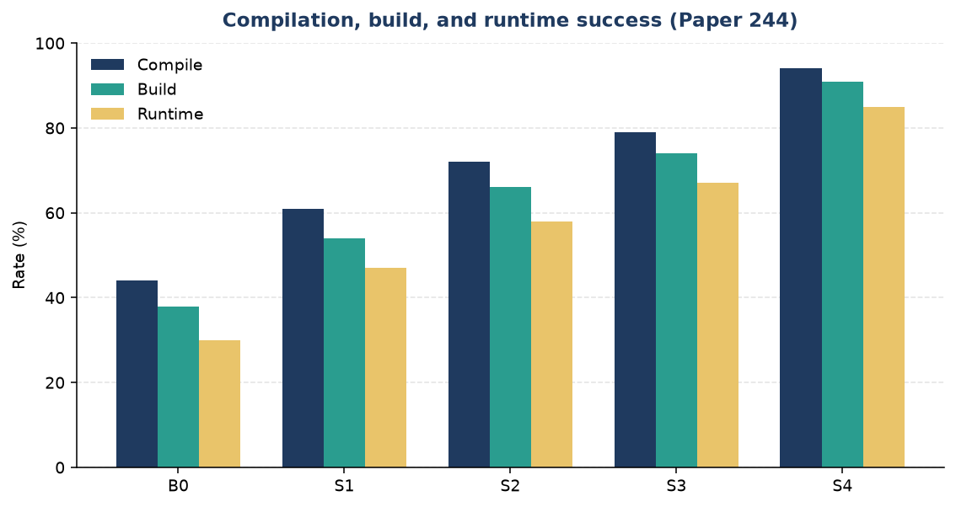
Figure 10. Compilation, build and runtime success from B0 to S4 (Paper 244).
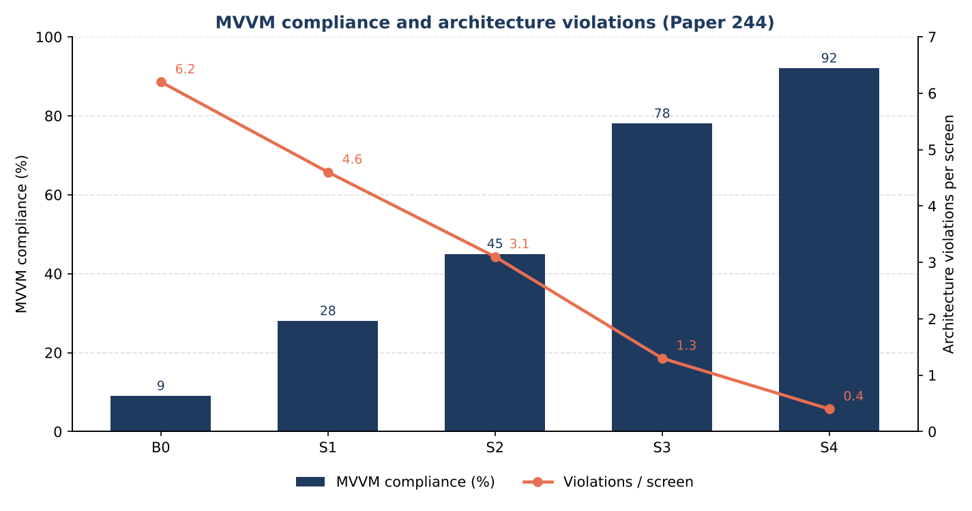
Figure 11. MVVM compliance and architecture violations per screen (Paper 244).

9. There Is No Interactive Demo
There is no web demo, dashboard or HTTP server. apps/harness exists only so that Gradle can compile each candidate and, with adb, install and launch it through the MigrationRoot entry composable. Operators use only python -m orchestrator.

10. Troubleshooting
Issue | Fix
python not found (Windows Store stub) | Use the venv: .\.venv\Scripts\python.exe
ModuleNotFoundError: orchestrator | Activate .venv; pip install -e ".[dev]"; always python -m orchestrator
Activate.ps1 blocked | Set-ExecutionPolicy -Scope CurrentUser RemoteSigned
OPENROUTER 401 / 402 | Put a billed key in .env. 402 means insufficient credit
Unknown model / model_returned mismatch | Keep the three OpenRouter ids of Section 6, Step 3
preflight: toolchain version mismatch | Use the pinned Kotlin 2.0, BOM 2024.09, AGP 8.5, Detekt 1.23.6, ktlint 1.3.1
Gradle wrapper missing | Keep apps/harness/gradlew and gradlew.bat
freeze-benchmark: not enough strata | Mine more Apache-2.0 MVVM screens; do not invent ids
Refusing to overwrite freeze | Leave benchmark_150.json in place unless you intend a new freeze
preflight: no adb device / fewer than 4 devices | Start one API 34 emulator per worker before run, verify-ground-truth or visual-fidelity
Emulator does not start | Enable WHPX / Hyper-V (Windows) or KVM (Linux)
visual-fidelity raises | Requires an emulator; there is no screenshot substitute
validate fails | Read the reported check (missing records, truncation, cache replay, non-emulator verdict) and re-run only the affected records

11. Notes
- Freeze and ground-truth sampling seed is 244.
- R1–R6 weights 20 / 10 / 25 / 15 / 10 / 20 are heuristic. MVVM-compliant ⇔ R1, R3, R4, R5 pass.
- Do not use Hilt, Koin or kapt/ksp; every prompt states this (prompt version v1.1-thesis).
- Do not type result numbers into tables; run collect, validate and stats after the full run.
- Screens are Apache-2.0 excerpts (THIRD_PARTY_NOTICES.md, docs/DATASET_SOURCES.md).
- API keys are read from .env only and are never written to logs or results.

12. Further Reading
- README.md, docs/ARCHITECTURE.md, docs/PROTOCOL.md, docs/DATASET_SOURCES.md, docs/SETUP_GUIDE.md
- Thesis Chapter 3 (framework, protocol), Appendix B (prompt templates), Appendix E (log schema)
- Paper 244: Nguyen & Dang, ICAIN 2026

