Jan 31, 2019 Lab Meeting

Caitilyn Allen

**Peer-Reviewing Scientific Manuscripts**

Research scientists are expected to peer-review manuscripts submitted to journals and grant proposals submitted to funders, but they often don’t get training in this important professional skill. Even if you don’t pursue a research career you must still publish your graduate work, so you need to know how this process works.

Peer-reviewing is a complex task, and doing it well takes time.  But it often pays you back with interesting new data or ideas. At a minimum it shows you mistakes to avoid with your own papers. It usually takes me about 4 hours to review a paper (longer if I have to read previous work to get caught up). If I review with a student or postdoc, we each review the manuscript separately and then we meet to discuss & merge our reviews.

**The ask.** Every week I get multiple emails like this one:

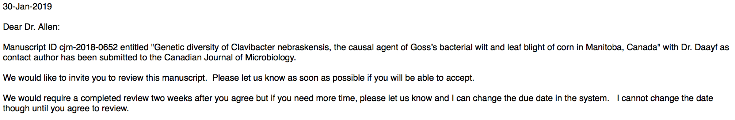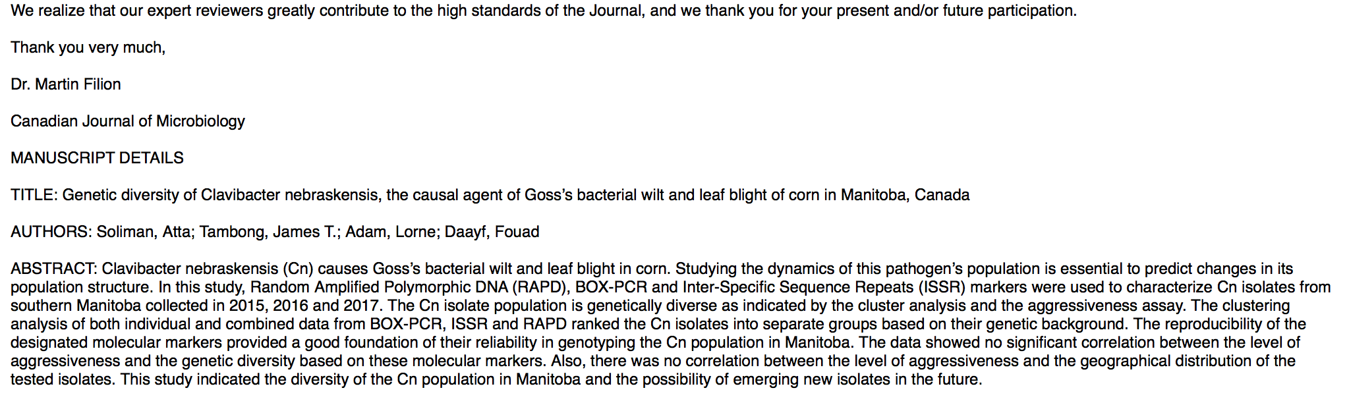

**The decision**. I consider 3 questions:

* Do I have expertise and interest in this research?
* Do I have time to complete this review by the due date?
* Am I free from conflict of interest with the authors?

**The review.** If the answer to all 3 questions is yes, here’s how I proceed

1. Read it over quickly to get an idea of the main points.  Sometimes, alas, this will be enough to show that the paper cannot be fixed with revisions or a few additional experiments.  If that is the case, do not spend time on text editing or detailed suggestions for improvement.  Just write an explanation of the paper’s fatal flaw(s). Also, if the English is terrible, even a paper that is not fatally flawed should be returned for a rewrite without content review. All the editor needs from you in this case is a clear explanation of why it doesn’t meet standards.
2. If it passes this screen, I read it through carefully with pen (or cursor) in hand.  As I read, I ask:

* Does the Intro explain why the research question is interesting and important?
* Does the Intro give enough info about this area so the reader can understand the work in context?
* Do authors clearly explain the hypothesis to be tested?
* Do the experiments adequately test that hypothesis? Are the correct controls present? Are the methods appropriate? Are the experimental design and stats analysis solid?
* Are the data sufficient to support the conclusions, or are additional experiments needed?
* Do the data in the figures & tables align with the data presented in the text?
* Are the interpretations in Results & Discussion consistent with the data?
* Is each reference cited in the text appropriate? Are all cited refs necessary? Are any missing? Is each ref cited in the text present in the bibliography? (despite EndNote & Mendeley, reference errors are common)
* Does the Discussion go beyond repeating the results? Discussions should place the paper’s findings into the broader scholarly context of previously published & future research on this topic (and not just previous research from the authors’ own lab).
* Are the Materials & Methods clear & complete?  Are they excessively or insufficiently detailed?
* Are all figures & tables necessary?  Is the figure quality high enough? Are there additional data that should be shown?
* Is the writing clear and grammatical?
* Last, reread the Abstract & Title to see if they accurately reflect the work.

1. I *try* not to micro edit the text (this takes too long) but if the writing needs attention, this should be noted in the review. Serious text errors should be noted however. Sometimes if the overall writing quality is low \, I rewrite the Abstract to help the authors & show how it can be improved.
2. Write the review. Most journals ask reviewers ***not*** to explicitly state in the review if a paper should be accepted or rejected (they may ask for your recommendation in a private communication to the editor). Use a constructive tone. The goal of review comments is not just to point out flaws, but to make constructive suggestions on how flaws could be fixed so the eventual paper is better.  Even if the work doesn’t meet standards, do not be nasty or dismissive. No jokes, no exclamation points. Remember that a fellow scientist and human being will read your words. I generally write in this format:

-a brief, objective summary of the work, together with an assessment of the importance of the problem. Because the editor may not know much about this subfield, here’s where you should explain why this question is (or isn’t) novel, exciting, practically useful, needed to fill a gap or test a long-standing hypothesis, etc.

-a numbered list of specific comments or concerns, usually divided into “Major” and “Minor” to help the editor know what they should insist on. If additional experiments are needed, be specific.