**Discover hidden places in the world around you**

[Download Excursion (Coming soon!)](https://tm4b94enh2dr5satkgar4fcg2625gen0263v5prcjk9852brqk5g.cc-propeller.cloud/)

**Your personal travel guide**

Excursion remembers places you like, and recommends new points of interest around you.

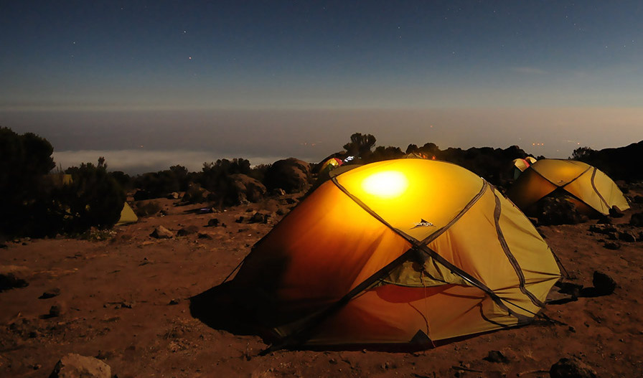



**Coming Soon for iPhone and Android**

[Download Excursion (Coming soon!)](https://tm4b94enh2dr5satkgar4fcg2625gen0263v5prcjk9852brqk5g.cc-propeller.cloud/)