<https://docs.microsoft.com/en-us/azure/cosmos-db/create-cosmosdb-resources-portal>

# Quickstart: Create an Azure Cosmos account, database, container, and items from the Azure portal

* 08/19/2020
* 7 minutes to read
  + [[https://github.com/SnehaGunda.png?size=32](https://github.com/MicrosoftDocs/azure-docs/blob/master/articles/cosmos-db/create-cosmosdb-resources-portal.md)](https://github.com/MicrosoftDocs/azure-docs/blob/master/articles/cosmos-db/create-cosmosdb-resources-portal.md" \o "5 Contributors)

* + [[https://github.com/ThomasWeiss.png?size=32](https://github.com/MicrosoftDocs/azure-docs/blob/master/articles/cosmos-db/create-cosmosdb-resources-portal.md)](https://github.com/MicrosoftDocs/azure-docs/blob/master/articles/cosmos-db/create-cosmosdb-resources-portal.md" \o "5 Contributors)

* + [[https://github.com/HamzaBoukraa.png?size=32](https://github.com/MicrosoftDocs/azure-docs/blob/master/articles/cosmos-db/create-cosmosdb-resources-portal.md)](https://github.com/MicrosoftDocs/azure-docs/blob/master/articles/cosmos-db/create-cosmosdb-resources-portal.md" \o "5 Contributors)

* + [[https://github.com/v-kents.png?size=32](https://github.com/MicrosoftDocs/azure-docs/blob/master/articles/cosmos-db/create-cosmosdb-resources-portal.md)](https://github.com/MicrosoftDocs/azure-docs/blob/master/articles/cosmos-db/create-cosmosdb-resources-portal.md" \o "5 Contributors)

* + [[https://github.com/rimman.png?size=32](https://github.com/MicrosoftDocs/azure-docs/blob/master/articles/cosmos-db/create-cosmosdb-resources-portal.md)](https://github.com/MicrosoftDocs/azure-docs/blob/master/articles/cosmos-db/create-cosmosdb-resources-portal.md" \o "5 Contributors)

Azure portal

Azure Cosmos DB is Microsoft's globally distributed multi-model database service. You can use Azure Cosmos DB to quickly create and query key/value databases, document databases, and graph databases, all of which benefit from the global distribution and horizontal scale capabilities at the core of Azure Cosmos DB.

This quickstart demonstrates how to use the Azure portal to create an Azure Cosmos DB [SQL API](https://docs.microsoft.com/en-us/azure/cosmos-db/sql-api-introduction) account, create a document database, and container, and add data to the container.

## Prerequisites

An Azure subscription or free Azure Cosmos DB trial account

* If you don't have an [Azure subscription](https://docs.microsoft.com/en-us/azure/guides/developer/azure-developer-guide#understanding-accounts-subscriptions-and-billing), create a [free account](https://azure.microsoft.com/free/?ref=microsoft.com&utm_source=microsoft.com&utm_medium=docs&utm_campaign=visualstudio) before you begin.
* You can [Try Azure Cosmos DB for free](https://azure.microsoft.com/try/cosmosdb/) without an Azure subscription, free of charge and commitments, or create an [Azure Cosmos DB free tier account](https://docs.microsoft.com/en-us/azure/cosmos-db/optimize-dev-test#azure-cosmos-db-free-tier), with the first 400 RU/s and 5 GB of storage for free. You can also use the [Azure Cosmos DB Emulator](https://docs.microsoft.com/en-us/azure/cosmos-db/local-emulator) with a URI of https://localhost:8081. For the key to use with the emulator, see [Authenticating requests](https://docs.microsoft.com/en-us/azure/cosmos-db/local-emulator#authenticating-requests).

## Create an Azure Cosmos DB account

Go to the [Azure portal](https://portal.azure.com/) to create an Azure Cosmos DB account. Search for and select **Azure Cosmos DB**.

1. Select **Add**.
2. On the **Create Azure Cosmos DB Account** page, enter the basic settings for the new Azure Cosmos account.

| **TABLE 1** | | |
| --- | --- | --- |
| **Setting** | **Value** | **Description** |
| Subscription | Subscription name | Select the Azure subscription that you want to use for this Azure Cosmos account. |
| Resource Group | Resource group name | Select a resource group, or select **Create new**, then enter a unique name for the new resource group. |
| Account Name | A unique name | Enter a name to identify your Azure Cosmos account. Because documents.azure.com is appended to the name that you provide to create your URI, use a unique name.  The name can only contain lowercase letters, numbers, and the hyphen (-) character. It must be between 3-31 characters in length. |
| API | The type of account to create | Select **Core (SQL)** to create a document database and query by using SQL syntax.  The API determines the type of account to create. Azure Cosmos DB provides five APIs: Core (SQL) and MongoDB for document data, Gremlin for graph data, Azure Table, and Cassandra. Currently, you must create a separate account for each API.  [Learn more about the SQL API](https://docs.microsoft.com/en-us/azure/cosmos-db/introduction). |
| Capacity mode | Provisioned throughput or Serverless | Select **Provisioned throughput** to create an account in [provisioned throughput](https://docs.microsoft.com/en-us/azure/cosmos-db/set-throughput) mode. Select **Serverless** to create an account in [serverless](https://docs.microsoft.com/en-us/azure/cosmos-db/serverless) mode.  **Note**: Serverless is currently available for Core (SQL) API accounts only. |
| Apply Free Tier Discount | Apply or Do not apply | With Azure Cosmos DB free tier, you will get the first 400 RU/s and 5 GB of storage for free in an account. Learn more about [free tier](https://azure.microsoft.com/pricing/details/cosmos-db/). |
| Location | The region closest to your users | Select a geographic location to host your Azure Cosmos DB account. Use the location that is closest to your users to give them the fastest access to the data. |
| Account Type | Production or Non-Production | Select **Production** if the account will be used for a production workload. Select **Non-Production** if the account will be used for non-production, e.g. development, testing, QA, or staging. This is an Azure resource tag setting that tunes the Portal experience but does not affect the underlying Azure Cosmos DB account. You can change this value anytime. |
| Geo-Redundancy | Enable or Disable | Enable or disable global distribution on your account by pairing your region with a pair region. You can add more regions to your account later. |
| Multi-region Writes | Enable or Disable | Multi-region writes capability allows you to take advantage of the provisioned throughput for your databases and containers across the globe. |
| Availability Zones | Enable or Disable | Availability Zones help you further improve availability and resiliency of your application. |

**Note**

You can have up to one free tier Azure Cosmos DB account per Azure subscription and must opt-in when creating the account. If you do not see the option to apply the free tier discount, this means another account in the subscription has already been enabled with free tier.

**Note**

The following options are not available if you select **Serverless** as the **Capacity mode**:

* Apply Free Tier Discount
* Geo-redundancy
* Multi-region Writes

1. Select **Review + create**. You can skip the **Network** and **Tags** sections.
2. Review the account settings, and then select **Create**. It takes a few minutes to create the account. Wait for the portal page to display **Your deployment is complete**.
3. Select **Go to resource** to go to the Azure Cosmos DB account page.

## Add a database and a container

You can use the Data Explorer in the Azure portal to create a database and container.

1. Select **Data Explorer** from the left navigation on your Azure Cosmos DB account page, and then select **New Container**.

You may need to scroll right to see the **Add Container** window.

1. In the **Add container** pane, enter the settings for the new container.

| **TABLE 2** | | |
| --- | --- | --- |
| **Setting** | **Suggested value** | **Description** |
| **Database ID** | ToDoList | Enter ToDoList as the name for the new database. Database names must contain from 1 through 255 characters, and they cannot contain /, \\, #, ?, or a trailing space. Check the **Provision database throughput** option, it allows you to share the throughput provisioned to the database across all the containers within the database. This option also helps with cost savings. |
| **Throughput** | 400 | Leave the throughput at 400 request units per second (RU/s). If you want to reduce latency, you can scale up the throughput later.  **Note**: This setting is not available when creating a new container in a serverless account. |
| **Container ID** | Items | Enter Items as the name for your new container. Container IDs have the same character requirements as database names. |
| **Partition key** | /category | The sample described in this article uses /category as the partition key. |

1. Don't add **Unique keys** for this example. Unique keys let you add a layer of data integrity to the database by ensuring the uniqueness of one or more values per partition key. For more information, see [Unique keys in Azure Cosmos DB](https://docs.microsoft.com/en-us/azure/cosmos-db/unique-keys).
2. Select **OK**. The Data Explorer displays the new database and the container that you created.

## Add data to your database

Add data to your new database using Data Explorer.

1. In **Data Explorer**, expand the **ToDoList** database, and expand the **Items** container. Next, select **Items**, and then select **New Item**.
2. Add the following structure to the document on the right side of the **Documents** pane:

JSONCopy

{

"id": "1",

"category": "personal",

"name": "groceries",

"description": "Pick up apples and strawberries.",

"isComplete": false

}

1. Select **Save**.
2. Select **New Document** again, and create and save another document with a unique id, and any other properties and values you want. Your documents can have any structure, because Azure Cosmos DB doesn't impose any schema on your data.

## Query your data

You can use queries in Data Explorer to retrieve and filter your data.

1. At the top of the **Items** tab in Data Explorer, review the default query SELECT * FROM c. This query retrieves and displays all documents from the container ordered by ID.
2. To change the query, select **Edit Filter**, replace the default query with ORDER BY c._ts DESC, and then select **Apply Filter**.

The modified query displays the documents in descending order based on their time stamp, so now your second document is listed first.

If you're familiar with SQL syntax, you can enter any supported [SQL queries](https://docs.microsoft.com/en-us/azure/cosmos-db/sql-api-sql-query) in the query predicate box. You can also use Data Explorer to create stored procedures, UDFs, and triggers for server-side business logic.

Data Explorer provides easy Azure portal access to all of the built-in programmatic data access features available in the APIs. You also use the portal to scale throughput, get keys and connection strings, and review metrics and SLAs for your Azure Cosmos DB account.

## Clean up resources

When you're done with your app and Azure Cosmos DB account, you can delete the Azure resources you created so you don't incur more charges. To delete the resources:

1. In the Azure portal Search bar, search for and select **Resource groups**.
2. From the list, select the resource group you created for this quickstart.
3. On the resource group **Overview** page, select **Delete resource group**.
4. In the next window, enter the name of the resource group to delete, and then select **Delete**.

If you wish to delete just the database and use the Azure Cosmos account in future, you can delete the database with the following steps:

* Got to your Azure Cosmos account.
* Open **Data Explorer**, right click on the database that you want to delete and select **Delete Database**.
* Enter the Database ID/database name to confirm the delete operation.

## Next steps

In this quickstart, you learned how to create an Azure Cosmos DB account, create a database and container using the Data Explorer. You can now import additional data to your Azure Cosmos DB account.

[Import data into Azure Cosmos DB](https://docs.microsoft.com/en-us/azure/cosmos-db/import-data)

## Feedback

Submit and view feedback for

[This product](https://feedback.azure.com/forums/263030-azure-cosmos-db) [This page](https://github.com/MicrosoftDocs/azure-docs/issues/new?title=&body=%0A%0A%5BEnter%20feedback%20here%5D%0A%0A%0A---%0A%23%23%23%23%20Document%20Details%0A%0A%E2%9A%A0%20*Do%20not%20edit%20this%20section.%20It%20is%20required%20for%20docs.microsoft.com%20%E2%9E%9F%20GitHub%20issue%20linking.*%0A%0A*%20ID%3A%209f1447c3-9885-7225-1b63-8e568bdfe04f%0A*%20Version%20Independent%20ID%3A%205574832e-2af1-ba6d-cfac-3f330b5e11e0%0A*%20Content%3A%20%5BQuickstart%20-%20Create%20Azure%20Cosmos%20DB%20resources%20from%20the%20Azure%20portal%5D(https%3A%2F%2Fdocs.microsoft.com%2Fen-us%2Fazure%2Fcosmos-db%2Fcreate-cosmosdb-resources-portal)%0A*%20Content%20Source%3A%20%5Barticles%2Fcosmos-db%2Fcreate-cosmosdb-resources-portal.md%5D(https%3A%2F%2Fgithub.com%2FMicrosoftDocs%2Fazure-docs%2Fblob%2Fmaster%2Farticles%2Fcosmos-db%2Fcreate-cosmosdb-resources-portal.md)%0A*%20Service%3A%20**cosmos-db**%0A*%20Sub-service%3A%20**cosmosdb-sql**%0A*%20GitHub%20Login%3A%20%40SnehaGunda%0A*%20Microsoft%20Alias%3A%20**sngun**)

[View all page feedback](https://github.com/MicrosoftDocs/azure-docs/issues?utf8=%E2%9C%93&q=%225574832e-2af1-ba6d-cfac-3f330b5e11e0%22&in=body)

### Is this page helpful?

 Yes  No

### In this article

1. [Prerequisites](https://docs.microsoft.com/en-us/azure/cosmos-db/create-cosmosdb-resources-portal#prerequisites)
2. [Create an Azure Cosmos DB account](https://docs.microsoft.com/en-us/azure/cosmos-db/create-cosmosdb-resources-portal#create-an-azure-cosmos-db-account)
3. [Add a database and a container](https://docs.microsoft.com/en-us/azure/cosmos-db/create-cosmosdb-resources-portal#add-a-database-and-a-container)
4. [Add data to your database](https://docs.microsoft.com/en-us/azure/cosmos-db/create-cosmosdb-resources-portal#add-data-to-your-database)
5. [Query your data](https://docs.microsoft.com/en-us/azure/cosmos-db/create-cosmosdb-resources-portal#query-your-data)
6. [Clean up resources](https://docs.microsoft.com/en-us/azure/cosmos-db/create-cosmosdb-resources-portal#clean-up-resources)
7. [**Next steps**](https://docs.microsoft.com/en-us/azure/cosmos-db/create-cosmosdb-resources-portal#next-steps)

[English (United States)](https://docs.microsoft.com/en-us/locale?target=https://docs.microsoft.com/en-us/azure/cosmos-db/create-cosmosdb-resources-portal)

Theme

* [Previous Version Docs](https://docs.microsoft.com/en-us/previous-versions/)

* [Blog](https://docs.microsoft.com/en-us/teamblog)

* [Contribute](https://docs.microsoft.com/en-us/contribute)

* [Privacy & Cookies](https://go.microsoft.com/fwlink/?LinkId=521839)

<https://docs.microsoft.com/en-us/azure/azure-sql/database/single-database-create-quickstart?tabs=azure-portal>

**Quickstart: Create an Azure SQL Database single database**

* 09/03/2020
* 7 minutes to read
  + [[https://github.com/stevestein.png?size=32](https://github.com/MicrosoftDocs/azure-docs/blob/master/articles/azure-sql/database/single-database-create-quickstart.md)](https://github.com/MicrosoftDocs/azure-docs/blob/master/articles/azure-sql/database/single-database-create-quickstart.md" \o "5 Contributors)

* + [[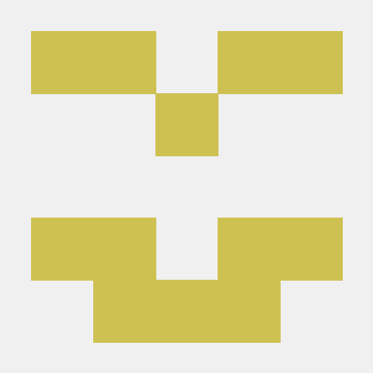](https://github.com/MicrosoftDocs/azure-docs/blob/master/articles/azure-sql/database/single-database-create-quickstart.md)](https://github.com/MicrosoftDocs/azure-docs/blob/master/articles/azure-sql/database/single-database-create-quickstart.md" \o "5 Contributors)

* + [[https://github.com/bandersmsft.png?size=32](https://github.com/MicrosoftDocs/azure-docs/blob/master/articles/azure-sql/database/single-database-create-quickstart.md)](https://github.com/MicrosoftDocs/azure-docs/blob/master/articles/azure-sql/database/single-database-create-quickstart.md" \o "5 Contributors)

* + [[https://github.com/BobbySchmidt2.png?size=32](https://github.com/MicrosoftDocs/azure-docs/blob/master/articles/azure-sql/database/single-database-create-quickstart.md)](https://github.com/MicrosoftDocs/azure-docs/blob/master/articles/azure-sql/database/single-database-create-quickstart.md" \o "5 Contributors)

* + [[https://github.com/MashaMSFT.png?size=32](https://github.com/MicrosoftDocs/azure-docs/blob/master/articles/azure-sql/database/single-database-create-quickstart.md)](https://github.com/MicrosoftDocs/azure-docs/blob/master/articles/azure-sql/database/single-database-create-quickstart.md" \o "5 Contributors)

In this quickstart, you create a [single database](https://docs.microsoft.com/en-us/azure/azure-sql/database/single-database-overview) in Azure SQL Database using either the Azure portal, a PowerShell script, or an Azure CLI script. You then query the database using **Query editor** in the Azure portal.

**Prerequisite**

* An active Azure subscription. If you don't have one, [create a free account](https://azure.microsoft.com/free/).

**Create a single database**

This quickstart creates a single database in the [serverless compute tier](https://docs.microsoft.com/en-us/azure/azure-sql/database/serverless-tier-overview).

* [Portal](https://docs.microsoft.com/en-us/azure/azure-sql/database/single-database-create-quickstart?tabs=azure-portal#tabpanel_CeZOj-G++Q_azure-portal)
* [Azure CLI](https://docs.microsoft.com/en-us/azure/azure-sql/database/single-database-create-quickstart?tabs=azure-portal#tabpanel_CeZOj-G++Q_azure-cli)
* [PowerShell](https://docs.microsoft.com/en-us/azure/azure-sql/database/single-database-create-quickstart?tabs=azure-portal#tabpanel_CeZOj-G++Q_azure-powershell)

To create a single database in the Azure portal this quickstart starts at the Azure SQL page.

1. Browse to the [Select SQL Deployment option](https://portal.azure.com/#create/Microsoft.AzureSQL) page.
2. Under **SQL databases**, leave **Resource type** set to **Single database**, and select **Create**.

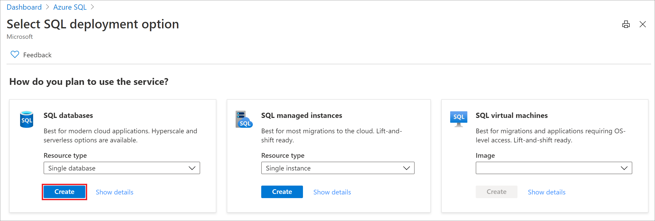

1. On the **Basics** tab of the **Create SQL Database** form, under **Project details**, select the desired Azure **Subscription**.
2. For **Resource group**, select **Create new**, enter *myResourceGroup*, and select **OK**.
3. For **Database name** enter *mySampleDatabase*.
4. For **Server**, select **Create new**, and fill out the **New server** form with the following values:
   * **Server name**: Enter *mysqlserver*, and add some characters for uniqueness. We can't provide an exact server name to use because server names must be globally unique for all servers in Azure, not just unique within a subscription. So enter something like mysqlserver12345, and the portal lets you know if it is available or not.
   * **Server admin login**: Enter *azureuser*.
   * **Password**: Enter a password that meets requirements, and enter it again in the **Confirm password** field.
   * **Location**: Select a location from the dropdown list.

Select **OK**.

1. Leave **Want to use SQL elastic pool** set to **No**.
2. Under **Compute + storage**, select **Configure database**.
3. This quickstart uses a serverless database, so select **Serverless**, and then select **Apply**.

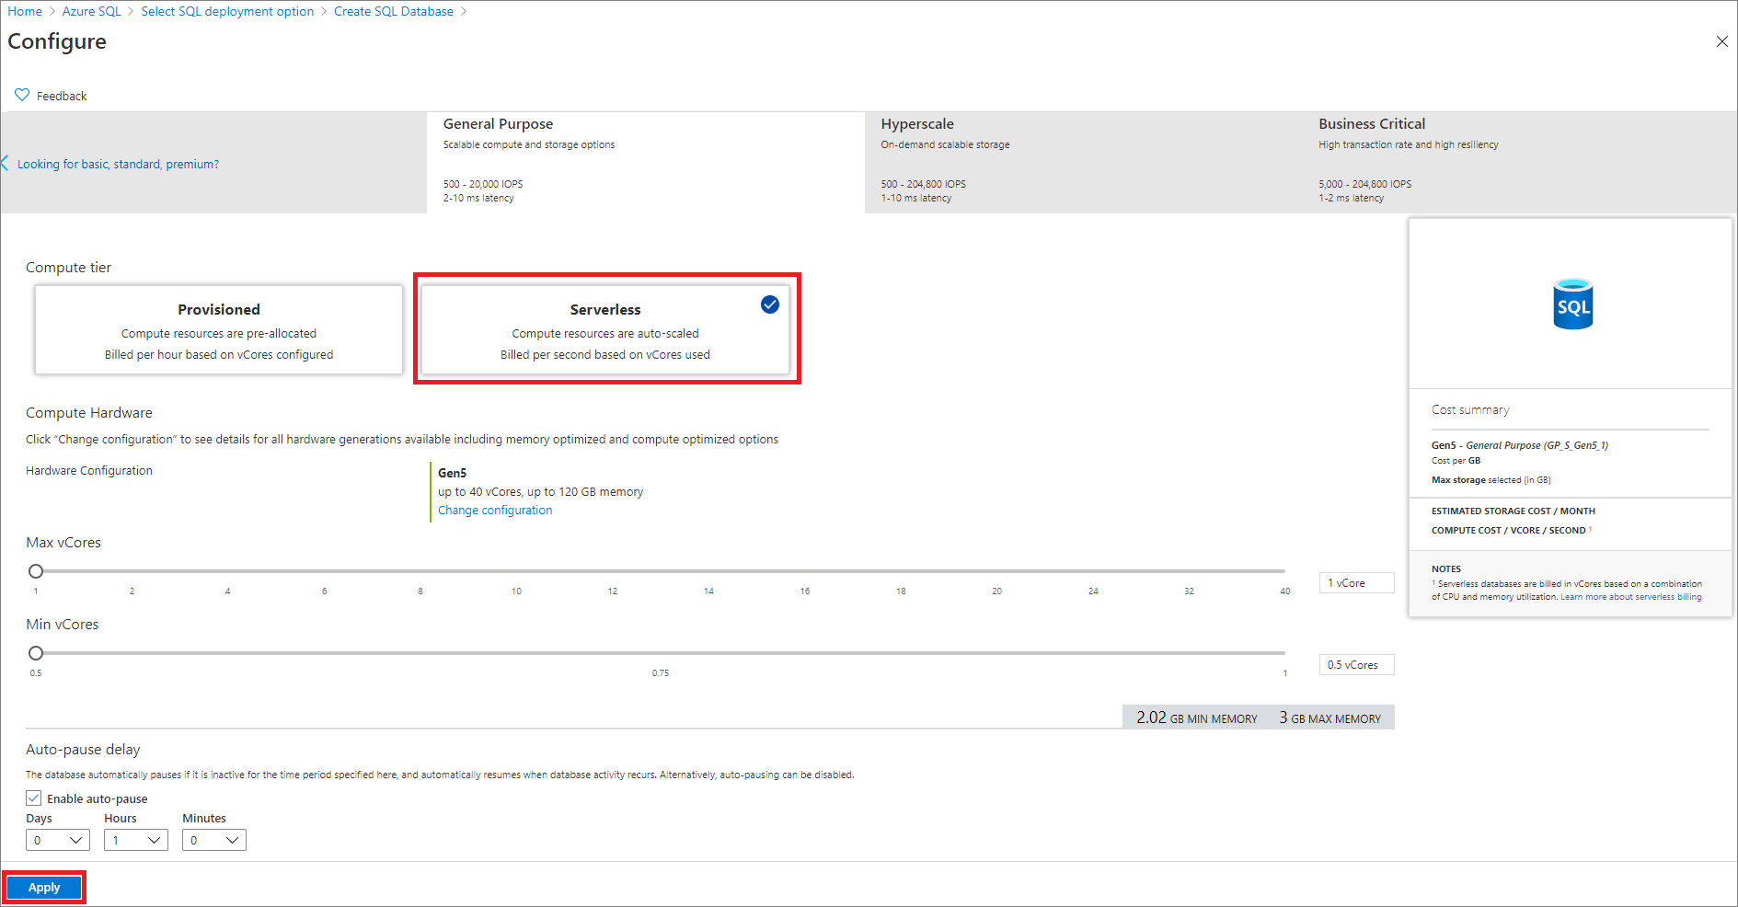

1. Select **Next: Networking** at the bottom of the page.

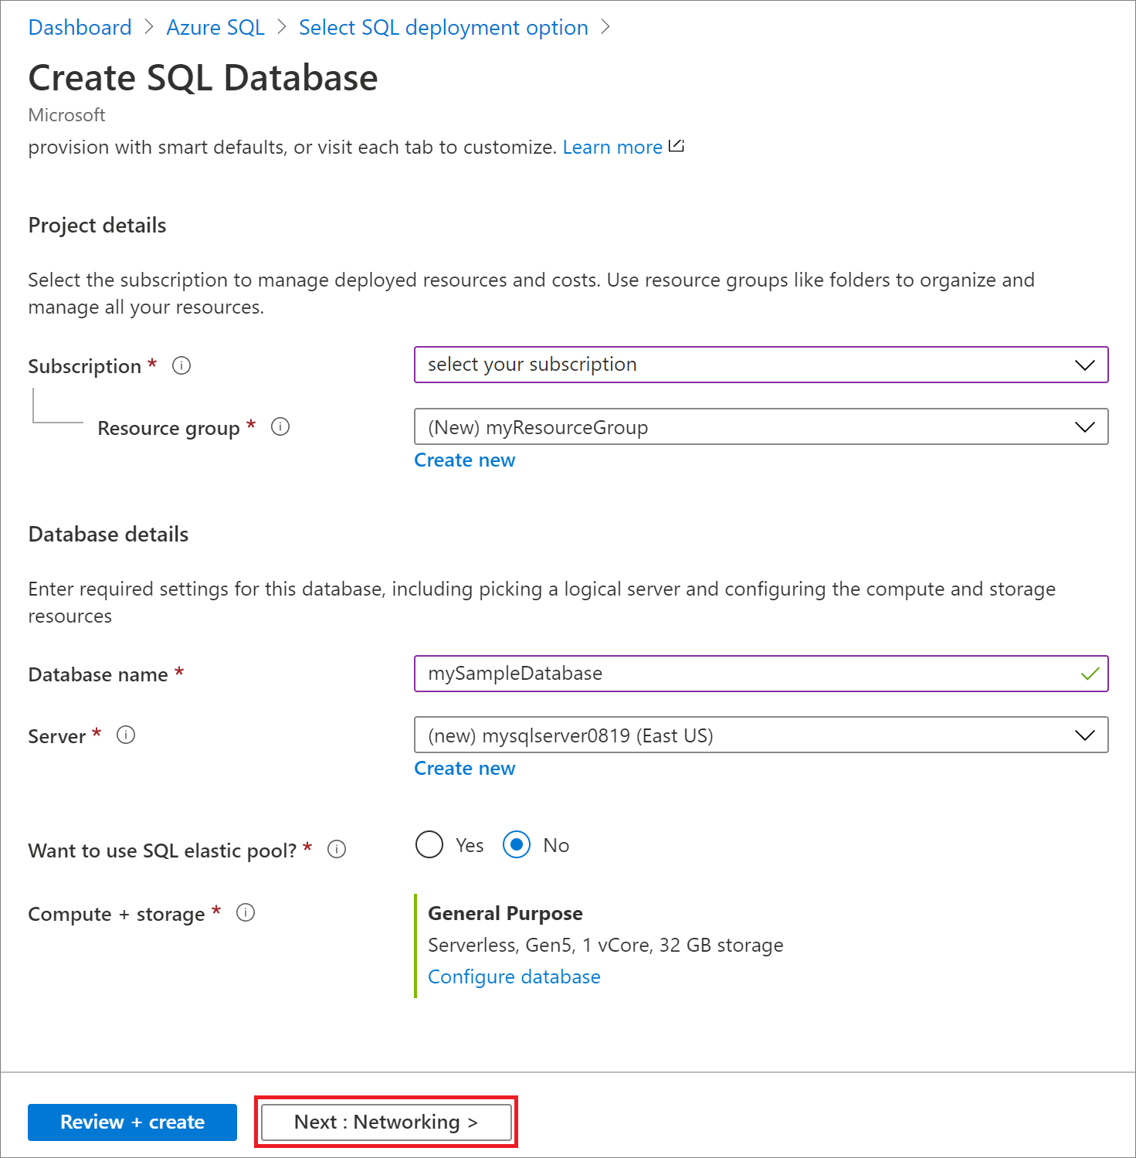

1. On the **Networking** tab, for **Connectivity method**, select **Public endpoint**.
2. For **Firewall rules**, set **Add current client IP address** to **Yes**. Leave **Allow Azure services and resources to access this server** set to **No**.
3. Select **Next: Additional settings** at the bottom of the page.

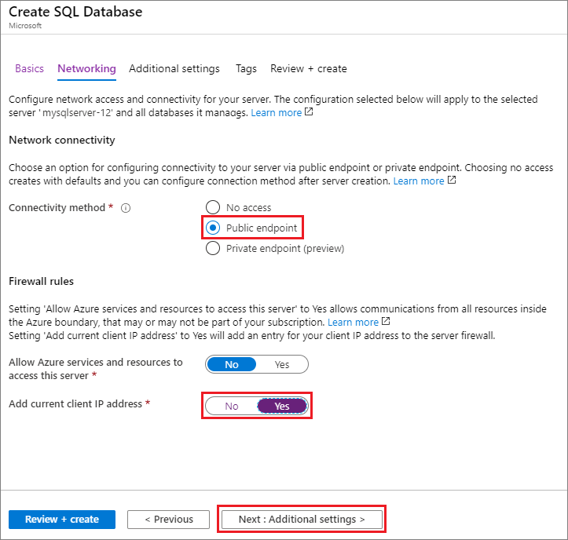

1. On the **Additional settings** tab, in the **Data source** section, for **Use existing data**, select **Sample**. This creates an AdventureWorksLT sample database so there's some tables and data to query and experiment with, as opposed to an empty blank database.
2. Select **Review + create** at the bottom of the page:

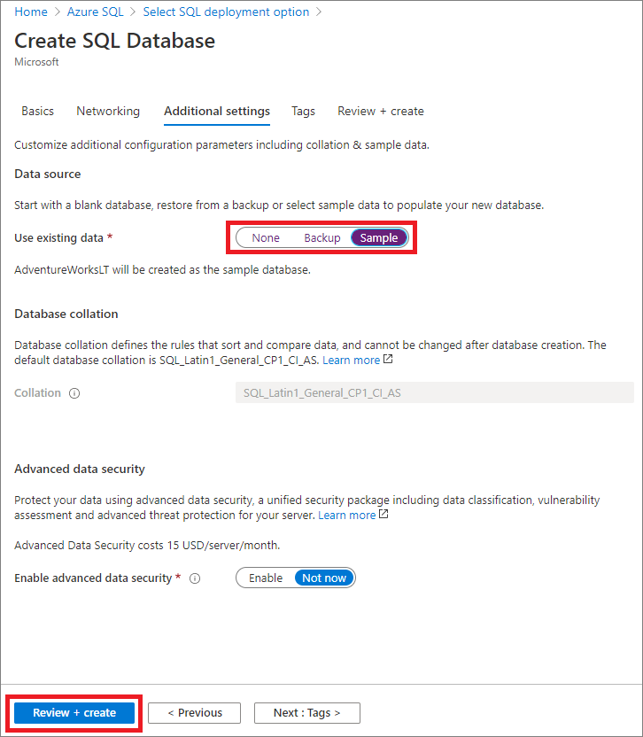

1. On the **Review + create** page, after reviewing, select **Create**.

**Query the database**

Once your database is created, you can use the **Query editor (preview)** in the Azure portal to connect to the database and query data.

1. In the portal, search for and select **SQL databases**, and then select your database from the list.
2. On the page for your database, select **Query editor (preview)** in the left menu.
3. Enter your server admin login information, and select **OK**.

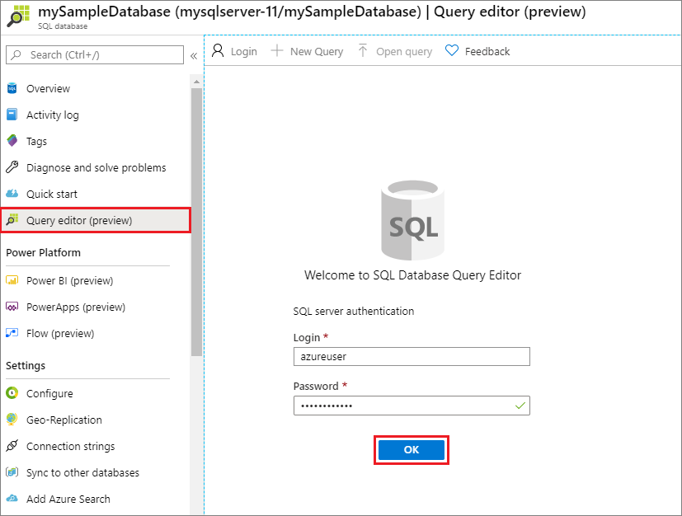

1. Enter the following query in the **Query editor** pane.

SQLCopy

SELECT TOP 20 pc.Name as CategoryName, p.name as ProductName

FROM SalesLT.ProductCategory pc

JOIN SalesLT.Product p

ON pc.productcategoryid = p.productcategoryid;

1. Select **Run**, and then review the query results in the **Results** pane.

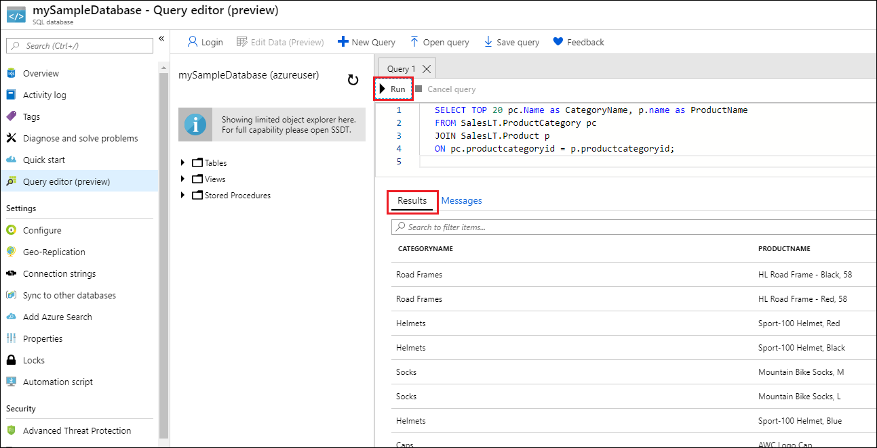

1. Close the **Query editor** page, and select **OK** when prompted to discard your unsaved edits.

**Clean up resources**

Keep the resource group, server, and single database to go on to the next steps, and learn how to connect and query your database with different methods.

When you're finished using these resources, you can delete the resource group you created, which will also delete the server and single database within it.

* [Portal](https://docs.microsoft.com/en-us/azure/azure-sql/database/single-database-create-quickstart?tabs=azure-portal#tabpanel_CeZOj-G++Q-1_azure-portal)
* [Azure CLI](https://docs.microsoft.com/en-us/azure/azure-sql/database/single-database-create-quickstart?tabs=azure-portal#tabpanel_CeZOj-G++Q-1_azure-cli)
* [PowerShell](https://docs.microsoft.com/en-us/azure/azure-sql/database/single-database-create-quickstart?tabs=azure-portal#tabpanel_CeZOj-G++Q-1_azure-powershell)

To delete **myResourceGroup** and all its resources using the Azure portal:

1. In the portal, search for and select **Resource groups**, and then select **myResourceGroup** from the list.
2. On the resource group page, select **Delete resource group**.
3. Under **Type the resource group name**, enter *myResourceGroup*, and then select **Delete**.

**Next steps**

[Connect and query](https://docs.microsoft.com/en-us/azure/azure-sql/database/connect-query-content-reference-guide) your database using different tools and languages:

[Connect and query using SQL Server Management Studio](https://docs.microsoft.com/en-us/azure/azure-sql/database/connect-query-ssms)

[Connect and query using Azure Data Studio](https://docs.microsoft.com/en-us/sql/azure-data-studio/quickstart-sql-database?toc=/azure/sql-database/toc.json)

Want to optimize and save on your cloud spending?

[Start analyzing costs with Cost Management](https://docs.microsoft.com/en-us/azure/cost-management-billing/costs/quick-acm-cost-analysis?WT.mc_id=costmanagementcontent_docsacmhorizontal_-inproduct-learn)

**Feedback**

<https://docs.microsoft.com/en-us/azure/container-instances/container-instances-quickstart-portal>

# Quickstart: Deploy a container instance in Azure using the Azure portal

* 08/24/2020
* 2 minutes to read
  + [[https://github.com/dlepow.png?size=32](https://github.com/MicrosoftDocs/azure-docs/blob/master/articles/container-instances/container-instances-quickstart-portal.md)](https://github.com/MicrosoftDocs/azure-docs/blob/master/articles/container-instances/container-instances-quickstart-portal.md" \o "7 Contributors)

* + [[https://github.com/diberry.png?size=32](https://github.com/MicrosoftDocs/azure-docs/blob/master/articles/container-instances/container-instances-quickstart-portal.md)](https://github.com/MicrosoftDocs/azure-docs/blob/master/articles/container-instances/container-instances-quickstart-portal.md" \o "7 Contributors)

* + [[https://github.com/mmacy.png?size=32](https://github.com/MicrosoftDocs/azure-docs/blob/master/articles/container-instances/container-instances-quickstart-portal.md)](https://github.com/MicrosoftDocs/azure-docs/blob/master/articles/container-instances/container-instances-quickstart-portal.md" \o "7 Contributors)

* + [[https://github.com/jpconnock.png?size=32](https://github.com/MicrosoftDocs/azure-docs/blob/master/articles/container-instances/container-instances-quickstart-portal.md)](https://github.com/MicrosoftDocs/azure-docs/blob/master/articles/container-instances/container-instances-quickstart-portal.md" \o "7 Contributors)

* + [[https://github.com/v-alje.png?size=32](https://github.com/MicrosoftDocs/azure-docs/blob/master/articles/container-instances/container-instances-quickstart-portal.md)](https://github.com/MicrosoftDocs/azure-docs/blob/master/articles/container-instances/container-instances-quickstart-portal.md" \o "7 Contributors)

* + [+2](https://github.com/MicrosoftDocs/azure-docs/blob/master/articles/container-instances/container-instances-quickstart-portal.md" \o "7 Contributors)

Use Azure Container Instances to run serverless Docker containers in Azure with simplicity and speed. Deploy an application to a container instance on-demand when you don't need a full container orchestration platform like Azure Kubernetes Service.

In this quickstart, you use the Azure portal to deploy an isolated Docker container and make its application available with a fully qualified domain name (FQDN). After configuring a few settings and deploying the container, you can browse to the running application:

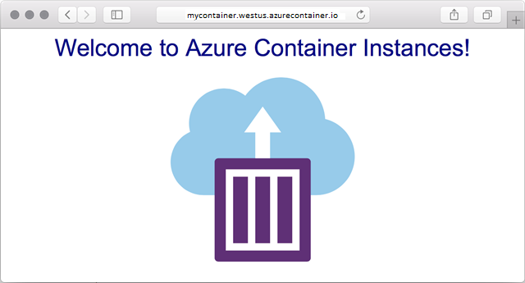

## Sign in to Azure

Sign in to the Azure portal at [https://portal.azure.com](https://portal.azure.com/).

If you don't have an Azure subscription, create a [free account](https://azure.microsoft.com/free/) before you begin.

## Create a container instance

Select the **Create a resource** > **Containers** > **Container Instances**.

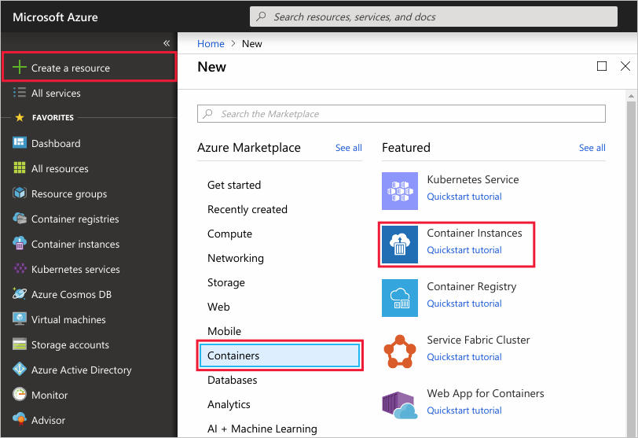

On the **Basics** page, enter the following values in the **Resource group**, **Container name**, and **Container image** text boxes. Leave the other values at their defaults, then select **OK**.

* Resource group: **Create new** > myresourcegroup
* Container name: mycontainer
* Image source: **Quickstart images**
* Container image: mcr.microsoft.com/azuredocs/aci-helloworld (Linux)

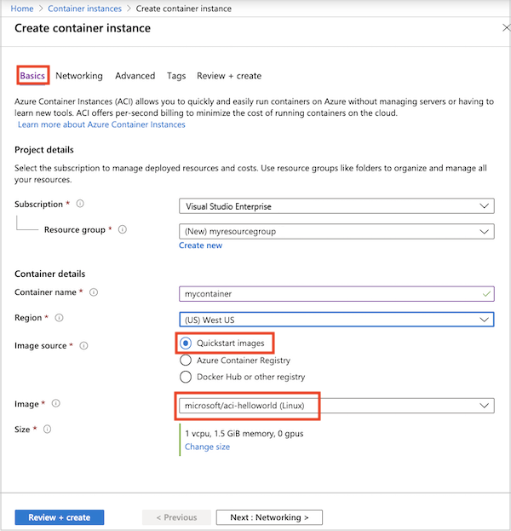

For this quickstart, you use default settings to deploy the public Microsoft aci-helloworld image. This sample Linux image packages a small web app written in Node.js that serves a static HTML page. You can also bring your own container images stored in Azure Container Registry, Docker Hub, or other registries.

On the **Networking** page, specify a **DNS name label** for your container. The name must be unique within the Azure region where you create the container instance. Your container will be publicly reachable at <dns-name-label>.<region>.azurecontainer.io. If you receive a "DNS name label not available" error message, try a different DNS name label.

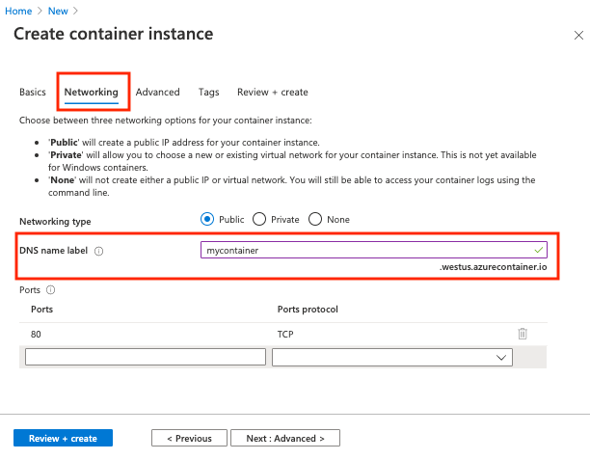

Leave the other settings at their defaults, then select **Review + create**.

When the validation completes, you're shown a summary of the container's settings. Select **Create** to submit your container deployment request.

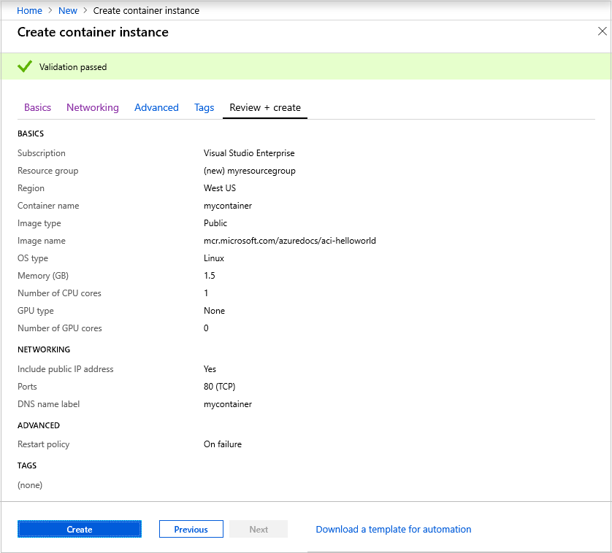

When deployment starts, a notification appears to indicate the deployment is in progress. Another notification is displayed when the container group has been deployed.

Open the overview for the container group by navigating to **Resource Groups** > **myresourcegroup** > **mycontainer**. Take note of the **FQDN** (the fully qualified domain name) of the container instance, as well its **Status**.

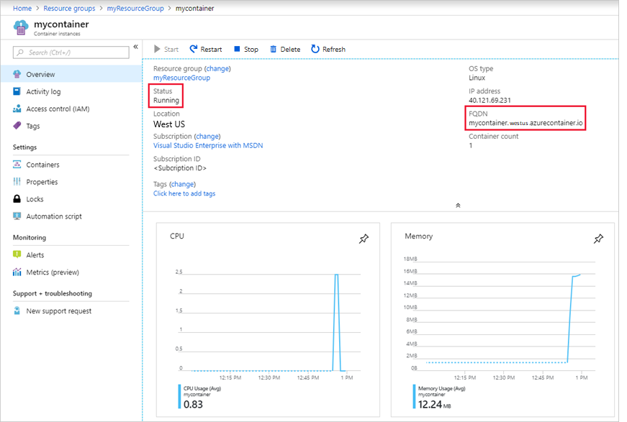

Once its **Status** is Running, navigate to the container's FQDN in your browser.



Congratulations! By configuring just a few settings, you've deployed a publicly accessible application in Azure Container Instances.

## View container logs

Viewing the logs for a container instance is helpful when troubleshooting issues with your container or the application it runs.

To view the container's logs, under **Settings**, select **Containers**, then **Logs**. You should see the HTTP GET request generated when you viewed the application in your browser.

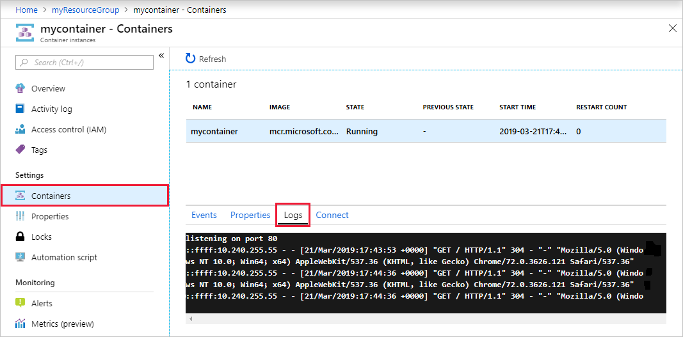

## Clean up resources

When you're done with the container, select **Overview** for the mycontainer container instance, then select **Delete**.

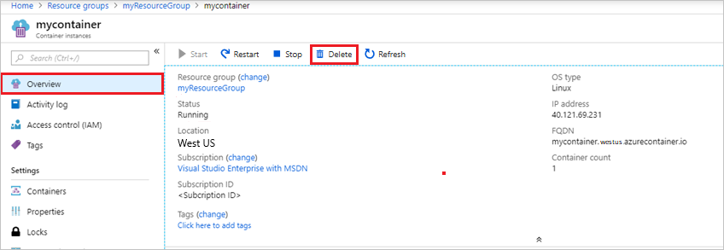

Select **Yes** when the confirmation dialog appears.

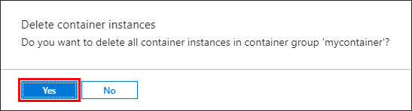

## Next steps

In this quickstart, you created an Azure container instance from a public Microsoft image. If you'd like to build a container image and deploy it from a private Azure container registry, continue to the Azure Container Instances tutorial.

[Azure Container Instances tutorial](https://docs.microsoft.com/en-us/azure/container-instances/container-instances-tutorial-prepare-app)

## Feedback

Submit and view feedback for

[This product](https://feedback.azure.com/forums/602224-azure-container-instances) [This page](https://github.com/MicrosoftDocs/azure-docs/issues/new?title=&body=%0A%0A%5BEnter%20feedback%20here%5D%0A%0A%0A---%0A%23%23%23%23%20Document%20Details%0A%0A%E2%9A%A0%20*Do%20not%20edit%20this%20section.%20It%20is%20required%20for%20docs.microsoft.com%20%E2%9E%9F%20GitHub%20issue%20linking.*%0A%0A*%20ID%3A%20196dd3fc-8ba7-5e5c-2bba-ca9f20b18e73%0A*%20Version%20Independent%20ID%3A%2087e1da3d-f013-a3d0-ffc7-fae698b68a90%0A*%20Content%3A%20%5BQuickstart%20-%20Deploy%20Docker%20container%20to%20container%20instance%20-%20Portal%20-%20Azure%20Container%20Instances%5D(https%3A%2F%2Fdocs.microsoft.com%2Fen-us%2Fazure%2Fcontainer-instances%2Fcontainer-instances-quickstart-portal)%0A*%20Content%20Source%3A%20%5Barticles%2Fcontainer-instances%2Fcontainer-instances-quickstart-portal.md%5D(https%3A%2F%2Fgithub.com%2FMicrosoftDocs%2Fazure-docs%2Fblob%2Fmaster%2Farticles%2Fcontainer-instances%2Fcontainer-instances-quickstart-portal.md)%0A*%20Service%3A%20**container-instances**%0A*%20GitHub%20Login%3A%20%40dlepow%0A*%20Microsoft%20Alias%3A%20**danlep**)

[View all page feedback](https://github.com/MicrosoftDocs/azure-docs/issues?utf8=%E2%9C%93&q=%2287e1da3d-f013-a3d0-ffc7-fae698b68a90%22&in=body)

### Is this page helpful?

 Yes  No

### In this article

1. [Sign in to Azure](https://docs.microsoft.com/en-us/azure/container-instances/container-instances-quickstart-portal#sign-in-to-azure)
2. [Create a container instance](https://docs.microsoft.com/en-us/azure/container-instances/container-instances-quickstart-portal#create-a-container-instance)
3. [View container logs](https://docs.microsoft.com/en-us/azure/container-instances/container-instances-quickstart-portal#view-container-logs)
4. [Clean up resources](https://docs.microsoft.com/en-us/azure/container-instances/container-instances-quickstart-portal#clean-up-resources)
5. [**Next steps**](https://docs.microsoft.com/en-us/azure/container-instances/container-instances-quickstart-portal#next-steps)

[English (United States)](https://docs.microsoft.com/en-us/locale?target=https://docs.microsoft.com/en-us/azure/container-instances/container-instances-quickstart-portal)

Theme

* [Previous Version Docs](https://docs.microsoft.com/en-us/previous-versions/)

* [Blog](https://docs.microsoft.com/en-us/teamblog)

* [Contribute](https://docs.microsoft.com/en-us/contribute)

* [Privacy & Cookies](https://go.microsoft.com/fwlink/?LinkId=521839)

# Quickstart: Deploy an Azure Kubernetes Service (AKS) cluster using the Azure portal

* 08/18/2020
* 6 minutes to read
  + [[https://github.com/mlearned.png?size=32](https://github.com/MicrosoftDocs/azure-docs/blob/master/articles/aks/kubernetes-walkthrough-portal.md)](https://github.com/MicrosoftDocs/azure-docs/blob/master/articles/aks/kubernetes-walkthrough-portal.md" \o "25 Contributors)

* + [[https://github.com/laurenhughes.png?size=32](https://github.com/MicrosoftDocs/azure-docs/blob/master/articles/aks/kubernetes-walkthrough-portal.md)](https://github.com/MicrosoftDocs/azure-docs/blob/master/articles/aks/kubernetes-walkthrough-portal.md" \o "25 Contributors)

* + [[https://github.com/rolyon.png?size=32](https://github.com/MicrosoftDocs/azure-docs/blob/master/articles/aks/kubernetes-walkthrough-portal.md)](https://github.com/MicrosoftDocs/azure-docs/blob/master/articles/aks/kubernetes-walkthrough-portal.md" \o "25 Contributors)

* + [[https://github.com/zr-msft.png?size=32](https://github.com/MicrosoftDocs/azure-docs/blob/master/articles/aks/kubernetes-walkthrough-portal.md)](https://github.com/MicrosoftDocs/azure-docs/blob/master/articles/aks/kubernetes-walkthrough-portal.md" \o "25 Contributors)

* + [[https://github.com/DCtheGeek.png?size=32](https://github.com/MicrosoftDocs/azure-docs/blob/master/articles/aks/kubernetes-walkthrough-portal.md)](https://github.com/MicrosoftDocs/azure-docs/blob/master/articles/aks/kubernetes-walkthrough-portal.md" \o "25 Contributors)

* + [+20](https://github.com/MicrosoftDocs/azure-docs/blob/master/articles/aks/kubernetes-walkthrough-portal.md" \o "25 Contributors)

Azure Kubernetes Service (AKS) is a managed Kubernetes service that lets you quickly deploy and manage clusters. In this quickstart, you deploy an AKS cluster using the Azure portal. A multi-container application that includes a web front end and a Redis instance is run in the cluster. You then see how to monitor the health of the cluster and pods that run your application.

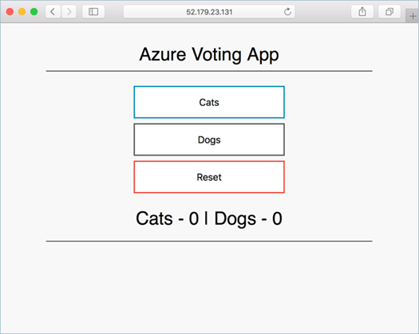

This quickstart assumes a basic understanding of Kubernetes concepts. For more information, see [Kubernetes core concepts for Azure Kubernetes Service (AKS)](https://docs.microsoft.com/en-us/azure/aks/concepts-clusters-workloads).

If you don't have an Azure subscription, create a [free account](https://azure.microsoft.com/free/?WT.mc_id=A261C142F) before you begin.

## Sign in to Azure

Sign in to the Azure portal at [https://portal.azure.com](https://portal.azure.com/).

## Create an AKS cluster

To create an AKS cluster, complete the following steps:

1. On the Azure portal menu or from the **Home** page, select **Create a resource**.
2. Select **Containers** > **Kubernetes Service**.
3. On the **Basics** page, configure the following options:
   * **Project details**: Select an Azure **Subscription**, then select or create an Azure **Resource group**, such as myResourceGroup.
   * **Cluster details**: Enter a **Kubernetes cluster name**, such as myAKSCluster. Select a **Region**, **Kubernetes version**, and **DNS name prefix** for the AKS cluster.
   * **Primary node pool**: Select a VM **Node size** for the AKS nodes. The VM size can't be changed once an AKS cluster has been deployed. - Select the number of nodes to deploy into the cluster. For this quickstart, set **Node count** to 1. Node count can be adjusted after the cluster has been deployed.

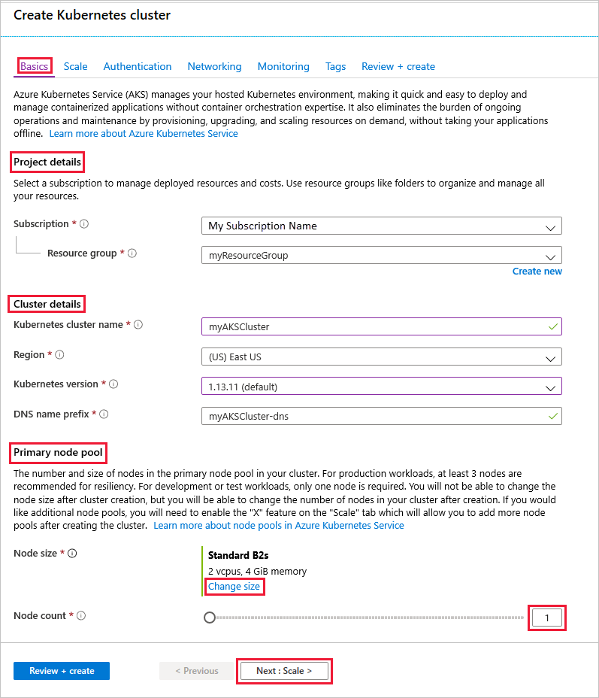

Select **Next: Scale** when complete.

1. On the **Scale** page, keep the default options. At the bottom of the screen, click **Next: Authentication**.

**Caution**

Creating new AAD Service Principals may take multiple minutes to propagate and become available causing Service Principal not found errors and validation failures in Azure portal. If you hit this please visit [**here**](https://docs.microsoft.com/en-us/azure/aks/troubleshooting#received-an-error-saying-my-service-principal-wasnt-found-or-is-invalid-when-i-try-to-create-a-new-cluster) for mitigation.

1. On the **Authentication** page, configure the following options:
   * Create a new service principal by leaving the **Service Principal** field with **(new) default service principal**. Or you can choose Configure service principal to use an existing one. If you use an existing one, you will need to provide the SPN client ID and secret.
   * Enable the option for Kubernetes role-based access control (RBAC). This will provide more fine-grained control over access to the Kubernetes resources deployed in your AKS cluster.

Alternatively, you can use a managed identity instead of a service principal. See [use managed identities](https://docs.microsoft.com/en-us/azure/aks/use-managed-identity) for more information.

By default, Basic networking is used, and Azure Monitor for containers is enabled. Click **Review + create** and then **Create** when validation completes.

It takes a few minutes to create the AKS cluster. When your deployment is complete, click **Go to resource**, or browse to the AKS cluster resource group, such as myResourceGroup, and select the AKS resource, such as myAKSCluster. The AKS cluster dashboard is shown, as in this example:

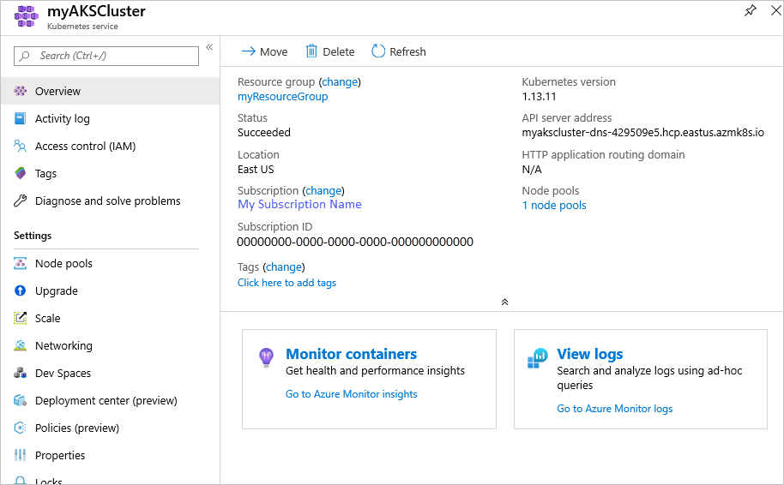

## Connect to the cluster

To manage a Kubernetes cluster, you use [kubectl](https://kubernetes.io/docs/user-guide/kubectl/), the Kubernetes command-line client. The kubectl client is pre-installed in the Azure Cloud Shell.

Open Cloud Shell using the >_ button on the top of the Azure portal.

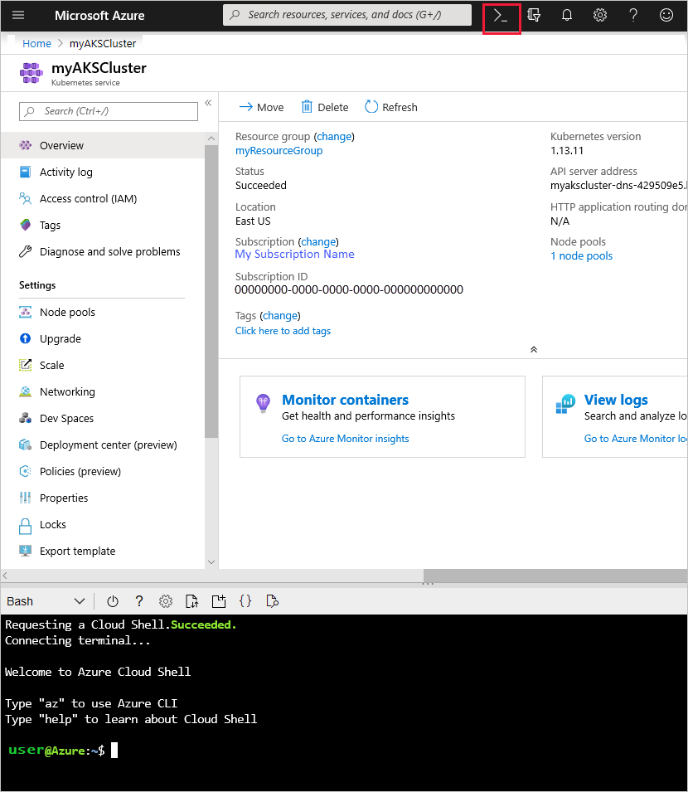

To configure kubectl to connect to your Kubernetes cluster, use the [az aks get-credentials](https://docs.microsoft.com/en-us/cli/azure/aks?view=azure-cli-latest" \l "az-aks-get-credentials) command. This command downloads credentials and configures the Kubernetes CLI to use them. The following example gets credentials for the cluster name myAKSCluster in the resource group named myResourceGroup:

Azure CLICopy

Try It

az aks get-credentials --resource-group myResourceGroup --name myAKSCluster

To verify the connection to your cluster, use the [kubectl get](https://kubernetes.io/docs/reference/generated/kubectl/kubectl-commands" \l "get) command to return a list of the cluster nodes.

ConsoleCopy

kubectl get nodes

The following example output shows the single node created in the previous steps. Make sure that the status of the node is Ready:

OutputCopy

NAME STATUS ROLES AGE VERSION

aks-agentpool-14693408-0 Ready agent 15m v1.11.5

## Run the application

A Kubernetes manifest file defines a desired state for the cluster, such as what container images to run. In this quickstart, a manifest is used to create all objects needed to run the Azure Vote application. This manifest includes two [Kubernetes deployments](https://docs.microsoft.com/en-us/azure/aks/concepts-clusters-workloads#deployments-and-yaml-manifests) - one for the sample Azure Vote Python applications, and the other for a Redis instance. Two [Kubernetes Services](https://docs.microsoft.com/en-us/azure/aks/concepts-network#services) are also created - an internal service for the Redis instance, and an external service to access the Azure Vote application from the internet.

In the Cloud Shell, use an editor to create a file named azure-vote.yaml, such as code azure-vote.yaml, nano azure-vote.yaml or vi azure-vote.yaml. Then copy in the following YAML definition:

YAMLCopy

apiVersion: apps/v1

kind: Deployment

metadata:

name: azure-vote-back

spec:

replicas: 1

selector:

matchLabels:

app: azure-vote-back

template:

metadata:

labels:

app: azure-vote-back

spec:

nodeSelector:

"beta.kubernetes.io/os": linux

containers:

- name: azure-vote-back

image: redis

resources:

requests:

cpu: 100m

memory: 128Mi

limits:

cpu: 250m

memory: 256Mi

ports:

- containerPort: 6379

name: redis

---

apiVersion: v1

kind: Service

metadata:

name: azure-vote-back

spec:

ports:

- port: 6379

selector:

app: azure-vote-back

---

apiVersion: apps/v1

kind: Deployment

metadata:

name: azure-vote-front

spec:

replicas: 1

selector:

matchLabels:

app: azure-vote-front

template:

metadata:

labels:

app: azure-vote-front

spec:

nodeSelector:

"beta.kubernetes.io/os": linux

containers:

- name: azure-vote-front

image: microsoft/azure-vote-front:v1

resources:

requests:

cpu: 100m

memory: 128Mi

limits:

cpu: 250m

memory: 256Mi

ports:

- containerPort: 80

env:

- name: REDIS

value: "azure-vote-back"

---

apiVersion: v1

kind: Service

metadata:

name: azure-vote-front

spec:

type: LoadBalancer

ports:

- port: 80

selector:

app: azure-vote-front

Deploy the application using the [kubectl apply](https://kubernetes.io/docs/reference/generated/kubectl/kubectl-commands" \l "apply) command and specify the name of your YAML manifest:

ConsoleCopy

kubectl apply -f azure-vote.yaml

The following example output shows the Deployments and Services created successfully:

OutputCopy

deployment "azure-vote-back" created

service "azure-vote-back" created

deployment "azure-vote-front" created

service "azure-vote-front" created

## Test the application

When the application runs, a Kubernetes service exposes the application front end to the internet. This process can take a few minutes to complete.

To monitor progress, use the [kubectl get service](https://kubernetes.io/docs/reference/generated/kubectl/kubectl-commands" \l "get) command with the --watch argument.

ConsoleCopy

kubectl get service azure-vote-front --watch

Initially the EXTERNAL-IP for the azure-vote-front service is shown as pending.

OutputCopy

NAME TYPE CLUSTER-IP EXTERNAL-IP PORT(S) AGE

azure-vote-front LoadBalancer 10.0.37.27 <pending> 80:30572/TCP 6s

When the EXTERNAL-IP address changes from pending to an actual public IP address, use CTRL-C to stop the kubectl watch process. The following example output shows a valid public IP address assigned to the service:

OutputCopy

azure-vote-front LoadBalancer 10.0.37.27 52.179.23.131 80:30572/TCP 2m

To see the Azure Vote app in action, open a web browser to the external IP address of your service.



## Monitor health and logs

When you created the cluster, Azure Monitor for containers was enabled. This monitoring feature provides health metrics for both the AKS cluster and pods running on the cluster.

It may take a few minutes for this data to populate in the Azure portal. To see current status, uptime, and resource usage for the Azure Vote pods, browse back to the AKS resource in the Azure portal, such as myAKSCluster. You can then access the health status as follows:

1. Under **Monitoring** on the left-hand side, choose **Insights**
2. Across the top, choose to **+ Add Filter**
3. Select Namespace as the property, then choose <All but kube-system>
4. Choose to view the **Containers**.

The azure-vote-back and azure-vote-front containers are displayed, as shown in the following example:

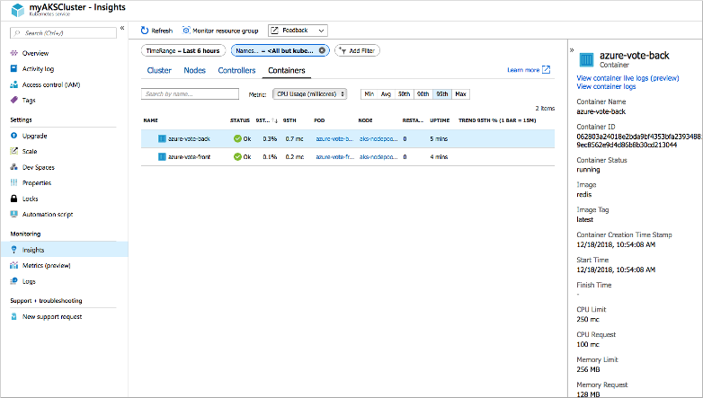

To see logs for the azure-vote-front pod, select the **View container logs** from the drop down of the containers list. These logs include the stdout and stderr streams from the container.

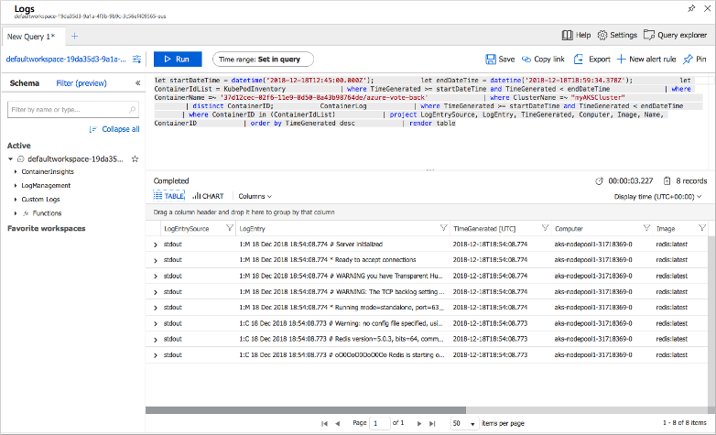

## Delete cluster

When the cluster is no longer needed, delete the cluster resource, which deletes all associated resources. This operation can be completed in the Azure portal by selecting the **Delete** button on the AKS cluster dashboard. Alternatively, the [az aks delete](https://docs.microsoft.com/en-us/cli/azure/aks" \l "az-aks-delete) command can be used in the Cloud Shell:

Azure CLICopy

Try It

az aks delete --resource-group myResourceGroup --name myAKSCluster --no-wait

**Note**

When you delete the cluster, the Azure Active Directory service principal used by the AKS cluster is not removed. For steps on how to remove the service principal, see [**AKS service principal considerations and deletion**](https://docs.microsoft.com/en-us/azure/aks/kubernetes-service-principal#additional-considerations). If you used a managed identity, the identity is managed by the platform and does not require removal.

## Get the code

In this quickstart, pre-created container images were used to create a Kubernetes deployment. The related application code, Dockerfile, and Kubernetes manifest file are available on GitHub.

[https://github.com/Azure-Samples/azure-voting-app-redis](https://github.com/Azure-Samples/azure-voting-app-redis.git)

## Next steps

In this quickstart, you deployed a Kubernetes cluster and deployed a multi-container application to it.

To learn more about AKS, and walk through a complete code to deployment example, continue to the Kubernetes cluster tutorial.

[AKS tutorial](https://docs.microsoft.com/en-us/azure/aks/tutorial-kubernetes-prepare-app)

## Feedback

Submit and view feedback for

[This product](https://feedback.azure.com/forums/914020-azure-kubernetes-service-aks) [This page](https://github.com/MicrosoftDocs/azure-docs/issues/new?title=&body=%0A%0A%5BEnter%20feedback%20here%5D%0A%0A%0A---%0A%23%23%23%23%20Document%20Details%0A%0A%E2%9A%A0%20*Do%20not%20edit%20this%20section.%20It%20is%20required%20for%20docs.microsoft.com%20%E2%9E%9F%20GitHub%20issue%20linking.*%0A%0A*%20ID%3A%20965a7faf-6684-1b1e-3570-ea0b38ce02db%0A*%20Version%20Independent%20ID%3A%202efd8393-0b5b-e827-8762-fa58d6758d93%0A*%20Content%3A%20%5BCreate%20an%20AKS%20cluster%20in%20the%20portal%20-%20Azure%20Kubernetes%20Service%5D(https%3A%2F%2Fdocs.microsoft.com%2Fen-us%2Fazure%2Faks%2Fkubernetes-walkthrough-portal)%0A*%20Content%20Source%3A%20%5Barticles%2Faks%2Fkubernetes-walkthrough-portal.md%5D(https%3A%2F%2Fgithub.com%2FMicrosoftDocs%2Fazure-docs%2Fblob%2Fmaster%2Farticles%2Faks%2Fkubernetes-walkthrough-portal.md)%0A*%20Service%3A%20**container-service**%0A*%20GitHub%20Login%3A%20%40mlearned%0A*%20Microsoft%20Alias%3A%20**mlearned**)

[View all page feedback](https://github.com/MicrosoftDocs/azure-docs/issues?utf8=%E2%9C%93&q=%222efd8393-0b5b-e827-8762-fa58d6758d93%22&in=body)

### Is this page helpful?

 Yes  No

### In this article

1. [Sign in to Azure](https://docs.microsoft.com/en-us/azure/aks/kubernetes-walkthrough-portal#sign-in-to-azure)
2. [Create an AKS cluster](https://docs.microsoft.com/en-us/azure/aks/kubernetes-walkthrough-portal#create-an-aks-cluster)
3. [Connect to the cluster](https://docs.microsoft.com/en-us/azure/aks/kubernetes-walkthrough-portal#connect-to-the-cluster)
4. [Run the application](https://docs.microsoft.com/en-us/azure/aks/kubernetes-walkthrough-portal#run-the-application)
5. [Test the application](https://docs.microsoft.com/en-us/azure/aks/kubernetes-walkthrough-portal#test-the-application)
6. [Monitor health and logs](https://docs.microsoft.com/en-us/azure/aks/kubernetes-walkthrough-portal#monitor-health-and-logs)
7. [Delete cluster](https://docs.microsoft.com/en-us/azure/aks/kubernetes-walkthrough-portal#delete-cluster)
8. [Get the code](https://docs.microsoft.com/en-us/azure/aks/kubernetes-walkthrough-portal#get-the-code)
9. [**Next steps**](https://docs.microsoft.com/en-us/azure/aks/kubernetes-walkthrough-portal#next-steps)

[English (United States)](https://docs.microsoft.com/en-us/locale?target=https://docs.microsoft.com/en-us/azure/aks/kubernetes-walkthrough-portal)

Theme

* [Previous Version Docs](https://docs.microsoft.com/en-us/previous-versions/)

* [Blog](https://docs.microsoft.com/en-us/teamblog)

* [Contribute](https://docs.microsoft.com/en-us/contribute)

* [Privacy & Cookies](https://go.microsoft.com/fwlink/?LinkId=521839)

**An introduction to Azure Functions**

* 01/16/2020
* 3 minutes to read
  + [[https://github.com/mattchenderson.png?size=32](https://github.com/MicrosoftDocs/azure-docs/blob/master/articles/azure-functions/functions-overview.md)](https://github.com/MicrosoftDocs/azure-docs/blob/master/articles/azure-functions/functions-overview.md" \o "22 Contributors)

* + [[https://github.com/mike-urnun-msft.png?size=32](https://github.com/MicrosoftDocs/azure-docs/blob/master/articles/azure-functions/functions-overview.md)](https://github.com/MicrosoftDocs/azure-docs/blob/master/articles/azure-functions/functions-overview.md" \o "22 Contributors)

* + [[https://github.com/simongottipalli.png?size=32](https://github.com/MicrosoftDocs/azure-docs/blob/master/articles/azure-functions/functions-overview.md)](https://github.com/MicrosoftDocs/azure-docs/blob/master/articles/azure-functions/functions-overview.md" \o "22 Contributors)

* + [[https://github.com/craigshoemaker.png?size=32](https://github.com/MicrosoftDocs/azure-docs/blob/master/articles/azure-functions/functions-overview.md)](https://github.com/MicrosoftDocs/azure-docs/blob/master/articles/azure-functions/functions-overview.md" \o "22 Contributors)

* + [[](https://github.com/MicrosoftDocs/azure-docs/blob/master/articles/azure-functions/functions-overview.md)](https://github.com/MicrosoftDocs/azure-docs/blob/master/articles/azure-functions/functions-overview.md" \o "22 Contributors)

* + [+17](https://github.com/MicrosoftDocs/azure-docs/blob/master/articles/azure-functions/functions-overview.md" \o "22 Contributors)

Azure Functions allows you to run small pieces of code (called "functions") without worrying about application infrastructure. With Azure Functions, the cloud infrastructure provides all the up-to-date servers you need to keep your application running at scale.

A function is "triggered" by a specific type of event. [Supported triggers](https://docs.microsoft.com/en-us/azure/azure-functions/functions-triggers-bindings) include responding to changes in data, responding to messages, running on a schedule, or as the result of an HTTP request.

While you can always code directly against a myriad of services, integrating with other services is streamlined by using bindings. Bindings give you [declarative access to a wide variety of Azure and third-party services](https://docs.microsoft.com/en-us/azure/azure-functions/functions-triggers-bindings).

**Features**

Some key features of Azure Functions include:

* **Serverless applications**: Functions allow you to develop [serverless](https://azure.microsoft.com/solutions/serverless/) applications on Microsoft Azure.
* **Choice of language**: Write functions using your choice of [C#, Java, JavaScript, Python, and PowerShell](https://docs.microsoft.com/en-us/azure/azure-functions/supported-languages).
* **Pay-per-use pricing model**: Pay only for the time spent running your code. See the Consumption hosting plan option in the [pricing section](https://docs.microsoft.com/en-us/azure/azure-functions/functions-overview#pricing).
* **Bring your own dependencies**: Functions supports NuGet and NPM, giving you access to your favorite libraries.
* **Integrated security**: Protect HTTP-triggered functions with OAuth providers such as Azure Active Directory, Facebook, Google, Twitter, and Microsoft Account.
* **Simplified integration**: Easily integrate with Azure services and software-as-a-service (SaaS) offerings.
* **Flexible development**: Set up continuous integration and deploy your code through [GitHub](https://docs.microsoft.com/en-us/azure/app-service/scripts/cli-continuous-deployment-github), [Azure DevOps Services](https://docs.microsoft.com/en-us/azure/app-service/scripts/cli-continuous-deployment-vsts), and other [supported development tools](https://docs.microsoft.com/en-us/azure/app-service/deploy-local-git).
* **Stateful serverless architecture**: Orchestrate serverless applications with [Durable Functions](https://docs.microsoft.com/en-us/azure/azure-functions/durable/durable-functions-overview).
* **Open-source**: The Functions runtime is open-source and [available on GitHub](https://github.com/azure/azure-webjobs-sdk-script).

**What can I do with Functions?**

Functions is a great solution for processing bulk data, integrating systems, working with the internet-of-things (IoT), and building simple APIs and micro-services.

A series of templates is available to get you started with key scenarios including:

* **HTTP**: Run code based on [HTTP requests](https://docs.microsoft.com/en-us/azure/azure-functions/functions-create-first-azure-function)
* **Timer**: Schedule code to [run at predefined times](https://docs.microsoft.com/en-us/azure/azure-functions/functions-create-scheduled-function)
* **Azure Cosmos DB**: Process [new and modified Azure Cosmos DB documents](https://docs.microsoft.com/en-us/azure/azure-functions/functions-create-cosmos-db-triggered-function)
* **Blob storage**: Process [new and modified Azure Storage blobs](https://docs.microsoft.com/en-us/azure/azure-functions/functions-create-storage-blob-triggered-function)
* **Queue storage**: Respond to [Azure Storage queue messages](https://docs.microsoft.com/en-us/azure/azure-functions/functions-create-storage-queue-triggered-function)
* **Event Grid**: Respond to [Azure Event Grid events via subscriptions and filters](https://docs.microsoft.com/en-us/azure/event-grid/resize-images-on-storage-blob-upload-event)
* **Event Hub**: Respond to [high-volumes of Azure Event Hub events](https://docs.microsoft.com/en-us/azure/azure-functions/functions-bindings-event-hubs)
* **Service Bus Queue**: Connect to other Azure or on-premises services by [responding Service Bus queue messages](https://docs.microsoft.com/en-us/azure/azure-functions/functions-bindings-service-bus)
* **Service Bus Topic**: Connect other Azure services or on-premises services by [responding to Service Bus topic messages](https://docs.microsoft.com/en-us/azure/azure-functions/functions-bindings-service-bus)

**How much does Functions cost?**

Azure Functions has three kinds of pricing plans. Choose the one that best fits your needs:

* **Consumption plan**: Azure provides all of the necessary computational resources. You don't have to worry about resource management, and only pay for the time that your code runs.
* **Premium plan**: You specify a number of pre-warmed instances that are always online and ready to immediately respond. When your function runs, Azure provides any additional computational resources that are needed. You pay for the pre-warmed instances running continuously and any additional instances you use as Azure scales your app in and out.
* **App Service plan**: Run your functions just like your web apps. If you use App Service for your other applications, your functions can run on the same plan at no additional cost.

For more information about hosting plans, see [Azure Functions hosting plan comparison](https://docs.microsoft.com/en-us/azure/azure-functions/functions-scale). Full pricing details are available on the [Functions Pricing page](https://azure.microsoft.com/pricing/details/functions/).

**Next Steps**

* [Create your first Azure Function](https://docs.microsoft.com/en-us/azure/azure-functions/functions-create-first-function-vs-code)  
  Get started with [Visual Studio Code](https://docs.microsoft.com/en-us/azure/azure-functions/functions-create-first-function-vs-code), the [command line](https://docs.microsoft.com/en-us/azure/azure-functions/functions-create-first-azure-function-azure-cli), or use the [Azure portal](https://docs.microsoft.com/en-us/azure/azure-functions/functions-create-first-azure-function).
* [Azure Functions developer reference](https://docs.microsoft.com/en-us/azure/azure-functions/functions-reference)  
  Provides more technical information about the Azure Functions runtime and a reference for coding functions and defining triggers and bindings.
* [How to scale Azure Functions](https://docs.microsoft.com/en-us/azure/azure-functions/functions-scale)  
  Discusses service plans available with Azure Functions, including the Consumption hosting plan, and how to choose the right plan.
* [Learn more about Azure App Service](https://docs.microsoft.com/en-us/azure/app-service/overview)  
  Azure Functions leverages Azure App Service for core functionality like deployments, environment variables, and diagnostics.

**Feedback**

**Quickstart: Create your first automated integration workflow by using Azure Logic Apps - Azure portal**

* 07/23/2020
* 7 minutes to read
  + [[https://github.com/ecfan.png?size=32](https://github.com/MicrosoftDocs/azure-docs/blob/master/articles/logic-apps/quickstart-create-first-logic-app-workflow.md)](https://github.com/MicrosoftDocs/azure-docs/blob/master/articles/logic-apps/quickstart-create-first-logic-app-workflow.md" \o "5 Contributors)

* + [[https://github.com/DCtheGeek.png?size=32](https://github.com/MicrosoftDocs/azure-docs/blob/master/articles/logic-apps/quickstart-create-first-logic-app-workflow.md)](https://github.com/MicrosoftDocs/azure-docs/blob/master/articles/logic-apps/quickstart-create-first-logic-app-workflow.md" \o "5 Contributors)

* + [[https://github.com/tfitzmac.png?size=32](https://github.com/MicrosoftDocs/azure-docs/blob/master/articles/logic-apps/quickstart-create-first-logic-app-workflow.md)](https://github.com/MicrosoftDocs/azure-docs/blob/master/articles/logic-apps/quickstart-create-first-logic-app-workflow.md" \o "5 Contributors)

* + [[https://github.com/salmanmkc.png?size=32](https://github.com/MicrosoftDocs/azure-docs/blob/master/articles/logic-apps/quickstart-create-first-logic-app-workflow.md)](https://github.com/MicrosoftDocs/azure-docs/blob/master/articles/logic-apps/quickstart-create-first-logic-app-workflow.md" \o "5 Contributors)

* + [[https://github.com/nschonni.png?size=32](https://github.com/MicrosoftDocs/azure-docs/blob/master/articles/logic-apps/quickstart-create-first-logic-app-workflow.md)](https://github.com/MicrosoftDocs/azure-docs/blob/master/articles/logic-apps/quickstart-create-first-logic-app-workflow.md" \o "5 Contributors)

This quickstart introduces the basic general concepts behind how to build your first workflow by using [Azure Logic Apps](https://docs.microsoft.com/en-us/azure/logic-apps/logic-apps-overview), such as creating a blank logic app, adding a trigger and an action, and then testing your logic app. In this quickstart, you build a logic app that regularly checks a website's RSS feed for new items. If new items exist, the logic app sends an email for each item. When you're done, your logic app looks like this workflow at a high level:



For this scenario, you need an Azure subscription or [sign up for a free Azure account](https://azure.microsoft.com/free/?WT.mc_id=A261C142F), an email account from a service that's supported by Azure Logic Apps, such as Office 365 Outlook, Outlook.com, or Gmail. For other supported email services, [review the connectors list here](https://docs.microsoft.com/en-us/connectors/). In this example, the logic app uses an Office 365 Outlook account. If you use a different email service, the overall general steps are the same, but your user interface might differ slightly.

**Important**

If you want to use the Gmail connector, only G-Suite business accounts can use this connector without restriction in logic apps. If you have a Gmail consumer account, you can use this connector with only specific Google-approved services, or you can [**create a Google client app to use for authentication with your Gmail connector**](https://docs.microsoft.com/en-us/connectors/gmail/#authentication-and-bring-your-own-application). For more information, see [**Data security and privacy policies for Google connectors in Azure Logic Apps**](https://docs.microsoft.com/en-us/azure/connectors/connectors-google-data-security-privacy-policy).

**Create your logic app**

1. Sign in to the [Azure portal](https://portal.azure.com/) with your Azure account credentials.
2. In the Azure portal search box, enter logic apps, and select **Logic Apps**.

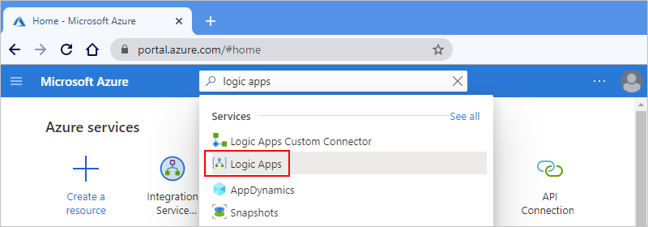

1. On the **Logic Apps** page, select **Add**.

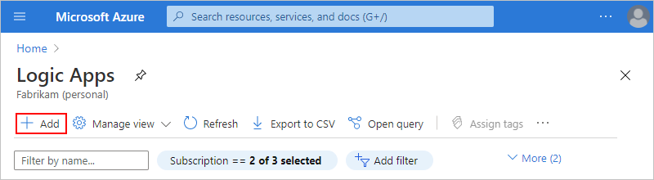

1. On the **Logic App** pane, provide details about your logic app as shown below.

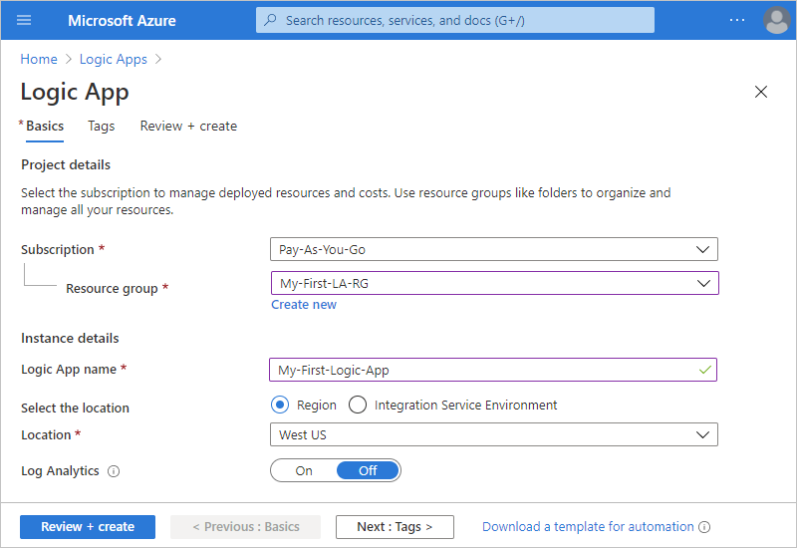

| **TABLE 1** | | |
| --- | --- | --- |
| **Property** | **Value** | **Description** |
| **Name** | <*logic-app-name*> | Your logic app's name, which must be unique across regions and can contain only letters, numbers, hyphens (-), underscores (_), parentheses ((, )), and periods (.). This example uses "My-First-Logic-App". |
| **Subscription** | <*Azure-subscription-name*> | Your Azure subscription name |
| **Resource group** | <*Azure-resource-group-name*> | The name for the [Azure resource group](https://docs.microsoft.com/en-us/azure/azure-resource-manager/management/overview), which must be unique across regions and is used to organize related resources. This example uses "My-First-LA-RG". |
| **Location** | <*Azure-region*> | The region where to store your logic app information. This example uses "West US". |
| **Log Analytics** | Off | Keep the **Off** setting for diagnostic logging. |
|  |  |  |

1. When you're ready, select **Review + Create**. Confirm the details that you provided, and select **Create**.
2. After Azure successfully deploys your app, select **Go to resource**.

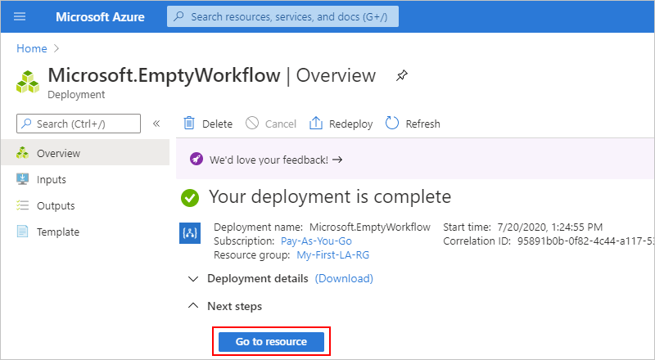

Or, you can find and select your logic app by typing the name in the search box.

The Logic Apps Designer opens and shows a page with an introduction video and commonly used triggers. Under **Templates**, select **Blank Logic App**.

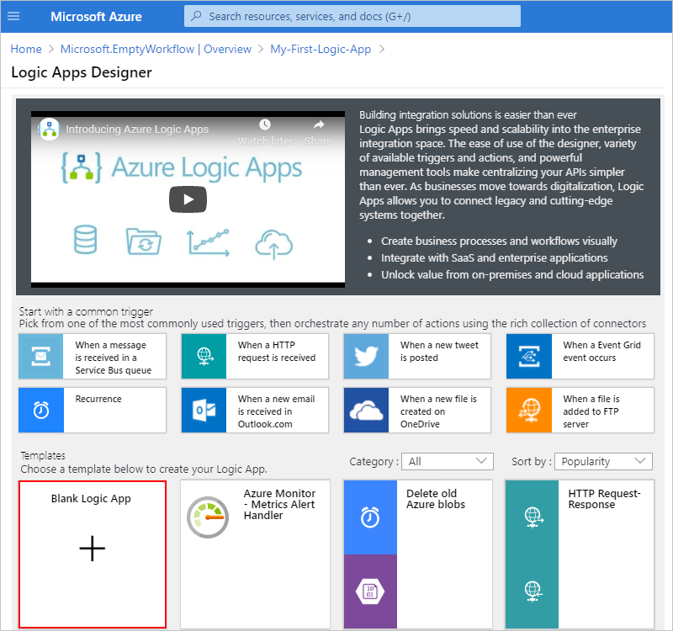

Next, add a [trigger](https://docs.microsoft.com/en-us/azure/logic-apps/logic-apps-overview#logic-app-concepts) that fires when a new RSS feed item appears. Every logic app must start with a trigger, which fires when a specific event happens or when a specific condition is met. Each time the trigger fires, the Azure Logic Apps engine creates a logic app instance that starts and runs your workflow.

**Add the RSS trigger**

1. In the **Logic App Designer**, under the search box, select **All**.
2. To find the RSS connector, in the search box, enter rss. From the triggers list, select the RSS trigger, **When a feed item is published**.

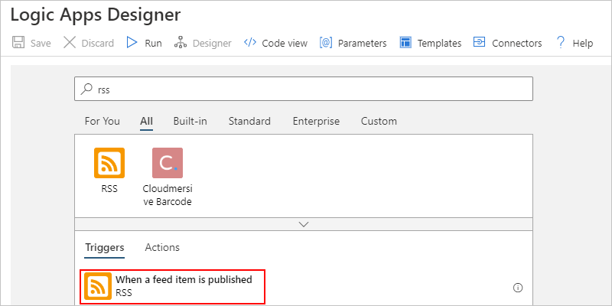

1. Provide the information for your trigger as described in this step:

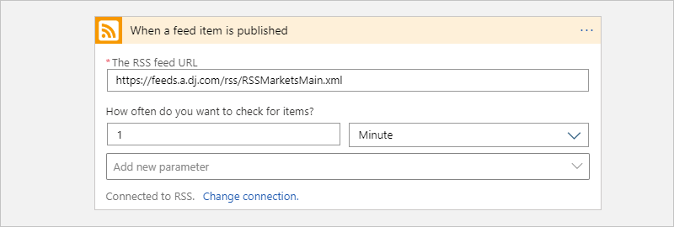

| **TABLE 2** | | |
| --- | --- | --- |
| **Property** | **Value** | **Description** |
| **The RSS feed URL** | <*RSS-feed-URL*> | The link for the RSS feed that you want to monitor. This example uses the Wall Street Journal's RSS feed at https://feeds.a.dj.com/rss/RSSMarketsMain.xml, but if you want, you can use your own RSS feed URL. |
| **Interval** | 1 | The number of intervals to wait between checks |
| **Frequency** | Minute | The unit of time for each interval between checks |
|  |  |  |

Together, the interval and frequency define the schedule for your logic app's trigger. This logic app checks the feed every minute.

1. To collapse the trigger details for now, click inside the trigger's title bar.



1. Save your logic app. On the designer toolbar, select **Save**.

Your logic app is now live but doesn't do anything other than check the RSS feed. So, add an action that responds when the trigger fires.

**Add the "send email" action**

Now add an [action](https://docs.microsoft.com/en-us/azure/logic-apps/logic-apps-overview#logic-app-concepts) that sends an email when a new item appears in the RSS feed.

1. Under the **When a feed item is published** trigger, select **New step**.

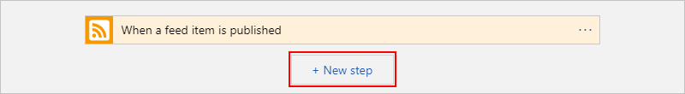

1. Under **Choose an action** and the search box, select **All**.
2. In the search box, enter send an email so that you can find connectors that offer this action. To filter the actions list to a specific app or service, you can select that app or service first.

For example, if you're using a Microsoft work or school account and want to use Office 365 Outlook, select **Office 365 Outlook**. Or, if you're using a personal Microsoft account, you can select Outlook.com. This example continues with Office 365 Outlook:

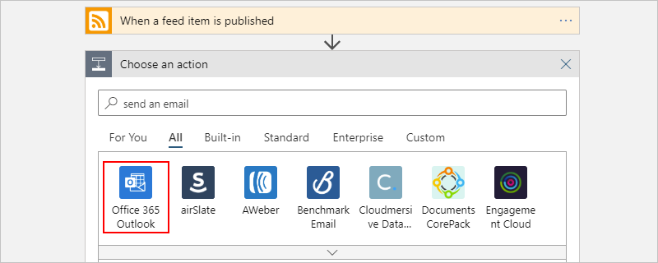

You can now more easily find and select the action that you want to use, for example, send an email:

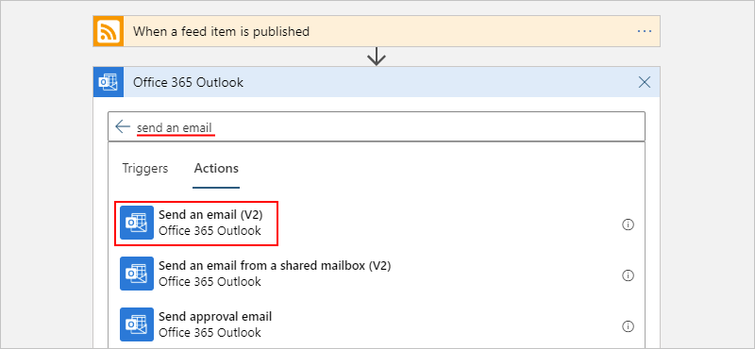

1. If your selected email connector prompts you to authenticate your identity, complete that step now to create a connection between your logic app and your email service.

**Note**

In this specific example, you manually authenticate your identity. However, connectors that require authentication differ in the authentication types that they support. You also have options to set up the way that you want to handle authentication. For example, when you use Azure Resource Manager templates for deployment, you can parameterize and improve security on inputs that you want to change often or easily, such as connection information. For more information, see these topics:

* + [**Template parameters for deployment**](https://docs.microsoft.com/en-us/azure/logic-apps/logic-apps-azure-resource-manager-templates-overview#template-parameters)
  + [**Authorize OAuth connections**](https://docs.microsoft.com/en-us/azure/logic-apps/logic-apps-deploy-azure-resource-manager-templates#authorize-oauth-connections)
  + [**Authenticate access with managed identities**](https://docs.microsoft.com/en-us/azure/logic-apps/create-managed-service-identity)
  + [**Authenticate connections for logic app deployment**](https://docs.microsoft.com/en-us/azure/logic-apps/logic-apps-azure-resource-manager-templates-overview#authenticate-connections)

1. In the **Send an email** action, specify the information to include in the email.
   * In the **To** box, enter the recipient's email address. For testing purposes, you can use your email address.

For now, ignore the **Add dynamic content** list that appears. When you click inside some edit boxes, this list appears and shows any available outputs from the previous step that you can use as inputs for the current action.

* + In the **Subject** box, enter this text with a trailing blank space: New RSS item:

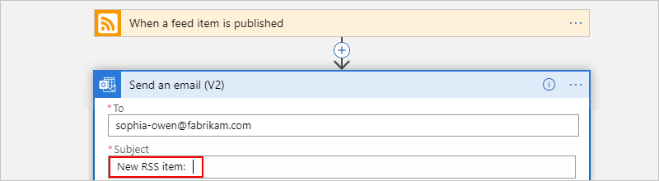

* + From the **Add dynamic content** list, select **Feed title**, which is output from the trigger, "When a feed item is published", that makes the RSS item title available for you to use.

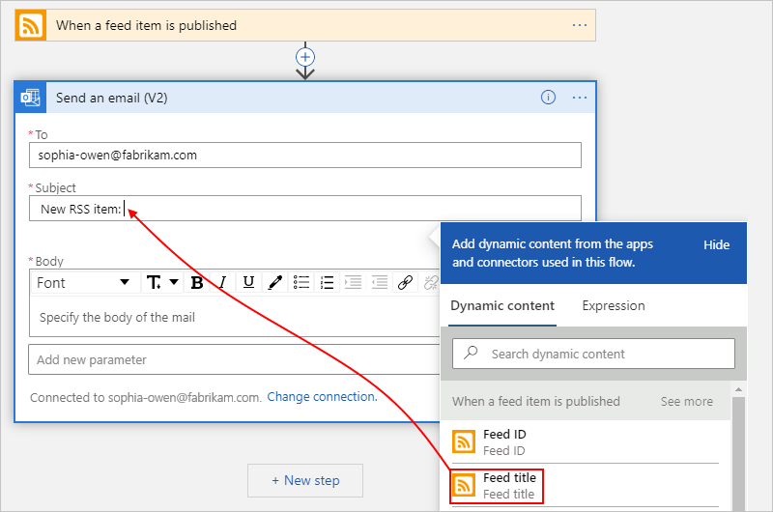

**Tip**

In the dynamic content list, if no outputs appear from the "When a feed item is published" trigger, next to the action's header, select **See more**.

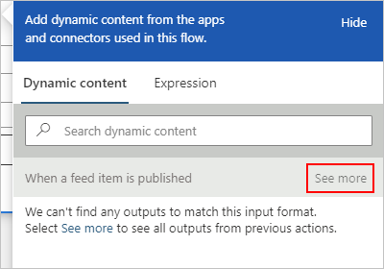

When you're done, the email subject looks like this example:

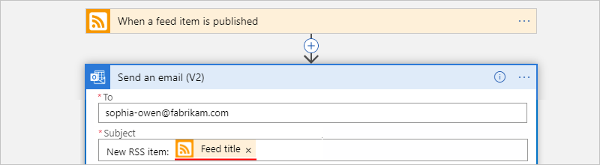

If a "For each" loop appears on the designer, then you selected a token for an array, for example, the **categories-Item** token. For these kinds of tokens, the designer automatically adds this loop around the action that references that token. That way, your logic app performs the same action on each array item. To remove the loop, select the **ellipses** (**...**) on the loop's title bar, then select **Delete**.

* + In the **Body** box, enter this text, and select these tokens for the email body. To add blank lines in an edit box, press Shift + Enter.

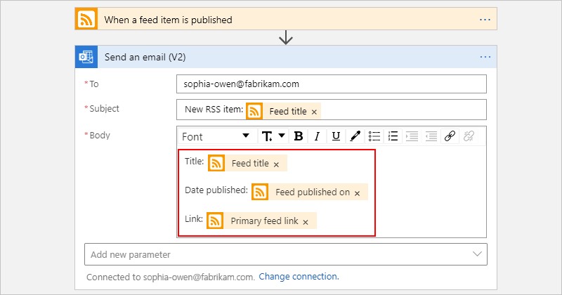

| **TABLE 3** | |
| --- | --- |
| **Property** | **Description** |
| **Feed title** | The item's title |
| **Feed published on** | The item's publishing date and time |
| **Primary feed link** | The URL for the item |
|  |  |

1. Save your logic app.

Next, test your logic app.

**Run your logic app**

To manually start your logic app, on the designer toolbar bar, select **Run**. Or, wait for your logic app to check the RSS feed based on your specified schedule (every minute).

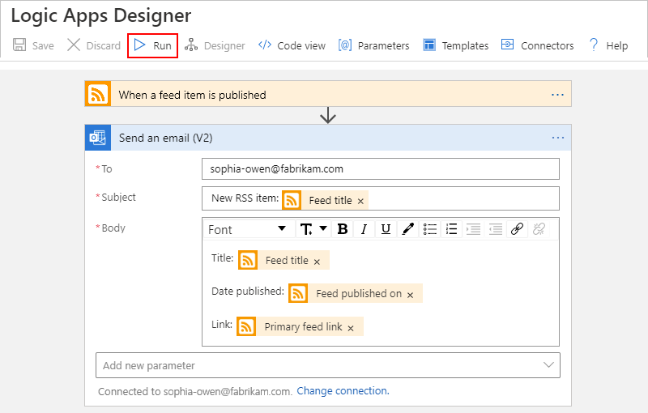

If the RSS feed has new items, your logic app sends an email for each new item. Otherwise, your logic app waits until the next interval before checking again. If you don't get any emails, check your junk email folder.

For example, here is a sample email that this logic app sends.

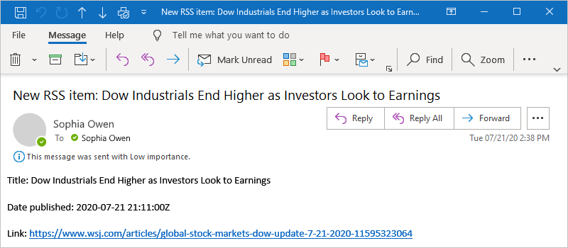

Technically, when the trigger checks the RSS feed and finds new items, the trigger fires, and the Azure Logic Apps engine creates an instance of your logic app workflow that runs the actions in the workflow. If the trigger doesn't find new items, the trigger doesn't fire and "skips" instantiating the workflow.

Congratulations, you've now successfully built and run your first logic app with the Azure portal.

**Clean up resources**

When you no longer need this sample, delete the resource group that contains your logic app and related resources.

1. In the Azure search box, enter resource groups, and then select **Resource groups**.

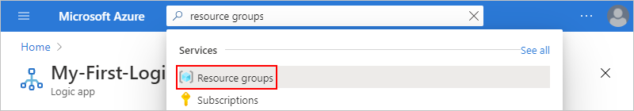

1. Find and select your logic app's resource group. On the **Overview** pane, select **Delete resource group**.

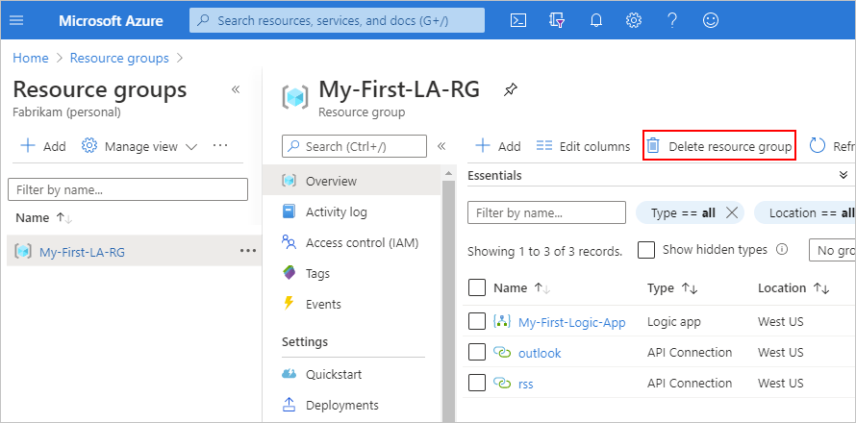

1. When the confirmation pane appears, enter the resource group name, and select **Delete**.

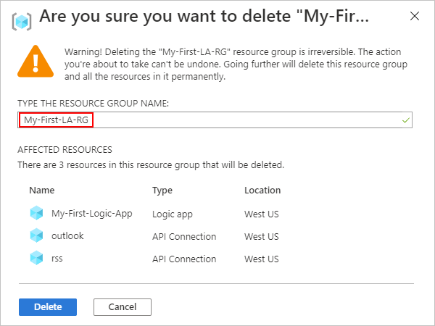

**Note**

When you delete a logic app, no new runs are instantiated. All in-progress and pending runs are canceled. If you have thousands of runs, cancellation might take significant time to complete.

**Next steps**

In this quickstart, you created your first logic app that checks for RSS updates based your specified schedule (every minute), and takes action (sends email) when updates exist. To learn more, continue with this tutorial that creates more advanced schedule-based workflows:

[Check traffic with a scheduled-based logic app](https://docs.microsoft.com/en-us/azure/logic-apps/tutorial-build-schedule-recurring-logic-app-workflow)

**Feedback**

Submit and view feedback for

# Quickstart: Route Blob storage events to web endpoint with the Azure portal

* 07/07/2020
* 5 minutes to read
  + [[https://github.com/spelluru.png?size=32](https://github.com/MicrosoftDocs/azure-docs/blob/master/articles/event-grid/blob-event-quickstart-portal.md)](https://github.com/MicrosoftDocs/azure-docs/blob/master/articles/event-grid/blob-event-quickstart-portal.md" \o "11 Contributors)

* + [[https://github.com/TimShererWithAquent.png?size=32](https://github.com/MicrosoftDocs/azure-docs/blob/master/articles/event-grid/blob-event-quickstart-portal.md)](https://github.com/MicrosoftDocs/azure-docs/blob/master/articles/event-grid/blob-event-quickstart-portal.md" \o "11 Contributors)

* + [[https://github.com/bandersmsft.png?size=32](https://github.com/MicrosoftDocs/azure-docs/blob/master/articles/event-grid/blob-event-quickstart-portal.md)](https://github.com/MicrosoftDocs/azure-docs/blob/master/articles/event-grid/blob-event-quickstart-portal.md" \o "11 Contributors)

* + [[https://github.com/v-hearya.png?size=32](https://github.com/MicrosoftDocs/azure-docs/blob/master/articles/event-grid/blob-event-quickstart-portal.md)](https://github.com/MicrosoftDocs/azure-docs/blob/master/articles/event-grid/blob-event-quickstart-portal.md" \o "11 Contributors)

* + [[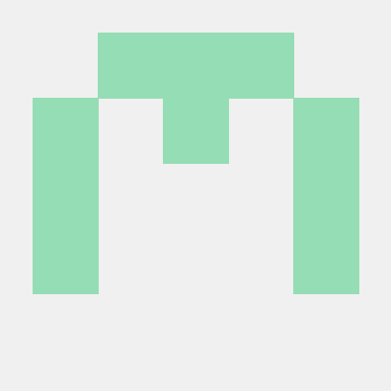](https://github.com/MicrosoftDocs/azure-docs/blob/master/articles/event-grid/blob-event-quickstart-portal.md)](https://github.com/MicrosoftDocs/azure-docs/blob/master/articles/event-grid/blob-event-quickstart-portal.md" \o "11 Contributors)

* + [+6](https://github.com/MicrosoftDocs/azure-docs/blob/master/articles/event-grid/blob-event-quickstart-portal.md" \o "11 Contributors)

Azure Event Grid is an eventing service for the cloud. In this article, you use the Azure portal to create a Blob storage account, subscribe to events for that blob storage, and trigger an event to view the result. Typically, you send events to an endpoint that processes the event data and takes actions. However, to simplify this article, you send the events to a web app that collects and displays the messages.

If you don't have an [Azure subscription](https://docs.microsoft.com/en-us/azure/guides/developer/azure-developer-guide#understanding-accounts-subscriptions-and-billing), create a [free account](https://azure.microsoft.com/free/?ref=microsoft.com&utm_source=microsoft.com&utm_medium=docs&utm_campaign=visualstudio) before you begin.

When you're finished, you see that the event data has been sent to the web app.

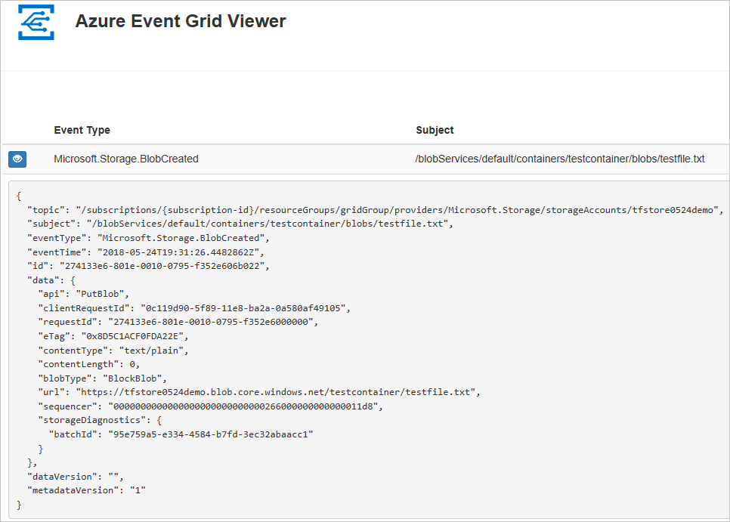

## Create a storage account

1. Sign in to [Azure portal](https://portal.azure.com/).
2. To create a Blob storage, select **Create a resource**.
3. Select for **Storage** to filter the available options, and select **Storage account - blob, file, table, queue**.

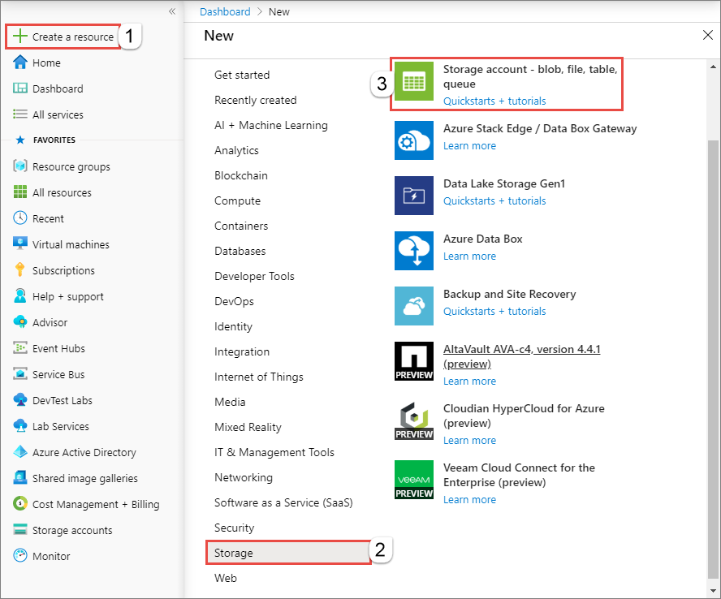

To subscribe to events, create either a general-purpose v2 storage account or a Blob storage account.

1. On the **Create storage account** page, do the following steps:
   1. Select your Azure subscription.
   2. For **Resource group**, create a new resource group or select an existing one.
   3. Enter the name for your storage account.
   4. Select **Review + create**.

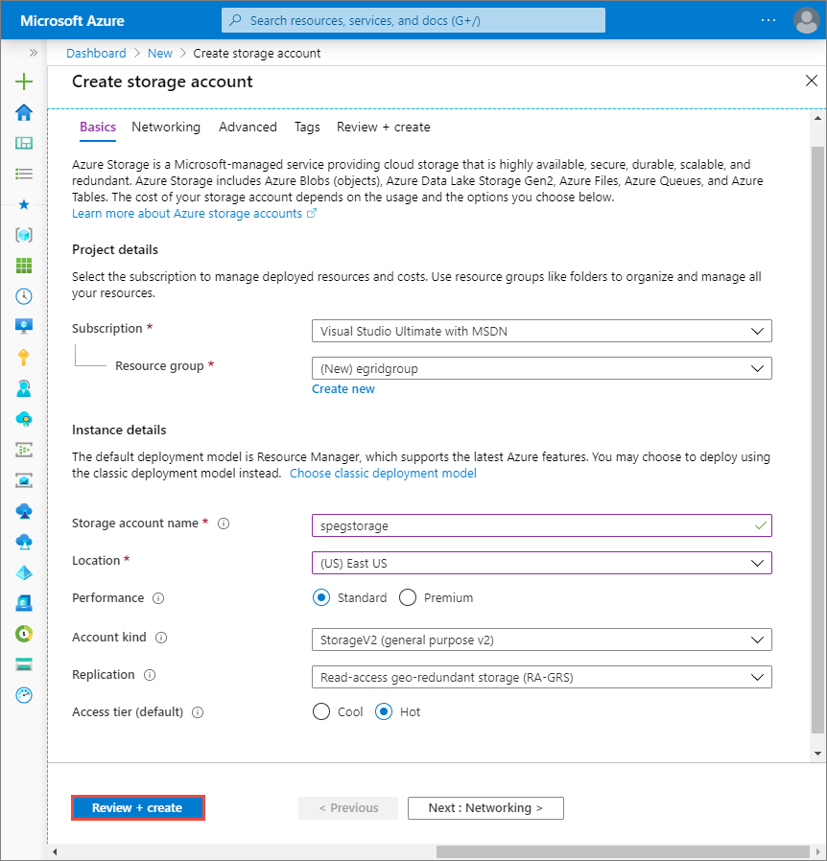

* 1. On the **Review + create** page, review the settings, and select **Create**.

**Note**

Only storage accounts of kind **StorageV2 (general purpose v2)** and **BlobStorage** support event integration. **Storage (genral purpose v1)** does not support integration with Event Grid.

## Create a message endpoint

Before subscribing to the events for the Blob storage, let's create the endpoint for the event message. Typically, the endpoint takes actions based on the event data. To simplify this quickstart, you deploy a [pre-built web app](https://github.com/Azure-Samples/azure-event-grid-viewer) that displays the event messages. The deployed solution includes an App Service plan, an App Service web app, and source code from GitHub.

1. Select **Deploy to Azure** to deploy the solution to your subscription.

[Button to Deploy to Aquent.](https://portal.azure.com/#create/Microsoft.Template/uri/https%3A%2F%2Fraw.githubusercontent.com%2FAzure-Samples%2Fazure-event-grid-viewer%2Fmaster%2Fazuredeploy.json)

1. On the **Custom deployment** page, do the following steps:
   1. For **Resource group**, select the resource group that you created when creating the storage account. It will be easier for you to clean up after you are done with the tutorial by deleting the resource group.
   2. For **Site Name**, enter a name for the web app.
   3. For **Hosting plan name**, enter a name for the App Service plan to use for hosting the web app.
   4. Select the check box for **I agree to the terms and conditions stated above**.
   5. Select **Purchase**.

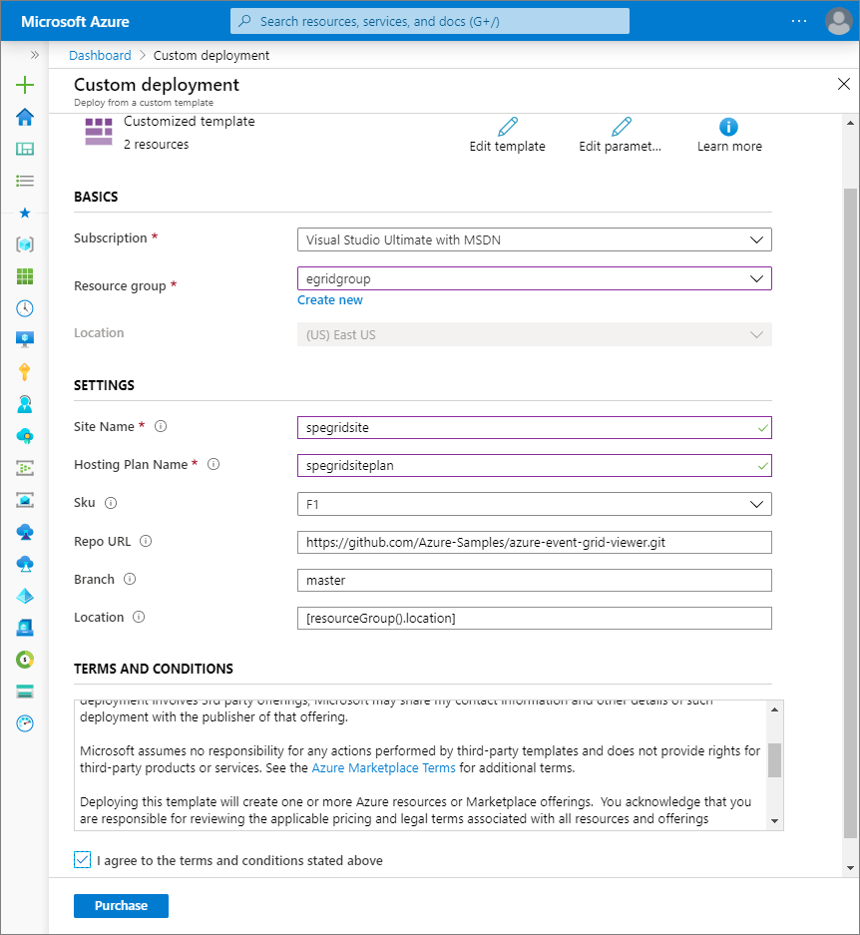

1. The deployment may take a few minutes to complete. Select Alerts (bell icon) in the portal, and then select **Go to resource group**.

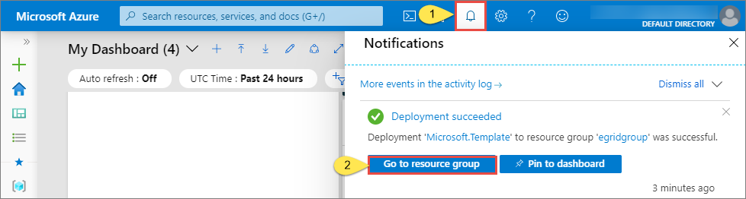

1. On the **Resource group** page, in the list of resources, select the web app that you created. You also see the App Service plan and the storage account in this list.

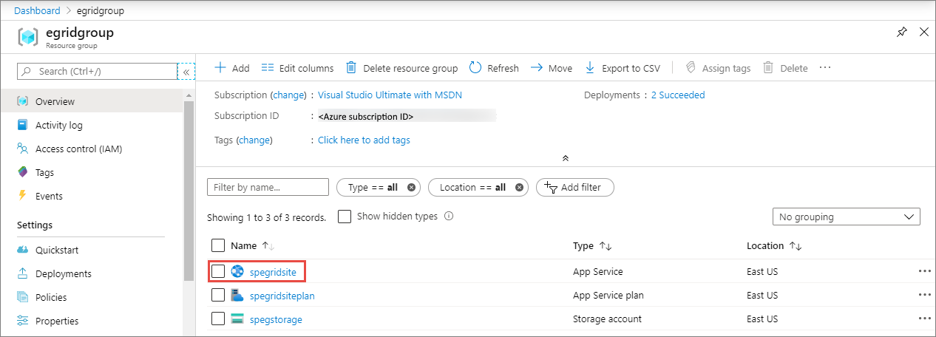

1. On the **App Service** page for your web app, select the URL to navigate to the web site. The URL should be in this format: https://<your-site-name>.azurewebsites.net.

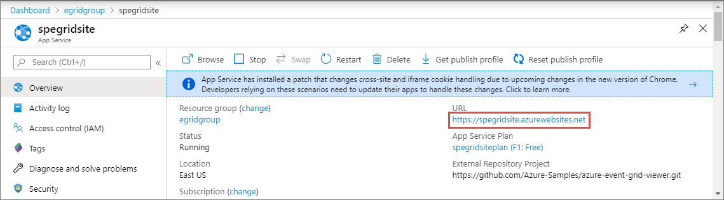

1. Confirm that you see the site but no events have been posted to it yet.

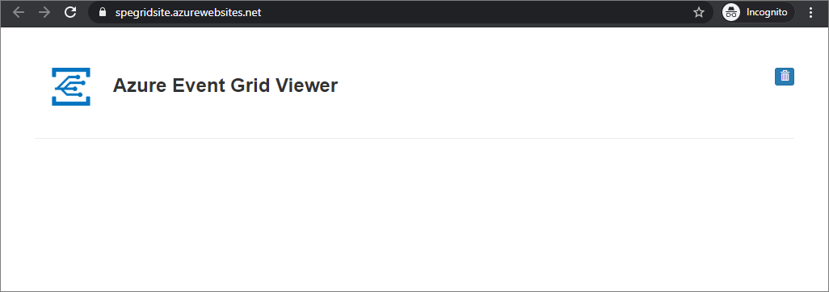

## Enable Event Grid resource provider

If you haven't previously used Event Grid in your Azure subscription, you may need to register the Event Grid resource provider.

In the Azure portal:

1. Select **Subscriptions** on the left menu.
2. Select the subscription you're using for Event Grid.
3. On the left menu, under **Settings**, select **Resource providers**.
4. Find **Microsoft.EventGrid**.
5. If not registered, select **Register**.

It may take a moment for the registration to finish. Select **Refresh** to update the status. When **Status** is **Registered**, you're ready to continue.

## Subscribe to the Blob storage

You subscribe to a topic to tell Event Grid which events you want to track, and where to send the events.

1. In the portal, navigate to your Azure Storage account that you created earlier. On the left menu, select **All resources** and select your storage account.
2. On the **Storage account** page, select **Events** on the left menu.
3. Select **More Options**, and **Web Hook**. You are sending events to your viewer app using a web hook for the endpoint.

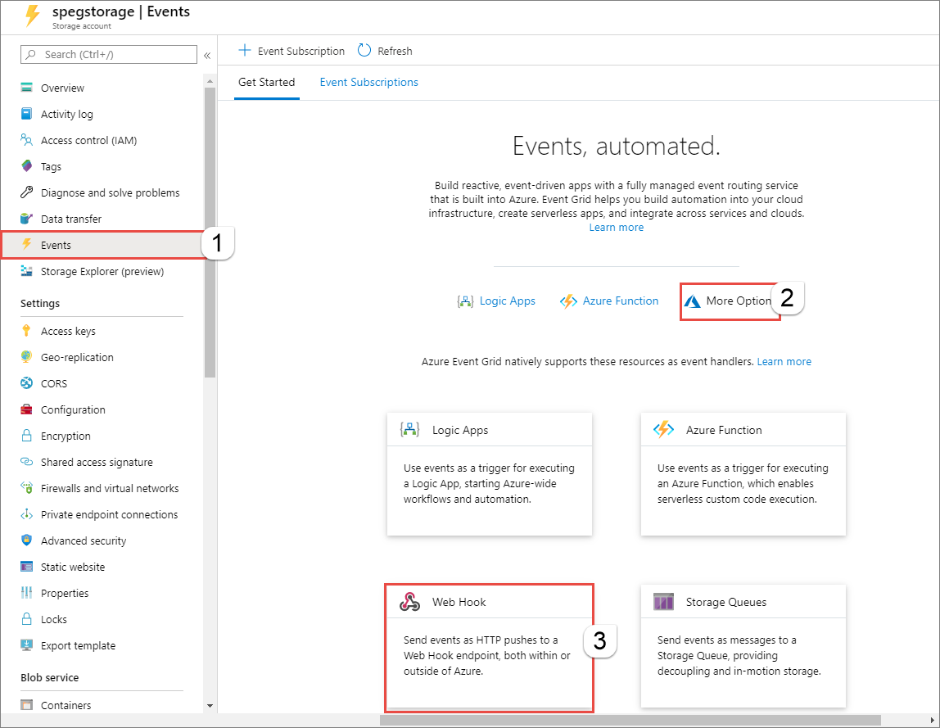

1. On the **Create Event Subscription** page, do the following steps:
   1. Enter a **name** for the event subscription.
   2. Enter a **name** for the **system topic**. To learn about system topics, see [Overview of system topics](https://docs.microsoft.com/en-us/azure/event-grid/system-topics).

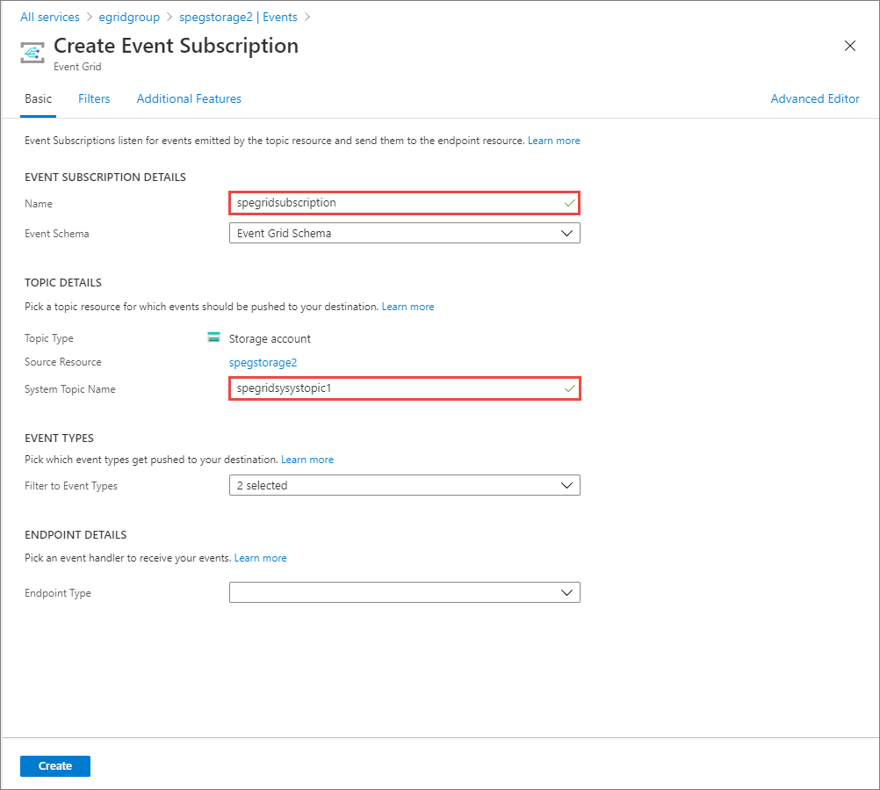

* 1. Select **Web Hook** for **Endpoint type**.

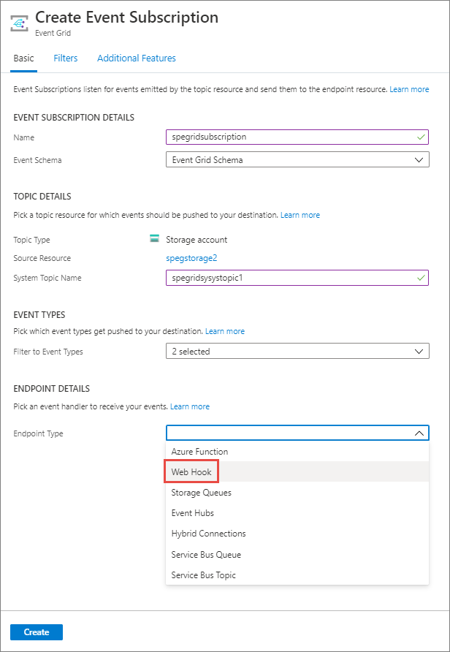

1. For **Endpoint**, click **Select an endpoint**, and enter the URL of your web app and add api/updates to the home page URL (for example: https://spegridsite.azurewebsites.net/api/updates), and then select **Confirm Selection**.

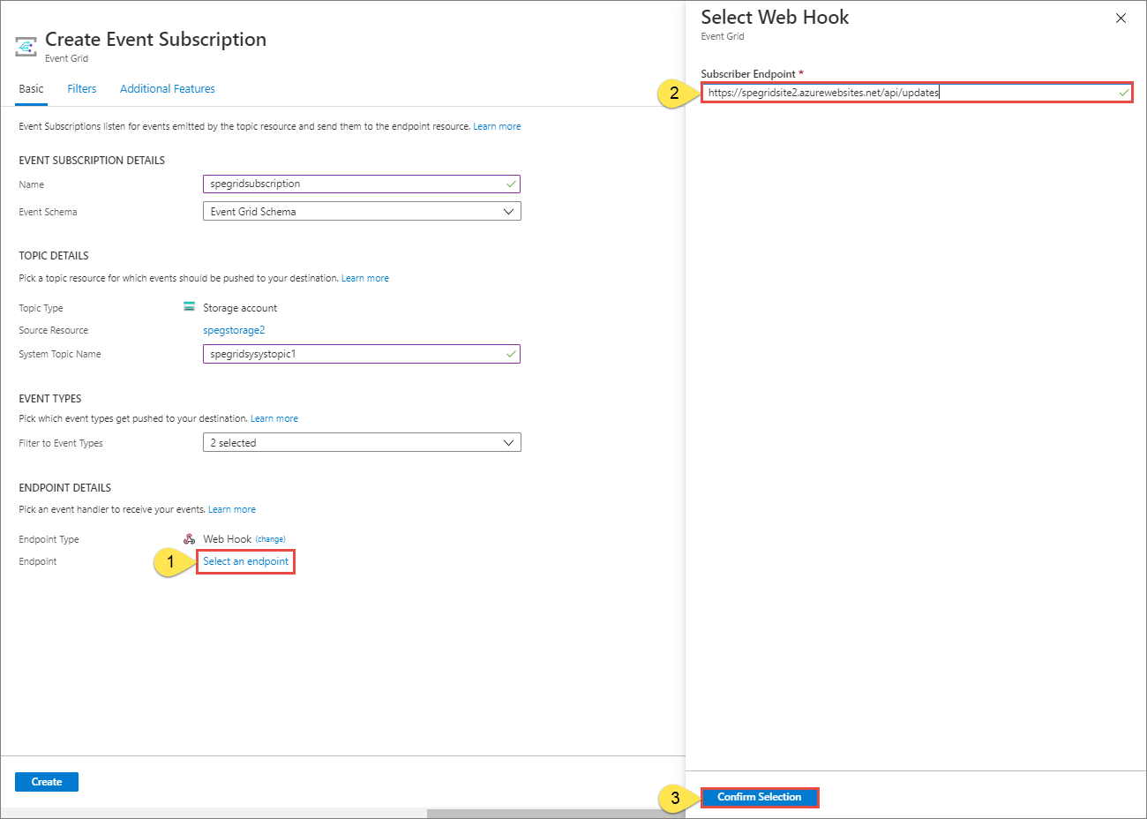

1. Now, on the **Create Event Subscription** page, select **Create** to create the event subscription.

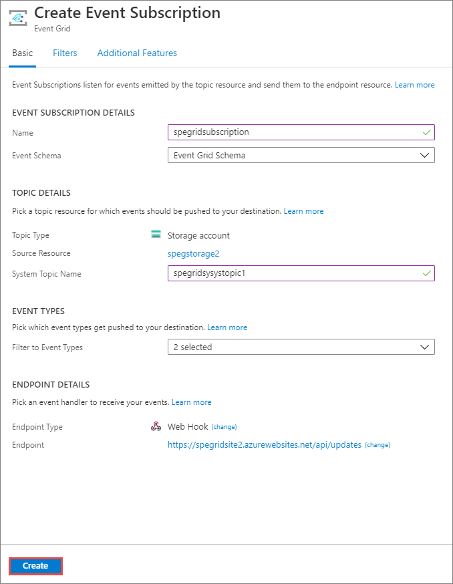

1. View your web app again, and notice that a subscription validation event has been sent to it. Select the eye icon to expand the event data. Event Grid sends the validation event so the endpoint can verify that it wants to receive event data. The web app includes code to validate the subscription.

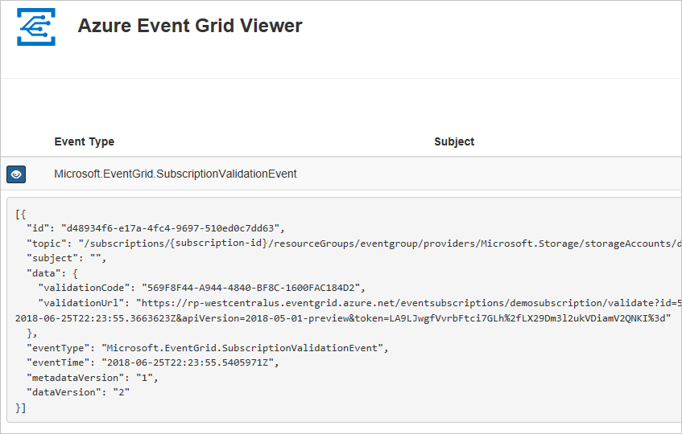

Now, let's trigger an event to see how Event Grid distributes the message to your endpoint.

## Send an event to your endpoint

You trigger an event for the Blob storage by uploading a file. The file doesn't need any specific content. The articles assumes you have a file named testfile.txt, but you can use any file.

1. In the Azure portal, navigate to your Blob storage account, and select **Containers** on the **Overview** page.

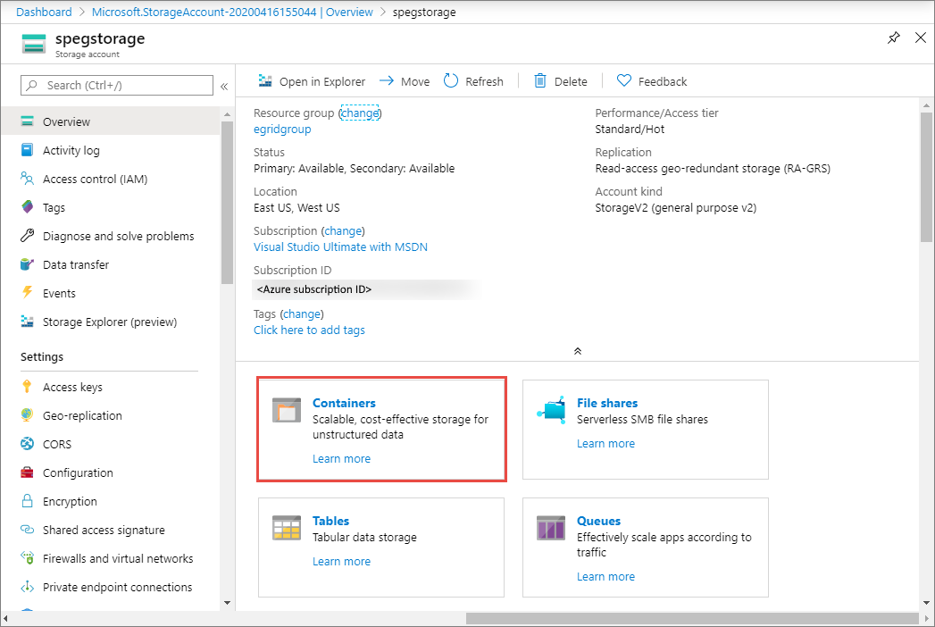

1. Select **+ Container**. Give you container a name, and use any access level, and select **Create**.

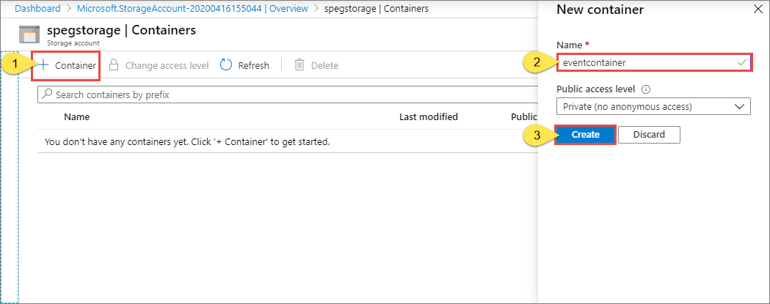

1. Select your new container.

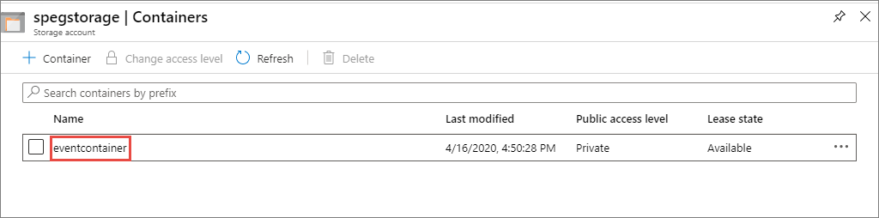

1. To upload a file, select **Upload**. On the **Upload blob** page, browse and select a file that you want to upload for testing, and then select **Upload** on that page.

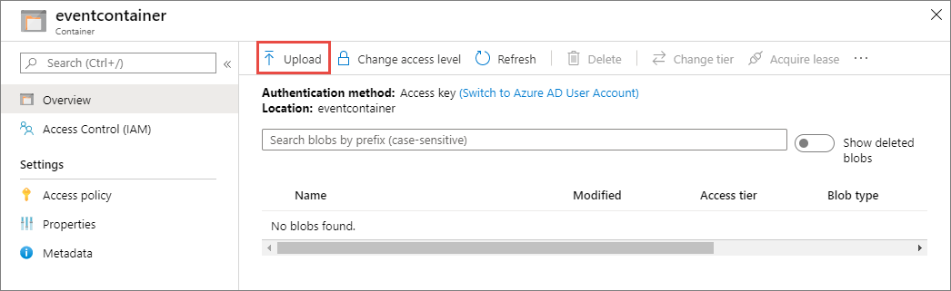

1. Browse to your test file and upload it.
2. You've triggered the event, and Event Grid sent the message to the endpoint you configured when subscribing. The message is in the JSON format and it contains an array with one or more events. In the following example, the JSON message contains an array with one event. View your web app and notice that a **blob created** event was received.

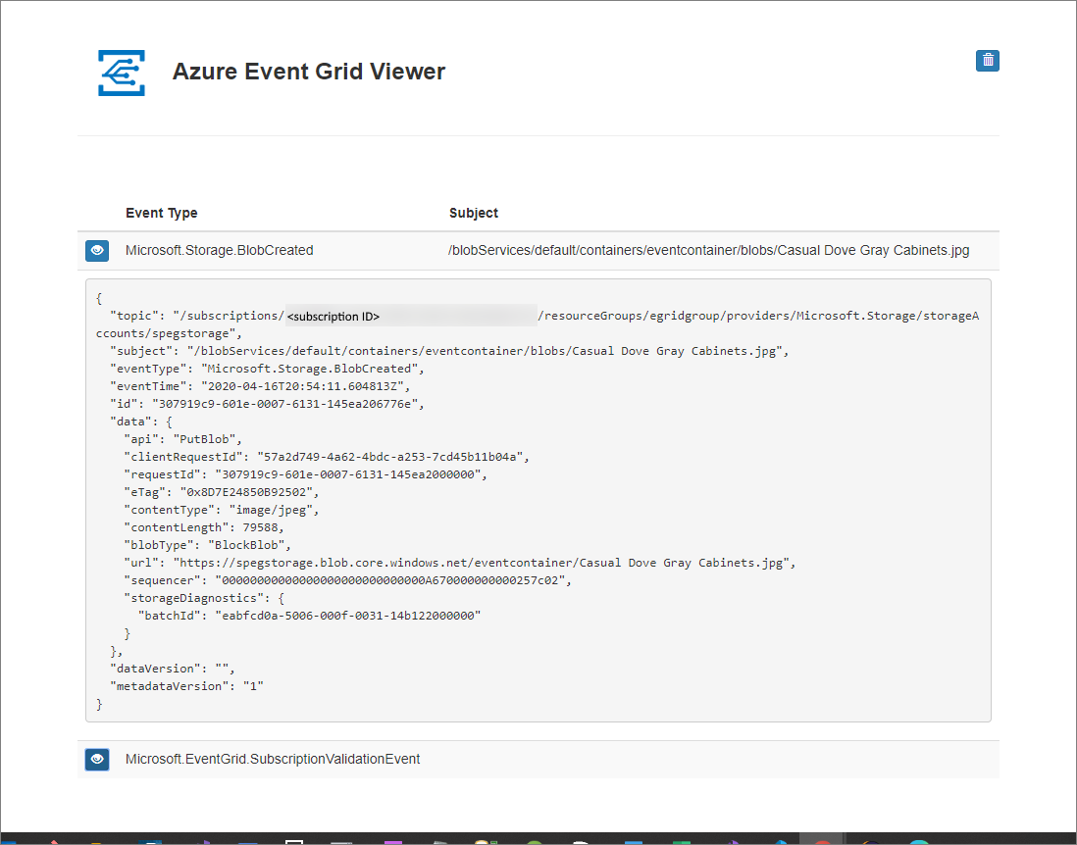

## Clean up resources

If you plan to continue working with this event, don't clean up the resources created in this article. Otherwise, delete the resources you created in this article.

Select the resource group, and select **Delete resource group**.

## Next steps

Now that you know how to create custom topics and event subscriptions, learn more about what Event Grid can help you do:

* [About Event Grid](https://docs.microsoft.com/en-us/azure/event-grid/overview)
* [Route Blob storage events to a custom web endpoint](https://docs.microsoft.com/en-us/azure/storage/blobs/storage-blob-event-quickstart?toc=/azure/event-grid/toc.json)
* [Monitor virtual machine changes with Azure Event Grid and Logic Apps](https://docs.microsoft.com/en-us/azure/event-grid/monitor-virtual-machine-changes-event-grid-logic-app)
* [Stream big data into a data warehouse](https://docs.microsoft.com/en-us/azure/event-grid/event-grid-event-hubs-integration)

## Feedback

Submit and view feedback for

[This product](https://feedback.azure.com/forums/34192--general-feedback) [This page](https://github.com/MicrosoftDocs/azure-docs/issues/new?title=&body=%0A%0A%5BEnter%20feedback%20here%5D%0A%0A%0A---%0A%23%23%23%23%20Document%20Details%0A%0A%E2%9A%A0%20*Do%20not%20edit%20this%20section.%20It%20is%20required%20for%20docs.microsoft.com%20%E2%9E%9F%20GitHub%20issue%20linking.*%0A%0A*%20ID%3A%20b250ca39-0ba3-20dc-179b-c5a0d80fba9f%0A*%20Version%20Independent%20ID%3A%205f1d000e-c731-4b98-8eb7-55836829ca47%0A*%20Content%3A%20%5BQuickstart%3A%20Send%20Blob%20storage%20events%20to%20web%20endpoint%20-%20portal%20-%20Azure%20Event%20Grid%5D(https%3A%2F%2Fdocs.microsoft.com%2Fen-us%2Fazure%2Fevent-grid%2Fblob-event-quickstart-portal)%0A*%20Content%20Source%3A%20%5Barticles%2Fevent-grid%2Fblob-event-quickstart-portal.md%5D(https%3A%2F%2Fgithub.com%2FMicrosoftDocs%2Fazure-docs%2Fblob%2Fmaster%2Farticles%2Fevent-grid%2Fblob-event-quickstart-portal.md)%0A*%20Service%3A%20**event-grid**%0A*%20GitHub%20Login%3A%20%40spelluru%0A*%20Microsoft%20Alias%3A%20**spelluru**)

[View all page feedback](https://github.com/MicrosoftDocs/azure-docs/issues?utf8=%E2%9C%93&q=%225f1d000e-c731-4b98-8eb7-55836829ca47%22&in=body)

### Is this page helpful?

 Yes  No

### In this article

1. [Create a storage account](https://docs.microsoft.com/en-us/azure/event-grid/blob-event-quickstart-portal#create-a-storage-account)
2. [Create a message endpoint](https://docs.microsoft.com/en-us/azure/event-grid/blob-event-quickstart-portal#create-a-message-endpoint)
3. [Enable Event Grid resource provider](https://docs.microsoft.com/en-us/azure/event-grid/blob-event-quickstart-portal#enable-event-grid-resource-provider)
4. [Subscribe to the Blob storage](https://docs.microsoft.com/en-us/azure/event-grid/blob-event-quickstart-portal#subscribe-to-the-blob-storage)
5. [Send an event to your endpoint](https://docs.microsoft.com/en-us/azure/event-grid/blob-event-quickstart-portal#send-an-event-to-your-endpoint)
6. [Clean up resources](https://docs.microsoft.com/en-us/azure/event-grid/blob-event-quickstart-portal#clean-up-resources)
7. [**Next steps**](https://docs.microsoft.com/en-us/azure/event-grid/blob-event-quickstart-portal#next-steps)

[English (United States)](https://docs.microsoft.com/en-us/locale?target=https://docs.microsoft.com/en-us/azure/event-grid/blob-event-quickstart-portal)

Theme

* [Previous Version Docs](https://docs.microsoft.com/en-us/previous-versions/)

* [Blog](https://docs.microsoft.com/en-us/teamblog)

* [Contribute](https://docs.microsoft.com/en-us/contribute)

* [Privacy & Cookies](https://go.microsoft.com/fwlink/?LinkId=521839)

* [Terms of Use](https://docs.microsoft.com/en-us/legal/termsofuse)