CERTIFICATE OF TRANSLATION

I, Inesa Zakaryan , am competent to translate from
(name of translator)

Armenian into English and certify that the translation of
(language)

“Testimony”
(names of documents)
is true and accurate to the best of my abilities.

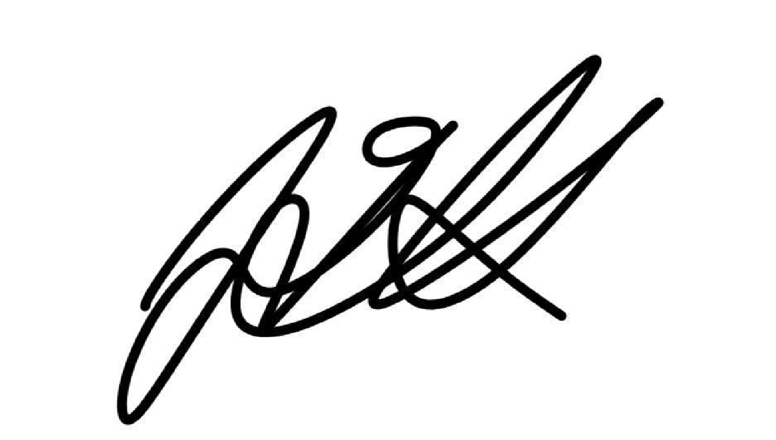
_________________ _____Inesa Zakaryan_______
(signature of translator) (typed/printed name of translator)

48 Moldovakan St, Yerevan, Armenia
(address of translator)
(+374) 94 45 52 34
(telephone number of translator)
09/20/2025
(date of translation)

