Amy’s Data Visuals Final

## Eelgrass Data Visualization

### Amy Yoger - BIOL 708

1 + 1

[1] 2

library(tidyverse)

Warning: package 'ggplot2' was built under R version 4.3.1

Warning: package 'lubridate' was built under R version 4.3.1

── Attaching core tidyverse packages ──────────────────────── tidyverse 2.0.0 ──  
✔ dplyr 1.1.3 ✔ readr 2.1.4  
✔ forcats 1.0.0 ✔ stringr 1.5.0  
✔ ggplot2 3.4.4 ✔ tibble 3.2.1  
✔ lubridate 1.9.3 ✔ tidyr 1.3.0  
✔ purrr 1.0.2   
── Conflicts ────────────────────────────────────────── tidyverse_conflicts() ──  
✖ dplyr::filter() masks stats::filter()  
✖ dplyr::lag() masks stats::lag()  
ℹ Use the conflicted package (<http://conflicted.r-lib.org/>) to force all conflicts to become errors

library(ggplot2)  
  
averageshoot <- read.csv("/Users/amyyoger/Library/Mobile Documents/com~apple~CloudDocs/SFSU/Classes/BIO 708 Simonis/GitHub/BIO-708/Data/averageshoot.csv")

Warning in read.table(file = file, header = header, sep = sep, quote = quote, :  
incomplete final line found by readTableHeader on  
'/Users/amyyoger/Library/Mobile Documents/com~apple~CloudDocs/SFSU/Classes/BIO  
708 Simonis/GitHub/BIO-708/Data/averageshoot.csv'

ggplot(data=averageshoot, mapping=aes(x=treatment, y=length, color=treatment, fill=treatment)) +  
 geom_bar(stat="identity") +  
labs(title= "Average Eelgrass Shoot Length By pH Treatment", x="pH Treatment", y="Shoot Length (cm)") +  
coord_cartesian(ylim=c(100,125))

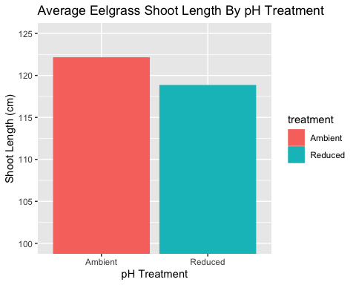

**Figure 1:** This graph shows the average eelgrass shoot length in reduced pH and ambient pH.

library(tidyverse)  
library(ggplot2)  
  
shootroot <- read.csv("/Users/amyyoger/Library/Mobile Documents/com~apple~CloudDocs/SFSU/Classes/BIO 708 Simonis/GitHub/BIO-708/Data/shootrhizome.csv")  
  
ggplot(data=shootroot, mapping=aes(x=Rhizome, y=Shoot, color=Treatment)) +  
 geom_point(stat="identity")+  
 labs(title= "Eelgrass Shoot vs. Rhizome Length at Different pH levels in San Francisco Bay", x="Rhizome Length (cm)", y="Shoot Length (cm)") + theme(plot.title = element_text(hjust=0.4))

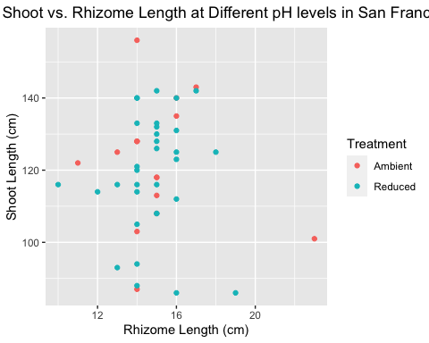

**Figure 2:** This graph compares eelgrass shoot to rhizome length at different pH levels.