Abstract
Handwritten numeral recognition for Indic scripts remains a challenging task due to substantial intra-class variability, stroke-level ambiguity, and structural similarities across digits. Although deep learning models—particularly convolutional and recurrent architectures—have achieved strong performance on benchmark datasets, many existing approaches rely on a single dominant representation paradigm, which can limit robustness and cross-dataset generalization. In this work, we present a multi-path feature disentanglement framework for handwritten numeral recognition that learns complementary representations in parallel. The framework integrates a deep convolutional path for hierarchical spatial feature extraction, a sequential recurrent path for modeling stroke-level dependencies, and a shallow linear projection path for capturing global intensity distributions. These heterogeneous features are fused into a unified representation for classification. The proposed framework is instantiated as WDS-Net and evaluated across three datasets: Hindi-MNIST for baseline benchmarking, CMATERdb for real-world handwritten robustness, and BanglaLekha-Isolated for cross-script generalization analysis. Experimental results demonstrate that the proposed approach achieves competitive recognition performance while exhibiting improved stability and generalization compared to single-path and serial hybrid baselines. The findings indicate that explicit disentanglement and fusion of heterogeneous feature representations constitute an effective design strategy for handwritten numeral recognition in complex Indic scripts.
Keywords— Handwritten Digit Recognition, Indic Scripts, Feature Disentanglement, Hybrid Neural Networks, CNN, GRU, Optical Character Recognition.
- Introduction
Handwritten and printed text recognition remains a fundamental problem in document analysis and computer vision, with applications ranging from archival digitization to industrial inspection and automated information retrieval. Despite significant progress achieved through deep learning, text recognition systems continue to face challenges arising from variations in writing styles, structural distortions, noise, and domain-specific constraints. Recent studies emphasize that achieving robust recognition performance requires not only powerful classifiers but also effective feature representations that can generalize across datasets, scripts, and acquisition conditions [1]. The complexity of text recognition increases substantially when dealing with non-Latin scripts, heterogeneous writing styles, or imperfect acquisition conditions. Representation learning has therefore emerged as a critical component in modern recognition pipelines. Davoudi and Traviglia demonstrated that conventional deep neural networks relying solely on continuous latent representations may inadequately capture the discrete structural components inherent in handwritten text, motivating alternative representation learning strategies that better align with the compositional nature of handwriting [1]. Recent advances in deep learning-based text recognition have largely centered on convolutional and hybrid architectures. CNN-based approaches have proven effective in capturing local spatial patterns, while sequential models such as LSTM and GRU networks have been employed to model temporal or stroke-level dependencies. However, existing approaches often rely on a single dominant feature paradigm, which can limit robustness when faced with variations in writing style, script structure, or data distribution. Studies focusing on transfer learning and limited-data scenarios highlight that strong performance on a single dataset does not necessarily translate to generalization across domains or scripts, underscoring the need for architectures that can integrate complementary representations [2][3]. Another line of research has investigated text recognition under challenging real-world conditions, such as curved surfaces, diverse printing methods, and inconsistent character shapes. Koponen et al. demonstrated that deep learning approaches can outperform traditional OCR engines in such settings; however, their study also revealed that model effectiveness is highly sensitive to dataset size, representation choice, and architectural design [4]. These observations reinforce the necessity of moving beyond dataset-specific solutions toward more generalizable recognition frameworks. Motivated by these limitations, recent research trends increasingly advocate feature diversity and representation complementarity as key factors for improving recognition robustness. Rather than relying on a single deep pathway, combining heterogeneous feature representations has been shown to reduce representation bias and improve stability, particularly in scenarios involving script variability and limited training data [5]. This perspective aligns with findings from discrete and hybrid representation learning studies, which suggest that explicitly disentangling different aspects of visual information can enhance both accuracy and generalization.
In this context, the present work adopts a multi-path feature learning perspective for handwritten numeral recognition in Indic scripts. Building upon insights from recent representation learning and robustness studies, the proposed approach aims to integrate complementary spatial, sequential, and global feature representations within a unified framework. By evaluating the framework across multiple datasets rather than a single benchmark, this study seeks to address persistent concerns regarding dataset bias and generalization, thereby contributing toward more reliable and extensible handwritten text recognition systems.
2. Related Work
2.1 Deep Learning Architectures for Handwritten and Text Recognition
Recent advances in handwritten and scene text recognition have been largely driven by deep learning architectures, particularly convolutional neural networks (CNNs), which have demonstrated superior performance over traditional machine learning techniques relying on handcrafted features. CNN-based models automatically learn hierarchical feature representations from raw pixel inputs, making them especially effective for capturing stroke-level and spatial characteristics inherent in handwritten characters. As a result, CNNs have become the foundational architecture for a wide range of optical character recognition (OCR) tasks across different scripts and document conditions.
Early deep learning approaches primarily employed standalone CNN architectures with multiple convolution and pooling layers, followed by fully connected classifiers. Such models have been shown to achieve high recognition accuracy on both standard benchmarks and script-specific datasets, particularly when combined with data augmentation strategies to address limited training samples. Comparative studies consistently report that CNN-based classifiers outperform classical methods such as support vector machines and k-nearest neighbors when applied to handwritten character recognition tasks, owing to their superior feature learning capability and robustness to intra-class variations [6].
To further enhance recognition performance, several studies have explored hybrid deep learning architectures that integrate CNNs with additional learning modules. In particular, convolutional recurrent neural network (CRNN) frameworks combine CNN-based feature extraction with recurrent neural networks (RNNs) to model sequential dependencies among characters, enabling effective recognition of variable-length text sequences. Such hybrid architectures have become especially prominent in scene text recognition, where contextual dependencies play a critical role in accurate decoding. The integration of recurrent layers allows the model to capture temporal and contextual information that cannot be effectively modeled by CNNs alone [7].
The application of deep convolutional neural networks for handwritten character recognition is investigated with a primary emphasis on improving classification accuracy through architectural design and systematic preprocessing. The work follows a conventional deep learning pipeline, wherein handwritten character images undergo normalization and feature learning via stacked convolutional layers, followed by fully connected classification layers. The authors demonstrate that CNN-based architectures are capable of effectively learning discriminative spatial features from handwritten inputs without reliance on handcrafted descriptors [8].
The deep learning architectures for handwritten Devanagari numeral recognition with a specific emphasis on achieving a balance between recognition accuracy and computational efficiency is investigated. The authors explore advanced vision-based models, including convolutional neural networks and transformer-inspired architectures, to capture complex spatial patterns present in handwritten numerals while maintaining low computational overhead. By systematically comparing conventional CNNs with more recent attention-driven designs, the work demonstrates that enhanced feature extraction mechanisms can improve discrimination between visually similar numerals, particularly under variations in handwriting style. The experimental evaluation highlights that architectural choices play a critical role not only in accuracy but also in inference efficiency, making the proposed approach suitable for resource-constrained environments. However, the study remains primarily architecture-centric and focuses on performance optimization within a single script and dataset, without explicitly addressing feature representation diversity or cross-dataset generalization, thereby positioning it as a strong architectural baseline rather than a generalizable recognition framework [9].
2.2 Representation Learning and Feature Fusion Approaches in Handwritten Recognition
Beyond architectural depth, recent studies have increasingly focused on improving handwritten recognition performance through enhanced representation learning strategies. Rather than relying solely on single-path convolutional features, these approaches aim to learn more discriminative, transferable, and compact representations by exploiting transfer learning, multi-level feature extraction, and feature fusion mechanisms. Such strategies are particularly effective in scenarios involving limited training samples, high intra-class variability, or script complexity.
Several works have demonstrated that transfer learning significantly improves feature representation quality when training data is scarce. The study reported in Electronics Letters (2020) systematically evaluates pre-trained deep networks and shows that fine-tuned transfer learning models outperform conventional CNNs in small-sample handwritten digit recognition, highlighting the importance of reusing high-level learned representations [10]. Similar observations are reported, where transfer learning with controlled fine-tuning levels is shown to provide superior generalization compared to training CNNs from scratch, especially under constrained data conditions [11]. In the context of Indic scripts, representation learning has also been enhanced through level-wise and hierarchical feature extraction. The work published introduces a level-wise CNN framework that progressively refines learned features using transfer learning and fine-tuning on VGG-based architectures. The results confirm that hierarchical feature reuse improves recognition accuracy while maintaining computational efficiency, particularly for complex Devanagari characters [12].
Complementary to transfer learning, several studies emphasize feature fusion and multi-representation modeling. The paper published explores the combination of learned deep features with complementary representations to improve discrimination among visually similar handwritten classes, demonstrating that fused feature spaces provide better class separability than isolated representations [13]. Likewise, this study integrates multiple feature learning streams to capture both spatial and contextual characteristics, showing improved robustness across diverse handwriting styles and acquisition conditions [14]. In addition, lightweight representation learning strategies have been proposed for deployment-constrained environments. The work reported in IJACSA (2022) employs character-level n-gram representations combined with deep sequential models, illustrating that carefully designed compact feature representations can achieve competitive performance while significantly reducing computational and memory overhead [15].
Overall, these studies indicate that representation learning and feature fusion play a crucial role in enhancing handwritten recognition performance beyond architectural depth alone. However, most existing approaches either rely on single-level feature abstractions or optimize representations for specific datasets, limiting their adaptability across scripts and writing conditions. This motivates the exploration of more robust and unified representation learning frameworks.
2.3 Generalization, Robustness, and Cross-Dataset Learning
Although deep learning models have achieved impressive performance in handwritten recognition tasks, their effectiveness is often challenged by limited training samples, data variability, and real-world distortions. Consequently, recent studies have focused on improving model generalization through augmentation strategies, alternative learning paradigms, and hybrid learning frameworks that explicitly address these constraints.
One prominent direction involves enhancing generalization performance under small training sample scenarios. The work reported in Journal of Physics: Conference Series (2021) systematically investigates data augmentation techniques for CNN-based handwritten digit classification and demonstrates that perspective-based transformations significantly improve generalization when training data is scarce. The study highlights that augmentation strategies play a crucial role in mitigating overfitting and stabilizing CNN performance in constrained learning settings [16].
Beyond augmentation, several studies have explored alternative learning paradigms to improve robustness. The work presented in Machine Learning with Applications (2021) introduces a two-phase modular learning framework for handwritten character recognition, showing that decomposing learning into sequential stages improves scalability and generalization. By separating feature learning and classification phases, the approach reduces model complexity while maintaining consistent performance across variations in handwriting styles [17].
Hybrid learning frameworks have also been proposed to improve robustness in challenging recognition scenarios. The study published in Trends in Computer Science and Information Technology (2021) combines convolutional neural networks with support vector machines to form a verification-based learning pipeline. The results demonstrate that hybrid CNN–SVM strategies can reduce misclassification under noisy and degraded inputs by leveraging complementary learning mechanisms, albeit with increased computational overhead [18]. In addition, sequence modeling approaches have been explored to improve recognition stability. The work reported in Advances in Parallel Computing Algorithms (2022) employs recurrent neural networks with LSTM units for handwritten digit recognition and demonstrates improved recognition consistency compared to traditional classifiers such as linear SVMs. While effective for digit-level tasks, the approach remains largely dataset-specific and does not explicitly address cross-script generalization or robustness to complex distortions [19].
Overall, these studies indicate that improving generalization in handwritten recognition requires more than architectural refinement alone. Data augmentation, modular learning strategies, and hybrid models offer partial solutions; however, most existing approaches evaluate robustness within limited experimental settings or single datasets. This underscores the need for learning frameworks that can generalize effectively across diverse handwriting styles, acquisition conditions, and datasets.
2.4 Indic Script–Based Handwritten and Text Recognition Studies
Indic scripts pose unique challenges for handwritten and text recognition due to their complex structural properties, including compound characters, modifiers, and high intra-class variability. As a result, several studies have focused specifically on Indic languages to address limitations observed in generic OCR frameworks.
The authors propose a CNN-based handwritten digit recognition framework and report strong performance on benchmark datasets. While the model achieves high accuracy, the experimental setup remains dataset-centric and lacks evaluation under diverse acquisition conditions, limiting its applicability to real-world Indic scripts [20].
Several studies have extended OCR research toward Indic script characters and numerals. The work published in IJMEMS (2022) presents CNN-based OCR models for printed Gujarati characters and handwritten numerals, emphasizing the difficulty posed by script-specific curves, modifiers, and joint characters. Although the proposed models demonstrate improved accuracy over traditional approaches, the study highlights the continued dependence on well-segmented and script-specific datasets [21].
More recent research has explored text-level recognition and multi-lingual scenarios. The study reported in IAES International Journal of Artificial Intelligence (2023) introduces a fusion neural network combining CNN and RNN layers for text detection and recognition using the Devanagari MLT-2019 dataset. The results demonstrate improved character and word recognition rates; however, the approach primarily targets scene text recognition and does not focus explicitly on handwritten numeral variability [22].
Overall, existing Indic script–oriented studies confirm that while deep learning models significantly improve recognition accuracy, most approaches remain constrained by dataset specificity, controlled experimental settings, or limited evaluation across multiple writing styles. These limitations underline the necessity for robust handwritten numeral recognition frameworks that can generalize effectively across datasets and script variations.
3. Research Gap and Motivation
The literature reviewed in the preceding sections demonstrates that deep learning has significantly advanced handwritten character and digit recognition, particularly through convolutional and hybrid neural architectures. CNN-based models and their extensions have proven effective in learning discriminative spatial features, while recurrent and attention-based variants further enhance recognition performance by incorporating contextual dependencies. These developments collectively establish deep learning as the dominant paradigm for handwritten OCR tasks.
However, a critical analysis of existing studies reveals several persistent limitations that restrict the robustness and generalization capability of current approaches. First, most deep learning architectures emphasize single-paradigm feature learning, typically prioritizing spatial representations extracted through convolutional layers. Although hybrid CNN–RNN models partially address sequential dependencies, such integrations are often serial in nature, resulting in feature dominance rather than complementary representation learning. Consequently, important structural and global characteristics of handwritten digits may remain under-exploited.

Second, while representation learning and feature fusion strategies have demonstrated improved recognition performance under constrained data scenarios, existing approaches often rely on ad hoc fusion mechanisms or dataset-specific optimizations. Many studies focus on enhancing accuracy within a single dataset, with limited analysis of how learned representations transfer across scripts, writing styles, or acquisition conditions. This raises concerns regarding the adaptability of such models in practical deployment settings.
Third, robustness and generalization remain insufficiently addressed in current handwritten recognition research. Although data augmentation, modular learning strategies, and hybrid classifiers have been explored to mitigate overfitting and variability, these solutions are frequently evaluated under restricted experimental settings. Cross-dataset validation and stress testing under realistic distortions are seldom incorporated as core evaluation criteria, limiting confidence in the real-world applicability of proposed models.
Finally, studies focusing on Indic scripts, including Devanagari, consistently highlight the complexity and variability inherent to these writing systems. While script-specific models achieve promising performance on curated datasets, their dependence on controlled conditions and narrowly scoped training data constrains broader generalization. This underscores the need for recognition frameworks that can effectively capture diverse feature characteristics while remaining robust across multiple datasets and scripts.
Motivated by these observations, there is a clear need for a unified handwritten numeral recognition framework that explicitly learns and integrates complementary feature representations, rather than relying on a single dominant learning paradigm. Such a framework should be designed to enhance representation completeness, reduce dataset bias, and improve generalization across diverse handwriting styles and acquisition conditions. Addressing these gaps forms the central motivation of the present work.
4. Proposed Methodology
4.1 Overview of the proposed framework
The proposed methodology introduces a unified multi-path feature learning framework designed to enhance handwritten numeral recognition by explicitly learning complementary feature representations. Unlike conventional approaches that rely on a single dominant feature extraction pathway, the proposed framework simultaneously exploits spatial, structural, and global characteristics of handwritten numerals through parallel learning paths.
Let
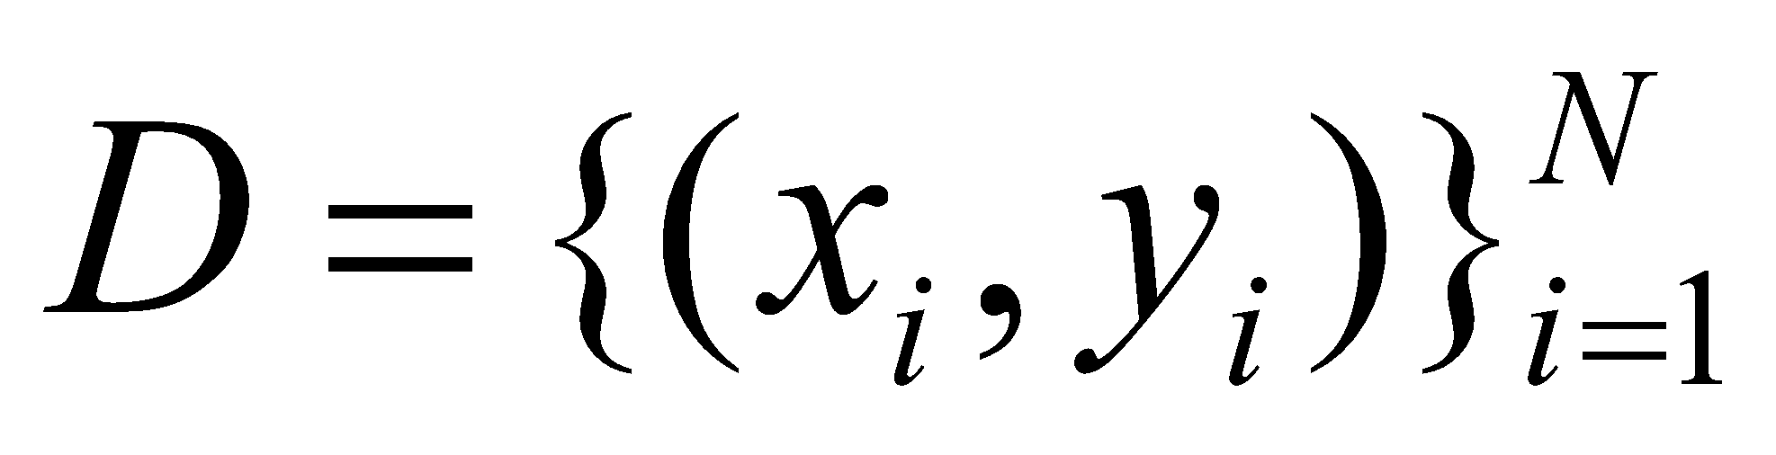 (1)
denote the handwritten numeral dataset, where 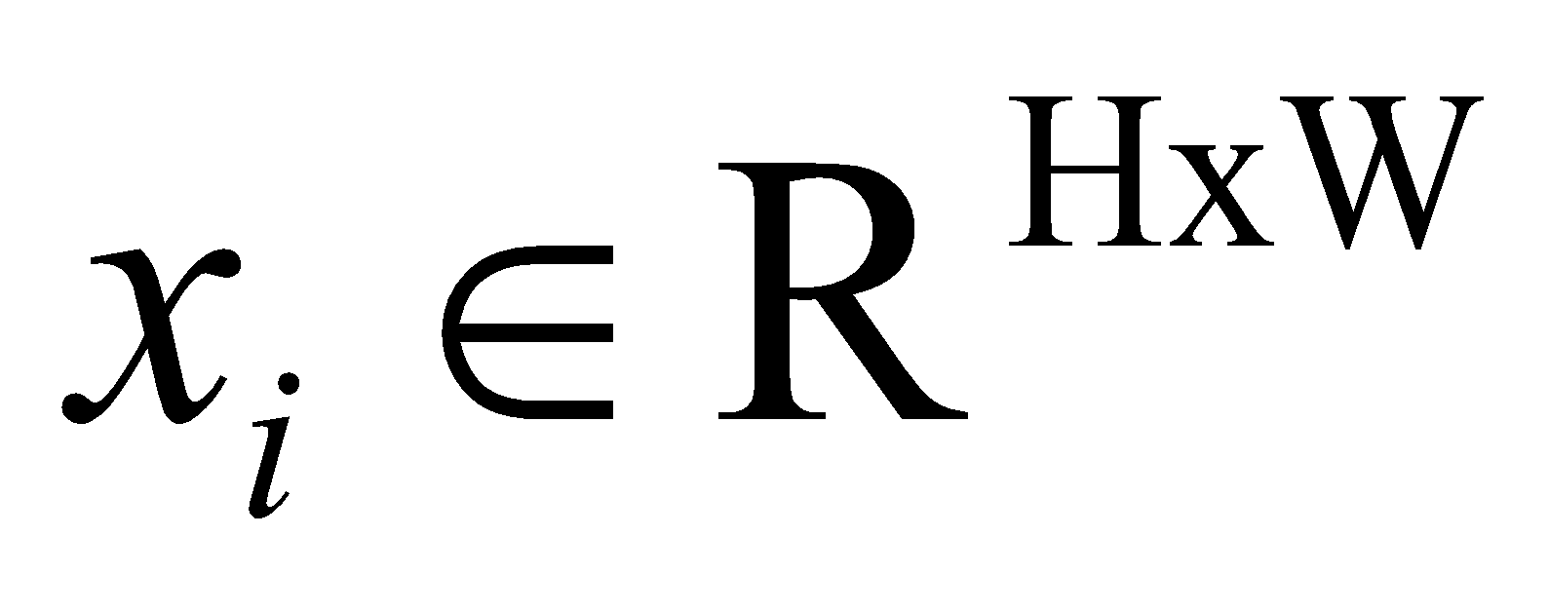represents an input grayscale numeral image and 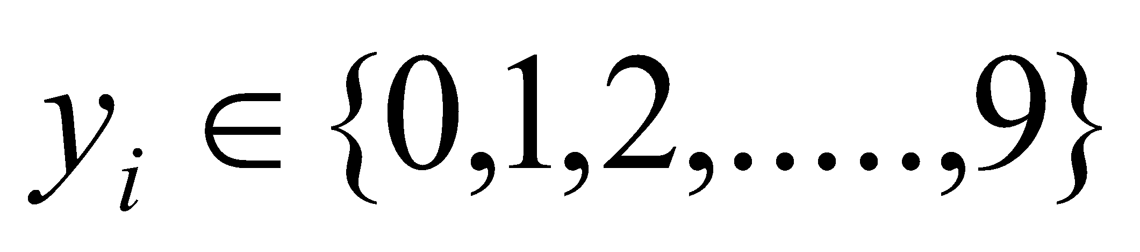denotes the corresponding class label.
The proposed framework consists of three coordinated learning modules:
Spatial Feature Learning Path (CNN-based)
Structural Dependency Learning Path

Global Feature Learning Path
The outputs of these paths are fused to form a unified feature representation, which is subsequently used for classification.
4.2 Data Preprocessing
Each input image 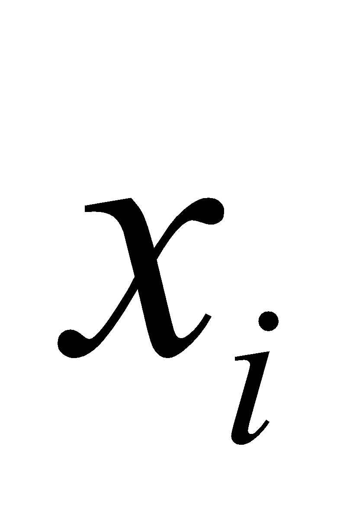undergoes the following preprocessing steps:
- Grayscale normalization
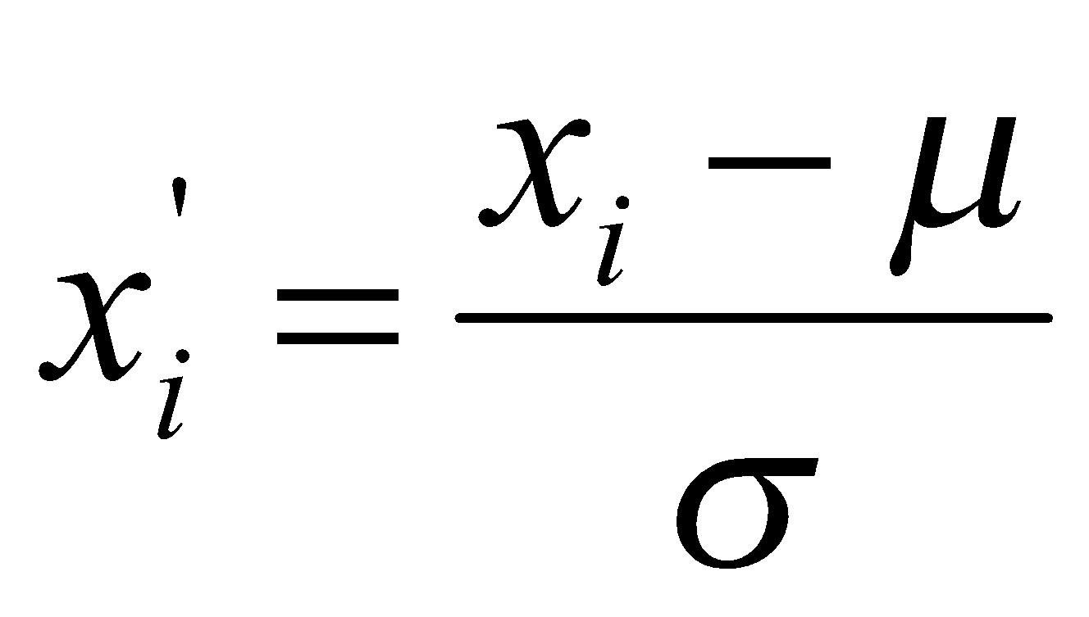
Where is the mean, is the standard deviation of the pixel intensities.
- Resizing
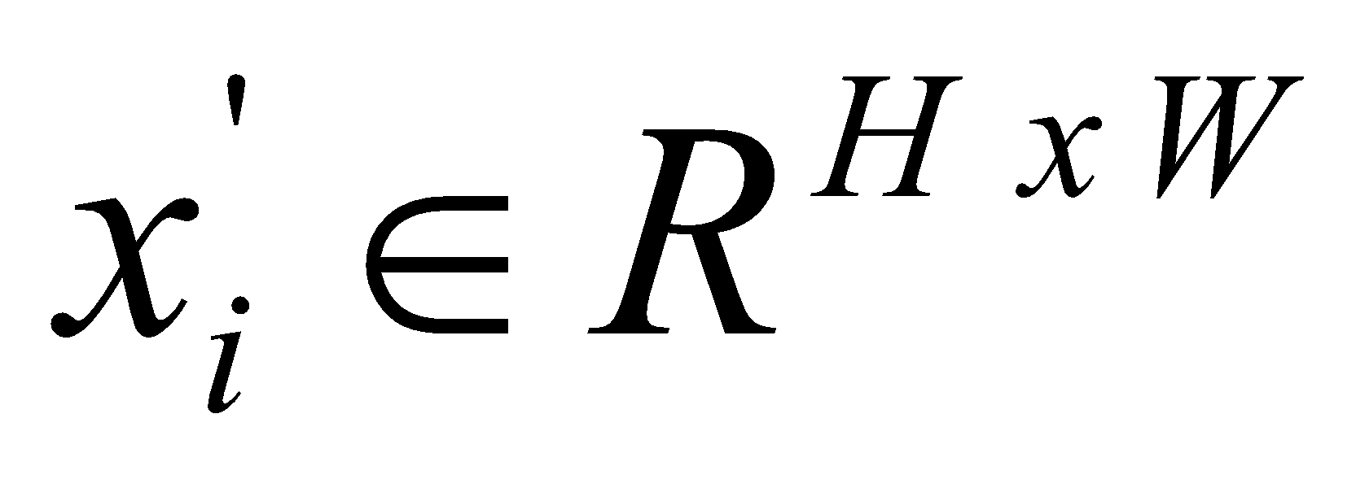
Here, H = W = 28.
- Noise suppression and smoothing is performed to reduce the stroke irregularities.
The preprocessed image 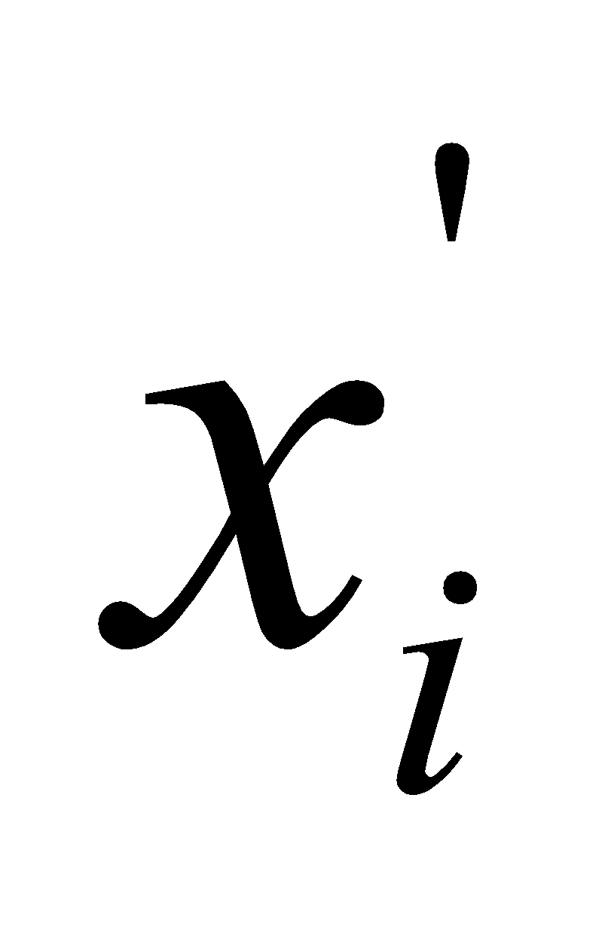is forwarded simultaneously to all the feature learning paths.
4.3 Spatial Feature Learning Path (Deep CNN)
The spatial learning path is responsible for capturing local and hierarchical spatial features, such as edges, curves, and stroke intersections.
Given input image , the convolutional feature maps are computed as follows:
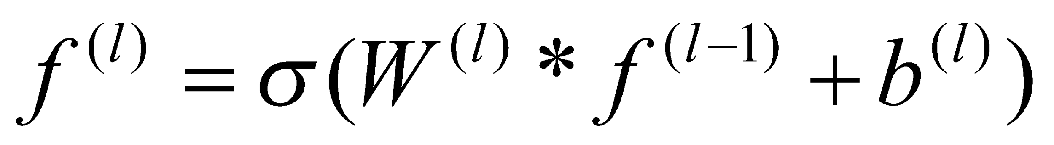
Where 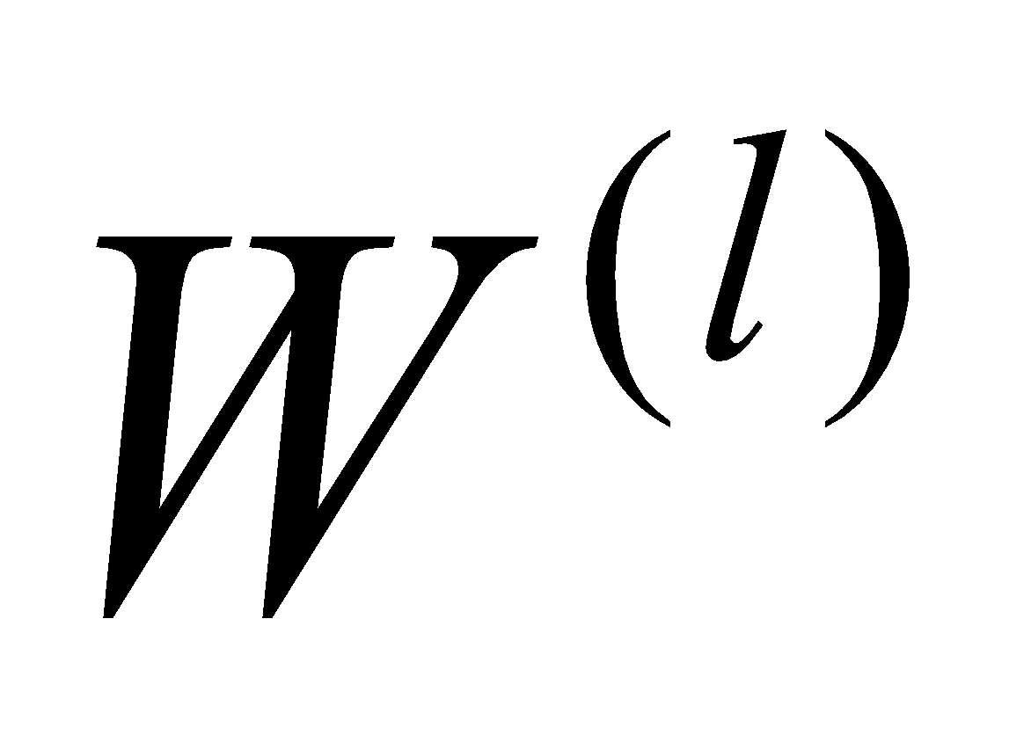 and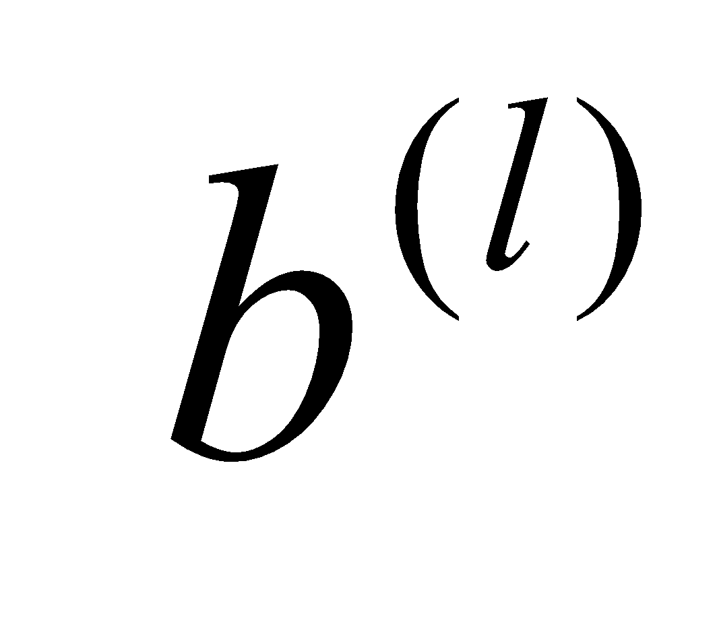are the convolutional weights and bias respectively and 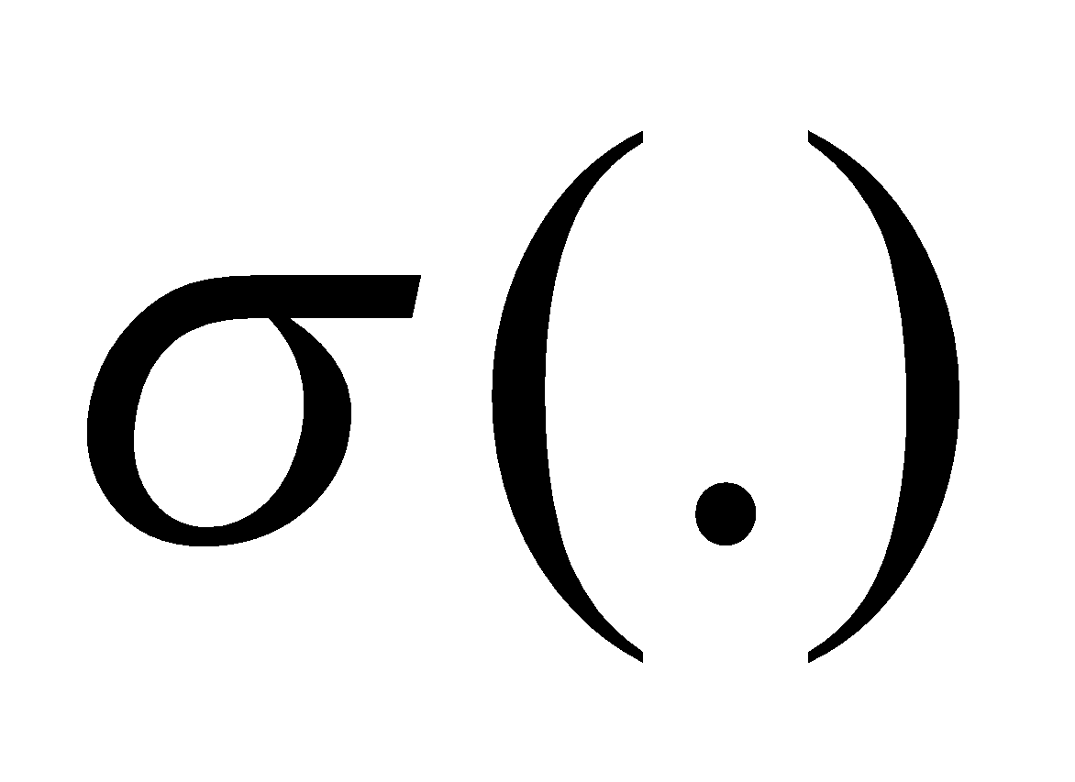is the nonlinear activation function (ReLU).
Pooling layers are applied to introduce spatial invariance.
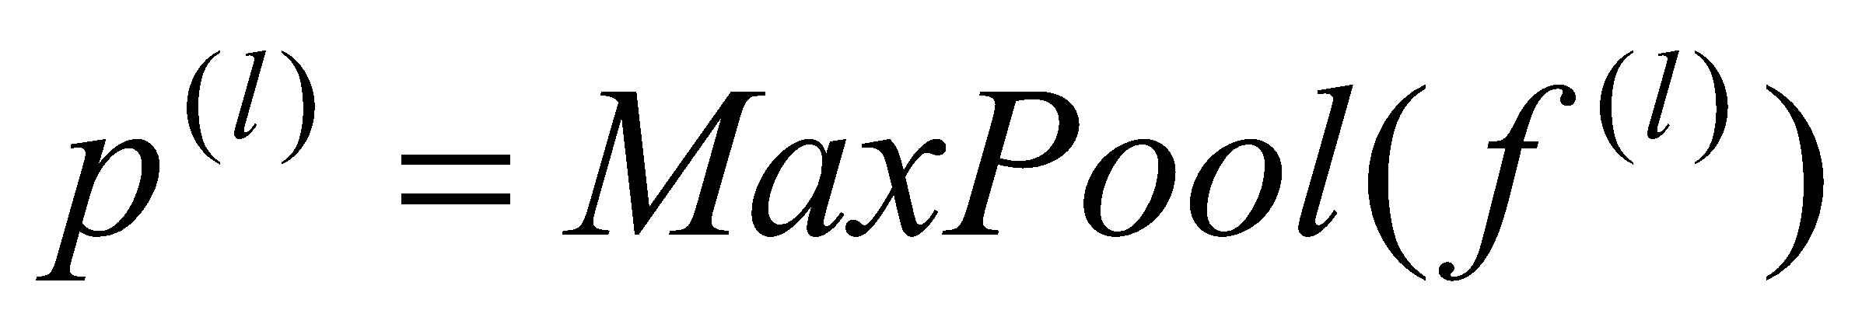
The final CNN output produces a spatial feature vector.
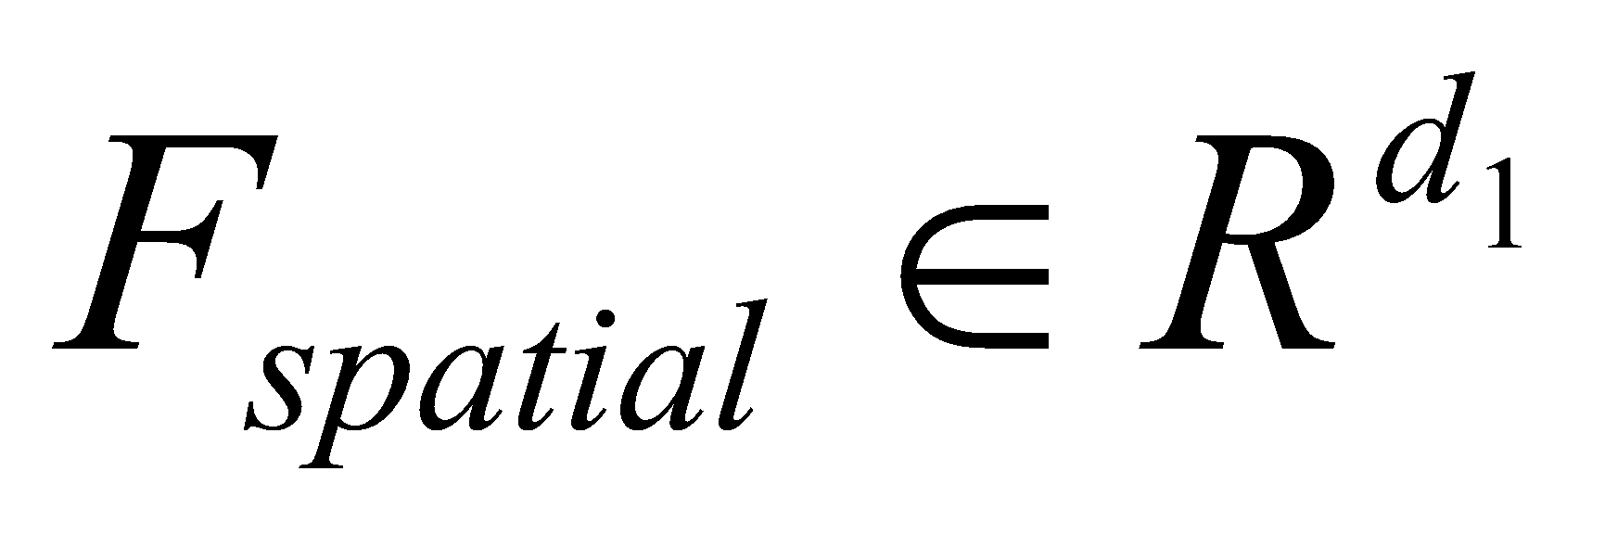
4.4 Structural Dependency Learning Path
Handwritten numerals exhibit implicit structural dependencies among strokes that are not fully captured by spatial convolutions alone. To address this, a structural dependency learning path is employed.
The spatial feature maps are reshaped into ordered sequences.
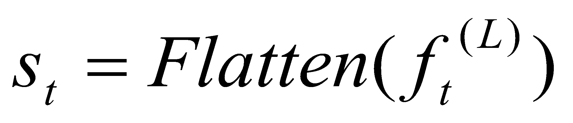
A recurrent modeling unit (e.g., LSTM) learns sequential dependencies.
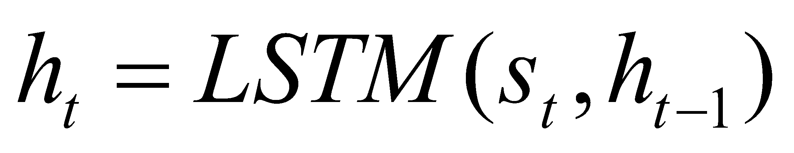
The final hidden state represents the structural feature embedding.
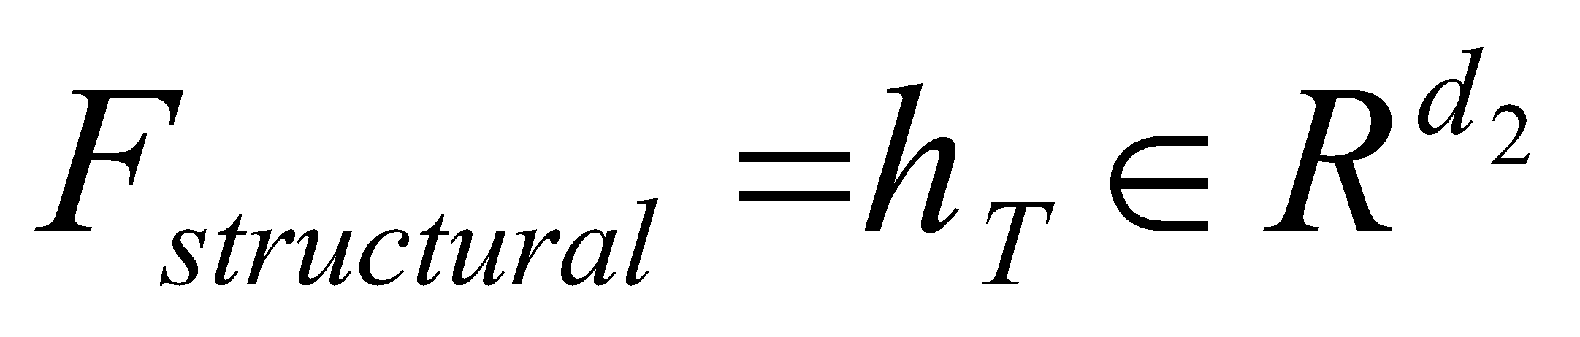
This path improves discrimination between visually similar numerals by modeling internal stroke relationships.
4.5 Global Feature Learning Path
To complement deep representations, a global feature learning path captures holistic characteristics such as intensity distribution and global shape.
Global descriptors are extracted using statistical pooling.
These features provide robustness against local distortions and writing inconsistencies.
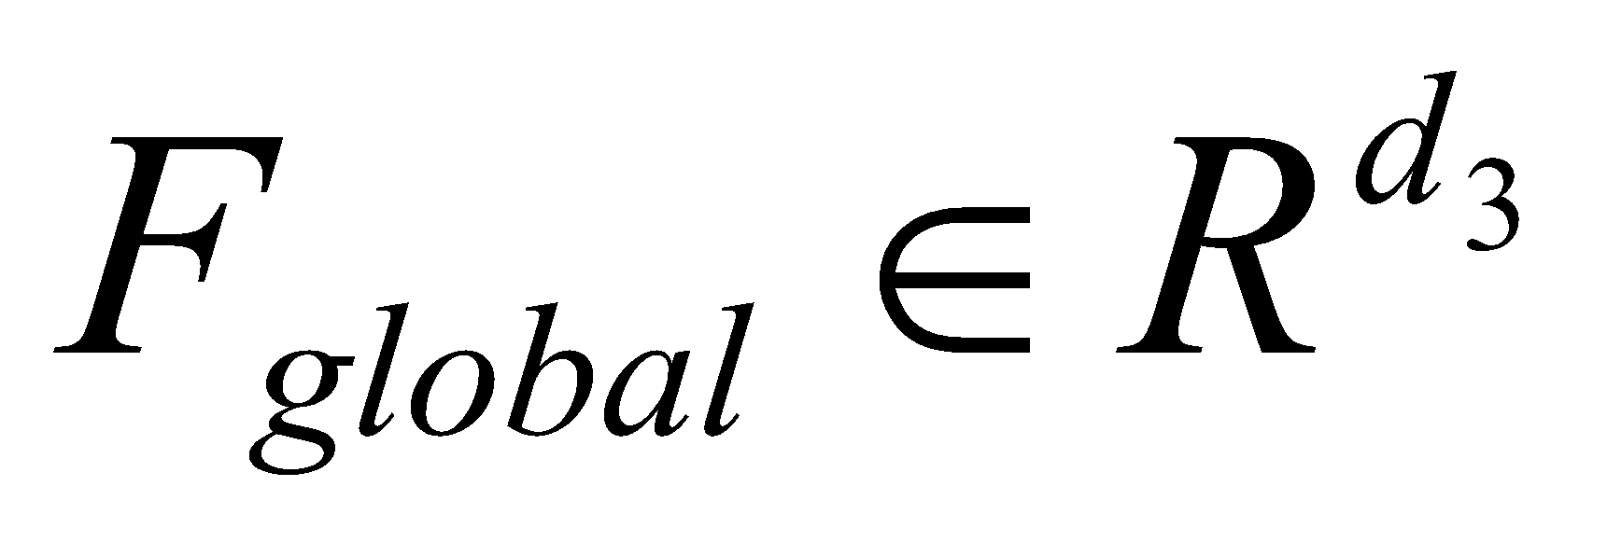
4.6 Feature Fusion Strategy
The three feature vectors are concatenated to form a unified representation.
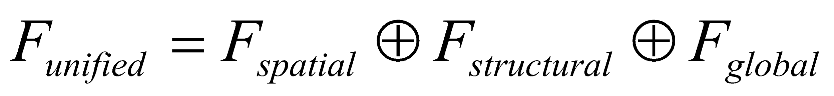
Where denotes the feature concatenation.
A fully connected fusion layer refines the combined representation.
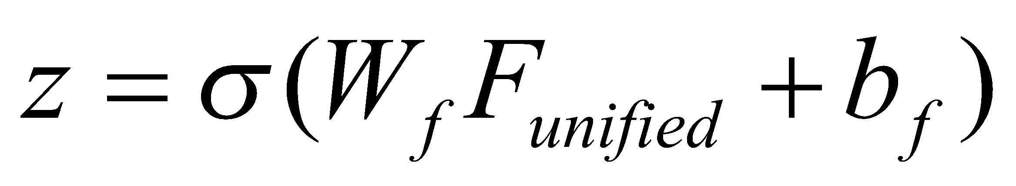
4.7 Classification and Optimization
The final classification is performed using a Softmax layer.
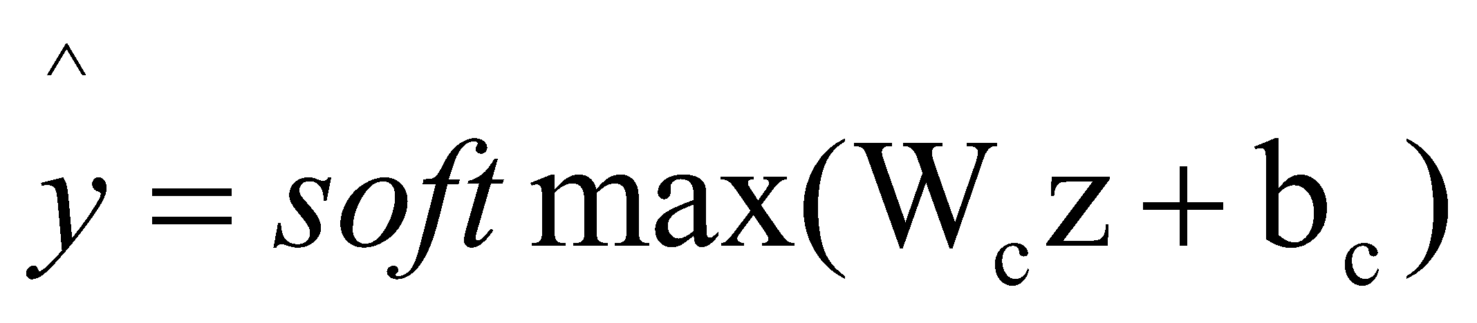
The model is trained by minimizing categorical cross-entropy loss.
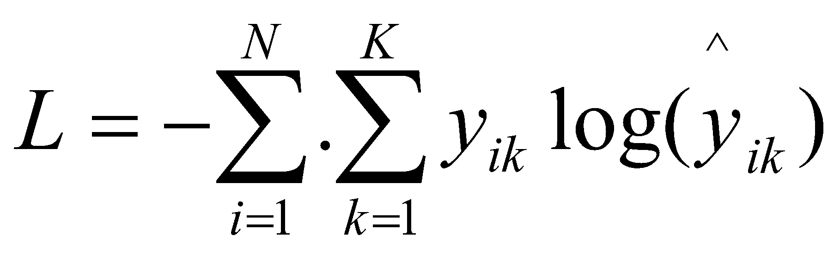
Optimization is carried out using the Adam optimizer with adaptive learning rates.
5. Pseudocode
Initialize CNN parameters θ_cnn
Initialize RNN/LSTM parameters θ_rnn
Initialize fusion layer parameters θ_f
Initialize classifier parameters θ_cls
for epoch = 1 to E do
for each mini-batch B ⊂ D do
// Step 1: Preprocessing
for each image x in B do
x_norm ← Normalize(x)
x_resized ← Resize(x_norm)
x_prep ← Denoise(x_resized)
end for
// Step 2: Spatial Feature Learning Path
F_spatial ← CNN_Forward(x_prep, θ_cnn)
// Step 3: Structural Dependency Learning Path
S ← Reshape_To_Sequence(F_spatial)
F_structural ← RNN_LSTM_Forward(S, θ_rnn)
// Step 4: Global Feature Learning Path
F_global ← Extract_Global_Features(x_prep)
// mean, variance, histogram statistics
// Step 5: Feature Fusion
F_unified ← Concatenate(F_spatial, F_structural, F_global)
Z ← FullyConnected(F_unified, θ_f)
// Step 6: Classification
y_pred ← Softmax(Z, θ_cls)
// Step 7: Loss Computation
L ← CrossEntropy(y_pred, y_true)
// Step 8: Backpropagation
Compute ∇L w.r.t θ_cnn, θ_rnn, θ_f, θ_cls
Update parameters using Adam optimizer
end for
end for
return Trained model M

Testing Phase
x_prep ← Preprocess(x)
F_spatial ← CNN_Forward(x_prep)
F_structural ← RNN_LSTM_Forward(Reshape(F_spatial))
F_global ← Extract_Global_Features(x_prep)
F_unified ← Concatenate(F_spatial, F_structural, F_global)
ŷ ← argmax(Softmax(F_unified))
return ŷ

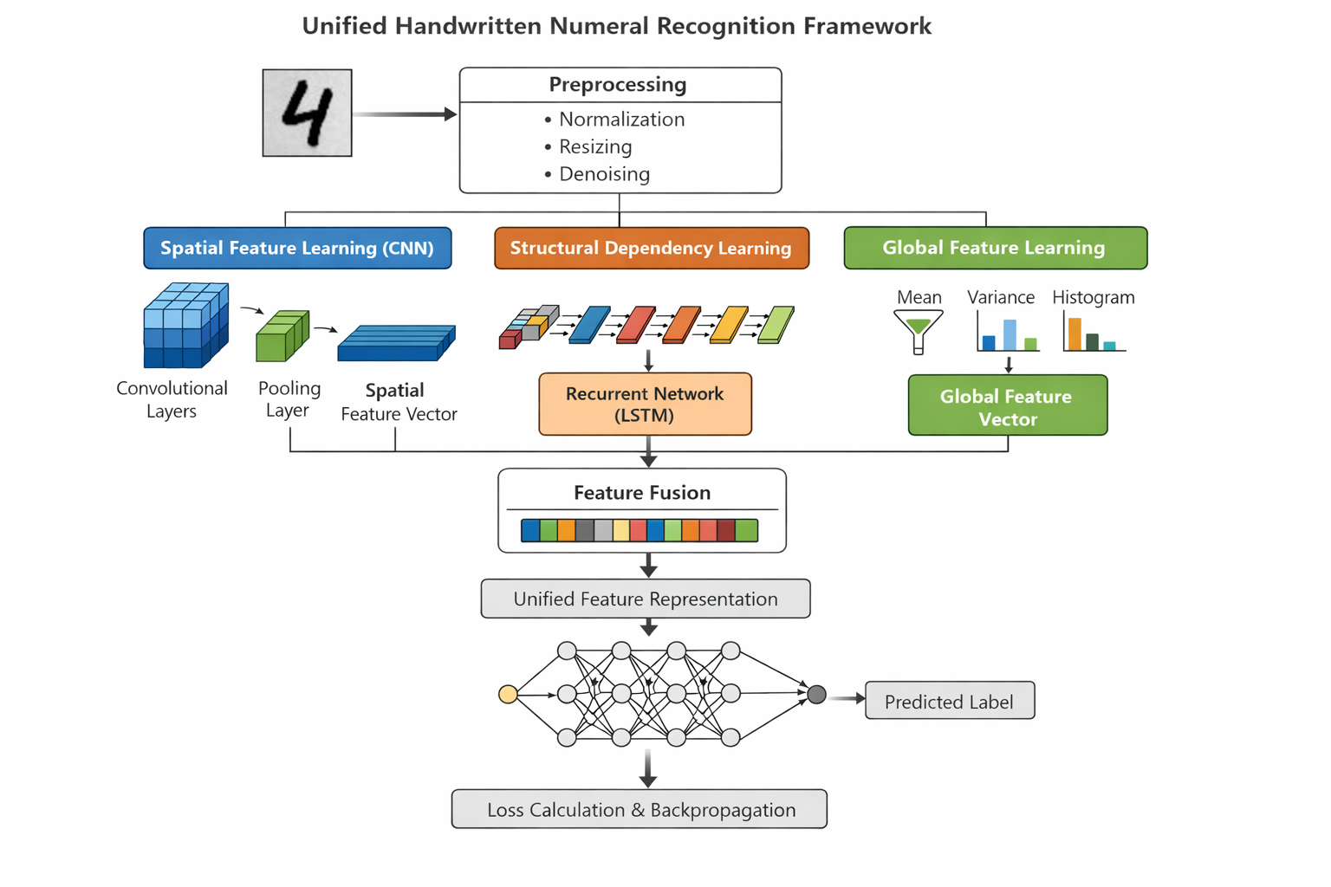
Figure 1. Architecture of the proposed model
Information related to dataset
- Hindi MNIST dataset:
The Hindi-MNIST dataset is a benchmark dataset designed for handwritten Devanagari numeral recognition. It consists of grayscale images of digits ranging from 0 to 9, collected from multiple writers. The dataset follows a structure similar to the original MNIST dataset and is commonly used for evaluating handwritten digit recognition models in the Devanagari script.
No. of classes | 10 (digits 0-9)
Total samples | 70000
Training samples | 10000
Image resolution | 28 * 28 pixels
Color format | Gray scale
Script | Devanagari

- CMATERdb 3.3.1 (Devanagari Numerals)
CMATERdb 3.3.1 is a widely used dataset developed by the Center for Microprocessor Applications for Training, Education and Research (CMATER). It contains handwritten Devanagari numeral images collected under less constrained conditions compared to Hindi-MNIST, resulting in increased variability in writing styles.
No. of classes | 10 (digits 0-9)
Total samples | 3000
Samples per class | 300
Image resolution | 28 * 28 pixels
Color format | Gray scale
Script | Devanagari

- BanglaLekha-Isolated Numeral Dataset
The BanglaLekha-Isolated dataset is a large-scale handwritten dataset containing numerals written by contributors from diverse demographic backgrounds. Although the dataset is based on the Bangla script, it shares structural similarities with Devanagari numerals, making it suitable for cross-script generalization analysis.
No. of classes | 10 (digits 0-9)
Total samples | 98000
Image resolution | 32 * 32 pixels (rescaled to 28 * 28 pixels for consistency)
Color format | Gray scale
Script | Bangla

References:
[1] H. Davoudi and A. Traviglia, “Discrete representation learning for handwritten text recognition,” Neural Comput. Appl., vol. 35, no. 21, pp. 15759–15773, 2023, doi: 10.1007/s00521-023-08445-9.
[2] R. Shelke and S. Vanjale, “Recursive LSTM for the Classification of Named Entity Recognition for Hindi Language,” Ing. des Syst. d’Information, vol. 27, no. 4, pp. 679–684, 2022, doi: 10.18280/isi.270420.
[3] S. Kumar et al., “Classification of Indian media titles using deep learning techniques,” Int. J. Cogn. Comput. Eng., vol. 3, no. November 2021, pp. 114–123, 2022, doi: 10.1016/j.ijcce.2022.04.001.
[4] K. Haataja and P. Toivanen, “RESEARCH ARTICLE A novel deep learning method for recognizing texts printed,” pp. 1–15, 2025.
[5] Y. Mitani, N. Yamaguchi, Y. Fujita, and Y. Hamamoto, “Evaluation of Transfer Learning for Handwritten Character Classification Using Small Training Samples,” J. Image Graph. Kingdom), vol. 11, no. 1, pp. 21–25, 2023, doi: 10.18178/joig.11.1.21-25.
[6] M. A. Islam and I. E. Iacob, “Manuscripts Character Recognition Using Machine Learning and Deep Learning,” Modelling, vol. 4, no. 2, pp. 168–188, 2023, doi: 10.3390/modelling4020010.
[7] L. Zou et al., “Text Recognition Model Based on Multi-Scale Fusion CRNN,” Sensors, vol. 23, no. 16, 2023, doi: 10.3390/s23167034.
[8] A. Moudgil, S. Singh, V. Gautam, S. Rani, and S. H. Shah, “Handwritten devanagari manuscript characters recognition using capsnet,” Int. J. Cogn. Comput. Eng., vol. 4, no. January, pp. 47–54, 2023, doi: 10.1016/j.ijcce.2023.02.001.
[9] D. Rajpal and A. R. Garg, “Deep Learning Model for Recognition of Handwritten Devanagari Numerals With Low Computational Complexity and Space Requirements,” IEEE Access, vol. 11, no. April, pp. 49530–49539, 2023, doi: 10.1109/ACCESS.2023.3277392.
[10] M. K. Mahto, K. Bhatia, and R. K. Sharma, “Deep Learning Based Models for Offline Gurmukhi Handwritten Character and Numeral Recognition,” Electron. Lett. Comput. Vis. Image Anal., vol. 20, no. 2, pp. 69–82, 2021, doi: 10.5565/rev/elcvia.1282.
[11] Y. Mitani, N. Yamaguchi, Y. Fujita, and Y. Hamamoto, “Effects of transfer learning for handwritten digit classification in a small training sample size situation,” ACM Int. Conf. Proceeding Ser., no. January, pp. 123–127, 2022, doi: 10.1145/3582099.3582119.
[12] S. P. Deore, “Dhcr Smartnet: Smart Devanagari Handwritten Character Recognition Using Level-Wised Cnn Architecture,” Comput. Sci., vol. 23, no. 3, pp. 303–319, 2022, doi: 10.7494/csci.2022.23.3.4487.
[13] J. Shaikh, “Handwritten Devnagari Character and Joint Devnagari Character Recognition Using Deep Learning,” Int. J. Res. Appl. Sci. Eng. Technol., vol. 11, no. 5, pp. 6877–6881, 2023, doi: 10.22214/ijraset.2023.53240.
[14] D. Rajpal, A. R. Garg, O. P. Mahela, H. H. Alhelou, and P. Siano, “A fusion-based hybrid-feature approach for recognition of unconstrained offline handwritten hindi characters,” Futur. Internet, vol. 13, no. 9, pp. 1–26, 2021, doi: 10.3390/fi13090239.
[15] Y. S. Yashwanth, “On-Device Major Indian Language Identification Classifiers to Run on Low Resource Devices,” Int. J. Adv. Comput. Sci. Appl., vol. 13, no. 9, pp. 755–760, 2022, doi: 10.14569/IJACSA.2022.0130989.
[16] Y. Mitani, Y. Fujita, and Y. Hamamoto, “Augmentation on CNNs for Handwritten Digit Classification in a Small Training Sample Size Situation,” J. Phys. Conf. Ser., vol. 1922, no. 1, 2021, doi: 10.1088/1742-6596/1922/1/012007.
[17] M. P. Singh and G. Singh, “Two phase learning technique in modular neural network for pattern classification of handwritten Hindi alphabets,” Mach. Learn. with Appl., vol. 6, no. October, p. 100174, 2021, doi: 10.1016/j.mlwa.2021.100174.
[18] P. P, M. HR, and V. Hrishikesh, “Study of using hybrid deep neural networks in character extraction from images containing text,” Trends Comput. Sci. Inf. Technol., vol. 6, pp. 045–052, 2021, doi: 10.17352/tcsit.000039.
[19] E. K. Subramanian and Harsh, “Recognizing Handwritten Digits Using Multi-Dimensional Recurrent Neural Networks Intelligent Character Recognition (ICR) with Improved F-Score Measures,” Adv. Parallel Comput., no. 41, pp. 636–641, 2022, doi: 10.3233/APC220091.
[20] A. Praneetha, S. Harisa, K. Satish, and B. Vivekananda, “Handwritten Text Recognition Using Word Beam Search,” 2023 9th Int. Conf. Adv. Comput. Commun. Syst. ICACCS 2023, vol. 12, no. 2, pp. 1878–1882, 2023, doi: 10.1109/ICACCS57279.2023.10112967.
[21] S. B. Suthar and A. R. Thakkar, “CNN-Based Optical Character Recognition for Isolated Printed Gujarati Characters and Handwritten Numerals,” Int. J. Math. Eng. Manag. Sci., vol. 7, no. 5, pp. 643–655, 2022, doi: 10.33889/IJMEMS.2022.7.5.042.
[22] S. K. Dasari and S. Mehta, “Text detection and recognition through deep learning-based fusion neural network,” IAES Int. J. Artif. Intell., vol. 12, no. 3, pp. 1396–1406, 2023, doi: 10.11591/ijai.v12.i3.pp1396-1406.

