

Project Report

**Online Turf Reservation System**

**Course Id:** CSE411

**Course Name:** Software Engineering

**Section:** 01

**Submitted To**

Sadia Sharmin

Lecturer, Department of CSE

**Submitted By**

Faisal Ahmed Id: 2015-2-60-019

Mushfiqur Rahman Id: 2015-2-60-021

Md. Ashfak Ragib Id: 2015-2-60-086

**Date of submission:** 09 December, 2018

|  |
| --- |
| Table of Contents |
|  |
| Motivation: 3  Stakeholders: 4  Reuirements: 5  User stroy: 6  Use Case Diagram: 7  Activity Diagram: 9  Class Diagram: 10  Conclusion: 11 |

# Motivation:

In our Dhaka city, we don’t have enough space for playing games for kids and athletes. Recently some entrepreneurs are concerned about this issue and they are trying to convert free spaces in playing fields where they are using natural grass or artificial grass. We have spotted two this kind of fields in our city, those are renting their fields for tournament or hourly basis playing for players through social media or their owned website. Recently an organization named JAFF are making a football ground in Bashundhara using artificial turf. Ours project is going to focus on their necessity of online turf's reservation system through website. We have contacted with them and generated idea for completing this project named Online Turf Reservation System.

For implementing this system we have used Laravel framework, which is mainly an open-source PHP web framework. We also have used MySQL database for designing the database of this project.

**Stakeholders:**

1. JAFF Organization who will use this website for giving rent their Turf field.
2. People who will booked field from this site and will give their information.
3. Members of the organization who will provide their information and will get different benefit from the organization.
4. Different Organizations who will use this site to book this turf filed and conduct practice session for children.
5. IT staff of the organization who will be responsible for installing and maintaining the site.
6. Information record staff mainly the admins who will be responsible for ensuring that system information can be maintained and preserved, and the record keeping procedures have been properly implemented.
7. Course Instructor of this course who will be responsible.

**Requirements:**

Functional Requirements:

1. Users and members shall have different profile management.
2. Users shall make reservation according to slots of the ground.
3. Users shall make reservation for tournaments.
4. Users shall get confirmation e-mail after the reservation has been made confirm by admin.
5. Users shall be able to see available date and time for booking the field.
6. Each members shall be identified using their 8-digit unique key.

Non-functional Requirements:

Product Requirements

1. The Online Turf Registration shall be available to the users and members 24/7 (Sunday-Saturday). Downtime in a day shall not exceed five seconds.
2. The size of the system shall not exceed 50MB.
3. Numbers of error shall not occur more than 2 a day.

Organizational Requirements

1. Users and members shall have different unique authentication keys.
2. Laravel framework shall be used for designing the system.
3. PHP and mysqlite database shall be used for handling the database.

External Requirements

1. The system shall implement users and members privacy provisions.
2. The system shall sent confirmation message to the users after a payment have been made.

**User Story:**

Initial assumption: A registered/unregistered customer wants to reserve the turf for a certain amount of time. He/she can go to the site by using any internet connected devices.

Normal flow of events: The customer choses his preferred time slot and also needs to check whether the slot is free or not. After that he needs to pay the rent by online payment system. He can monitor his records from his registered account. On completion of the booking, the system automatically sends an email with reservation details to the customer’s given email address.

What can go wrong: While registering a customer account his username might be already taken. The customer should be asked if he wish to enter a distinct username. While searching for slots the customer might search irrational things.

Other activities: The administrators may be logged on to the system and may motorized all reservations made by the customers.

Completion: All the processes for turf reservation for customers are completed. They are authorized to use the turf on their selected slots.

**Use Case Diagram:**

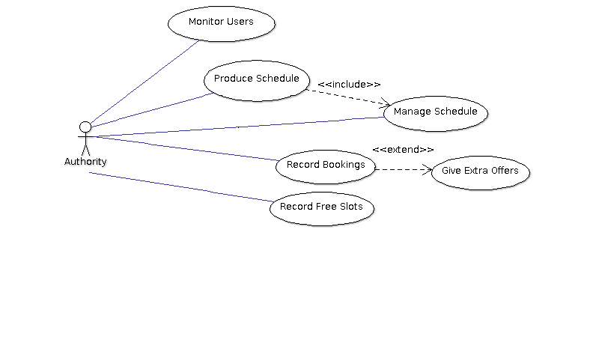

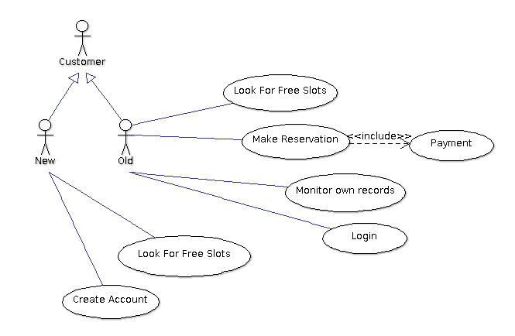

Activity Diagram**:** 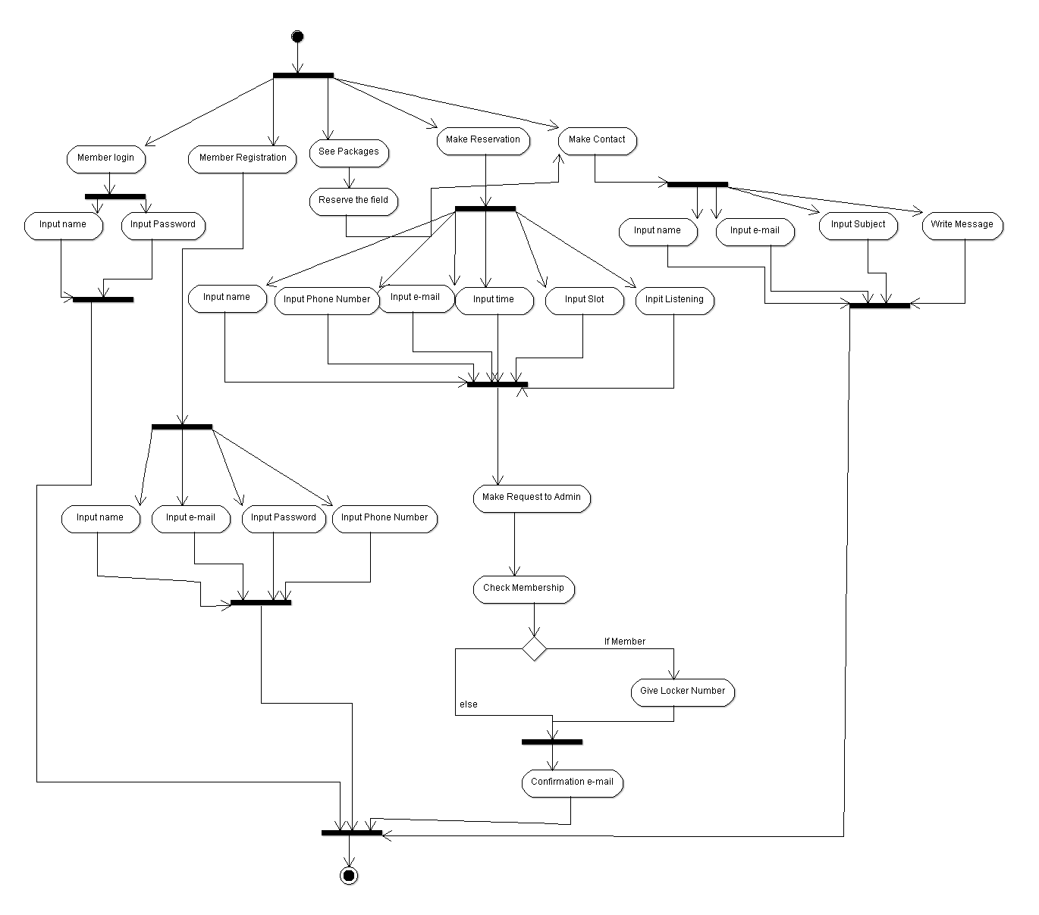

**Class Diagram:**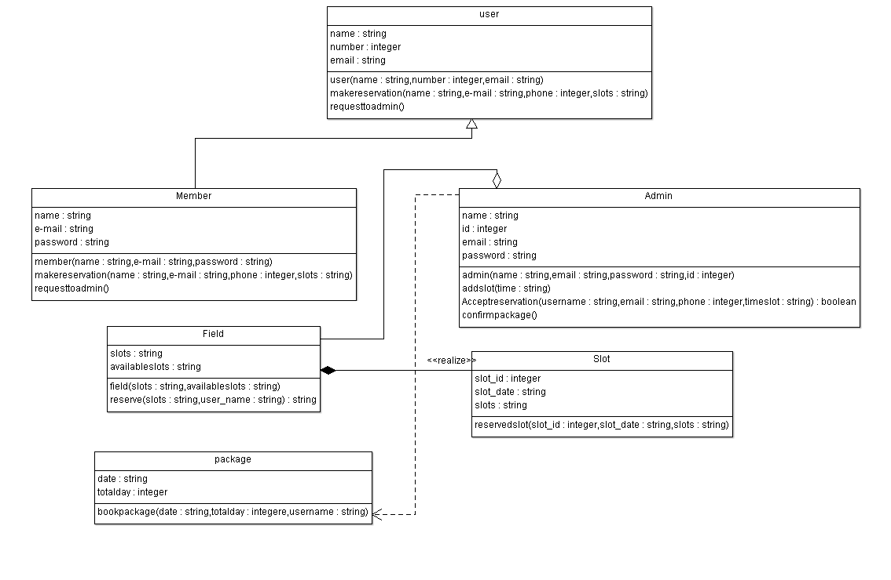

**Conclusion:**

In our project we tried a make an online system where people can reserve turf to play games or participate in tournaments. It’s a real world based project. As technology is moving so fast, we need to cope up with the change. This types of project will be very helpful for people. It will save their time and troubles.

By making this project as a student we learned many software related things. For example: front-end and back-end web languages, software modeling, relation between software users and authority etc. This experience will help us in future to build our career.