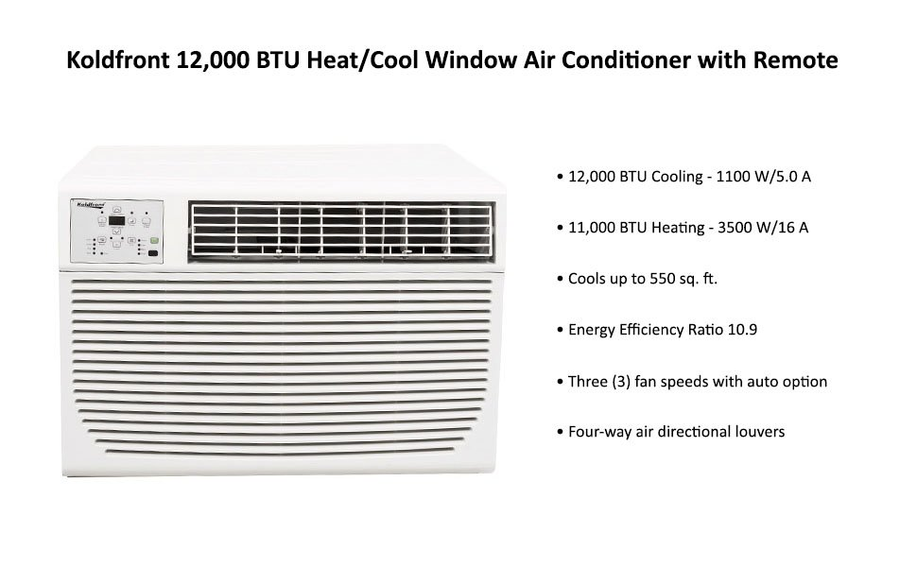

The energy efficient Koldfront 12,000 BTU Heat/Cool Window Air Conditioner (**WAC12001W**) can service a space up to 550 square feet. The air conditioner has 12,000 BTUs of cooling power and 11,000 BTUs of electric heating power. Using the electronic thermostat and digital display, you can set your desired temperature as well as control other convenient features like the energy saver mode, fan speed and 24 hour timer.  
  
**Energy Efficient:**  
This Koldfront unit offers several energy-saving features, including a Check Filter light, thermostat-controlled operation, sleep mode and Energy Saver mode  
  
**Digital Display with Dehumidifier:**  
A control panel with digital temperature display and three (3) fan speeds lets you control airflow, with a dehumidifying mode to dry your space  
  
**Sleep Function:**  
To save energy, sleep mode will adjust the temperature periodically before returning to the set temperature after six (6) hours  
  
**Remote Control:**  
Operate the temperature setting and fan speed from anywhere in the room with the convenient remote control

|  |
| --- |
| https://images-na.ssl-images-amazon.com/images/S/aplus-seller-content-images-us-east-1/ATVPDKIKX0DER/A5D5QHQMB730E/B00QXR9794/QjhziwGOR7m6._UX847_TTW_.jpg |

**Specifications**

* Model: WAC12001W
* Dehumidification capacity: approximately 60 pints/day
* 12,000 BTU cooling - 1100 W/5.0A
* 11,000 BTU heating - 3500 W/16.0A
* Coverage area: 400 sq. ft. (heat) 550 sq. ft. (cool)
* Four (4) operating modes including Dry Mode for dehumidifying
* Three (3) fan speeds with auto option
* 24-hour timer
* Dehumidification capacity: approximately 60 pints/day
* Digital thermostat-controlled heating and cooling
* Maintains temperatures between 62° F (17° C) and 86° F (30° C)
* Installation hardware and weather seals included
* Four-way air directional louvers
* Input voltage: 220 V/60 Hz
* Weight: 88.4 lbs
* Window width: 26 7/8"- 36"
* Dimensions: 16.1" H x 22.6" W x 23" D
* Minimum window height: 16 1/2"