**SOP for Installing Git Bash, WinSCP, and Connecting to a Designated Server**

**Installation of Git Bash**

To install Git Bash on Windows, kindly follow instructions on this link

<https://www.stanleyulili.com/git/how-to-install-git-bash-on-windows/>

If you are using a MacBook, you don’t need to install Git Bash. You already have a Terminal. Just search your system for “Terminal” or “ITerm”.

Downloading and Installing WinSCP

Download the WinSCP Installation package.

Run the WinSCP Installer as you would any other Windows program.

When prompted, choose Typical installation as the Setup type.

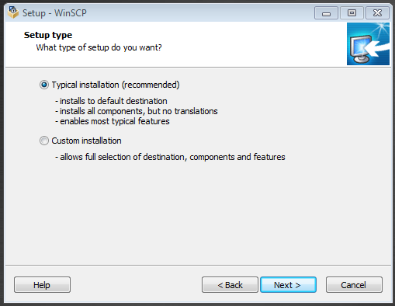

When prompted, choose **Commander** as the preferred user interface option

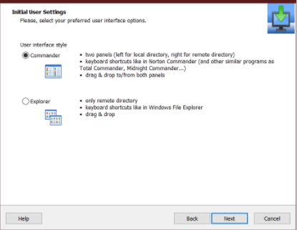

Complete the installation and restart your computer

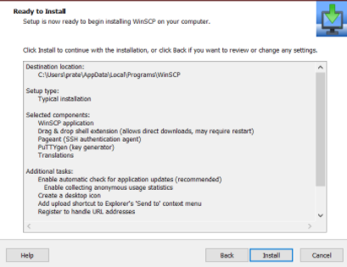

**Connect to the server**

Your username is your name_surname e.g paul_olatinwo (Note: kindly take note of the underscore “_” between the names.

The usernames available are; comfort_ogunniran, bashirat_ayobola, fatima_onawoga, rebecca_peters, paul_olatinwo, abiodun_egwuenu, aaron_aboderin, chimaobi_chukwu, anthony_anuforo

To log in to the server, fire up Git Bash

Type ssh [name_surname@137.205.69.162](mailto:name_surname@137.205.69.162), e.g



Hit the “Enter” key. You will see this message



Type “yes”

You will see this message



Type in your password. Kindly note that you won’t see anything while typing your password. After typing your password, simply hit the “Enter” key. At the moment, your password is the same as your username. If you are interested in changing the password, instructions will be given during the practical sessions.

And voila!!! You are in!!!

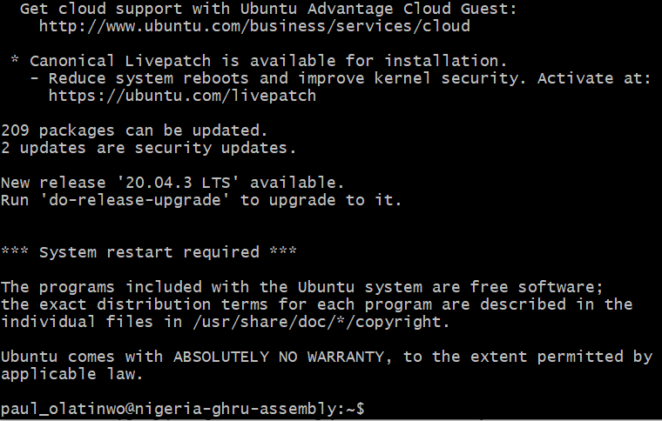

To exit the server, simply type “exit” on the Terminal

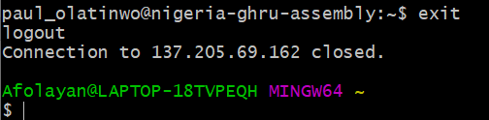

The next time you log in, you won’t see any warning message (it’s going to be a seamless process)