| Description | Type | Parameter |
| --- | --- | --- |
|  |  |  |
|  |  |  |
|  |  |  |
|  |  |  |
|  |  |  |
|  |  |  |
|  |  |  |
|  |  |  |
|  |  |  |
|  |  |  |

| Description | Outputs | Inputs | Method Name |
| --- | --- | --- | --- |
|  |  |  |  |
|  |  |  |  |
|  |  |  |  |
|  |  |  |  |
|  |  |  |  |
|  |  |  |  |
|  |  |  |  |
|  |  |  |  |
|  |  |  |  |
|  |  |  |  |

Class Name:

Data Holder Operational

Model Controller

Application:

# Application Overview

### Application Name:

### List of User Stories:

# User Story Overview

### User Story Name:

### User Story Code:

### List of Screens:

# Screen Overview

### Screen Title:

### Screen Code:

### List of Functions:

| User Action | Input | Trigger | Case | Output |
| --- | --- | --- | --- | --- |
| Login | Username | Login Button Click | Valid Login | Go to home |
|  | Password |  | Invalid Login | Notification Message |
|  |  |  | Empty fields | App Error |
| Go to signup | —- | Register button | Normal Case | Go to Signup |
|  |  |  |  |  |
|  |  |  |  |  |
|  |  |  |  |  |
|  |  |  |  |  |
|  |  |  |  |  |
|  |  |  |  |  |
|  |  |  |  |  |
|  |  |  |  |  |
|  |  |  |  |  |
|  |  |  |  |  |
|  |  |  |  |  |
|  |  |  |  |  |
|  |  |  |  |  |
|  |  |  |  |  |
|  |  |  |  |  |

# Screen Overview

### Screen Title:

### Screen Code:

### List of Functions:

| User Action | Input | Trigger | Case | Output |
| --- | --- | --- | --- | --- |
|  |  |  |  |  |
|  |  |  |  |  |
|  |  |  |  |  |
|  |  |  |  |  |
|  |  |  |  |  |
|  |  |  |  |  |
|  |  |  |  |  |
|  |  |  |  |  |
|  |  |  |  |  |
|  |  |  |  |  |
|  |  |  |  |  |
|  |  |  |  |  |
|  |  |  |  |  |
|  |  |  |  |  |
|  |  |  |  |  |
|  |  |  |  |  |
|  |  |  |  |  |
|  |  |  |  |  |
|  |  |  |  |  |

# Screen Overview

### Screen Title:

### Screen Code:

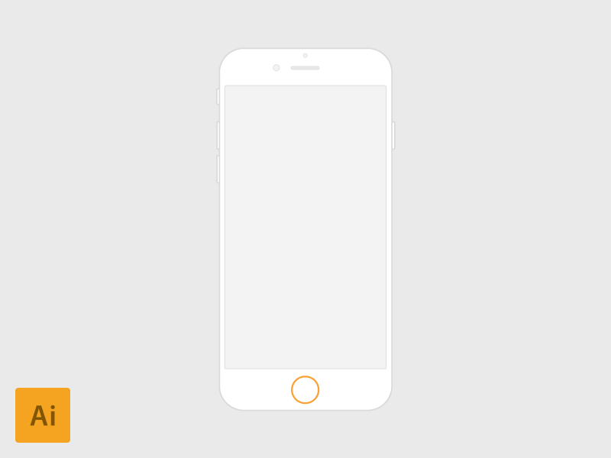

Description

UX Design

# Screen Overview

### Screen Title:

### Screen Code:



Description

UX Design