Large-Scale EVRPTW with Partial Recharging and Heterogeneous Charging Using ALNS-HCO

Abstract
Electric vehicle routing with time windows becomes more complex when charging stations differ in charging rate, electricity price, and waiting time. This paper presents a two-phase Adaptive Large Neighborhood Search with a Heterogeneous Charging Oracle (ALNS-HCO) for large-scale electric vehicle routing with time windows. In Phase I, ALNS uses partial, just-enough-oriented recharging to construct a strong feasible routing solution and determine the fleet size. In Phase II, this fleet size is fixed while customer assignments and visit sequences may still change. The Heterogeneous Charging Oracle evaluates charging alternatives using expected electricity price, expected waiting time, charging rate, explicit partial charging quantities, and complete route feasibility. The method is evaluated on 120 Hanif benchmark instances with 1,000 customers under Original and Relaxed time windows. The experimental design separates three effects, full versus partial recharging, detour-only versus heterogeneous station selection, and fixed-fleet Phase-II search with versus without HCO. Results show that partial recharging provides the largest and most consistent benefit, reducing charging expense by about 26.8% under Original time windows and 12.6% under Relaxed time windows, together with clear reductions in charged energy and charging time. Heterogeneous charging information provides smaller and more selective improvements. On identical fixed routes, it slightly reduces expected charging expense and station waiting under Original time windows, while the matched Phase-II analysis shows that larger gains are concentrated mainly in the C1 family. Under Relaxed time windows, the heterogeneous effect is weak or absent. Overall, the study shows that recharge quantity, station heterogeneity, and charging-aware rerouting should be evaluated separately when assessing large-scale electric vehicle routing methods.

Symbol | Explanation
$$G=\left(N , A\right)$$ | Directed network representing the EVRPTW
$$N$$ | Set of all nodes
$$A$$ | Set of arcs connecting the nodes
$$0$$ | Depot
$$C$$ | Set of customers
$$S$$ | Set of charging stations
$$d_{ij}$$ | Travel distance from node $i$to node $j$
$$τ_{ij}$$ | Travel time from node $i$to node $j$
$$q_{i}$$ | Demand of customer $i$
$$s_{i}$$ | Service time of customer $i$
$$\left[a_{i} , b_{i}\right]$$ | Time window of customer $i$
$$Q$$ | Vehicle load capacity
$$B^{max}$$ | Maximum vehicle battery capacity
$$B^{0}$$ | Initial vehicle battery level
$$B_{i}^{arr}$$ | Battery level when arriving at node $i$
$$B_{i}^{dep}$$ | Battery level when leaving node $i$
$$h$$ | Energy-consumption rate per unit of distance
$$E_{ij}$$ | Energy required to travel from $i$to $j$
$$e_{s}$$ | Energy charged during a visit to station $s$
$$r_{s}$$ | Charging rate of station $s$
$$μ_{s}^{P},σ_{s}^{P}$$ | Lognormal distribution parameters for charging price at station $s$
$$μ_{s}^{W},σ_{s}^{W}$$ | Lognormal distribution parameters for waiting time at station $s$
$${\overline{P}}_{s}$$ | Expected electricity price at station $s$
$${\overline{W}}_{s}$$ | Expected waiting time at station $s$
$$t_{s}^{ch}$$ | Charging time at station $s$
$$c_{s}^{ch}$$ | Expected charging expense at station $s$
$$t_{s}^{station}$$ | Total station time, including expected waiting and charging
$$A_{i}$$ | Arrival time at node $i$
$$D_{i}$$ | Departure time from node $i$
$$R$$ | Complete vehicle route
$$R^{C}$$ | Customer sequence supplied to HCO
$$V_{ch}$$ | Set of charging visits in a solution
$$X$$ | Current complete solution
$$X^{'}$$ | Candidate solution
$$X^{PR}$$ | Best solution obtained at the end of Phase I
$$X^{*}$$ | Final solution returned by ALNS-HCO
$$K$$ | Number of vehicles used
$$K^{*}$$ | Fleet size fixed after Phase I, $K\left(X^{PR}\right)$
$$D$$ | Total travel distance
$$D_{PR}$$ | Travel distance of the Phase-I solution $X^{PR}$
$$T$$ | Total route duration
$$N_{ch}$$ | Total number of charging visits
$$E_{ch}$$ | Total energy charged
$$T_{wait}$$ | Total expected station waiting time
$$T_{ch}$$ | Total charging time
$$C_{ch}$$ | Total expected charging expense
$${\overline{P}}_{used}$$ | Mean expected price of the charging stations used
$${\overline{W}}_{used}$$ | Mean expected waiting time of the charging stations used
$${\overline{r}}_{used}$$ | Mean charging rate of the charging stations used
$$ε$$ | Maximum Phase-II distance tolerance relative to $D_{PR}$
$$k$$ | Number of stations retained from each HCO ranking criterion
$$L$$ | Number of reinsertion alternatives retained in the Phase-II shortlist

Introduction
The use of electric vehicles in freight distribution has created new routing problems that do not appear in conventional vehicle routing. In addition to deciding which customers should be served by each vehicle and in which order, an electric fleet must operate with limited battery capacity and may need to visit charging stations during its routes. These charging stops can increase travel distance, route duration, and the risk of arriving late at customers. Early green vehicle routing studies showed that limited driving range and the location of refueling or charging facilities can strongly affect route feasibility and routing cost [1]. The Electric Vehicle Routing Problem with Time Windows and Recharging Stations (EVRPTW) later provided a widely used framework that combines customer time windows, vehicle capacity, battery restrictions, and visits to charging stations [2]. Since then, many extensions have been proposed to make electric vehicle routing closer to real operating conditions. These include mixed fleets of electric and conventional vehicles, more realistic energy-consumption models, different vehicle types, fleet-size decisions, multiple visits to charging stations, and exact solution approaches [3–5]. One of the most important developments has been the treatment of the charging quantity as a decision instead of assuming that every vehicle must fully recharge its battery. Studies considering several charging technologies and partial charging showed that the amount of energy taken at a station can influence both route feasibility and total operating time [6,7]. Later work using Adaptive Large Neighborhood Search (ALNS) confirmed that partial charging can produce better EVRPTW solutions than a full-recharge policy because vehicles can avoid spending unnecessary time at charging stations [8]. Exact algorithms reached a similar conclusion, showing that multiple and partial recharges can reduce routing costs and, in some cases, the number of vehicles required [5]. These findings changed the role of charging in EV routing, charging is not only a way to restore battery feasibility, but also an operational decision that can directly affect route quality. More detailed models have also shown that simplified charging assumptions may lead to poor decisions. For example, nonlinear charging functions can change the amount of time required to reach a given battery level and therefore affect the feasibility and cost of a route [9]. Reviews of the EV routing literature confirm that battery management, charging policy, energy consumption, and charging infrastructure have become central parts of modern EV routing models [14,18,19].
A further challenge appears when charging stations are not identical. Many early EVRPTW models mainly considered the location of a station and the time required to recharge, while practical charging networks may contain stations with very different operating conditions. A station may be geographically attractive but expensive, another may provide faster charging but require a longer detour, and another may offer a low electricity price but have a high expected waiting time. These differences mean that the nearest charging station is not always the best choice. Research that included waiting at charging stations showed that queues can significantly affect routing and charging decisions and that vehicles may benefit from avoiding busy stations even when this requires a different route [10]. When waiting times are uncertain, route plans based only on deterministic travel and charging times can also become less reliable, which has led to simulation-based ALNS approaches that construct routes using expected station waiting and then examine their performance under uncertain conditions [11]. Public charging infrastructure introduces similar decisions because vehicles must balance route structure with the expected availability and operating conditions of external charging facilities [12]. At the route level, charging itself can also be treated as a separate optimization problem, once a customer sequence is known, the algorithm must decide where charging stations should be inserted and how much energy should be obtained at each charging stop [13]. These studies show that routing and charging are closely connected, but they also show that the charging decision has enough structure to be studied and improved separately. More recent research has moved further toward heterogeneous charging networks by jointly considering differences in charging technology, charging functions, electricity prices, and waiting conditions [15]. This confirms that station heterogeneity can affect much more than charging cost; it can influence route duration, station selection, charging quantity, and even the customer-routing structure itself. At the same time, adding these decisions makes the problem harder to solve, especially when the number of customers becomes large. Much of the classical EVRPTW literature has therefore relied on benchmark instances with up to about 100 customers, while exact approaches become increasingly difficult as problem size and charging detail increase [5,14]. Recent work has also explored two-phase ALNS structures in which fleet sizing is handled before later routing improvement, showing that separating important decisions can make large EV routing problems easier to manage [16]. However, there is still limited controlled evidence on how partial charging, station price, expected waiting, charging rate, and charging-aware customer rerouting interact when the problem contains hundreds or thousands of customers. This gap is important because a method that performs well on small EVRPTW instances may become too slow or too complex when charging decisions must be evaluated repeatedly on a much larger network.
This paper studies this problem through ALNS-HCO, an ALNS-based framework with a Heterogeneous Charging Oracle for large EVRPTW instances with heterogeneous charging stations. The study uses a benchmark containing 120 instances with 1,000 customers each, built from clustered, random, and mixed customer distributions and provided under both original and relaxed time-window settings [17]. Charging stations in this benchmark differ in charging rate and are also described by parameters for charging price and waiting time, which makes it possible to study routing and charging decisions under controlled station heterogeneity [17]. The proposed framework contains two connected phases. In the first phase, ALNS searches for feasible and high-quality customer routes while using partial, just-enough charging instead of forcing vehicles to return to full battery at every charging stop. This phase determines the fleet size and provides the main routing solution. The fleet size is then fixed. In the second phase, the search continues with the Heterogeneous Charging Oracle, which evaluates charging decisions using the expected electricity price, expected waiting time, charging rate, and energy required at each station. Customer assignments and sequences may still be adjusted during this phase, but the established fleet size is preserved, allowing the method to study whether charging-aware routing can improve operating conditions without requiring additional vehicles. The main contribution is therefore not the introduction of ALNS, partial charging, or heterogeneous charging stations individually, since all of these ideas have appeared in earlier research [8,13,15]. Instead, the paper provides a controlled large-scale analysis of how these components work together in a 1,000-customer EVRPTW setting. In particular, the experiments separate four effects, full recharging, partial recharging, HCO applied to fixed customer routes, and charging-aware rerouting with HCO. This separation is important because an observed reduction in charging expense can have several different causes. A vehicle may charge less total energy, visit fewer stations, choose stations with lower expected electricity prices, experience less waiting, or use stations with higher charging rates. For this reason, the study evaluates not only fleet size and travel distance, but also route duration, number of charging visits, total charged energy, expected station waiting, charging time, charging expense, and computational time. By examining these measures separately across 120 large instances and six customer-distribution families, the paper aims to provide a clear view of the benefits, limits, and trade-offs of charging-aware electric vehicle routing at a scale that remains less studied in the existing EVRPTW literature.
2. Related Work
Electric vehicle routing research has gradually developed from basic battery-feasibility models toward models that include charging quantity, charging time, station selection, and more detailed energy considerations. The classical EVRPTW considers customer demands, time windows, vehicle capacity, battery limits, and charging-station visits [2]. Later studies extended this setting to mixed fleets [3], fleet-size decisions [4], exact solution methods [5], different charging technologies [6], and partial recharging [7,8]. Partial recharging is particularly important because a vehicle does not always need to restore its battery to full capacity. Charging only the required amount can reduce unnecessary charging time and improve route flexibility [5,8]. Other studies have considered different battery characteristics, energy-consumption assumptions, charging speeds, and charging technologies [21,23–25]. These developments show that charging quantity and routing decisions are closely connected.
More detailed charging and energy models have also been proposed. Nonlinear charging functions account for the fact that charging speed may change with the battery state [9]. Other studies have examined vehicle scheduling, uncertain energy consumption, and the effects of traffic, payload, road conditions, and driving behavior on energy use [26,27,31]. Charging-station location has also been integrated with routing decisions [32,33]. These richer models provide a more realistic description of electric-vehicle operations, but they also increase computational difficulty, particularly when charging decisions must be evaluated repeatedly for large customer sets.
Charging-station conditions form another important research direction. Time-dependent waiting at charging stations can affect both route timing and station selection [10], while stochastic waiting has been studied using simulation-based approaches [11]. Public charging stations introduce additional uncertainty because their availability and operating conditions may vary [12]. Station capacity and queueing interactions have also been considered when several vehicles may compete for the same charging resource [22,30]. More recent work has focused on heterogeneous charging networks with differences in charging rate, charging technology, electricity price, and waiting conditions [15,21,25]. These studies show that the nearest charging station is not always the most attractive optionm a nearby station may be expensive or congested, while a more distant station may offer lower expected cost or better operating conditions. In the present study, station heterogeneity is represented through charging rate, expected electricity price, and expected waiting time, which allows these effects to be evaluated repeatedly within a large-scale search procedure.
Electric vehicle routing remains computationally difficult because a change in customer order can affect arrival times, battery levels, charging requirements, and overall route feasibility. Exact methods can solve some small and medium-sized EVRPTW instances [5,25], whereas metaheuristics are generally more suitable for large problems. Adaptive Large Neighborhood Search has been widely applied to EV routing with partial charging [8], charging technologies [21], time-dependent waiting [10], stochastic waiting [11], and other time-dependent routing settings [29]. ALNS is attractive because it repeatedly destroys and repairs parts of the current solution and adapts the selection of search operators according to their performance [20,28].
Several studies also separate customer routing from charging optimization. In such approaches, the customer sequence is first determined and a separate procedure then selects charging stations and charging quantities [10,13,21]. This decomposition can reduce computational effort, but a fixed customer sequence may prevent the charging procedure from finding route structures that provide better access to charging stations. Recent research has also considered two-phase approaches that separate fleet construction from later route improvement [16]. The ALNS-HCO framework follows this general decomposition idea but focuses on a different question, it keeps the Phase-I fleet size fixed while allowing customer routes to change and uses HCO to evaluate charging consequences during the second search phase. The computational study then separates the effects of partial recharging, heterogeneous station information, and charging-aware rerouting rather than attributing all changes to a single combined method.
Table 1. Comparison of representative studies on electric vehicle routing and charging decisions
Study | Partial recharge | Different charging rates / technologies | Charging cost / price | Waiting / queueing | Charging-aware routing | Main approach | Main focus
[2] | No | No | No | No | Limited | Hybrid heuristic | Basic EVRPTW
[8] | Yes | No | No | No | Yes | ALNS | Partial charging
[9] | Yes | Charging function | No | No | Yes | Metaheuristic | Nonlinear charging
[10] | Yes | No | Yes | Time-dependent | Yes | ALNS and optimization | Station waiting
[11] | Yes | No | Yes | Stochastic | Yes | Simulation and ALNS | Uncertain waiting
[21] | Yes | Yes | Yes | No | Yes | ALNS and route optimization | Fast chargers
[25] | Yes | Yes | Yes | No | Yes | Branch-and-price | Charging technologies
[15] | Yes | Yes | Yes | Time-dependent | Yes | MILP and local search | Heterogeneous stations
This study | Yes | Yes | Expected price | Expected waiting | Yes | Two-phase ALNS and HCO | Controlled large-scale charging analysis
Table 1 shows that partial charging, different charging technologies, charging cost, station waiting, and heterogeneous charging have all been studied previously. The contribution of this work is therefore not any of these elements individually. Instead, the study provides a controlled large-scale analysis on 120 Hanif instances with 1,000 customers [17]. Full and partial recharging are first compared under the same search budget. The effect of heterogeneous station information is then isolated by comparing a detour-only oracle with HCO-Heterogeneous on identical customer routes, while the contribution of HCO during Phase II is evaluated against a matched fixed-fleet search without HCO. This design makes it possible to distinguish improvements caused by recharge quantity, station selection, and customer-route restructuring.

Problem Setting
Problem Description and Assumptions
The problem is defined on a directed network $G=\left(N , A\right)$, where $N=\left\{0\right\}∪C∪S$contains one depot $0$, a set of customers $C$, and a set of charging stations $S$. Each arc $\left(i , j\right)∈A$has a travel distance $d_{ij}$and a travel time $τ_{ij}$. A homogeneous fleet of electric vehicles starts from the depot, serves all customers, may visit charging stations when necessary, and returns to the depot at the end of each route. Each customer must be served exactly once. The Hanif benchmark used in this study contains 1,000 customers per instance and heterogeneous charging stations distributed throughout the service region [17].
Each customer $i∈C$has a demand $q_{i}$, a service time $s_{i}$, and a time window $\left[a_{i} , b_{i}\right]$. A vehicle may arrive before $a_{i}$, but service cannot start before this time and must start no later than $b_{i}$. Each vehicle has a load capacity $Q$, and the total customer demand assigned to a route cannot exceed this capacity.
Each vehicle also has a maximum battery capacity $B^{max}$and an initial battery level $B^{0}$defined by the benchmark. Travel consumes energy according to the distance between two consecutive nodes. Let $h$denote the energy-consumption rate per unit of distance. The energy required to travel from node $i$to node $j$is
$$E_{ij}=h d_{ij}$$
The battery level must remain non-negative throughout the route. When the available energy is insufficient to continue the route, the vehicle may visit a charging station.
The problem permits partial recharging. A vehicle is therefore not required to return to full battery capacity at every charging stop and may instead obtain only the energy required for the continuation of its route. Let $e_{s}$denote the amount of energy charged during a visit to station $s$. The charging quantity satisfies
$$0≤e_{s}≤B^{max}-B_{s}^{arr}$$
where $B_{s}^{arr}$is the battery level on arrival at the station. The full-recharge policy used later as an experimental baseline is a restricted case in which the battery is replenished to $B^{max}$at every charging visit.
Charging stations are heterogeneous. Each station $s∈S$is characterized by a charging rate $r_{s}$, an expected electricity price ${\overline{P}}_{s}$, and an expected waiting time ${\overline{W}}_{s}$. In the Hanif benchmark, charging price and station waiting are represented using lognormal distributions [17]. Their expected values are
$${\overline{P}}_{s}=\exp\left(μ_{s}^{P}+\frac{{\left(σ_{s}^{P}\right)}^{2}}{2}\right)$$
and
$${\overline{W}}_{s}=\exp\left(μ_{s}^{W}+\frac{{\left(σ_{s}^{W}\right)}^{2}}{2}\right)$$
These expected values are used directly during optimization; no stochastic price or waiting-time realizations are sampled during the search.
For a charging quantity $e_{s}$, the charging time is
$$t_{s}^{ch}=\frac{e_{s}}{r_{s}}$$
and the expected charging expense is
$$c_{s}^{ch}=e_{s}{\overline{P}}_{s}$$
The total time associated with the charging visit is therefore
$$t_{s}^{station}={\overline{W}}_{s}+\frac{e_{s}}{r_{s}}$$
The heterogeneous station attributes create a trade-off among route detour, electricity price, expected waiting, and charging speed. A nearby station may have a high price or expected waiting time, while a more distant station may provide cheaper or faster charging. Station selection must therefore be considered together with the required charging quantity and route feasibility.
The model allows a vehicle to visit charging stations multiple times when required. Charging is assumed to be linear at the station-specific rate $r_{s}$, and the station attributes ${\overline{P}}_{s}$ and ${\overline{W}}_{s}$ are treated as deterministic expected values during optimization. Charging stations are assumed to have sufficient capacity, so interactions between vehicles using the same station are not modeled. Nonlinear battery-charging functions, stochastic station realizations, and time-dependent station congestion are outside the scope of the present study.
Feasibility and Performance Measures
A vehicle route is represented as
$$R=\left(v_{0} , v_{1} , … , v_{m} , v_{m+1}\right)$$
where $v_{0}=v_{m+1}=0$denotes the depot and the intermediate nodes may be customers or charging stations. A route is feasible only if it satisfies the load-capacity, time-window, battery, and depot-return conditions.
The vehicle-capacity constraint is
$$\sum_{i∈C∩R}{q_{i}}≤Q$$
Let $A_{i}$ and $D_{i}$ denote the arrival and departure times at node $i$. For two consecutive route nodes $i$and $j$,
$$A_{j}=D_{i}+τ_{ij}$$
If $j$is a customer, service starts at
$$S_{j}=\max\left\{A_{j} , a_{j}\right\}$$
and time-window feasibility requires
$$S_{j}≤b_{j}$$
The departure time from the customer is
$$D_{j}=S_{j}+s_{j}$$
If $j=s∈S$is a charging station, the departure time is
$$D_{s}=A_{s}+{\overline{W}}_{s}+\frac{e_{s}}{r_{s}}$$
Battery energy is updated after every traveled arc. If the vehicle leaves node $i$with battery level $B_{i}^{dep}$, its battery level on arrival at $j$is
$$B_{j}^{arr}=B_{i}^{dep}-h d_{ij}$$
Battery feasibility requires
$$B_{j}^{arr}≥0$$
at every visited node. At a charging station,
$$B_{s}^{dep}=B_{s}^{arr}+e_{s}$$
with
$$0≤B_{s}^{dep}≤B^{max}$$
At customers and other non-charging nodes, the battery level is unchanged during service. Every vehicle must complete its route and return to the depot while satisfying all capacity, time-window, and battery conditions.
Because routing and charging performance cannot be described by a single measure, several indicators are recorded for each complete solution. The first is fleet size,
$$K$$
which represents the number of vehicles used. Total travel distance is
$$D=\sum_{R}{\sum_{\left(i , j\right)∈R}{d_{ij}}}$$
Total route duration is denoted by $T$and includes travel, customer waiting, customer service, expected station waiting, and charging time.
The total number of charging visits is
$$N_{ch}=\sum_{R}{∣\left\{s:s∈R∩S\right\}∣}$$
The total charged energy is
$$E_{ch}=\sum_{s∈V_{ch}}{e_{s}}$$
where $V_{ch}$denotes all charging visits in the solution. Total expected station waiting is
$$T_{wait}=\sum_{s∈V_{ch}}{{\overline{W}}_{s}}$$
while total charging time is
$$T_{ch}=\sum_{s∈V_{ch}}{\frac{e_{s}}{r_{s}}}$$
The total expected charging expense is
$$C_{ch}=\sum_{s∈V_{ch}}{e_{s}}{\overline{P}}_{s}$$
Three derived measures are used to explain the source of changes in charging performance. The effective charging expense per unit of energy is
$$\frac{C_{ch}}{E_{ch}}$$
the expected waiting time per charging visit is
$$\frac{T_{wait}}{N_{ch}}$$
and the charging time per unit of energy is
$$\frac{T_{ch}}{E_{ch}}$$
These indicators help distinguish between effects caused by charging less energy, using fewer station visits, paying a different effective electricity price, or charging at different effective rates.
The corrected experiments also record the characteristics of the charging stations actually selected by each method. For $N_{ch}>0$, the mean expected price of the used stations is
$${\overline{P}}_{used}=\frac{1}{N_{ch}}\sum_{s∈V_{ch}}{{\overline{P}}_{s}},$$
the mean expected waiting time is
$${\overline{W}}_{used}=\frac{1}{N_{ch}}\sum_{s∈V_{ch}}{{\overline{W}}_{s}},$$
and the mean charging rate is
$${\overline{r}}_{used}=\frac{1}{N_{ch}}\sum_{s∈V_{ch}}{r_{s}}.$$
These measures allow the computational study to determine directly whether heterogeneous charging information shifts charging toward stations with different price, waiting, or charging-rate characteristics.
A feasible solution must therefore serve every customer exactly once, respect vehicle capacity and customer time windows, maintain battery feasibility throughout every route, and return all vehicles to the depot. The measures defined above are used to evaluate routing and charging performance. They should not be interpreted as a single optimization objective; the phase-specific rules used to rank and accept candidate solutions are defined in Section 4.
ALNS-HCO Methodology
The proposed ALNS-HCO framework separates routing and charging improvement into two connected phases. Phase I applies Adaptive Large Neighborhood Search with partial recharging to obtain a strong feasible routing solution and determine the fleet size. Phase II fixes this fleet size and continues the search while using a Heterogeneous Charging Oracle (HCO) to evaluate charging decisions. This separation allows charging performance to be improved without increasing the number of vehicles established during the first phase.
Two-Phase Search
Let $X^{PR}$denote the best solution obtained in Phase I. Its fleet size and travel distance are
$$K^{*}=K\left(X^{PR}\right)$$
and
$$D_{PR}=D\left(X^{PR}\right).$$
Phase II starts from $X^{PR}$and keeps the fleet size fixed at $K^{*}$, although customers may still be reassigned or reordered among the existing routes. To protect the routing quality obtained in Phase I, a Phase-II solution $X$is admissible only if
$$K\left(X\right)=K^{*}$$
and
$$D\left(X\right)≤\left(1+ε\right)D_{PR},$$
where $ε$is a distance-tolerance parameter.
Among admissible Phase-II solutions, charging performance is compared lexicographically using
$$\left(C_{ch} , T_{wait} , T_{ch} , D\right).$$
Charging expense therefore has the first priority, followed by expected station waiting, charging time, and travel distance. This avoids introducing an arbitrary weighted combination of monetary and time-based measures.
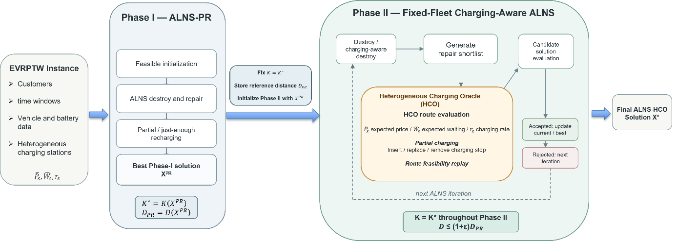
Figure 1: Two-phase structure of the proposed ALNS-HCO method
Figure 1 summarizes the complete search structure. Phase I establishes $X^{PR}$, $K^{*}$, and $D_{PR}$, while Phase II performs fixed-fleet charging-aware improvement through repeated destroy, repair, HCO evaluation, and candidate acceptance.
Algorithm 1: ALNS-HCO main procedure
Input: EVRPTW instance $I$
Output: Final solution $X^{*}$
1. | $$X^{PR}←\text{ALNS-PR}\left(I\right)$$
2. | $$K^{*}←K\left(X^{PR}\right)$$
3. | $$D_{PR}←D\left(X^{PR}\right)$$
3. | Fix the fleet size at $K=K^{*}$for Phase II
4. | $$X^{*}←\text{FixedFleet-ALNS-HCO}\left(I , X^{PR} , K^{*},D_{PR}\right)$$
5. | Apply final HCO refinement to $X^{*}$
6. | Replay and validate $X^{*}$
7. | If $X^{*}$ is infeasible or $K\left(X^{*}\right)≠K^{*}$ then
8. | $X^{*}←X^{PR}$
9. | End if
10. | Return $X^{*}$

Phase I: ALNS with Partial Recharging
Phase I begins with a feasible insertion-based solution and improves it through ALNS destroy-and-repair iterations. Four removal operators are used, random removal, worst-detour removal, related removal, and short-route removal. These operators explore different customer assignments and route structures.
Removed customers are reinserted into promising feasible positions while capacity, time-window, and battery constraints are checked through route replay. When charging is necessary, the method permits partial recharging instead of requiring a full battery at every station. The charging policy is just-enough oriented, the method first attempts to take only the energy needed to continue the route, while larger charging quantities may be used when required for feasibility.
Phase-I solutions are ranked first by fleet size and then by travel distance. For two feasible solutions $X_{a}$and $X_{b}$, $X_{a}$is preferred if
$$K\left(X_{a}\right)<K\left(X_{b}\right),$$
or, when the fleet sizes are equal, if
$$D\left(X_{a}\right)<D\left(X_{b}\right).$$
This priority is important because the best Phase-I fleet size becomes fixed in Phase II.
Destroy operators are selected adaptively according to their recent performance. Simulated annealing is also used to accept some non-improving distance moves when the fleet size is not worsened. This provides diversification while maintaining the main fleet-size objective [20,28]. At the end of the search, the best solution becomes $X^{PR}$.
Algorithm 2: Phase I ALNS with partial recharging
Input: EVRPTW instance I
Output: Best Phase-I solution $X^{PR}$
1. | Construct an initial feasible solution X
2. | Set $X^{PR}←X$ and initialize ALNS parameters
3. | While the stopping condition is not met do
4. | Destroy part of X and repair using partial recharging
6. | Replay and validate the candidate solution $X^{'}$
7. | If $X^{'}$is accepted then $X←X^{'}$
8. | If $X$ improves the best Phase-I solution then $X^{PR}←X$
9. | Update operator weights and annealing parameters
10. | End while
11. | Return $X^{PR}$

Heterogeneous Charging Oracle
HCO is a deterministic route-level heuristic that constructs or improves the charging plan of a given customer sequence. It determines which charging stations should be visited and how much energy should be obtained at each visit. HCO is used repeatedly during Phase II and is therefore designed to evaluate a restricted set of promising stations rather than all stations in the network.
When a route becomes battery-infeasible, HCO identifies the first infeasible route segment and builds candidate-station rankings according to
$$\text{detour}↑, {\overline{P}}_{s}↑, {\overline{W}}_{s}↑, r_{s}↓.$$
The first $k$stations from each ranking are combined, duplicate candidates are removed, and dominated candidates are discarded. In the final implementation, $k=5$.
For every retained station, HCO determines an explicit partial charging quantity and performs a complete route replay. Battery levels are propagated sequentially through all previous charging events, so every charging stop has an explicit energy decision $e_{s}$. Feasible charging alternatives are compared using
$$\left(C_{ch} , T_{wait} , T_{ch} , D\right).$$
After a feasible charging plan is constructed, the oracle may test station removal or replacement. A modified plan is retained only when feasibility is preserved and the resulting charging plan is better under the same lexicographic criterion. Consequently, HCO is non-worsening with respect to the charging plan supplied as input.
Previously evaluated route structures are cached to reduce repeated charging evaluations during ALNS.
For experimental analysis, a detour-only version of HCO is also considered. This control selects charging stations using only travel detour and a deterministic station-identifier tie-break. Expected price, expected waiting, and charging rate do not influence its station-selection decisions. This allows the effect of heterogeneous station information to be studied separately in Section 5.
Algorithm 3: Heterogeneous Charging Oracle
Input: Customer route $R^{C}$, charging-station set S
Output: Improved feasible charging route R
1. | Set $R←R^{C}$ and replay the route
2. | While R is battery-infeasible do
3. | Identify the first infeasible route segment
4. | Rank stations by detour, ${\overline{P}}_{s}$, ${\overline{W}}_{s}$, and $r_{s}$
5. | Form the top-$k$ candidate union and remove dominated stations
6. | for each candidate station s do
7. | Insert $s$ and determine explicit partial charge $e_{s}$
8. | Replay the complete route
9. | End for
10. | Keep the best feasible alternative by $\left(C_{ch} , T_{wait} , T_{ch} , D\right)$
11. | End while
12. | Test feasible station removal or replacement
13. | Keep only improving modifications
14. | Compare the final plan with the input plan
15. | Keep the input plan if the new plan is not better
16 | Replay and validate R
17. | Return R

Phase II: Fixed-Fleet Charging-Aware Search
Phase II starts from $X^{PR}$and keeps $K=K^{*}$throughout the accepted search solutions. Customer assignments and visit sequences may still change, allowing the search to identify route structures that provide better charging opportunities.
The general Phase-I destroy operators are retained and are complemented by charging-aware removal. The charging-aware mechanism targets route regions associated with unfavorable charging conditions using information related to charging expense, expected waiting, charging rate, station detour, and charged energy. Removing customers around these regions gives the repair stage an opportunity to reconstruct the surrounding route.
The main difference from Phase I is that HCO is integrated directly into customer reinsertion. For each removed customer, the method first generates several promising insertion alternatives. A short list of the best candidates is retained; the final implementation uses five alternatives. HCO then evaluates the affected route for each shortlisted insertion, and the best HCO-evaluated alternative is selected. Charging information can therefore influence the reinsertion decision itself rather than being applied only after the customer route has already been fixed.
After all removed customers have been reinserted, the complete candidate solution is replayed. A candidate is rejected if it is infeasible, uses a fleet size different from $K^{*}$, or violates
$$D\left(X\right)≤\left(1+ε\right)D_{PR}.$$
Admissible solutions are ranked according to
$$\left(C_{ch} , T_{wait} , T_{ch} , D\right).$$
Simulated annealing is retained to permit limited exploratory acceptance of non-improving candidates, while operator weights are updated adaptively according to search performance.
At the end of Phase II, the best retained solution undergoes a final non-worsening HCO refinement and complete feasibility replay. The validated solution is returned as $X^{*}$.
Algorithm 4: Phase II fixed-fleet charging-aware ALNS
Input: $X^{PR},K^{*},D_{PR}$
Output: Final solution $X^{*}$
2. | Set $X←X^{PR}$, $X^{*}←X$
3. | Initialize Phase-II ALNS parameters
4. | While stopping condition is not met do
5. | Select a general or charging-aware destroy operator
6. | Remove a subset of customers from 𝑋
7. | Generate a shortlist of promising reinsertion alternatives
8. | Apply HCO to each shortlisted alternative
9. | Select the best HCO-evaluated repair
 | Replay the complete candidate X^{\prime }
10. | If $X^{'}$ is feasible and $K\left(X^{'}\right)=K^{*}$ and $D\left(X^{'}\right)≤\left(1+ε\right)D_{PR}$ then
11. | Apply the ALNS acceptance rule
12. | Update $X$ if the candidate is accepted
13. | Update $X^{*}$if $\left(C_{ch} , T_{wait} , T_{ch} , D\right)$ improves
14. | End if
15. | Update operator weights and annealing parameters
16 | End while
17. | Apply final HCO refinement and validate $X^{*}$
19. | Return $X^{*}$

Computational Study
The computational study evaluates ALNS-HCO on the Hanif large-scale EVRPTW benchmark [17]. The experiments are designed to separate the effects of routing search, recharge quantity, heterogeneous station information, and charging-aware route improvement. The first analysis compares the main routing baselines and measures the effect of replacing full recharge with partial recharge. The later analyses use a common Phase-I solution to isolate the contribution of HCO and heterogeneous station information without mixing these effects with differences in Phase-I search time.
Benchmark and Experimental Setup
The Hanif benchmark [17] extends 1,000-customer routing instances with heterogeneous charging-station attributes. It contains 60 base instances from six families, C1, C2, R1, R2, RC1, and RC2. Each instance is available under two time-window regimes. The Original TW version keeps the original customer time windows, whereas the Relaxed TW version extends the customer due dates. The complete study therefore contains 120 instances, with 60 instances in each regime.
The routing comparison includes Greedy Insertion (GI), Variable Neighborhood Search (VNS), Simulated Annealing (SA), ALNS with full recharging (ALNS-FR), and ALNS with partial recharging (ALNS-PR). ALNS-FR and ALNS-PR both receive a 30 s search budget, which provides a direct comparison of the two recharge policies.
The charging-aware experiments use a separate controlled design. For each instance and seed, a 15 s ALNS-PR solution, denoted $X_{15}^{PR}$, is generated once and stored. All fixed-route HCO and Phase-II variants start from this same solution. This ensures that differences among these variants are caused by the charging treatment or Phase-II search rather than by different Phase-I starting solutions. Phase II receives an additional 15 s, giving the complete two-phase method a total nominal budget of 30 s.
The final Phase-II configuration uses $ε=0$, so accepted Phase-II solutions cannot exceed the travel distance of their shared Phase-I starting solution. HCO retains up to five candidate stations from each station-ranking criterion, while Phase-II repair keeps five promising insertion alternatives for HCO evaluation. The 15/15 time allocation is used as an equal division of the common 30 s budget and is not claimed to be an optimal allocation.
Table 2. Experimental settings.
Setting | Value
Benchmark | Hanif EVRPTW [17]
Instances | 120
Customers per instance | 1,000
TW settings | Original, Relaxed
Families | C1, C2, R1, R2, RC1, RC2
Runs per stochastic method | 5
Time budget | 30 s
ALNS-HCO budget | 15 s Phase I + 15 s Phase II

Overall Performance and Effect of Partial Recharging
Table 3 reports the overall routing performance of the baseline methods. The ALNS variants produce the smallest mean fleet sizes in both time-window regimes. Under Original TW, ALNS-FR obtains a mean fleet size of 69.96 and the shortest mean distance of 47,363.0, while ALNS-PR obtains the shortest mean route duration of 169,554.7. Under Relaxed TW, ALNS-FR and ALNS-PR again produce similar fleet and duration results, while VNS obtains the shortest mean travel distance. These results show that the two ALNS recharge policies provide comparable routing quality, making their charging-related differences particularly informative.
Table 3. Overall routing performance of the baseline methods.
TW | Method | Mean $K$ | Mean $D$ | Mean $T$ | Runtime (s)
Original | GI | 77.17 | 59,123.7 | 181,686.8 | 0.89
 | VNS | 75.56 | 48,813.3 | 179,163.3 | 30.87
 | SA | 75.87 | 49,344.5 | 182,011.1 | 30.85
 | ALNS-FR | 69.96 | 47,363.0 | 171,026.9 | 30.88
 | ALNS-PR | 70.07 | 48,766.9 | 169,554.7 | 30.88
Relaxed | GI | 77.00 | 68,841.6 | 184,023.6 | 1.13
 | VNS | 72.26 | 48,027.0 | 166,422.8 | 31.12
 | SA | 72.10 | 49,366.9 | 168,195.5 | 31.10
 | ALNS-FR | 61.86 | 48,167.4 | 149,526.2 | 31.12
 | ALNS-PR | 62.06 | 49,464.4 | 149,529.4 | 31.12

The direct comparison between ALNS-FR and ALNS-PR shows that the main benefit of partial recharging appears in charging performance rather than in travel distance. Under Original TW, partial recharging reduces mean paired charged energy by 26.01%, charging time by 25.43%, and charging expense by 26.82%. Their 95% confidence intervals are $\left[- , 33.42-18.52\right]$, $\left[- , 32.73-17.92\right]$, and $\left[- , 34.57-19.10\right]$, respectively. Charging visits decrease by 20.62% and expected station waiting by 22.39%. These gains are accompanied by a 3.34% increase in travel distance, while total route duration decreases slightly by 0.93%.
Under Relaxed TW, the same pattern remains but is weaker. Charged energy decreases by 11.52%, charging time by 10.74%, and charging expense by 12.62%, with all three confidence intervals remaining below zero. Charging visits decrease by 13.88% and expected station waiting by 15.41%. Travel distance increases by 3.37%, whereas the change in total route duration is only 0.07% and its confidence interval includes zero.
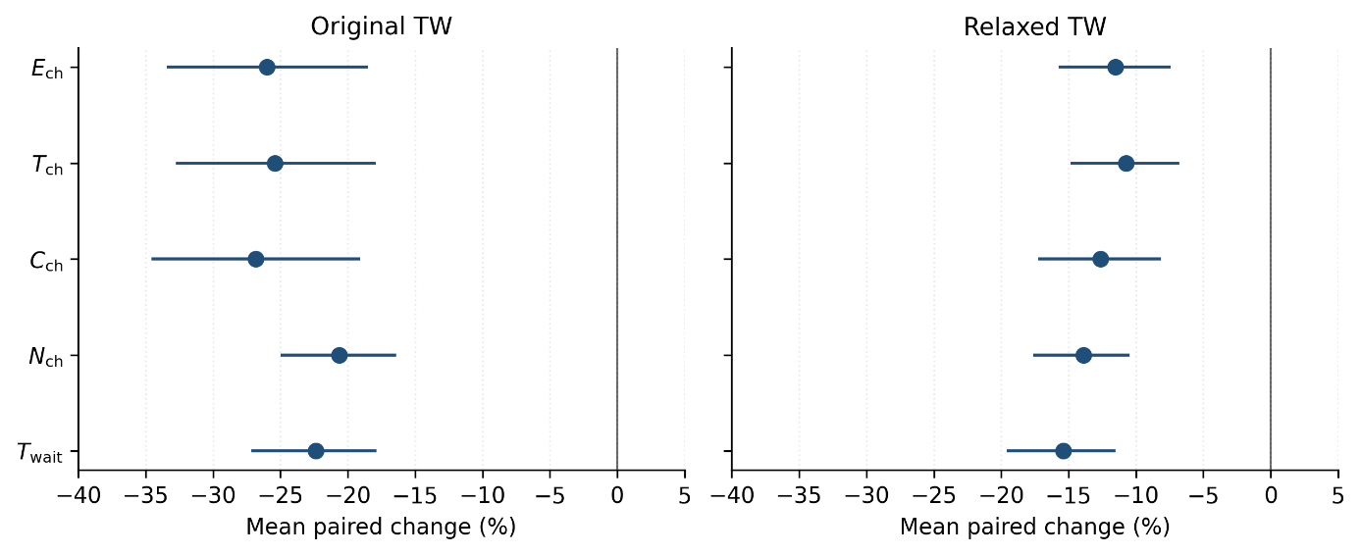
Figure 2. Effect of Partial Recharging on Routing and Charging Performance
Figure 2 presents the paired instance-level effects across the two time-window regimes. The results show that partial recharging consistently avoids unnecessary charging activity, vehicles make fewer charging visits, take less energy, spend less time charging, and incur lower expected charging expense. The effect is strongest under Original TW but remains clear under Relaxed TW. The percentages shown in Figure 2 are averages of instance-level relative changes and therefore are not obtained directly from the ratio of the aggregate means reported in Table 3.
Charging-Aware Phase and HCO Analysis
The charging-aware analysis uses the common $X_{15}^{PR}$starting solution so that all variants begin with the same routes and fleet size. The first comparison isolates the effect of heterogeneous station information by applying two HCO variants to identical customer routes. HCO-Detour selects stations using travel detour only, whereas HCO-Heterogeneous also considers expected price, expected waiting time, and charging rate.
Under Original TW, heterogeneous HCO reduces mean paired charging expense by $0.37\%$and expected station waiting by $1.25\%$. Charging time increases by $0.78\%$, while the number of charging visits remains unchanged. The difference is concentrated in only 7 of the 60 instances; the remaining 53 instances produce the same charging plan. Under Relaxed TW, the two HCO variants give identical results on all 60 instances.
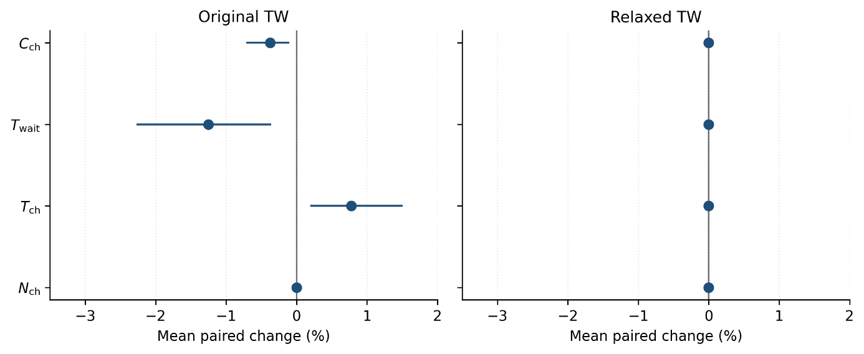
Figure 3. Fixed-Route Effect of Heterogeneous Charging Information
The station-level records explain this trade-off. Under Original TW, heterogeneous HCO selects stations with slightly lower expected price and waiting time than the detour-only oracle. However, the selected stations also have a slightly lower mean charging rate. This explains why waiting and charging expense decrease while charging time increases slightly.
Table 4. Characteristics of charging stations selected by the fixed-route HCO variants.
TW | HCO variant | $${\overline{P}}_{used}$$ | $${\overline{W}}_{used}$$ | $${\overline{r}}_{used}$$
Original | Detour | 0.5165 | 14.4205 | 1.1942
 | Heterogeneous | 0.5116 | 14.2645 | 1.1861
Relaxed | Detour | 0.5188 | 14.4949 | 1.1980
 | Heterogeneous | 0.5188 | 14.4949 | 1.1980

A second comparison measures whether HCO adds value beyond the same Phase-II search. PhaseII-NoHCO and PhaseII-Heterogeneous use the same starting solution, fleet size, operators, search budget, and acceptance rules; the main difference is the use of heterogeneous HCO during repair. Under Original TW, HCO reduces mean paired charging expense by $3.66\%$, expected station waiting by $3.04\%$, and charging time by $1.56\%$, while travel distance is almost unchanged.
These gains are not uniform across the benchmark. For charging expense, HCO improves 8 instances, ties on 29, and worsens 23, while the median paired change is zero. The negative mean is therefore driven by a limited set of instances with comparatively large improvements. Under Relaxed TW, HCO provides no overall benefit, charging expense increases slightly by $0.32\%$, and the changes in the other charging measures are also small.
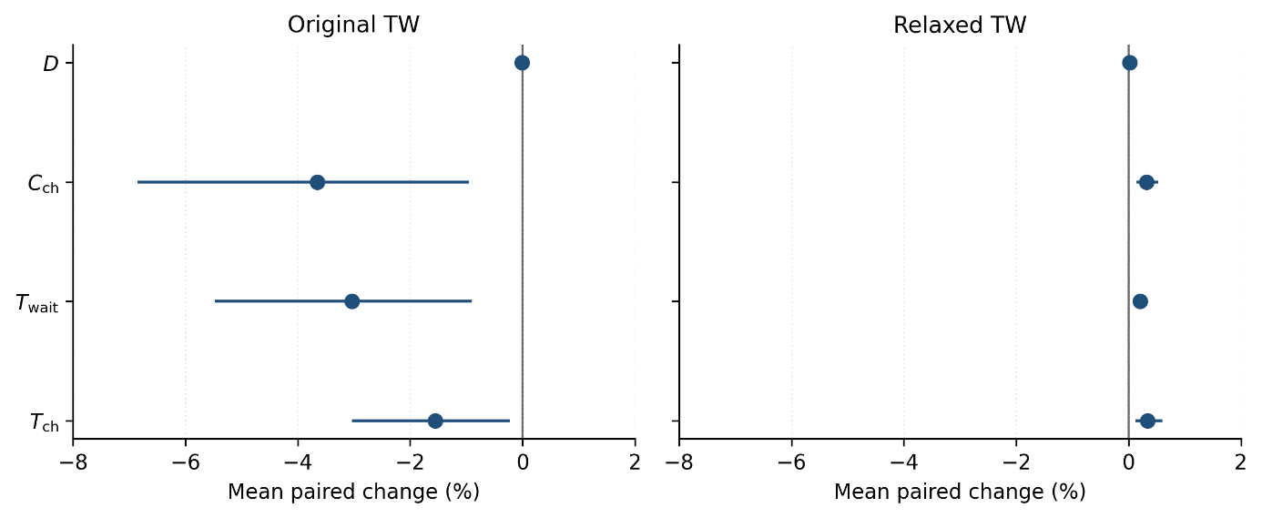
Figure 4. Effect of HCO Relative to the Matched Phase-II NoHCO Search
A further comparison between PhaseII-Detour and PhaseII-Heterogeneous gives a similar result. Under Original TW, heterogeneous station selection reduces charging expense by $0.53\%$and expected waiting by $1.63\%$, whereas the two variants are identical under Relaxed TW. Overall, heterogeneous charging information has a measurable but selective effect rather than a uniform benefit across all instances.
Effects of Instance Family and Time-Window Regime
The aggregate results hide clear differences among the six benchmark families. For the fixed-route heterogeneity comparison, Original C1 is the most responsive family. HCO-Heterogeneous reduces charging expense by $2.04\%$and expected waiting by $6.66\%$relative to HCO-Detour, although charging time increases by $4.39\%$. C2 and R1 show much smaller changes, while R2, RC1, and RC2 show no measurable fixed-route effect. Under Relaxed TW, all six families produce the same result for the two HCO variants.
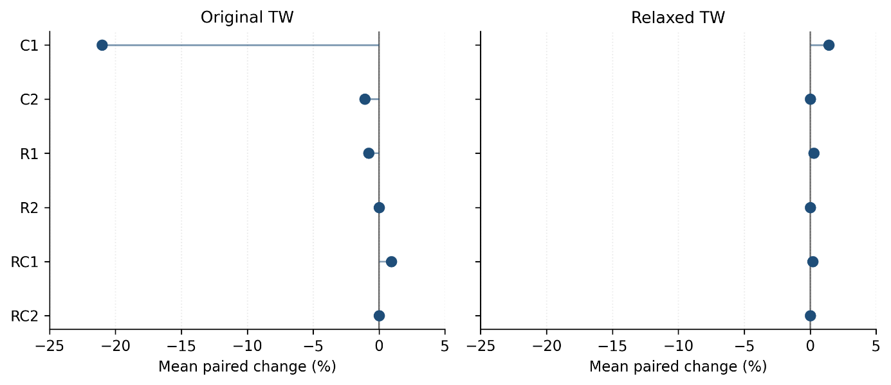
Figure 5. Family-Level Effect of Heterogeneous Charging Information
The matched PhaseII-NoHCO comparison shows an even stronger concentration of the HCO benefit in Original C1. Charging expense decreases by about $21.0\%$for C1, compared with only $1.07\%$for C2 and $0.79\%$for R1. R2 and RC2 show essentially no change, while RC1 increases slightly. Under Relaxed TW, none of the families obtains a meaningful reduction in charging expense.
Table 5. Mean paired change in charging expense by instance family (%).
Family | Fixed-route Het. vs Detour, Original | PhaseII-HCO vs NoHCO, Original | Fixed-route Het. vs Detour, Relaxed | PhaseII-HCO vs NoHCO, Relaxed
C1 | −2.04 | −21.00 | 0.00 | +1.42
C2 | −0.09 | −1.07 | 0.00 | +0.02
R1 | −0.11 | −0.79 | 0.00 | +0.27
R2 | 0.00 | 0.00 | 0.00 | 0.00
RC1 | 0.00 | +0.92 | 0.00 | +0.21
RC2 | 0.00 | 0.00 | 0.00 | +0.01

These results show that the value of heterogeneous charging awareness depends strongly on route structure and time-window tightness. The effect is concentrated mainly in Original-TW instances, particularly C1, while relaxed time windows leave little opportunity for the heterogeneous oracle to improve the charging decisions.
Discussion
The results show that partial recharging provides the largest and most consistent operational benefit. Compared with full recharging, ALNS-PR substantially reduces charged energy, charging time, and charging expense under both Original and Relaxed time windows. This confirms that avoiding unnecessary full charges is more important than simply changing the charging station, especially when route feasibility can be preserved with smaller energy amounts [8,21]. The effect of heterogeneous charging information is more limited. On fixed customer routes, HCO-Heterogeneous slightly reduces expected charging expense and station waiting under Original TW, but the effect appears in only a small number of instances and disappears under Relaxed TW. The station-level results also show a clear trade-off, heterogeneous HCO selects stations with slightly lower expected price and waiting time, but these stations are not necessarily faster. Therefore, considering station heterogeneity can improve some charging decisions, but it does not guarantee simultaneous improvements in price, waiting, charging time, and distance. This behavior is consistent with previous studies showing that charging price, waiting, charging technology, and route structure may create competing decisions [10,15,25].
The Phase-II experiments further show that the value of HCO depends strongly on the structure of the instance. Compared with the matched PhaseII-NoHCO control, heterogeneous HCO produces a favorable mean change under Original TW, but the improvement is concentrated in a limited number of instances, especially the C1 family, while many instances show no change or even a small deterioration. Under Relaxed TW, the benefit is almost absent. This suggests that charging-aware rerouting is most useful when tighter routing and time-window structures restrict the available charging choices and make station selection more important. The study also has some limitations. HCO is a deterministic heuristic rather than an exact charging optimizer, expected price and waiting time are used instead of stochastic realizations, and nonlinear charging curves and station-capacity interactions are not modeled. Future work could therefore examine stronger route-level charging optimization, adaptive allocation of search time between the two phases, nonlinear charging functions, stochastic station conditions, and capacitated charging stations.
Conclusion
This paper studied the EVRPTW with heterogeneous charging-station conditions and proposed a two-phase ALNS-HCO framework that combines partial recharging with fixed-fleet charging-aware route improvement. Phase I uses ALNS with partial recharging to determine a strong routing solution and fleet size, while Phase II keeps this fleet fixed and uses a Heterogeneous Charging Oracle to evaluate station choice and charging quantities using expected price, expected waiting time, charging rate, and route feasibility. The method was evaluated on 120 Hanif instances with 1,000 customers under Original and Relaxed time windows. The results show that partial recharging provides the largest and most consistent benefit by reducing charged energy, charging time, and charging expense. Heterogeneous charging information provides a smaller and more selective effect. On identical fixed routes, it slightly improves charging expense and expected waiting under Original TW, while the matched Phase-II analysis shows that larger benefits are concentrated mainly in the C1 family. Under Relaxed TW, the effect is weak or absent. Overall, the study shows that recharge quantity, heterogeneous station information, and charging-aware rerouting should be evaluated separately because they contribute differently to solution performance. Future research can extend the framework with stronger charging optimization, nonlinear charging, stochastic station conditions, adaptive phase budgets, and charging-station capacity constraints.

References
[1] S. Erdoğan and E. Miller-Hooks, “A Green Vehicle Routing Problem,” Transportation Research Part E: Logistics and Transportation Review, vol. 48, no. 1, pp. 100–114, 2012. DOI: 10.1016/j.tre.2011.08.001.
[2] M. Schneider, A. Stenger, and D. Goeke, “The Electric Vehicle-Routing Problem with Time Windows and Recharging Stations,” Transportation Science, vol. 48, no. 4, pp. 500–520, 2014. DOI: 10.1287/trsc.2013.0490.
[3] D. Goeke and M. Schneider, “Routing a Mixed Fleet of Electric and Conventional Vehicles,” European Journal of Operational Research, vol. 245, no. 1, pp. 81–99, 2015. DOI: 10.1016/j.ejor.2015.01.049.
[4] G. Hiermann, J. Puchinger, S. Ropke, and R. F. Hartl, “The Electric Fleet Size and Mix Vehicle Routing Problem with Time Windows and Recharging Stations,” European Journal of Operational Research, vol. 252, no. 3, pp. 995–1018, 2016. DOI: 10.1016/j.ejor.2016.01.038.
[5] G. Desaulniers, F. Errico, S. Irnich, and M. Schneider, “Exact Algorithms for Electric Vehicle-Routing Problems with Time Windows,” Operations Research, vol. 64, no. 6, pp. 1388–1405, 2016. DOI: 10.1287/opre.2016.1535.
[6] Á. Felipe, M. T. Ortuño, G. Righini, and G. Tirado, “A Heuristic Approach for the Green Vehicle Routing Problem with Multiple Technologies and Partial Recharges,” Transportation Research Part E: Logistics and Transportation Review, vol. 71, pp. 111–128, 2014. DOI: 10.1016/j.tre.2014.09.003.
[7] M. Bruglieri, F. Pezzella, O. Pisacane, and S. Suraci, “A Variable Neighborhood Search Branching for the Electric Vehicle Routing Problem with Time Windows,” Electronic Notes in Discrete Mathematics, vol. 47, pp. 221–228, 2015. DOI: 10.1016/j.endm.2014.11.029.
[8] M. Keskin and B. Çatay, “Partial Recharge Strategies for the Electric Vehicle Routing Problem with Time Windows,” Transportation Research Part C: Emerging Technologies, vol. 65, pp. 111–127, 2016. DOI: 10.1016/j.trc.2016.01.013.
[9] A. Montoya, C. Guéret, J. E. Mendoza, and J. G. Villegas, “The Electric Vehicle Routing Problem with Nonlinear Charging Function,” Transportation Research Part B: Methodological, vol. 103, pp. 87–110, 2017. DOI: 10.1016/j.trb.2017.02.004.
[10] M. Keskin, G. Laporte, and B. Çatay, “Electric Vehicle Routing Problem with Time-Dependent Waiting Times at Recharging Stations,” Computers & Operations Research, vol. 107, pp. 77–94, 2019. DOI: 10.1016/j.cor.2019.02.014.
[11] M. Keskin, B. Çatay, and G. Laporte, “A Simulation-Based Heuristic for the Electric Vehicle Routing Problem with Time Windows and Stochastic Waiting Times at Recharging Stations,” Computers & Operations Research, vol. 125, Art. 105060, 2021. DOI: 10.1016/j.cor.2020.105060.
[12] N. D. Kullman, J. C. Goodson, and J. E. Mendoza, “Electric Vehicle Routing with Public Charging Stations,” Transportation Science, vol. 55, no. 3, pp. 637–659, 2021. DOI: 10.1287/trsc.2020.1018.
[13] N. D. Kullman, A. Froger, J. E. Mendoza, and J. C. Goodson, “frvcpy: An Open-Source Solver for the Fixed Route Vehicle Charging Problem,” INFORMS Journal on Computing, vol. 33, no. 4, pp. 1277–1283, 2021. DOI: 10.1287/ijoc.2020.1035.
[14] I. Kucukoglu, R. Dewil, and D. Cattrysse, “The Electric Vehicle Routing Problem and Its Variations: A Literature Review,” Computers & Industrial Engineering, vol. 161, Art. 107650, 2021. DOI: 10.1016/j.cie.2021.107650.
[15] W. Wang, Y. Adulyasak, and J.-F. Cordeau, “Electric Vehicle Routing with Heterogeneous Charging Stations,” Computers & Operations Research, vol. 189, Art. 107374, 2026. DOI: 10.1016/j.cor.2025.107374.
[16] J. Wang, K. Ouyang, Y. Wu, and J. Gao, “A Two-Phase Lexicographic Optimization Framework for Fleet Sizing and Routing in Electric Vehicle Routing Problems,” Transportation Research Part E: Logistics and Transportation Review, vol. 213, Art. 104944, 2026. DOI: 10.1016/j.tre.2026.104944.
[17] A. Hanif, M. Abid, M. Tabaa, H. Bensag, and M. Youssfi, “Electric Vehicle Routing with Time Windows and Heterogeneous Charging-Station Attribute Dataset,” Data, vol. 11, no. 4, Art. 83, 2026. DOI: 10.3390/data11040083.
[18] M. Abid, M. Tabaa, A. Chakir, and H. Hachimi, “Routing and Charging of Electric Vehicles: Literature Review,” Energy Reports, vol. 8, pp. 556–578, 2022. DOI: 10.1016/j.egyr.2022.07.089.
[19] Y. Xiao, Y. Zhang, I. Kaku, R. Kang, and X. Pan, “Electric Vehicle Routing Problem: A Systematic Review and a New Comprehensive Model with Nonlinear Energy Recharging and Consumption,” Renewable and Sustainable Energy Reviews, vol. 151, Art. 111567, 2021. DOI: 10.1016/j.rser.2021.111567.
[20] S. Ropke and D. Pisinger, “An Adaptive Large Neighborhood Search Heuristic for the Pickup and Delivery Problem with Time Windows,” Transportation Science, vol. 40, no. 4, pp. 455–472, 2006. DOI: 10.1287/trsc.1050.0135.
[21] M. Keskin and B. Çatay, “A Matheuristic Method for the Electric Vehicle Routing Problem with Time Windows and Fast Chargers,” Computers & Operations Research, vol. 100, pp. 172–188, 2018. DOI: 10.1016/j.cor.2018.06.019.
[22] A. Froger, O. Jabali, J. E. Mendoza, and G. Laporte, “The Electric Vehicle Routing Problem with Capacitated Charging Stations,” Transportation Science, vol. 56, no. 2, pp. 460–482, 2022. DOI: 10.1287/trsc.2021.1111.
[23] U. Bac and M. Erdem, “Optimization of Electric Vehicle Recharge Schedule and Routing Problem with Time Windows and Partial Recharge: A Comparative Study for an Urban Logistics Fleet,” Sustainable Cities and Society, vol. 70, Art. 102883, 2021. DOI: 10.1016/j.scs.2021.102883.
[24] H. Park and S. Jin, “Electric Vehicle Routing Problem with Heterogeneous Vehicles and Partial Charge,” International Journal of Industrial Engineering and Management, vol. 11, no. 4, pp. 215–225, 2020. DOI: 10.24867/IJIEM-2020-4-266.
[25] D. Bezzi, A. Ceselli, and G. Righini, “A Route-Based Algorithm for the Electric Vehicle Routing Problem with Multiple Technologies,” Transportation Research Part C: Emerging Technologies, vol. 157, Art. 104374, 2023. DOI: 10.1016/j.trc.2023.104374.
[26] S. Pelletier, O. Jabali, and G. Laporte, “Charge Scheduling for Electric Freight Vehicles,” Transportation Research Part B: Methodological, vol. 115, pp. 246–269, 2018. DOI: 10.1016/j.trb.2018.07.010.
[27] S. Pelletier, O. Jabali, and G. Laporte, “The Electric Vehicle Routing Problem with Energy Consumption Uncertainty,” Transportation Research Part B: Methodological, vol. 126, pp. 225–255, 2019. DOI: 10.1016/j.trb.2019.06.006.
[28] S. T. W. Mara, R. Norcahyo, P. Jodiawan, L. Lusiantoro, and A. P. Rifai, “A Survey of Adaptive Large Neighborhood Search Algorithms and Applications,” Computers & Operations Research, vol. 146, Art. 105903, 2022. DOI: 10.1016/j.cor.2022.105903.
[29] T. Erdelić, M. Đurasević, M. Erdelić, and T. Carić, “Time-Dependent Electric Vehicle Routing Problem with Time Windows and Charging Time Dependent on the State of Charge,” Computers & Industrial Engineering, vol. 213, Art. 111758, 2026. DOI: 10.1016/j.cie.2025.111758.
[30] Z. Huang, S. Zhu, and Y. Wang, “Adaptive Large Neighborhood Search Algorithm for Electric Vehicle Routing Problem with Capacitated Charging Stations and Queueing,” Sustainability, vol. 18, no. 15, Art. 7580, 2026. DOI: 10.3390/su18157580.
[31] R. Basso, B. Kulcsár, and I. Sanchez-Diaz, “Electric Vehicle Routing Problem with Machine Learning for Energy Prediction,” Transportation Research Part B: Methodological, vol. 145, pp. 24–55, 2021. DOI: 10.1016/j.trb.2020.12.007.
[32] M. Schiffer and G. Walther, “The Electric Location Routing Problem with Time Windows and Partial Recharging,” European Journal of Operational Research, vol. 260, no. 3, pp. 995–1013, 2017. DOI: 10.1016/j.ejor.2017.01.011.
[33] M. Schiffer and G. Walther, “Strategic Planning of Electric Logistics Fleet Networks: A Robust Location-Routing Approach,” Omega, vol. 80, pp. 31–42, 2018. DOI: 10.1016/j.omega.2017.09.003.

