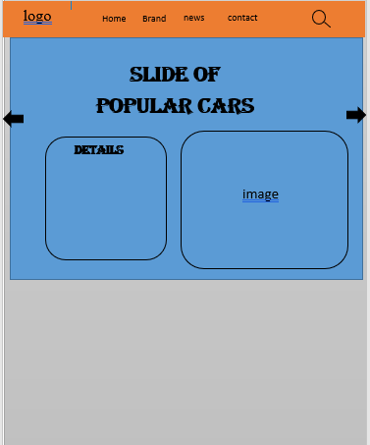

**News**

review

contact

**Brands**

footer