Mechanistic simulation of heritable expression states, cell division and drug response in single-cell populations
Ayoub Lasri¹
¹ Department of Physiology and Medical Physics, Royal College of Surgeons in Ireland, Dublin, Ireland. Correspondence: alasri@berache.com
Abstract
Heritable, non-genetic differences in gene expression decide which cancer cells survive a drug, yet the simulators used to benchmark single-cell methods model neither cell growth nor division, and therefore cannot generate such states from first principles. Here we present Biomodelling.jl 2.0, a framework in which stochastic reaction kinetics run inside growing, dividing and drug-treated cells. Exact, hybrid and adaptive kernels are coupled to exponential growth, volume-scaled transcription, gene replication and division with binomial partitioning and promoter inheritance, to dose schedules and state-dependent killing, to a complete lineage record, to single-cell observation models and to likelihood-free inference. Expression memory, cell-size scaling and cell-cycle-dependent bursting emerge from this physiology rather than being imposed. A single resistance gene with slow promoter switching reproduces the reported signatures of drug-tolerant persisters, and the framework supplies the ground truth that benchmarks of memory-gene detection, network inference and perturbation prediction lack. Calibrated to time-lapse measurements of cisplatin-treated cells, the model predicts held-out concentrations, lineage correlations and single-cell timing. Used with a built-in optimiser, it recovers the opposite rankings of intermittent dosing reported in a melanoma trial and in xenografts, attributes the difference to the fitness of resistant cells without drug, and searches for better schedules.
Isogenic cells differ in their transcriptional states, those differences are often inherited across several divisions, and the inherited state decides what a cell does under stress. Cancer cells that survive targeted or cytotoxic therapy frequently do so without a resistance mutation: they occupy a rare, reversible, drug-tolerant expression state that pre-exists the treatment or is induced by it^{1–5}. Lineage-resolved experiments now measure this memory directly. The fates of sisters and cousins are correlated, clonal barcode diversity is preserved or collapsed depending on whether tolerance pre-exists or is induced, and the timescale of expression fluctuations relative to the cell cycle decides which genes carry memory at all^{6–9}. In parallel, mechanistic analyses of single-cell RNA-sequencing data have shown that transcriptional kinetics can be inferred correctly only when gene copy number, cell age and partitioning at division are modelled explicitly^{10–12}, and evaluations of “virtual cell” models for perturbation prediction keep finding that deep-learning approaches fail to beat simple baselines, largely for want of mechanism and causal structure^{13–16}.
These developments create a demand that existing simulators do not meet. The simulators used to benchmark single-cell methods, among them SERGIO, dyngen, scMultiSim and GRouNdGAN^{17–20}, model regulation and technical noise but not cell growth, volume-dependent transcription, gene replication or the partitioning of molecules at division; lineage simulators such as TedSim²¹ generate division trees but attach phenomenological, largely Markovian expression to them. None of them can therefore produce expression memory, cell-size scaling, cell-cycle-dependent bursting or persister dynamics from first principles, and none provides the ground truth that the methods now being developed for exactly those phenomena require²². Stochastic simulators of growing and dividing cells exist^{23,24} but stop at the single-cell state: they offer no drug response, no lineage statistics, no observation models, no inference and no benchmark generation.
Here we present Biomodelling.jl 2.0, a rewrite of a Julia framework whose distinguishing feature, the coupling of stochastic reaction kinetics to exponential growth, volume-scaled transcription and binomial partitioning at division²⁵, is precisely the mechanism behind heritable expression states. Version 2.0 turns that feature into a complete framework for the mechanistic study of drug tolerance and for single-cell benchmarking. We validate the engine against exact stationary laws and an independent implementation, show that growth, division and partitioning alone reproduce published results on cell-size scaling, partitioning noise, lineage-versus-population statistics and cell-cycle-dependent bursting, and demonstrate that a single resistance gene with slow promoter switching reproduces the quantitative signatures of drug-tolerant persisters. We then use the framework as a ground-truth generator for memory-gene detection, network inference, imputation and perturbation prediction; as an inference engine that recovers kinetic and drug parameters from snapshot and lineage data and quantifies the bias of ignoring division; as a model calibrated to published time-lapse measurements and validated on conditions it was not fitted to; and, with a built-in schedule optimiser, as a testbed in which clinical dosing regimens are compared and better ones are sought.

Results

A layered simulator of growing, dividing, treated cells
Biomodelling.jl 2.0 is organised in layers (Fig. 1). A model is a list of reactions with mass-action, Hill or custom kinetics and named parameters; promoter states are explicit species, grouped so that they are inherited at division and doubled at replication. Four kernels advance a cell’s state at fixed volume: the exact direct method, fixed-step tau-leaping, a hybrid scheme that falls back to the exact method whenever a leap would produce a negative count, and adaptive tau-leaping with critical-reaction handling. The population layer grows each cell’s volume exponentially, scales propensities with volume so that concentrations are invariant, replicates genes at a set point of the cycle, divides cells by a sizer, adder or timer rule with binomial or over-dispersed partitioning, and controls the population size by Moran-like replacement, free growth or a logistic hazard. A perturbation layer applies dose schedules, state-dependent death, growth inhibition, drug-induced rate changes and genetic perturbations. Every cell’s ancestry, fate and state at birth and division enter a lineage table, from which heritability, autocorrelation, memory timescales, fluctuation-test and clonal-memory statistics follow. Observation models convert true counts into scRNA-seq, smFISH or time-lapse measurements, and the same forward model drives likelihood-free inference. Table 1 sets these capabilities against those of the simulators most used to benchmark single-cell methods.
Table 1. Capabilities of single-cell simulators (✓ native; ○ partial or phenomenological; – absent). SERGIO¹⁷, dyngen¹⁸, scMultiSim¹⁹, GRouNdGAN²⁰, TedSim²¹, Cassiopeia²⁶, ABM.jl (AgentBasedModeling.jl)²⁴, Biomodelling.jl v1.x²⁵ and v2.0 (this work). Cassiopeia simulates division topologies with heritable fitness and CRISPR barcodes rather than molecular content, and its inference recovers phylogenies rather than kinetic parameters; entries were read from each tool’s publication and documentation.
Capability | SERGIO | dyngen | scMulti- Sim | GRouNd- GAN | TedSim | Cassio- peia | ABM.jl | v1.x | v2.0
Mechanistic reaction kinetics (SSA / tau-leaping) | ○ | ✓ | ○ | – | – | – | ✓ | ✓ | ✓
Gene regulatory networks with known ground truth | ✓ | ✓ | ✓ | ✓ | – | – | ○ | ✓ | ✓
Cell growth, volume-scaled transcription | – | – | – | – | – | – | ✓ | ✓ | ✓
Gene replication / cell- cycle copy number | – | – | – | – | – | – | – | – | ✓
Division with molecular partitioning | – | – | – | – | ○ | ○ | ✓ | ✓ | ✓
Heritable promoter states, expression memory | – | – | – | – | ○ | – | ○ | ○ | ✓
Lineage tree with per-cell fates | – | – | – | – | ✓ | ✓ | ○ | – | ✓
Drug response: dose schedules, state-dependent death | – | – | – | – | – | – | – | – | ✓
Genetic perturbations (knockdown / overexpression) | ✓ | ✓ | ○ | ✓ | – | – | ○ | – | ✓
scRNA-seq observation model | ✓ | ✓ | ✓ | ✓ | ✓ | – | – | ○ | ✓
smFISH / time-lapse observation | – | – | – | – | – | – | – | – | ✓
Parameter inference from data | – | – | – | – | – | ○ | – | – | ✓
AnnData output | ✓ | ✓ | ✓ | ✓ | ○ | ○ | – | – | ✓

The engine is exact and reproducible in another package
We first verified the kernels against exact stationary laws (Fig. 2). For a birth-death process the simulated distribution of 50,000 cells is indistinguishable from the Poisson law (Fig. 2a); for the telegraph model in an intermediate and in a bursty regime it matches the Beta-Poisson distribution²⁷ (Fig. 2b); and for bursty protein production it matches the negative binomial (Fig. 2c). Across kernels, Kolmogorov-Smirnov distances to the exact law with 20,000 cells lie below the 99% critical value for the direct method and for the hybrid and adaptive schemes at their default tolerances, at wall-clock costs of 0.25 s to 0.91 s per 10⁴ cells (Fig. 2d). Simulating the same telegraph model with JumpProcesses.jl gives distributions whose two-sample Kolmogorov-Smirnov statistic against Biomodelling.jl is 0.0034 (99% critical value 0.0163; Fig. 2e), with a 6.2-fold (in favour of JumpProcesses.jl) difference in serial wall-clock time. Population simulations scale linearly with the number of cells and approximately linearly with the number of reactions: 2.6 s for 5000 cells × 10 telegraph genes × 200 steps (hybrid kernel) with four threads (Fig. 2f).

Physiology alone generates memory, size scaling and cell-cycle effects
The physiology of the population layer suffices to produce properties of single-cell data that phenomenological simulators must impose by hand (Fig. 3). In a single lineage of a slowly switching gene, mRNA and protein track volume within a cycle and are halved at division, while the promoter state, inherited by both daughters, persists over many divisions (Fig. 3a). For a fast-switching gene without replication, transcript numbers scale linearly with cell volume, so that concentration is homeostatic; adding mid-cycle gene replication doubles transcription in the second half of the cycle and lifts counts of large cells above the volume-scaling line (Fig. 3b), the copy-number effect that mechanistic fits to scRNA-seq data must account for¹⁰. Correlations of protein concentration at division between mothers and daughters, sisters and cousins fall from 0.94 to 0.02 as the promoter switching rate crosses the inverse cell-cycle time (Fig. 3c), with sisters more correlated than mother-daughter pairs and cousins less, and mRNA less heritable than protein. The memory timescale extracted from the generation-resolved lineage autocorrelation is set by the promoter switching time and is nearly independent of the cell-cycle time as long as memory outlasts the cycle; when the two are comparable the estimate is bounded below by one cell cycle, the resolution of the autocorrelation (Fig. 3d). As reported for real lineages¹¹, the coefficient of variation of a stable protein’s concentration is larger across the population than along single lineages, whether or not cell-cycle times are noisy, and over-dispersed partitioning adds variability in both perspectives (Fig. 3e). Telegraph parameters fitted separately to cells before and after replication differ by the expected factor of two in burst frequency, and a fit that ignores the cell cycle returns intermediate values (Fig. 3f).

One resistance gene reproduces persister phenomenology
To test whether heritable expression states suffice to reproduce the phenomenology of drug-tolerant persisters, we coupled a resistance gene with slow promoter switching (memory timescale 45 time units, cell-cycle time 20) to a death hazard that rises with dose and is suppressed by the concentration of the gene’s protein product (Methods). Under continuous, pulsed and reduced-dose schedules the population first collapses as low-expressing cells die, then regrows from high-expressing survivors (Fig. 4a); kill curves are biphasic with a surviving fraction that falls with dose (Fig. 4b). Between doses 0.5 and 2 the net rate of population decline over the first 30 time units of treatment rises from 0.023 to 0.050 per time unit (2.1-fold), while the mean division time of cells born under drug changes by 0.0% and the mean time to death of killed cells moves only from 8.5 to 6.2 time units (Fig. 4c). This reproduces the observation that population decay depends strongly on dose even though single-cell division and death times barely do⁶, because fate is decided by states that exist before the drug arrives.
Related cells accordingly share the fate of their lineages. Among cells born in the 25 time units before the drug, one whose sister founded a surviving lineage does so itself with probability 0.39, against a marginal probability of 0.08 (4.8-fold enrichment over 1830 sister pairs; 2.9-fold for cousins), whereas in a fast-switching control, in which survival is rarer, the conditional and marginal probabilities coincide (0.03 versus 0.02; Fig. 4d). When tolerance pre-exists, survivors descend from a minority of founder clones and the effective number of clones drops from 491 to 89; when tolerance is drug-induced, so that the drug raises the promoter activation rate of every cell, barcode diversity is largely preserved (165 of 492; Fig. 4e). This is the signature that distinguishes the two origins in barcoding experiments^{2,6}.
Disrupting expression memory changes the outcome, and when it is disrupted matters. Accelerating promoter switching 20-fold from two cell-cycle times before the drug, as memory-disrupting epigenetic compounds do⁹, leaves the number of surviving clones unchanged if the acceleration stops when the drug arrives (98 versus 120 clones), because it reshuffles which cells occupy the resistant state without changing how many do. Maintaining it during exposure reduces the count to 7 clones (10 cells, against 792; Fig. 4f), because resistant cells now leave the protected state within a fraction of the time they need to found a colony. In the model, memory must be disrupted while the drug is present. Compartment theory for phenotypic switching already predicts that an agent which perturbs the retention of the resistant state can turn treatment failure into success²⁸; what the simulations add is the timing requirement and a lineage-resolved readout, the number of surviving clones, by which it can be tested. A transient pulse enriches high-expressing cells and, with slow switching, the enrichment persists for many generations after the drug is removed, whereas with fast switching it relaxes within a few cycles (Fig. 4g): phenotypic selection with stable inheritance, as in the original MGMT model²⁹. Finally, scanning release periods and doses of intermittent schedules (Fig. 4h), the most effective schedule is release period 0, dose 2 (growth rate +0.004 per time unit) for pre-existing tolerance, release period 10, dose 2 (growth rate -0.016 per time unit) when the resistant state carries a fitness cost, and release period 10, dose 1 (growth rate +0.009 per time unit) for drug-induced tolerance. Without a fitness cost nothing beats continuous dosing at the highest dose, since every release period lets the resistant subpopulation regrow. With a fitness cost the population declines under every schedule at dose ≥ 0.5, and release periods of up to 10 time units match continuous dosing (-0.013 per time unit under continuous dose 2), because cells that leave the resistant state during a holiday are killed on re-exposure. For drug-induced tolerance the ranking of doses reverses: the highest dose induces tolerance in more cells than it kills, so dose 1 outperforms dose 2 at every release period (release period 10, dose 1 (growth rate +0.009 per time unit), against +0.012 for continuous dose 2), the intermediate-dose optimum reported previously³⁰; the benefit of release periods reported in that work does not appear here, because in this model the induced state decays at the same rate with and without drug, so a holiday only postpones the death of reverting cells while all cells grow.

Ground truth for memory genes, networks and perturbations
Because every cell’s clone, lineage and true state are known, the framework supplies ground truth that observational data cannot (Fig. 5). For 40 independent genes whose memory times span three decades, MemorySeq-style clonal variance scores computed on true concentrations rise from 1.0 for genes with memory far below the cell-cycle time to 29.6 for the slowest genes, and the ranking survives computation on sequenced counts at 20% capture efficiency (Fig. 5a); the score separates genes with memory longer than the cycle from the rest with an area under the receiver operating curve of 1.00 on true concentrations and 0.99 on sequenced counts. For a 30-gene network simulated at fixed volume, in a dividing population and after sequencing, correlation-based and GENIE3 inference lose most of their accuracy in the dividing population when raw counts are used (area under the precision-recall curve 0.52 to 0.14 for Pearson correlation and 0.32 to 0.13 for GENIE3, against 0.08 for a random ranking), because volume and gene copy number induce positive correlations between all genes. Normalising counts to concentrations removes the volume effect but recovers little (0.18 and 0.18), since the dependence on copy number and cell age remains; regressing expression on the true cell-cycle covariates, which the simulation provides and which cell-cycle scoring approximates in real data, recovers most of the loss (0.46 and 0.30). Sequencing at 15% capture efficiency lowers accuracy further (0.11 raw and 0.24 library-size-normalised for Pearson correlation; 0.07 and 0.08 for GENIE3; Fig. 5b). Imputation with kNN-smoothing and MAGIC before inference changes the area under the precision-recall curve by +0.05 to +0.21 (Pearson correlation) (Fig. 5c), consistent with the original benchmark²⁵. Knocking down the five most connected regulators of a 20-gene network produces true fold changes that a no-change baseline and the propagation of observational correlations predict with coefficients of determination of -0.16 and -0.23 (Fig. 5d), illustrating how causal, out-of-distribution ground truth can be generated for the evaluation of perturbation-prediction models^{13,14}.

Inference recovers parameters and exposes the cost of ignoring division
On a snapshot of 2,000 non-dividing cells, ABC-SMC with log-uniform priors over three decades and the Wasserstein distance between simulated and observed counts³¹ concentrates on the true telegraph parameters and agrees with the exact maximum-likelihood estimate (posterior medians (0.31, 0.60, 20.9) for truth 0.3, 0.6, 20; Fig. 6a), the broadest posterior falling on the promoter inactivation rate, which a single snapshot constrains least. On a snapshot of a growing and dividing population with volume-scaled transcription and mid-cycle replication, the naive telegraph fit is biased (k_on = 0.47, k_off = 1.95, k_tx = 71.5) because volume and copy number inflate counts and their dispersion, whereas ABC with the population simulator as forward model recovers the truth ((0.30, 0.68, 20.8); Fig. 6b). Drug parameters follow from population data in the same way: from a kill curve and the concordance of sister fates, the posterior over the maximal death rate and the protection threshold is a ridge (weighted correlation of the two log parameters -0.85) that contains the truth (Fig. 6c), and posterior predictive kill curves simulated at the posterior median reproduce the observed one (Fig. 6d). The two summaries constrain the product of death rate and unprotected fraction, so separating the parameters requires measuring the protective protein: an experimental-design question the forward model answers before an experiment is run.

Calibration to time-lapse data predicts held-out conditions
A simulator is useful for treatment questions only if it can be fitted to the data a laboratory produces and then predict what it was not fitted to. We therefore calibrated the resistance-gene model to time-lapse measurements in which U2OS cells were tracked for three days under 7, 10 and 13 µM cisplatin and every cell present at drug addition was scored as dying, dividing or surviving without dividing⁶ (Supplementary Table 4). Six parameters, the two promoter switching rates, the maximal death rate, the EC$​_{50}$ and Hill coefficient of death and the IC$​_{50}$ of growth arrest, were fitted to the fate fractions at 7 and 13 µM by simulated moments with common random numbers, under a weak prior keeping the memory of the resistant state near the two to three generations that the same study inferred from lineage correlations (Methods). The calibrated model (memory 2.8 generations, resistant fraction 15.2%, EC$​_{50}$ 16.7 µM; Fig. 7f) reproduces the training fractions with a root-mean-square error of 0.071 and predicts the held-out 10 µM condition with an error of 0.093 (observed died, divided and survived fractions 0.28, 0.31 and 0.41; predicted 0.39, 0.20 and 0.41; Fig. 7a).
Properties that were not fitted can then be compared with the data. Death fates are correlated between sisters (0.09), first cousins (0.06) and second cousins (0.05), and the correlation decays to 0.02 for third cousins and 0.00 for unrelated cells (Fig. 7c), the pattern reported for HCT116 lineages. The mean time to death changes by 8% between 7 and 13 µM while the death fraction rises from 0.13 to 0.59 (Fig. 7d), the dose-invariance of single-cell timing that motivated the original study, and it arises here because dose changes the fraction of unprotected cells rather than their kinetics. The predicted kill curves (Fig. 7b) are 1.5-fold steeper at 13 µM in their first two days than in their second half, but the calibrated memory of 2.8 generations is too short to produce the plateau that HCT116 cells reach after about 100 h: in the model, cells leave the resistant state within days and are then killed. Reproducing the plateau requires a longer memory or a drug-induced stabilisation of the resistant state, which is the kind of conclusion a calibrated forward model can draw and a lineage-tracing experiment can test. The calibration landscape (Fig. 7e) shows how the fitted death rate and EC$​_{50}$ are constrained by the fate fractions alone; the protocol applies to any observable a laboratory records.

Schedule optimisation reproduces and explains clinical outcomes
With a calibrated model the framework becomes a schedule testbed. We first asked which schedule best delays regrowth of a melanoma-like population with a rare, heritable pre-resistant state² treated at a fractional-killing dose, comparing continuous dosing, the intermittent schedule of the SWOG S1320 trial, in which patients received a continuous 8-week lead-in and were then randomised to continuous dosing or to cycles of 3 weeks off and 5 weeks on³², and adaptive therapy, in which the drug is withdrawn when the population has halved and resumed when it regrows to its initial size³³. Because adaptive therapy deliberately lets the tumour regrow, schedules are compared by the time after randomisation at which the population exceeds 120% of its pre-treatment size (loss of control), with the RECIST-like time to progression from the nadir reported alongside (Methods).
The answer depends on two properties of the resistant cells (Fig. 8a–d). When the resistant state is fully protective and carries no fitness cost, as lineage data indicate for pre-existing tolerance⁶, resistant cells grow at the same rate with or without drug, holidays only let sensitive cells regrow and be killed again, and the three schedules lose control after 23, 26 and 27 weeks, the intermittent schedule delivering 65% of the cumulative dose. When resistant cells pay a 50% fitness cost in the absence of drug, the drug addiction that made intermittent dosing superior in patient-derived xenografts³⁴, holidays let sensitive cells outcompete them: none of the three schedules loses control within the 52-week follow-up (52+, 52+ and 52+ weeks, censored), and adaptive therapy achieves this with 36% of the cumulative dose of continuous dosing. When resistant cells are only partly protected and grow at half speed under drug, holidays release them: continuous dosing keeps control for 52+ weeks against 49 for the intermittent schedule and 43 for adaptive therapy, the ranking observed in the trial, where continuous dosing gave a median progression-free survival of 9.0 months against 5.5 months for intermittent dosing. That the benefit of holidays should depend on a cost of resistance is established by compartment models of adaptive therapy, which also show that tumour turnover modulates how large that cost must be³⁵. Here the dependence emerges from single cells whose resistance is a heritable expression state rather than a fixed compartment, the cost and the degree of protection are properties of cells that lineage experiments measure, and the third case shows that partial protection reverses the ranking even when a cost is absent. The optimiser makes the dependence explicit (Fig. 8e): over intermittent schedules of any period and duty cycle after the lead-in, the best schedule is a period of 2.2 weeks with 39% of the time on drug (27 weeks to loss of control) without a fitness cost, a period of 1.0 weeks with 47% of the time on drug (52 weeks to loss of control) with a fitness cost and a period of 1.0 weeks with 100% of the time on drug (52 weeks to loss of control) with partial protection. The model therefore reproduces both the clinical and the preclinical outcome and attributes their difference to measurable properties of the resistant cells, their growth under drug and their fitness without it, both of which are properties of cells rather than of the tumour, and which growth and lineage experiments can bound, within the identifiability limits of Fig. 6c, before a schedule is chosen.
The second case study concerns glioblastoma, where the RTOG 0525 trial compared the standard temozolomide regimen (150–200 mg m⁻² on days 1–5 of 28-day cycles) with a dose-dense regimen (75–100 mg m⁻² on days 1–21) that delivers about twice the cumulative dose and was designed to deplete MGMT, and found no difference in survival for either MGMT-methylated or unmethylated tumours³⁶. We simulated both regimens with one-compartment pharmacokinetics (elimination half-life 2.1 h; ref.³⁷) on populations in which 1% (methylated) or 30% (unmethylated) of cells express MGMT, with MGMT protein protecting cells from the drug²⁹ and either stable or consumed by it, as a suicide enzyme is (Fig. 8f,g). With stable MGMT, the depth of response over six cycles is 0.20 log$​_{10}$ units for the standard regimen and 1.00 for the dose-dense regimen in the methylated population (0.08 and 0.10 in the unmethylated one), and a 21-day regimen at the standard cumulative dose achieves no measurable kill (0.00 log$​_{10}$ units): the death hazard rises steeply with concentration, so spreading the same dose over more days loses efficacy, and the advantage of the dose-dense arm in the model is entirely its larger cumulative dose. When the drug consumes MGMT, prolonged exposure depletes the protection of expressing cells: in the methylated population the dose-dense regimen deepens its response to 1.24 log$​_{10}$ units against 0.21 for the standard regimen, and in the unmethylated population, where 30% of cells start protected, both regimens improve (final size 1.7 and 1.4 times the initial size, against 4.9 and 3.6 with stable MGMT) but neither controls the population, so the difference between the arms stays small (0.14 against 0.17 log$​_{10}$ units), as in the trial. At the standard cumulative dose the number of dosing days per cycle that minimises the final population is 9 (methylated) and 9 (unmethylated) with stable MGMT, and 9 and 5 when MGMT is consumed (Fig. 8h). These simulations are not fits to the trial, whose end points depend on much that the model omits, dose-limiting toxicity among it, but they turn the rationale of dose-dense dosing into a quantitative prediction and identify the measurement that decides between the regimens: how fast the drug consumes MGMT in the tumour.

Discussion
Biomodelling.jl 2.0 fills a gap in the single-cell toolkit: a simulator in which expression memory, cell-size effects, cell-cycle dependence and drug-tolerant persistence follow from explicit biophysics instead of being assumptions of a generative model. It is worth separating what is new here from what it confirms. The individual ingredients are not new: stochastic kinetics in growing and dividing cells have been simulated before^{23–25}, lineage-tracing data have their own simulators^{21,26}, compartment models of adaptive therapy established that the benefit of treatment holidays depends on a cost of resistance and on turnover^{33,35}, and phenotypic-switching theory established that perturbing the retention of a resistant state can decide a treatment outcome²⁸. Three things are new. First, the combination itself: molecular kinetics, volume-scaled transcription, gene replication, partitioning and promoter inheritance, drug schedules with state-dependent killing, a complete lineage record, observation models and inference in one forward model, which is what allows a resistance phenotype to be a heritable expression state with measurable kinetics rather than a compartment with an assumed rate. Second, the ground truth this makes available: the same simulation supplies known memory genes, known networks, known perturbation effects and the true lineage tree, which is what the quantification of how growth and sequencing destroy network inference, and of how far cell-cycle regression recovers it, depends on. Third, the calibrate-then-predict protocol applied to schedule questions, which turns a mechanism into a falsifiable prediction: here it identifies the growth of resistant cells without drug and their residual growth under drug as the two properties that decide whether holidays help, and identifies the rate at which temozolomide consumes MGMT as the measurement that separates the two glioblastoma regimens. That difference has practical consequences. As a hypothesis engine for non-genetic drug tolerance, the framework answers which schedule, which combination or which memory-modulating pretreatment minimises the long-term fitness of a treated population, with cell-level rules that can be matched to time-lapse and lineage-tracing data. As a ground-truth generator, it produces data with known memory genes, known networks, known perturbation effects and known lineage trees, which is what MemorySeq-style scores, lineage-aware models and virtual-cell benchmarks need in order to be evaluated fairly, and what existing simulators cannot supply. As a likelihood-free inference engine, it estimates mechanistic parameters from data that are now routinely collected, while quantifying the bias of simpler models.
The calibration and schedule studies set out a workflow for in silico single-cell pharmacology: declare the training and validation observables before fitting, fit by simulated moments or approximate Bayesian computation with common random numbers, validate on conditions and statistics that were not fitted, and only then compare regimens, reporting outcomes that map onto clinical end points. The case studies show why mechanism matters. The same question, continuous or intermittent dosing, has opposite answers depending on whether resistant cells pay a fitness cost without drug, and a trial result and a xenograft result that appeared to contradict each other are both reproduced once that property is set. Because the framework simulates the lineage-resolved data from which such properties are measured, it can also say which experiment would settle the question before a trial is designed.
Several limitations delimit this release. Cells are well-mixed compartments without spatial structure or cell-cell signalling; the pharmacology is a one-compartment model; growth is exponential with phenomenological size control; and the inference layer, although general, relies on user-chosen summary statistics, so posterior calibration should be checked with predictive simulations. The persister case study is deliberately minimal, a single resistance gene with slow switching, and its calibration used fate fractions transcribed from a published study rather than raw tracks. The clinical case studies use literature values for cell-cycle times, resistant fractions and pharmacokinetics rather than patient-specific measurements, so their conclusions concern mechanisms and rankings, not absolute survival times. A bridge to the Catalyst.jl ecosystem is not part of this release. The benchmark results should be read as demonstrations of what the framework makes possible rather than as verdicts on the methods compared, which were run with default settings on small networks.
Spatial coupling through neighbourhood-dependent rates, cell-cell communication, chromatin states with their own inheritance rules and neural simulation-based inference are natural extensions of the existing forward model. Because the framework is deterministic given a seed, fast enough to simulate tens of thousands of cells in minutes, and writes AnnData files, it can be dropped into single-cell analysis pipelines as a source of mechanistically grounded synthetic data, and into virtual-cell training and evaluation as a source of causal, out-of-distribution contexts.

Methods

Reaction model and propensities
A model is a set of species and reaction channels. Species are molecules (partitioned at division) or promoter states (inherited). For a reaction with reactant counts $x_{i}$, stoichiometric coefficients $ν_{i}$, rate constant $k$ and volume exponent $e$, the mass-action propensity is
a=k Vei​xiνi,
where by default e=1−i​νi, so that zero-order production scales with volume, first-order reactions are volume independent and bimolecular reactions scale as $1/V$; this keeps concentrations invariant under growth. Regulated reactions multiply this by $b+(1−b)F(c)$, where $b$ is a basal fraction and $F$ combines Hill terms of the regulator concentrations $c_{j}=x_{j}/V$, $h_{j}=c_{j}^{n_{j}}/(K_{j}^{n_{j}}+c_{j}^{n_{j}})$ for activators and $1−h_{j}$ for inhibitors, either as a product (AND logic) or as 1−j​(1−hj) (OR logic). Promoter switching is represented by explicit promoter species (for instance $G_{off}⇌G_{on}$) grouped into promoter groups. Custom propensities can be supplied as functions of counts, volume, parameters and time.

Stochastic simulation kernels
Within one update step the cell volume and gene copy number are held fixed and the reaction network is advanced by one of four kernels: the direct method³⁸ with propensities updated through a species-reaction dependency graph; fixed-step Poisson tau-leaping³⁹; a hybrid scheme in which a leap that would drive any species negative is rejected and the interval is instead simulated exactly (this is the exact version of the “switching” scheme of version 1); and adaptive tau-leaping with the step-size selection of⁴⁰ and the critical-reaction partition of⁴¹, falling back to a fixed number of exact events when the proposed leap is shorter than $10/a_{0}$. Every kernel takes an explicit random number generator.

Cells, growth, replication and division
Each cell carries its volume $V$, age, generation, lineage identifiers, gene copy state, growth rate, molecule counts, a cell-specific parameter vector and its own random number generator (seeded from the parent’s generator, which makes results independent of the number of threads). Volume grows exponentially, $\dot{V}=λV$, with an optional log-normal spread of $λ$ between cells. Division is triggered by a sizer ($V≥V_{div}$), an adder ($V−V_{birth}≥Δ$) or a timer (age $≥T$), each with a per-cell noise factor drawn at birth. At division the first daughter inherits a volume fraction $f∼N(0.5,σ^{2})$ (clipped to $[0.05,0.95]$) and each molecule is assigned to it independently with probability $f$ (binomial partitioning); a beta-binomial option models over-dispersed partitioning. Promoter groups are inherited by both daughters when unreplicated and split one copy per daughter, in random assignment, when replicated. Gene replication, if enabled, doubles the promoter counts (and the propensity of reactions flagged as copy-number dependent) once the cell has completed a set fraction of its cycle, and is reset at division. Populations can be started from per-founder states and volumes (for instance a snapshot of a burnt-in constant-size population). Population control is either constant size (every second daughter replaces a uniformly chosen cell, the behaviour of version 1), free growth (all daughters kept, with uniform subsampling above a cap and book-keeping of the true size) or logistic (free growth with an additional hazard $λN/K$).

Drug and perturbation layer
A perturbation combines a dose schedule $d(t)$ (constant, pulsed, piecewise, one-compartment bolus pharmacokinetics or an arbitrary function) with effects evaluated for every cell at every step: a death hazard
$$h=h_{max}\frac{d^{m}}{{EC}_{50}^{m}+d^{m}}⋅\frac{K^{q}}{K^{q}+c_{P}^{ q}},$$
where $c_{P}$ is the concentration of a protective species (survival probability over a step is $e^{−h Δt}$); growth inhibition by $1/(1+(d/{IC}_{50})^{m})$; a dose-independent fitness cost of a cell state, $1−c_{max} c_{P}^{ q}/(K^{q}+c_{P}^{ q})$, on the growth rate; multiplicative modulation of any parameter by a function of the dose; and genetic perturbations (knockdown, knockout, over-expression) of any parameter in a random fraction of cells, the flag being inherited by daughters.

Lineage statistics
The lineage table records, for every cell, its parent, founder (clone), generation, birth and end times, fate (divided, died, removed, alive) and its volume and state at birth and at the end of its life. From it we compute Pearson correlations of expression at division between mothers and daughters, sisters and cousins; the lineage autocorrelation $r_{g}$ between a cell and its ancestor $g$ generations earlier, and the memory timescale $τ$ from $r_{g}=e^{−g/τ}$; single-lineage traces by following the ancestral line of a surviving cell; the coefficient of variation squared of concentration across the population versus along single lineages; Luria-Delbrück fluctuation tests (variance of a phenotype across clones grown from single cells compared with the binomial expectation); and MemorySeq-style clonal scores⁴², the variance of clone-mean expression divided by its permutation-null expectation.

Observation models
True counts are converted to observations by a scRNA-seq model in which each cell captures every molecule independently with a Beta-distributed efficiency (mean and coefficient of variation set by the protocol), optional multinomial down-sampling to a Poisson-distributed depth, optional additional dropout and batch scaling; an smFISH model with a fixed detection efficiency; and a time-lapse model that samples a species along lineages at a fixed interval with additive or multiplicative measurement noise. Because counts scale with volume, library size correlates with cell size, reproducing the transcriptome-size confound of real data. Outputs are written as CSV or as AnnData-compatible HDF5 files.

Inference
Snapshot counts of a gene in non-dividing cells follow the Beta-Poisson law of the telegraph model²⁷, which we evaluate through Kummer’s confluent hypergeometric function with rescaled series summation, and maximise by a grid-initialised Nelder-Mead search in log-parameter space. For any model, including populations, we implement sequential Monte Carlo approximate Bayesian computation⁴³ with an adaptive tolerance schedule (the $α$ quantile of the previous generation’s distances), Gaussian perturbation kernels of variance twice the weighted population variance, importance weights against the prior, and parallel evaluation of the user-supplied distance function; for count distributions we use the Wasserstein-1 distance between simulated and observed samples³¹.

Calibration to laboratory data and validation strategy
Reference values were transcribed from the text and tables of the cited articles into paper/data/ with their provenance (Supplementary Table 4). For the cisplatin case study the model is a resistance gene with slow promoter switching whose protein product protects against a dose-dependent death hazard and against a dose-dependent growth arrest (Methods above), with a 24-h cell cycle. Its six free parameters (activation and inactivation rates, maximal death rate, EC$​_{50}$ and Hill coefficient of death, IC$​_{50}$ of growth arrest) were fitted by the method of simulated moments: the root-mean-square difference between simulated and observed fractions of cells that died, divided or survived without dividing during 72 h of drug, for the training concentrations (7 and 13 µM), plus a weak penalty keeping the memory of the resistant state near the 2-3 generations inferred from lineage correlations, was minimised with the bounded optimiser described below using common random numbers (the same seeds for every candidate). Validation used only quantities not fitted: the fate fractions at the held-out concentration (10 µM), the biphasic kill curve and its plateau, the extent of lineage correlations in fate (sisters, first, second and third cousins) and the invariance of single-cell division and death times across concentrations. The protocol is deliberately generic: any observable computable from a PopulationResult (kill curves, fate fractions, lineage correlations, snapshot distributions) can enter the distance, and the split between training and validation conditions is declared before fitting.

Clinical regimens, treatment outcomes and schedule optimisation
Regimens are built from the schedule primitives of the perturbation layer: PulsedDose with a finite number of cycles, PiecewiseDose for arbitrary calendars (the S1320 schedule), daily_boluses and cycle_days for daily oral doses with one-compartment pharmacokinetics, and AdaptiveDose, a feedback schedule that withdraws the drug when the population falls below a fraction of its initial size and resumes it when the population regrows above another fraction, evaluated with the current population size at every step³³. Outcomes computed from a simulation are the net growth rate, the depth of response (log$​_{10}$ of the ratio of the initial to the smallest population), the time to progression (first time the population exceeds a threshold, 1.2, times its running minimum, the analogue of RECIST progression from the nadir; censored at the end of the simulation), the extinction probability over replicates and the cumulative dose actually applied. optimize_schedule minimises any such outcome over a box of schedule parameters: a log-spaced grid (or a Latin hypercube when the grid is large) is evaluated with the same random seeds for every candidate, and the best point is refined by Nelder-Mead in a bounded transform of the box; constraints such as a fixed cumulative dose enter as penalties or as the parameterisation (for instance a per-day dose equal to the budget divided by the number of dosing days). The case studies are run at the scale of a tumour rather than a culture: the cell cycle of the model is the net doubling time of the tumour (4 weeks for melanoma, 40 days for glioblastoma), gene-expression rates are scaled to the hour (mRNA half-life 7 h, protein half-life 35 h) and founders are drawn from the stationary distribution of promoter states. The melanoma case uses a pre-resistant fraction of 1:200 with a memory of five generations^{2,42} and drug effects at the fractional-killing dose: sensitive cells arrest and die with a half-life of two weeks, cells in the resistant state are protected, and the drug stabilises the resistant state ten-fold (the drug-induced reprogramming of²). Three variants of the resistant state are compared: full protection without cost; a 50% fitness cost in the absence of drug³⁴; and partial protection, in which resistant cells grow at half speed under drug. Progression is scored in two ways: from the nadir, as in RECIST (a 20% increase in diameter, taken as a 1.73-fold increase in cell number, after the 8-week lead-in), and as loss of control, the time after randomisation at which the population exceeds 120% of its pre-treatment size, the end point of adaptive-therapy studies, which is the one used to compare schedules that deliberately let the tumour regrow. The temozolomide case uses an elimination half-life of 2.1 h³⁷, the regimens of RTOG 0525³⁶ (200 mg/m² on days 1-5 or 100 mg/m² on days 1-21 of 28-day cycles, six cycles), MGMT-expressing fractions of 1% and 30% for methylated and unmethylated promoters, and MGMT either stable or consumed by the drug (its degradation rate increased 20-fold at the standard peak concentration), the suicide-enzyme behaviour that motivated dose-dense schedules.

Random regulatory networks
Random networks are built with a chosen number of activating and inhibiting edges under Erdős-Rényi or preferential-attachment (scale-free) sampling; regulation acts on the transcription rate of constitutive genes or on the promoter activation rate of telegraph genes through AND-combined Hill functions; per-gene rate constants can be drawn log-uniformly from ranges.

Validation protocols
Exactness was tested by Kolmogorov-Smirnov distances between simulated stationary distributions and the analytic laws (Poisson for birth-death, Beta-Poisson for the telegraph model, negative binomial for bursty protein production^{44,45}), by agreement between kernels, and by a two-sample comparison against JumpProcesses.jl⁴⁶ on the same model. Population-level properties were compared with the analytic expectations for cell-size scaling and concentration homeostasis²³, partitioning noise⁴⁷, lineage versus population statistics¹¹ and cell-cycle-dependent burst parameters¹⁰. Persister simulations were compared with the quantitative signatures reported by⁶,³⁰ and⁹, and with the phenotypic-selection model of²⁹. All scripts, seeds and outputs are in the paper/ directory of the repository.

Statistics and reproducibility
No statistical method was used to predetermine sample size, and no experimental data were generated in this study; sample sizes are the numbers of simulated cells, founders or seeds stated in each figure legend and in Supplementary Table 2. No data were excluded. Randomisation and blinding do not apply: every result is a deterministic function of an explicit random seed, and all seeds are fixed in the scripts that generate the figures. Replicates are independent simulations differing only in seed; where a mean and a standard deviation are reported, the number of seeds is given in the legend. Kolmogorov-Smirnov distances are compared with the 99% critical value for the stated sample size. Distributional agreement between kernels and with an independent implementation was assessed by two-sample Kolmogorov-Smirnov statistics. Correlations are Pearson correlations unless stated otherwise; correlations of binary fates between related cells are phi coefficients. Posterior summaries are medians, because the posteriors are asymmetric on the log scale. Multithreaded runs give results identical to single-threaded runs, because each cell carries its own random number generator seeded from its parent.

Data availability
The laboratory and clinical reference values used for calibration and validation were transcribed from the published articles cited in Supplementary Table 4 and are provided, with their provenance, in the paper/data/ directory of the software repository (https://github.com/ayoublasri/Biomodelling.jl). All other data in this Article are simulated and are regenerated from fixed seeds by the scripts in the paper/ directory; the generated tables are archived with the software release.

Code availability
Biomodelling.jl 2.0 is open source under the MIT licence at https://github.com/ayoublasri/Biomodelling.jl, with documentation, tutorials and a test suite that runs under continuous integration. Every figure is regenerated by julia --project=paper paper/run_all.jl followed by python paper/plot_all.py.

Software
Biomodelling.jl 2.0 is written in Julia (≥ 1.10) and depends on Distributions.jl, PoissonRandom.jl, QuadGK.jl, Optim.jl, SpecialFunctions.jl and StatsBase.jl; HDF5.jl is an optional extension. Benchmarks used absolute Pearson and Spearman correlations and scikit-learn random forests re-implementing GENIE3⁴⁸, MAGIC⁴⁹ and kNN-smoothing⁵⁰. The test suite (Aqua quality checks and statistical tests) runs under GitHub Actions on Julia 1.10 and the latest release.

Figure legends
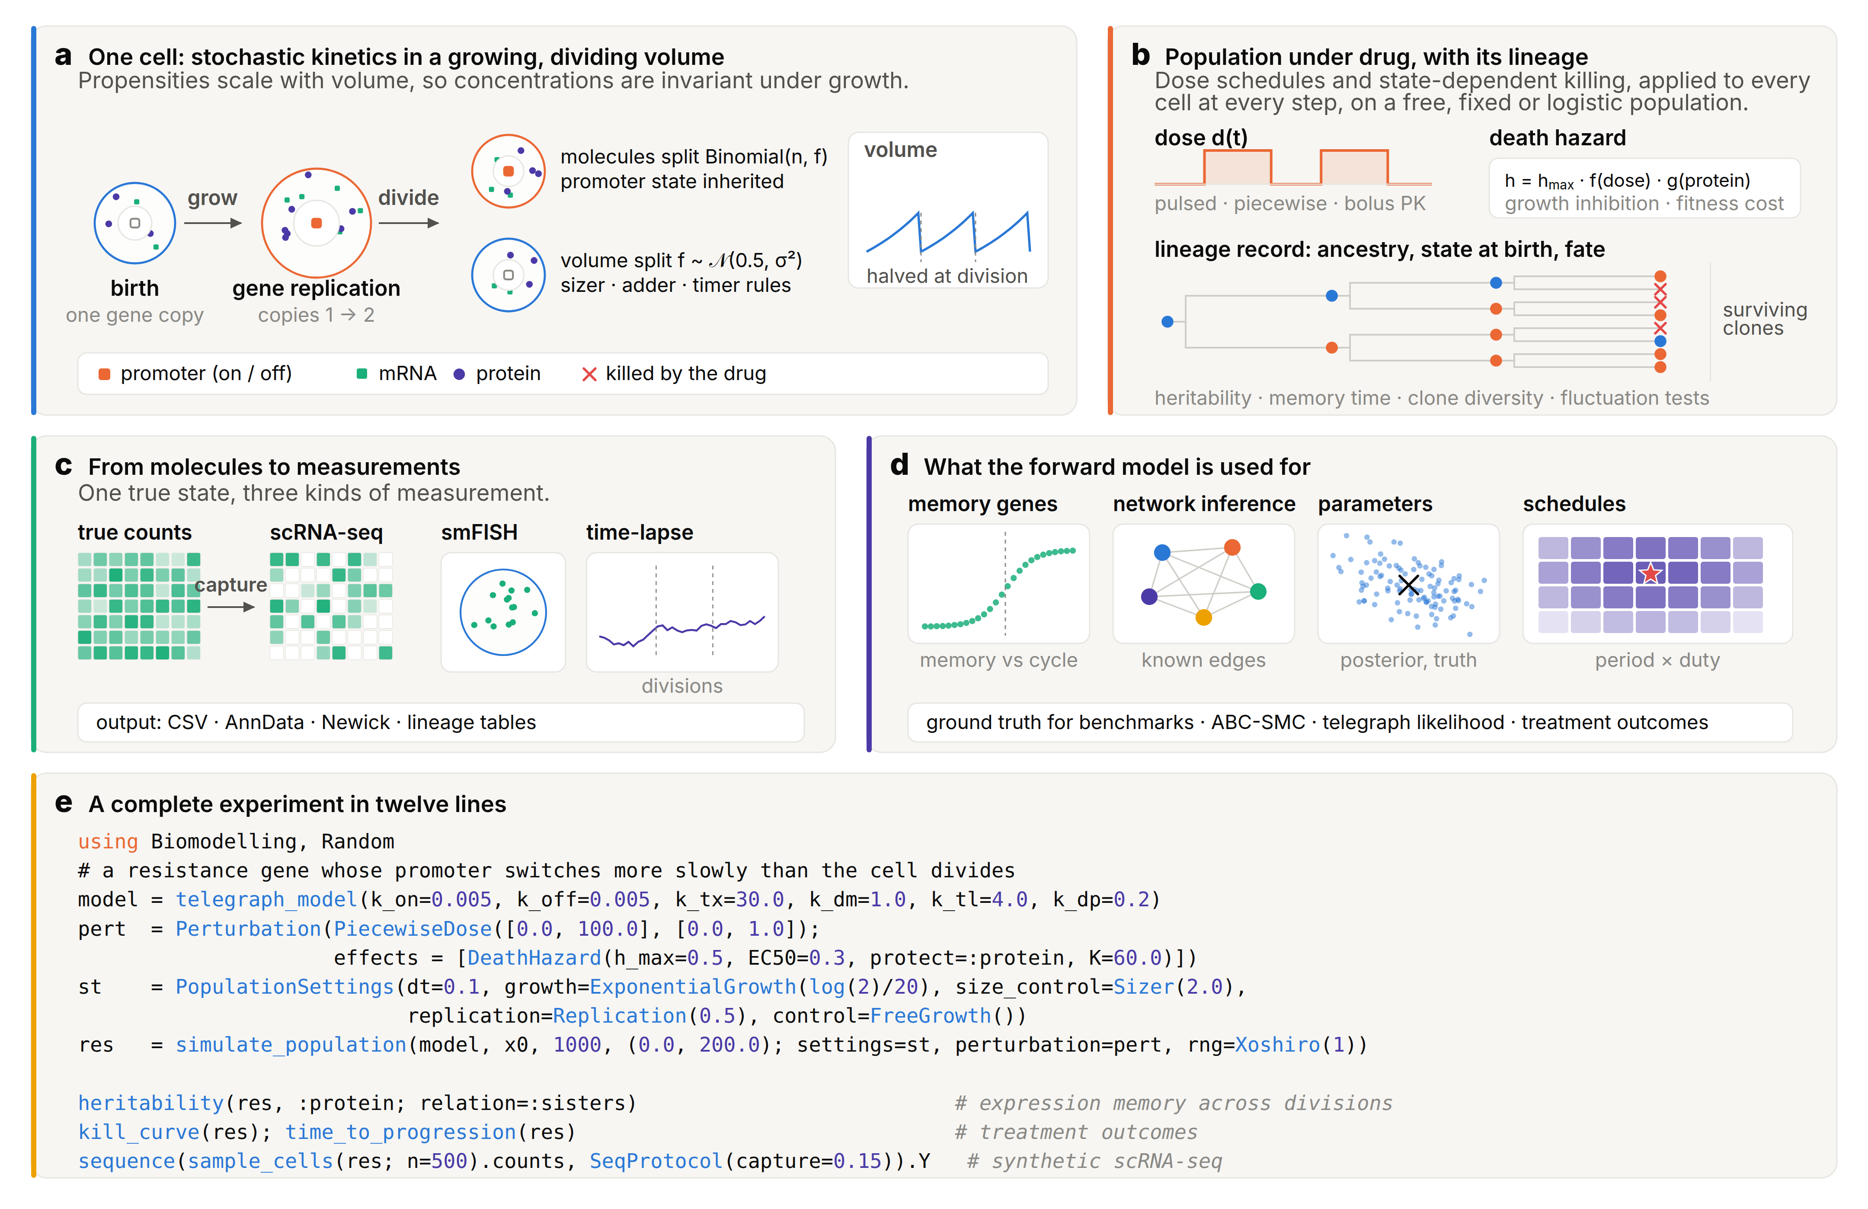
Fig. 1 | The Biomodelling.jl 2.0 framework. a, One cell. Reactions run at the cell’s current volume, with propensities scaled so that concentrations are invariant under growth; genes replicate at a set point of the cycle; division splits every molecule binomially while both daughters inherit the promoter state. Inset: exponential volume growth, halved at each division. b, Populations under free growth, constant-size or logistic control, with dose schedules and a state-dependent death hazard evaluated for every cell at every step, and the lineage record from which heritability, autocorrelation, memory timescales, clone diversity and fluctuation tests are computed; crosses mark cells killed by the drug. c, Observation models turn true counts into scRNA-seq counts with capture, depth, dropout and batch effects, into smFISH spots, or into time-lapse reporter traces; outputs are CSV, AnnData and Newick. d, Uses of the forward model: detection of memory genes, benchmarking of network and perturbation inference against known ground truth, likelihood-free parameter inference, and schedule optimisation over the period and the fraction of time on drug (star, optimum). e, A complete experiment in twelve lines of code.
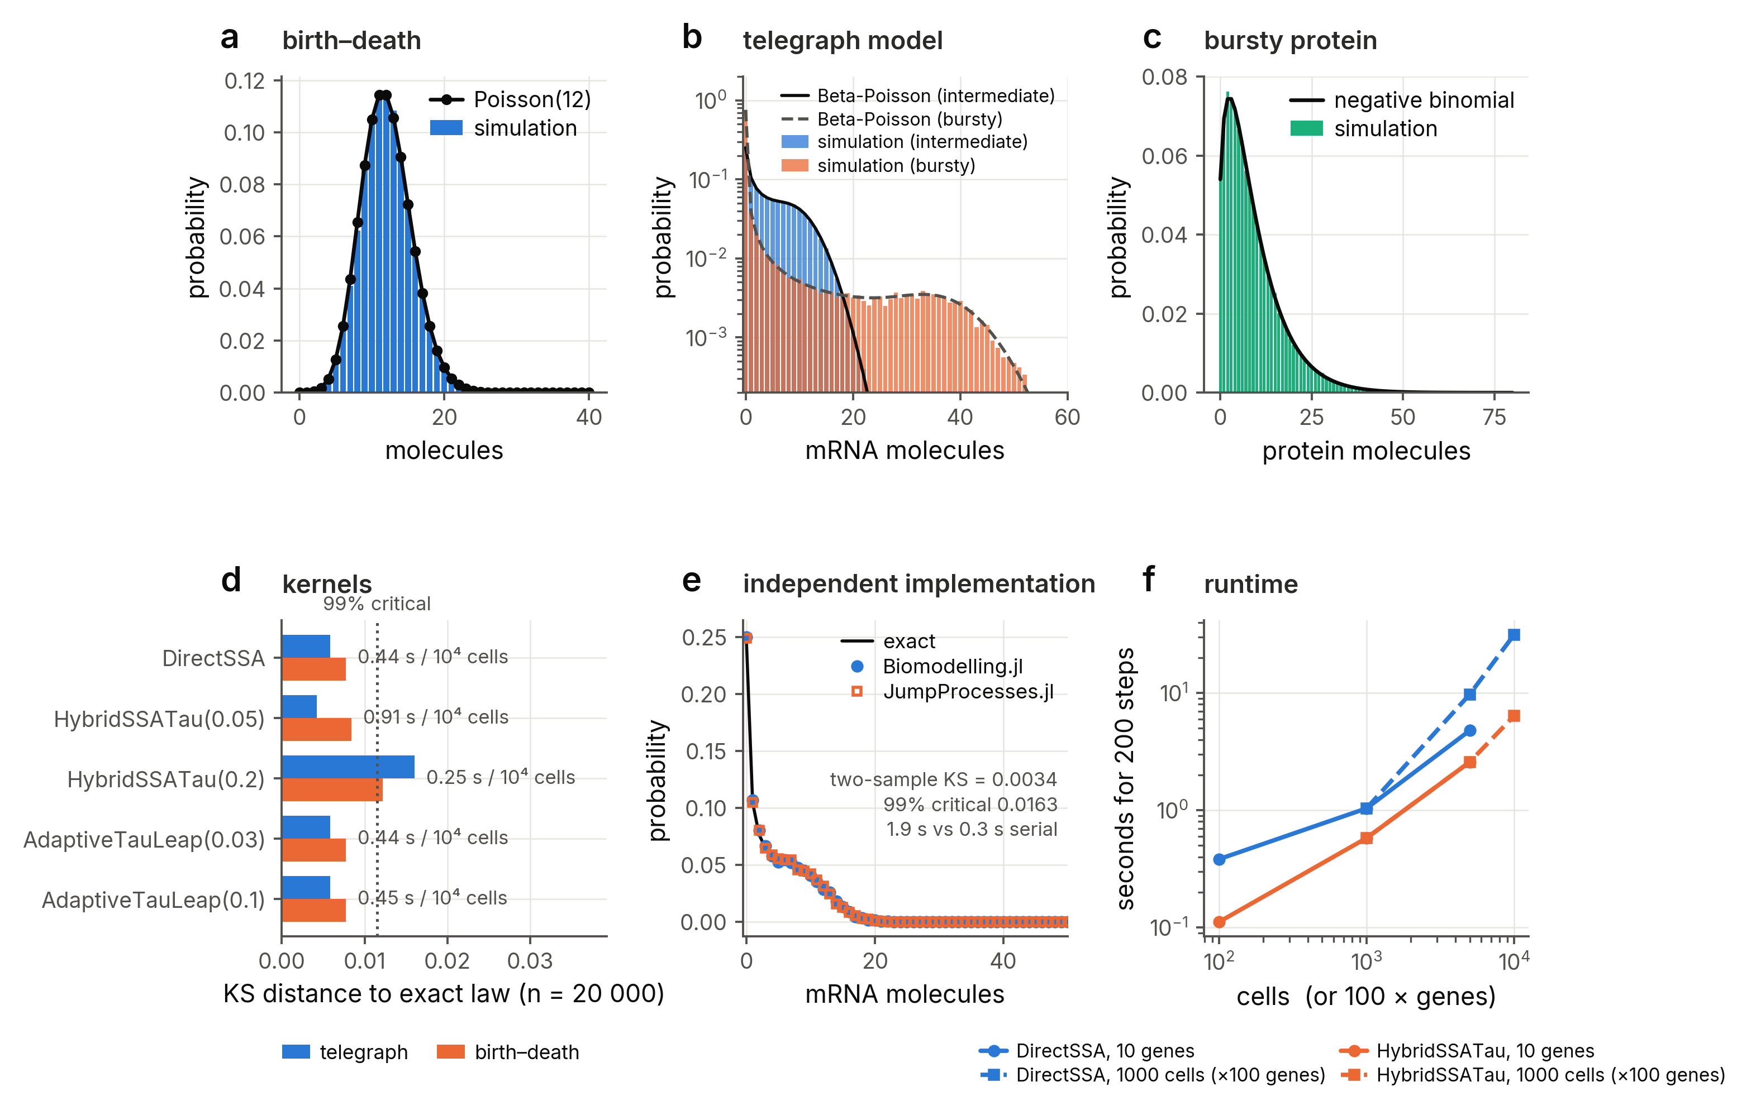
Fig. 2 | The engine is exact and agrees with an independent implementation. a, Stationary distribution of a birth-death process (bars, 50,000 simulated cells; line, Poisson law). b, Telegraph model in an intermediate and a bursty regime against the Beta-Poisson law. c, Bursty protein production against the negative binomial. d, Kolmogorov-Smirnov distance to the exact law for every kernel (n = 20,000; dotted line, 99% critical value) with wall-clock time per 10⁴ cells. e, Telegraph model simulated with Biomodelling.jl and with JumpProcesses.jl on the same model; the two-sample Kolmogorov-Smirnov statistic lies below its 99% critical value. f, Runtime of population simulations against the number of cells (10 genes) and genes (1,000 cells) for the exact and hybrid kernels.
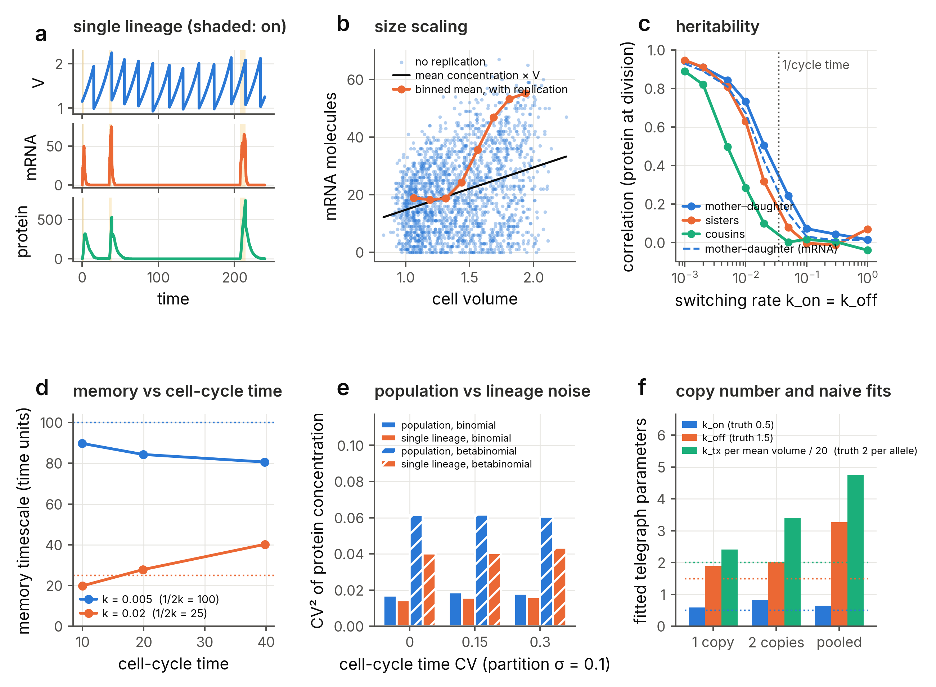
Fig. 3 | Growth, division and partitioning generate memory, size scaling and cell-cycle effects. a, A single lineage: volume, mRNA and protein of a slowly switching gene, with the promoter-on state shaded. b, mRNA count against cell volume for a fast-switching gene without replication (points; line, mean concentration × V) and with gene replication at mid-cycle (binned means). c, Correlation of protein concentration at division between mothers and daughters, sisters and cousins as a function of the promoter switching rate; dotted line, inverse cell-cycle time. d, Memory timescale against the measured cell-cycle time for two switching rates; dotted lines, 1/(k_on + k_off). e, Squared coefficient of variation of a stable protein’s concentration across the population and along single lineages, for increasing partitioning noise and cell-cycle-time noise. f, Telegraph parameters fitted to cells before replication (one gene copy), after replication (two copies) and pooled; dotted lines, per-allele values.
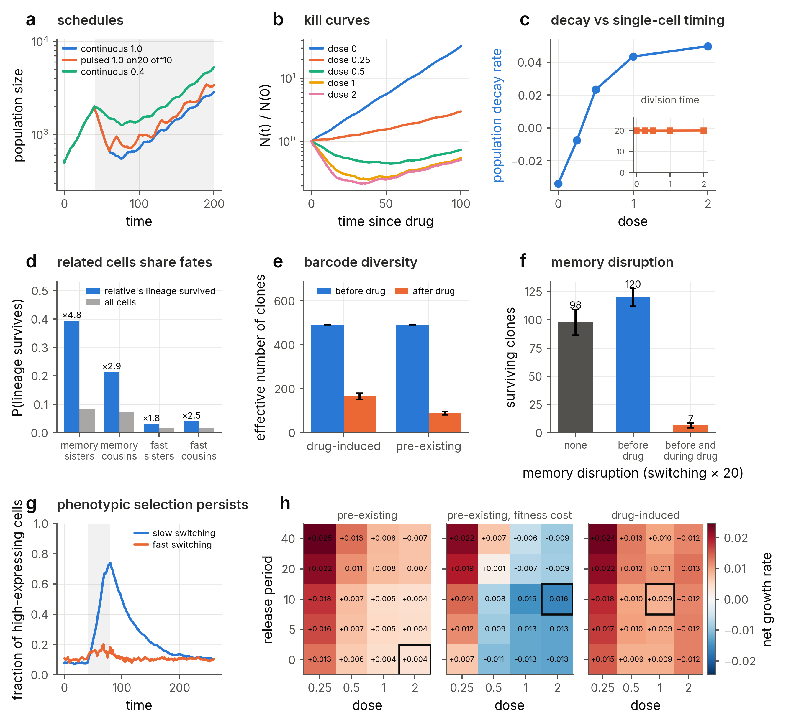
Fig. 4 | A single resistance gene with slow promoter switching reproduces persister biology. a, Population size under continuous, pulsed and reduced-dose schedules (shading, drug present). b, Kill curves at increasing dose. c, Net population decay rate over the first 30 time units of treatment against dose, with the mean division time of cells born under drug (inset), which is unchanged. d, Probability that a cell’s lineage survives the treatment (at least one descendant alive at the end of the run) given that its sister’s or cousin’s lineage survived, against the marginal survival probability, for cells born in the 25 time units before the drug; memory gene and fast-switching control, with the fold enrichment above each bar. e, Effective number of clones (barcodes) before and after drug for pre-existing and drug-induced tolerance (mean ± s.d. of three seeds). f, Surviving clones after drug without memory disruption, with promoter switching accelerated 20-fold from two cell-cycle times before the drug until the drug arrives, and with the acceleration maintained during exposure (mean ± s.d. of five seeds). g, Fraction of high-expressing cells before, during and after a drug pulse for slow and fast switching. h, Net population growth rate over a 200-time-unit course as a function of release period (time units without drug between 20-time-unit exposures) and dose, for pre-existing tolerance without and with a fitness cost of the resistant state and for drug-induced tolerance; the box marks the most effective schedule.
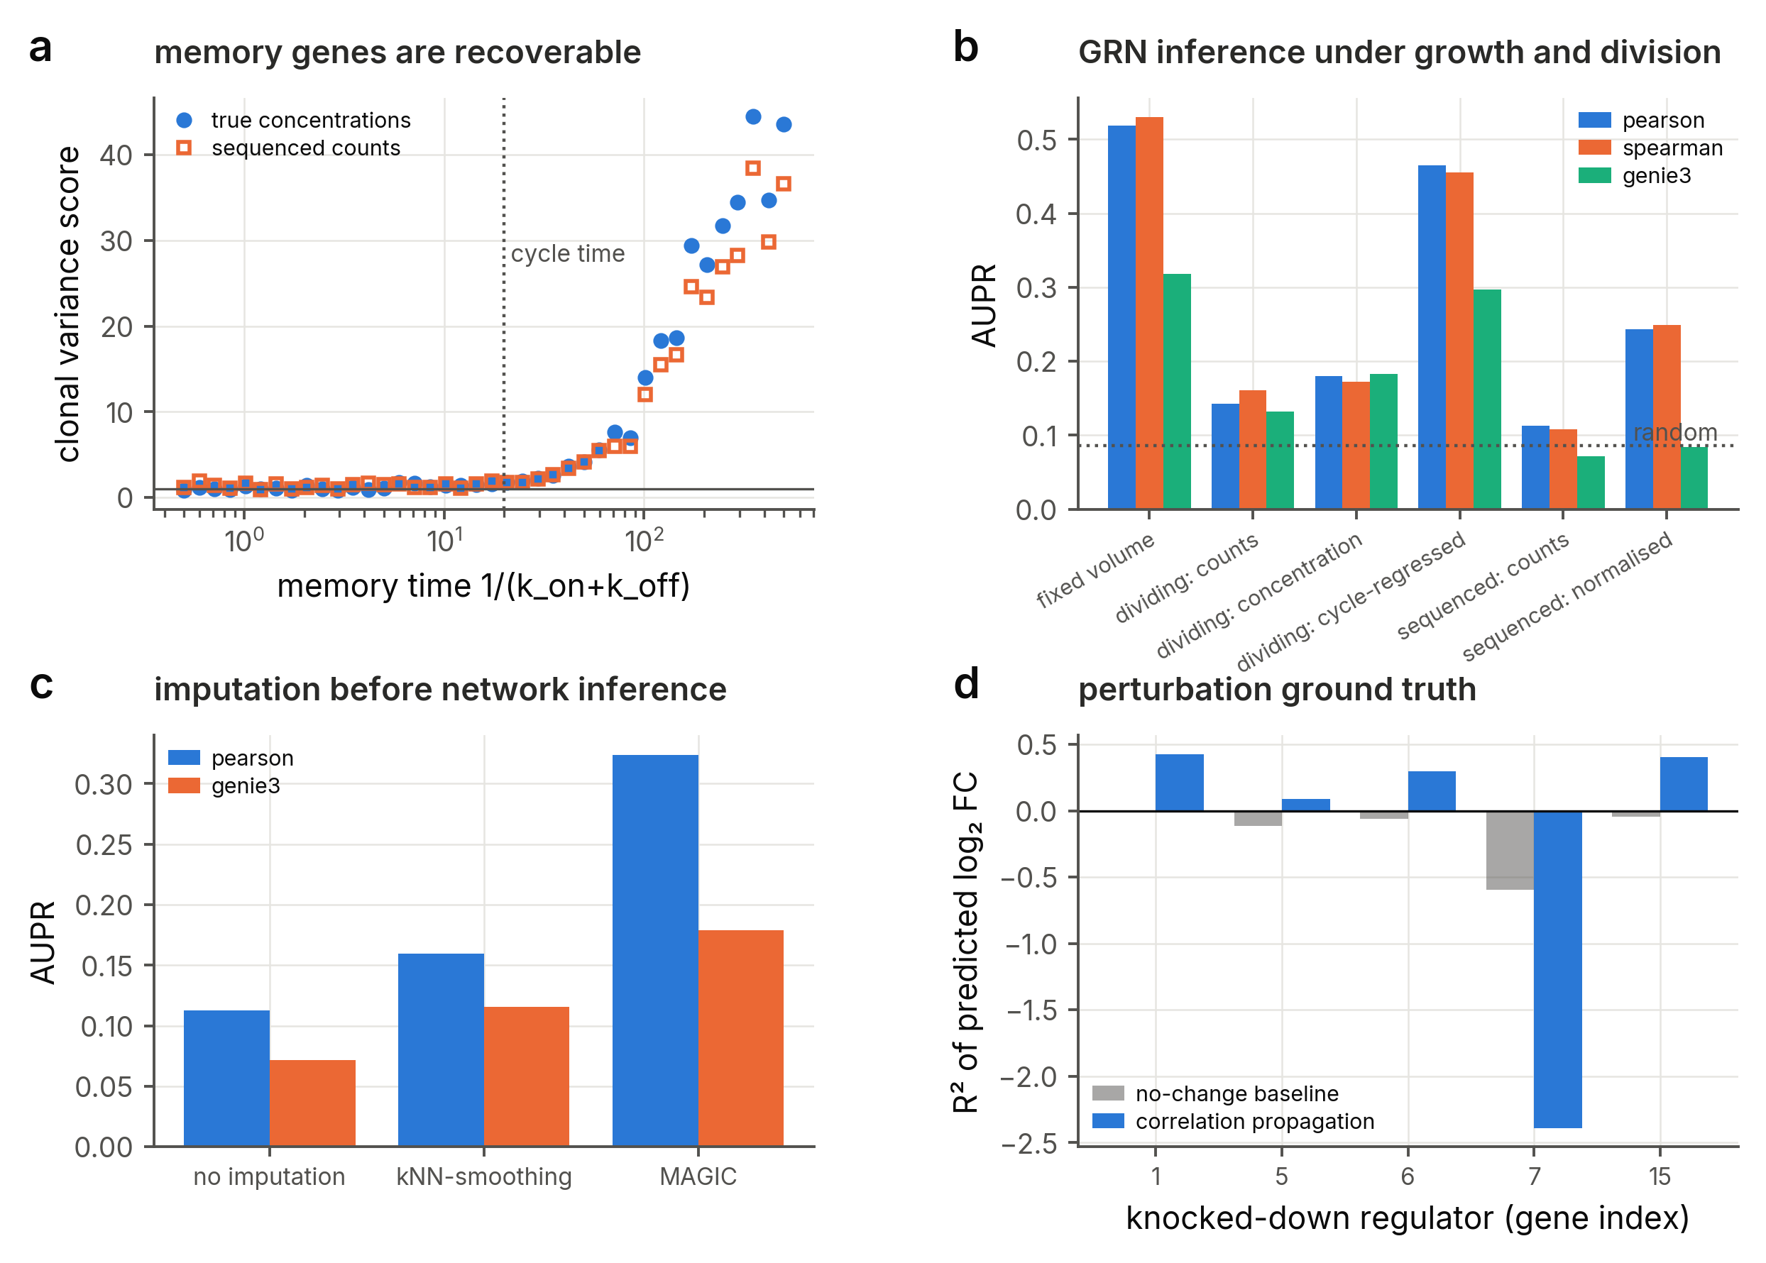
Fig. 5 | Ground-truth benchmarks. a, Clonal variance score against the known memory time of 40 independent genes, from true concentrations and from sequenced counts; dotted line, cell-cycle time. b, Area under the precision-recall curve of correlation (Pearson, Spearman) and GENIE3 network inference on the same 30-gene network observed at fixed volume, in a dividing population (raw counts, concentrations, and concentrations regressed on the cell-cycle covariates copy number and age) and after sequencing (raw and library-size normalised counts); dotted line, random ranking. c, Effect of kNN-smoothing and MAGIC imputation before inference. d, Coefficient of determination of predicted log₂ fold changes after knocking down the five most connected regulators, for a no-change baseline and for propagation of observational correlations.
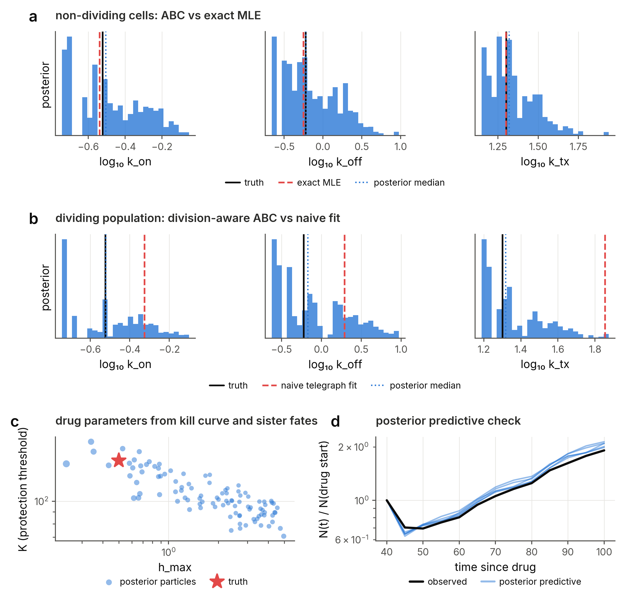
Fig. 6 | Inference with the forward model. a, Posterior distributions of telegraph parameters from ABC-SMC on a snapshot of non-dividing cells, with the truth and the exact maximum-likelihood estimate. b, The same for a snapshot of a growing and dividing population: the naive telegraph fit is biased while division-aware ABC recovers the truth. c, Posterior particles for the maximal death rate and the protection threshold inferred from a kill curve and sister fate concordance: the two parameters trade off along a ridge that contains the truth. d, Posterior predictive kill curves simulated at the posterior median against the observed curve.
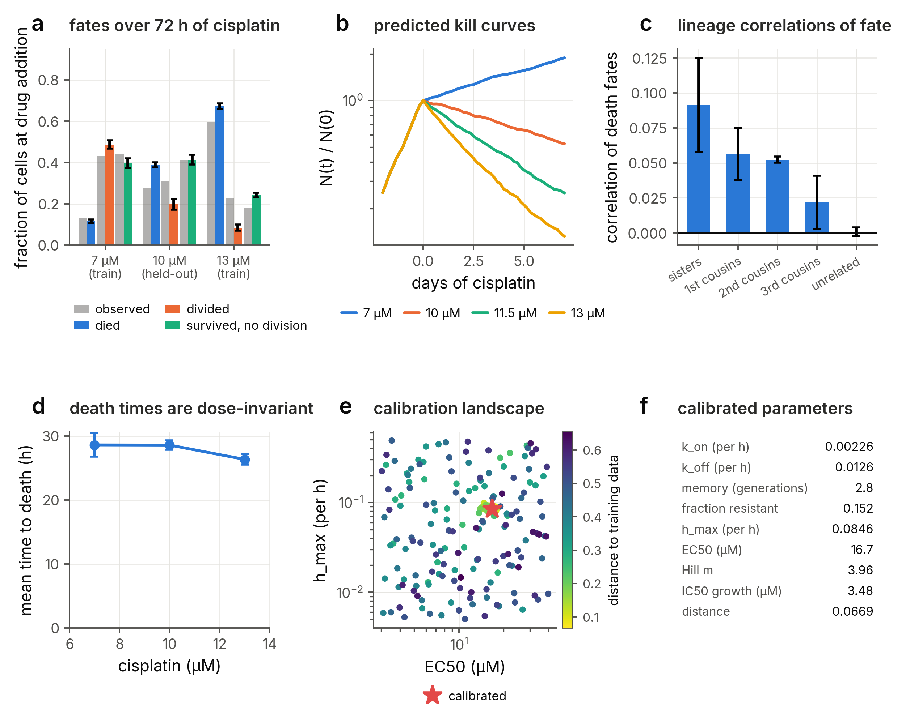
Fig. 7 | Calibration to laboratory time-lapse data and validation on held-out conditions. a, Fates over 72 h of cisplatin of U2OS cells present at drug addition, observed by time-lapse microscopy (grey; ref.⁶) and simulated by the calibrated model (colours; mean ± s.d. of four seeds); the model was calibrated on 7 and 13 µM and the 10 µM condition is predicted. b, Predicted population size at the three concentrations and at 11.5 µM, from two days before the drug to seven days of exposure. c, Correlation of death fates between sisters, first, second and third cousins present at drug addition, and between unrelated cells (mean ± s.d. of three seeds), against the observation that correlations extend to second but not third cousins. d, Mean time to death of cells present at drug addition, and mean division time where at least 20 cells born under drug divided, against concentration (mean ± s.d. of four seeds). e, Calibration landscape: every parameter set evaluated by the optimiser, coloured by its distance to the training data. f, Calibrated parameters.
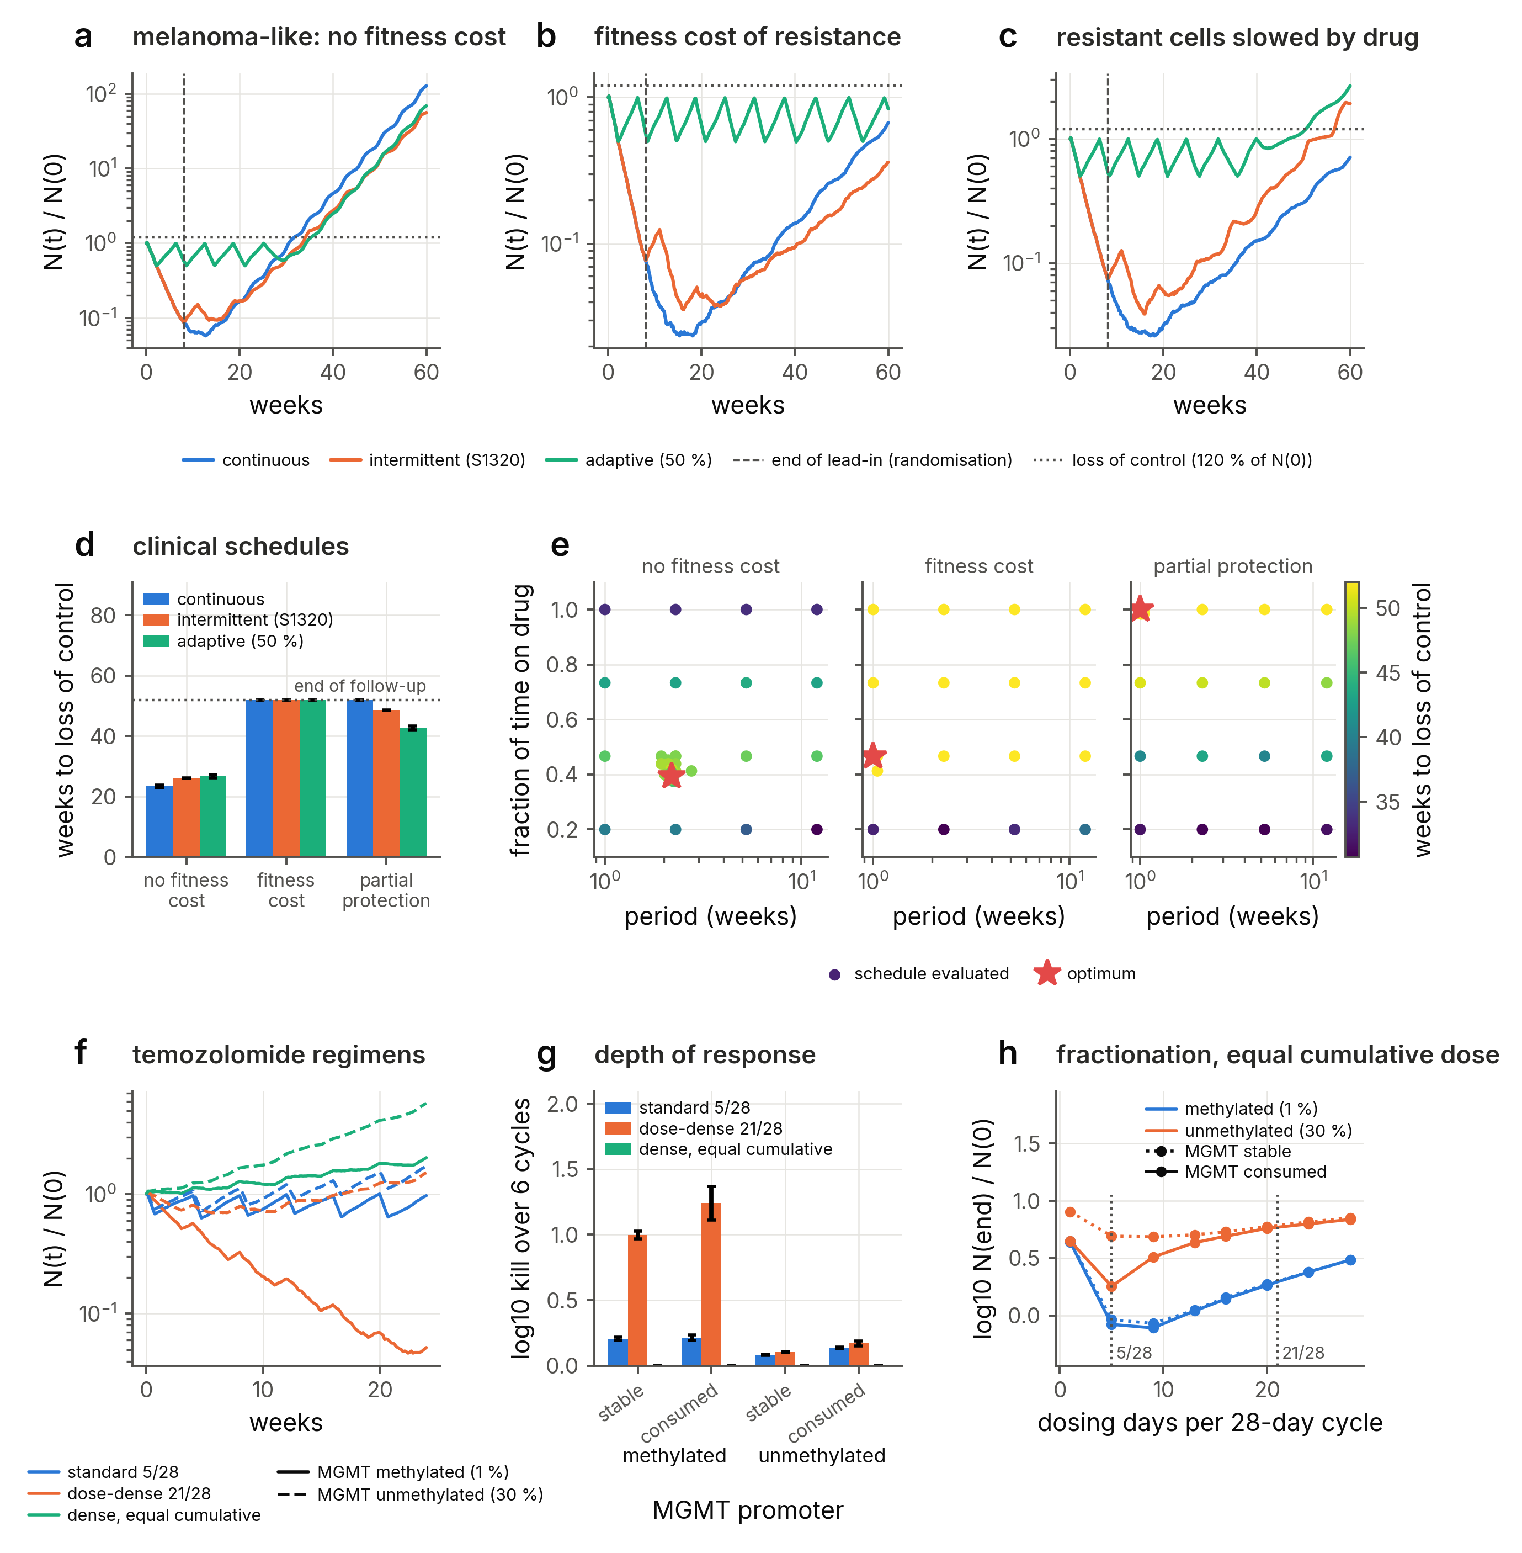
Fig. 8 | Dose and schedule optimisation against clinical regimens. a–c, Population size, relative to its pre-treatment value, under continuous dosing, the intermittent schedule of the SWOG S1320 trial (8-week lead-in, dashed line, then 3 weeks off and 5 weeks on) and adaptive therapy (drug withdrawn below 50% of the initial size, resumed at the initial size) for a melanoma-like population with a rare, heritable pre-resistant state, when the resistant state carries no fitness cost (a), when resistant cells grow 50% slower in the absence of drug (b), and when resistant cells are only partly protected and grow at half speed under drug (c); dotted line, 120% of the initial size. d, Weeks after randomisation until the population exceeds 120% of its pre-treatment size (loss of control; mean ± s.d. of four seeds, censored at 52 weeks). e, The same end point over intermittent schedules of given period and fraction of time on drug after the lead-in, for every schedule evaluated by the optimiser (star, best), for the three mechanisms. f, Population size under the standard (5 of 28 days) and dose-dense (21 of 28 days) temozolomide regimens of the RTOG 0525 trial and a 21-day regimen at the standard cumulative dose, with one-compartment pharmacokinetics (elimination half-life 2.1 h) and consumption of MGMT by the drug, for populations in which 1% (methylated promoter, solid) or 30% (unmethylated, dashed) of cells express MGMT. g, Depth of response over six cycles for the three regimens, the two populations and MGMT either stable or consumed by the drug (mean ± s.d. of two seeds). h, Final population size against the number of dosing days per 28-day cycle at the standard cumulative dose.

Acknowledgements
Version 1 of the framework was developed with Marc Sturrock and Vahid Shahrezaei, whose contributions to that work are described in ref.²⁵. This Article and version 2.0 of the software were authored with Claude (Anthropic), an AI assistant, under the direction and supervision of the author, who verified every result and takes full responsibility for the content.

Author contributions
A.L. conceived the study, defined its scope, the validation strategy and the case studies, supervised the work, verified all results and wrote the final version of the manuscript. The implementation of the software, the simulations, the analyses, the figures and the first draft of the manuscript were produced with Claude (Anthropic) under the author’s direction.

Competing interests
The author declares no competing interests.

Additional information
Supplementary information accompanies this Article. Correspondence and requests for materials should be addressed to A.L.

References
1. Sharma, S. V. et al. A chromatin-mediated reversible drug-tolerant state in cancer cell subpopulations. Cell 141, 69–80 (2010).
2. Shaffer, S. M. et al. Rare cell variability and drug-induced reprogramming as a mode of cancer drug resistance. Nature 546, 431–435 (2017).
3. Hata, A. N. et al. Tumor cells can follow distinct evolutionary paths to become resistant to epidermal growth factor receptor inhibition. Nature Medicine 22, 262–269 (2016).
4. Oren, Y. et al. Cycling cancer persister cells arise from lineages with distinct programs. Nature 596, 576–582 (2021).
5. França, G. S. et al. Cellular adaptation to cancer therapy along a resistance continuum. Nature 631, 876–883 (2024).
6. Iyer, A., Alva, A., Granada, A. E. & Chakrabarti, S. Inheritable cell-states shape drug-persister correlations and population dynamics in cancer cells. PLoS Computational Biology 21, e1013446 (2025).
7. Lin, Y., Chen, X., Wu, L., Zhou, Y. & Lin, Y. Widespread transcriptional memory shapes heritable states and functional heterogeneity in cancer and stem cells. Cell Systems 17, 101621 (2026).
8. Ghosh, S., Chakrabarti, S. & Raju, A. Identifying memory gene expression from single sample scRNA-seq data using power law signatures. bioRxiv https://doi.org/10.1101/2025.01.15.633183 (2025) doi:10.1101/2025.01.15.633183.
9. Harmange, G. et al. Disrupting cellular memory to overcome drug resistance. Nature Communications 14, 7130 (2023).
10. Sukys, A. & Grima, R. Cell-cycle dependence of bursty gene expression: Insights from fitting mechanistic models to single-cell RNA-seq data. Nucleic Acids Research 53, gkaf295 (2025).
11. Zhang, Z. et al. Stochastic gene expression in proliferating cells: Differing noise intensity in single-cell and population perspectives. PLoS Computational Biology 21, e1013014 (2025).
12. Okochi, Y., Sawazaki, Y., Kondo, Y. & Naoki, H. Inferring division-associated stochasticity from time-series single-cell transcriptomes. bioRxiv https://doi.org/10.64898/2026.04.14.718485 (2026) doi:10.64898/2026.04.14.718485.
13. Ahlmann-Eltze, C., Huber, W. & Anders, S. Deep-learning-based gene perturbation effect prediction does not yet outperform simple linear baselines. Nature Methods 22, (2025).
14. Vollenweider, M. S. & Bühlmann, P. Signal, bounds, and baselines: Principles for rigorous evaluation of high-dimensional biological perturbation prediction. bioRxiv https://doi.org/10.64898/2026.04.20.719650 (2026) doi:10.64898/2026.04.20.719650.
15. Dibaeinia, P. et al. Virtual cells need context, not just scale. bioRxiv https://doi.org/10.64898/2026.02.04.703804 (2026) doi:10.64898/2026.02.04.703804.
16. Bunne, C. et al. How to build the virtual cell with artificial intelligence: Priorities and opportunities. Cell 187, 7045–7063 (2024).
17. Dibaeinia, P. & Sinha, S. SERGIO: A single-cell expression simulator guided by gene regulatory networks. Cell Systems 11, 252–271 (2020).
18. Cannoodt, R., Saelens, W., Deconinck, L. & Saeys, Y. Spearheading future omics analyses using dyngen, a multi-modal simulator of single cells. Nature Communications 12, 3942 (2021).
19. Li, H., Zhang, Z., Squires, M., Chen, X. & Zhang, X. scMultiSim: Simulation of single-cell multi-omics and spatial data guided by gene regulatory networks and cell–cell interactions. Nature Methods https://doi.org/10.1038/s41592-025-02651-0 (2025) doi:10.1038/s41592-025-02651-0.
20. Zinati, Y., Takiddeen, A. & Emad, A. GRouNdGAN: GRN-guided simulation of single-cell RNA-seq data using causal generative adversarial networks. Nature Communications 15, 4055 (2024).
21. Pan, X., Li, H. & Zhang, X. TedSim: Temporal dynamics simulation of single-cell RNA sequencing data and cell division history. Nucleic Acids Research 50, 4272–4288 (2022).
22. Pratapa, A., Jalihal, A. P., Law, J. N., Bharadwaj, A. & Murali, T. M. Benchmarking algorithms for gene regulatory network inference from single-cell transcriptomic data. Nature Methods 17, 147–154 (2020).
23. Bertaux, F., Marguerat, S. & Shahrezaei, V. Division rate, cell size and proteome allocation: Impact on gene expression noise and implications for the dynamics of genetic circuits. Royal Society Open Science 5, 172234 (2018).
24. Piho, P. & Thomas, P. AgentBasedModeling.jl: A tool for stochastic simulation of structured population dynamics. PLoS Computational Biology 22, e1014366 (2026).
25. Lasri, A., Shahrezaei, V. & Sturrock, M. Benchmarking imputation methods for network inference using a novel method of synthetic scRNA-seq data generation. BMC Bioinformatics 23, 236 (2022).
26. Jones, M. G. et al. Inference of single-cell phylogenies from lineage tracing data using Cassiopeia. Genome Biology 21, 92 (2020).
27. Peccoud, J. & Ycart, B. Markovian modeling of gene-product synthesis. Theoretical Population Biology 48, 222–234 (1995).
28. Gunnarsson, E. B., De, S., Leder, K. & Foo, J. Understanding the role of phenotypic switching in cancer drug resistance. Journal of Theoretical Biology 490, 110162 (2020).
29. Lasri, A. et al. Phenotypic selection through cell death: Stochastic modelling of O-6-methylguanine-DNA methyltransferase dynamics. Royal Society Open Science 7, 191243 (2020).
30. Corigliano, M., Di Bernardo, A., Cosentino Lagomarsino, M. & Pompei, S. Optimal treatment for drug-induced cancer persisters involves release periods and intermediate drug doses. PRX Life https://doi.org/10.1103/mh5v-lcyw (2025) doi:10.1103/mh5v-lcyw.
31. Bernton, E., Jacob, P. E., Gerber, M. & Robert, C. P. Approximate Bayesian computation with the Wasserstein distance. Journal of the Royal Statistical Society: Series B 81, 235–269 (2019).
32. Algazi, A. P. et al. Continuous versus intermittent BRAF and MEK inhibition in patients with BRAF-mutated melanoma: A randomized phase 2 trial. Nature Medicine 26, 1564–1568 (2020).
33. Zhang, J., Cunningham, J. J., Brown, J. S. & Gatenby, R. A. Integrating evolutionary dynamics into treatment of metastatic castrate-resistant prostate cancer. Nature Communications 8, 1816 (2017).
34. Das Thakur, M. & Stuart, D. D. The evolution of melanoma resistance reveals therapeutic opportunities. Cancer Research 73, 6106–6110 (2013).
35. Strobl, M. A. R. et al. Turnover modulates the need for a cost of resistance in adaptive therapy. Cancer Research 81, 1135–1147 (2021).
36. Gilbert, M. R. et al. Dose-dense temozolomide for newly diagnosed glioblastoma: A randomized phase III clinical trial. Journal of Clinical Oncology 31, 4085–4091 (2013).
37. Ostermann, S. et al. Plasma and cerebrospinal fluid population pharmacokinetics of temozolomide in malignant glioma patients. Clinical Cancer Research 10, 3728–3736 (2004).
38. Gillespie, D. T. Exact stochastic simulation of coupled chemical reactions. The Journal of Physical Chemistry 81, 2340–2361 (1977).
39. Gillespie, D. T. Approximate accelerated stochastic simulation of chemically reacting systems. The Journal of Chemical Physics 115, 1716–1733 (2001).
40. Cao, Y., Gillespie, D. T. & Petzold, L. R. Efficient step size selection for the tau-leaping simulation method. The Journal of Chemical Physics 124, 044109 (2006).
41. Cao, Y., Gillespie, D. T. & Petzold, L. R. Avoiding negative populations in explicit Poisson tau-leaping. The Journal of Chemical Physics 123, 054104 (2005).
42. Shaffer, S. M. et al. Memory sequencing reveals heritable single-cell gene expression programs associated with distinct cellular behaviors. Cell 182, 947–959 (2020).
43. Toni, T., Welch, D., Strelkowa, N., Ipsen, A. & Stumpf, M. P. H. Approximate Bayesian computation scheme for parameter inference and model selection in dynamical systems. Journal of the Royal Society Interface 6, 187–202 (2009).
44. Friedman, N., Cai, L. & Xie, X. S. Linking stochastic dynamics to population distribution: An analytical framework of gene expression. Physical Review Letters 97, 168302 (2006).
45. Shahrezaei, V. & Swain, P. S. Analytical distributions for stochastic gene expression. Proceedings of the National Academy of Sciences 105, 17256–17261 (2008).
46. Rackauckas, C. & Nie, Q. DifferentialEquations.jl – a performant and feature-rich ecosystem for solving differential equations in Julia. Journal of Open Research Software vol. 5 15 (2017).
47. Huh, D. & Paulsson, J. Non-genetic heterogeneity from stochastic partitioning at cell division. Nature Genetics 43, 95–100 (2011).
48. Huynh-Thu, V. A., Irrthum, A., Wehenkel, L. & Geurts, P. Inferring regulatory networks from expression data using tree-based methods. PLoS ONE 5, e12776 (2010).
49. Dijk, D. van et al. Recovering gene interactions from single-cell data using data diffusion. Cell 174, 716–729 (2018).
50. Wagner, F., Yan, Y. & Yanai, I. K-nearest neighbor smoothing for high-throughput single-cell RNA-Seq data. bioRxiv https://doi.org/10.1101/217737 (2018) doi:10.1101/217737.

