Mechanistic simulation of heritable expression states, cell division and drug response in single-cell populations
Ayoub Lasri
Berache Limited, Dublin, Ireland. Correspondence: alasri@berache.com
Abstract
Heritable differences in gene expression can decide which cancer cells survive a drug, yet the simulators used to benchmark single-cell methods model neither growth nor division, and stochastic simulators of dividing cells carry no drug layer. Here we present Biomodelling.jl 2.0, in which stochastic reaction kinetics run inside growing, dividing, drug-treated cells. Exact, hybrid and adaptive kernels couple to exponential growth, volume-scaled transcription, gene replication, division with partitioning, dose schedules with state-dependent killing, a lineage record, observation models and likelihood-free inference. Expression memory, cell-size scaling and cell-cycle-dependent bursting emerge from this physiology rather than being imposed. One resistance gene with slow promoter switching reproduces the lineage and memory signatures of drug tolerance, and the framework supplies the ground truth that benchmarks of memory genes, network inference and perturbation prediction lack. Calibrated to time-lapse measurements of cisplatin-treated U2OS cells, the model reproduces their dose-invariance of single-cell timing and matches the kin fate correlations reported for HCT116 cells in the same study. That match is a consistency check across cell lines rather than an independent validation, because the memory timescale was taken from those correlations as a prior; six parameters fitted to six fate fractions leave it undetermined, and a cycle-gated hazard fits as well. The schedule optimiser reproduces the opposite rankings of intermittent dosing reported in a melanoma trial and in xenografts, the xenograft ranking as a lower tumour burden at the end of the 60-week simulation rather than as a longer time to loss of control, on which all three schedules are censored, and shows the ranking to turn on measurable properties of resistant cells: growth under drug, fitness without it, and whether the drug stabilises the resistant state.

Author summary
Two cancer cells with the same genome, given the same drug, can meet opposite fates. Part of that difference can come from which genes each cell happens to be expressing strongly when treatment begins, and cells pass those states to their daughters when they divide. The simulators used to test single-cell analysis methods model neither growth nor division, so they cannot produce such inherited states; those that do model dividing cells carry no drug.
We built Biomodelling.jl 2.0, in which chemical reactions play out inside cells that grow, copy their genes, divide and meet drugs on realistic schedules. Expression memory, cell-size effects and cell-cycle dependence emerge from that physiology rather than being assumed. We checked it against cases whose answers are known exactly in mathematics, fitted it to published time-lapse recordings of cells under chemotherapy, and asked it to predict a concentration it had not seen.
We then put a clinical question to it: should a drug be given continuously, or with breaks? The answer turns on three measurable properties of resistant cells: how fast they grow under the drug, how they fare without it, and whether the drug itself holds the resistant state in place.
Isogenic cells differ in their transcriptional states, those differences are often inherited across several divisions, and the inherited state biases what a cell does under stress. Cancer cells that survive targeted or cytotoxic therapy frequently do so without a resistance mutation: they occupy a rare, reversible, drug-tolerant expression state that pre-exists the treatment or is induced by it [1–5]. Lineage-resolved experiments now measure this memory directly. The fates of sisters and cousins are correlated, clonal barcode diversity is preserved or collapsed depending on whether tolerance pre-exists or is induced, and the timescale of expression fluctuations relative to the cell cycle decides which genes carry memory at all [6–9]. In parallel, mechanistic analyses of single-cell RNA-sequencing data have shown that transcriptional kinetics can be inferred correctly only when gene copy number, cell age and partitioning at division are modelled explicitly [10–12], and evaluations of “virtual cell” models for perturbation prediction keep finding that deep-learning approaches fail to beat simple baselines, largely for want of mechanism and causal structure [13–16].
These developments create a demand that existing simulators do not meet. The simulators used to benchmark single-cell methods divide according to whether they supply a regulatory network as ground truth, and neither kind models cell growth, volume-dependent transcription, gene replication or the partitioning of molecules at division. Splatter and scDesign3 draw counts from statistical models fitted to reference data, and SymSim draws them from a two-state promoter whose kinetic parameters are products of cell-specific and gene-specific factors; none of the three supplies a network [17–19]. SERGIO, dyngen and scMultiSim simulate the kinetics of a user-specified network [20–22], and GRouNdGAN imposes one on an adversarially trained generator, so that each gene’s counts follow from those of its transcription factors [23]. Most of these simulators place cells on a differentiation trajectory, and lineage simulators such as TedSim and Cassiopeia [24,25] generate division trees, but the expression attached to those trees is phenomenological and largely Markovian. Expression memory, cell-size scaling, cell-cycle-dependent bursting and persister dynamics therefore have to be imposed on them rather than emerging, and none provides the ground truth that the methods now being developed for exactly those phenomena require [26]. Stochastic simulators of growing and dividing cells do exist, and the most complete of them couples reaction kinetics to growth, division and inference from lineage data [27–30]; what none of them adds is a drug and schedule layer, observation models for the measurements these questions are asked of, and benchmark generation. Agent-based tumour simulators supply the drug response and the spatial structure but not stochastic transcription in dividing cells [31,32].
Here we present Biomodelling.jl 2.0, a rewrite of a Julia framework whose distinguishing feature, the coupling of stochastic reaction kinetics to exponential growth, volume-scaled transcription and binomial partitioning at division [33], is precisely the mechanism behind heritable expression states. Version 2.0 turns that feature into a complete framework for the mechanistic study of drug tolerance and for single-cell benchmarking. We validate the engine against exact stationary laws and an independent implementation, show that growth, division and partitioning alone reproduce published results on cell-size scaling, partitioning noise, lineage-versus-population statistics and cell-cycle-dependent bursting, and demonstrate that a single resistance gene with slow promoter switching reproduces the quantitative lineage and memory signatures of heritable drug tolerance. We then use the framework as a ground-truth generator for memory-gene detection, network inference, imputation and perturbation prediction; as an inference engine that recovers kinetic parameters from snapshot and lineage data, quantifies the bias of ignoring division, and maps the ridge to which drug parameters are determined by population data; as a model calibrated to published time-lapse measurements and confronted with conditions it was not fitted to; and, with a built-in schedule optimiser, as a testbed in which clinical dosing regimens are compared and better ones are sought.

Results

Layers couple reaction kinetics to growth and division
Biomodelling.jl 2.0 is organised in layers (Fig. 1). A model is a list of reactions with mass-action, Hill or custom kinetics and named parameters; promoter states are explicit species, grouped so that they are inherited at division and doubled at replication. Four kernels advance a cell’s state at fixed volume: the exact direct method, fixed-step tau-leaping, a hybrid scheme that falls back to the exact method whenever a leap would produce a negative count, and adaptive tau-leaping with critical-reaction handling. The population layer grows each cell’s volume exponentially, scales propensities with volume so that concentrations are invariant, replicates genes at a set point of the cycle, divides cells by a sizer, adder or timer rule with binomial or over-dispersed partitioning, and controls the population size by Moran-like replacement, free growth, a logistic hazard or mother-machine sampling that keeps one daughter at each division. A perturbation layer applies dose schedules, state-dependent death, growth inhibition, drug-induced rate changes and genetic perturbations. Every cell’s ancestry, fate and state at birth and division enter a lineage table, from which heritability, autocorrelation, memory timescales, fluctuation-test and clonal-memory statistics follow. Observation models convert true counts into scRNA-seq, smFISH or time-lapse measurements, and the same forward model drives likelihood-free inference. Table 1 sets these capabilities against those of the simulators most used to benchmark single-cell methods.
Table 1. Capabilities of single-cell simulators (✓ native; ○ partial or phenomenological; – absent). SERGIO [20], dyngen [21], scMultiSim [22], GRouNdGAN [23], TedSim [24], Cassiopeia [25], ABM.jl (AgentBasedModeling.jl) [28], Biomodelling.jl v1.x [33] and v2.0 (this work). Entries were read from each tool’s publication and documentation, and describe what the tool provides rather than what its formalism could express. Three readings need qualifying. SERGIO is a Python package that returns expression matrices as arrays and scMultiSim is an R package returning SingleCellExperiment-style objects, so neither writes AnnData natively; scMultiSim does carry a differentiation tree, so cells are related by a trajectory even though per-cell division and fate are not simulated. ABM.jl is the closest comparator: it simulates stochastic reaction networks in growing, dividing agents with an adder division rule, binomial partitioning, death and environmental coupling, and its companion work infers kinetic and selection parameters from mother-machine and lineage-tree data [29]; its ○ entries are for gene replication, which its agent formalism can express but does not provide, and for lineage output, which traces a cell back to its ancestor rather than recording a tree with per-cell fates. Cassiopeia simulates division topologies with heritable fitness and CRISPR barcodes rather than molecular content, and its inference recovers phylogenies rather than kinetic parameters.
Capability | SERGIO | dyngen | scMulti- Sim | GRouNd- GAN | TedSim | Cassio- peia | ABM.jl | v1.x | v2.0
Mechanistic reaction kinetics (SSA / tau-leaping) | ○ | ✓ | ○ | – | – | – | ✓ | ✓ | ✓
Gene regulatory networks with known ground truth | ✓ | ✓ | ✓ | ✓ | – | – | ✓ | ✓ | ✓
Cell growth, volume-scaled transcription | – | – | – | – | – | – | ✓ | ✓ | ✓
Gene replication / cell- cycle copy number | – | – | – | – | – | – | ○ | – | ✓
Division with molecular partitioning | – | – | – | – | ○ | ○ | ✓ | ✓ | ✓
Heritable promoter states, expression memory | – | – | – | – | ○ | – | ✓ | ○ | ✓
Lineage tree with per-cell fates | – | – | ○ | – | ✓ | ✓ | ○ | – | ✓
Drug response: dose schedules, state-dependent death | – | – | – | – | – | – | – | – | ✓
Genetic perturbations (knockdown / overexpression) | ✓ | ✓ | ○ | ✓ | – | – | ○ | – | ✓
scRNA-seq observation model | ✓ | ✓ | ✓ | ✓ | ✓ | – | – | ✓ | ✓
smFISH / time-lapse observation | – | – | – | – | – | – | – | – | ✓
Parameter inference from data | – | – | – | – | – | ○ | ✓ | – | ✓
AnnData output | – | ✓ | – | ✓ | ○ | ○ | – | – | ✓

The engine matches exact laws and an independent package
We first verified the kernels against exact stationary laws (Fig. 2). For a birth-death process the simulated distribution of 50,000 cells is indistinguishable from the Poisson law (Fig. 2a); for the telegraph model in an intermediate and in a bursty regime it matches the Beta-Poisson distribution [34] (Fig. 2b); and for bursty protein production it matches the negative binomial (Fig. 2c). Across kernels, Kolmogorov-Smirnov distances to the exact law with 20,000 cells lie below the 99% critical value for the direct method, for the adaptive scheme at both tolerances and for the hybrid scheme at the shorter step, and above it for the hybrid scheme at the longer step (0.0160 and 0.0122 against a critical value of 0.0115; Fig. 2d). That is the expected behaviour of an approximate kernel, and it sets the step below which the approximation is not detectable at this sample size; wall-clock costs are 0.25 s to 0.91 s per 10⁴ cells. Simulating the same telegraph model with JumpProcesses.jl gives distributions whose two-sample Kolmogorov-Smirnov statistic against Biomodelling.jl is 0.0034 (99% critical value 0.0163; Fig. 2e), with a 6.2-fold (in favour of JumpProcesses.jl) difference in serial wall-clock time. Those tests exercise one cell at fixed volume. The layer above them, growth, replication, partitioning and the difference between a lineage and a population, has exact solutions of its own for this class of model, which take different closed forms in the two settings [35–37]. We reproduced four analytically solvable members of that class, with constitutive, bursty and two-state promoter kinetics under a memoryless interdivision time and with volume-scaled synthesis from a replicating gene under a deterministic cycle, in both modes. Along single lineages, where the mother-machine control makes the recorded cells independent and the Kolmogorov-Smirnov test applies as it stands, all 4 samples match the exact law of their mode (distances 0.0023 to 0.0054 against 99% critical values of 0.0081 to 0.0115). A population snapshot is not an independent sample, because its cells share ancestors, so the independent critical value understates the true one and the population mode is judged on the agreement of its replicate means with the exact mean. Those means sit within 2.5 standard errors of the exact values (18 of the 20 individual samples also fall below the independent critical value, the largest distance being 0.0170). All four population means are nonetheless slightly low, by 0.03% to 0.70%; no single deviation is resolved, the largest being 2.5 standard errors ($p=0.07$, Student’s t), but the common sign is not accounted for by the discretisation, the subsampling cap or the burn-in, each of which is excluded in Supplementary Note 14. Scored against the exact law of the other mode, the same samples give distances at least 6 times larger, so the comparison has ample power to tell the two settings apart. The two differ because a snapshot of a growing population over-weights cells that have just divided and so just lost half their molecules: the mean molecule number is constitutive production 13.33 against 10.00; bursts of four molecules 13.33 against 10.00; two-state promoter 8.89 against 6.67; volume-scaled synthesis with gene replication 25.64 against 23.96 along a lineage and in a population respectively (Supplementary Note 14 and Supplementary Fig. 6). Population simulations scale linearly with the number of cells: 2.6 s for 5000 cells × 10 telegraph genes × 200 steps (hybrid kernel) with four threads (Fig. 2f and Supplementary Table 3). Scaling in the number of reactions depends on the kernel and is close to linear only for the hybrid one (0.58 s to 6.4 s for the hybrid kernel, a factor of 11 for the same factor of 10 in genes; 1.04 s to 31.4 s for the direct kernel, a factor of 30 for the same factor of 10 in genes), because the direct method draws one event at a time while the hybrid kernel leaps over the non-critical channels in a fixed number of operations.

Physiology generates memory, scaling and cycle effects
The physiology of the population layer suffices to produce properties of single-cell data that phenomenological simulators must impose by hand (Fig. 3). In a single lineage of a slowly switching gene, mRNA and protein track volume within a cycle and are halved at division, while the promoter state, inherited by both daughters, persists over many divisions (Fig. 3a). For a fast-switching gene without replication, transcript numbers scale linearly with cell volume, so that concentration is homeostatic; adding mid-cycle gene replication doubles transcription in the second half of the cycle and lifts counts of large cells above the volume-scaling line (Fig. 3b), the copy-number effect that mechanistic fits to scRNA-seq data must account for [10]. Correlations of protein concentration at division between mothers and daughters, sisters and cousins fall from 0.94 to 0.02 as the promoter switching rate crosses the inverse cell-cycle time (Fig. 3c), mother-daughter and sister pairs correlating similarly at slow switching and mother-daughter pairs more strongly as switching quickens, cousins least, and mRNA less heritable than protein. The memory timescale extracted from the generation-resolved lineage autocorrelation is set by the promoter switching time and is nearly independent of the cell-cycle time as long as memory outlasts the cycle; when the two are comparable the estimate is bounded below by one cell cycle, the resolution of the autocorrelation (Fig. 3d). Theory predicts that the two perspectives separate for a stable protein under two conditions: when the protein inhibits growth at high concentration, so that dilution acts as a positive feedback, and when partitioning noise is combined with randomness in the interdivision time; with neither, a population and a single lineage give the same concentration distribution [11]. In our simulations the coefficient of variation of a stable protein’s concentration is larger across the population than along single lineages, whether or not cell-cycle times are noisy, and over-dispersed partitioning adds variability in both perspectives (Fig. 3e). Telegraph parameters fitted separately to cells before and after replication move in the direction gene replication implies, but not by the factor it alone would give (Fig. 3f). Between the one-copy and the two-copy subsets the fitted transcription rate rises 2.0-fold, of which 1.4-fold is the larger volume of cells that have already replicated, leaving 1.4-fold per unit volume rather than the twofold that doubling the copy number implies; the fitted activation rate rises 1.4-fold over the same comparison, and the pooled fit that ignores the cell cycle returns a transcription rate above both subsets. Part of that shortfall is misspecification rather than copy number, and the figure shows it: two independently switching alleles are not one telegraph gene, and neither subset fit recovers the truth (0.5 and 1.5 for the switching rates and 2 for the transcription rate as Fig. 3f scales it, that is the true 40 transcripts per unit time per unit volume per allele divided by twenty, against 0.59, 1.89 and 2.4 fitted to the one-copy cells and 0.65, 3.27 and 4.8 pooled, whose transcription rates are scaled the same way). What the panel demonstrates is that a cell-cycle-blind fit is biased, not how large the copy-number effect is.

One resistance gene reproduces tolerance signatures
To test whether heritable expression states suffice to reproduce the lineage and memory signatures of drug-tolerant persistence, we coupled a resistance gene with slow promoter switching (memory timescale 45 time units, cell-cycle time 20) to a death hazard that rises with dose and is suppressed by the concentration of the gene’s protein product (Methods). Under continuous, pulsed and reduced-dose schedules the population first collapses as low-expressing cells die, then regrows from high-expressing survivors (Fig. 4a); kill curves are biphasic with a surviving fraction that falls with dose (Fig. 4b). Between doses 0.5 and 2 the net rate of population decline over the first 30 time units of treatment rises from 0.023 to 0.050 per time unit (2.1-fold), while the mean division time of cells born under drug changes by 0.3% and the mean time to death of killed cells moves only from 7.6 to 6.2 time units (Fig. 4c; the single-cell timing distributions are in Supplementary Fig. 1). This reproduces the observation that population decay depends strongly on dose even though single-cell division and death times barely do [6], because fate is biased by states that exist before the drug arrives. Unlike the growth-arrested persisters of the canonical definition [1], the survivors here divide at an essentially unchanged rate (Fig. 4c, inset), so the model reproduces the heritable-state selection signatures of tolerance rather than its proliferative-arrest hallmark.
Related cells accordingly share the fate of their lineages. Among cells born in the 25 time units before the drug, one whose sister founded a surviving lineage does so itself with probability 0.39, against a marginal probability of 0.08 (4.8-fold enrichment over 1830 sister pairs; 2.9-fold for cousins), whereas in a fast-switching control, in which survival is rarer, the 1.8- and 2.5-fold values the panel prints rest on one sister pair and two cousin pairs in which both lineages survived, and the concordance sits at the independent expectation (+0.000 above it, against +0.051 for the memory gene; Fig. 4d). When tolerance pre-exists, survivors descend from a minority of founder clones and the effective number of clones drops from 491 to 89; when tolerance is drug-induced, so that the drug raises the promoter activation rate of every cell, diversity collapses less but is not preserved (165 of 492; Fig. 4e). That difference, rather than preservation itself, is the signature that distinguishes the two origins in barcoding experiments [2,6]; the follow-up method that traces resistant fates back to their drug-naive precursors puts those precursors at an initial frequency of about 1 in 1,000 to 1 in 10,000 cells [38]. The melanoma case study below does not sit in that regime: it uses 1:200, the per-marker frequency at which rare cells express resistance genes before drug [2], which is 5- to 50-fold higher. That range is in any case not resolvable at the size of this study, since a draw of its 2,000 founders would contain no pre-resistant cell at all with probability 0.8 at 1 in 10,000. The consequence is a larger and less clonal pre-existing resistant pool, so that among the arms which do lose control it is lost earlier than the traced frequency would give; the ranking of the schedules follows from the growth of resistant cells with and without drug rather than from their initial frequency, but it was not re-tested at a lower fraction.
Disrupting expression memory changes the outcome, and when it is disrupted matters. Accelerating promoter switching 20-fold from two cell-cycle times before the drug does not reduce the number of surviving clones if the acceleration stops when the drug arrives: it raises them, from 98 to 120 (mean of 5 seeds each, P = 0.009, Welch’s t test). Reshuffling spreads the resistant state over more lineages, so more clones carry a protected cell when the drug arrives, even though protection itself is untouched. The acceleration multiplies both switching rates by the same factor, so it leaves the stationary promoter-on fraction unchanged; what it shifts slightly is the fraction of high-expressing cells, those whose protein concentration exceeds the half-protection value of the death hazard, from 0.09 to 0.11, because it shortens the intervals a cell spends in each promoter state relative to the lifetime of the protein. Maintaining it during exposure reduces the count to 7 clones (10 cells, against 792; Fig. 4f), because resistant cells now leave the protected state within a fraction of the time they need to found a colony. In the model, memory must be disrupted while the drug is present.
Two published experiments bear on this prediction and they point in opposite directions, so it is worth being explicit about which perturbation each one performs. A CRISPR screen for modulators of single-cell variability found that inhibiting DOT1L before adding a BRAF inhibitor produced more therapy resistance than giving the two together [39], which is the ordering the model predicts. A lineage-tracing study that identified PI3K and TGF-β signalling as switching modulators found the opposite for its own pretreatment: a PI3K inhibitor applied before targeted therapy left less resistance than targeted therapy alone [9]. The two results are not in conflict with each other, and only the first is a test of what is simulated here. The perturbation in the model is symmetric: it multiplies the activation and the inactivation rate by the same factor, so it accelerates relaxation towards the stationary resistant fraction without moving that fraction, and its only effect before the drug is to spread the resistant state over more lineages. A modulator that shifts the balance between the states is a different perturbation, and a pretreatment that drives cells out of the primed state lowers the number of protected cells at the moment the drug arrives, which reduces resistance whether or not it is maintained. The prediction here is therefore specific to perturbations that speed switching without biasing it, of which DOT1L inhibition appears to be one and PI3K inhibition is not; distinguishing the two experimentally requires measuring the resistant fraction as well as the switching rate, which memory-sequencing and lineage-tracing assays do. Compartment theory for phenotypic switching already predicts that an agent which perturbs the retention of the resistant state can turn treatment failure into success [40]; what the simulations add is the timing requirement and a lineage-resolved readout, the number of surviving clones, by which it can be tested. A transient pulse enriches high-expressing cells and, with slow switching, the enrichment persists for many generations after the drug is removed, whereas with fast switching it relaxes within a few cycles (Fig. 4g): phenotypic selection with stable inheritance, as in the original MGMT model [41]. Finally, scanning release periods and doses of intermittent schedules (Fig. 4h), the most effective schedule is release period 0, dose 2 (growth rate +0.0038 per time unit, ± 0.0007 over 5 seeds) for pre-existing tolerance, release period 0, dose 2 (growth rate -0.0151 per time unit, ± 0.0012 over 5 seeds) when the resistant state carries a fitness cost, and release period 0, dose 1 (growth rate +0.0089 per time unit, ± 0.0001 over 5 seeds) for drug-induced tolerance. Each point of the scan is the mean of 5 independent seeds, and every schedule is run on the same 5 seeds, so schedules are compared by their paired differences, in which the shared founder population cancels; the spread quoted beside each winner above is the seed-to-seed scatter of its absolute growth rate, which is 0.5 to 2.0 times the paired differences and is not the error on them. The winning schedule beats the best schedule with a non-zero release period by 0.00026 to 0.00142 per time unit against paired standard errors of 0.00013 to 0.00028, a margin that a two-sided paired t-test resolves at the 5% level in 1 of the 3 mechanisms, the one in which the resistant state carries a fitness cost. Elsewhere the scan identifies a region of good schedules rather than a single best one (pre-existing tolerance +0.00037 against 0.00023, $t=1.61$ on 4 d.f., $P=0.18$; drug-induced tolerance +0.00026 against 0.00013, $t=2.02$ on 4 d.f., $P=0.11$). Without a fitness cost nothing beats continuous dosing at the highest dose, since every release period lets the resistant subpopulation regrow (the drug does not act on the switching rates in this model; when it also stabilises the resistant state, as in the melanoma case study below, holidays regain a small advantage even without a cost). With a fitness cost the population declines under every schedule at dose 1 and above, and at dose 0.5 under every schedule but the longest holidays, where it still grows (release periods of 20 and 40 time units, +0.0008 and +0.0064 per time unit); release periods of up to 10 time units at doses of 1 and 2 cost little, though 3 of those 4 are resolvably worse than continuous dosing at the highest dose (+0.0014 to +0.0029 per time unit, -0.0151 per time unit under continuous dose 2), because cells that leave the resistant state during a holiday are killed on re-exposure. For drug-induced tolerance the ranking of doses reverses: the highest dose induces tolerance in more cells than it kills, so dose 1 outperforms dose 2 at every release period (release period 0, dose 1 (growth rate +0.0089 per time unit, ± 0.0001 over 5 seeds), against +0.0123 for continuous dose 2), the intermediate-dose optimum reported previously [42]; the benefit of release periods reported in that work does not appear here, because in this model the induced state decays at the same rate with and without drug, so a holiday only postpones the death of reverting cells while all cells grow.
The hazard above does not depend on where a cell is in its division cycle, and the calibration below will show that fate data cannot exclude one that does, so we repeated these simulations with three quarters of the hazard confined to a window around mid-cycle. Population decay still rises with dose (-0.001 to +0.023 per time unit over doses 0.5 to 2, against +0.023 to +0.050 without the gate) and the mean time to death stays nearly dose-invariant (8.4 to 9.3 against 6.2 to 7.6 time units over the same doses), so neither signature depends on a cycle-blind hazard. Sisters share a birth time and so a cycle phase, which lets a gated hazard correlate their fates with no inherited state; it does not do so to any useful degree, lifting the sister concordance of the memoryless fast-switching control only to +0.008 above independence (from +0.000), against +0.054 for the memory gene, so the kin signature still reads expression memory rather than the cycle. In the schedule scan, continuous dosing wins in all 3 models with the gate as without it, at the same dose in 3 of 3. The gate raises the long-term growth rate (+0.0026 to +0.0155 per time unit at all 60 points of the scan), which is what confining three quarters of the hazard to a window of the cycle implies, and it perturbs the order of the schedules below the winner (Spearman correlation 0.977 to 0.998 between the gated and cycle-blind orderings), but it changes neither which schedule wins nor the intermediate-dose optimum under drug-induced tolerance (+0.0156 against +0.0190 under the gate and +0.0089 against +0.0123 without it). Across the two scans a two-sided paired t-test resolves the margin over the best holiday at the 5% level in 4 of the 6 comparisons, the exceptions being pre-existing tolerance without the gate (+0.0004 against a paired standard error of 0.0002) and drug-induced tolerance without the gate (+0.0003 against a paired standard error of 0.0001) (Supplementary Note 13 and Supplementary Fig. 5).

Simulated ground truth benchmarks inference methods
Because every cell’s clone, lineage and true state are known, the framework supplies ground truth that observational data cannot (Fig. 5). For 40 independent genes whose memory times span three decades, MemorySeq-style clonal variance scores computed on true concentrations rise from 1.0 for genes with memory far below the cell-cycle time to a mean of 29.6 for genes with memory beyond a hundred time units, five cell-cycle times, the highest single gene reaching 44.5 (38.4 on sequenced counts), and the ranking survives computation on sequenced counts at 20% capture efficiency (Fig. 5a); the score separates genes with memory longer than the cycle from the rest with an area under the receiver operating characteristic (ROC) curve of 1.00 on true concentrations and 0.99 on sequenced counts. For a 30-gene network, small enough that the methods were run with their default settings and the ranking of datasets rather than the absolute accuracy is what should be read, simulated at fixed volume, in a dividing population and after sequencing, correlation-based and GENIE3 inference lose most of their accuracy in the dividing population when raw counts are used (area under the precision-recall curve 0.52 to 0.14 for Pearson correlation and 0.32 to 0.13 for GENIE3, against 0.10 for a random ranking of undirected pairs and 0.05 for directed edges), because volume and gene copy number induce positive correlations between all genes. Normalising counts to concentrations removes the volume effect but recovers little (0.18 and 0.18), since the dependence on copy number and cell age remains; regressing expression on the true cell-cycle covariates, which the simulation provides and which cell-cycle scoring approximates in real data, recovers most of the loss (0.46 and 0.30). Sequencing at 15% capture efficiency lowers accuracy further (0.11 raw and 0.24 library-size-normalised for Pearson correlation; 0.07 and 0.08 for GENIE3; Fig. 5b). One comparison in that panel runs the wrong way: for Pearson correlation the library-size-normalised sequenced counts score above the true concentrations (0.24 against 0.18). Dividing counts by the library size removes cell-to-cell scale, and in a dividing population that scale is dominated by volume and gene copy number, so the normalisation acts as a coarse correction for the growth confound that dividing by the true volume does not make. It is not evidence that sequencing helps; the fixed-volume ceiling (0.52) is above both, and the cell-cycle regression (0.46) is above both as well. Imputing the sequenced counts before inference recovers part of that loss: MAGIC raises the area under the precision-recall curve from 0.11 to 0.32 for Pearson correlation and from 0.07 to 0.18 for GENIE3, and kNN-smoothing gives 0.16 and 0.12 (Fig. 5c). Neither reaches the accuracy obtained at fixed volume, nor that of regressing out the cell-cycle covariates, so imputation mitigates the sequencing loss without touching the growth confound that produces most of it [33]. Knocking down the five most connected regulators of a 20-gene network, again small and run at default settings, gives true fold changes that a no-change baseline predicts with a mean coefficient of determination of -0.16. Propagating observational correlations beats that baseline for 4 of 5 knockdowns, with coefficients of determination from 0.09 to 0.43, and fails on the remaining one (-2.39), so its mean over the five is -0.23 against a median of 0.30 (Fig. 5d). A predictor that is useful for most perturbations and badly wrong for one is precisely what an out-of-distribution evaluation has to expose, and exposing it needs the causal ground truth that the simulation supplies [13,14].

Inference recovers parameters and exposes division bias
On a snapshot of 2,000 non-dividing cells, ABC-SMC with log-uniform priors over three decades and the Wasserstein distance between simulated and observed counts [43] gives posterior medians close to the true telegraph parameters and agrees with the exact maximum-likelihood estimate (posterior medians (0.31, 0.60, 20.9) for truth 0.3, 0.6, 20; Fig. 6a), the broadest posterior falling on the promoter inactivation rate, which a single snapshot constrains least. On a snapshot of a growing and dividing population with volume-scaled transcription and mid-cycle replication, the naive telegraph fit is biased ($k_{on}=0.47$, $k_{off}=1.95$, $k_{tx}=71.5$) because volume and copy number inflate counts and their dispersion, whereas ABC with the population simulator as forward model recovers the truth ((0.30, 0.68, 20.8); Fig. 6b). Drug parameters follow from population data in the same way: from a kill curve and the concordance of sister fates, the posterior over the maximal death rate and the protection threshold is a ridge (weighted correlation of the two log parameters -0.85) that contains the truth (Fig. 6c), and posterior predictive kill curves simulated at the posterior median reproduce the observed one (Fig. 6d). The two summaries constrain the product of death rate and unprotected fraction, so separating the parameters requires measuring the protective protein: an experimental-design question the forward model answers before an experiment is run (the tolerance and acceptance-rate schedules of all three ABC runs are in Supplementary Fig. 2).

Calibration to time-lapse data is tested on held-out data
A simulator is useful for treatment questions only if it can be fitted to the data a laboratory produces and then predict what it was not fitted to. We therefore calibrated the resistance-gene model to time-lapse measurements in which U2OS cells were tracked for three days under 7, 10 and 13 µM cisplatin and every cell present at drug addition was scored as dying, dividing or surviving without dividing [6] (Supplementary Table 4). Six parameters, the two promoter switching rates, the maximal death rate, the EC$​_{50}$ and Hill coefficient of death and the IC$​_{50}$ of growth arrest, were fitted to the fate fractions at 7 and 13 µM by simulated moments with common random numbers, under a weak prior keeping the memory of the resistant state near the at least two to three generations that the same study inferred from lineage correlations in HCT116 cells, a different cell line from the U2OS cells whose fates are fitted here (Methods). The calibrated model reproduces the training fractions with a root-mean-square error of 0.077 (memory 2.8 generations, resistant fraction 15.2%, EC$​_{50}$ 16.7 µM; Fig. 7a,f). Three related numbers appear in this Article and are not interchangeable. Every root-mean-square error quoted in the text is the residual of the seed-averaged fate fractions pooled over every fraction of the concentrations named: four seeds per condition for the calibration, here and at the held-out concentration, and three for the comparison of the two killing mechanisms below, whose training errors alone are single-seed, because the optimiser evaluates one seed per candidate. The colour scale of Fig. 7e is the quantity the optimiser minimised, which is evaluated on a single seed and adds the memory prior: at the optimum it is 0.067, made up of 0.061 of single-seed training error and 0.006 of prior penalty. The comparison of the two killing mechanisms in Supplementary Note 12 uses that single-seed training error for both models, so that they are scored by the same rule as the fit itself. That error should be read against the precision of the measurement: the observed fractions carry a mean binomial standard error of 0.028 and repeated simulations differ by 0.015, so the fit is about 2.4 times the combined noise and the model does not reproduce the training data within error. At the held-out concentration the root-mean-square error is 0.093, and the discrepancy is specific rather than diffuse: the model matches the fraction surviving without dividing but over-predicts death and under-predicts division (observed died, divided and survived 0.28, 0.31 and 0.41; predicted 0.39, 0.20 and 0.41; Fig. 7a), so it captures the ordering of the three concentrations while misplacing the split between death and division at the intermediate one.
Six parameters fitted to six numbers are not all determined by them. Moving one parameter at a time from the fitted values, with the others held there, the fate fractions constrain the death parameters to within about a factor of 2 but leave the two switching rates free over roughly a factor of 6 (Supplementary Fig. 3a), which is why the memory of the resistant state was given a prior rather than left to the fate data. Holding the death parameters at their fitted values, memories from 1.0 to 9.0 generations paired with resistant fractions from 1% to 25% all describe the fate fractions within the noise of the measurement (Supplementary Fig. 3b), because a shorter memory with more resistant cells and a longer memory with fewer are hard to tell apart from fates alone. The parameters quoted above should therefore be read as one member of a family of fits that describe these fate fractions equally well, and the biological reading of the memory rests on the lineage correlations that set the prior, not on the fate fractions. Halving the integration step changes the simulated fractions by 0.005, less than the seed-to-seed spread, so the discretisation is not a factor (Supplementary Fig. 3c).
A second mechanism can produce the same fates. Cisplatin kills preferentially during replication, so where a cell sits in its division cycle when the drug arrives is a competing explanation both for the dose-invariance of death timing and for the cells that survive three days without dividing: a hazard confined to part of the cycle spares whatever never enters it, with no heritable state at all. We therefore refitted the model with a cell-cycle-dependent hazard, adding one parameter, the fraction of the hazard that is independent of cycle position, with killing otherwise peaking at mid-cycle, under the same objective, bounds, budget and seeds (Methods). The two fits describe the training fractions equally well (0.064 against 0.061, against a mean sampling error of 0.028 in the measurement), and the cycle-dependent fit does not improve the held-out prediction either (0.106 against 0.095). The fitted cycle-independent fraction is 0.34, but values from 0.20 to 0.80 all sit within one sampling error of the best fit, so the fate fractions do not determine it (Supplementary Note 12 and Supplementary Fig. 4). Three fate counts per concentration cannot separate inherited protection from cell-cycle position; the measurement that can is the cycle position of each cell at the moment the drug arrives, which a cycle reporter records directly.
Properties that were not fitted can then be compared with the data. The predicted kill curves (Fig. 7b) are 1.5-fold steeper at 13 µM in their first two days than in their second half, but they do not plateau, as HCT116 cells do after about 100 h. The U2OS populations the model was calibrated to show no such plateau: their decay after cisplatin is single-phase at all three concentrations, and the biphasic form of the HCT116 curve is absent from them [6]. Death fates are correlated between sisters (0.09), first cousins (0.06) and second cousins (0.05), and the correlation decays to 0.02 for third cousins (95% confidence interval -0.026 to +0.069, Student’s t on two degrees of freedom over three seeds, a range that contains zero) and 0.00 for unrelated cells (Fig. 7c). That is the pattern reported for HCT116 lineages, in which fate correlations are present for first and second cousins and absent for third cousins, with memory inherited over at least two to three generations [6]; the comparison is qualitative on both sides, because the source reports these correlations graphically and gives no numeric coefficients or confidence intervals to match. Two things keep it from being an independent validation. The correlations come from a different cell line from the one the model was calibrated to: full lineages were tracked only in the HCT116 experiment, whereas the U2OS experiment that supplied the fate fractions followed a single randomly chosen daughter after each division, so sister and cousin pairs cannot be formed in it at all [6]. And the two to three generations those correlations imply is the value the prior held the fitted memory near, so the agreement in Fig. 7c is a cross-cell-line consistency check with the memory timescale partly built in. A third caveat belongs beside it. Cells here draw their cycle times independently, so no cycle timing is inherited and every correlation between related cells is carried by the inherited promoter state. Cell-cycle duration is in fact heritable over several generations, and its inheritance alone produces strong cousin and second-cousin correlations even when mother-daughter correlations are weak [44–46]. Coupled to a cycle-gated hazard, that is a complete alternative explanation for the correlations fitted here, and the model as built cannot produce it. In the simulations the mean time to death changes by 8% between 7 and 13 µM (Fig. 7d) while the simulated death fraction rises from 0.12 to 0.67 (Fig. 7a), against an observed rise from 0.13 to 0.59 (30 of 232 and 176 of 296 cells) in the source data [6]. This is the dose-invariance of single-cell timing that motivated the original study, and it arises here because dose changes the fraction of unprotected cells rather than their kinetics. The plateau the kill curves miss is the sharpest discrepancy of the minimal model, with the caveat that it is an HCT116 feature: reproducing it requires cells to stay in the resistant state for longer than the memory of 2.8 generations allows, and that memory was set by the prior taken from the HCT116 lineage correlations rather than by the kill curves. Because the U2OS populations the model was fitted to decay in a single phase, the missing plateau may be a difference between the two cell lines as much as a failure of the model, and the tension it creates is a tension between two HCT116 observations. Within this minimal model those two observations pull in opposite directions: correlations that vanish by the third cousin call for a short memory, and a kill curve that flattens calls for a long one. A single switching gene cannot satisfy both, which is a concrete and testable limitation, and points to a drug-induced stabilisation of the resistant state, for which there is independent evidence [2], as the mechanism a lineage-tracing experiment should look for. The calibration landscape (Fig. 7e) shows how the fitted death rate and EC$​_{50}$ are constrained by the fate fractions alone; the protocol applies to any observable a laboratory records.

Schedule optimisation is consistent with clinical outcomes
With a calibrated model the framework becomes a schedule testbed. We first asked which schedule best delays regrowth of a melanoma-like population with a rare, heritable pre-resistant state [2] treated at a fractional-killing dose, comparing continuous dosing, the intermittent schedule of the SWOG S1320 trial, in which patients received a continuous 8-week lead-in and were then randomised to continuous dosing or to cycles of 3 weeks off and 5 weeks on [47], and adaptive therapy, in which the drug is withdrawn when the population has halved and resumed when it regrows to its initial size [48]. Because adaptive therapy deliberately lets the tumour regrow, schedules are compared by the time after randomisation at which the population exceeds 120% of its pre-treatment size (loss of control), with the RECIST-like time to progression from the nadir reported alongside (Methods).
The answer depends on three properties of the resistant cells (Fig. 8a–d): their growth under drug, their fitness without it, and whether the drug stabilises the resistant state. When the resistant state is fully protective and carries no fitness cost, as lineage data indicate for pre-existing tolerance [6], resistant cells grow at the same rate with or without drug, so a holiday cannot cost the resistant subpopulation anything and can only let sensitive cells regrow to be killed again. Even so, both interrupted schedules keep control longer than continuous dosing: the three lose control after 23, 26 and 27 weeks, with the intermittent schedule delivering 65% of the cumulative dose of continuous dosing over the full 60-week simulation. The reason is a second drug effect rather than the fitness of resistant cells: the drug stabilises the resistant state tenfold by suppressing the promoter inactivation rate (Methods), so continuous exposure keeps cells resistant that a holiday allows to revert. That effect is set in the model, not fitted, and it is what makes holidays worth anything at all in this arm. When resistant cells pay a 50% fitness cost in the absence of drug, a coarse stand-in for the drug dependence that made intermittent dosing superior in vemurafenib-treated patient-derived xenografts, where withdrawal drove established resistant tumours to regress rather than merely grow more slowly [49], holidays let sensitive cells outcompete them. On the declared end point the three schedules are indistinguishable: none loses control within the 52-week follow-up (52+, 52+ and 52+ weeks, censored). The xenograft ranking appears instead in the tumour burden at the end of the 60-week simulation, which the intermittent schedule leaves at 0.35 of the pre-treatment size against 0.77 under continuous dosing, on 65% of its cumulative dose; adaptive therapy, which withdraws the drug earliest, ends higher at 0.83 but on 36% of the cumulative dose of continuous dosing. When resistant cells are only partly protected and grow at half speed under drug, holidays release them: continuous dosing keeps control for 52+ weeks against 49 for the intermittent schedule and 43 for adaptive therapy, the ranking observed in the trial, where continuous dosing gave a median progression-free survival of 9.0 months against 5.5 months for intermittent dosing. Scored from the nadir instead, as in RECIST, the same simulations give 9, 11 and 4 weeks for continuous, intermittent and adaptive dosing without a fitness cost, 16, 26 and 4 weeks with a fitness cost, and 15, 12 and 4 weeks under partial protection. Adaptive therapy progresses from its nadir almost at once in every mechanism, because the schedule withholds the drug until the population has regrown to its pre-treatment size, and in the fitness-cost arm all three schedules progress from the nadir although none loses control within the follow-up. That discordance is why the schedules are compared by loss of control: an end point referred to the nadir penalises a schedule for the regrowth it is designed to permit. Gating three quarters of the death hazard to a window of the cell cycle, as in the persister simulations above, leaves these comparisons standing, whether or not the maximal hazard is raised to hold the cycle-averaged hazard fixed (Supplementary Note 13 and Supplementary Fig. 5): the best schedule is unchanged in 3 of 3 mechanisms and the model still favours continuous dosing under partial protection (52 against 43 weeks, from 52 and 49). The memory of the resistant state, five net population doublings, is an assumption rather than a measurement, and it is what decides whether resistant cells revert during a three-week holiday; scanning it from two to twelve doublings leaves the ranking unchanged in the two arms scanned, without and with a fitness cost of resistance, and narrows the advantage of holidays from 9 weeks at 2 net doublings of memory to 1.7 weeks at 12; the partial-protection arm, the one that reproduces the ranking of the trial, was not scanned (Supplementary Note 15). That the benefit of holidays should depend on a cost of resistance is established by compartment models of adaptive therapy, which also show that tumour turnover modulates how large that cost must be [50]. Here the dependence emerges from single cells whose resistance is a heritable expression state rather than a fixed compartment, the cost and the degree of protection are properties of cells that lineage experiments measure, and the third case shows that partial protection reverses the ranking even when a cost is absent. The optimiser makes the dependence explicit (Fig. 8e): over intermittent schedules of any period and duty cycle after the lead-in, the best schedule without a fitness cost is a period of 2.2 weeks with 39% of the time on drug (27 weeks to loss of control). With a fitness cost, no best schedule is identified: 12 of the 16 grid points reach the 52-week censoring limit without loss of control, at every duty cycle of 47% or more and at every period from 1.0 to 12 weeks; with partial protection, continuous dosing is the only schedule that keeps control for the whole 52-week follow-up: the 4 of the 16 grid points that reach the censoring limit are all at a duty cycle of 100%, which is the same schedule whatever the nominal period. With a fitness cost the star in Fig. 8e is therefore the first point of a tie and not an optimum, and what the scan establishes there is that control is kept for the whole follow-up, not which schedule keeps it best; under partial protection the tie is between four grid points that are all continuous dosing, so there the star does mark the winning schedule. A bacterial-persistence model adapted to colorectal-cancer lines reaches the same conclusion by another route: an intermediate dose with release periods is optimal, because the rate of transition into the persistent state rises with concentration and then saturates [42]. The agreement is partial and the difference is informative. Where tolerance is drug-induced, the optimiser here also selects an intermediate dose over the highest one, for the same reason. Release periods, however, help there only when the drug changes the kinetics of the resistant state, either by stabilising it, as in the melanoma arm above, or by inducing it at a rate that saturates, as in that model; with a state whose decay rate is the same with and without drug, a holiday merely postpones the death of reverting cells while every cell grows, and the optimiser rejects it. The model therefore reproduces both the clinical and the preclinical outcome, the preclinical one as a lower burden at the end of the simulation rather than as a longer time to loss of control, and shows their difference to depend on measurable properties of the resistant cells, their growth under drug, their fitness without it and whether the drug stabilises their state, properties of cells rather than of the tumour, which growth and lineage experiments can bound, within the identifiability limits of Fig. 6c, before a schedule is chosen. The mechanism is set in each case, not inferred from the outcome, so this is a demonstration that the ranking follows from cell properties rather than a claim that these particular cells carry them; and because the trial and the xenograft also differ in drug and species (dabrafenib plus trametinib in patients, vemurafenib monotherapy in mice), their contrast is not attributable to resistant-cell fitness alone.
The second case study concerns glioblastoma, where the RTOG 0525 trial compared the standard temozolomide regimen (150–200 mg/m² on days 1–5 of 28-day cycles) with a dose-dense regimen (75–100 mg/m² on days 1–21) that delivers about twice the cumulative dose and was designed to deplete MGMT, and found no difference in survival for either MGMT-methylated or unmethylated tumours [51]. We simulated both regimens with one-compartment pharmacokinetics (elimination half-life 2.1 h, a plasma value from a three-compartment population model of plasma and cerebrospinal fluid [52]; an independent single-dose study gives 1.8 h [53]) on populations in which 1% (methylated) or 30% (unmethylated) of cells express MGMT. Those two fractions are illustrative values that bracket low and high expression, not measurements, and the idealisation matters: promoter methylation shifts MGMT expression as a graded quantity across cells rather than switching a discrete subpopulation on, so the whole dose-dense prediction below rests on treating it as two states. With that caveat, with MGMT protein protecting cells from the drug [41] and either stable or consumed by it stoichiometrically, one molecule per lesion repaired, as a suicide enzyme is, so that the pool follows the cumulative exposure rather than the peak concentration (Fig. 8f,g). Lesions are not tracked as a state variable: they are taken to form in proportion to dose and to be repaired at once, so “one molecule per lesion” enters only through the rate of consumption, and no unrepaired damage accumulates. The rate constant of that consumption is not fitted to data; it is set so that consumption at the standard bolus peak matches the first-order parameterisation it replaces, which makes the two mechanisms comparable at the same initial rate and isolates how each integrates over time. With stable MGMT, the depth of response over six cycles is 0.20 log$​_{10}$ units for the standard regimen and 1.00 for the dose-dense regimen in the methylated population (0.08 and 0.10 in the unmethylated one), and a 21-day regimen at the standard cumulative dose achieves no measurable kill (0.00 log$​_{10}$ units): the death hazard rises steeply with concentration, so spreading the same dose over more days loses efficacy, and the advantage of the dose-dense arm in the model is entirely its larger cumulative dose. With stable MGMT the two arms therefore differ little in the unmethylated population (0.08 against 0.10 log$​_{10}$ units), as in the trial. In the methylated population, where almost no cell is protected, they differ a great deal. The death hazard is already close to saturation at both daily peaks, so halving the dose per day costs less than quadrupling the number of dosing days gains, and the dose-dense arm reaches 1.00 against 0.20 log$​_{10}$ units on cumulative dose alone, with MGMT stable and no consumption at all. RTOG 0525 found no advantage in the methylated subgroup either, so that discrepancy belongs to the model’s mapping from dose to kill, and to the exposure it assumes was delivered, rather than to anything about MGMT. Consumption changes that. Because one molecule is spent per lesion repaired, the pool follows the cumulative exposure, which the dose-dense regimen more than doubles: in the methylated population its response deepens to 1.52 log$​_{10}$ units against 0.22 for the standard regimen, and in the unmethylated population, where 30% of cells start protected, the same depletion turns a regimen that barely worked into one that controls the population (1.08 against 0.18 log$​_{10}$ units; final size 0.1 against 1.1 times the initial size, and 4.9 and 3.6 with stable MGMT). Modelled as the suicide enzyme it is, MGMT therefore creates a dose-dense advantage where the model had none: in the unmethylated population, consumption alone separates two regimens that the stable model, like the trial, ranked as equivalent. That is the inference the trial can carry, and read as a bound rather than as a fit it is informative: either temozolomide consumes MGMT in unmethylated tumours far more slowly than this stoichiometry allows, or the benefit of depleting it is offset by something the model leaves out. It cannot be carried over to the methylated population, where the divergence from the trial is already present with MGMT stable and is merely deepened by consumption (1.52 against 1.00 log$​_{10}$ units for the dose-dense arm), so the null there bounds the consumption rate not at all. At the standard cumulative dose the number of dosing days per cycle that minimises the final population is 9 (methylated) and 9 (unmethylated) with stable MGMT, and 9 and 5 when MGMT is consumed (Fig. 8h). These simulations are not fits to the trial, whose end points depend on much that the model omits, dose-limiting toxicity and the dose reductions it forces among it: grade 3 or worse events were far commoner in the dose-dense arm, 53% against 34%, mostly lymphopenia and fatigue [51], while both arms here receive their nominal dose for all six cycles, so the twofold difference in exposure that drives the modelled separation need not be the difference the patients received. What they add is a sharper version of the rationale for dose-dense dosing, and it holds for unmethylated tumours alone: there the benefit that dose-dense dosing is supposed to deliver exists in the model only at consumption rates that the trial’s null result appears to exclude. In methylated tumours the modelled advantage comes from cumulative dose rather than from depletion, so its absence in the trial bounds nothing about MGMT and marks instead the limit of a dose response calibrated on the peak concentration. The quantity the argument rests on is the per-lesion molecular rate constant of that consumption, which has not been measured directly, although bulk depletion time-courses have: protracted temozolomide lowers alkyltransferase activity in peripheral blood mononuclear cells by about 63% at 14 days and 73% at 21 days [54], a compressed 1,000 mg/m² schedule takes it to 18% of initial levels while O⁶-methylguanine accumulates in both blood cells and tumour biopsies [55], and in orthotopic GBM43 xenografts tumour MGMT activity is depleted by day 6 on both the standard and the 21-day schedule and stays suppressed only on the 21-day one [56]. The last of these is the sharpest comparison available, and it makes the disagreement more specific than the trial alone does: the deeper and longer tumour depletion that the dose-dense schedule is supposed to deliver was confirmed in that model, and survival still did not improve. Either the depletion measured in bulk is not the per-cell depletion that matters for killing, or the benefit of depleting MGMT is offset by something the model leaves out.

Discussion
Biomodelling.jl 2.0 fills a gap in the single-cell toolkit: a simulator in which expression memory, cell-size effects, cell-cycle dependence and drug-tolerant persistence follow from explicit biophysics instead of being assumptions of a generative model. It is worth separating what is new here from what it confirms. No individual ingredient is new, and the claim is not that any of them is: stochastic kinetics in growing and dividing cells have been simulated before [27,28,33], lineage-tracing data have their own simulators [24,25], compartment models of adaptive therapy established that the benefit of treatment holidays depends on a cost of resistance and on turnover [48,50], and phenotypic-switching theory established that perturbing the retention of a resistant state can decide a treatment outcome [40]. What is new is that this is the first package to combine these mechanisms with joint inference and schedule optimisation in a single forward model. Version 1 of this framework already simulated stochastic gene networks in growing and dividing cells and generated synthetic scRNA-seq for imputation and network-inference benchmarking [33]; what version 2 adds to it is gene replication and cell-cycle copy number, division by sizer, adder or timer rules rather than a timer alone, inherited promoter states, the lineage table and its statistics, the drug and pharmacokinetic layer with state-dependent killing, likelihood-free inference, and the schedule optimiser. Relative to the closest external comparator, an agent-based framework that already couples stochastic kinetics to growth, adder division, partitioning and inference from lineage data [28,29], what is added is the drug and schedule layer, the observation models, gene replication, and the benchmark-generation use. Two consequences follow from the combination rather than from any part of it. It makes a resistance phenotype a heritable expression state with measurable kinetics instead of a compartment with an assumed rate, and it supplies ground truth of a kind observational data cannot: the same simulation gives known memory genes, known networks, known perturbation effects and the true lineage tree, which is what the quantification of how growth and sequencing destroy network inference, and of how far cell-cycle regression recovers it, depends on. It also makes the calibrate-then-predict protocol available for schedule questions, which turns a mechanism into a falsifiable prediction: here it identifies the growth of resistant cells without drug, their residual growth under drug and whether the drug stabilises their state as the properties that decide whether holidays help, and points to the rate at which temozolomide consumes MGMT as the measurement that would decide whether the two glioblastoma regimens differ in unmethylated tumours. That difference has practical consequences. As a hypothesis engine for non-genetic drug tolerance, the framework can be used to compare schedules and memory-modulating pretreatments by the long-term fitness they leave in a treated population, with cell-level rules that can be matched to time-lapse and lineage-tracing data. As a ground-truth generator, it produces data with known memory genes, known networks, known perturbation effects and known lineage trees, which is what MemorySeq-style scores, lineage-aware models and virtual-cell benchmarks need in order to be evaluated fairly, and what existing simulators cannot supply. As a likelihood-free inference engine, it estimates mechanistic parameters from data that are now routinely collected, while quantifying the bias of simpler models.
The calibration and schedule studies set out a workflow for in silico single-cell pharmacology: declare the training and validation observables before fitting, fit by simulated moments or approximate Bayesian computation with common random numbers, validate on conditions and statistics that were not fitted, and only then compare regimens, reporting outcomes that map onto clinical end points. The case studies show why mechanism matters. The same question, continuous or intermittent dosing, has opposite answers depending on measurable properties of the resistant cells, their growth under drug, their fitness without it and whether the drug stabilises their state, and a trial result and a xenograft result that appeared to contradict each other are both reproduced once those properties are set, the xenograft result as a lower burden at the end of the simulation rather than as a longer time to loss of control. They are set in each case rather than inferred from the outcomes, so the case studies show that the ranking follows from cell properties, not that any particular tumour has them. Neither anchor is as one-sided as a single end point makes it look. In SWOG S1320 the progression-free survival advantage of continuous dosing (median 9.0 against 5.5 months, hazard ratio 1.36 for intermittent against continuous, $P=0.063$ against the trial’s pre-specified two-sided $α$ of 0.2) did not carry through to overall survival, a secondary end point for which the trial was not powered and on which the two arms were equal at a median of 29.2 months [47]; and in the xenografts the resistant tumours were drug-addicted, regressing on withdrawal rather than merely growing more slowly [49], which is the extreme of the fitness cost that the second mechanism here represents. Because the framework simulates the lineage-resolved data from which such properties are measured, it can also say which experiment would settle the question before a trial is designed.
Several limitations delimit this release. Cells are well-mixed compartments without spatial structure or cell-cell signalling; the pharmacology is a one-compartment model; growth is exponential with phenomenological size control; and the inference layer, although general, relies on user-chosen summary statistics, so posterior calibration should be checked with predictive simulations. The persister case study is deliberately minimal, a single resistance gene with slow switching, and its calibration used fate fractions transcribed from a published study rather than raw tracks. Its death hazard was first written without cell-cycle dependence, which matters for a drug such as cisplatin whose lethality is enhanced during replication. Refitting with a cycle-dependent hazard shows that the two mechanisms are not separable by these data: a model in which killing is confined to the replication window accounts for the fate fractions as well as heritable protective expression does, and the fraction of the hazard that is cycle-independent is not determined by them at all. Cell-cycle position at the moment the drug arrives is therefore a live alternative to inherited protection, and the experiment that distinguishes them is a cycle reporter read at drug addition rather than more fate counts. Cells draw their interdivision times independently, so cell-cycle duration is not inherited, and every fate correlation between related cells in these simulations is carried by the inherited promoter state. That is a real restriction and not only a simplification. Cell-cycle duration is heritable over several generations in mammalian cells, and its inheritance alone produces strong correlations between cousins and second cousins even where mother-daughter correlations are weak [44–46]; combined with a cycle-gated hazard it is a complete competing explanation for the second-cousin fate correlations that the calibration in Fig. 7 reproduces, and the model as built cannot generate it, so the fit has no choice but to load all of that correlation onto expression memory. Chromatin states or cycle timing with their own inheritance rules would let the two be separated, and are the extension this points to. Six parameters fitted to six fractions leave the switching rates weakly determined, so the memory of the resistant state rests on the lineage correlations used as a prior rather than on the fates themselves; those correlations, and the kill-curve plateau the model fails to reproduce, are properties of HCT116 cells, whereas the fate fractions fitted are of U2OS cells, in which only one daughter per division was tracked and the population decay is not biphasic, so the agreement with the correlations is a consistency check across cell lines rather than an independent validation, and the absent plateau may be a difference between the lines as much as a shortcoming of the model; and that memory is carried by one slow promoter, a coarse proxy for chromatin-based inheritance whose single-exponential, symmetric form is a simplification of a process that can be multi-timescale and bistable. The clinical case studies use literature values for cell-cycle times, resistant fractions and pharmacokinetics rather than patient-specific measurements, so their conclusions concern mechanisms and rankings, not absolute survival times. In the glioblastoma study MGMT is consumed stoichiometrically, one molecule per lesion repaired, so its depletion follows the cumulative exposure as a suicide enzyme’s should. Two things about that model should be read with care. Lesions are not a state variable: they are assumed to form in proportion to dose and to be repaired immediately, so “one molecule per lesion” enters only through the consumption rate and no unrepaired damage accumulates. And the rate constant of that consumption was set so that the initial consumption rate at the standard bolus peak matches the first-order parameterisation it replaces, which makes the two mechanisms comparable but leaves the constant itself unmeasured; bulk depletion time-courses in blood cells and in tumour tissue exist [54–56] and bound it loosely, and that is why we name the per-lesion constant as the quantity that separates the regimens in unmethylated tumours. In methylated tumours the model separates them even with MGMT stable, on cumulative dose alone, and RTOG 0525 found no advantage there either; that discrepancy constrains the model’s dose response and the exposure it assumes was delivered, not the rate of consumption. MGMT is in any case only one determinant of a temozolomide response that is also mismatch-repair-dependent, and the 1% and 30% expressing fractions are illustrative values that bracket low and high expression rather than measured quantities: promoter methylation shifts expression as a graded quantity across cells rather than switching a discrete subpopulation on, and the dose-dense prediction rests entirely on this two-state idealisation. The memory of the resistant state is expressed in these tumour-scale studies as a number of net population doublings, not of cell divisions, and so is not the division-counted memory of memory-sequencing experiments. A bridge to the Catalyst.jl ecosystem is not part of this release. The benchmark results should be read as demonstrations of what the framework makes possible rather than as verdicts on the methods compared, which were run with default settings on small networks.
Spatial coupling through neighbourhood-dependent rates, cell-cell communication, chromatin states with their own inheritance rules and neural simulation-based inference are natural extensions of the existing forward model; the spatial half of that list is the province of agent-based tumour simulators such as PhysiCell and PhysiBoSS [31,32], which model tissue mechanics and microenvironment but not stochastic transcription in dividing cells, so the two are complementary rather than competing. Because the framework is deterministic given a seed, fast enough to simulate tens of thousands of cells in minutes, and writes AnnData files, it can be dropped into single-cell analysis pipelines as a source of mechanistically grounded synthetic data, and into virtual-cell training and evaluation as a source of causal, out-of-distribution contexts.

Methods

Reaction model and propensities
A model is a set of species and reaction channels. Species are molecules (partitioned at division) or promoter states (inherited). For a reaction with reactant counts $x_{i}$, stoichiometric coefficients $ν_{i}$, rate constant $k$ and volume exponent $e$, the mass-action propensity is
a=k Vei​xiνi,
where by default e=1−i​νi, so that zero-order production scales with volume, first-order reactions are volume independent and bimolecular reactions scale as $1/V$; this keeps concentrations invariant under growth. Regulated reactions multiply this by $b+\left(1−b\right)F\left(c\right)$, where $b$ is a basal fraction and $F$ combines Hill terms of the regulator concentrations $c_{j}=x_{j}/V$, $h_{j}=c_{j}^{n_{j}}/\left(K_{j}^{n_{j}}+c_{j}^{n_{j}}\right)$ for activators and $1−h_{j}$ for inhibitors, either as a product (AND logic) or as 1−j​1−hj (OR logic). Promoter switching is represented by explicit promoter species (for instance $G_{off}⇌G_{on}$) grouped into promoter groups. Custom propensities can be supplied as functions of counts, volume, parameters and time.

Stochastic simulation kernels
Within one update step the cell volume and gene copy number are held fixed and the reaction network is advanced by one of four kernels: the direct method [57] with propensities updated through a species-reaction dependency graph; fixed-step Poisson tau-leaping [58]; a hybrid scheme in which a leap that would drive any species negative is discarded and that interval is simulated exactly instead (the “switching” scheme of version 1, with the discarded interval resolved exactly rather than clipped); and adaptive tau-leaping with the step-size selection of [59] and the critical-reaction partition of [60], falling back to a fixed number of exact events when the proposed leap is shorter than $10/a_{0}$. The hybrid scheme is approximate rather than exact: a leap is kept only when it leaves every species non-negative, so an accepted step follows the Poisson leap truncated to the non-negative region, and only the discarded intervals follow the exact process. The discrepancy falls with $τ$ and is bounded by the Kolmogorov-Smirnov test of Fig. 2d, which the scheme passes at $τ=0.05$ and fails at $τ=0.2$ for the models tested; the direct method is used wherever exactness is required (Supplementary Table 1 lists the kernel correctness tests). Every kernel takes an explicit random number generator.

Cells, growth, replication and division
Each cell carries its volume $V$, age, generation, lineage identifiers, gene copy state, growth rate, molecule counts, a cell-specific parameter vector and its own random number generator (seeded from the parent’s generator, which makes results independent of the number of threads). Volume grows exponentially, $\dot{V}=λV$, with an optional log-normal spread of $λ$ between cells. Division is triggered by a sizer ($V≥V_{div}$), an adder ($V−V_{birth}≥Δ$) or a timer (age $≥T$), each with a per-cell noise factor drawn at birth. At division the first daughter inherits a volume fraction $f∼N\left(0.5,σ^{2}\right)$ (clipped to $\left[0.05,0.95\right]$) and each molecule is assigned to it independently with probability $f$ (binomial partitioning); a beta-binomial option models over-dispersed partitioning. Promoter groups are inherited by both daughters when unreplicated and split one copy per daughter, in random assignment, when replicated. Gene replication, if enabled, doubles the promoter counts (and the propensity of reactions flagged as copy-number dependent) once the cell has completed a set fraction of its cycle, and is reset at division. Populations can be started from per-founder states and volumes (for instance a snapshot of a burnt-in constant-size population). Population control is either constant size (every second daughter replaces a uniformly chosen cell, the behaviour of version 1), free growth (all daughters kept, with uniform subsampling above a cap and book-keeping of the true size), logistic (free growth with an additional hazard $λN/K$) or a mother machine (one daughter kept at random at every division, so that each founder gives one statistically independent lineage and the recorded cells follow the single-lineage rather than the population snapshot distribution).

Drug and perturbation layer
A perturbation combines a dose schedule $d\left(t\right)$ (constant, pulsed, piecewise, one-compartment bolus pharmacokinetics or an arbitrary function) with effects evaluated for every cell at every step: a death hazard
$$h=h_{max}\frac{d^{m}}{{EC}_{50}^{m}+d^{m}}⋅\frac{K^{q}}{K^{q}+c_{P}^{ q}},$$
where $c_{P}$ is the concentration of a protective species (survival probability over a step is $e^{−h Δt}$); growth inhibition by $1/\left(1+{\left(d/{IC}_{50}\right)}^{m_{g}}\right)$, whose Hill coefficient $m_{g}$ is separate from the death coefficient $m$ and is 2 in every simulation reported here; a dose-independent fitness cost of a cell state, $1−c_{max} c_{P}^{ q}/\left(K^{q}+c_{P}^{ q}\right)$, on the growth rate; multiplicative modulation of any parameter by a function of the dose; and genetic perturbations (knockdown, knockout, over-expression) of any parameter in a random fraction of cells, the flag being inherited by daughters.
Two further effects couple the drug to the cell cycle and to the protein that resists it. A cell-cycle-dependent hazard multiplies $h$ by
$$β+\left(1−β\right)exp​\left[−1/2{\left(\frac{φ−φ_{0}}{w}\right)}^{2}\right],$$
where $φ$ is the fraction of the cell’s volume increment completed, $\left(V−V_{birth}\right)/\left(V_{div}−V_{birth}\right)$ under a sizer and $\left(V−V_{birth}\right)/Δ$ under an adder, and the fraction of the interdivision time elapsed under a timer (0 at birth, 1 at division), so that killing peaks at $φ_{0}$ and falls to a fraction $β$ of the peak elsewhere; $β=1$ is the cycle-independent hazard and $β=0$ confines killing to a window of width $w$ around $φ_{0}$. This represents an agent whose lesions are converted into death during replication. Stoichiometric consumption of a protective protein removes molecules of it at rate
$$k d V \frac{c_{P}}{c_{P}+K_{m}},$$
by a Poisson draw over the step. Because lesions form in proportion to the dose, the rate is set by lesion formation alone while the protein is abundant, so the pool follows the cumulative exposure rather than the peak concentration, and falls with what remains once the pool runs low; resynthesis is whatever the reaction model provides. This is the behaviour of a suicide enzyme such as MGMT, which is inactivated by the very lesion it repairs.

Lineage statistics
The lineage table records, for every cell, its parent, founder (clone), generation, birth and end times, fate (divided, died, removed, alive) and its volume and state at birth and at the end of its life. From it we compute Pearson correlations of expression at division between mothers and daughters, sisters and cousins; the lineage autocorrelation $r_{g}$ between a cell and its ancestor $g$ generations earlier, and the memory timescale $τ$ from $r_{g}=e^{−g/τ}$; single-lineage traces by following the ancestral line of a surviving cell; the coefficient of variation squared of concentration across the population versus along single lineages; Luria-Delbrück fluctuation tests (variance of a phenotype across clones grown from single cells compared with the binomial expectation); and MemorySeq-style clonal scores [61], the variance of clone-mean expression divided by its permutation-null expectation.

Observation models
True counts are converted to observations by a scRNA-seq model in which each cell captures every molecule independently with a Beta-distributed efficiency (mean and coefficient of variation set by the protocol), optional multinomial down-sampling to a Poisson-distributed depth, optional additional dropout and batch scaling; an smFISH model with a fixed detection efficiency; and a time-lapse model that samples a species along lineages at a fixed interval with additive or multiplicative measurement noise. Because counts scale with volume, library size correlates with cell size, reproducing the transcriptome-size confound of real data. Outputs are written as CSV, as AnnData-compatible HDF5 files, or as Newick lineage trees.

Inference
Snapshot counts of a gene in non-dividing cells follow the Beta-Poisson law of the telegraph model [34], which we evaluate through Kummer’s confluent hypergeometric function with rescaled series summation, and maximise by a grid-initialised Nelder-Mead search in log-parameter space. For any model, including populations, we implement sequential Monte Carlo approximate Bayesian computation [62] with an adaptive tolerance schedule (the $α$ quantile of the previous generation’s distances), Gaussian perturbation kernels of variance twice the weighted population variance, importance weights against the prior, and parallel evaluation of the user-supplied distance function; for count distributions we use the Wasserstein-1 distance between simulated and observed samples [43].

Calibration to laboratory data and validation strategy
Reference values were transcribed from the text and tables of the cited articles into paper/data/ with their provenance (Supplementary Table 4). For the cisplatin case study the model is a resistance gene with slow promoter switching whose protein product protects against a dose-dependent death hazard and against a dose-dependent growth arrest (Methods above), with a 24-h cell cycle (at the fast end of reported U2OS doubling times and consistent with the intermitotic times tracked by [6]). Its six free parameters (activation and inactivation rates, maximal death rate, EC$​_{50}$ and Hill coefficient of death, IC$​_{50}$ of growth arrest) were fitted by the method of simulated moments: the root-mean-square difference between simulated and observed fractions of cells that died, divided or survived without dividing during 72 h of drug, for the training concentrations (7 and 13 µM), plus a weak penalty keeping the memory of the resistant state near the at least two to three generations inferred from lineage correlations in HCT116 cells, a different cell line from the U2OS cells whose fate fractions are fitted here, which is why the later comparison with those correlations is a consistency check and not an independent test, was minimised with the bounded optimiser described below using common random numbers (the same seeds for every candidate). Validation used only quantities not fitted, but they are not all of one kind. The fate fractions at the held-out concentration (10 µM) and the invariance of single-cell division and death times across concentrations are U2OS measurements, as the training fractions are, and are held out in the ordinary sense. The biphasic kill curve with its plateau and the extent of lineage correlations in fate (first, second and third cousins) are HCT116 measurements, because only that dataset tracked full lineages and only it shows a biphasic decay; these two are therefore compared across cell lines, and the lineage correlations additionally set the memory prior, so neither is an independent test of the calibrated model. The protocol is deliberately generic: any observable computable from a PopulationResult (kill curves, fate fractions, lineage correlations, snapshot distributions) can enter the distance, and the split between training and validation conditions is declared before fitting.

Clinical regimens, treatment outcomes and schedule optimisation
Regimens are built from the schedule primitives of the perturbation layer: PulsedDose with a finite number of cycles, PiecewiseDose for arbitrary calendars (the S1320 schedule), daily_boluses and cycle_days for daily oral doses with one-compartment pharmacokinetics, and AdaptiveDose, a feedback schedule that withdraws the drug when the population falls below a fraction of its initial size and resumes it when the population regrows above another fraction, evaluated with the current population size at every step [48]. Outcomes computed from a simulation are the net growth rate, the depth of response (log$​_{10}$ of the ratio of the initial to the smallest population), the time to progression (first time the population exceeds a threshold multiple of its running minimum, the analogue of RECIST progression from the nadir; the multiple is an argument of the function, 1.2 by default, and the melanoma case study below sets it to 1.73; censored at the end of the simulation), the extinction probability over replicates and the cumulative dose actually applied. optimize_schedule minimises any such outcome over a box of schedule parameters: a log-spaced grid (or a Latin hypercube when the grid is large) is evaluated with the same random seeds for every candidate, and the best point is refined by Nelder-Mead in a bounded transform of the box; constraints such as a fixed cumulative dose enter as penalties or as the parameterisation (for instance a per-day dose equal to the budget divided by the number of dosing days). The case studies are run at the scale of a tumour rather than a culture: the cell cycle of the model is the net doubling time of the tumour (4 weeks for melanoma, 40 days for glioblastoma). The glioblastoma value lies within the volume doubling times measured for untreated tumours, a median of 21 days in one magnetic-resonance series and 50 days in another [63,64]; the melanoma value is an assumption, since net doubling times of treated cutaneous melanoma are not established, and it sets the time axis of the melanoma case study rather than the ranking of schedules, which follows from the resistance mechanism. Growth is exponential throughout, which is a simplification: the same measurements favour Gompertzian slowing in large glioblastomas [64], so absolute regrowth times in Fig. 8 are shorter than a saturating model would give. Gene-expression rates are scaled to the hour (mRNA half-life 7 h and protein half-life 35 h, generic mammalian values; at the tumour time scale both species turn over many times per generation, so the results are insensitive to them and all heritable memory resides in the promoter), and founders are drawn from the stationary distribution of promoter states. The melanoma case uses a pre-resistant fraction of 1:200 (a per-marker frequency [2] used as a proxy for the functional pre-resistant fraction, which is not the same quantity, and 5- to 50-fold higher than the 1 in 1,000 to 1 in 10,000 at which drug-naive precursors of resistant fates have been traced [38]; the arms of Fig. 8 that lose control therefore do so earlier than the traced frequency would give, while those censored at 52 weeks are unaffected), with a memory of five net doublings (the model’s generation is the net doubling of the tumour, a modelling choice rather than the cell-division-counted memory of memory sequencing [61]) and drug effects at the fractional-killing dose: sensitive cells arrest and die with a half-life of two weeks, cells in the resistant state are protected, and the drug stabilises the resistant state ten-fold (the drug-induced reprogramming of [2]). Three variants of the resistant state are compared: full protection without cost; a 50% fitness cost in the absence of drug [49]; and partial protection, in which resistant cells grow at half speed under drug. Progression is scored in two ways: from the nadir, as in RECIST (a 20% increase in diameter, taken as a 1.73-fold increase in cell number, after the 8-week lead-in; a well-mixed cell count cannot represent RECIST’s absolute 5 mm threshold, its new-lesion and non-target criteria or its sum-of-diameters basis, and it assumes cell number proportional to volume, so this is an analogue rather than the clinical end point), and as loss of control, the time after randomisation at which the population exceeds 120% of its pre-treatment size, the end point of adaptive-therapy studies, which is the one used to compare schedules that deliberately let the tumour regrow. The two differ in their reference point as well as in their multiple: progression from the nadir is 1.73 times the running minimum of the population after randomisation, whereas loss of control is 1.2 times its size before treatment, which does not depend on how deep the response was. Both are computed for every arm of the melanoma study and both are reported. The temozolomide case uses a one-compartment elimination half-life of 2.1 h [52] (a plasma value from a three-compartment population model of plasma and cerebrospinal fluid; that study measured cerebrospinal fluid rather than tumour tissue and found its exposure to be 20% of plasma exposure, so a plasma half-life stands here as a surrogate for what the tumour sees), the regimens of RTOG 0525 [51] (200 mg/m² on days 1-5 or 100 mg/m² on days 1-21 of 28-day cycles, six cycles), MGMT-expressing fractions of 1% and 30% for methylated and unmethylated promoters (illustrative values bracketing low and high expression rather than measured fractions; methylation shifts graded expression rather than a bimodal positive fraction), and MGMT either stable or consumed stoichiometrically by the drug, one molecule per lesion repaired ($k=300$, $K_{m}=150$ in the expression above). The rate constant was chosen so that the consumption rate at the standard bolus peak equals that of a dose-scaled first-order degradation, which isolates the consequence of letting depletion follow the cumulative exposure instead of the peak concentration; this is the suicide-enzyme behaviour that motivated dose-dense schedules.

Random regulatory networks
Random networks are built with a chosen number of activating and inhibiting edges under Erdős-Rényi or preferential-attachment (scale-free) sampling; regulation acts on the transcription rate of constitutive genes or on the promoter activation rate of telegraph genes through AND-combined Hill functions; per-gene rate constants can be drawn log-uniformly from ranges.

Validation protocols
Exactness was tested by Kolmogorov-Smirnov distances between simulated stationary distributions and the analytic laws (Poisson for birth-death, Beta-Poisson for the telegraph model, negative binomial for bursty protein production [65,66]), by agreement between kernels, and by a two-sample comparison against JumpProcesses.jl [67] on the same model.
The population and lineage layers were then validated against exact solutions for growing, dividing populations, which exist for this class of model and take different forms for a single lineage and for a population snapshot [30,35–37]. Four analytically solvable members of that class were simulated in both modes: constitutive production, production in bursts of fixed size, and a two-state promoter, each with a memoryless interdivision time; and volume-scaled synthesis from a gene that replicates at mid-cycle, with a deterministic cycle and exponential volume growth. Single lineages were generated with a mother-machine population control that keeps one daughter at random at every division, so that the recorded cells are independent; population snapshots were generated by free branching growth with uniform subsampling, which preserves the snapshot distribution. For the memoryless models the exact stationary law of the scheme the simulator runs is the leading eigenvector of one update step, exact kinetics over $dt$ followed by division with probability $1−e^{−dt/T}$, with the division operator carrying a factor of two in the population mode; it was computed by matrix exponentiation and checked against the closed-form factorial moments, and the step size was scanned to show the discretisation of the interdivision time vanishing. For the replication model the count distribution at every cycle phase is exactly Poisson, and the cycle-phase weights of the population were obtained by iterating the age map of the scheme from the founder ages used, so that no assumption about convergence to a stable age distribution enters. Each simulated distribution was compared with the exact law of its own mode and with that of the other mode, the second as a check that the comparison can tell them apart (Supplementary Note 14). Population-level properties were compared with the analytic expectations for cell-size scaling and concentration homeostasis [27], partitioning noise [68], lineage versus population statistics [11] and cell-cycle-dependent burst parameters [10]. Persister simulations were compared with the quantitative signatures reported by [6], [42] and [9], and with the phenotypic-selection model of [41]. All scripts, seeds and outputs are in the paper/ directory of the repository.

Identifiability and numerical robustness of the calibration
Because six parameters were fitted to six measured fractions, the calibration was examined in three ways. A conditional profile moves one parameter at a time over its full range on a log grid of eleven points, holding the others at their fitted values, and records the root-mean-square error of the fate fractions without the memory prior; parameters whose error stays within the binomial standard error of the measurement over a wide range are not determined by these data. A two-dimensional slice does the same over the memory of the resistant state and the fraction of cells in it, the two quantities that trade off most directly, with the death parameters held at their fitted values; a slice was used in preference to a profile with re-optimisation because, at this cost per evaluation, the inner search did not reliably recover the fitted solution and reported spuriously poor fits at short memory. Numerical robustness was checked by halving the integration step and comparing the simulated fractions with the seed-to-seed spread at the fitted parameters.
Because the lethality of cisplatin is enhanced during replication, the position of a cell in its division cycle when the drug arrives is a competing explanation for the dose-invariance of death timing and for the fraction of cells that survive without dividing. To test it, the same six parameters were refitted together with a seventh, the cycle-independent fraction $β$ of the death hazard, with the peak of killing half-way through the volume added over the cycle ($φ_{0}=0.5$, $w=0.15$), under the same objective, bounds, optimiser budget and seeds as the main fit. The two fits are compared by the root-mean-square error of the fate fractions without the memory prior, by their predictions at the held-out concentration, and by a conditional profile over $β$ with the remaining parameters held at the cycle-dependent fit. The same gate ($β=0.25$, $φ_{0}=0.5$, $w=0.15$) was then applied to the persister simulations of Fig. 4 and the melanoma simulations of Fig. 8a-e, everything else unchanged, to test whether their conclusions depend on the hazard being cycle-blind (Supplementary Note 13). The window position is a modelling choice rather than a claim about either agent: what is tested is robustness to a strong cell-cycle gate of any kind.

Statistics and reproducibility
No statistical method was used to predetermine sample size, and no experimental data were generated in this study; sample sizes are the numbers of simulated cells, founders or seeds stated in each figure legend and in Supplementary Table 2. No data were excluded. Randomisation and blinding do not apply: every result is a deterministic function of an explicit random seed, and all seeds are fixed in the scripts that generate the figures. Replicates are independent simulations differing only in seed; where a mean and a standard deviation are reported, the number of seeds is given in the legend. Kolmogorov-Smirnov distances are compared with the 99% critical value for the stated sample size. Distributional agreement between kernels and with an independent implementation was assessed by two-sample Kolmogorov-Smirnov statistics. Correlations are Pearson correlations unless stated otherwise; correlations of binary fates between related cells are phi coefficients. Posterior summaries are medians, because the posteriors are asymmetric on the log scale. Schedules within a scan are evaluated on common random numbers, the same seeds for every point of the grid, so they are compared by the paired differences over those seeds rather than by an unpaired standard error, which the shared founder population would make invalid; a margin is called resolved when a two-sided paired Student’s t-test rejects equality at the 5% level, which on four degrees of freedom requires the margin to exceed 2.776 of its paired standard errors rather than two. Multithreaded runs give results identical to single-threaded runs, because each cell carries its own random number generator seeded from its parent.

Use of artificial intelligence
The software and the first draft of this Article were produced with Claude (Anthropic), a large language model, under the direction and supervision of the author. Specifically, Claude wrote the Julia source of the package, the simulation and plotting scripts, the test suite and the first draft of the text, and reviewed and revised successive drafts, working from the author’s specification of the scope, the models, the validation strategy and the case studies. The author defined every scientific question addressed here, chose the models, parameters and reference data, independently verified all numerical results against the generated output tables, checked every claim against its cited source, and wrote the final version of the manuscript; the author takes full responsibility for the content. The tools used were Claude Opus 5, Claude Opus 4.8 and Claude Fable 5.1 (Anthropic), accessed through the Claude Code command-line interface between 19 and 22 September 2026; the model used for each commit is recorded in that commit’s trailer in the repository, so the record is auditable rather than summary. The model was also used to suggest candidate literature, and most of the references cited here were first surfaced during model-assisted drafting and review. None was cited on the model’s assertion alone: every reference was independently retrieved by the author from the primary record through PubMed, PubMed Central or bioRxiv, and its bibliographic details, together with every quantitative claim drawn from it, were checked against that record before it entered the bibliography. The model is not an author, in keeping with journal policy on generative artificial intelligence, and the author is accountable for the accuracy and integrity of everything reported here.
No display item in this Article is generated by a generative model. Every figure and table is produced deterministically from simulation output by the scripts in the paper/ directory: the panels by matplotlib from the comma-separated tables in paper/output/, and every number quoted in the Results and the Supplementary Information by paper/manuscript/fill_numbers.py, which substitutes values read from those tables into the manuscript source. Figure 1 is a schematic drawn by paper/fig1_schematic.py. Re-running the scripts from the fixed seeds reproduces all of them.

Data availability
The laboratory and clinical reference values used for calibration and validation were transcribed from the published articles cited in Supplementary Table 4 and are provided, with their provenance, in the paper/data/ directory of the software repository (https://github.com/ayoublasri/Biomodelling.jl). All other data in this Article are simulated: they are regenerated exactly, from fixed seeds, by the scripts in the paper/ directory of that repository, so those scripts rather than a deposited table are the primary record. The archived release carries them (version DOI 10.5281/zenodo.22894286 for v2.0.0; concept DOI 10.5281/zenodo.22894285).

Code availability
Biomodelling.jl 2.0 is open source under the MIT licence at https://github.com/ayoublasri/Biomodelling.jl, with documentation, tutorials and a test suite that runs under continuous integration. Every figure is regenerated from fixed seeds by the scripts in paper/. After instantiating the environment (julia --project=paper -e 'using Pkg; Pkg.develop(path="."); Pkg.instantiate()'), the simulation data are produced by julia --project=paper -t 4 paper/run_all.jl, the Python network-inference and imputation benchmarks of Fig. 5b–d by python paper/scripts/benchmarks_python.py, and the identifiability analysis of Supplementary Fig. 3 by julia --project=paper paper/scripts/fig7_calibration.jl profile. The remaining opt-in analyses, the cell-cycle refits and scans (fig7_calibration.jl cycle, fig4_persisters.jl cycle seeds, fig8_schedules.jl melanoma_cycle melanoma_memory) and the exact-solution validation of Supplementary Fig. 6 (fig9_validation.jl, followed by python paper/scripts/exact_solutions.py), are listed in paper/README.md with their invocations. The panels are then assembled by python paper/fig1_schematic.py, python paper/plot_all.py and python paper/plot_supplement.py. Full instructions, including the four-thread invocation that produces the timings of Supplementary Table 3, are in paper/README.md. Version 2.0.0, the version used for every result in this Article, is archived at Zenodo under the version DOI 10.5281/zenodo.22894286, which is frozen to that release; the concept DOI 10.5281/zenodo.22894285 resolves to the latest release instead.

Software
Biomodelling.jl 2.0 is written in Julia (≥ 1.10) and depends on Distributions.jl, PoissonRandom.jl, QuadGK.jl, Optim.jl, SpecialFunctions.jl and StatsBase.jl; HDF5.jl is an optional extension. Benchmarks used absolute Pearson and Spearman correlations and scikit-learn random forests re-implementing GENIE3 [69], MAGIC [70] and kNN-smoothing [71]. The test suite (Aqua quality checks and statistical tests) runs under GitHub Actions on Julia 1.10 and the latest release.

Figure legends
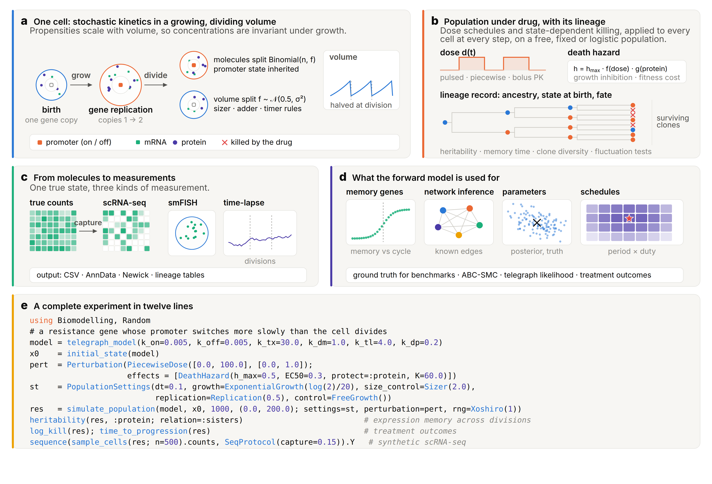
Fig. 1 | The Biomodelling.jl 2.0 framework. a, One cell. Reactions run at the cell’s current volume, with propensities scaled so that concentrations are invariant under growth; genes replicate at a set point of the cycle; division splits every molecule binomially while both daughters inherit the promoter state. Inset: exponential volume growth, halved at each division. b, Populations under free growth, constant-size or logistic control, with dose schedules and a state-dependent death hazard evaluated for every cell at every step, and the lineage record from which heritability, autocorrelation, memory timescales, clone diversity and fluctuation tests are computed; crosses mark cells killed by the drug. c, Observation models turn true counts into scRNA-seq counts with capture, depth, dropout and batch effects, into smFISH spots, or into time-lapse reporter traces; outputs are CSV, AnnData and Newick. d, Uses of the forward model: detection of memory genes, benchmarking of network and perturbation inference against known ground truth, likelihood-free parameter inference, and schedule optimisation over the period and the fraction of time on drug (star, optimum). e, A complete experiment in twelve lines of code.
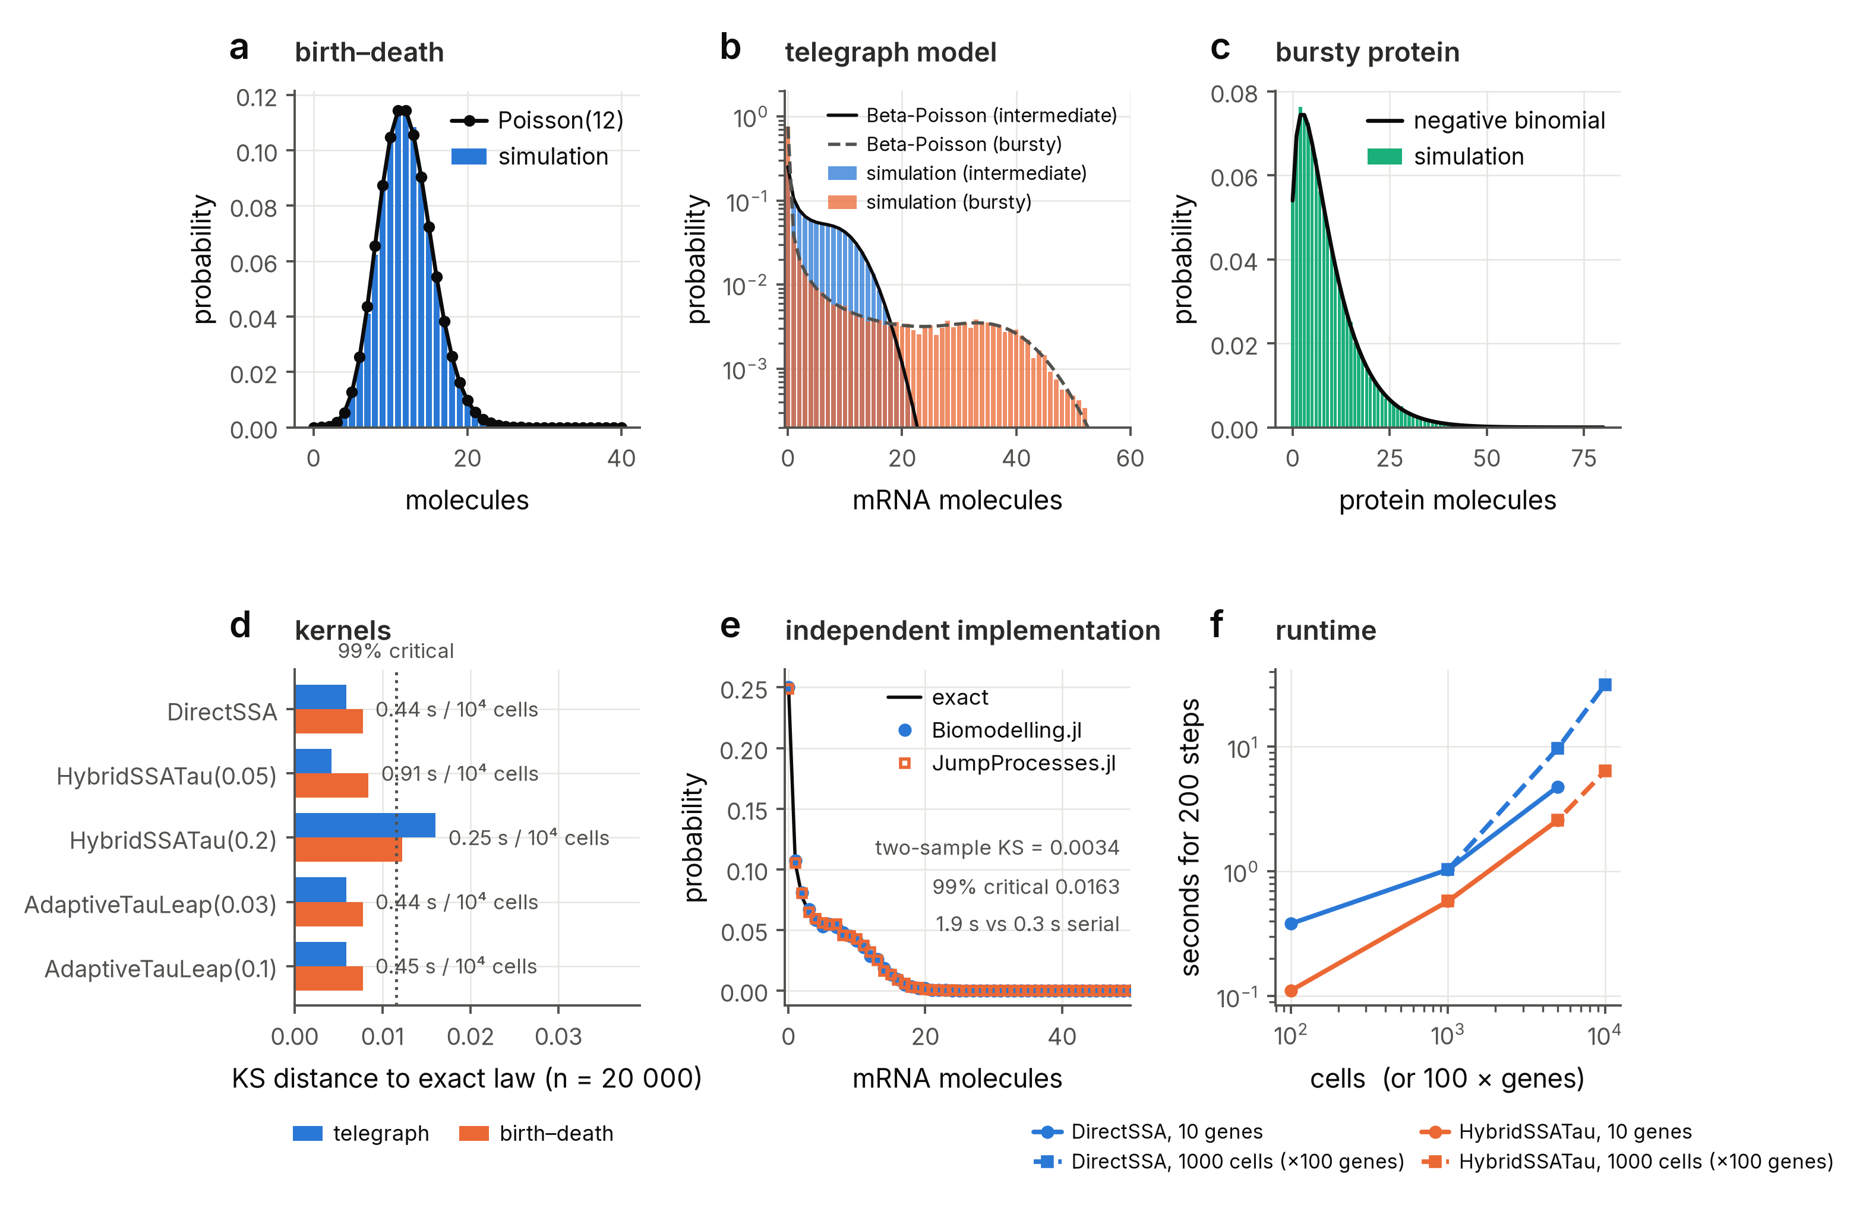
Fig. 2 | The engine matches exact laws and an independent implementation. a, Stationary distribution of a birth-death process (bars, 50,000 simulated cells; line, Poisson law). b, Telegraph model in an intermediate and a bursty regime against the Beta-Poisson law. c, Bursty protein production against the negative binomial. d, Kolmogorov-Smirnov distance to the exact law for every kernel (n = 20,000; dotted line, 99% critical value) with wall-clock time per 10⁴ cells. e, Telegraph model simulated with Biomodelling.jl and with JumpProcesses.jl on the same model; the two-sample Kolmogorov-Smirnov statistic lies below its 99% critical value. f, Runtime of population simulations against the number of cells (10 genes) and genes (1,000 cells) for the exact and hybrid kernels.
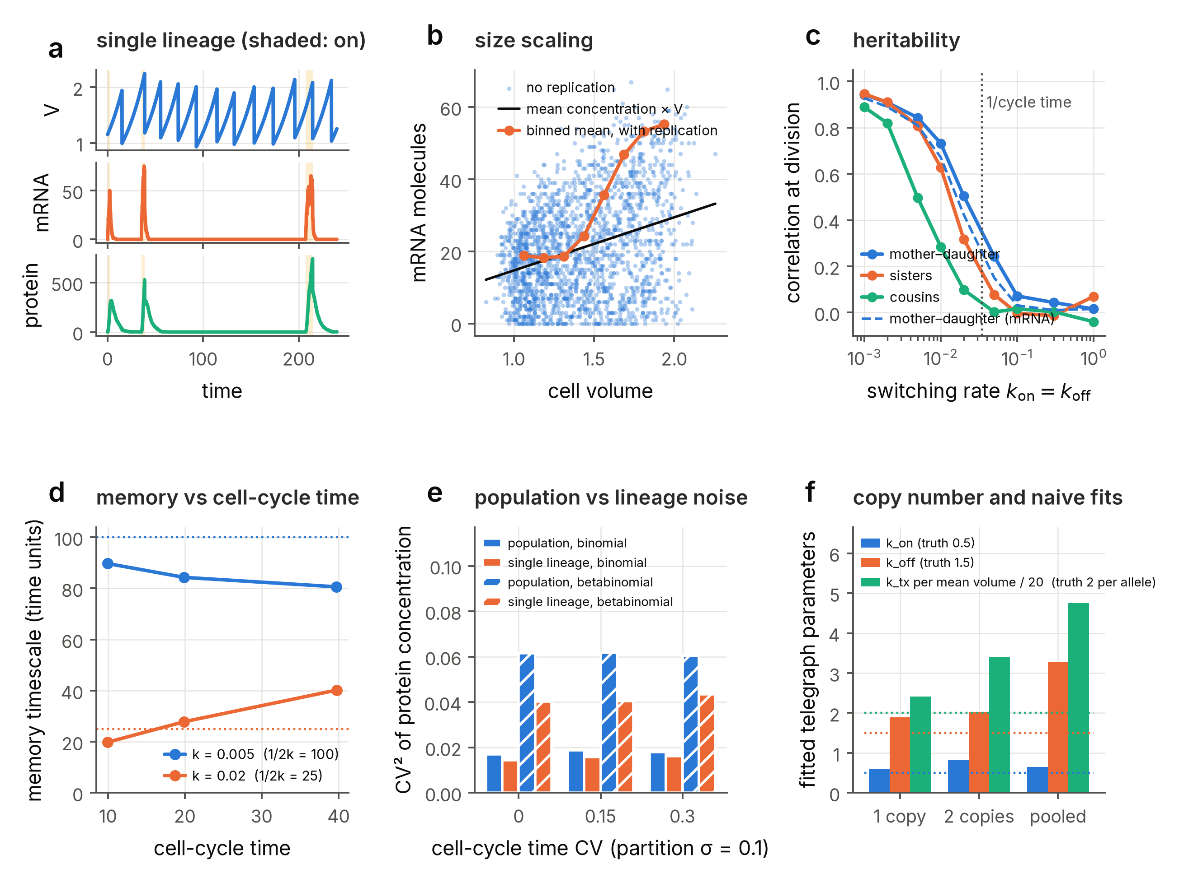
Fig. 3 | Growth, division and partitioning generate memory, size scaling and cell-cycle effects. a, A single lineage: volume, mRNA and protein of a slowly switching gene, with the promoter-on state shaded. b, mRNA count against cell volume for a fast-switching gene without replication (points; line, mean concentration × V) and with gene replication at mid-cycle (binned means). c, Correlation at division between mothers and daughters, sisters and cousins as a function of the promoter switching rate (protein concentration, solid; mother–daughter mRNA, dashed); dotted line, inverse cell-cycle time. d, Memory timescale against the measured cell-cycle time for two switching rates; dotted lines, $1/\left(k_{on}+k_{off}\right)$. e, Squared coefficient of variation of a stable protein’s concentration across the population and along single lineages, for increasing partitioning noise and cell-cycle-time noise. f, Telegraph parameters fitted to cells before replication (one gene copy), after replication (two copies) and pooled. The transcription rate is plotted per unit cell volume and divided by twenty, so that all three series share an axis and the dotted lines mark the true per-allele values ($k_{on}=0.5$, $k_{off}=1.5$, and 2 for the scaled transcription rate); the raw fitted transcription rates are in paper/output/fig3f_copynumber.csv.
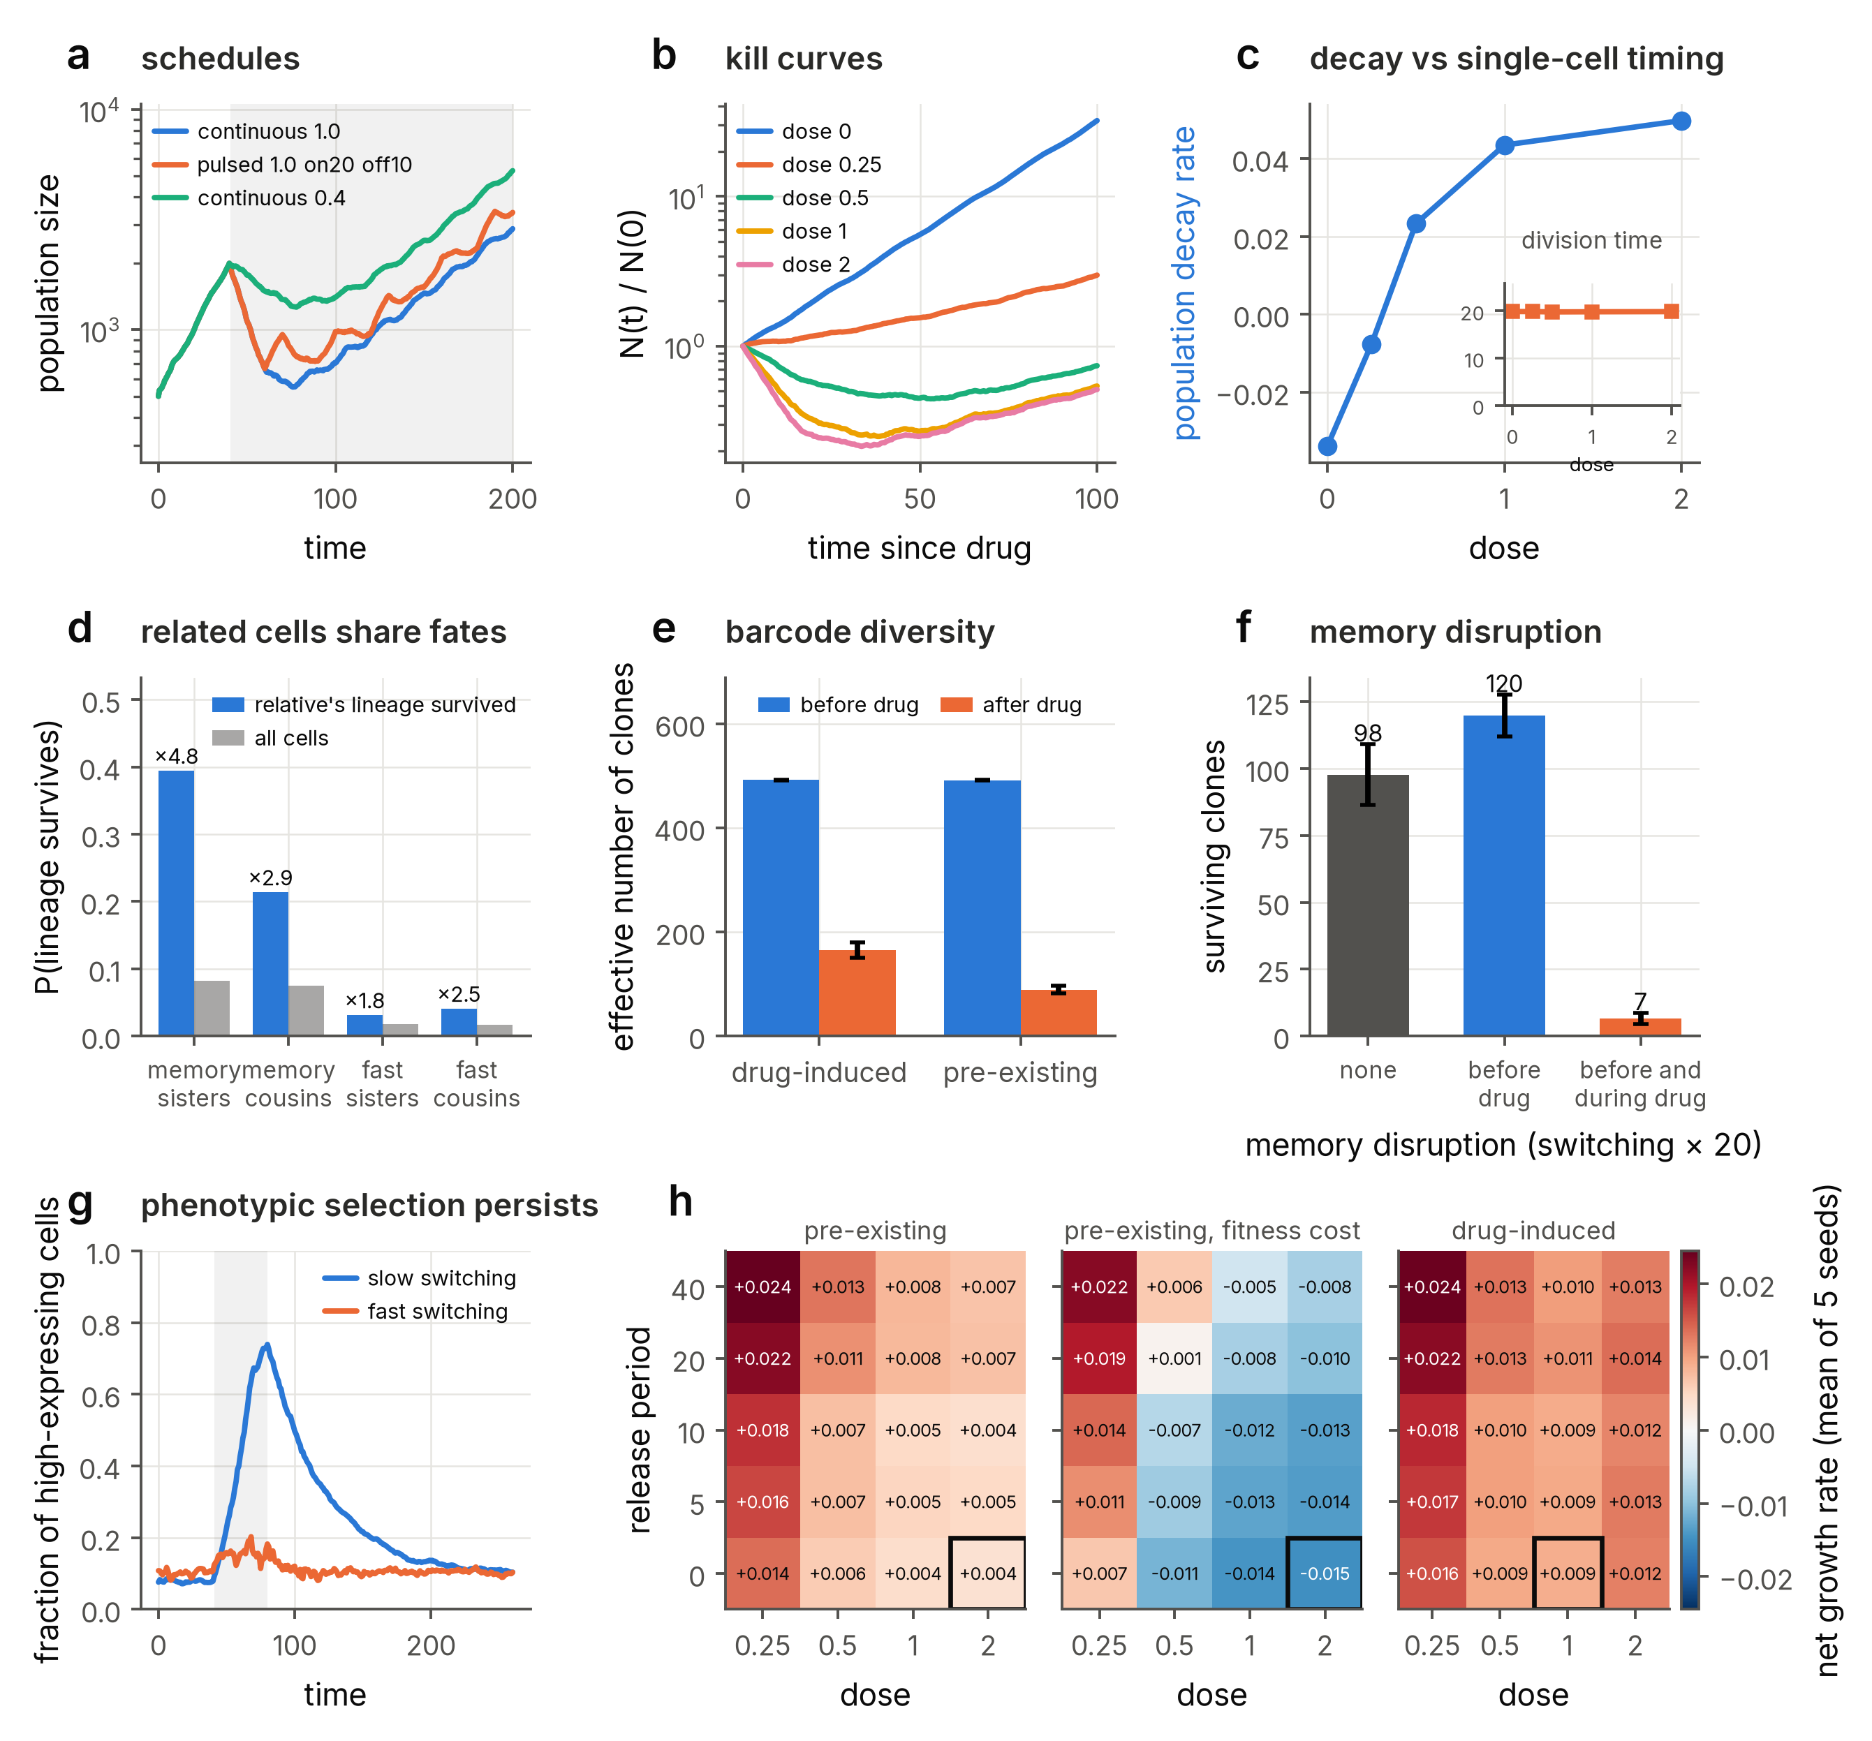
Fig. 4 | A single resistance gene with slow promoter switching reproduces persister biology. a, Population size under continuous, pulsed and reduced-dose schedules (shading, treatment window). b, Kill curves at increasing dose. c, Net population decay rate over the first 30 time units of treatment against dose, with the mean division time of cells born under drug (inset), which is unchanged. d, Probability that a cell’s lineage survives the treatment (at least one descendant alive at the end of the run) given that its sister’s or cousin’s lineage survived, against the marginal survival probability, for cells born in the 25 time units before the drug; memory gene and fast-switching control, with the fold enrichment above each bar. e, Effective number of clones (barcodes) before and after drug for pre-existing and drug-induced tolerance (mean ± s.d. of three seeds). f, Surviving clones after drug without memory disruption, with promoter switching accelerated 20-fold from two cell-cycle times before the drug until the drug arrives, and with the acceleration maintained during exposure (mean ± s.d. of five seeds). g, Fraction of high-expressing cells before, during and after a drug pulse for slow and fast switching. h, Net population growth rate over a 200-time-unit course as a function of release period (time units without drug between 20-time-unit exposures) and dose, for pre-existing tolerance without and with a fitness cost of the resistant state and for drug-induced tolerance; each cell of the map is the mean of five independent seeds and the box marks the schedule with the lowest mean growth rate; every schedule is run on the same five seeds and compared by paired differences, and the margin over the best alternative with a non-zero release period is resolved in only one of the three mechanisms (Supplementary Note 4).
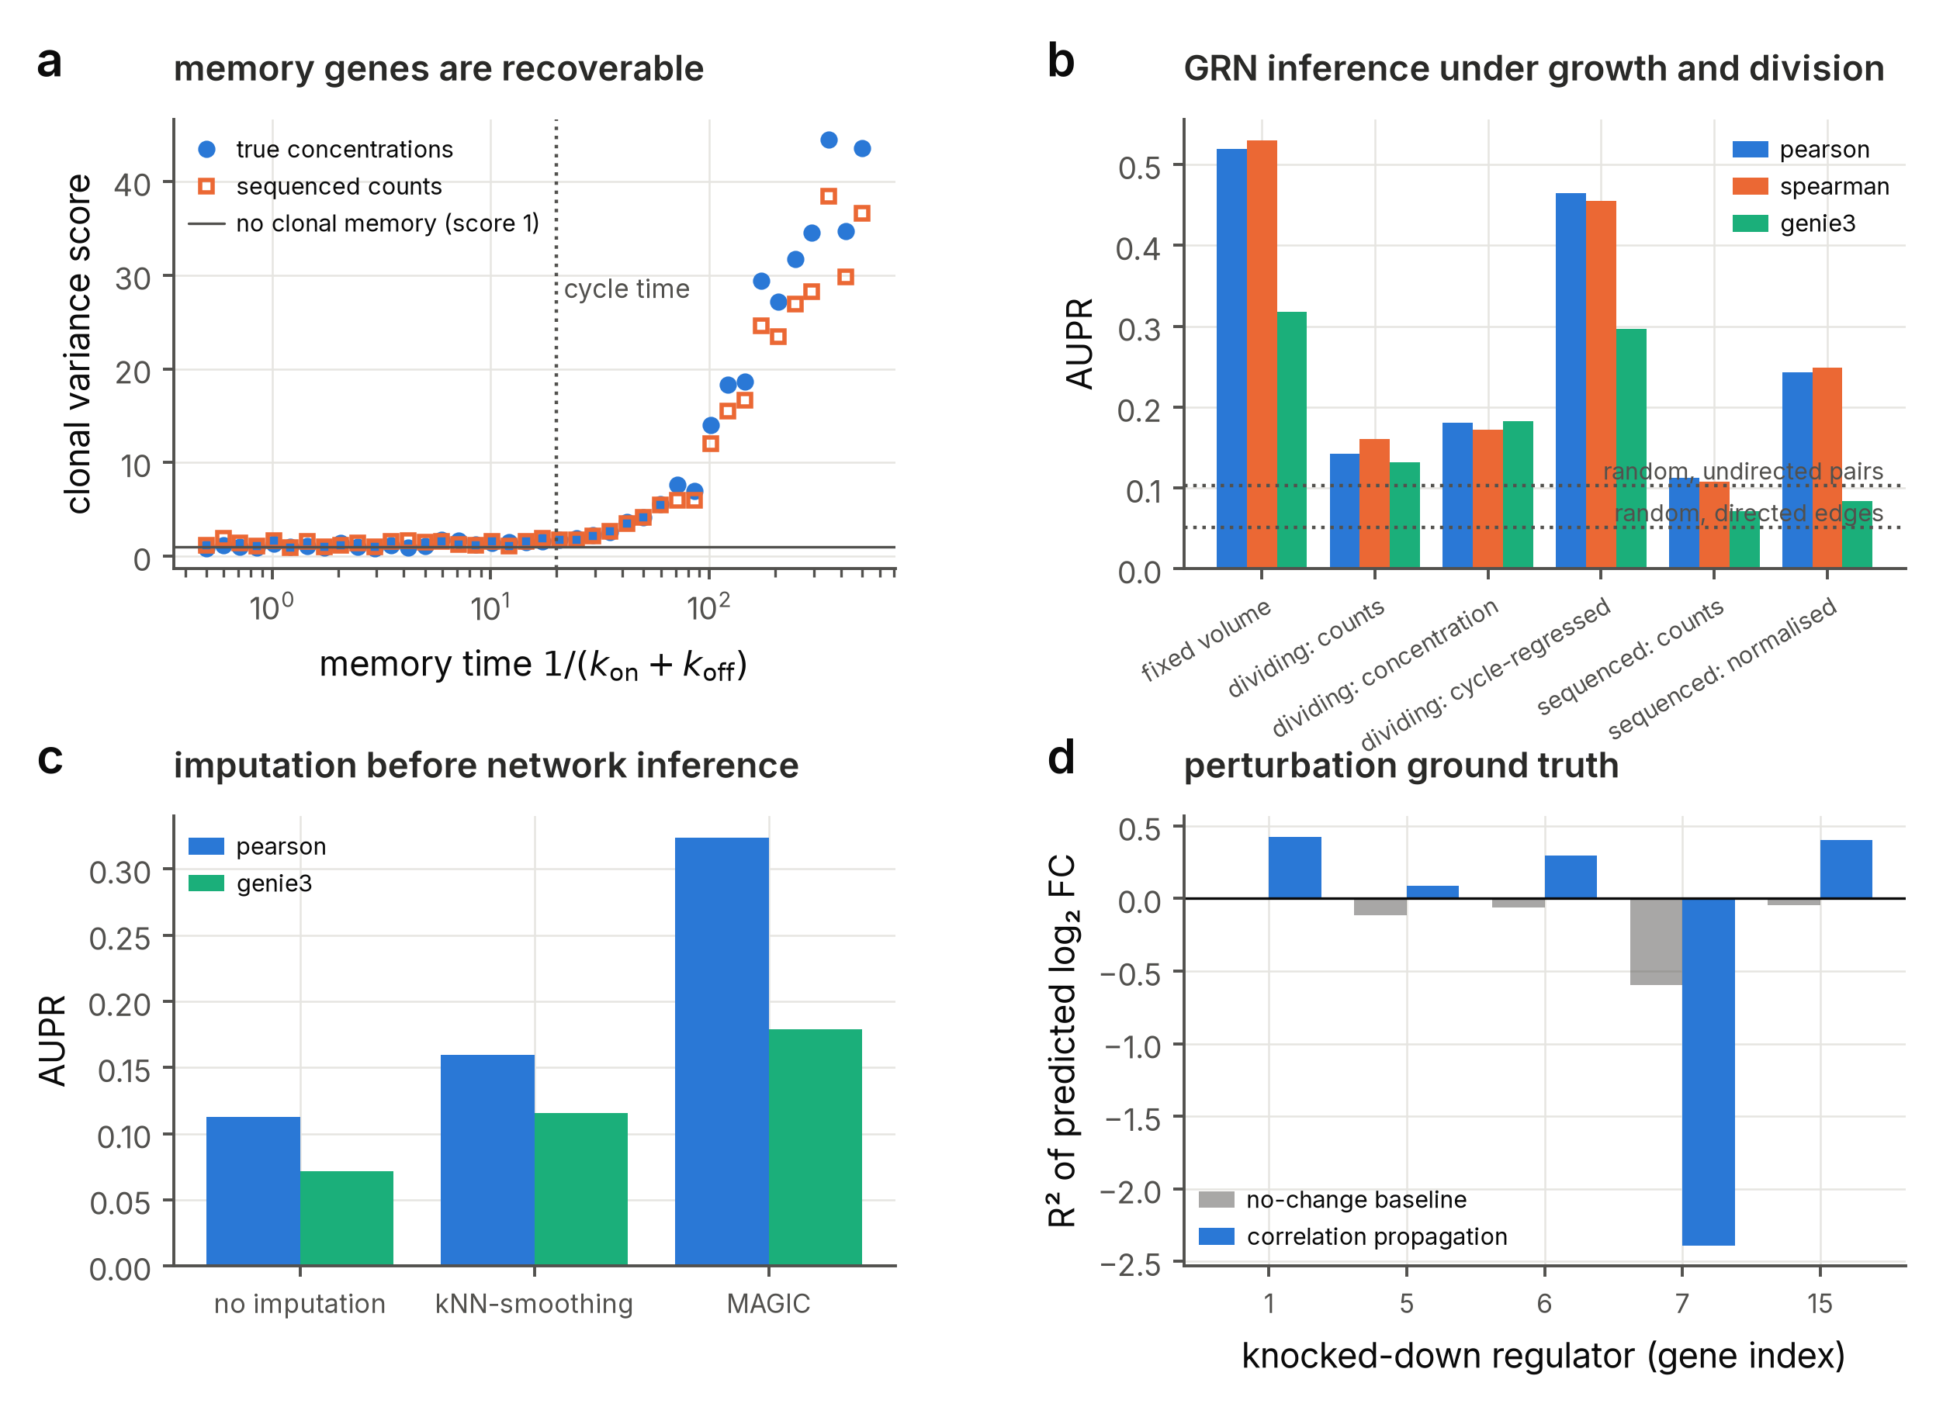
Fig. 5 | Ground-truth benchmarks. a, Clonal variance score against the known memory time of 40 independent genes, from true concentrations and from sequenced counts; dotted line, cell-cycle time. b, Area under the precision-recall curve of correlation (Pearson, Spearman) and GENIE3 network inference on the same 30-gene network observed at fixed volume, in a dividing population (raw counts, concentrations, and concentrations regressed on the cell-cycle covariates copy number and age) and after sequencing (raw and library-size normalised counts); dotted lines, random ranking of undirected pairs (upper, for the correlation methods) and of directed edges (lower, for GENIE3). c, Effect of kNN-smoothing and MAGIC imputation before inference. d, Coefficient of determination of predicted log₂ fold changes after knocking down the five most connected regulators, for a no-change baseline and for propagation of observational correlations.
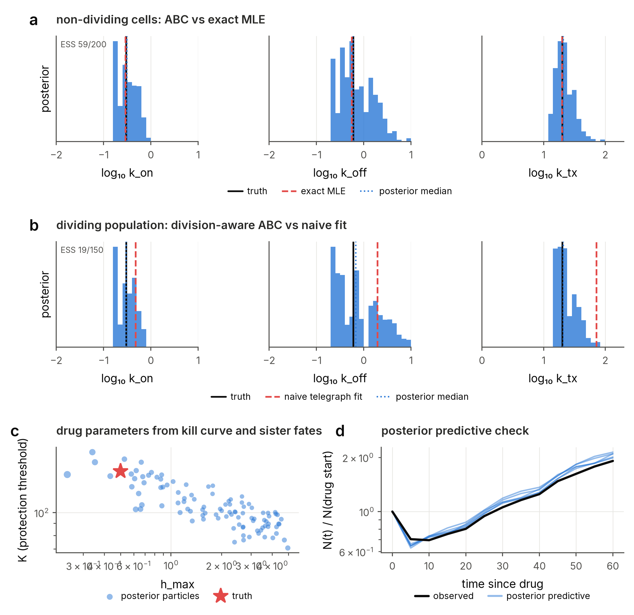
Fig. 6 | Inference with the forward model. a, Posterior distributions of telegraph parameters from ABC-SMC on a snapshot of non-dividing cells, with the truth and the exact maximum-likelihood estimate. Each histogram is weighted by the importance weights of the final generation and binned over the whole log-uniform prior support, which sets the axis limits; the effective sample size of that generation is given in the first panel of each row, and at a few tens of effectively independent particles the bar-to-bar structure of the histograms is sampling noise rather than a feature of the posterior (Supplementary Note 6). b, The same for a snapshot of a growing and dividing population: the naive telegraph fit is biased while division-aware ABC recovers the truth. c, Posterior particles for the maximal death rate and the protection threshold inferred from a kill curve and sister fate concordance: the two parameters trade off along a ridge that contains the truth. d, Posterior predictive kill curves simulated at the posterior median against the observed curve.
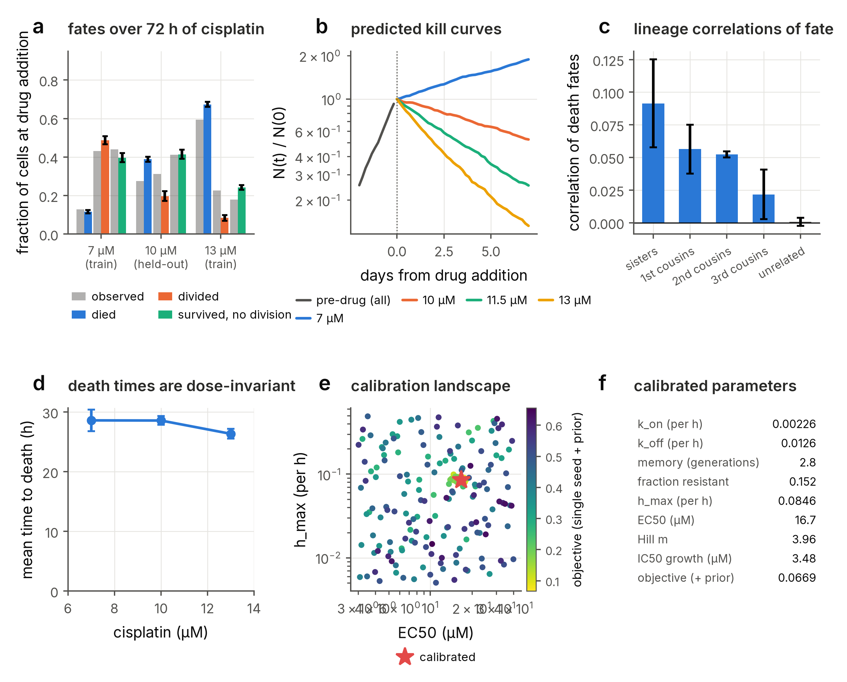
Fig. 7 | Calibration to laboratory time-lapse data and validation on held-out conditions. a, Fates over 72 h of cisplatin of U2OS cells present at drug addition, observed by time-lapse microscopy (grey; ref. [6]) and simulated by the calibrated model (colours; mean ± s.d. of four seeds); the model was calibrated on 7 and 13 µM and the 10 µM condition is predicted. b, Predicted population size at the three concentrations and at 11.5 µM, from two days before the drug to seven days of exposure. c, Correlation of death fates between sisters, first, second and third cousins present at drug addition, and between unrelated cells (mean ± s.d. of three seeds), against the observation that correlations extend to second but not third cousins. That observation comes from the HCT116 lineages of ref. [6] and not from the U2OS cells the model was calibrated to, in which a single daughter was tracked after each division; it is reported graphically with no numeric coefficients, and the memory it implies set the prior used in the fit. The comparison is therefore of pattern rather than of value, and a consistency check across cell lines rather than an independent validation. d, Mean time to death of cells present at drug addition against concentration (mean ± s.d. of four seeds); division times are not shown because too few cells born under drug divided again to estimate them (at most four per condition). e, Calibration landscape: every parameter set evaluated by the optimiser, coloured by the objective it minimised, which is the single-seed training error plus the memory prior and is not the seed-averaged error quoted in the text. f, Calibrated parameters.
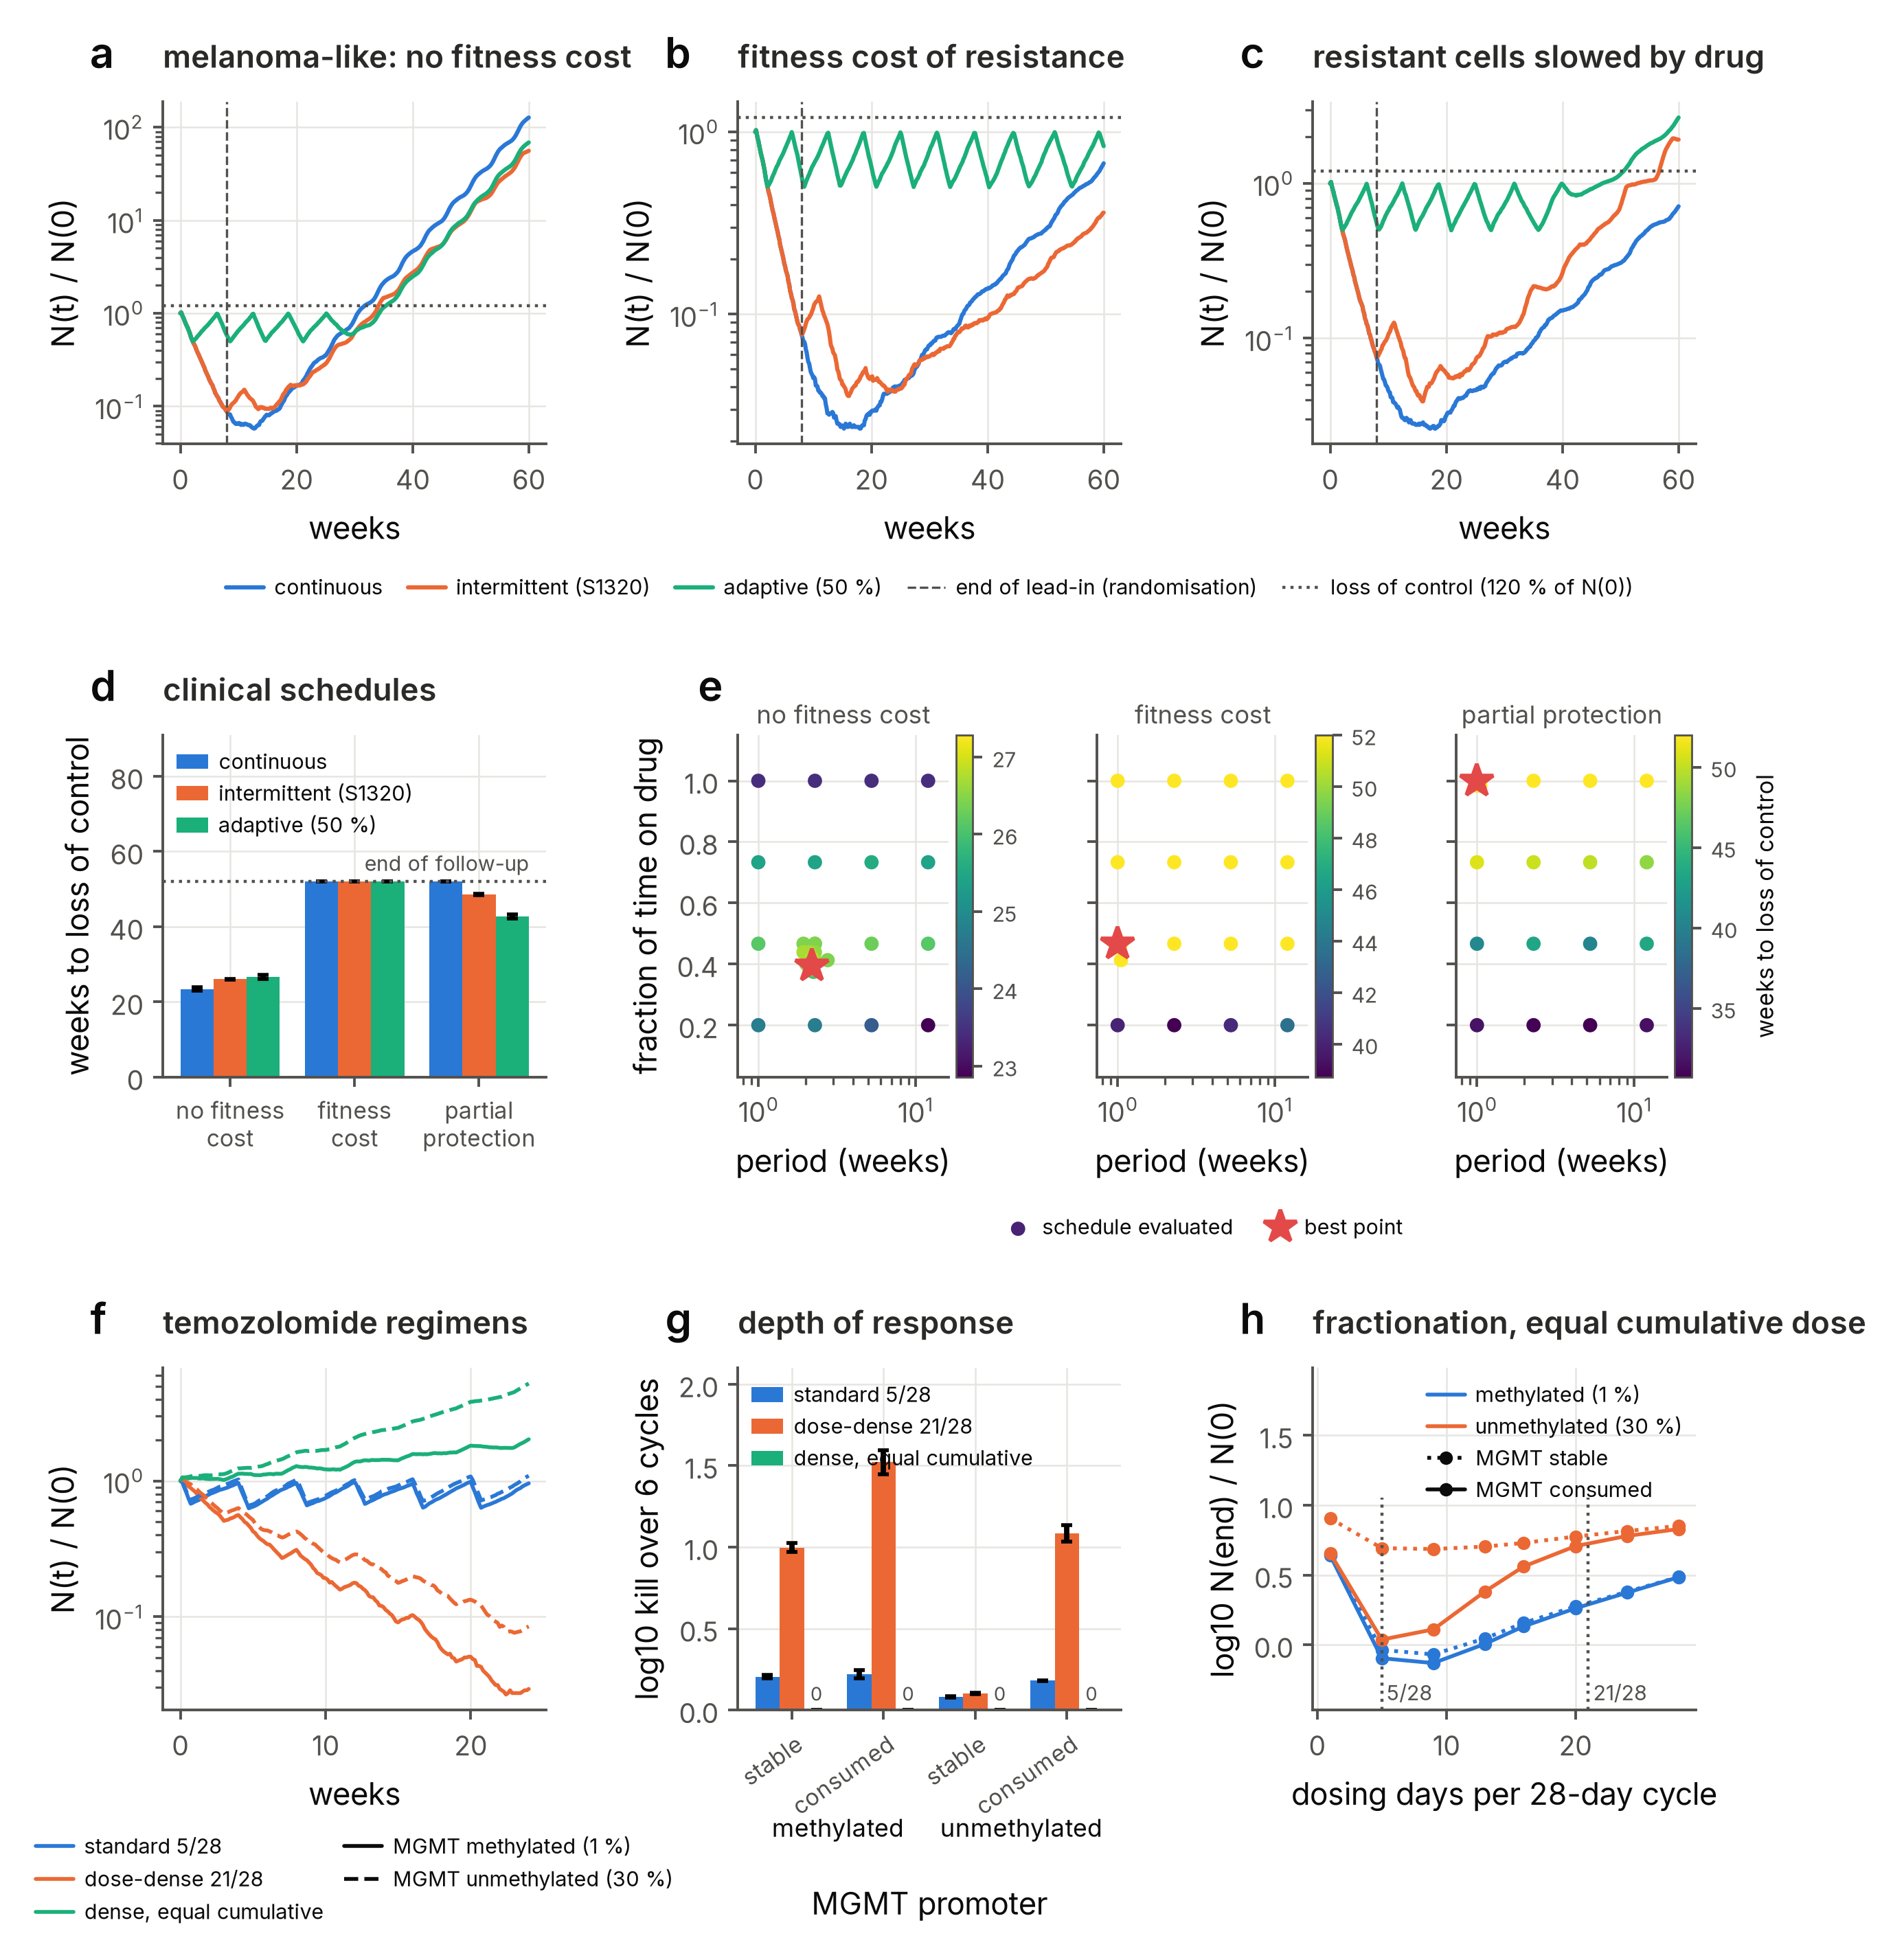
Fig. 8 | Dose and schedule optimisation against clinical regimens. a–c, Population size, relative to its pre-treatment value, under continuous dosing, the intermittent schedule of the SWOG S1320 trial (8-week lead-in, dashed line, then 3 weeks off and 5 weeks on) and adaptive therapy (drug withdrawn below 50% of the initial size, resumed at the initial size) for a melanoma-like population with a rare, heritable pre-resistant state, when the resistant state carries no fitness cost (a), when resistant cells grow 50% slower in the absence of drug (b), and when resistant cells are only partly protected and grow at half speed under drug (c); dotted line, 120% of the initial size. d, Weeks after randomisation until the population exceeds 120% of its pre-treatment size (loss of control; mean ± s.d. of four seeds, censored at 52 weeks). e, The same end point over intermittent schedules of given period and fraction of time on drug after the lead-in, for every schedule evaluated by the optimiser (star, best point; where several schedules reach the 52-week censoring limit it marks the first of a tie), for the three mechanisms. f, Population size under the standard (5 of 28 days) and dose-dense (21 of 28 days) temozolomide regimens of the RTOG 0525 trial and a 21-day regimen at the standard cumulative dose, with one-compartment pharmacokinetics (elimination half-life 2.1 h, a plasma value; an independent study gives 1.8 h) and stoichiometric consumption of MGMT by the drug, one molecule per lesion repaired, for populations in which 1% (methylated promoter, solid) or 30% (unmethylated, dashed) of cells express MGMT. g, Depth of response over six cycles for the three regimens, the two populations and MGMT either stable or consumed by the drug (mean ± s.d. of two seeds); a bar at zero marks a regimen that achieves no net kill (the 21-day schedule at the standard cumulative dose). h, Final population size against the number of dosing days per 28-day cycle at the standard cumulative dose.

Acknowledgements
Version 1 of the framework was developed with Marc Sturrock and Vahid Shahrezaei, whose contributions to that work are described in ref. [33]. This Article and version 2.0 of the software were authored with Claude (Anthropic), a large language model, under the direction and supervision of the author; what the model did and what the author verified independently are set out in the Methods, under Use of artificial intelligence.

Author contributions
A.L. conceived the study, defined its scope, the validation strategy and the case studies, supervised the work, verified all numerical results and biological interpretations against their sources, and wrote the final version of the manuscript. The implementation of the software, the simulations, the analyses, the figures and the first draft of the manuscript were produced with Claude (Anthropic) under the author’s direction, as described in the Methods. Claude is not an author and no display item was produced by a generative model.

Financial disclosure
The author received no specific funding for this work.

Competing interests
A.L. is a director of Berache Limited, Dublin, Ireland, a consulting company active in modelling, computational biology and pharmaceutical manufacturing; this commercial activity overlaps the subject area of this Article. A.L. derives no revenue from Biomodelling.jl, which is released under the MIT licence. This does not alter the author’s adherence to the journal’s policies on sharing data and materials.

Additional information
Ayoub Lasri, ORCID 0000-0003-0806-9072.
Supplementary information accompanies this Article. Correspondence and requests for materials should be addressed to A.L. (alasri@berache.com).

References
1. Sharma SV, Lee DY, Li B, Quinlan MP, Takahashi F, Maheswaran S, et al. A chromatin-mediated reversible drug-tolerant state in cancer cell subpopulations. Cell. 2010;141: 69–80. doi:10.1016/j.cell.2010.02.027
2. Shaffer SM, Dunagin MC, Torborg SR, Torre EA, Emert B, Krepler C, et al. Rare cell variability and drug-induced reprogramming as a mode of cancer drug resistance. Nature. 2017;546: 431–435. doi:10.1038/nature22794
3. Hata AN, Niederst MJ, Archibald HL, Gomez-Caraballo M, Siddiqui FM, Mulvey HE, et al. Tumor cells can follow distinct evolutionary paths to become resistant to epidermal growth factor receptor inhibition. Nat Med. 2016;22: 262–269. doi:10.1038/nm.4040
4. Oren Y, Tsabar M, Cuoco MS, Amir-Zilberstein L, Cabanos HF, Hütter J-C, et al. Cycling cancer persister cells arise from lineages with distinct programs. Nature. 2021;596: 576–582. doi:10.1038/s41586-021-03796-6
5. França GS, Baron M, King BR, Bossowski JP, Bjornberg A, Pour M, et al. Cellular adaptation to cancer therapy along a resistance continuum. Nature. 2024;631: 876–883. doi:10.1038/s41586-024-07690-9
6. Iyer A, Alva A, Granada AE, Chakrabarti S. Inheritable cell-states shape drug-persister correlations and population dynamics in cancer cells. PLoS Comput Biol. 2025;21: e1013446. doi:10.1371/journal.pcbi.1013446
7. Lin Y, Chen X, Wu L, Zhou Y, Lin Y. Widespread transcriptional memory shapes heritable states and functional heterogeneity in cancer and stem cells. Cell Syst. 2026;17: 101621. doi:10.1016/j.cels.2026.101621
8. Ghosh S, Chakrabarti S, Raju A. Identifying memory gene expression from single sample scRNA-seq data using power law signatures. bioRxiv. 2025. doi:10.1101/2025.01.15.633183
9. Harmange G, Reyes Hueros RA, Schaff DL, Emert B, Saint-Antoine M, Kim LC, et al. Disrupting cellular memory to overcome drug resistance. Nat Commun. 2023;14: 7130. doi:10.1038/s41467-023-41811-8
10. Sukys A, Grima R. Cell-cycle dependence of bursty gene expression: Insights from fitting mechanistic models to single-cell RNA-seq data. Nucleic Acids Res. 2025;53: gkaf295. doi:10.1093/nar/gkaf295
11. Zhang Z, Zabaikina I, Nieto C, Vahdat Z, Bokes P, Singh A. Stochastic gene expression in proliferating cells: Differing noise intensity in single-cell and population perspectives. PLoS Comput Biol. 2025;21: e1013014. doi:10.1371/journal.pcbi.1013014
12. Okochi Y, Sawazaki Y, Kondo Y, Naoki H. Inferring division-associated stochasticity from time-series single-cell transcriptomes. bioRxiv. 2026. doi:10.64898/2026.04.14.718485
13. Ahlmann-Eltze C, Huber W, Anders S. Deep-learning-based gene perturbation effect prediction does not yet outperform simple linear baselines. Nat Methods. 2025;22: 1657–1661. doi:10.1038/s41592-025-02772-6
14. Vollenweider MS, Bühlmann P. Signal, bounds, and baselines: Principles for rigorous evaluation of high-dimensional biological perturbation prediction. bioRxiv. 2026. doi:10.64898/2026.04.20.719650
15. Dibaeinia P, Babu S, Knudson M, ElSheikh A, Wen Y, Liu H, et al. Virtual cells need context, not just scale. bioRxiv. 2026. doi:10.64898/2026.02.04.703804
16. Bunne C, Roohani Y, Rosen Y, Gupta A, Zhang X, Roed M, et al. How to build the virtual cell with artificial intelligence: Priorities and opportunities. Cell. 2024;187: 7045–7063. doi:10.1016/j.cell.2024.11.015
17. Zappia L, Phipson B, Oshlack A. Splatter: Simulation of single-cell RNA sequencing data. Genome Biol. 2017;18: 174. doi:10.1186/s13059-017-1305-0
18. Song D, Wang Q, Yan G, Liu T, Sun T, Li JJ. scDesign3 generates realistic in silico data for multimodal single-cell and spatial omics. Nat Biotechnol. 2024;42: 247–252. doi:10.1038/s41587-023-01772-1
19. Zhang X, Xu C, Yosef N. Simulating multiple faceted variability in single cell RNA sequencing. Nat Commun. 2019;10: 2611. doi:10.1038/s41467-019-10500-w
20. Dibaeinia P, Sinha S. SERGIO: A single-cell expression simulator guided by gene regulatory networks. Cell Syst. 2020;11: 252–271. doi:10.1016/j.cels.2020.08.003
21. Cannoodt R, Saelens W, Deconinck L, Saeys Y. Spearheading future omics analyses using dyngen, a multi-modal simulator of single cells. Nat Commun. 2021;12: 3942. doi:10.1038/s41467-021-24152-2
22. Li H, Zhang Z, Squires M, Chen X, Zhang X. scMultiSim: Simulation of single-cell multi-omics and spatial data guided by gene regulatory networks and cell–cell interactions. Nat Methods. 2025;22: 982–993. doi:10.1038/s41592-025-02651-0
23. Zinati Y, Takiddeen A, Emad A. GRouNdGAN: GRN-guided simulation of single-cell RNA-seq data using causal generative adversarial networks. Nat Commun. 2024;15: 4055. doi:10.1038/s41467-024-48516-6
24. Pan X, Li H, Zhang X. TedSim: Temporal dynamics simulation of single-cell RNA sequencing data and cell division history. Nucleic Acids Res. 2022;50: 4272–4288. doi:10.1093/nar/gkac235
25. Jones MG, Khodaverdian A, Quinn JJ, Chan MM, Hussmann JA, Wang R, et al. Inference of single-cell phylogenies from lineage tracing data using Cassiopeia. Genome Biol. 2020;21: 92. doi:10.1186/s13059-020-02000-8
26. Pratapa A, Jalihal AP, Law JN, Bharadwaj A, Murali TM. Benchmarking algorithms for gene regulatory network inference from single-cell transcriptomic data. Nat Methods. 2020;17: 147–154. doi:10.1038/s41592-019-0690-6
27. Bertaux F, Marguerat S, Shahrezaei V. Division rate, cell size and proteome allocation: Impact on gene expression noise and implications for the dynamics of genetic circuits. R Soc Open Sci. 2018;5: 172234. doi:10.1098/rsos.172234
28. Piho P, Thomas P. AgentBasedModeling.jl: A tool for stochastic simulation of structured population dynamics. PLoS Comput Biol. 2026;22: e1014366. doi:10.1371/journal.pcbi.1014366
29. Piho P, Thomas P. Feedback between stochastic gene networks and population dynamics enables cellular decision-making. Sci Adv. 2024;10: eadl4895. doi:10.1126/sciadv.adl4895
30. Thomas P, Shahrezaei V. Coordination of gene expression noise with cell size: Analytical results for agent-based models of growing cell populations. J R Soc Interface. 2021;18: 20210274. doi:10.1098/rsif.2021.0274
31. Ghaffarizadeh A, Heiland R, Friedman SH, Mumenthaler SM, Macklin P. PhysiCell: An open source physics-based cell simulator for 3-D multicellular systems. PLoS Comput Biol. 2018;14: e1005991. doi:10.1371/journal.pcbi.1005991
32. Ponce-de-Leon M, Montagud A, Noël V, Meert A, Pradas G, Barillot E, et al. PhysiBoSS 2.0: A sustainable integration of stochastic Boolean and agent-based modelling frameworks. NPJ Syst Biol Appl. 2023;9: 54. doi:10.1038/s41540-023-00314-4
33. Lasri A, Shahrezaei V, Sturrock M. Benchmarking imputation methods for network inference using a novel method of synthetic scRNA-seq data generation. BMC Bioinformatics. 2022;23: 236. doi:10.1186/s12859-022-04778-9
34. Peccoud J, Ycart B. Markovian modeling of gene-product synthesis. Theor Popul Biol. 1995;48: 222–234. doi:10.1006/tpbi.1995.1027
35. Beentjes CHL, Perez-Carrasco R, Grima R. Exact solution of stochastic gene expression models with bursting, cell cycle and replication dynamics. Phys Rev E. 2020;101: 032403. doi:10.1103/PhysRevE.101.032403
36. Jia C, Grima R. Coupling gene expression dynamics to cell size dynamics and cell cycle events: Exact and approximate solutions of the extended telegraph model. iScience. 2023;26: 105746. doi:10.1016/j.isci.2022.105746
37. Thomas P. Making sense of snapshot data: Ergodic principle for clonal cell populations. J R Soc Interface. 2017;14: 20170467. doi:10.1098/rsif.2017.0467
38. Emert BL, Cote CJ, Torre EA, Dardani IP, Jiang CL, Jain N, et al. Variability within rare cell states enables multiple paths toward drug resistance. Nat Biotechnol. 2021;39: 865–876. doi:10.1038/s41587-021-00837-3
39. Torre EA, Arai E, Bayatpour S, Jiang CL, Beck LE, Emert BL, et al. Genetic screening for single-cell variability modulators driving therapy resistance. Nat Genet. 2021;53: 76–85. doi:10.1038/s41588-020-00749-z
40. Gunnarsson EB, De S, Leder K, Foo J. Understanding the role of phenotypic switching in cancer drug resistance. J Theor Biol. 2020;490: 110162. doi:10.1016/j.jtbi.2020.110162
41. Lasri A, Juric V, Verreault M, Bielle F, Idbaih A, Kel A, et al. Phenotypic selection through cell death: Stochastic modelling of O-6-methylguanine-DNA methyltransferase dynamics. R Soc Open Sci. 2020;7: 191243. doi:10.1098/rsos.191243
42. Corigliano M, Di Bernardo A, Cosentino Lagomarsino M, Pompei S. Optimal treatment for drug-induced cancer persisters involves release periods and intermediate drug doses. PRX Life. 2025. doi:10.1103/mh5v-lcyw
43. Bernton E, Jacob PE, Gerber M, Robert CP. Approximate Bayesian computation with the Wasserstein distance. J R Stat Soc Series B Stat Methodol. 2019;81: 235–269. doi:10.1111/rssb.12312
44. Sandler O, Mizrahi SP, Weiss N, Agam O, Simon I, Balaban NQ. Lineage correlations of single cell division time as a probe of cell-cycle dynamics. Nature. 2015;519: 468–471. doi:10.1038/nature14318
45. Kuchen EE, Becker NB, Claudino N, Höfer T. Hidden long-range memories of growth and cycle speed correlate cell cycles in lineage trees. Elife. 2020;9: e51002. doi:10.7554/eLife.51002
46. Chakrabarti S, Paek AL, Reyes J, Lasick KA, Lahav G, Michor F. Hidden heterogeneity and circadian-controlled cell fate inferred from single cell lineages. Nat Commun. 2018;9: 5372. doi:10.1038/s41467-018-07788-5
47. Algazi AP, Othus M, Daud AI, Lo RS, Mehnert JM, Truong T-G, et al. Continuous versus intermittent BRAF and MEK inhibition in patients with BRAF-mutated melanoma: A randomized phase 2 trial. Nat Med. 2020;26: 1564–1568. doi:10.1038/s41591-020-1060-8
48. Zhang J, Cunningham JJ, Brown JS, Gatenby RA. Integrating evolutionary dynamics into treatment of metastatic castrate-resistant prostate cancer. Nat Commun. 2017;8: 1816. doi:10.1038/s41467-017-01968-5
49. Das Thakur M, Salangsang F, Landman AS, Sellers WR, Pryer NK, Levesque MP, et al. Modelling vemurafenib resistance in melanoma reveals a strategy to forestall drug resistance. Nature. 2013;494: 251–255. doi:10.1038/nature11814
50. Strobl MAR, West J, Viossat Y, Damaghi M, Robertson-Tessi M, Brown JS, et al. Turnover modulates the need for a cost of resistance in adaptive therapy. Cancer Res. 2021;81: 1135–1147. doi:10.1158/0008-5472.CAN-20-0806
51. Gilbert MR, Wang M, Aldape KD, Stupp R, Hegi ME, Jaeckle KA, et al. Dose-dense temozolomide for newly diagnosed glioblastoma: A randomized phase III clinical trial. J Clin Oncol. 2013;31: 4085–4091. doi:10.1200/JCO.2013.49.6968
52. Ostermann S, Csajka C, Buclin T, Leyvraz S, Lejeune F, Decosterd LA, et al. Plasma and cerebrospinal fluid population pharmacokinetics of temozolomide in malignant glioma patients. Clin Cancer Res. 2004;10: 3728–3736. doi:10.1158/1078-0432.CCR-03-0807
53. Rudek MA, Donehower RC, Statkevich P, Batra VK, Cutler DL, Baker SD. Temozolomide in patients with advanced cancer: Phase I and pharmacokinetic study. Pharmacotherapy. 2004;24: 16–25. doi:10.1592/phco.24.1.16.34800
54. Tolcher AW, Gerson SL, Denis L, Geyer C, Hammond LA, Patnaik A, et al. Marked inactivation of O6-alkylguanine-DNA alkyltransferase activity with protracted temozolomide schedules. Br J Cancer. 2003;88: 1004–1011. doi:10.1038/sj.bjc.6600827
55. Middleton MR, Lee SM, Arance A, Wood M, Thatcher N, Margison GP. O6-methylguanine formation, repair protein depletion and clinical outcome with a 4 hr schedule of temozolomide in the treatment of advanced melanoma: Results of a phase II study. Int J Cancer. 2000;88: 469–473. doi:10.1002/1097-0215(20001101)88:3<469::AID-IJC21>3.0.CO;2-7
56. Robinson CG, Palomo JM, Rahmathulla G, McGraw M, Donze J, Liu L, et al. Effect of alternative temozolomide schedules on glioblastoma O6-methylguanine-DNA methyltransferase activity and survival. Br J Cancer. 2010;103: 498–504. doi:10.1038/sj.bjc.6605792
57. Gillespie DT. Exact stochastic simulation of coupled chemical reactions. J Phys Chem. 1977;81: 2340–2361. doi:10.1021/j100540a008
58. Gillespie DT. Approximate accelerated stochastic simulation of chemically reacting systems. J Chem Phys. 2001;115: 1716–1733. doi:10.1063/1.1378322
59. Cao Y, Gillespie DT, Petzold LR. Efficient step size selection for the tau-leaping simulation method. J Chem Phys. 2006;124: 044109. doi:10.1063/1.2159468
60. Cao Y, Gillespie DT, Petzold LR. Avoiding negative populations in explicit Poisson tau-leaping. J Chem Phys. 2005;123: 054104. doi:10.1063/1.1992473
61. Shaffer SM, Emert BL, Reyes Hueros RA, Cote C, Harmange G, Schaff DL, et al. Memory sequencing reveals heritable single-cell gene expression programs associated with distinct cellular behaviors. Cell. 2020;182: 947–959. doi:10.1016/j.cell.2020.07.003
62. Toni T, Welch D, Strelkowa N, Ipsen A, Stumpf MPH. Approximate Bayesian computation scheme for parameter inference and model selection in dynamical systems. J R Soc Interface. 2009;6: 187–202. doi:10.1098/rsif.2008.0172
63. Ellingson BM, Nguyen HN, Lai A, Nechifor RE, Zaw O, Pope WB, et al. Contrast-enhancing tumor growth dynamics of preoperative, treatment-naive human glioblastoma. Cancer. 2016;122: 1718–1727. doi:10.1002/cncr.29957
64. Stensjøen AL, Solheim O, Kvistad KA, Håberg AK, Salvesen Ø, Berntsen EM. Growth dynamics of untreated glioblastomas in vivo. Neuro Oncol. 2015;17: 1402–1411. doi:10.1093/neuonc/nov029
65. Friedman N, Cai L, Xie XS. Linking stochastic dynamics to population distribution: An analytical framework of gene expression. Phys Rev Lett. 2006;97: 168302. doi:10.1103/PhysRevLett.97.168302
66. Shahrezaei V, Swain PS. Analytical distributions for stochastic gene expression. Proc Natl Acad Sci U S A. 2008;105: 17256–17261. doi:10.1073/pnas.0803850105
67. Rackauckas C, Nie Q. DifferentialEquations.jl – a performant and feature-rich ecosystem for solving differential equations in Julia. J Open Res Softw. 2017;5: 15. doi:10.5334/jors.151
68. Huh D, Paulsson J. Non-genetic heterogeneity from stochastic partitioning at cell division. Nat Genet. 2011;43: 95–100. doi:10.1038/ng.729
69. Huynh-Thu VA, Irrthum A, Wehenkel L, Geurts P. Inferring regulatory networks from expression data using tree-based methods. PLoS One. 2010;5: e12776. doi:10.1371/journal.pone.0012776
70. van Dijk D, Sharma R, Nainys J, Yim K, Kathail P, Carr AJ, et al. Recovering gene interactions from single-cell data using data diffusion. Cell. 2018;174: 716–729. doi:10.1016/j.cell.2018.05.061
71. Wagner F, Yan Y, Yanai I. K-nearest neighbor smoothing for high-throughput single-cell RNA-Seq data. bioRxiv. 2018. doi:10.1101/217737

