CivicPulse
FYP Code: 23F-90
Software Design Specification

BY

AYOUSH KUMAR, CMS. ID: 023-23-0220
SARICHAND, CMS. ID: 023-23-0024
RAINUKA BAI, CMS. ID: 023-23-0053


Supervised by: Dr. Saif Hassan
Co-Supervised by: Dr. Ismail

DEPARTMENT OF COMPUTER SCIENCE FACULTY OF SCIENCE AND INFORMATION TECHNOLOGY
SUKKUR IBA UNIVERSITY NOVEMBER 2026

Document Revision History

Version | Date | Prepared by | Description
1.0 | 4 November 2026 | Ayoush Kumar, Sarichand, Rainuka Bai | Initial version for supervisor review
1.1 | 7 November 2026 | Ayoush Kumar, Sarichand, Rainuka Bai | Revised after supervisor review: routes, class, database and sequence diagrams, screens, test traceability and references
1.2 | 12 November 2026 | Ayoush Kumar, Sarichand, Rainuka Bai | Revised after second supervisor review: exact version dates, table of contents spacing, built and pending screens, note on Experiment tests, corrected Covers for TC-05, TC-22 and TC-43

Table of Contents
- Introduction 1
  - Purpose of Document 1
  - Definitions, acronyms, and abbreviations 1
- Overall System Description 2
  - Project Background 2
  - Project Objectives 2
- System Architecture 3
- Domain Model 5
- Class Diagram 6
- Database Diagram 9
- Entity Relationship Diagram (ERD) 13
- Sequence Diagram 15
- System Interface Design 19
- Test Cases 21
- References 25

List of Figures
Figure 1: Detailed system architecture 3
Figure 2: Domain model 5
Figure 3: Class diagram, part 1: accounts, reports, merging and vision 6
Figure 4: Class diagram, part 2: ranking, weather, repair checks and rewards 7
Figure 5: Database diagram: accounts and rate limiting 9
Figure 6: Database diagram: reports, pins, images and analysis 10
Figure 7: Database diagram: missions, repair claims, points and coupons 11
Figure 8: Database diagram: weather, ranking settings and audit log 12
Figure 9: Entity relationship diagram: users, reports, pins and images 13
Figure 10: Entity relationship diagram: missions, rewards and weather 14
Figure 11: Sequence diagram: registration, verification and login 15
Figure 12: Sequence diagram: report submission and merging 16
Figure 13: Sequence diagram: repair verification and approval 17
Figure 14: Sequence diagram: token refresh and session revocation 18
Figure 15: Citizen application screens as built 19
Figure 16: Administrator dashboard screen designs 20
List of Tables
Table 1: Definitions, acronyms and abbreviations 1
Table 2: Project objectives and responsible design elements 2
Table 3: Principal architectural decisions 3
Table 4: API route groups 4
Table 5: Responsibilities of the service classes 8
Table 6: Principal constraints and indexes 12
Table 7: Citizen application screens 19
Table 8: Planned test cases 21

Introduction

Purpose of Document
This Software Design Specification describes how CivicPulse will satisfy the requirements in its Software Requirements Specification and approved proposal [12]. It records the architecture, domain concepts, classes, database, principal interactions, interface designs and planned tests. It is the common reference for developers, and it lets the evaluation committee examine the design behind each graded result. Components not yet implemented are described as planned work.

Definitions, acronyms, and abbreviations
Table 1: Definitions, acronyms and abbreviations

Term | Definition
Active window | The period after which an open pin no longer accepts new reports
API / REST | Application Programming Interface / Representational State Transfer
Award key | A unique value derived from user, reason and reference, which prevents a repeated award
DBSCAN | Density-Based Spatial Clustering of Applications with Noise, used in the offline radius sweep [7], [13]
ERD | Entity Relationship Diagram
Gate | One of five sequential repair checks
JWT | JSON Web Token
ORB / RANSAC | Keypoint matching method [8] / method for rejecting inconsistent matches
ORM | Object-Relational Mapper, here SQLAlchemy
Pair threshold | The merge distance calculated for one report and one pin from their accuracy values
pHash / SHA-256 | Perceptual image hash / cryptographic file hash
Pin | A single physical hazard on the map, to which reports are attached
Report | One citizen submission with photograph, category and position
YOLO | The object detection model family used for defects [9], [14]

Overall System Description

Project Background
Every monsoon severely damages the road network of Sindh, and Sukkur Division alone recorded 1,055 km of damaged road in the 2022 floods [1]. Funding reaches only a few selected roads, as in Karachi in 2024 [2], so authorities must set priorities, although existing complaint systems provide limited support for doing so. The national complaint portal reports 98.7% of complaints resolved while only about 30% of complainants are satisfied [3], and report-only platforms reduce duplicates mainly by publishing reports for everyone to see [4]. As a result, duplicate tickets obscure how many people are affected, severity is not measured and ticket closure gives no evidence of repair.
Citizens use the CivicPulse Android application to photograph hazards. The server groups duplicate reports into pins, estimates severity from the photograph and ranks open hazards for a reviewer. A repair is accepted only after its evidence has passed automatic checks and a human reviewer. Because a phone cannot be fully trusted, the server makes every consequential decision.

Project Objectives
Table 2: Project objectives and responsible design elements

ID | Objective | Responsible design elements
O1 | One pin per physical hazard, measured against labelled data | Merge engine, PostGIS indexes, split operation, sweep script
O2 | Defect detection and severity estimation from a photograph | Vision service, job worker, severity rule
O3 | Verification of claimed repairs and measurement of false acceptance | Repair gate controller, ORB matcher, gate switches
O4 | Hazard ranking with a transparent score | Priority engine, ranking settings, breakdown display
O5 | Warnings to affected zones and raised priorities | Weather scheduler, push delivery, notification log
O6 | Demonstrably correct points, ranking and coupons | Points ledger, unique keys, atomic redemption
O7  (stretch) | Observation of real use, subject to recruiting users | Existing logs; no additional design required

System Architecture
Decision | Rationale
Single FastAPI codebase | The detector is written in Python, so one language and deployment avoid an unnecessary network hop.
PostgreSQL job table in place of a message broker | Claiming with SELECT FOR UPDATE SKIP LOCKED is safe across workers and avoids an additional service.
Inline merging and background analysis | An indexed lookup is fast, whereas inference takes seconds.
Rate-limit counters in the database | Counts survive restarts and remain correct across server processes.
Photographs on disk, served from a second origin | One disk provides enough capacity, and a separate origin prevents a crafted file from executing in an administrator's session.
Inference on the server | Results remain consistent across handsets and application versions.

CivicPulse follows a three-tier client-server architecture, with background processes on the server. Both clients communicate only with the API. Time-consuming work runs outside the request path, so the phone does not wait for model inference. When the application uploads a report to report intake, the image service validates and stores the photograph, and the merge engine assigns the report to a pin in the database. A queued job then runs the vision service, and the priority engine updates the pin's score for the dashboard.
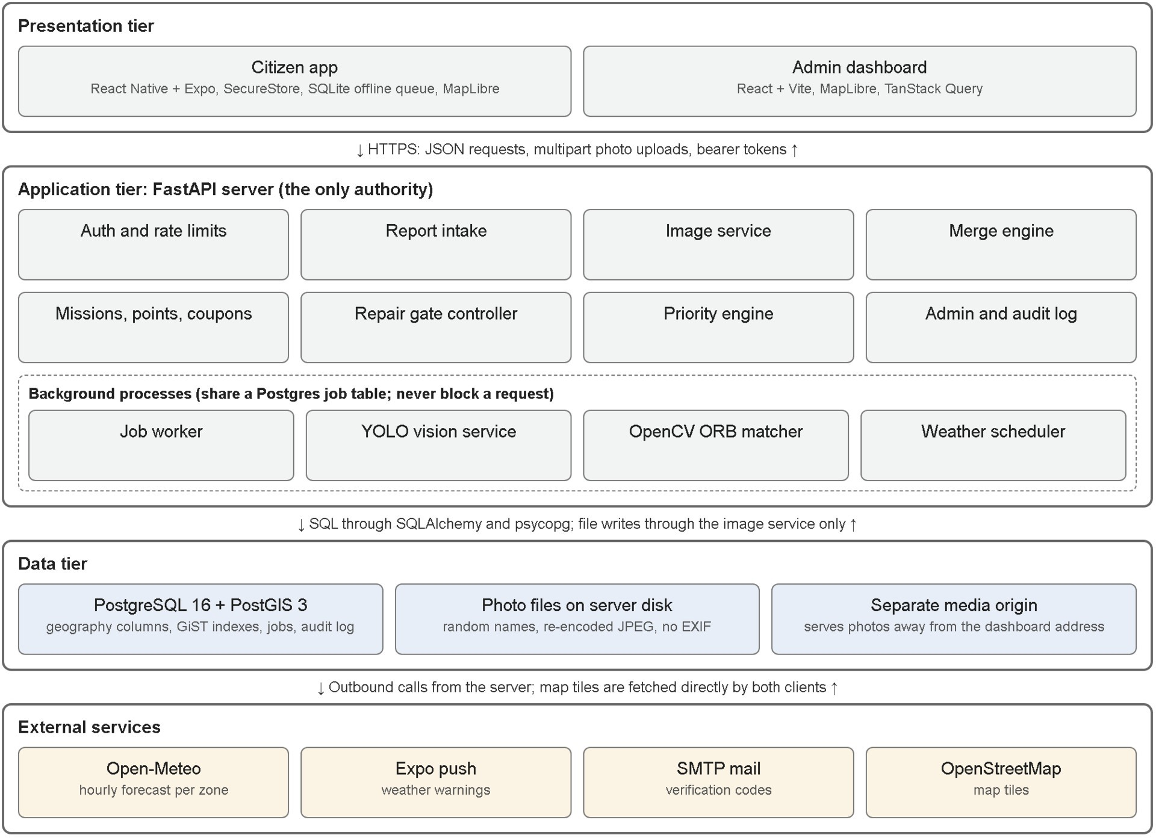
Figure 1: Detailed system architecture Table 3: Principal architectural decisions

Table 4: API route groups

Route group | Representative routes | Access
Authentication | POST /auth/register, /auth/verify-email, /auth/resend-code, /auth/login, /auth/refresh, /auth/logout, /auth/forgot-password, /auth/reset-password | Public
Profile and device | GET, PATCH /me; GET /me/impact; POST /me/password; POST /devices | User
Reporting | GET /categories; POST /reports; GET /reports/mine, /reports/{id} | User
Map | GET /pins, /pins/{id} | User
Weather | GET /weather/warnings; PUT /devices/me/zone; POST  /notifications/{id}/received | User
Missions | GET /missions/available, /missions/{id}; POST /pins/{id}/confirm,  /missions/{id}/accept, /missions/{id}/submit | User
Rewards | GET /points/me, /leaderboard, /coupons; POST /coupons/{id}/claim | User
Administration | GET /admin/queue, /admin/claims, /admin/audit, /admin/stats; POST  /admin/pins/{id}/split, /admin/pins/{id}/status, /admin/claims/{id}/decision,  /admin/coupons, /coupons/redeem; GET, PUT /admin/ranking-config | Admin
Health | GET /health | Public

Domain Model
The domain model presents the principal real-world concepts and their relationships, independent of implementation. An account files reports, and each report describes one hazard pin. Missions direct people to pins. An approved repair claim closes the pin and awards points.
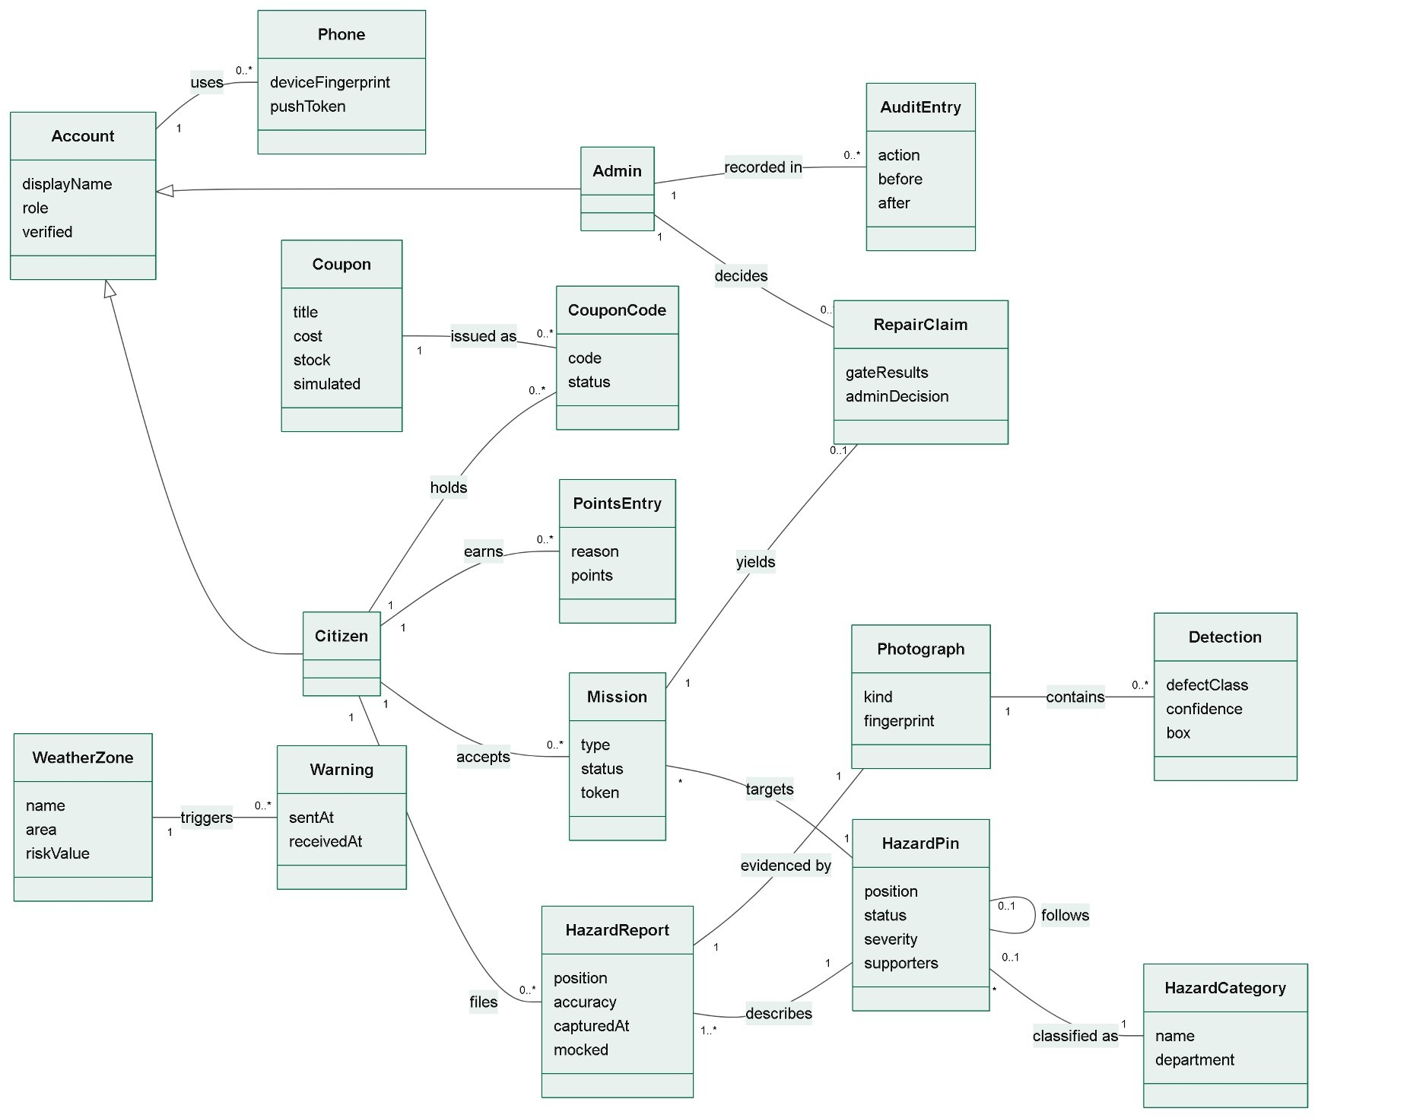
Figure 2: Domain model

Class Diagram
Entity classes map to database tables through SQLAlchemy, and service classes hold the business rules. A service may be written in Python as a module of functions with the same responsibilities. Figure 3 covers accounts, report intake, merging and analysis, and Figure 4 covers ranking, weather, repair checks and rewards.
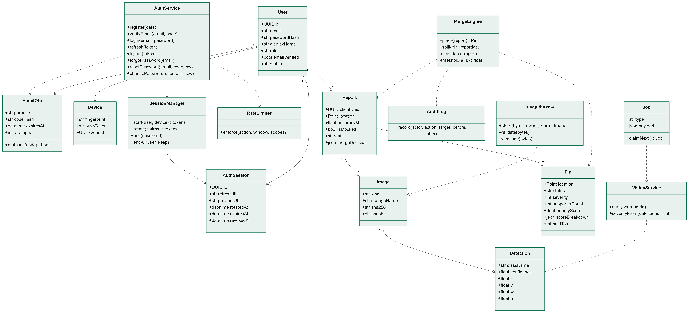
Figure 3: Class diagram, part 1: accounts, reports, merging and vision

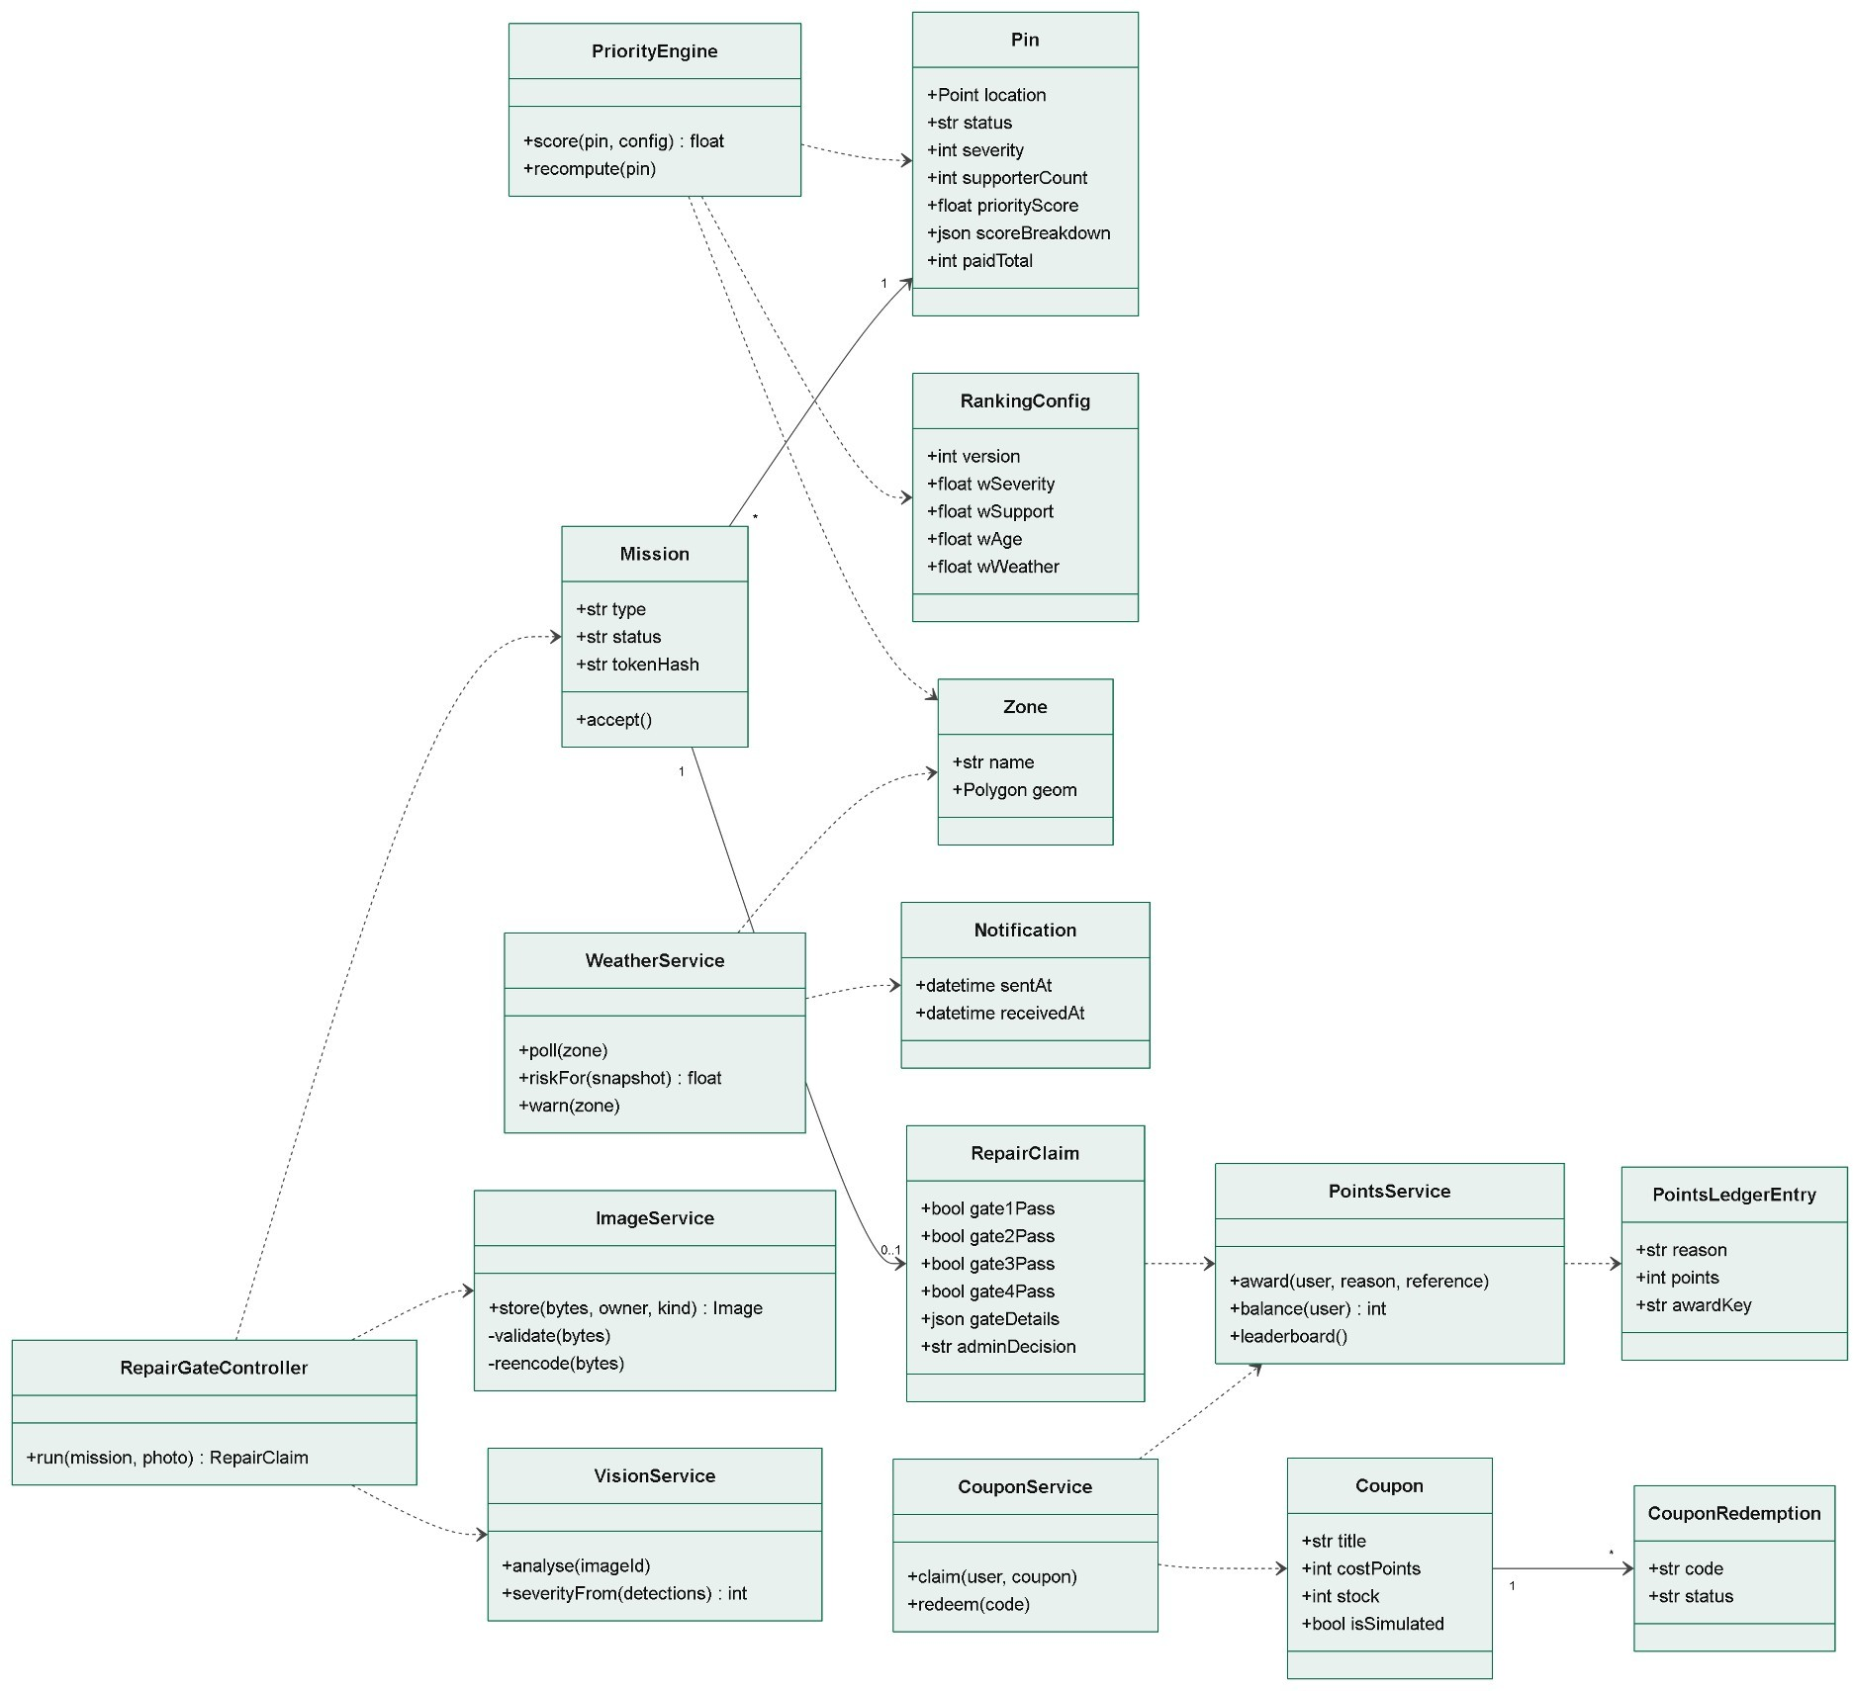
Figure 4: Class diagram, part 2: ranking, weather, repair checks and rewards

Table 5: Responsibilities of the service classes

Class | Principal responsibility
AuthService | Handles registration, code verification, login, token refresh, logout, and password reset and change.
SessionManager | Starts a session at login, rotates its refresh token on every refresh, and revokes it on reuse of an old token, logout or a password change.
RateLimiter | Increments a counter for each action and scope, and refuses requests above the limit.
ImageService | Is the only component permitted to write photograph files; it validates, re-encodes, names and hashes them.
MergeEngine | Acquires an advisory lock per category, finds candidates, applies the pair threshold (which uses reported GPS accuracy [6]), attaches or creates a pin, and records its decision.
VisionService | Loads the model trained on RDD2022 [5] and local data once, stores detections and computes severity.
PriorityEngine | Provides a pure scoring function and the triggers that recompute a pin's score.
WeatherService | Polls Open-Meteo [10], computes risk, suppresses repeat warnings and sends push messages.
RepairGateController | Runs the gates in order, applies the evaluation switches and stores each measurement. It also notes the mock-location flag reported by the phone [11].
PointsService | Awards points using the unique key, enforces the cap and builds the leaderboard.
CouponService | Claims coupons under a row lock and redeems them with one conditional update.
AuditLog | Provides a single helper that writes an audit record within the caller's transaction.

Database Diagram
The database uses PostgreSQL 16 with the PostGIS 3 extension. Identifiers are UUIDs and times are stored in UTC. The physical tables are grouped below by subject area. A table owned by another area appears only with its primary key, to show the relationship.
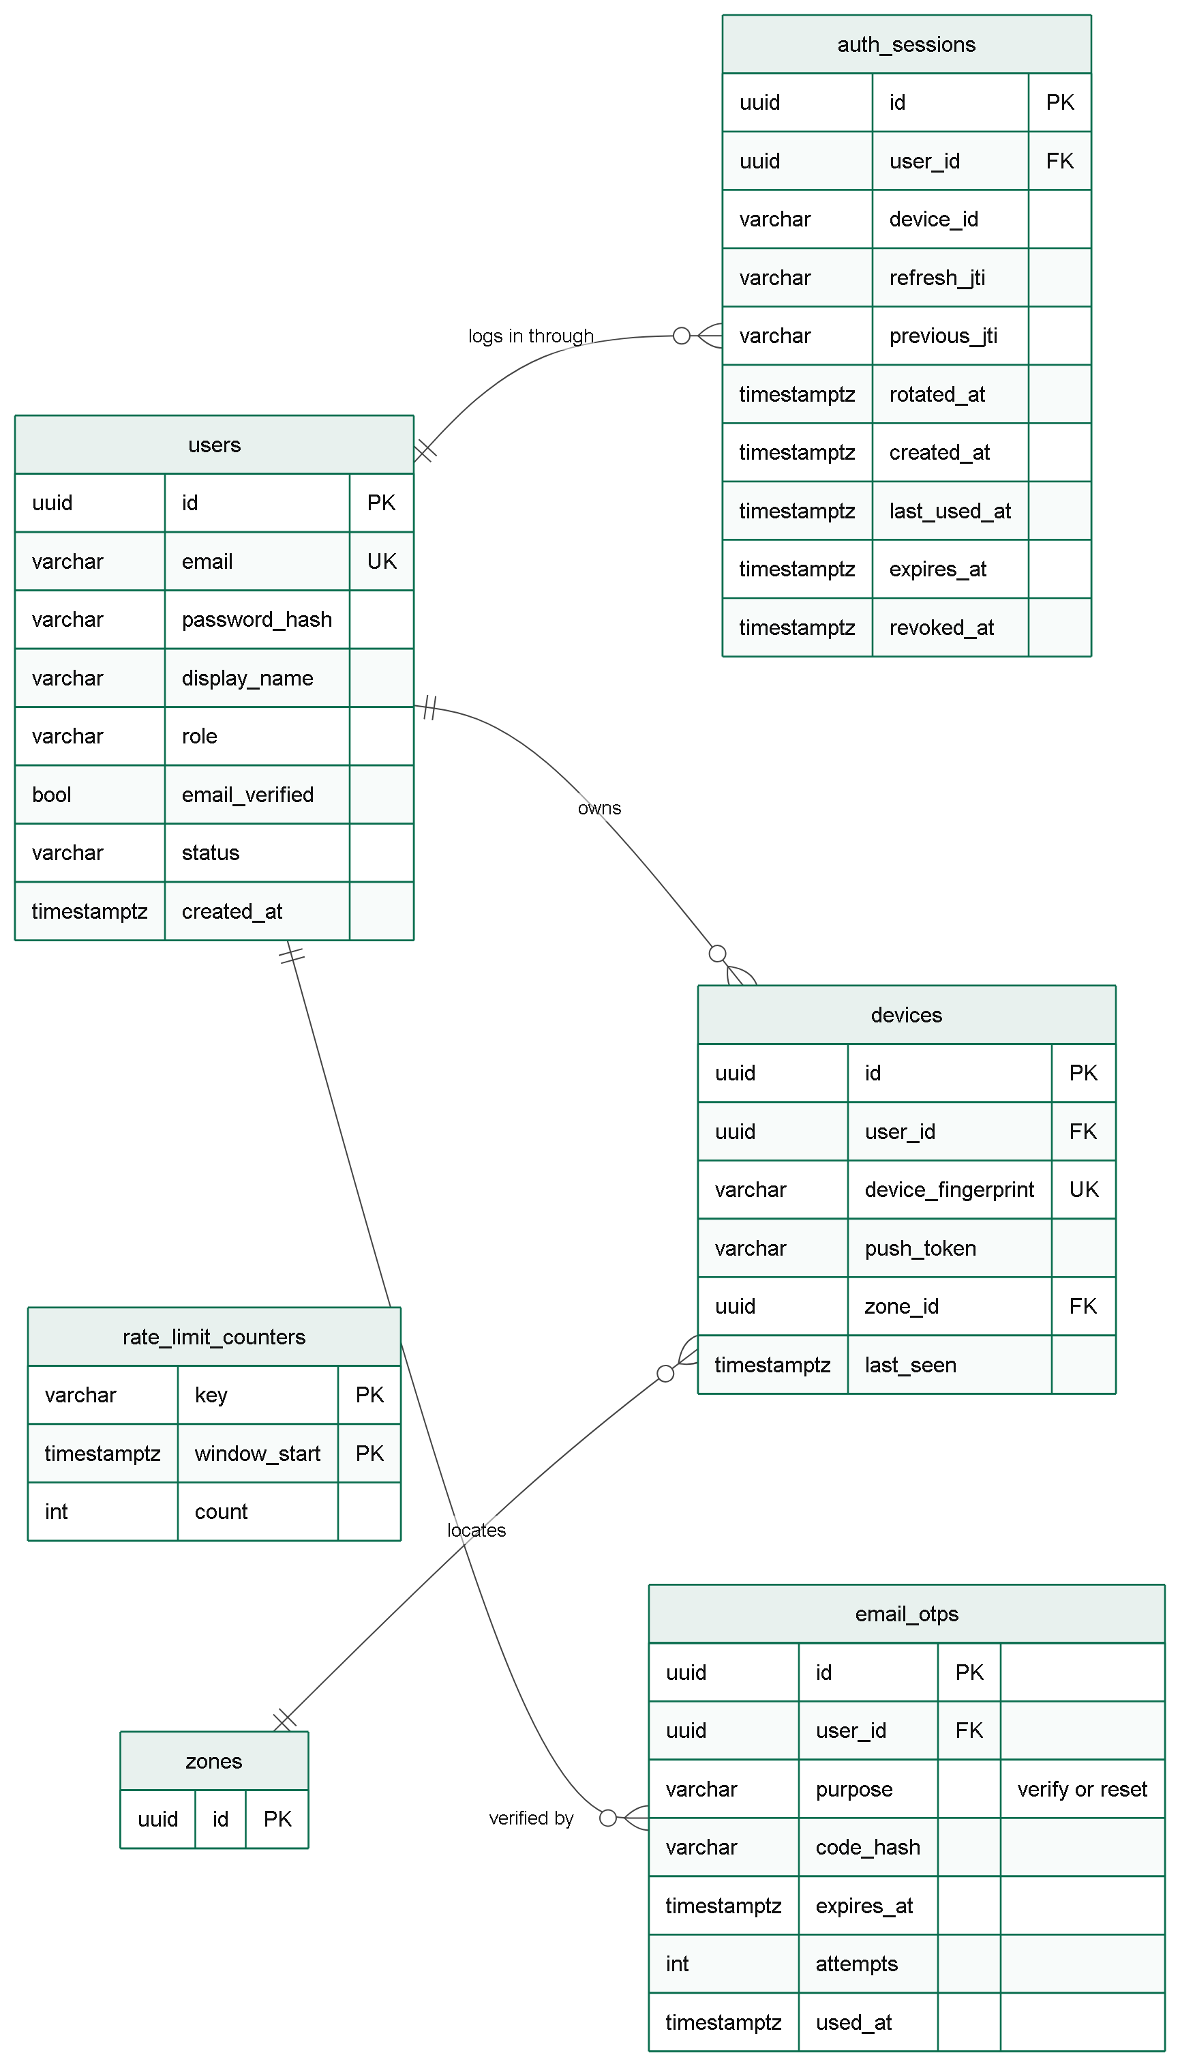
Figure 5: Database diagram: accounts and rate limiting

FYP-Code: 23F-90 Software Design Specification Document

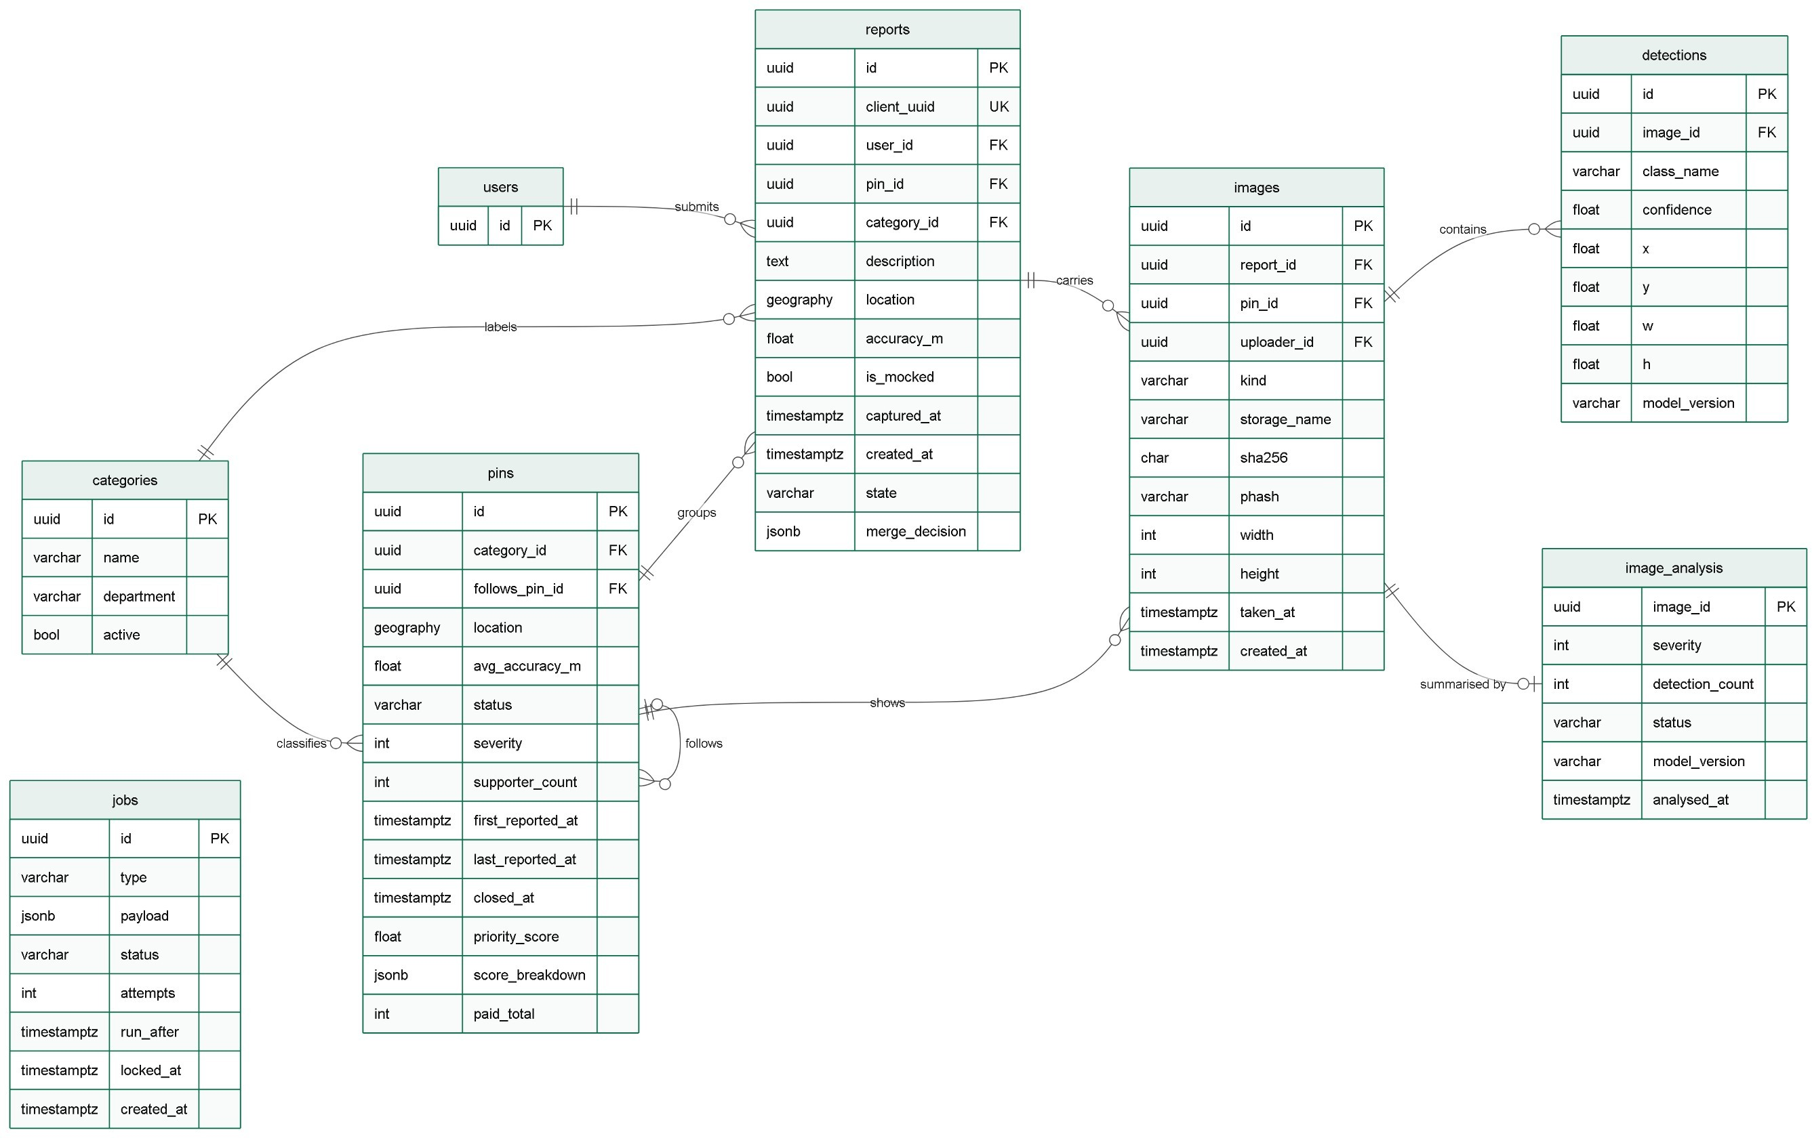
Figure 6: Database diagram: reports, pins, images and analysis

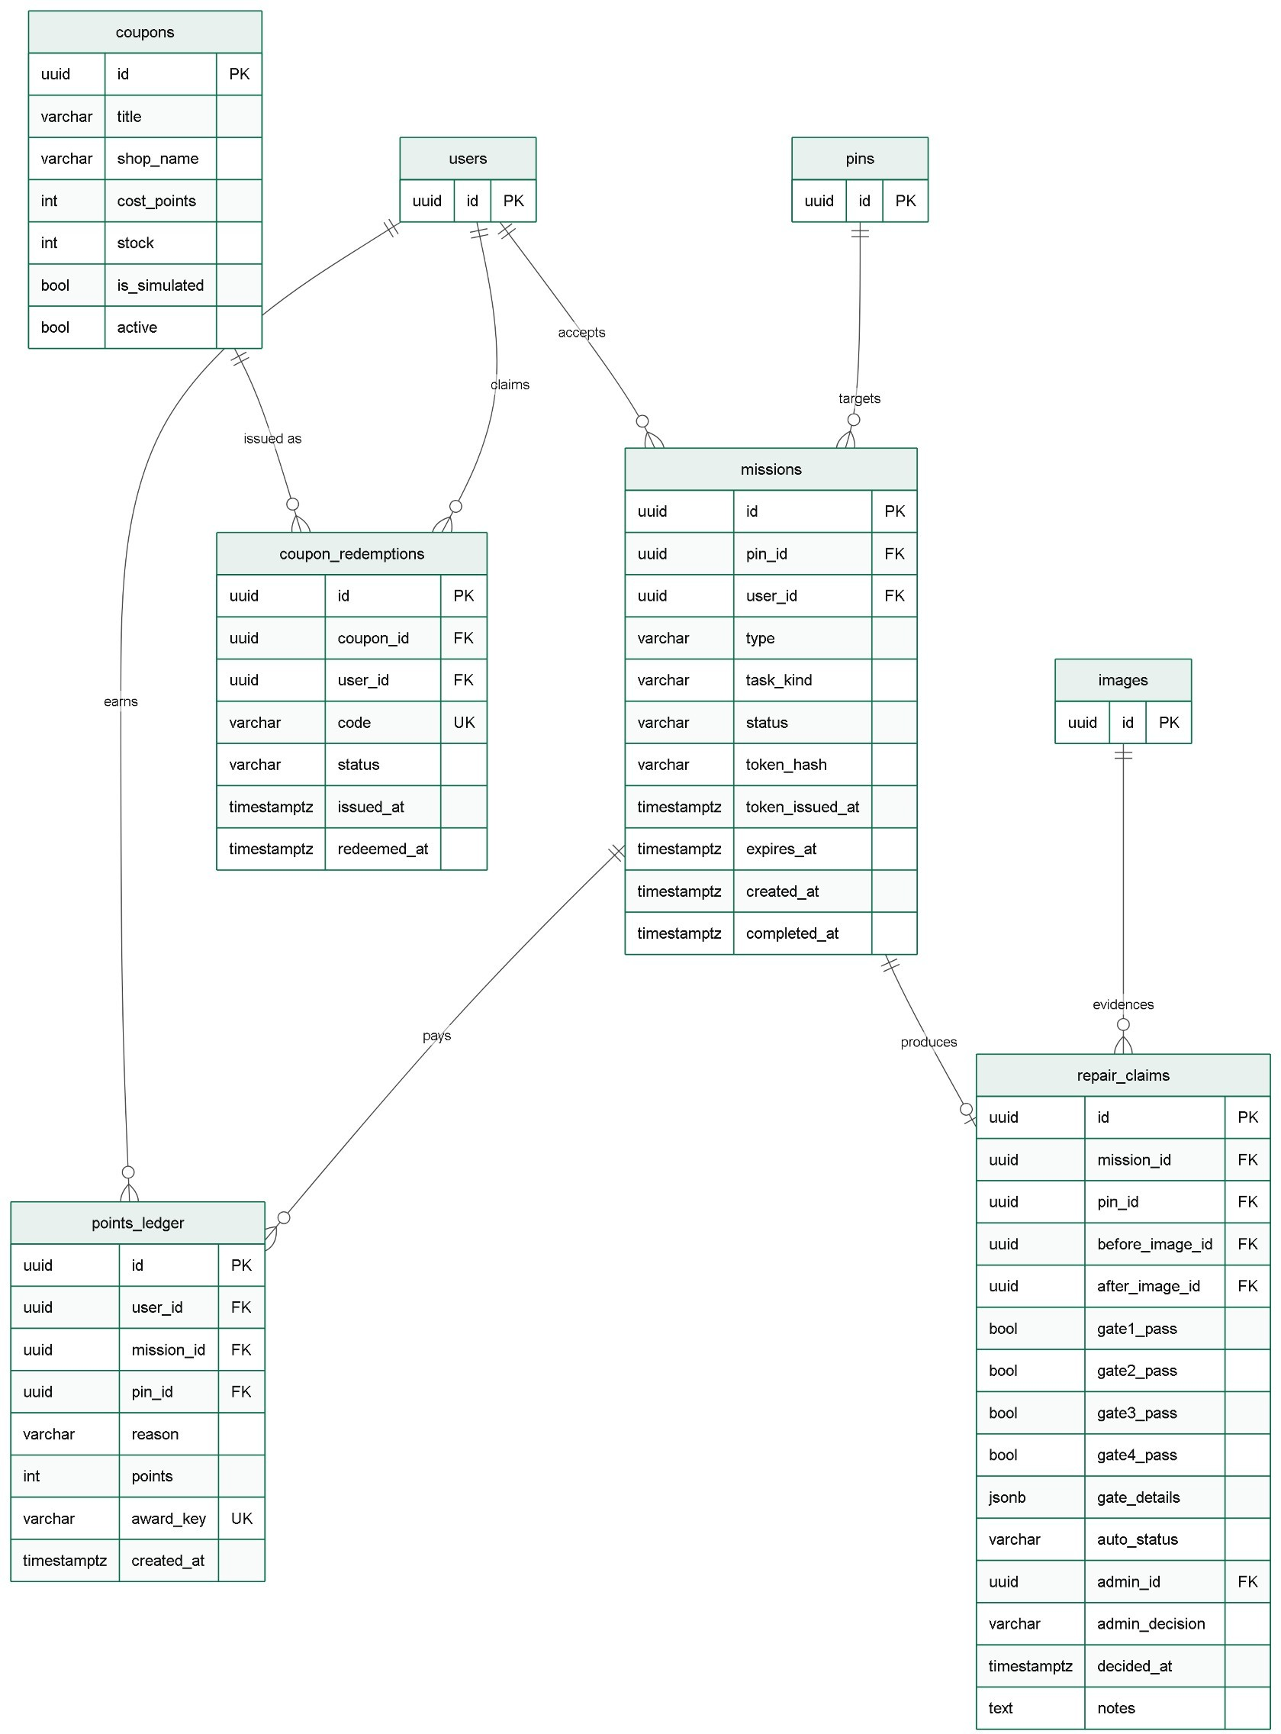
Figure 7: Database diagram: missions, repair claims, points and coupons

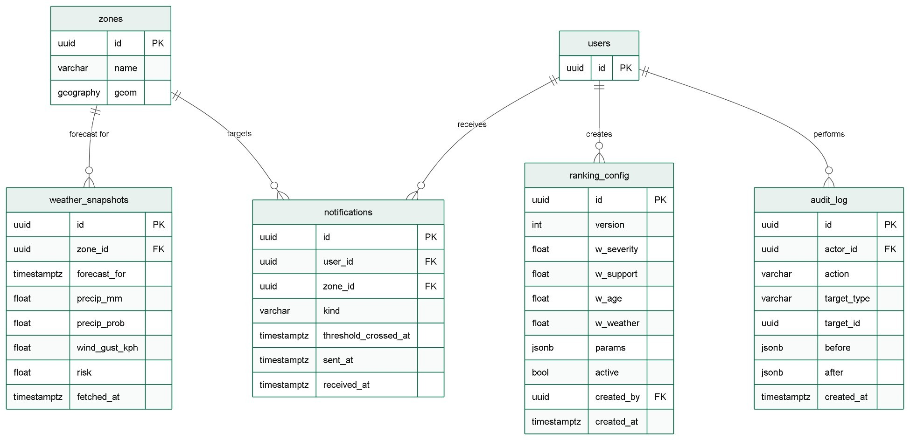
Figure 8: Database diagram: weather, ranking settings and audit log Table 6: Principal constraints and indexes
Constraint or index | Purpose
GiST index on reports.location, pins.location, zones.geom | Supports indexed nearby-pin and viewport queries.
Composite index on pins (category_id, status, last_reported_at) | Narrows merge candidates efficiently.
Unique reports.client_uuid | Prevents a repeated offline upload from creating a second report.
Unique points_ledger.award_key | Makes a replayed award violate the constraint, so it is not paid twice.
Unique coupon_redemptions.code | Keeps each issued code distinct.
Unique devices.device_fingerprint | Ties a shared phone's push token to the current account only.
Unique users.email; check constraints on role and status | Enforces one account per email and valid role and status values.

Entity Relationship Diagram (ERD)
The entity relationship diagrams show the same data at the conceptual level, without attributes. Figure 9 covers users, reports, pins and images, and Figure 10 covers missions, rewards and weather. A report belongs to a pin but remains a separate record, so a split can be reversed. The relationship from PIN to itself records that a new pin follows a closed pin, so failed repairs and recurring defects can be identified.
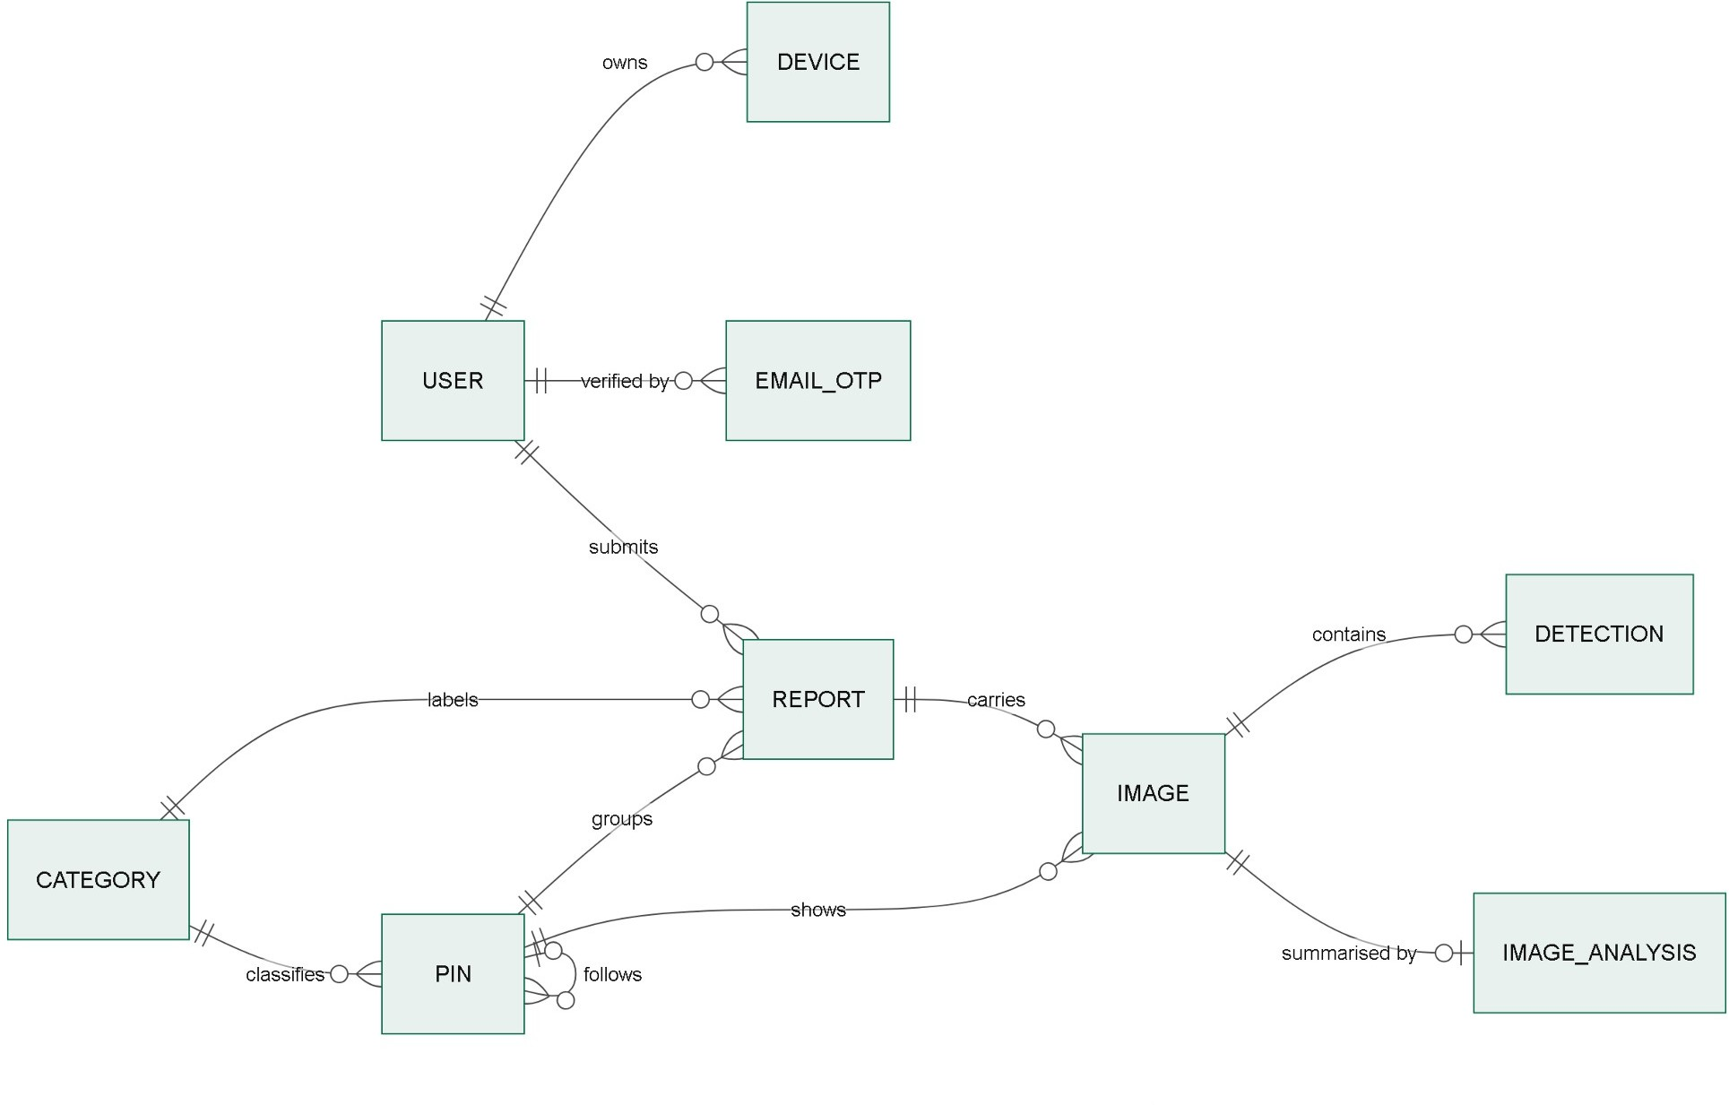
Figure 9: Entity relationship diagram: users, reports, pins and images

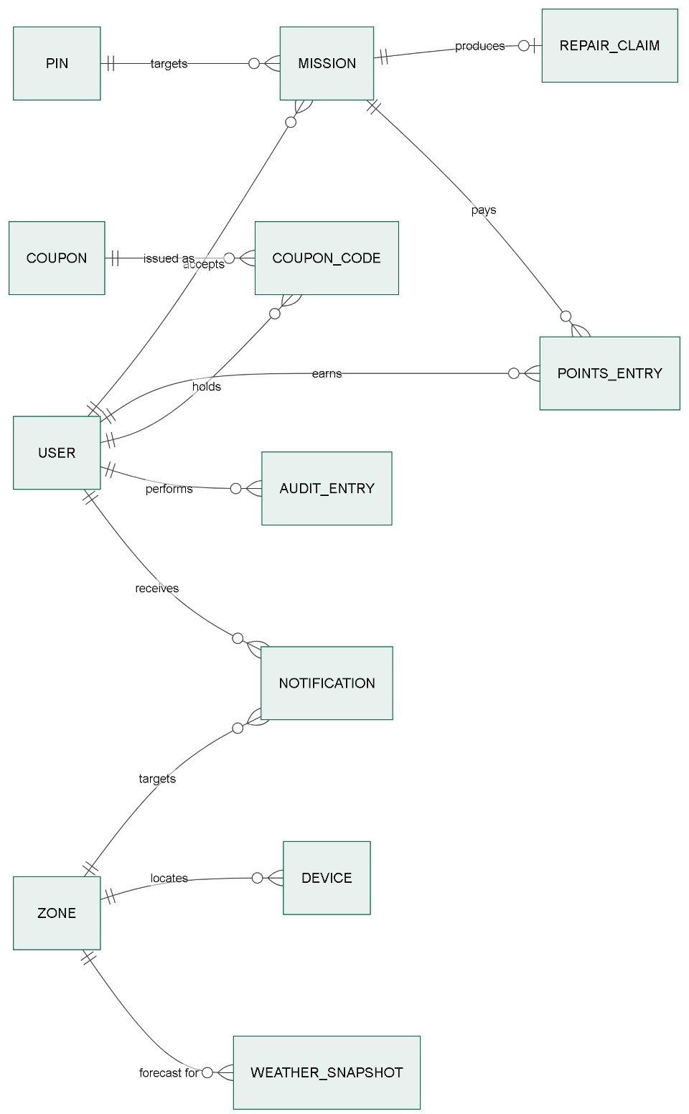
Figure 10: Entity relationship diagram: missions, rewards and weather

Sequence Diagram
Figures 11 to 14 show the four interactions with the greatest technical risk.
Registration and login. The verification email is sent after the transaction commits, so a mail failure cannot lose the account, and the user can request a new code.
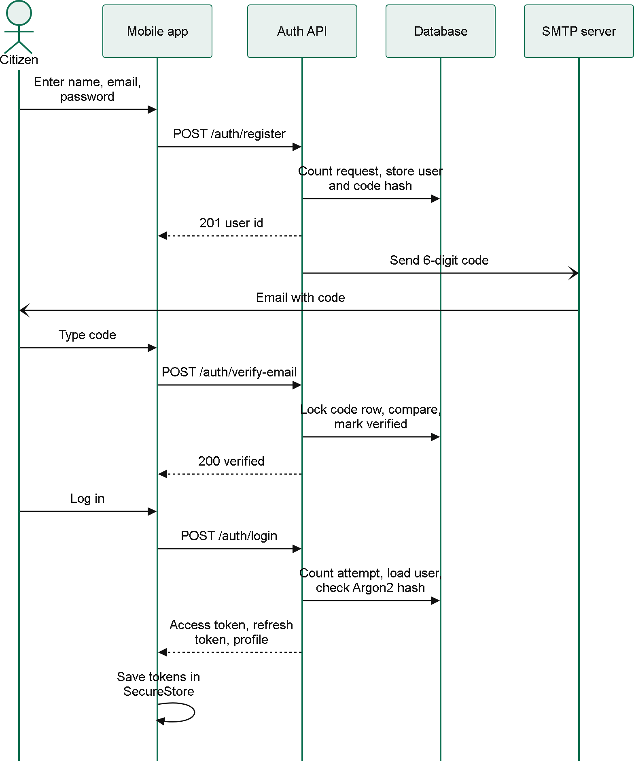
Figure 11: Sequence diagram: registration, verification and login

Report submission and merging. The client identifier makes retries safe. The merge runs in one transaction under a per-category lock, which prevents two simultaneous reports of one pothole from creating two pins.
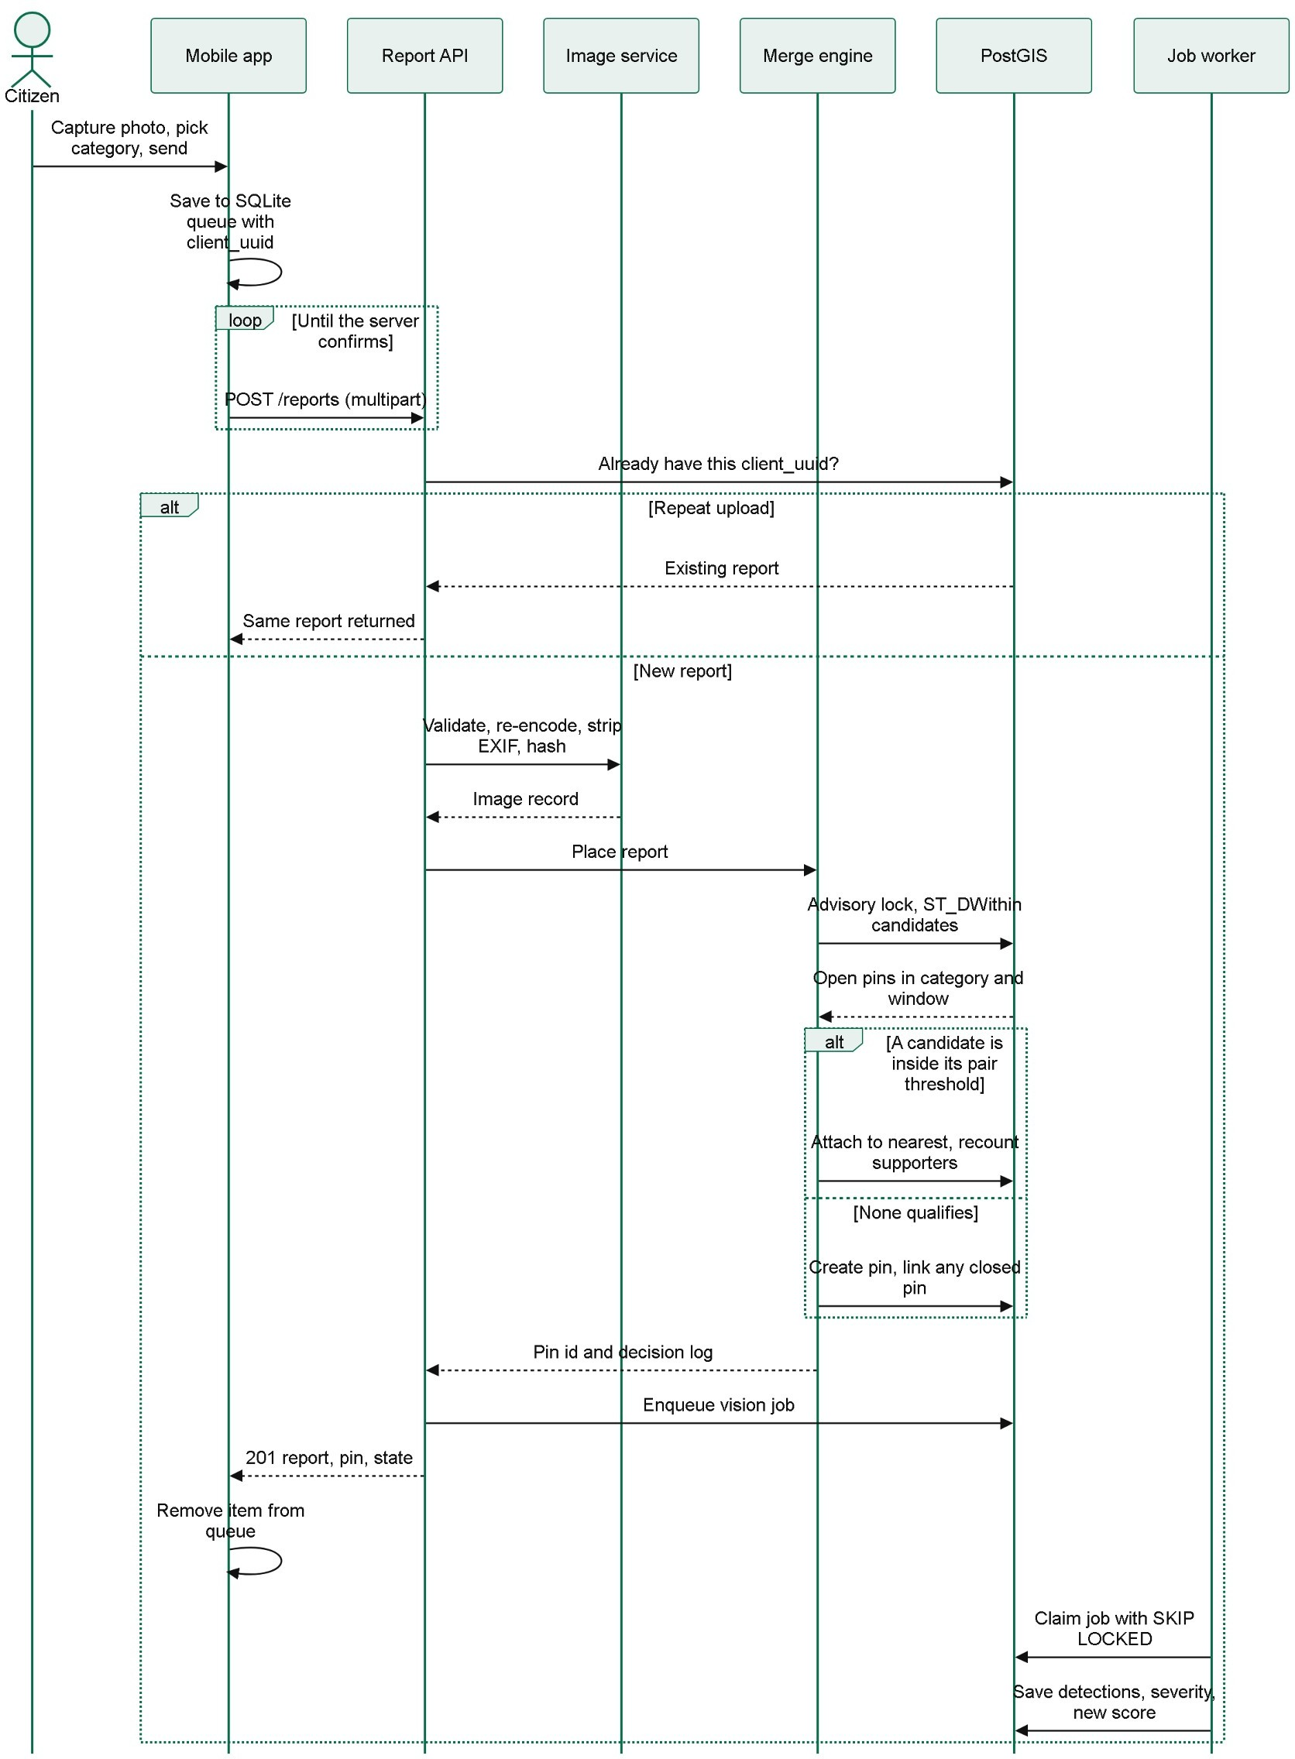
Figure 12: Sequence diagram: report submission and merging

Repair verification. Inexpensive gates run first, and processing stops at the first failure. Points are awarded only after the administrator's decision, and a unique key protects that step from repetition.
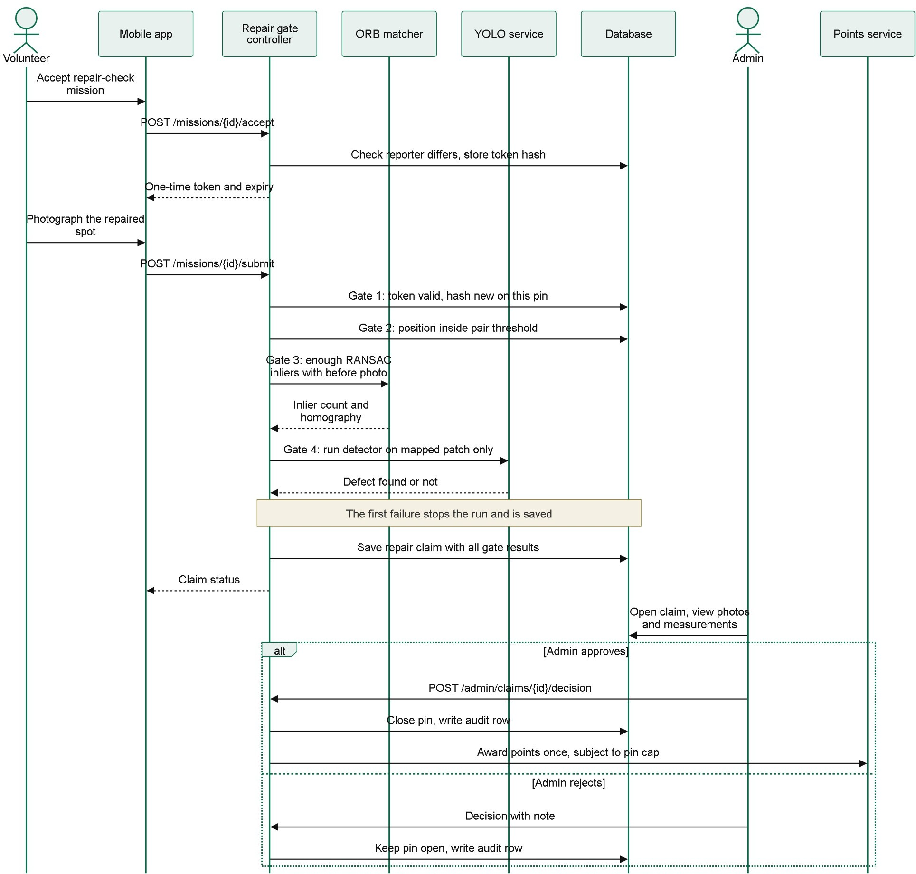
Figure 13: Sequence diagram: repair verification and approval
Token refresh. Each refresh replaces the refresh token, so a copied token stops working as soon as either holder uses it, and reusing an old token ends the session. A reply lost in transit is covered by a 60-second grace period.
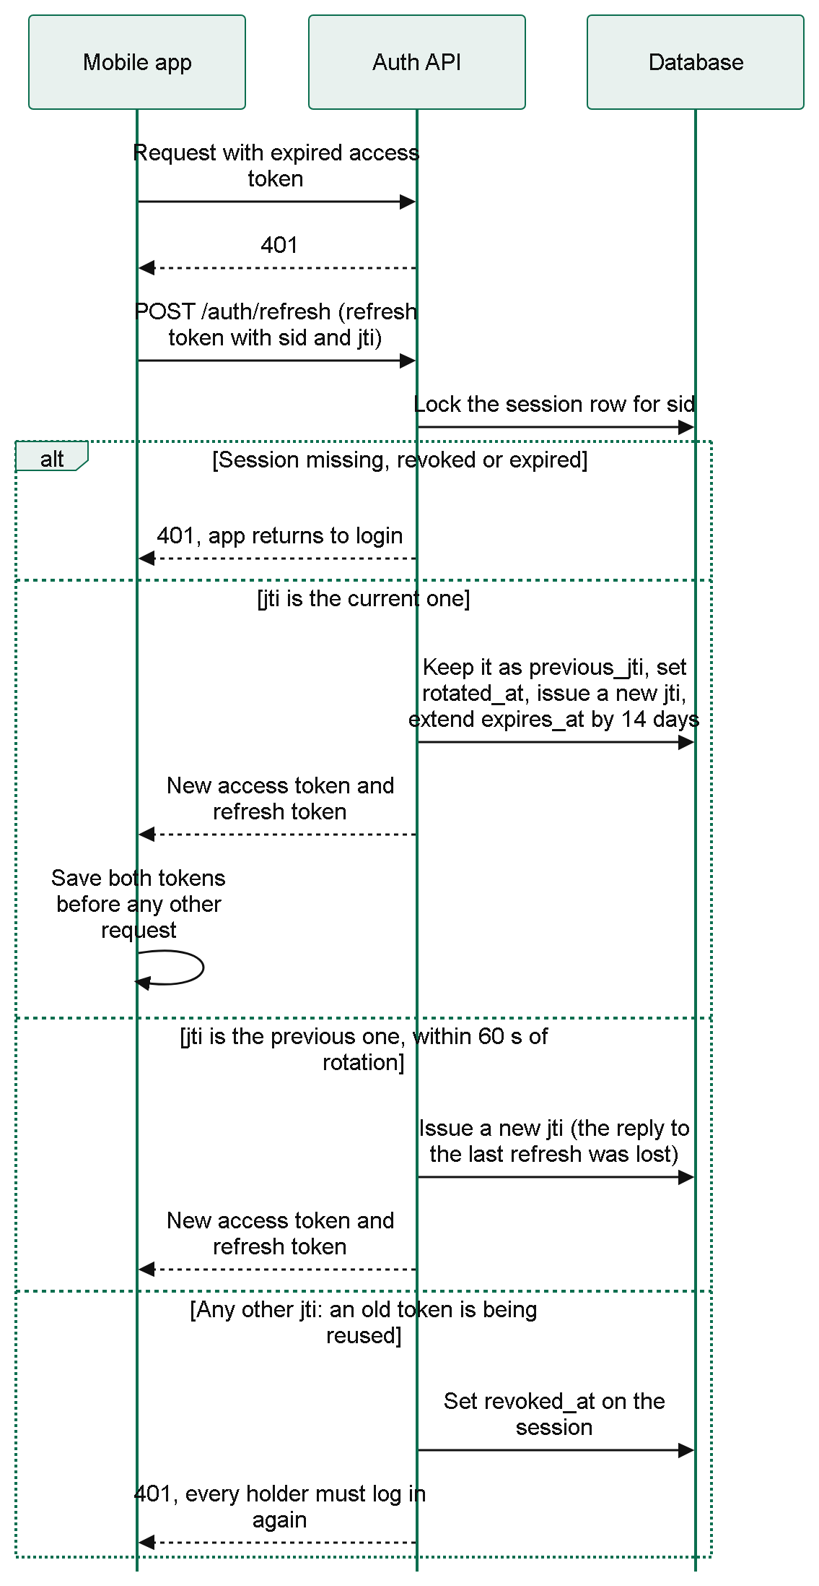
Figure 14: Sequence diagram: token refresh and session revocation

System Interface Design
Screen | Purpose | Use case
Log in, Create account, Verify code, Reset password | Account creation and access | UC-01 to UC-03, UC-20
Home | Rank, impact totals and own reports as tickets | UC-06, UC-23
New report, Hazard map | Reporting a hazard; pins with a detail card | UC-05, UC-07
Profile, Change password, Server address | Badges, name, password, server, log out | UC-04, UC-21, UC-22
Repair check, Missions, Points (planned) | Repair photos, tasks, points and coupons | UC-09, UC-10, UC-16, UC-17

Figure 15 shows the citizen application as built, captured with sample data. The map in screen f is a placeholder (*), because map tiles are drawn by MapLibre only on the phone. The application uses large controls and short workflows for outdoor use. The citizen screens built so far are log in, create account, verify code, reset password, home, new report, hazard map, profile, change password and server address. The repair check, missions and points screens (UC-09, UC-10, UC-16 and UC-17) are pending and follow in Modules 9 and 10, and the administrator dashboard in Figure 16 is a design that has not been built yet.
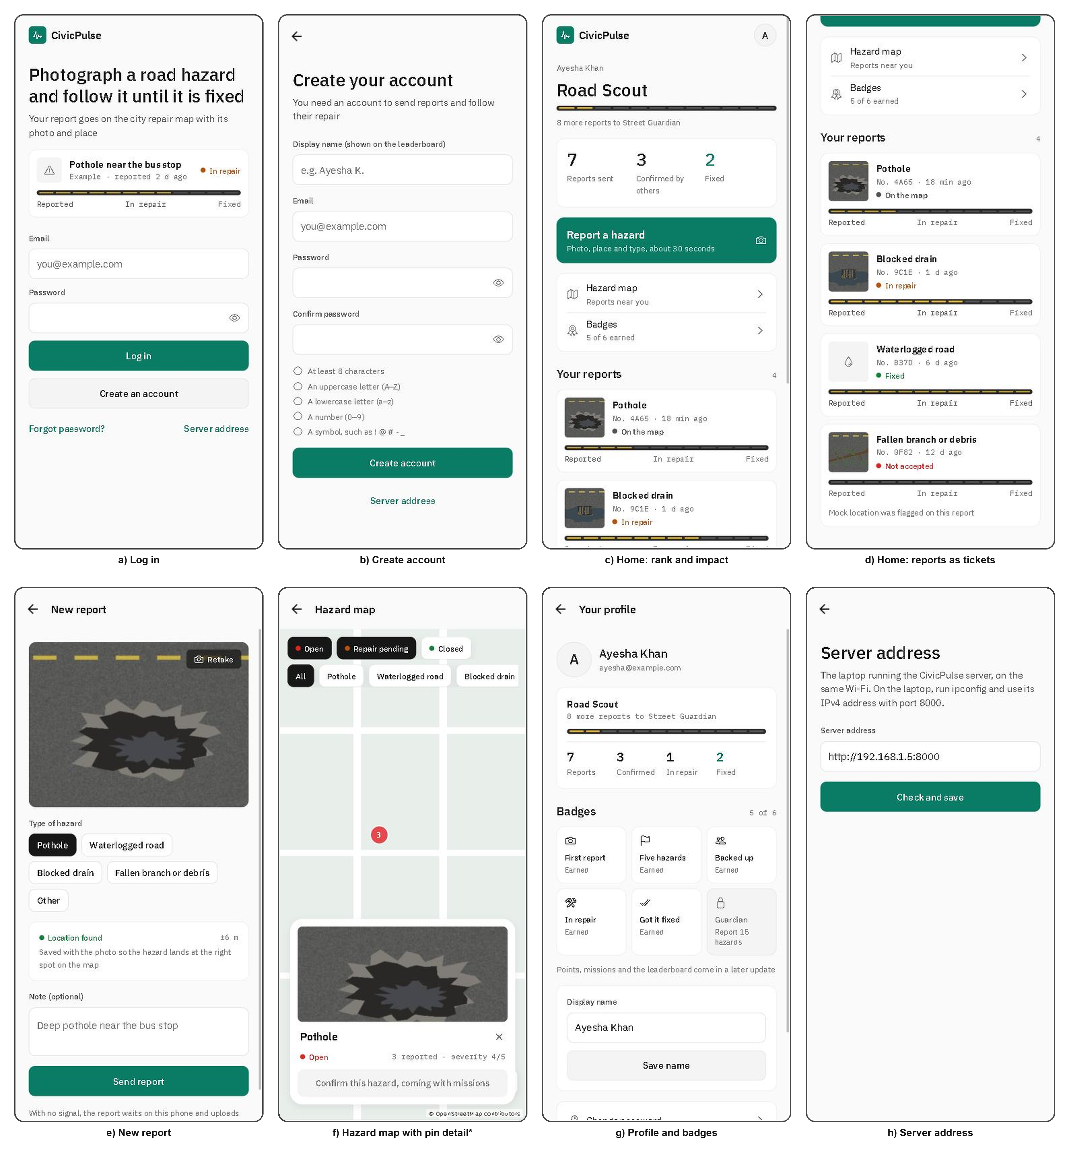
Figure 15: Citizen application screens as built Table 7: Citizen application screens

The dashboard is designed for desk use. The queue explains each hazard's rank, the claim review displays evidence and gate measurements side by side, and the audit log records each administrative change. Stored text is rendered through React's default escaping.
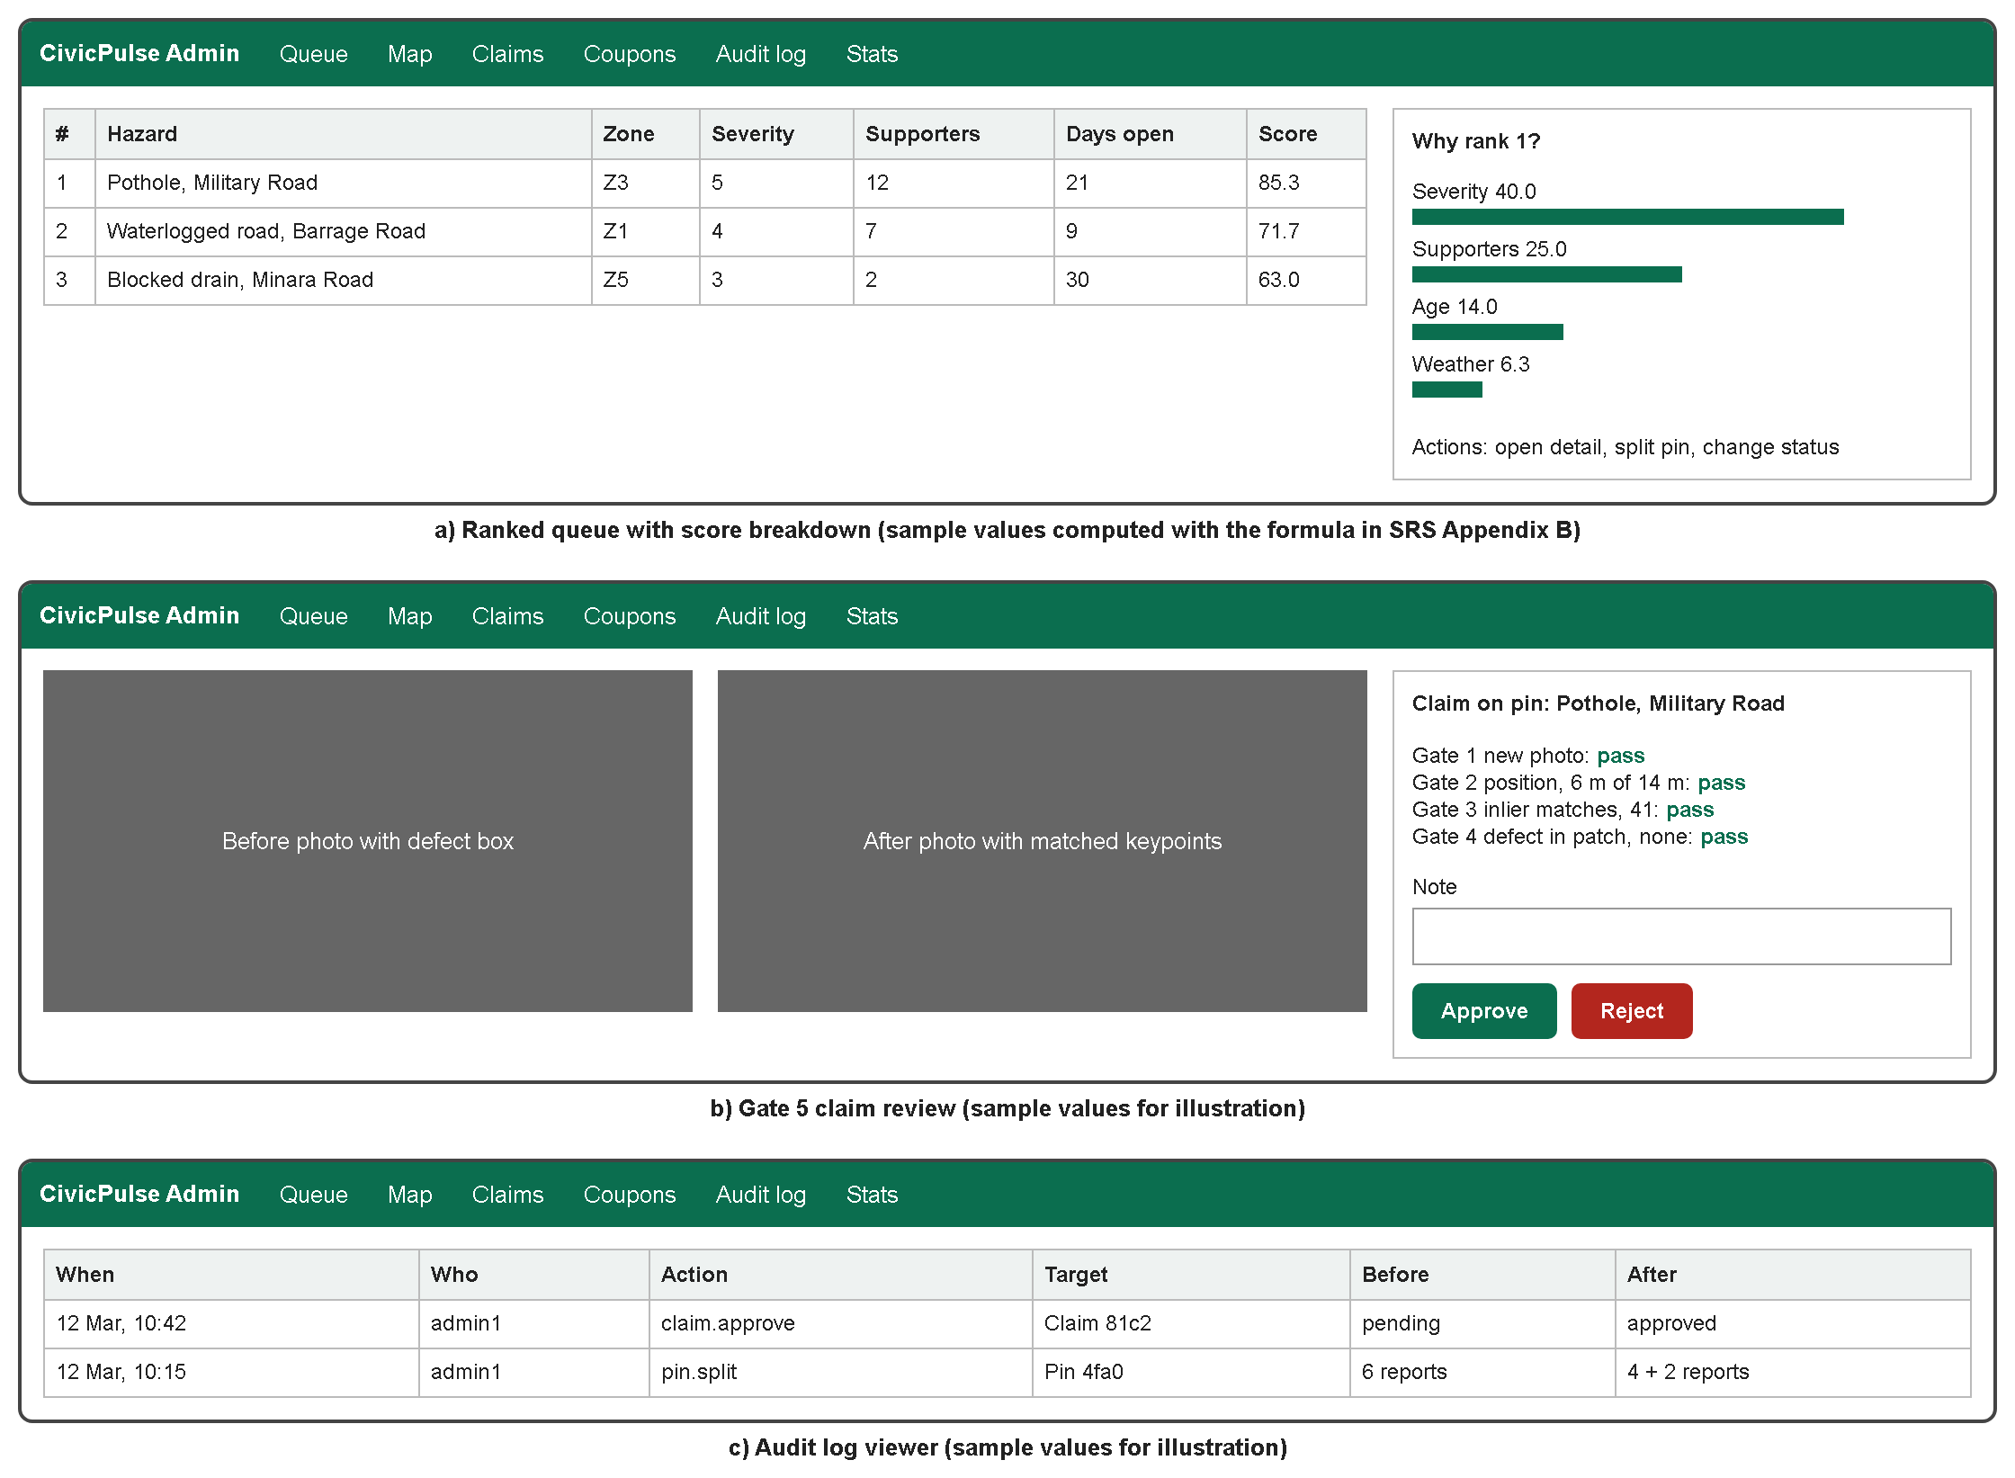
Figure 16: Administrator dashboard screen designs

Test Cases
The following checks are planned, and results will be recorded as each module is completed. Unit, database and API tests run under pytest against a real PostGIS container, and mobile tests are performed manually on an Android phone.
Tests of type Experiment (TC-22, TC-24, TC-28, TC-29 and TC-32 to TC-35) are evaluation runs. Each one runs the merge engine, the detection model, the ranking score, the warning service or the repair gates on held-out labelled data or a scripted scenario, and records the measure given for its objective in Table 3 of the SRS, such as precision and recall or mAP@0.5. They have no fixed pass mark. An experiment runs once the module it evaluates is complete and its data set is ready, and its measured values are reported against the objectives.
Table 8: Planned test cases

ID | Scenario | Expected result | Type | Covers
TC-01 | Register an existing email in a different letter case | Status 409; no second account | API | FR-01
TC-02 | Submit five incorrect codes, then the correct one | Code locks on the fifth attempt; correct code receives 423 | API | FR-02
TC-03 | Submit a code after 10 minutes | Refused as expired | API | FR-02
TC-04 | Attempt login before verification | Status 403 email_not_verified | API | FR-04
TC-05 | Make six login attempts in one minute | Sixth attempt receives 429 with Retry-After | API | FR-04, NFR-15
TC-06 | Use a citizen token on an administrator route | Status 403 | API | FR-04
TC-07 | Use a refresh token as an access token, and the reverse | Status 401 in both cases | API | FR-03
TC-08 | Log in, then restart the application with no signal | User remains logged in | Mobile | FR-08
TC-09 | Report in airplane mode, then reconnect | Report reaches the server exactly once | Mobile | FR-08
TC-10 | Send the same client_uuid twice | One report is stored | API | FR-08
TC-11 | Upload a script renamed with a .jpg extension | Rejected | Security | FR-09
TC-12 | Upload a photograph containing GPS EXIF data | Stored copy contains no EXIF data | Security | FR-09
TC-13 | Upload a 6 MB file | Rejected | Security | FR-09
TC-14 | Supply a file name containing ../ | Ignored; the server assigns the name | Security | FR-09
TC-15 | One account reports one hazard five times | Supporter count remains 1 | Database | FR-12
TC-16 | Five accounts report one hazard | Supporter count is 5 | Database | FR-12
TC-17 | Report a different category at the same location | New pin | Database | FR-11
TC-18 | Report at the location of a closed pin | New pin linked to the closed pin | Database | FR-13
TC-19 | Report 90 days after the last report on a pin | New pin | Database | FR-11
TC-20 | Submit opposite-kerb reports 12 m apart, and reports of two defects 10 m apart | Opposite kerbs: two pins; two defects 10 m apart: one pin, with the decision recorded | Database | FR-11
TC-21 | Split a pin | Two pins, all reports intact, audit record written | API | FR-14
TC-22 | Sweep the merge radius from 5 m to 40 m on the labelled set | Precision and recall curve produced | Experiment | Objective O1
TC-23 | Upload a photograph with no defect | Marked unanalysed; category default used; no failure | Unit | FR-15, FR-16
TC-24 | Evaluate public-only and fine-tuned models on held-out Sukkur photographs | Two mAP@0.5 values reported | Experiment | FR-15
TC-25 | Compute severity and score for hand-worked inputs | Values match the manual calculation | Unit | FR-16, FR-19
TC-26 | Add a supporter to a pin | Score does not decrease | Unit | FR-19
TC-27 | Score one pin in a high-risk zone and in a calm zone | High-risk version ranks higher | Unit | FR-19
TC-28 | Compare the score with rankings of about 50 hazards by three people | Spearman's rho and largest disagreements documented | Experiment | FR-19
TC-29 | Repeatedly trigger a mocked threshold crossing | Push arrives in the zone only; median delay and targeting recorded | Experiment | FR-18
TC-30 | Force the forecast request to fail | Scheduler continues using the last snapshot | Unit | FR-17

ID | Scenario | Expected result | Type | Covers
TC-31 | Submit the original before photograph as the after photograph | Rejected at Gate 1 | API | FR-22
TC-32 | Submit a photograph of clean road elsewhere | Rejected at Gate 2 | Experiment | FR-22
TC-33 | Submit a different, genuinely repaired pothole nearby | Rejected at Gate 3 | Experiment | FR-22
TC-34 | Frame the defect out of shot, or photograph from far away | Rejected at Gate 4 | Experiment | FR-22
TC-35 | Run the faked set with Gates 2 to 4 disabled, then enabled | Fakes pass when disabled; false-accept and false-reject rates recorded when enabled | Experiment | FR-24
TC-36 | The reporter of a pin attempts its repair check | Refused | API | FR-21
TC-37 | Submit a claim that passes Gates 1 to 4, with no administrator decision | No points in the ledger | API | FR-23
TC-38 | Award each mission type | Each amount equals the published table | Unit | FR-25
TC-39 | Replay an award request | Paid once | Database | FR-25
TC-40 | Attempt payment above the per-pin cap | No further payout | Database | FR-26
TC-41 | Read a leaderboard with tied totals repeatedly | Order is unchanged | Database | FR-27
TC-42 | Redeem one code from two connections simultaneously | One success and one status 409 | Database | FR-28
TC-43 | Store a description containing a script tag, then view it | Displayed as plain text | Security | NFR-19
TC-44 | Perform each administrator action | One audit record for each action | API | FR-31
TC-45 | Request the public pin list | No reporter identity in the response | API | FR-10
TC-46 | Wait past the access and refresh token lifetimes | Access token refused after 15 minutes, refresh token after 14 days | Unit | FR-03
TC-47 | Refresh twice with the same refresh token, more than 60 seconds apart | Second use refused and the whole session revoked | API | FR-03
TC-48 | Create an administrator with the server script, then try to set a role through the API | Script creates the administrator; the API ignores the role | API | FR-05
TC-49 | Register the same device for a second account | The device record belongs only to the second account | Database | FR-06
TC-50 | Send a report from the phone and read it back | Photo, category, note, position, accuracy, time and mock flag stored | Mobile | FR-07
TC-51 | Change a ranking weight | New settings version stored and the change logged | API | FR-20
TC-52 | Report a pin, then confirm it from a second account | Report points held until the second supporter, then released once | Database | FR-26
TC-53 | Complete a volunteer task, then have it approved | Points awarded once, and only after approval | API | FR-29
TC-54 | Open each dashboard page as an administrator | Queue, map, pin detail, claims, coupons and statistics load | Manual | FR-30
TC-55 | Try passwords missing each character class, a common one and one containing the email name | Each refused with its reason; a valid password accepted | API | FR-32
TC-56 | Request reset codes for an unknown and a known email, then reset | Same answer for both; new password works; older sessions refused | API | FR-33
TC-57 | Change password with a wrong current password, then correctly | First refused with 400; then other sessions refused, this one kept | API | FR-34
TC-58 | Log out, then use the old refresh token | Refused with 401 | API | FR-35
TC-59 | Two accounts send reports; each reads My Reports and the totals | Each sees only its own reports; rejected reports not counted | API | FR-36, FR-37
TC-60 | Enter an address with no server, then the correct one | First refused naming the address; second saved | Mobile | FR-38
TC-61 | Approve a claim that failed Gate 3 | Approved, logged as an override, points paid once | API | FR-23

References
- Provincial Disaster Management Authority, Government of Sindh, Flood 2022 in Sindh, from June 20, 2022 to March 31, 2023, p. 17. [Online]. Available:
https://pdma.gos.pk/Documents/Reports/Flood%202022%20In%20Sindh.pdf (accessed Sep. 3, 2026).
- T. Siddiqui and I. Ayub, "Murad allocates Rs1.5bn for repair of few select rain-damaged roads in city," Dawn, Sep. 19, 2024. [Online]. Available: https://www.dawn.com/news/1859688 (accessed Nov. 7, 2026).
- A. Gardezi, "Govt celebrates Citizen Portal success despite only 30% satisfaction rate," ProPakistani, Aug. 6, 2026. [Online]. Available: https://propakistani.pk/2026/08/06/govt-celebrates-citizen-portal-success-despite-only-30-satisfaction-rate/ (accessed Nov. 7, 2026).
- mySociety, "FixMyStreet.com: The UK's street fault reporting website." [Online]. Available: https://www.mysociety.org/community/fixmystreet-in-the-uk/ (accessed Nov. 7, 2026).
- D. Arya, H. Maeda, S. K. Ghosh, D. Toshniwal, and Y. Sekimoto, "RDD2022: A multi-national image dataset for automatic road damage detection," arXiv preprint arXiv:2209.08538, 2022, doi: 10.48550/arXiv.2209.08538.
- National Coordination Office for Space-Based Positioning, Navigation, and Timing, "GPS Accuracy." [Online]. Available: https://www.gps.gov/gps-accuracy (accessed Sep. 4, 2026).
- PostGIS Project, "ST_ClusterDBSCAN," PostGIS Reference. [Online]. Available: https://postgis.net/docs/ST_ClusterDBSCAN.html (accessed Sep. 4, 2026).
- E. Rublee, V. Rabaud, K. Konolige, and G. Bradski, "ORB: An efficient alternative to SIFT or SURF," in Proc. IEEE Int. Conf. Computer Vision (ICCV), 2011, pp. 2564-2571, doi: 10.1109/ICCV.2011.6126544.
- Ultralytics, "Ultralytics YOLO Docs." [Online]. Available: https://docs.ultralytics.com/ (accessed Sep. 4, 2026).
- Open-Meteo, "Weather API Features." [Online]. Available: https://open-meteo.com/en/features (accessed Sep. 4, 2026).
- Expo, "Location: LocationObject," Expo SDK Documentation. [Online]. Available: https://docs.expo.dev/versions/latest/sdk/location/ (accessed Sep. 4, 2026).
- A. Kumar, Sarichand, and R. Bai, "CivicPulse: A civic platform that proves a road hazard was actually repaired," Final Year Project Proposal 23F-90, Dept. of Computer Science, Sukkur IBA University, 2026.
- M. Ester, H.-P. Kriegel, J. Sander, and X. Xu, "A density-based algorithm for discovering clusters in large spatial databases with noise," in Proc. 2nd Int. Conf. Knowledge Discovery and Data Mining (KDD-96), 1996, pp. 226-231.
- J. Redmon, S. Divvala, R. Girshick, and A. Farhadi, "You only look once: Unified, real-time object detection," in Proc. IEEE Conf. Computer Vision and Pattern Recognition (CVPR), 2016, pp. 779-788.

