|  |
| --- |
| BS(CS) - D |
| **DS ASSIGNMENT 01** |
| FAST NUCES ISLAMABAD |

|  |
| --- |
| **Ayra Alamdar**  **21i- 2968** |

**Graph for Question number 1:**

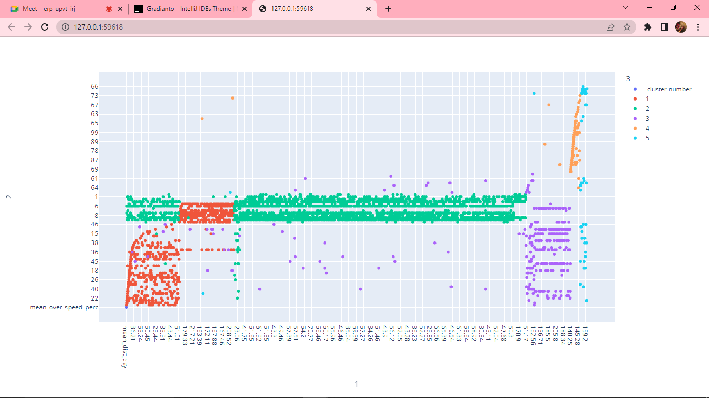

The clusters are colour oriented because I used the output file after my code ran. Each cluster is represented by a different colour as shown above. There is a table at the top right corner for which cluster is represented by each cluster. I have attached a couple of the readings from the excel sheet below for question 1;

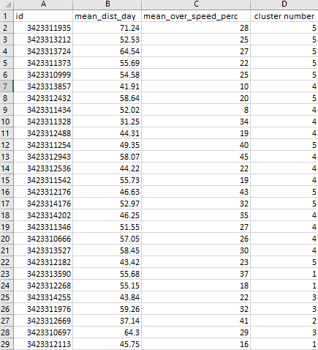

**Graph for Question number 2:**

The plot is 3D for question 3 as I used the scatter command of Python. The clusters are colour oriented because I used the output file after my code ran. Each cluster is represented by a different colour as shown above. There is a table at the top right corner for which cluster is represented by each cluster. I have attached a couple of the readings from the excel sheet below for question 2;

