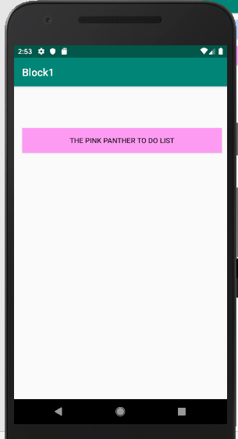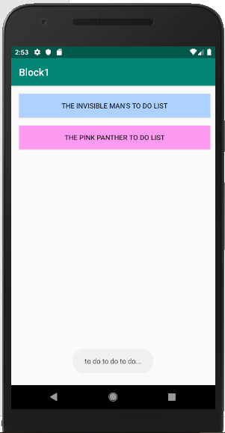

package com.example.block1;  
  
import android.support.v7.app.AppCompatActivity;  
import android.os.Bundle;  
import android.view.View;  
import android.widget.Button;  
import android.widget.Toast;  
  
public class MainActivity extends AppCompatActivity implements View.OnClickListener {  
 Button buttonBlue, buttonPink;  
  
 @Override  
 protected void onCreate(Bundle savedInstanceState) {  
 super.onCreate(savedInstanceState);  
 setContentView(R.layout.*activity_main*);  
 buttonBlue = (Button) findViewById(R.id.*button_blueinvisible*);  
 buttonBlue.setOnClickListener(this);  
 buttonPink = (Button) findViewById(R.id.*button_pinkPanther*);  
 buttonPink.setOnClickListener(this);  
 }  
 public void toDo(View v) {  
 if (v.equals(buttonBlue))  
 v.setVisibility(View.*INVISIBLE*);  
 if (v.equals(buttonPink))  
 Toast.*makeText*(getApplicationContext(),  
 "to do to do to do...",  
 Toast.*LENGTH_SHORT*).show();  
  
 }  
  
 @Override  
 public void onClick(View v) {  
 toDo(v);  
 }  
}