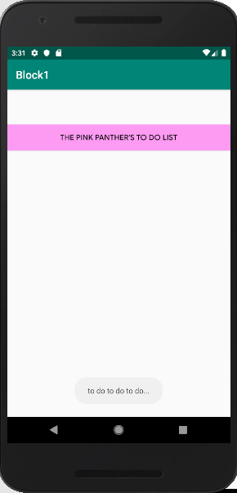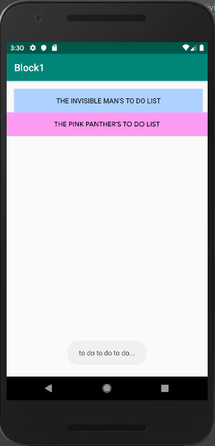

<?xml version="1.0" encoding="utf-8"?>  
<RelativeLayout xmlns:android="http://schemas.android.com/apk/res/android"  
 xmlns:app="http://schemas.android.com/apk/res-auto"  
 xmlns:tools="http://schemas.android.com/tools"  
 android:layout_width="match_parent"  
 android:layout_height="match_parent"  
 android:id="@+id/relativeLayout_mainScreen"  
 tools:context=".MainActivity">  
  
  
 <Button  
 android:id="@+id/button_blueinvisible"  
 android:layout_width="match_parent"  
 android:layout_height="wrap_content"  
 android:layout_marginStart="16dp"  
 android:layout_marginLeft="16dp"  
 android:layout_marginTop="16dp"  
 android:layout_marginEnd="10dp"  
 android:layout_marginRight="10dp"  
 android:background="#AED2FF"  
 android:text="The Invisible Man's To Do List"  
 app:layout_constraintEnd_toEndOf="parent"  
 app:layout_constraintStart_toStartOf="parent"  
 app:layout_constraintTop_toTopOf="parent" />  
  
  
</RelativeLayout

package com.example.block1;  
  
import android.graphics.Color;  
import android.support.v7.app.AppCompatActivity;  
import android.os.Bundle;  
import android.view.View;  
import android.widget.Button;  
import android.widget.RelativeLayout;  
import android.widget.Toast;  
  
public class MainActivity extends AppCompatActivity implements View.OnClickListener {  
 Button buttonBlue, buttonPink;  
  
 @Override  
 protected void onCreate(Bundle savedInstanceState) {  
 super.onCreate(savedInstanceState);  
 setContentView(R.layout.*activity_main*);  
 buttonBlue = (Button) findViewById(R.id.*button_blueinvisible*);  
 buttonBlue.setOnClickListener(this);  
 buttonPink = new Button(getApplicationContext());  
 buttonPink.setTextColor(Color.*BLACK*);  
 buttonPink.setBackgroundColor(Color.*parseColor*(("#FD9BF3")));  
 buttonPink.setText("THE PINK PANTHER'S TO DO LIST");  
 RelativeLayout rl_mainScreen = (RelativeLayout) findViewById(R.id.*relativeLayout_mainScreen*);  
 RelativeLayout.LayoutParams params = new RelativeLayout.LayoutParams(  
 RelativeLayout.LayoutParams.*MATCH_PARENT*,  
 RelativeLayout.LayoutParams.*WRAP_CONTENT*);  
 params.addRule(RelativeLayout.*BELOW*, buttonBlue.getId());  
 rl_mainScreen.addView(buttonPink, params);  
 buttonPink.setOnClickListener(this);  
 }  
 public void toDo(View v) {  
 if (v.equals(buttonBlue))  
 v.setVisibility(View.*INVISIBLE*);  
 if (v.equals(buttonPink))  
 Toast.*makeText*(getApplicationContext(),  
 "to do to do to do...",  
 Toast.*LENGTH_SHORT*).show();  
  
 }  
  
 @Override  
 public void onClick(View v) {  
 toDo(v);  
 }  
}