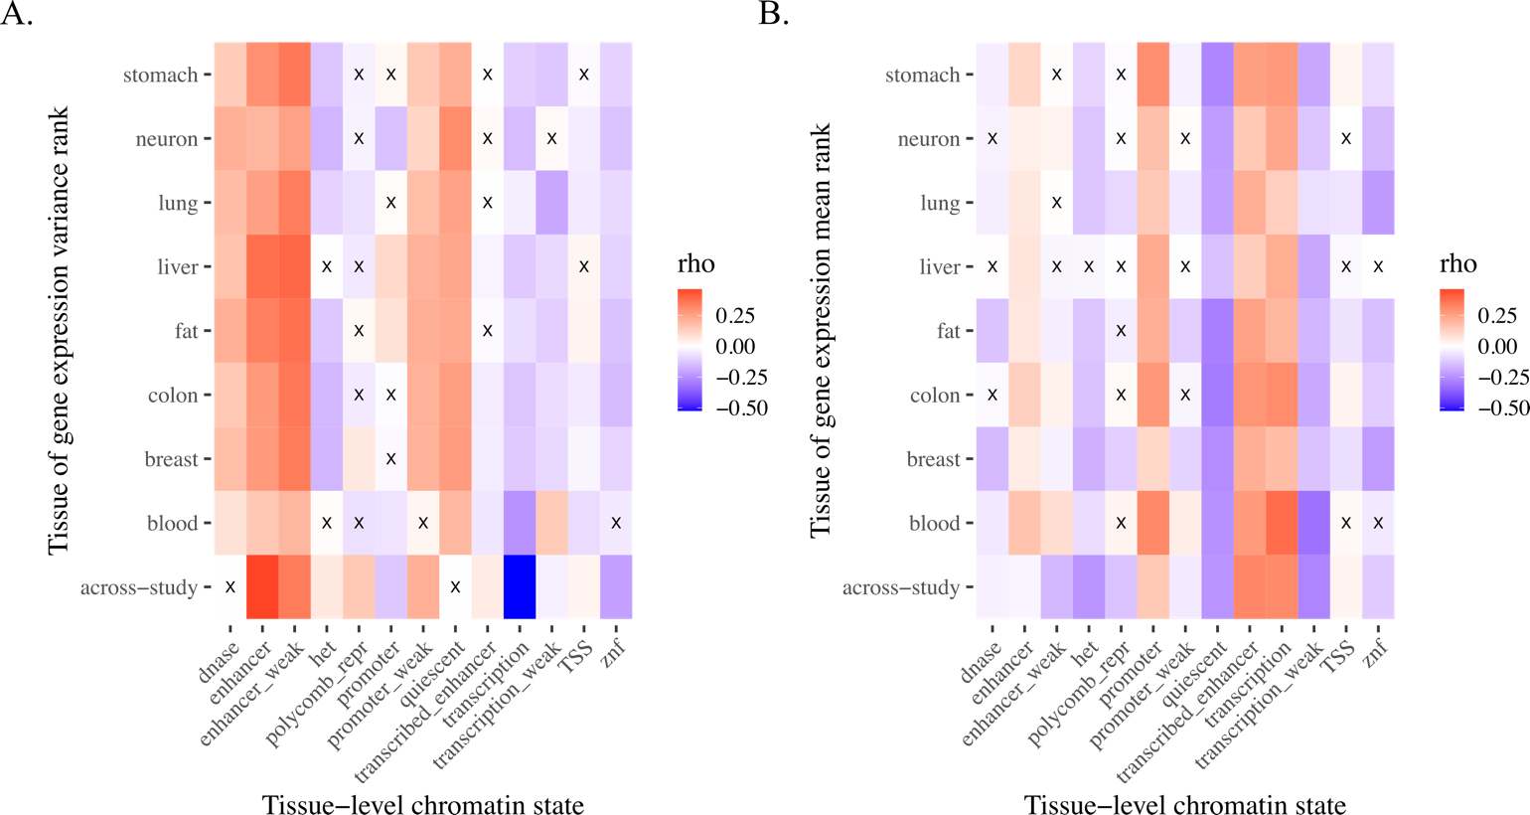

**Supplementary Figure 1. Across-study and tissue-specific gene expression variance and mean correlations with non-overlapping chromatin states through ChromHMM**1**.** The across-study variance (A) and mean (B) rank metrics (“across-study” on y-axis) were associated with universal chromatin states2 (x-axis). The tissue-level variance (A) and mean (B) rank metrics (see Methods; Supplementary Table 1; named tissues on y-axis) were associated with their respective tissue-specific chromatin states3 (x-axis, see Supplementary Table 1). Boxes marked with an “X” are not significantly correlated; all other comparisons are significant (Benjamini-Hochberg adjusted *p* < 0.05). Het indicates heterochromatin; TSS, transcription start sites; znf, zinc finger genes.

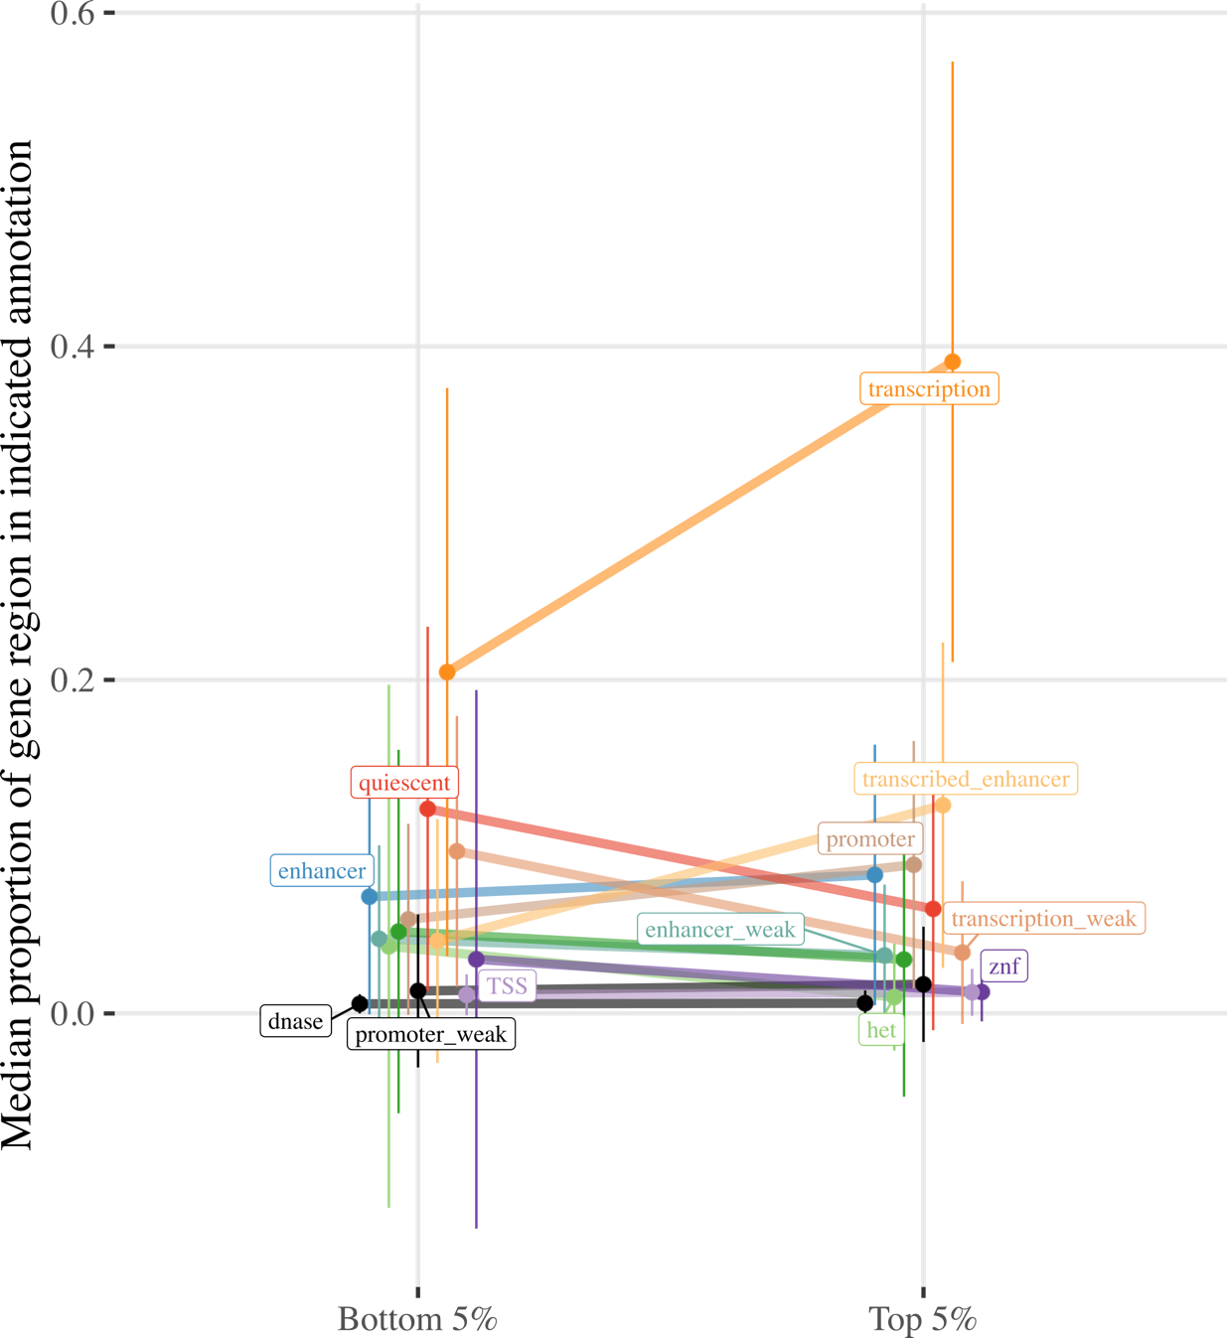

**Supplementary Figure 2. Proportion of gene regions made up of ChromHMM chromatin states for genes in the top and bottom 5% of the across-study mean rank metric.** Line plot contrasts the proportion of gene regions made up of the indicated chromatin states for genes in the top and bottom 5% of the across-study mean rank metric. Ends denote the median proportion of gene regions made up of the chromatin state, and error bars represent the standard error of the mean (SEM). States colored black are not significant, all others exhibit significant differences in gene region made up of the chromatin state for genes in the top and bottom 5% of the mean rank metric (Benjamini-Hochberg adjusted pWilcoxon < 0.05). Het indicates heterochromatin; TSS, transcription start sites; znf, zinc finger genes.

**Supplementary Figure 3. Scree plot on mean rank correlation matrix.**

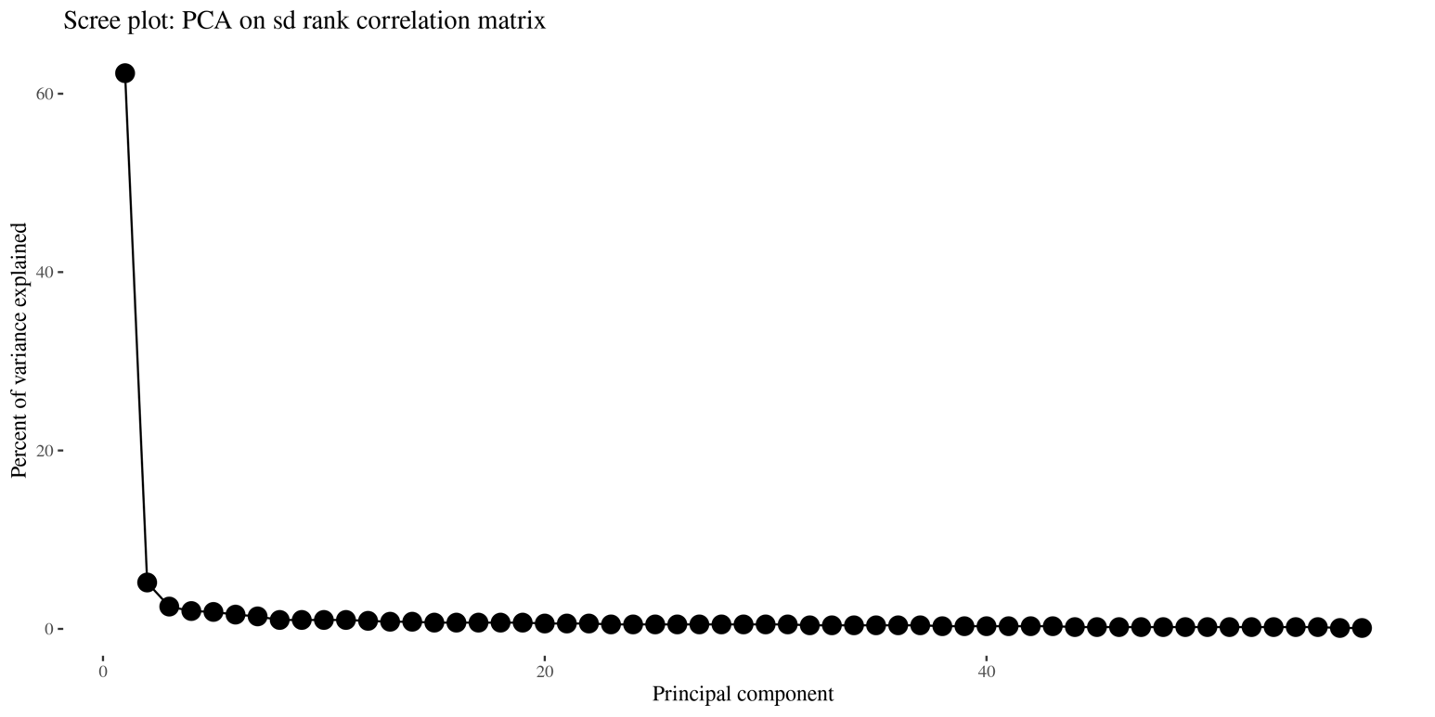

**Supplementary Figure 4. Scree plot on standard deviation rank correlation matrix.**

**Supplementary Table 1. Variance and mean rank metrics and the corresponding ChromHMM annotations used.**

|  |  |  |
| --- | --- | --- |
| **Variance/mean rank metric** | **ChromHMM annotation** | **Roadmap ID** |
| Across-study | Universal2 |  |
| Blood | Primary mononuclear cells from peripheral blood | E062 |
| Breast | Breast Myoepithelial Primary Cells | E027 |
| Colon | Sigmoid Colon | E106 |
| Fat | Adipose Nuclei | E063 |
| Liver | Liver | E066 |
| Lung | Lung | E096 |
| Neuron | H9 Derived Neuron Cultured Cells | E010 |
| Stomach | Stomach Smooth Muscle | E111 |

**Supplemental references**

1. Ernst, J. & Kellis, M. ChromHMM: Automating chromatin-state discovery and characterization. *Nature Methods* vol. 9 (2012).

2. Vu, H. & Ernst, J. Universal annotation of the human genome through integration of over a thousand epigenomic datasets. *Genome Biol.* **23**, 9 (2022).

3. Ernst, J. & Kellis, M. Large-scale imputation of epigenomic datasets for systematic annotation of diverse human tissues. *Nat. Biotechnol.* **33**, 364–76 (2015).