***Udemy – Git developer***

To login into GIT hub - <https://github.com/>

Bt Email  
Adesso****

Git -terms

Project = Repository

Working Directory  
Staging  
Commit  
  
Install Git

<https://git-scm.com/>

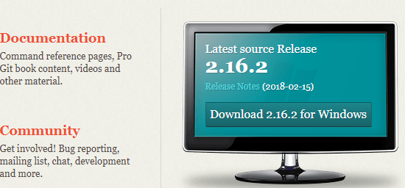

Download Git for windows

Open Git Bash in the list of programs – (click the windows button and search for the application)  
Search for Git bash from within windows

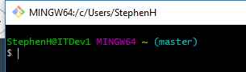

Enter  
git config --global user.name "steve"

git config --global user.email = [stephen.higgins3@btinternet.com](mailto:stephen.higgins3@btinternet.com)

To list config commands settings

Git config --list

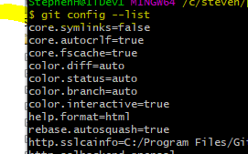

Current working directory type pwd

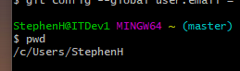

Change directory to a working folder cd /c/steveh/projects (Notice no colon required for c: drive)  
e.g. cd /c/development/gitFolder

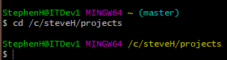

Make a new directory in projects folder called hello-world mkdir “Hello-World”  
probably better to make a folder called ‘Test’



Change directory to hello world



Now tell Git to track changes in this folder

Git init

To create a file type touch “index.html” (*For* this test I am using index3.html. Index.html is already there

Edit file and some text e.g. <h1>Hello world</h1>

Type Git status

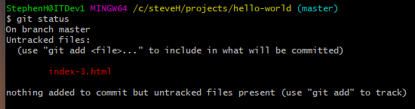

Add to the staging area

$ git add index-3.html

(use rm to remove a file from staging e.g. $ git rm --cached index3.html)  
(Reset does the same as rm but is easier to use $ git reset index3.html)

Type git status

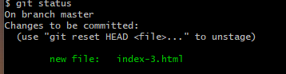

Commit file

$ git commit -m "my first commit"

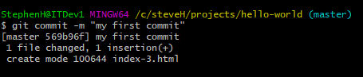

Type Git Status and there should be no files to check-in.

**Change file and save (index3.html).**

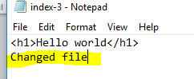

Enter Git status   
(name of file in red with the word ‘Modified’ next to it)

*To save the changes type (Adds to staging area)*  
git add index3.html (type git status to see file is green with the word modified next to it)

Commit changes   
$ git commit –m ‘Added some data’  
*(you can also specify a file name $ git commit –m ‘Added some data’ index3.html)*

Another way to commit is to use –a flag with commit. Using this flag you don’t need to include the staging step.

Step1 – make change to file  
~~step2 – git add index3.html~~

Step3 - git commit -a -m "test commit again"

**Revert back to the original file when changes have been made**

Make a change to a file and then type Git status (modified appears next to file)

$ git checkout -- . (Make sure you include the dot)

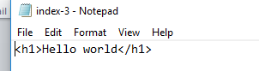

Notice file is back to original

Add a new file to the directory and type Git status or Git status steve2.txt

File name appears in RED

Add to staging git add . or git add ‘steve2.txt’

Go to the projects folder and type (Do this in GIT command line)

$ git clone <https://github.com/learnwebcode/welcome-to-git.git>

If look to the projects folder you now have a new folder called welcome-to-git

Open index.html in folder to view page.

Renaming a file

Type dir to list files

To change Steve .txt to steve1.txt type  
git mv -v steve.txt steve1.txt (-v is equal to verbose)

Create a Git Hub account – already have one called BT Email and Adesso password

Sign into Github

Create plus sign in top right corner and click ‘New Repository’

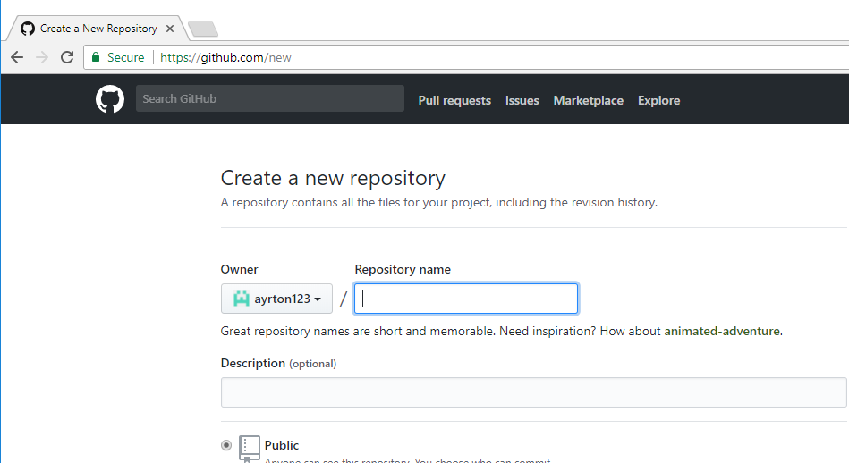

Enter a repository name and click create repository.

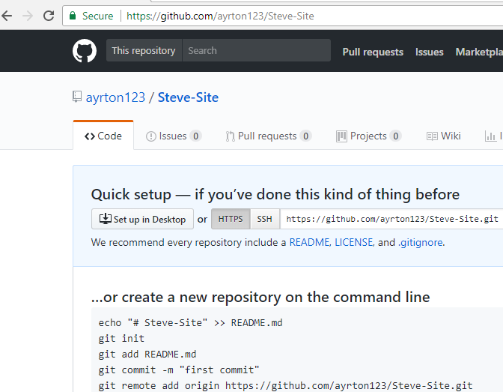

Go command line – navigate to projects folder  


Type git clone <https://github.com/learn>........ On the commad line



Rename folder from travel-site-files to Travel-site

Now you have some files for the project from the author – now push the files to your own repository on Github

Install Node.js

Go to Nodejs.org and choose the LTS version to download

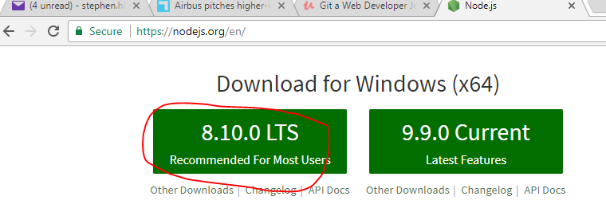

Then go to Command prompt and type node

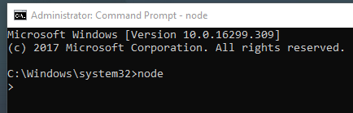

Start Git Bash if Git is not open

Change project to travel-site

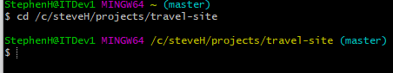

Now because the project was cloned from a previous destination if you tried to push the project it goes to its original destination.

*For the files for this project – they were retrieved from a github account – now those file will be used in my Git hub account*

Type   
git remote –v

This will give you the destination where the project will load files to

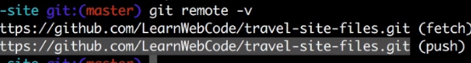

You need to tell it to push files to <https://github.com/ayrton123/travel-site.git>

Git remote set-url origin <https://github.com/ayrton123/travel-site.git>

git remote –v

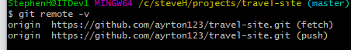

git push orgin master (master is branch name)

Add username and password

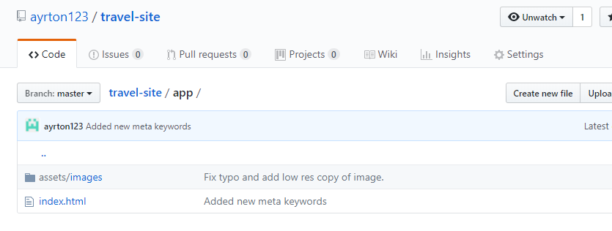

Make a trivial change to a file and uipload to GitHub

Change file Index.html in the project on your local PC



Type Git status

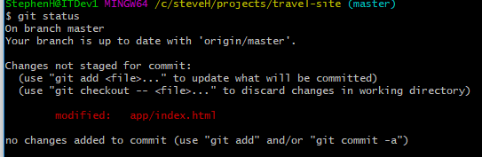

Notice one file has been modified

Need to stage changes

Git add –A

Git status

File has been staged so it I ready to be committed

git commit -m 'Updated index file'

git push origin master

In git hub

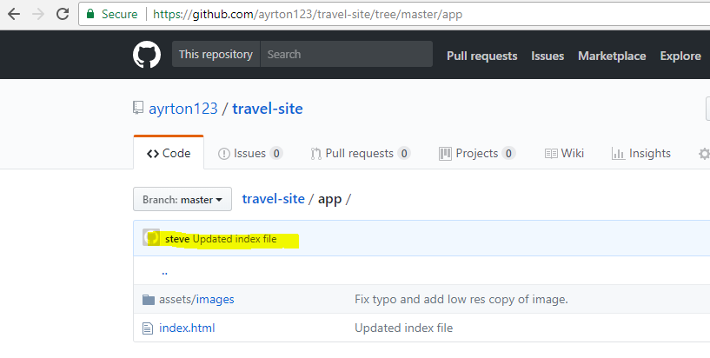

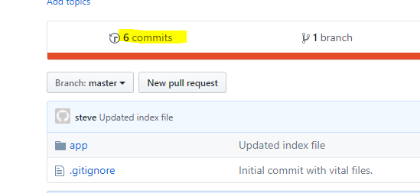

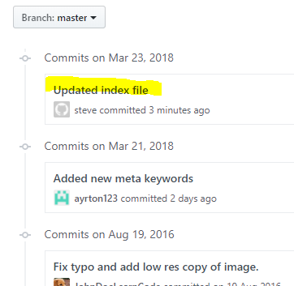

Git tutorial

From Youtube video - <https://www.youtube.com/watch?v=0fKg7e37bQE>

Go to github.com and create a new repository –NewGetTest

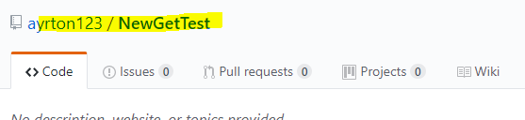

Get to your local pc – Clone

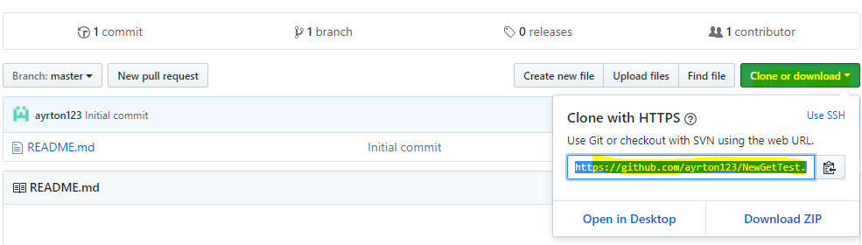

This will create a URL – this is the location of the repository.

Copy URL

Open Git Bash from windows menu

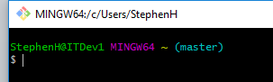

To locate current directory type pwd

Move to directory where files are to be located using the cd command



git clone https://github.com/ayrton123/NewGetTest.git

This will get files to your local directory

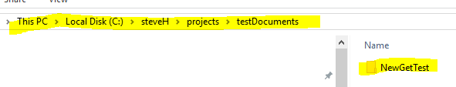

Now move to the new directory

Cd newGetTest



Create a new file called Index.html

