Math 2030 – Solutions to Assignment #2

1 (a) A bookstore has a draw for a $25 book certificate. Each customer draws a ticket from a bowl of 100 tickets. Only one of the tickets is a winning ticket and once the certificate is won, the draw is over. If the tickets are drawn with replacement, what is the probability that the winner is one of the first 10 customers?
Solution: Since the tickets are drawn with replacement, the probability of a winning ticket being picked on any draw remains constant and is 1/100. The repeated draws are also independent since this model is equivalent to flipping a coin with probability of heads = 1/ 100 and asking if the first head appears in the first 10 flips of the coin.
Method 1: Let A = event that a winner is chosen is one of the 1st 10 customers
Then A^{c} = event that no winner is chosen in the 1st 10 customers = event that 1st 10 draws are F (failures)
P(A) = 1 − P(A^{c}) and P(A^{c}) is easier to compute. Since the draws are independent (sampling with replacement), P(A^{c}) = (P(10 F's in a row) = (1/100)¹⁰, so that P(A) = 1 − (1/100)¹⁰.
The probability that the winner is one of the first 10 customers is 1 − (1/100)¹⁰.
Method 2: Since the model is a repeated S-F experiment, we can let X = # successes in 1st 10 draws.
Then the range of X is {0, 1, 2, …, 10} and 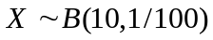, that is, X is Binomial with parameters
n = 10 and p = 1/100. While X is not our actual modeling variable (since we stop once the winner is found), the event P(X ≥ 1) = P(a winners in the 1st 10 draws). P(X ≥ 1) = 1 − P(X = 0) = 1 − (1/100)¹⁰ and
Method 3: Let X = draw on which the winner is drawn. Then the range of X is {1, 2, …, 200, …} [Note that the number of draws can exceed 100.] Let X_{i} = outcome on draw i and let P(X_{i}=1) = p so that
P(X_{i}=0) = q = 1 − p. In this example, p = 1/100. Then P(X= 1) = P(X₁ = 1) = p.
P(X= 1) = P(X₁ = 0, X₁ = 1) = qp, …, P(X= k) = P(X₁ = 0, …, X_{k−1} =0, X_{k} = 1) = q^{k−1}p
X is said to have the geometric distribution with parameter p.
P(X ≤ 10) = p+qp+q²p+…+q⁹p. This is the same as 1 − P(X > 10). P(X > 10) = q¹⁰p+q¹¹p +… which is the sum to infinity of a geometric series having common ratio q.
This sum (as we will show in class) can be computed easily and 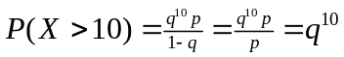. Thus
P(X ≤ 10) = 1 − q¹⁰ which in this problem is 1 − (1/100)¹⁰ so the probability that the winner is one of the first 10 customers is 1 − (1/100)¹⁰.

1.(b) If the tickets in part (a) are drawn without replacement, what is the probability that the winner occurs no later than the 99th customer?
Solution: 99 of the 100 tickets are non-winners ("L") while one ticket is a winner "W". However, when sampling without replacement, this is not a S-F experiment. Nor are the outcomes independent. For example, P(X₂ = X₃= … = X₁₀₀ =L| X₁=W) = 1. So how do we solve this problem?
Method 1: Consider the ordered 100-tuples of 99 Ls and 1 W. There are exactly 100 such 100-tuples since, once the L is placed in one of the positions 1 to 100, the remaining positions must be filled with Ls. Since the tickets are chosen at random, the one W is equally likely to be in any of the 100 positions so that the 100 100-tuples are equally likely. Only one of the 100-tuples has W in the 100th position, so that the probability that the winner occurs before the 100th draw is 99/100.
Method 2: Let A be the event that the winner occurs no later than the 99th draw.
Then P(A) = 1 − P(X₁₀₀= W)=1 − P(X₁ = X₂= … = X₉₉ =L)
P(X₁ = X₂= … = X₉₉ =L) = P(X₉₉ =L | X₁ = X₂= … = X₉₈ =L) P(X₁ = X₂= … = X₉₈ =L)
= ½ P(X₁ = X₂= … = X₉₈ =L) since at the 99th draw there are only two tickets left and each is equally likely to be drawn.
P(X₁ = X₂= … = X₉₈ =L) = P(X₉₈ =L | X₁ = X₂= … = X₉₇ =L) P(X₁ = X₂= … = X₉₇ =L)
= 2/3 P(X₁ = X₂= … = X₉₇ =L) since at the 98th outcome there are three tickets left, each is equally likely to be drawn, two of which are L and one of which is W
Continuing in this way we get
P(X₁ = X₂= … = X₉₉ =L) =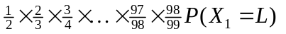Now at the 1st draw, 99 of the tickets are L out of 100 tickets and since each is equally likely, P(X₁ = L) = 99/100.
Thus P(X₁ = X₂= … = X₉₉ =L) =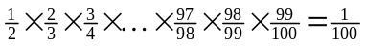 so P(A) = 1 − 1/100 = 99/100, that is, the probability that the winner occurs before the 100th draw is 99/100.
Method 3: We could have started with P(X₁ = L) = 99/100 since all the tickets are equally likely and 99 of the outcomes are L. since given X₁=L, there are 98 L tickets out of 99 tickets left and all tickets are equally likely to be chosen in the 2nd draw.
Proceeding in this way (use math induction) P(X₁ = X₂= … = X₉₉ =L) = 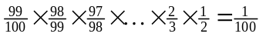 so that P(A) = 1 − 1/100 = 99/100, that is, the probability that the winner occurs before the 100th draw is 99/100.

2. (a) What is the outcome space O for problem # 1. Is the outcome space different for parts (a) and (b)?
For part (a), O = {1, 2, 3, …} = strictly positive integers where the outcome is the number of the draw on which the winning ticket is drawn. This is the true outcome space
For part (b), O = {1, 2, 3, …, 100} where the outcome is the number of the draw on which the winning ticket is drawn.
Yes, the outcome spaces are different since in part (b) the draw on which the winning ticket is drawn is ≤100 while in part (a) there is no upper bound on when the winning ticket is drawn.

2. (b) Describe the probability space (Ω, ℑ, P), that is, the sample space Ω, the event space ℑ, and the probability measure P you used in 1(a) and 1(b) above.
For part (a), we may take Ω = {(a₁, a₂, …): a_{i} = W or a_{i} = L for each i }. ℑ ≠ ℘(Ω) for reasons beyond this course. However, when we consider Ω_{n} = {(a₁, a₂, … a_{n}): a_{i} = W or a_{i} = L for each 1 ≤i ≤n}, then ℑ_{n} is ℘(Ω). For methods 1 and 2 on the restricted sample space Ω₁₀, P is the probability measure for 10 S-F experiments with success parameter p = 1/100 so the probability measure is the Binomial distribution with parameters n = 10, p = 1/100.

For part (b), we took Ω = {(a₁, a₂, …, a₁₀₀): exactly one a_{i} = W for some 1 ≤ i ≤ 100 and a_{j} = L for j ≠ i }
ℑ = ℘(Ω) and P is equiprobable measure, that is, P({(a₁, a₂, …, a₁₀₀)}) = 1/100.

3. (a) p. 45 # 4
Let (Ω, ℑ, P) be our probability space and let A and B be the independent events with P((A) = 0.1 and P(B) = 0.3. The event that A does not occur is A^{c} . The event that B does not occur is B^{c}.
Therefore the event that neither A nor B occurs is A^{c}∩B^{c}, so we need to compute P(A^{c}∩B^{c}).
Method 1(fairly long):
Using DeMorgan's Law, A^{c}∩B^{c} = (A∪ B)^{c}, so P(A^{c}∩B^{c})=P((A∪ B)^{c}).
P(A∪ B)+ P((A∪ B)^{c}) = P(Ω) = 1 so P(A^{c}∩B^{c}) = 1 – P(A∪ B)
But P(A∪ B) = P(A) + P(B) – P(A∩B). Hence P(A^{c}∩B^{c}) = 1 – P(A) – P(B) + P(A∩B).
Note that up to this point we have not used independence of A and B so the computations hold for any events A and B.
Since A and B are independent, P(A∩B) = P(A)∙P(B) = (0.1)∙(0.3) = 0.03.
Hence P(A^{c}∩B^{c}) = 1 – P(A) – P(B) + P(A∩B) = 1 – 0.3 – 0.1 + 0.03 = 0.63
Therefore the probability that neither event occurs is 0.63.
Method 2 (a little shorter):
Since A and B are independent, P(A∩B) = P(A)∙P(B) = (0.1)∙(0.3) = 0.03
Now P(A∪ B) = P(A) + P(B) – P(A∩B) = 0.1 + 0.3 − .03 = 0.37
Also P(A∪ B) + P((A∪ B)^{c}) = P(Ω) = 1 so that P((A∪ B)^{c}) = 1 − P(A∪ B) = 1 − 0.37 = 0.63
Therefore the probability that neither event occurs is 0.63.
Method 3 (even shorter except that an additional proposition must be proved):
A and B independent imply that A^{c} and B^{c} are independent. (This needs proof.)
Hence P(A^{c}∩B^{c}) = P(A^{c})∙P(B^{c}) = (1−P(A)) (1−P(B)) = (1−0.1)(1−0.3) = (0.9)(0.7) = 0.63
Therefore the probability that neither event occurs is 0.63.
(We still need to prove that A and B independent implies that A^{c} and B^{c} are independent. Intuitively it makes sense: knowing B or B^{c} is the same since if one is given B, then one is given B^{c} and vice versa. Hence, if A^{c} and B^{c} are not independent, then A^{c} and B are not independent. But if knowing B changes the likelihood of A^{c}, then it changes the likelihood of A given B since A and A^{c} determine each other. A formal proof follows:
We first show that if A and B are independent, then A and B^{c} are independent.
P(A∩B) + P(A∩B^{c}) = P(A) so P(A∩B^{c}) = P(A)− P(A∩B)
Since A and B are independent, P(A∩B)=P(A)P(B)
Hence P(A∩B^{c}) = P(A)−P(A)P(B)=P(A)(1-P(B)) = P(A)P(B^{c}) so that A and B^{c} are independent.
Apply this result to the two independent events B^{c} and A gives B^{c} and A^{c} are independent
.
4(b) (setup as in 4(a): Method 1:At least one of the events occur is the complement of the event that neither occur so we want P((A^{c}∩B^{c})^{c}) = 1 −P(A^{c}∩B^{c}) = 1.63 =.37
Method 2: A∪B is the event that either A or B occurs (“at least one”) so we want to compute P(A∪B) = P(A) + P(B) − P(A∩B) = P(A) + P(B) − P(A)P(B) by the independence of A and B.
Substituting for P(A) and P(B) gives P(A∪B) = .1 +.3 − (0.1)(0.3) = 0.37
4(c) Method 1: “Exactly one of the events occurs” means A or B but not A and B so we want
P(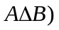= P((A−B)∪(B−A)) = P(A−B)+P(B−A) since (A−B) and (B−A) are disjoint. Hence P(= P(A∩B^{c}) + P(B∩A^{c}) =P(A)P(B^{c}) + P(B)P(A^{c}) since the prop. above showed that A and B^{c}, and B and A^{c} must also be independent.
Hence P(= (0.1)(0.7) + (0.9)(0.3) = .07 + .27 = .34
Hence the probability that exactly one of the events occurs is 0.34.
Method 2: : “Exactly one of the events occurs” means A or B but not A and B which is (A−B)∪(B−A) so we want P((A−B)∪(B−A)) = P(A−B)+P(B−A) since (A−B) and (B−A) are disjoint. Now (A−B)∪(A∩B) = A and form a partition of A, so that P(A) = P(A−B) + P(A∩B).
Hence P(A−B) = P(A) − P(A∩B) = P(A) −P(A)P(B) since A and B are independent.
Similarly P(B−A) = P(B) − P(B)P(A).
So P(A−B) = 0.1 −(0.1)(0.3) = 0.1−.03 = .07 and P(B−A) = 0.3−(0.3)(0.1) = 0.3−.03 = 0.27.
Therefore, P((A−B)∪(B−A)) = 0.27 + 0.07 = 0.34.
Hence the probability that exactly one of the events occurs is 0.34.

3. (b) p. 46 # 6
Let Ω = {(c₁,c₂): c₁ and c₂ are the first two cards drawn from a deck of 52 cards}
Let ℑ = ℘(Ω) = power set of Ω = all subsets of Ω
P({(c₁,c₂)} = (1/52) (1/51) for any two cards drawn (without replacement)
Let B be the event that the first card drawn (c₁) is black.
Let S be the event that second card drawn (c₂) is a spade.
We are asked to find 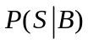. Let C be the event that the second card drawn is a club and let R be the event that the second card drawn is red.
Method 1: + 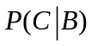+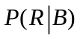= 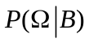= 1. The probability of drawing a spade or a club (both black cards) given that the first card is black is the same by symmetry. Also we can easily compute = 13/51 since there are 13 red cards out of the remaining 51.
[Formally: 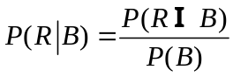. P(B) = 26/52 = ½ (It is equally likely to pick either color on the first draw.) P(R∩B) = 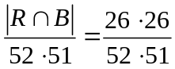= ½ (26/51).
So 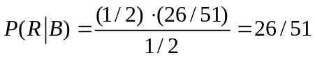]
Hence 2+26/51=1 which implies that 2=25/51; i.e. = 25/102.
Method 2(direct): 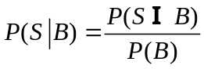 . The probability of a black card on the first draw is computed as follows: # different ways of drawing a black card on the first draw is 26. Each of these possible draws has probability 1/52, so P(B) = 26/52 = ½.
# of possible outcomes in the two draws is 52 x 51 since we are sampling without replacement.
Let B₁ and B₂ be the events that that the black card drawn on the first draw is a club and spade respectively. Then B = B₁∪B₂ where B₁ and B₂ are disjoint.
Then P(S∩B) = P(S∩(B₁∪B₂)) = P((S∩B₁)∪(S∩B₂)) = P(S∩B₁)+P(S∩B₂).
#ways of getting a club on the first draw and a spade on the second is 13 x 13 (using the Fundamental Method of Counting). Hence P(S∩B₁) = (13∙13)/(52∙51) = ¼∙(13/51)
#ways of getting a spade on the first draw and a spade on the second is 13 x 12 (using the Fundamental Method of Counting). Hence P(S∩B₁) = (13∙12)/(52∙51) = ¼∙(12/51).
Hence P(S∩B) = ¼∙13/51 + ¼∙(12/51) = ¼∙(13/51 + 12/51) = ¼∙(25/51) so
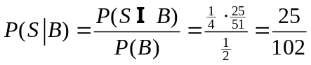

4. (a) p. 53 # 4
(a) Method 1: Use Bayes’ Rule.
Let (Ω,ℑ,P) be a probability space. The events T₀, T₁ form a partition of Ω. We are given
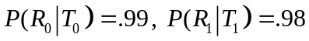, and P(T₁) = 0.5. Given R₁ (receiver concludes that a 1 was sent), a transmission occurs if 0 was actually sent, namely T₀. So we want 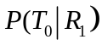. By Bayes’ Rule,
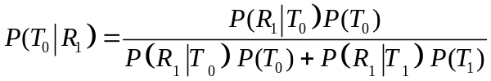
and P(T₀) = 1 − P(T₁) = 1 − 0.5 = 0.5 so
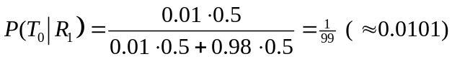
The probability of a transmission error given R₁ is 1/99 which is approx. 0.0101
(b) An error in transmission occurs when a 0 is sent and received as a1, or when 1 is sent and is received as a 0, which is (T₀∩R₁)∪ (T₁∩R₀) which is the union of disjoint sets.
Hence P((T₀∩R₁)∪ (T₁∩R₀)) = P(T₀∩R₁)+P(T₁∩R₀).
Now P(T₀∩R₁) = 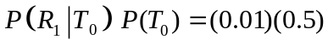 and
P(T₁∩R₀) =
so P((T₀∩R₁)∪ (T₁∩R₀)) = (0.01)(0.5) + (0.02)(0.5) = (0. 5)(.03) = 0.015
The probability of an error in transmission is 0.015.
(c) Now suppose P(T₁) = 0.8 so that P(T₀) = 1−0.8 = 0.2. For Part (a)
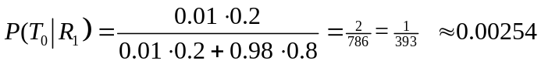
The probability of a transmission error given R₁ is 1/393 which is approx.0.00254.
For the overall transmission error, we need to compute
P((T₀∩R₁)∪ (T₁∩R₀)) = 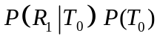 + 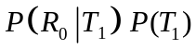
= (0.01)(0.2) + (0.02)(0.8) = 0.002 + 0.016 = 0.018
The probability of an error in transmission is 0.018.
(Note that the probability of a transmission error has increased when P(T₁) is increased from 0.5 to 0.8. This occurs because the reliability of transmission of a 0 is grater than the reliability of transmission of a 1 − 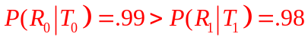)
#4 (Method 2) can also be solved using a Tree Diagram: (Please note that I have drawn the tree upside down but it does not really matter which direction one draws the tree.)
Root
T₀
0 is transmitted.
P(T₀)
0.5
T₁
A 1 is transmitted.
P(T₁)
0.5
R₀
0 is received

0.99
R₁
1 is received

0.98
R₀
0 is received

= 0.02
R₁
1 is received

0.01

“Given R₀” means we are only concerned with the innermost two branches. Those two branches have total probability (.5)(.01) +(.5)(.98). “T₀ given R₁” is possible only on the left of those two branches, that is P(T₀∩R₁) = (.5)(.01). Hence

The overall transmission error is obtained by calculating the probability of the paths on which an error occurs, in this case, (from the left) the 2nd and the 4th. The 2nd path is an error in transmission since 0 is transmitted and 1 is received. The 4th is an error in transmission since 1 is transmitted and 0 is received.
The probability of these paths is (.5)(.01) + (.5)(.02) = (.5)(.01+.02) = (.5)(.03) = .015
When P(T₁) = 0.8, the only changes that need to be made to the tree are to change the probability values along the first level of the tree.
4. (b) p. 71 # 8b, c
Method 1: For the events B₁₂, B₂₃, and B₁₃ to be mutually independent, the events B₁₃ and (B₁₂∩B₂₃) must be independent. (Proof?)
Now B₁₂∩B₂₃ is the event that persons 1 and 2 have the same birthday AND that persons 2 3 have the same birthday which means that all three persons have the same birthday.
Hence 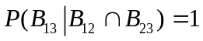.
#ways person 3 can have the same birthday as person 1 is 1. Hence P(B₁₃) = 1/365
so P(B₁₃) = 1/365≠ 1 = 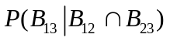
Hence the events B₁₂ , B₂₃ and B₁₃ are not mutually independent.
Method 2: B₁₂∩B₂₃∩ B₁₃ is the event that all 3 persons have the same birthday.
# possible outcomes = 365∙365∙365 (using the Fundamental Method of Counting)
First person’s birthday can be any of 365 days.
For each of these ways, 2nd person can have only 1 day
For each of all of these ways, 3rd person can only have 1 day
So total # ways is 365∙1∙1 for all 3 persons to have same birthday.
Hence P(B₁₂∩B₂₃∩ B₁₃) = [365∙1∙1]/ (365)³ = 1/365²
As above for B₁₂, # days for person #1 is 365
For each of these ways, only day possible for person #2.
So, by the Fundamental Method of Counting, 365∙1 is the total # ways for B₁₂ to occur.
Total possible outcomes for person #1 and 2 is 365∙365 so P(B₁₂) = [365∙1]/365² =1/365.
Hence P (B₁₂∩B₂₃∩ B₁₃) = 1/365² ≠ 1/365³ = P(B₁₂) P(B₂₃) P(B₁₃)
Hence the events B₁₂ , B₂₃ and B₁₃ are not mutually independent.
.
c) As above , P(B₁₂)=P(B₂₃)=P(B₁₃)=1/365. Also the intersection of any pair of the sets B₁₂ , B₂₃ and B₁₃ is the event that all 3 persons have the same birthday. The latter probability was calculated above to be 1/365². The product of the probabilities of any pair e.g. P(B₁₂)P(B₁₃) is also 1/365² so the probability of the intersection of any pair is the product of the probabilities and so the events are pairwise independent.
(Note: The above makes sense intuitively −and this intuition can be turned into a formal proof. Consider B₁₂ given B₂₃. The fact that persons 2 and 3 have the same birthday has no influence on whether or not person 1 has the same birthday as persop5n 2 since person 1’s birthday can still be any one of 365 days.)

5. (a) p. 74 # 6
(The proof was given in the comments in #3a.)
We first show that if A and B are independent, then A and B^{c} are independent.
P(A∩B) + P(A∩B^{c}) = P(A) so P(A∩B^{c}) = P(A)− P(A∩B)
Since A and B are independent, P(A∩B)=P(A)P(B)
Hence P(A∩B^{c}) = P(A)−P(A)P(B)=P(A)(1-P(B)) = P(A)P(B^{c}) so that A and B^{c} are independent.
Reversing the roles of A and B to B and A gives B and A^{c} are independent.
So we have shown that if A and B are independent, then A and B^{c} are independent and A^{c} and B are independent.
Apply the first result to the two independent events B^{c} and A gives B^{c} and A^{c} are independent.

5 (b) p. 91 # 10
10(a) Let A be the event that exactly k−1 heads occur in n tosses.
Let B be the event that exactly k heads occur in n tosses.
We want a simple formula for 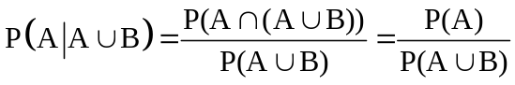 since A and B are disjoint, that is, A∩B = φ (the empty set). The latter also implies that P(A∪B) = P(A) + P(B) and hence
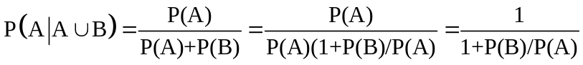
P(B)/P(A) is just R(k) (see p. 85 Pitman), namely the ratio of two successive values for the Binomial distribution, with p=q= ½ since the coin is fair which equals (n−k+1)/k . Therefore
(If you did not remember the formula for R(k), you could have computed it:

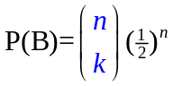 while 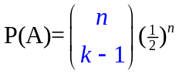 so that P(B)/P(A) = 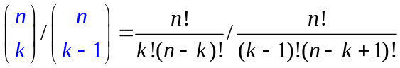
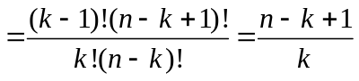

10(b) We are asked to compute 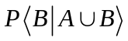
Method 1: proceed as in part (a): 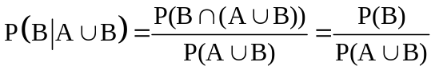 since A and B are disjoint, that is, A∩B = φ (the empty set). The latter also implies that P(A∪B) = P(A) + P(B) and hence
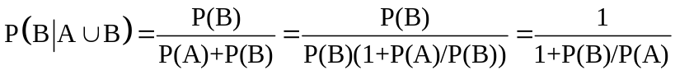
P(B)/P(A) is just R(k) (see p. 85 Pitman), namely the ratio of two successive values for the Binomial distribution, with p=q= ½ since the coin is fair which equals (n−k+1)/k . Therefore
Method 2(much shorter and preferred method): since A and B are disjoint. But 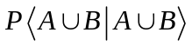 = 1 so that 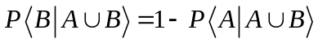. We already calculated 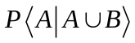 in part 10{a) so 

