YORK UNIVERSITY

Faculty of Liberal Arts and Professional Studies – Faculty of Science and Engineering
Class Test I
October 5, 2010

Mathematics 2030 A 3.0F
Elementary Probability

NAME: ________________________ __________________________________(PLEASE PRINT)
(Family Name) (Given Name)

By signing your name, you affirm that you are registered in the course. You also acknowledge that cheating on an examination, including impersonation, is a breach of academic honesty and is punishable under the regulations of the senate of the university
No. | Value | Grade
1 | 8
2 | 2
3 | 10
4 | 2
5 | 14
6 | 14
Total | 50
SIGNATURE: ____________________________________________

STUDENT NUMBER: _____________________________________

PHOTO ID TYPE:_________________________________________
NUMBER _______________________________________________
Acceptable forms of photo identification include:
(1) York University ID (preferred)
(2) Ontario driver's licence
(3) Citizenship Card
(4) Passport
(5) Age of Majority Card
TTC passes are not acceptable.

Instructions:
1. This is a 50 minute closed book examination.
2. No calculator is permitted. Sharing of material (including pens) is NOT allowed.
2. The exam consists of 4 pages, in addition to this cover sheet.
3. The exam has 6 questions that everyone must answer.
4. No cell phones or other wireless device may be on your person and must be turned off.

It is your responsibility to ensure that your exam paper is complete. If you are not certain that you have received a complete examination, please ask one of the invigilators for assistance.

Use the following Venn Diagram in answering problem #1.
(Ω, ℑ, P) is a probability space and A, B, and C are three events. The sets D, E, F, G, H, I, J and K label the disjoint regions of Ω arising from A, B and C.
Ω
C
G
E
F
H
J
I
A
B
D
K

1. ANSWER ONLY – no supporting work required. Provide a formula for the requested region in terms of the events D, E, F, G, H, I, J and K ONLY. Your answer must be simplified as much as possible.
a. (2 marks) (A∪B^{c}∪C^{c})^{c}__I______________________________________________
b. (2 marks) "a partition of Ω " ___{D, E, F, G, H, I, J, K}______________________
For parts (c), (d): A coin (H or T) is tossed three times. Let A be the event that the coin lands H on the 1st toss, B be the event that the coin lands H on the 2nd toss, and C be the event that the coin lands H on the 3rd toss.
c. (2 marks) "the coin lands H on at most two of the tosses" D∪E∪F∪G∪H∪I∪K
[also accept J^{c} for full points]
d. (2 marks) P(J) if P(A) =1/3 and the tosses are independent 1/3×1/3×1/3=1/27_______
2. (2 marks) Which ONE of the following statements is TRUE?
(A) If A and B are events, then A ∪ B must always be an event, but it is possible that
A^{c} ∩B is not an event.
(B) The outcome space is O is never equal to the sample space Ω.
(C) The event space is always a collection of subsets of the sample space Ω, but not necessarily all subsets of Ω.
(D) The event space should always be used as the sample space.
pc +1 (E) None of (A) through (D) is true.
3a. (5 marks) P(A) = 0.2 and P(B) = 0.3; What value of P(A∪B) ensures that A and B are disjoint?
If A and B are disjoint, then P(A∪B) = P(A) + P(B).
In this case P(A∪B) = 0.2 +0.3 = 0.5 so take P(A∪B) 0.5
If A and B are not disjoint, then P(A∪B) = P(A) + P(B)−P(A∩B) = P(φ) = 0
Hence 0.5 = 0.2 +0.3 − P(A∩B) so that P(A∩B) = 0.
From a probability point of view, this means that A and B are disjoint (even though from a set theoretic point of view, there may be points common to A and B).

3b. (5 marks) P(A) = 0.2 and P(B) = 0.3; What value of P(A∪B) ensures that A and B are independent?
P(A∪B) = P(A) + P(B)−P(A∩B) = 0.2 + 0.3 −P(A∩B) = 0.5 − P(A∩B)
If A and B are independent, then P(A∩B) = P(A)P(B) = 0.2 × 0.3 = 0.06 so in this case
P(A∪B) = 0.5 − .06 = 0.44 Take P(A∪B) = 0.44 .
Then 0.44 = 0.5 − P(A∩B) so P(A∩B) = 0.5 − .44 − = 0.06 = 0.2 × 0.3 = P(A)P(B)
Hence A and B are independent.

4. (2 marks) Competitors in the Long-Life Marathon are known to have probability .4 of completing the race. If this year's race has 36 competitors, then which ONE of the following statements is FALSE?
(A) The probability that exactly 12 finish the race is 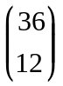(.4)¹²(.6)²⁴.
(B) The results of the 36 competitors are pairwise independent.
(C) This can be viewed as 36 repeated, independent, success-failure experiments, each experiment having probability .4 of success.
pc +1 (D) The probability that exactly 12 finish the race is 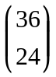(.4)¹²(.6)²⁴.
(E) None of (A) through (D) is false.
5. A 6 person jury is selected randomly from a pool of a mixture of 10 men and 10 women. The judge is concerned about gender bias and asks a statistician if having exactly 1 man on the jury is an unlikely outcome.
5a. (3 marks) What is the outcome space O and the event space for this problem?
The outcomes are the number of men on the jury so O = {0, 1, 2, … , 6}.
The event space is ℘(O) = power set of O = {A: A  O}.

Question 4 cont'd. …
5b. (4 marks) Let X denote the number of men on the jury and let Y denote the number of women on the jury. Calculate P(X =1). Show your work.
[An aside: This problem is like the problem of getting a particular hand from a deck of cards only here there are only 20 cards and only two suits, men and women. To solve this problem, we need to define the sample space Ω and the event space ℑ. We could take Ω to be the space of all 6 person juries which can be made from the ten men and ten women. More formally,
let M = {m₁, m₂, … , m₁₀}, W = {w₁, w₂, … ,w₁₀} and define the probability space
Ω = [{a₁, a₂, a₃, a₄, a₅, a₆}: a_{i} ≠ a_{j} if i ≠ j and a_{i} εM∪W}, ℑ = ℘(Ω), and P is equiprobable probability. In other words, Ω is the space of all possible juries from the 20 people.]
We consider the sample space of all possible juries from the 20 (distinguishable) people.
The event {X=1} is the event that exactly 1 man and 5 women are on the jury.
The 1 man on the jury can be chosen in 10 ways.
For each of these ways, the 5 women can be chosen in 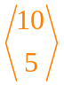ways.
By the Fundamental Theorem of Counting, both operations can be done in 10 ways.
From part (d), the total number of juries is 120 × 19 × 17 and since the outcomes are equiprobable
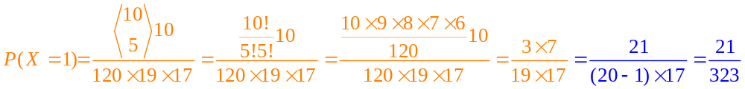
5c. (4 marks) Calculate P(X < Y). What is the event {X < Y} in terms of the jury selection?
Let p =P(X < Y). Since the results are equiprobable and the jury pool of women is the same number as the jury pool of men, P(X < Y) = P(Y < X) =p. The three event {X < Y}, {Y < X} and {Y=X} form a partition of the sample space so that 2p + P(X = Y) = 1.
The event {X= Y} is the same as the event {X = 3, Y =3} since X + Y = 6.
The number of juries with exactly 3 men ( and 3 women) can be computed as in part (a) and is
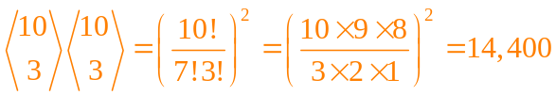. Each of these outcomes has probability 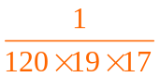 so P(X = Y) = 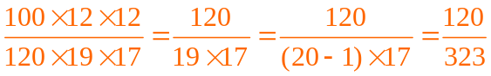
Hence 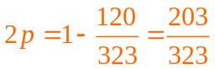 so 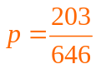
Therefore, P(X < Y) = 203/646 .

5d. (3 marks) How many different juries could be made from the jury pool?
There are 20 different people from which we must select 6 so the number of juries is 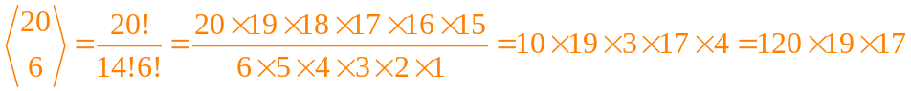
[An aside: 10×19×3×17×4 = 10×[(20−1)×17]×12 = 10×[340−17]×[10+2] = 10×323[10+2]
= 10×323×10 + 10×323×2 = 32,300 + 6,460 = 38,760 no calculator needed!]
The number of possible juries is 120 × 19 × 17 [which is 38,760].
6. Ten cards are dealt from a well shuffled 52 card deck.
6a. (5 marks) What is the probability that of these 10 cards, exactly 5 will be hearts and 4 will be aces? Show your work.
All sets of 10 cards from the 52 card deck are equiprobable. There are 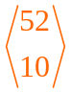 different sets of 10 cards from the 52 card deck. Each set has probability 1/. Let A = the event that, of the ten cards, exactly 5 are hearts and let B = the event that, of the ten cards, exactly 4 are aces
We want to find P(AB) so we need to calculate the cardinality of AB. We do this by constructing all possible 10 card sets (hands) from the 52 card deck which have exactly 4 aces and 5 hearts.The number of ways of choosing the 4 aces is 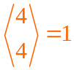. We note that one of the aces is a heart so of the remaining 12 hearts we must choose exactly 4 which can be done in 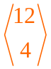 ways. For each of these ways, the remaining 2 cards may be chosen from (52–4–12)= 36 cards in 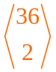 ways. By the Fundamental Principle of Counting, the total number of ways is 1 ways. P(AB) = 1×× / [full marks]= 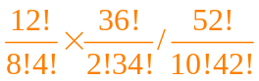
=11∙10∙9²∙35∙13∙17∙7∙47∙23∙5∙44∙43 [the last two step is NOT necessary for full marks]
6b. (5 marks) Describe a probability space (Ω, ℑ, P) on which your answer to part (a) could be based. Let the deck D = {S1,S2, …,S13; C1,C2, …C13; H1,H2, …, H13; D1,D2, … D13}] Let Ω =[{a₁, a₂, …, a₁₀}: a_{i} ≠ a_{j}, for i ≠ j and a_{i} εD for i = 1, 2, … , 10]. ℑ = ℘(Ω) and P is equiprobable measure. [There are other ways of describing this space and other answers.]
6c. (4 marks) If we are told that, of the 10 cards, two of the cards are the ace of spades and the king of hearts, calculate the probability that, of the 10 cards, exactly 5 will be hearts and 4 will be aces. Ω*=[{S1,H13, a₁,a₂, …, a₈}: a_{i} ≠ a_{j}, for i ≠ j , a_{i} εD for i = 1,2,…,10]
[This is the restricted sample space of 10 card hands having the ace of spades and the king of hearts.] We calculate |Ω*|. The number of cards remaining in the deck is 50 from which we choose 8. This can be done in 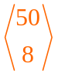ways. Since each of the outcomes in Ω* are equiprobable, each outcome has probability 1/. We calculate |AB∩Ω*|. The remaining 3 aces must be in the hand so we can choose them in only 1 way. Of the remaining 11 hearts, we must choose exactly 3 (since KH and AH are already in the hand) which can be done in 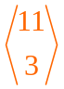 ways. The last 2 cards may be chosen from the remaining (52−4−13) = 36 in ways. By the Fundamental Theorem of Counting, |AB∩Ω*| = 1 so that the P_{Ω*}(A∩B) = /

