|  |  |
| --- | --- |
| AutoML Modeling Report |  |

*AYŞE DEMİREL*

Binary Classifier with Clean/Balanced Data

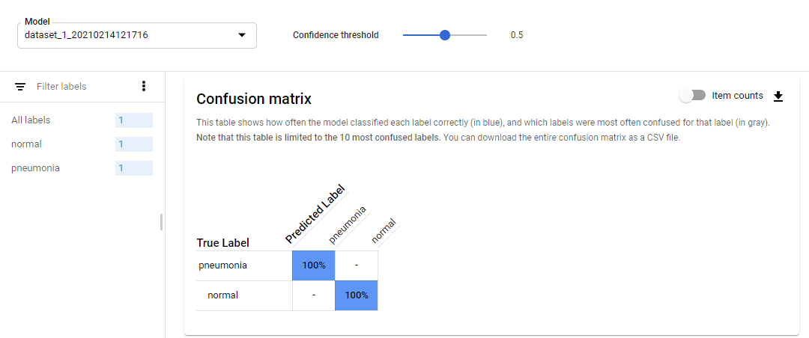

|  |  |
| --- | --- |
| **Train/Test Split**  How much data was used for training? How much data was used for testing? | Totaly, there was 200 images, 180 images were used for training and 20 images were used for testing. |
| **Confusion Matrix**  What do each of the cells in the confusion matrix describe? What values did you observe (include a screenshot)? What is the true positive rate for the “pneumonia” class? What is the false positive rate for the “normal” class? | Label : Pneumonia, Normal  TP = %100  FP = %100 |
| **Precision and Recall**  What does precision measure? What does recall measure? What precision and recall did the model achieve (report the values for a score threshold of 0.5)? | Precision measures the ratio of TP to predicted positives. Recall measures the ratio of TP to actual positives. Precision and recall values are %100 for the score threshold of 0.5 |
| **Score Threshold**  When you increase the threshold what happens to precision? What happens to recall? Why? | When I increased the threshold until 1, the recall value decreased(%65) and the precision value unchanged. The recall value decreased because the expectation of the truth increased so the TP value decreased. |

Binary Classifier with Clean/Unbalanced Data

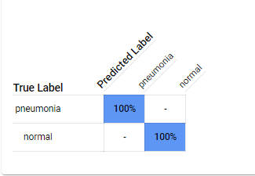

|  |  |
| --- | --- |
| **Train/Test Split**  How much data was used for training? How much data was used for testing? | Totaly, there were 400 images, 100 images were normal label, 300 images were pneumonia label. 40 items used for testing and 360 items used for training. |
| **Confusion Matrix**  How has the confusion matrix been affected by the unbalanced data? Include a screenshot of the new confusion matrix. | Not affected. Actually, it was an unexpected result for me. Test data is also unbalanced, so the result is same. |
| **Precision and Recall**  How have the model’s precision and recall been affected by the unbalanced data (report the values for a score threshold of 0.5)? | Same. |
| **Unbalanced Classes**  From what you have observed, how do unbalanced classed affect a machine learning model? | When threshold value incereased, the recall value decreased. When threshold value is 1, recall value %0. Accuracy affected from unbalanced classed. |

Binary Classifier with Dirty/Balanced Data

|  |  |
| --- | --- |
| **Confusion Matrix**  How has the confusion matrix been affected by the dirty data? Include a screenshot of the new confusion matrix. | Totaly, there were 200 images. 100 normal and 100 pneumonia. Switched the labels of 30 images in each class. |
| **Precision and Recall**  How have the model’s precision and recall been affected by the dirty data (report the values for a score threshold of 0.5)? Of the binary classifiers, which has the highest precision? Which has the highest recall? | Normal -> precision: 81,82% , recall: 90%  Pneumonia -> precision: 88,89% , recall: 80%  Highest precision: pneumonia  Highest recall: normal |
| **Dirty Data**  From what you have observed, how does dirty data affect a machine learning model? | Precision and recall values decreased so accuracy of model decreased. |

3-Class Model

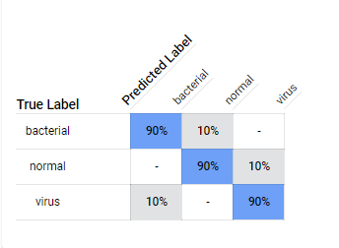

|  |  |
| --- | --- |
| **Confusion Matrix**  Summarize the 3-class confusion matrix. Which classes is the model most likely to confuse? Which class(es) is the model most likely to get right? Why might you do to try to remedy the model’s “confusion”? Include a screenshot of the new confusion matrix. | There were 100 "normal" images, 100 "bacterial pneumonia" images, and 100 "virus pneumonia" images. Bacterial and virus pneumonia classes are the model most likely to confuse. Normal class is the model likely to get right. Model needs more data to solve the confusion. |
| **Precision and Recall**  What are the model’s precision and recall? How are these values calculated (report the values for a score threshold of 0.5)? |  |
| **F1 Score**  What is this model’s F1 score? | F1 = (2*9/10*9/20)/(9/10+9/10) = 0,9 |